Asbuilt Documentation
SunDAT — Process Guide for Uploading and Processing Asbuilt Layouts

1. Project Creation
Create a manual project using a valid latitude and longitude.

2. Upload Asbuilt DWG File
Upload the DWG file using the “Import Asbuilt” option.
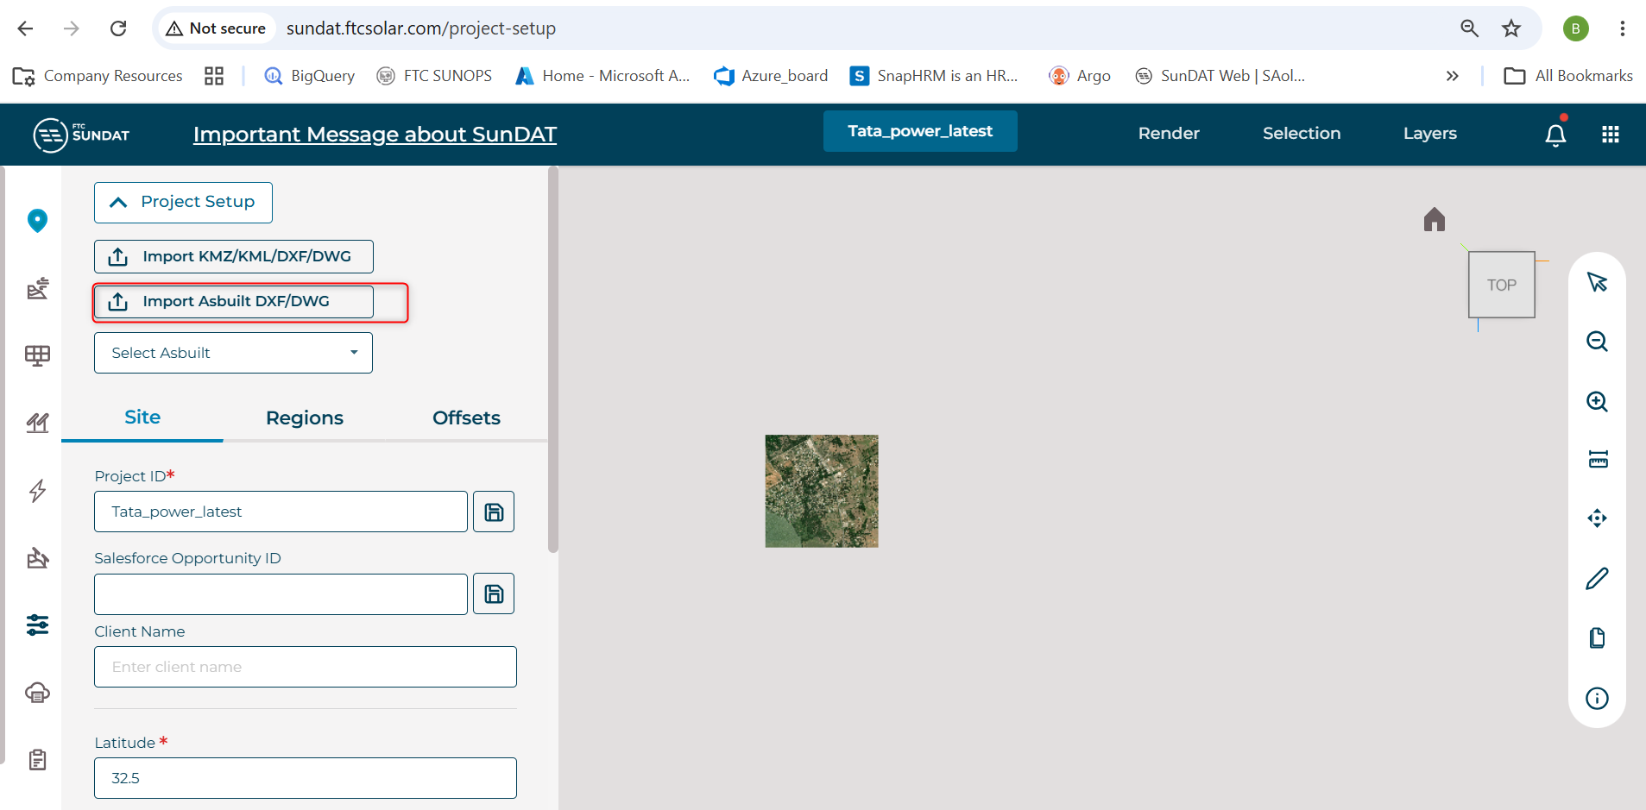
Figure 1: Import Asbuilt option

2.1 Step 1 – Boundary and Contour Layer Selection
After uploading the DWG file, the Step 1 input pop-up appears. The boundary and contour layers should be selected.
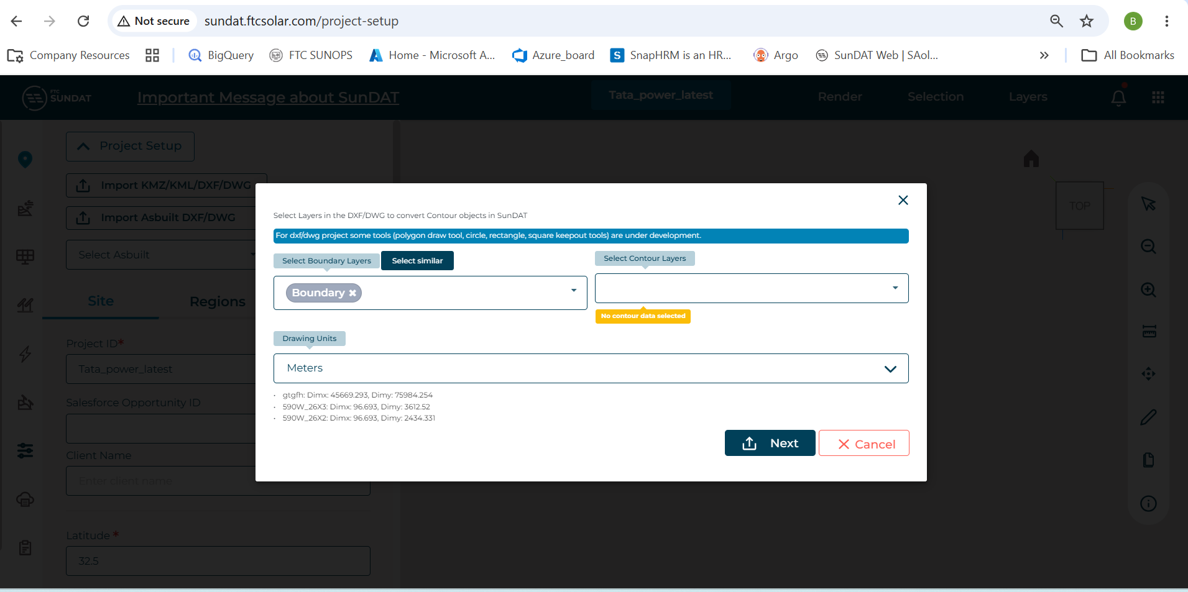
Figure 2: Step 1 input – boundary and contour layer selection
After selecting the boundary and contour layers, click the Next button. This opens the Step 2 input pop-up.
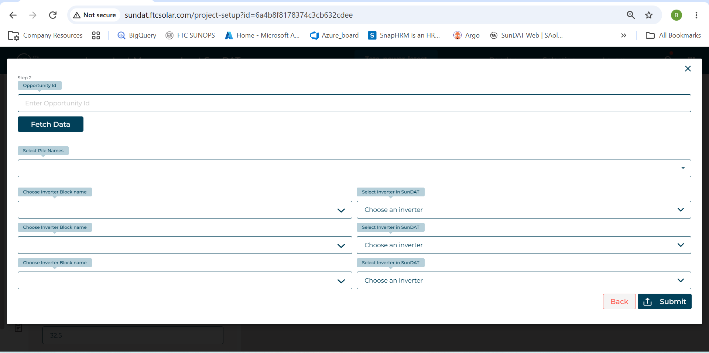
Figure 3: Proceeding to Step 2 input

2.2 Step 2 – Inverter Block Selection
It is mandatory to select an inverter block name (any option from the available list may be selected). The corresponding SunDAT inverter must then be chosen for the selected inverter block name.
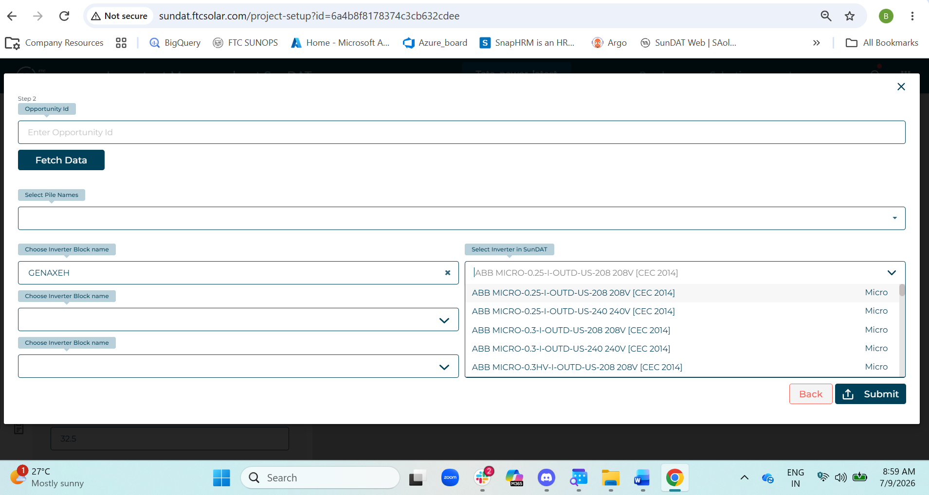
Figure 4: Inverter block and SunDAT inverter selection

2.3 Table and Module Detail Selection
Once the inverter block and SunDAT inverter are selected, a table and module details table are displayed in the pop-up. This table lists everything the SunDAT app has identified as a “table” from the DWG file — which may occasionally include other components identified incorrectly.
Note: Review the listed items carefully. Unselect any incorrectly identified components and select the correct module for the valid tables.
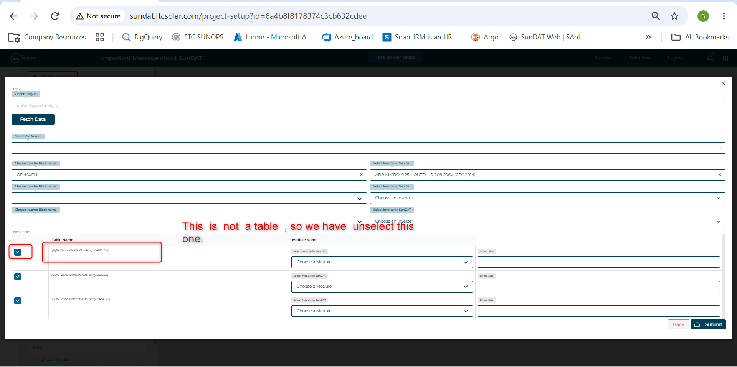
Figure 5: Table and module details review

3. Module Selection
Select the appropriate module in SunDAT for each selected table, ensuring that the module’s Dim X and Dim Y match the dimensions shown in the table name.
Module details used in the field are typically provided by the sales team. If the exact module is not available in the SunDAT library, clone a module in the library and set its Dim X and Dim Y to match the module used in the field. Then click the Submit button.
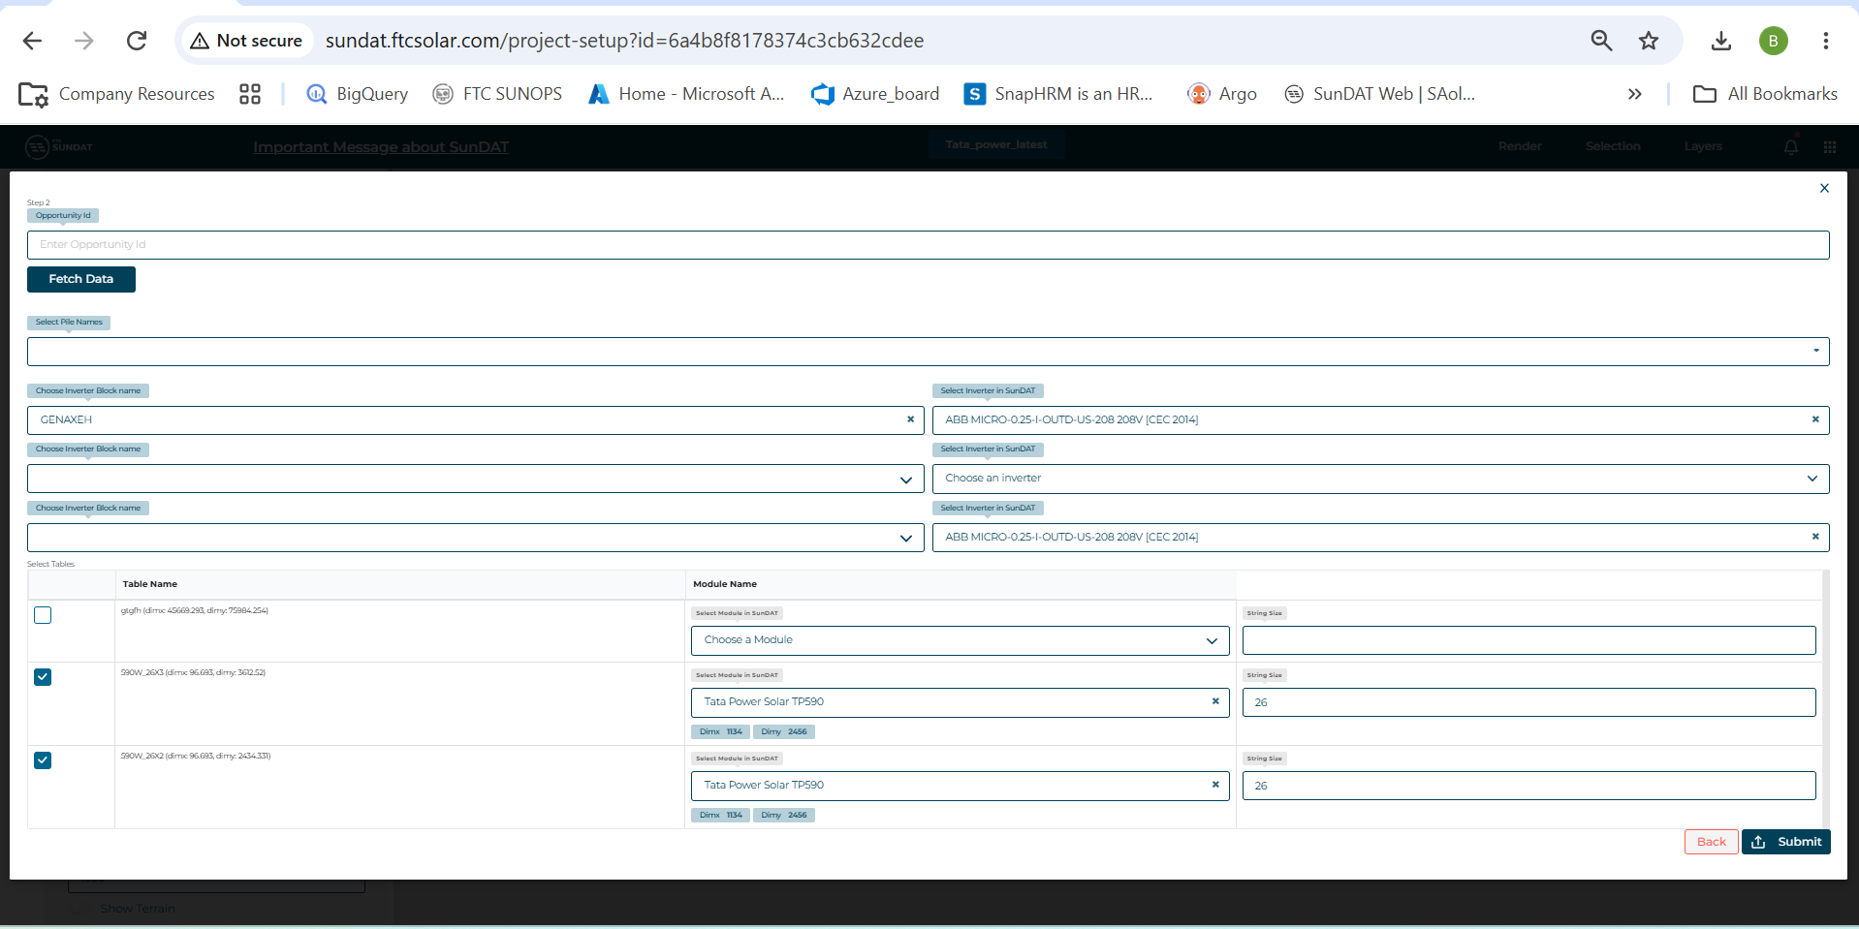
Figure 6: Module selection and dimension matching
Once submitted, the layout is uploaded into SunDAT.
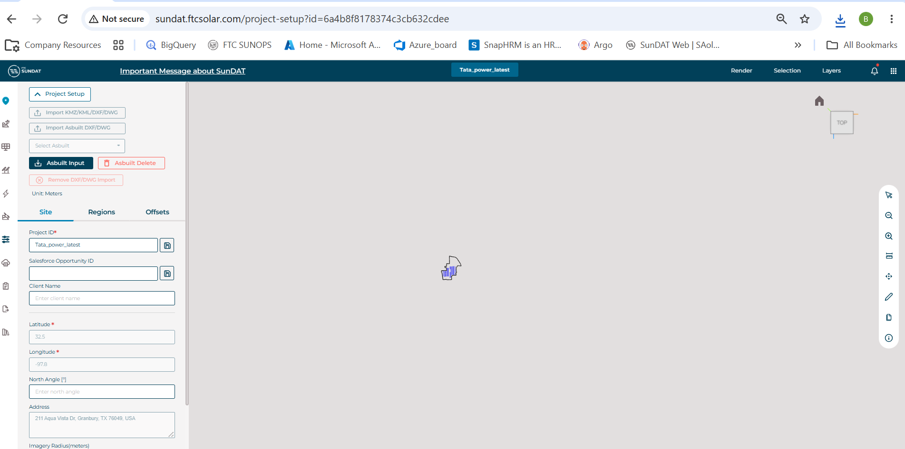
Figure 7: Layout uploaded into SunDAT

4. Managing the Asbuilt Upload
- Delete: Use the Asbuilt – Delete button to remove an uploaded Asbuilt.
- Download Input JSON: Downloading the Asbuilt input JSON provides all details entered in the Step 1 and Step 2 input forms.
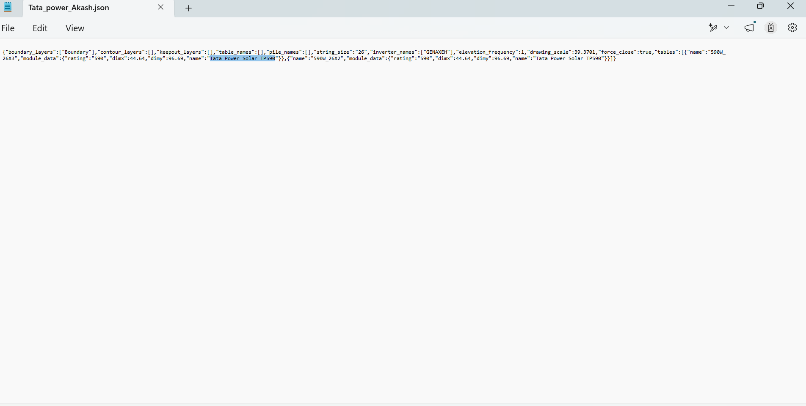
Figure 8: Asbuilt delete and download input JSON options

5. Generating the Construction Asbuilt JSON
To generate the construction Asbuilt JSON, navigate to the Plugins menu and open the Asbuilt tab.
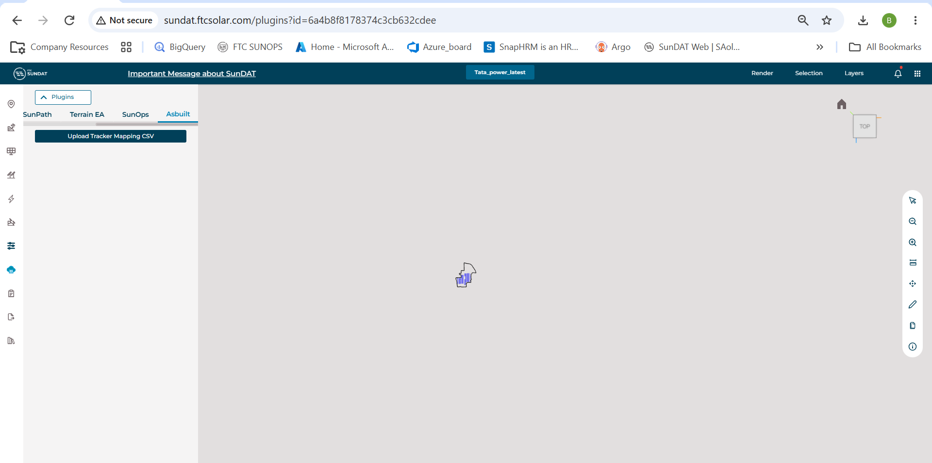
Figure 9: Navigating to the Asbuilt tab under Plugins

5.1 Upload Latitude/Longitude CSV
Upload the latitude/longitude CSV file for the Asbuilt project, which is provided by the Sales Engineering team.
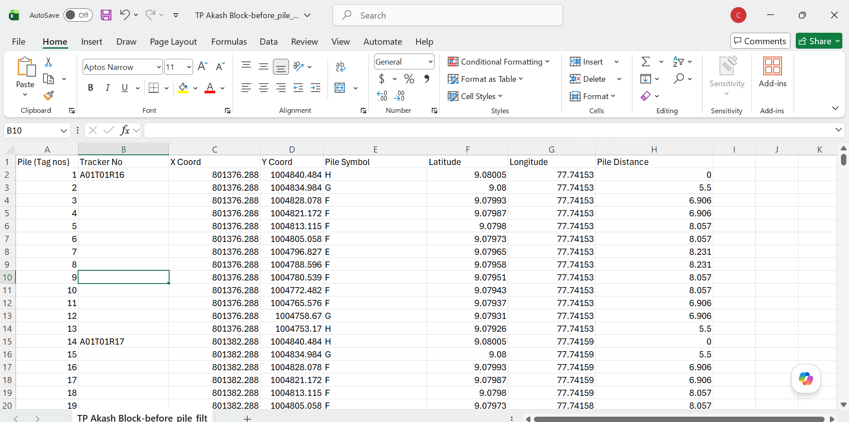
Figure 10: Uploading the lat/long CSV file

5.2 Configuration Check
After uploading the lat/long CSV file, a configuration check pop-up is displayed with the following details:
- Unmapped tracker in the active layout: Count of extra trackers present in the layout but not found in the CSV file.
- Unmapped tracker in the uploaded CSV: Count of extra trackers present in the CSV file but not found in the layout.
- Mapped trackers: Count of trackers in the layout that match trackers in the CSV file.
Select the type of tracker used in the layout (Pioneer, Voyager, or Normal), then click Continue.
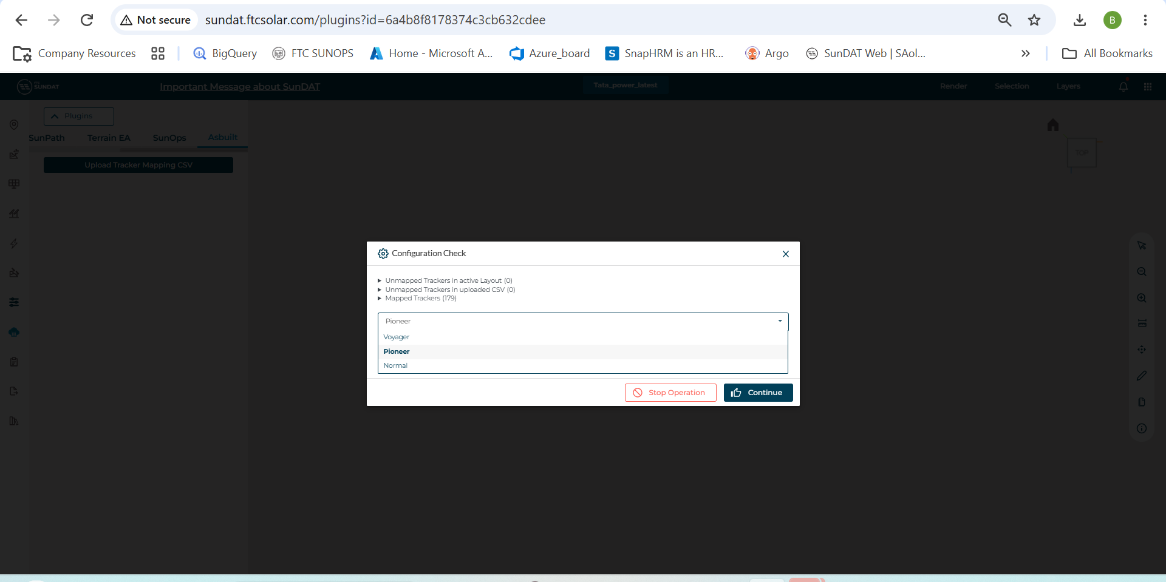
Figure 11: Configuration check and tracker type selection

5.3 Download the JSON File
After completing the configuration check, download the JSON file by selecting the appropriate version. Version numbers are maintained based on how many times the lat/long CSV file has been uploaded.
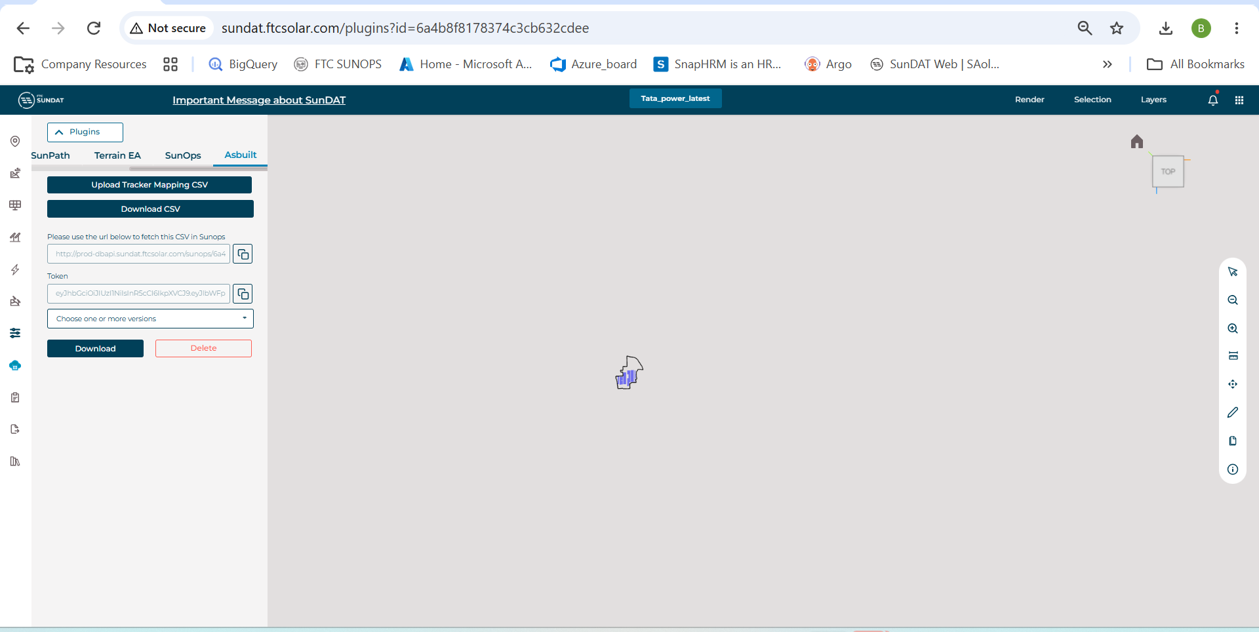
Figure 12: Selecting the JSON version
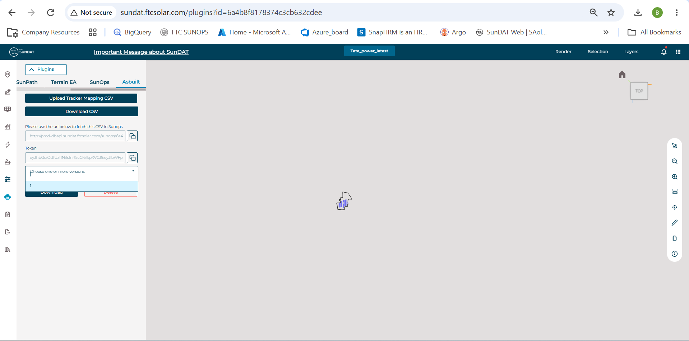
Figure 13: Downloading the JSON file
A sample of the resulting JSON file is shown below.
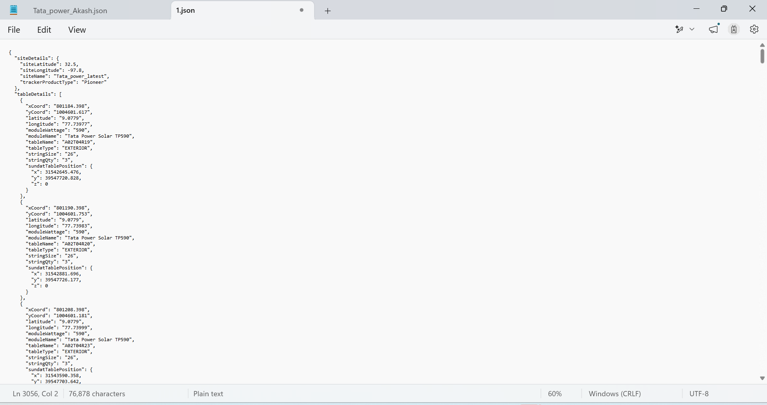
Figure 14: Sample construction Asbuilt JSON output

