Construction AI
Updated JSON Generation Process — Pile Point Adjustment Workflow
This document outlines the end-to-end process for adjusting tracker pile point coordinates and generating an updated Construction AI JSON file. The workflow combines manual CSV preparation with a Python automation script to calculate adjusted latitude and longitude values, which are then merged into the Construction AI JSON exported from SunDAT.

Process Overview
- Step 1 — Reduce each tracker's pile points to first and last only
- Step 2 — Calculate the longitude difference between adjacent trackers in a row
- Step 3 — Calculate the latitude difference between the same tracker across adjacent rows
- Step 4 — Add adjusted latitude/longitude columns to the CSV
- Step 5 — Generate the updated Construction AI JSON file

Step 1: Reduce Pile Points to First and Last
Update the Latitude/Longitude CSV file so that, for each tracker, if more than two pile points are present, only the first and last pile points are retained; all intermediate pile points are removed.
This process is automated using a Python script.
Below is a sample showing all the pile points available for a single tracker before processing.
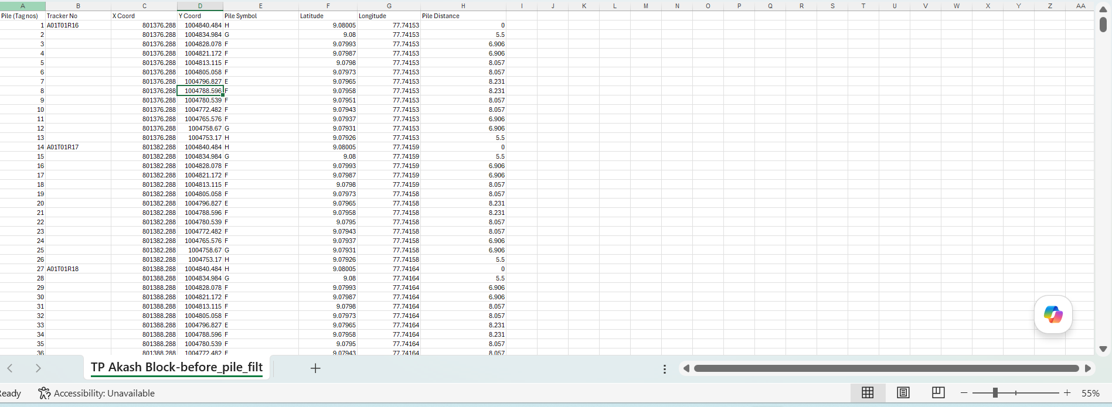
Figure 1 — Pile points before processing
After removing the intermediate pile points, the CSV file contains only the first and last pile points for each tracker, as shown below.
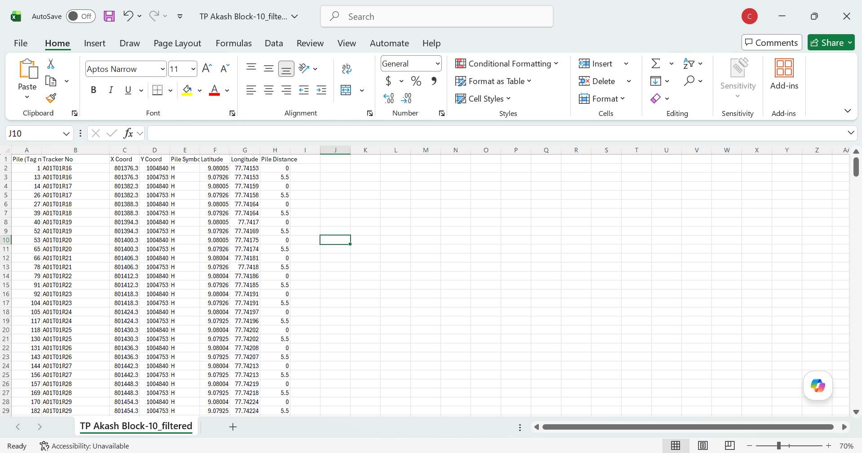
Figure 2 — Pile points after processing (first and last retained)

Step 2: Longitude Difference Calculation
The longitude difference is calculated using two adjacent trackers in the same row.
For example, A01T01R16 and A01T01R17 are adjacent trackers in row T01.
- Take the first pile point of tracker A01T01R16.
- Take the last pile point of the adjacent tracker A01T01R17.
- Subtract the longitude of the first pile point of A01T01R16 from the longitude of the last pile point of A01T01R17.
- In this example, the calculated difference is -0.0000600.
- Divide this value by 2. The resulting value is the longitude difference used for further calculations.
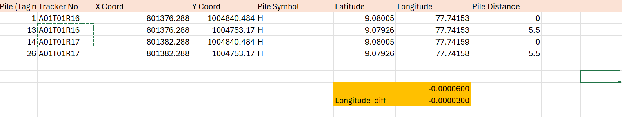
Figure 3 — Longitude difference calculation

Step 3: Latitude Difference Calculation
To calculate the latitude difference, consider the same tracker in two adjacent rows.
For example, A01T01R16 and A01T02R16 represent tracker R16 in rows T01 and T02, respectively.
- Take the last pile point of the tracker in the current row (A01T01R16).
- Take the first pile point of the corresponding tracker in the next row (A01T02R16).
- Subtract the latitude value of the last pile point of A01T01R16 from the latitude value of the first pile point of A01T02R16.
- In this example, the calculated latitude difference is 0.0000500.
- Divide this value by 2. The resulting value, 0.0000250, is the latitude difference used for further calculations.
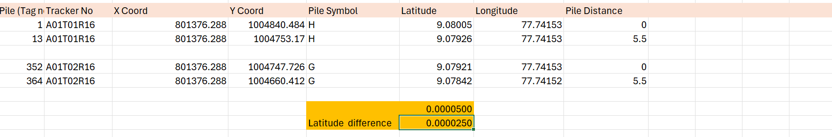
Figure 4 — Latitude difference calculation

Step 4: Add Additional Columns to the CSV File
Add the following four columns to the Latitude/Longitude CSV file:
- Lat Diff
- Long Diff
- AdjustedLat
- AdjustedLong
Populate the Lat Diff column with the latitude difference calculated in Step 3. Similarly, populate the Long Diff column with the longitude difference calculated in Step 2.
Calculate the AdjustedLat and AdjustedLong values as follows:
Pile Point | AdjustedLat | AdjustedLong
First pile point | Latitude + Lat Diff | Longitude + Long Diff
Last pile point | Latitude − Lat Diff | Longitude − Long Diff

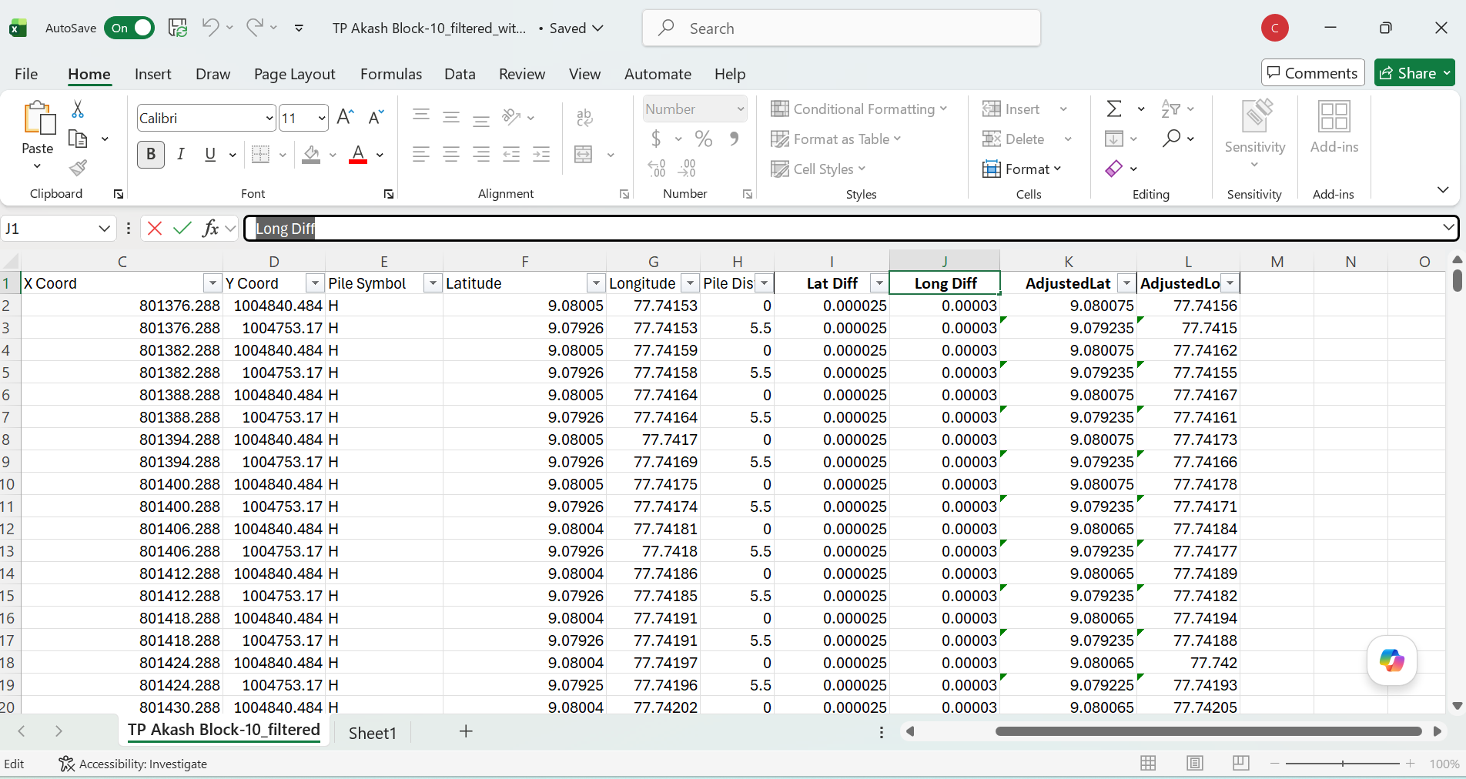
Figure 5 — CSV file with Lat Diff, Long Diff, AdjustedLat, and AdjustedLong columns populated

Step 5: Generate the Updated Construction AI JSON File
Use the Python script to generate an updated Construction AI JSON file. Provide the following input files to the script:
- The Construction AI JSON file exported from SunDAT.
- The Latitude/Longitude CSV file containing the calculated Lat Diff, Long Diff, AdjustedLat, and AdjustedLong values.
The script reads both input files, updates the Construction AI JSON with the adjusted latitude and longitude values from the CSV file, and generates an updated Construction AI JSON file as the output.
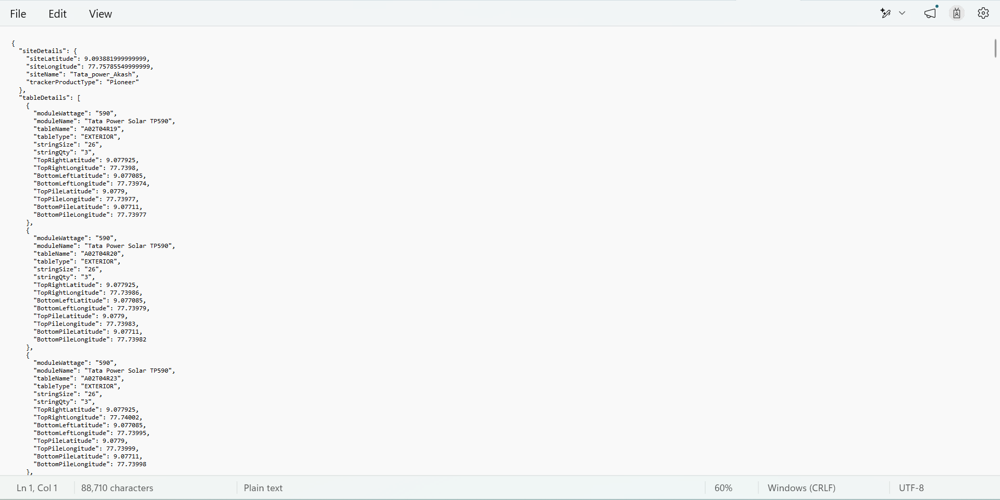
Figure 6 — Updated Construction AI JSON output

