Netflix! What started in 1997 as a DVD rental service has since exploded into one of the largest entertainment and media companies. You work for a production company that specializes in nostalgic styles. You want to do some research on movies released in the 1990's.

You have been supplied with the dataset **netflix_data.csv**, along with the following table detailing the column names and descriptions.

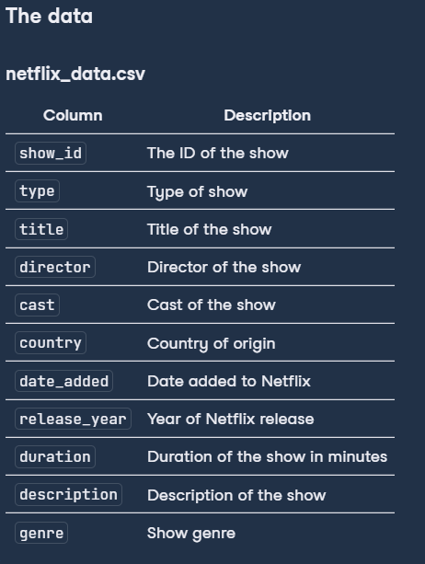

Perform exploratory data analysis on the **netflix_data.csv** data to understand more about movies from the 1990s decade.

Q1 - What was the most frequent movie duration in the 1990s? Save an approximate answer as an integer called **duration**.

Q2 - A movie is considered short if it is less than 90 minutes. Count the number of short action movies released in the 1990s and save this integer as **short_movie_count**.