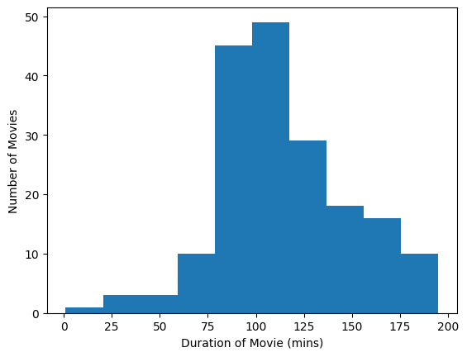

7 (short_action_movieCount)