**Analysing the social-ECONOMIC IMPACT of Wireless Mobile SERVICES DURING and before COVID-19 using topic modelling and Sentiment analysis on Tweets**

by

**[Wehel Hadi]**

A thesis submitted in partial fulfillment of the requirements for the degree of

**[Applied Data Science]**

**[University Utrecht]**

2021

**Approved by:** Dr. M.(Michael) Behrisch

Chairperson of Supervisory Committee

**Thesis supervisor:** Dr.A.A.A.(Hakim) Qahtan

**Second examiner:** Dr.M.W.(Mel) Chekol

**Program   
to Offer Degree:** Master’s degree

**Date:** 02/08/2021



**Table of Contents**

1. **Introduction**

Over the past twenty years, wireless communication has undergone a technological revolution. Wireless mobile services have become the fastest growing part of the telecommunications sector (Ronald Beaubrun, 2010). The use of a mobile phone has become an essential part of today's society. Today, 90 percent of the world's population over the age of six has access to a mobile phone, i.e. billions of people(Emerce, 2014). This makes wireless mobile communication a worldwide phenomenon, for developed countries as undeveloped countries. The rise of mobile technology therefore has a direct social-economic impact. The study of Subramani Parasuraman (2017) showed that a significant number of the participants of the research had an addiction to mobile phone usage. Another interesting result was that the majority of these participants didn’t recognized that they were addicted.

In contrast, wireless mobile services also have a positive social economic impact. Wireless mobile services, make a positive contribution to personal security. Nowadays it is possible to immediately ask for help in dangerous situations with the help of always available internet and mobile phone calls. In addition, the rise of this technology has also created a completely new industry. This has created many jobs for people, which has had a positive impact on employment and the economy (Ronald Beaubrun, 2010). This emerging industry is made up of different companies with different perspectives and ways of providing services. Two companies that differ in their way of delivering services are Infinity mobile and Mint Mobile. While Infinity mobile opts for the traditional fixed plan approach (Mobile I. , sd), Mint Mobile opts for more flexible plans for their customers (Mobile, sd).

THERE NEEDS TO BE MORE HERE

Therefore, this paper examines the social-economic impact of wireless mobile services for the companies Infinity Mobile and Mint Mobile. These two companies contradict each other in their way of delivering services. This paper will focus on the impact of wireless mobile services on user satisfaction (social effect), affordability (economic effect) and willingness to use (social effect). The analysis will be performed using topic modelling and sentiment analysis on data from twitter. Topic modelling will reflect the various topics discussed in the data. The purpose of this topic modelling analysis is determining the tweets that are related to the topics: user satisfaction, affordability and willingness. The sentiment analysis will determine what the sentiment is for each of these values. During this analysis, the changes in the sentiment score over time will be determined. Based on that, it will be clear whether COVID-19 affected the sentiment score or not.

The remainder of this paper is organized as follows: section 2 is the theoretical framework, where the two different companies are discussed and a brief introduction of the methods that are used for the analysis. Section 3 is the methodology, in this part the data collection, data cleaning, topic modelling and the sentiment analysis is discussed. Section 4 discusses the results, one part for the topic modelling and another part for the sentiment analysis. Section 5 contains the conclusion and section 6 contains the discussion. Section 7 describes the limitations of the research and the further research that needs to be done. The last section is the appendix.

1. Theoretical Framework
   1. Topic modelling
   2. Sentiment analysis
2. Theoretical Literature

Wireless mobile services are indispensable in our society today, but this has not always been the case. The wireless technology industry has evolved over the years, leading to a mobile revolution with fundamental and major consequences for the world. However, this revolution has not yet come to an end, innovations are made every year. This requires adaptability from both society and the economy. However, the advantages of these emerging technologies outweigh the disadvantages. This revolution has made it possible to obtain more easily available data so that decision makers can make better decisions. It has also had a positive influence on communication between people, but also between institutions and people. The government has been given a tool that makes it easier to reach the people. Companies also have this advantage with regard to their customers (Keng Siau, 2003). The development of this sector has gone through several intermediate steps. These step will be discussed in chapter 3.1.

* 1. Evolution of wireless mobile services

The wireless mobile services revolution started in 1980, since then this technology has been developing constantly and rapidly (Keng Siau, 2003). This mobile technology has gone from 1G in 1980 to 5G in 2020. This is shown in figure 1.

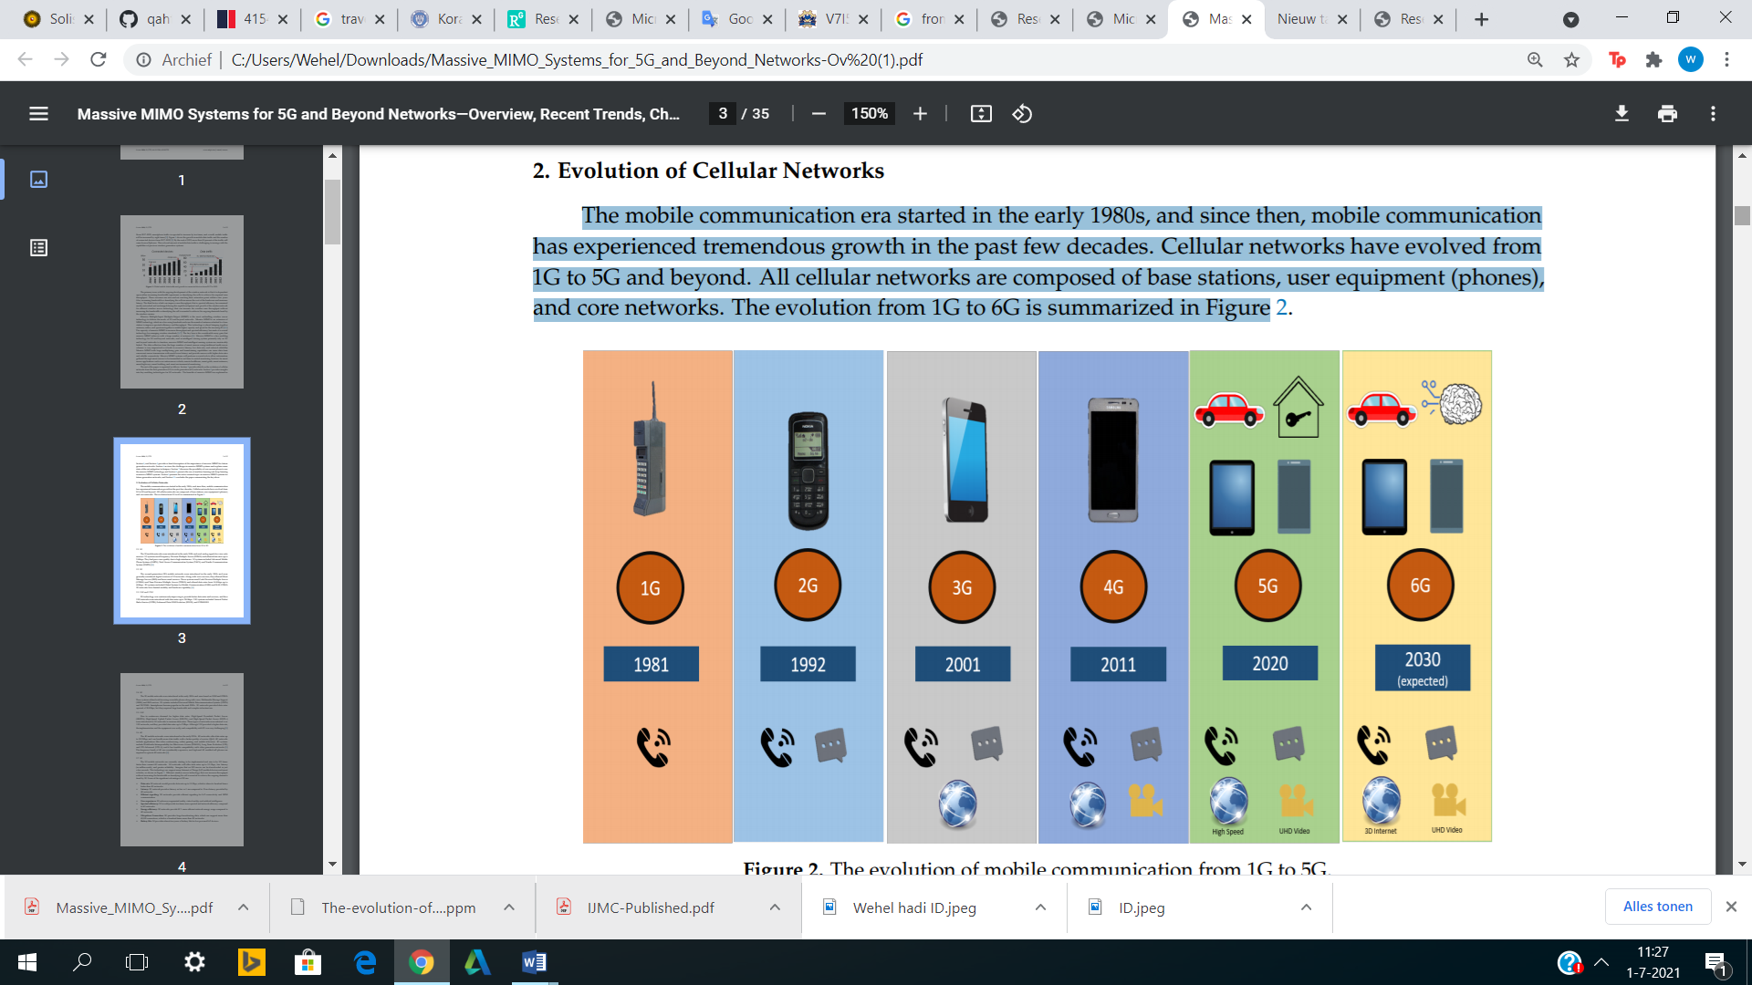

Figure 1: The evolution of mobile communication from 1G to 5G (Chataut, 2020)

However, the basic concept for each of these innovations is the same, namely that the cellular network consists of a base station, user equipment(phone) and core networks (Chataut, 2020). The enormous demand by consumers, companies and governments for these mobile services has accelerated the developments around mobile technology. The various phases that led to this development are described below.

* In the beginning of 1980 the 1G mobile networks came on the market. This network used analog signals for voice-only services. This network also provided data rates up to 2.4 kbps. This was the beginning of this technology and because of this there were many shortcomings in the wireless mobile service. A big disadvantage of these 1G mobile networks was that it had a poor voice quality, this was due to high interference (Chataut, 2020).
* At the beginning of 1990, the 2G mobile networks came on the market. The 2G networks were more like a digital version of the 1G networks from the 1980s. This made it possible to send a text message and a number of simple email services with a mobile in addition to the voice services. This mobile network also provided data rates up to 64 kbps. Despite the fact that the 2G mobile networks were an improvement compared to the 1G mobile networks, there were still shortcomings. A major drawback of this network was that it had limited mobility and hardware capability (Chataut, 2020).
* In the early 2000s, the 3G mobile networks came on the market. The system behind this network was called GSM. This system made it possible to browse the web in addition to calling and texting. This network also had a data rate up to 384 kbps. This system was another major step forward, but the major drawback of this network was that it required a large bandwidth (Chataut, 2020).
* At the beginning of the 2010s, 4G mobile networks came on the market. This network has many similarities with the 3G network, but it is able to handle more data with a better service. The data rates of this network can reach up to 100 Mbps. In contrast to the older networks, this network makes it possible to play online games, make video calls and watch television on your mobile. However, this network has the disadvantage that the frequency bands are expensive and that customers need a high tech telephone to make this network work(which is expensive) (Chataut, 2020).
* The 5G
  1. Social-economic impact of wireless mobile services
  2. Mint Mobile
  3. Infinity Mobile

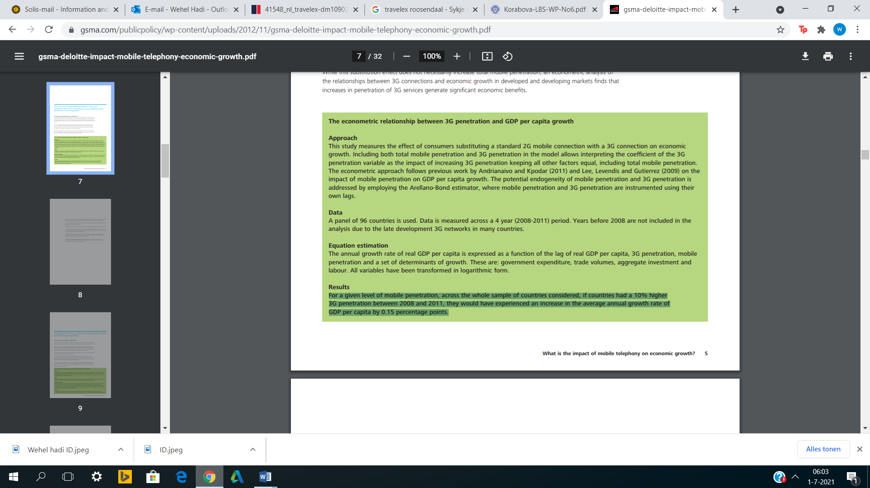

<https://stackoverflow.com/questions/10059594/a-simple-explanation-of-naive-bayes-classification>

1. Methodology
2. Results
3. Conclusion
4. Discussion
5. References