TWC-SWQP: A Semantic Portal for Next Generation Environmental Monitoring
Ping Wang¹, Jin Guang Zheng¹, Linyun Fu¹, Evan W. Patton¹, Timothy Lebo¹,
Li Ding¹, Qing Liu², Joanne S. Luciano¹, Deborah L. McGuinness¹
¹Tetherless World Constellation, Rensselaer Polytechnic Institute, USA
² Tasmanian ICT Centre, CSIRO, Australia
Abstract. We present a novel ontology integration and reasoning approach for the development of environmental information systems. This approach is applied in the Tetherless World Constellation Semantic Water Quality Portal (TWC-SWQP). Our integration scheme uses a core ontology to model domain concepts and their relationships. It integrates water data from different sources along with multiple regulation ontologies to enable pollution detection. Our reasoning scheme, which is based on OWL2's advanced numerical datatype constraint, identifies pollution events based on the integrated data. It also captures and leverages provenance to improve the transparency of the portal. In addition, semantic water quality portal features provenance-based query answering and visualization computed using the Pellet reasoner over the integrated data via SPARQL.
- Introduction
Concerns over environmental issues such as biodiversity loss [35], water problems [34], atmospheric pollution [36], and sustainable development [37] have highlighted the need for reliable information system to monitor environmental trends, support scientific research and inform citizens. In particular, semantic technologies have been used in environment monitoring information systems to facilitate domain knowledge integration across multiple sources and support collaborative scientific workflows [33]. Meanwhile, growing interests have been observed from citizens, demanding direct and transparent access to environmental information [32]. For example, residents of Bristol County, Rhode Island commented a government announcement (tap water was contain mated by E. coli bacteria) with concerns such as “Wonder when the contamination began”, “how this happened”, .
In this paper, we developed the Tetherless World Constellation’s Semantic Water Quality Portal (TWC-SWQP), a semantic information portal, to identify the challenges in building the next generation environmental monitoring systems for citizens and evaluate the fitness of our Linked-Data based approach. The portal integrates water monitoring and regulation data from multiple sources following Linked Data principles, captures the semantics of water quality domain knowledge using a simple OWL2 ontology, preserves provenance metadata using the Proof Markup Language (PML) ontology [14], and infers water pollution events using OWL2 inference. The portal has been deployed on the Web to deliver water quality information and the reasoning results to citizens via a faceted browsing capable map interface.
The contributions of this work are multi-folded. The overall design provides a template for those interested in creating environmental monitoring portals. This particular portal allows anyone, including those who do not have depth of knowledge in aspects of water pollution regulation, to monitor water quality in any region of the United States. It could also be used to integrate data generated by citizen scientists as a potential indicator that professional collection and evaluation may be needed in particular areas. Last but not the least, water quality professionals can use this system to conduct provenance-aware analysis such as explaining the cause of a water problem and cross-validating water quality data from different data sources with similar contextual provenance parameters (e.g. time and location).
In the rest of this paper, section 2 reviews the challenges in the development of the TWC-SWQP on real world data, section 3 elaborates how semantic web technologies has been used in the portal, including ontology-based domain knowledge modeling, real world water quality data integration, and provenance-aware computing. Section 4 shows implementation details of the portal and section 5 discusses several highlighting experiences in system development. Related work is reviewed and compared in section 6 and section 7 concludes this work with future research plan.
- Water Quality Information System Challenges
Water quality Water quality is important not only to protect public health: water provides ecosystem habitats, is used for farming, fishing and mining, and contributes to recreation and tourism. If water quality is not maintained, it is not just the environment that will suffer - the commercial and recreational value of our water resources will also diminish. Thus, a publicly accessible information system that facilitates water monitoring, specifically the discovery of polluted water sources, the specific contaminants, and any nearby polluting facilities would be beneficial.

Modeling Water Monitoring Domain Knowledge
Domain knowledge for monitoring water quality consists of three major parts: observation data collected by sensors, regulation data published by government, and domain ontologies generated by scientists.
The information system needs to model appropriate domain knowledge. The basic high level domain concepts include: water contaminant, contaminant measurement at various locations and time with different test methods, and thresholds of allowable contaminant values are defined in regulations or guidelines by authoritative bodies. To the best of our knowledge, none of the existing ontologies models all these concepts in an integrated way. They either just model general concepts related to water like the SWEET ontology, or just model relationships among water quality data sets [5], or just focus on a specific aspect of water quality [7]. Moreover, regulations concerning water quality have not been modeled as part of any existing ontology according to our survey. The best we can get is regulation specifications organized in HTML tables.
Water regulations give the lists of contaminants and their allowable thresholds, e.g. the maximum threshold for Arsenic as 0.01 mg/L in the the National Primary Drinking Water Regulations (NPDWR). Besides NPDWR stipulated by the US EPA, at the state level, each state is responsible for drawing up and enforcing its own water regulations and guidelines. For instance, the Massachusetts Department of Environmental Protection issued the "2011 Standards & Guidelines for Contaminants in Massachusetts Drinking Water." These water regulations specify sometimes different, sometimes overlapping, and occasionally contradictory rules. For example, the threshold for Lead is 0 mg/l in NPDWR and 0.015 mg/l in the MA water guide. Since some users may be interested in applying their local regulations and others may prefer to use the federal regulation, the information system must be able to model various water regulations applied to the same observational data. Such modeling would be time consuming without well designed automated mechanisms because water quality regulations stipulate rules using terminology different from other similar regulations.

Collecting Real World Data
Second, the information system usually integrates data collected from distributed data sources for the purposes of enlarging data coverage and data validation. There are two major government agencies in the US that publish water quality data: EPA and USGS. Permit compliance and enforcement status of facilities is regulated by the National Pollutant Discharge Elimination System (NPDES) under the Clean Water Act (CWA) from ICIS-NPDES, an EPA system. The NPDES datasets contain descriptions of the facilities (e.g. name, permit number, address, geographic location) and measurements of contaminants in the water discharged by the facilities, and also the threshold values for up to five test types per contaminant. USGS provides the National Water Information System (NWIS) to publish data about water collection sites (e.g. identifier, geographic location) and the measurements of substances contained in those samples. However, these water data are not ready to be consumed by an information system for several reasons. TODO: focus on linking and compare.
- These water quality data are presented in tabular form. Each column represents a property; each row corresponds to a record, and each table cell contains the value of the corresponding property in the corresponding record. Such data are literals local to their datasets. One concept may have multiple local names, and all the local names cannot be understood by people except the data providers. For example, the USGS measurement dataset uses "CharacteristicName" and the EPA dataset uses "Name" for contaminant name.
- The semantics of the water quality data are not explicitly encoded in the data files, but are instead scattered in web pages on web sites (e.g. help page , technical documentation ). To decide if a water measurement reveals a pollution, the information system need to compare the measurement value with the threshold from regulations. However, such comparison cannot be conducted if the system do not understand the semantics of the data. For example, the EPA measurement dataset, one row contains test results for up to five test options as shown in Table 2. C1 and C2 represent different test types and there are up to five test types. Three test types (C1, C2, C3) use concentration-based limits, while the other two (Q1, Q2) use quantity-based or mass-based limits. C1_VALUE and C1_UNIT are the measurement value and unit. Without given prior knowledge, it is impossible for a information system to interpret such data correctly.
Table 2. Cell-based conversion example: For the facility with permit RI0100005, the 469th row for Coliform_fecal_general measurements on 09/30/2010 contains 2 tests.
C1_VALUE | C1_UNIT | C2_VALUE | C2_UNIT
34.07 | MPN/100ML | 53.83 | MPN/100ML

Provenance-Aware Computing
Lastly, the information system needs to capture and leverage the provenance data to increase its extensibility and transparency.
- To give credits to data providers and increase the transparency of the system,, the water information system maintains a description of data sources for presentation to users. If the system incorporates data from a new data source, it should update this list of data sources. Without capturing provenance about data sources, this update would require developers to modify the system implementation. But in a water information system that keeps comprehensive provenance data, the description of data sources can be generated and updated automatically, which makes incorporating new data sources easier.
- It is quite common that information systems incorporate abnormal data based on our experience of dealing with information systems. Abnormal data can be cause by various reasons, e.g. mistakes during data collection, the misinterpretation of the data by the information system. Detection of abnormal data helps revealing the mistakes in either data providers or information systems and allows people to fix the mistakes. Thus, the information system should perform data validation aiming at discovering the abnormal data. However, the system needs to tackle the feature of environmental data that such data depends on the geographic location and the measurement time, which implies only data measured at close locations and time could be used to validate each other. Thus, data validation in environment information systems should consider provenance, e.g. geographic location and the measurement time.
- Semantic Web Approach
We use a semantic web approach to tackle the inherent challenges for environmental information systems. We focus on water quality in our current project, but we attempted to design a foundation that could be re-used in other environmental monitoring tasks. Our driving use cases involve support for automatically identifying polluting facilities and polluted water sites, as well as the corresponding water measurements that violate regulations.
  - Domain Knowledge Modeling and Reasoning
Environmental monitoring systems can benefit by modeling the target domain using two types of ontologies: a relatively static core ontology that includes terms of interest in the particular environmental area (such as body of water) and a dynamic regulation ontology containing information about items that are monitored (such as arsenic), relevant tests and acceptable threshold values. For our water quality portal, we designed a simple foundational environmental information ontology monitoring upper level with more depth in the domain of water. Our TWC water ontology contains two parts: a static core water ontology and a dynamic regulation ontology. Heterogeneous water quality data and regulation data can be easily converted to fit in our water ontology, and the regulation ontology is loaded on demand to detect water pollution according to different regulations.

Core ontology design.
We design our own water ontology because existing ontologies about water cannot be reused for our water pollution detection task, as mentioned in Section 2.1, but we reuse portions of existing ontologies, for example, although the SWEET ontology does not contain anything about pollutant, its concepts about hydro body such as Lake and Stream are reused in our ontology.
The core ontology models domain objects (e.g. water sites, facilities, measurements, and characteristics) as classes, and the relationships among the domain objects (e.g. hasMeasurement, hasValue, hasUnit) as properties. A subset of the ontology is illustrated in Figure 1. We model a polluted water site (PollutedWaterSource) as the intersection of water site (WaterSource) and something that has a characteristic measurement with a value that exceeds its threshold, i.e., it satisfies an owl:Restriction that encodes the specific definition of an excessive measurement for a characteristic as a numeric range constraint. However, the thresholds for the characteristic measurements are not defined in the core ontology, but in the regulation ontology, so that polluted water sites can be detected with different regulations.
Connect to other ontology, SWEET and OWL Time, benefit (no need to define more water body or time) include an instance
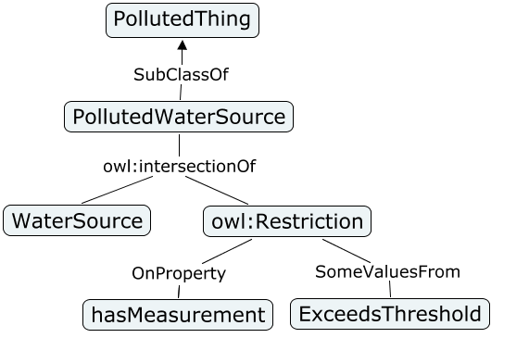
Fig. 1. Portion of the TWC Core Water Ontology.

Regulation Ontology Design.
Because regions differ in their ecology and each state is responsible for its own regulations, the number of characteristics measured and the threshold values vary in the federal and state water quality regulations. Thus, we have a dynamic regulation ontology to encode the various water quality regulations on demand. We use the numeric range restriction on a datatype property supported in OWL2 to encode the allowable ranges of the characteristics in water defined in the regulations. For example, for the piece of the EPA regulations that defines the maximum threshold for Arsenic as 0.01 mg/L, we create the class ExcessiveArsenicMeasurement as a water measurement with value greater than or equal to 0.01 mg/L. Combining the definition of polluted water site in the core ontology and the definition of specific excessive measurement in the EPA regulation ontology, a reasoner can decide if a water site is polluted with respect to various characteristics in various regulations. A subset of the EPA regulation ontology is shown in Figure 2.

Add Federal rule vs. local rule, put time constraint here to avoid time mismatch
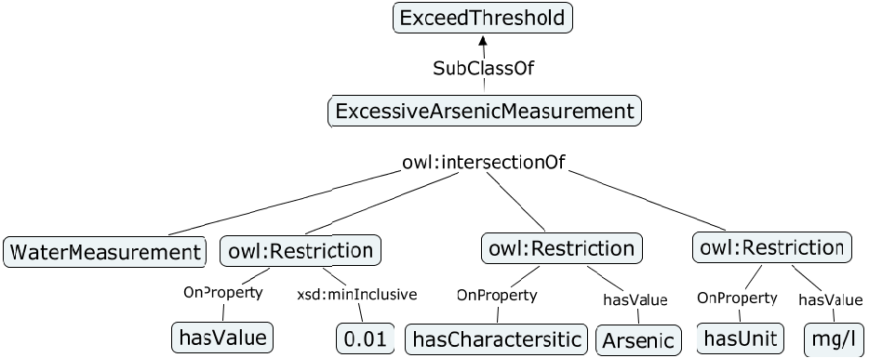
Fig. 2. Portion of EPA Regulation Ontology.

Reasoning Domain Data with Regulations
Our ontology design separates the definition of pollution concepts (e.g. polluted water site) and specific thresholds. This design brings several benefits. First, the core ontology is small and easy to maintain. Our core ontology consists of only 18 classes, 4 object properties, and 10 data properties. Secondly, the ontology component can be easily extended to incorporate more regulations. We wrote ad hoc converters to extract four states’ regulation data from HTML web pages and translated them into OWL 2 [11] constraints that align with the core. It is similarly not difficult to obtain the remaining state regulations using either our existing ad-hoc converters or potentially new converters if the data is in different forms. Furthermore, this design leads to flexible reasoning: the user can select the regulation to apply on the data and the reasoning component will reason over only the ontology for the selected regulation together with the core ontology and the water quality data. For example, when Rhode Island regulations are applied to water quality data for zip code 02888 (Warwick, RI), the portal detects 13 polluted water sites. If the user chooses to apply California regulations on the same region, the portal replied 16 polluted water sites. The resulted 23% increase would be of interest to environmental researchers and local residents.

  - Data integration
When integrating data from multiple sources, environmental monitoring systems can benefit from adopting the data organization methodology developed for the Linking Open Government Data (LOGD) project [19]. The open source tool csv2rdf4lod integrates data from multiple sources by producing well structured and connected RDF representations of tabular data.

Integration phases: csv2rdf4lod can be used to produce RDF by performing four phases: name, retrieve, convert, and publish. Naming a dataset involves assigning three identifiers; the first identifies the source organization providing the data, the second identifies the particular dataset that the organization is providing, and the third identifies the version (or release) of the dataset. These identifiers are used to construct the URI for the dataset itself, which in turn serves as a namespace for the entities that the dataset mentions. Retrieving a version of a dataset is done using a provenance-enabled URL fetch utility that stores a PML file in the same directory as the retrieved file. Converting tabular source data into RDF is performed according to interpretation parameters encoded using a conversion vocabulary. Using parameters instead of custom code to perform conversions allows repeatable, easily inspectable, and queryable transformations; provides more consistent results; and includes a wealth of metadata. Publishing begins with the conversion results and can involve hosting dump files on the web, loading into a triple store, and hosting as Linked Data.

Linking to ontological terms: A typical challenge when integrating datasets from multiple sources is the need to establish mappings to an existing vocabulary. Different datasets commonly use different names for identical concepts. For instance, the USGS measurement dataset uses the property "CharacteristicName" for contaminant name while the EPA measurement dataset simply uses "Name". To model this equivalence, we specify a csv2rdf4lod enhancement to reuse a common URI when interpreting the source data. Some properties in the water datasets also describe general concepts like latitude, longitude, time, that can be modeled using well known ontologies. We also use the "conversion:equivalent_property" enhancement to map the local properties to their correspondents in existing best practice ontologies, e.g. wgs1:lat, time2:inXSDDateTime. This way, we use vocabulary that is known to a large community to capture the semantics of our datasets.

Aligning instance references: Data linking: We also promote some property values to RDF resource and assign them URIs. We promote each characteristic in the water datasets from literal to URI, e.g. "Arsenic" is promoted to "twcwater:Arsenic", which then can be linked to external resources like "http://en.wikipedia.org/wiki/Arsenic" using owl:sameAs. In another case, we promote the permit of a facility to URI to connect the water measurements to their facilities properly. If a water measurement points to the same permit as the facility, the measurement is for the facility.

Cell based conversion: With the default conversion, each table cell is converted into a triple in the form of (Row URI, Column URI, Cell Value). Such conversion is row-base, since the row URI is the common subject for all the triples generated from the row. However, in the EPA measurement dataset, one row contains multiple test results as shown in Table 2.
It is more natural to create multiple subjects to model the distinct tests than using the row URI as the only subject. In such senarios, we need to use the cell-based interpretation provided by csv2rdf4lod. In the enhancement we mark the columns whose cell values need to be interpred as a subject as "scovo:Item". In our example, for the two tests, we mark the columns for the test values (column 20 and 31) and create two additional subjects: measurement_469_20 and measurement_469_31. After we have multiple subjects, we specify the subjects for other cells, e.g. measurement unit, limit operators, using the "conversion:bundled_by" enhancement. We give the partial converted RDF for test C1 in (X) for illustration.
:measurement_469_20 epa:FacilityMeasurement ;
epa:hasPermit epa:FacilityPermit-RI0100005 ;
epa:hasCharacteristic epa:Coliform_fecal_general ;
dcterms:date "2010-09-30"^^xsd:date ;
e1:test_type typed-test:C1 ;
rdf:value "34.07"^^xsd:decimal ; (X)
epa:hasUnit "MPN/100ML" ;
epa:hasLimitType "avg" .
  - Provenance
The provenance data in the system come from two sources. (1) The datasets contain provenance data e.g. measurement location and time. (2) The portal automatically captures provenance data during the data integration stages and encode them in PML2 [14] due to the provenance support from csv2rdf4lod. At the retrieval stage, we capture provenance, e.g. the URL of the data source, who fetched the source data at what time, what agent and protocol are used for retrieving the data. At the conversion stage, we keep provenance, e.g. what engine performs the conversion, what antecedent data are involved and play what roles. At the publish stage, we capture provenance, e.g. who load the data to the triple store at what time.

Our portal utilize provenance from two aspects: generation of data source facet, and provenance-aware data validation.

Data Source as Provenance.
With provenance about data source, the building and maintenance of the description of data sources can be automated, as we exemplified in our portal.
- The system can get the list of the graphs that stores water quality data given the URI of the person who loads the data.
- The system constructs a named graph to store the metadata about the data sources by extracting the URI of the data source from each graph that stores water quality data, and loading the extracted URIs. The named graph is abbreviated as the DS graph.
- The water information system can query the DS graph to get the URIs of the data sources, and dynamically generates the list of data sources on the user interface. When the system loads more metadata about the data source, e.g. classification, ranking, and contact information, it can build more detailed description of data sources.
- With the presentation of the data sources on the interface, the system can further allow the user to select the data sources he/she trusts (see Fig. 1). It retrieves the graphs whose data are from the selected source and use only data from these graphs. This is one provenance-based query and we can design more provenance-based queries that give the user more options to specify his/her data retrieval request, e.g. some users may be only interested in data published within two years.
The SPARQL queries used in each steps is available at: XXX.

Provenance-aware data validation.
We could use semantic approach to facilitate the validation of environmental data from multiple sources. We can write SPARQL queries to make the retrieved data satisfy the requirement that they are measured at close locations and time. For example, the filter feature of SPARQL shown in X can be used to find a facility and a site that are closely located. After we obtain comparable data, we can conduction validation by plotting the data or computing the correlation of the data. Figure X plots the measurement of PH collect by an EPA facility and USGS site that located within 1KM from each other for a common period. We can see that the PH values measured by USGS went below the minimum value from EPA very often and went above the maximum value from EPA once.

FILTER ( ?facLat < (?siteLat+"+delta+") && ?facLat > (?siteLat-"+delta+") && ?facLong < (?siteLong+"+delta+") && ?facLong > (?siteLong-"+delta+"))
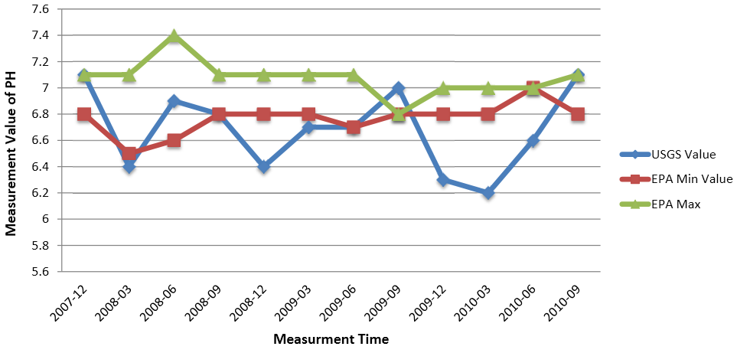ig. 3. Data Validation Example

Semantic Water Quality Portal
  - System Implementation.
Figure 1 gives a demonstration of the semantic water quality portal. The portal enables the user to issue customized requests to discover water pollution events. The user specifies a geographic region by inputting a zip code (mark 1), and can customize queries from multiple facets: data source (mark 2), water regulation (mark 3), water characteristic (mark 5) and health concern (mark 6). After the portal generates the results for the user request, it visualizes the results on a Google map, using different icons to distinguish between clean and polluted water sources, and between clean and polluting facilities (mark 4). The user can access more details about the pollution by clicking on the polluted water site or polluting facility. The information provided in the pop up window (mark 6) include: the names of contaminants, the measured values, the limit values and the water measurement time. The pop up window also gives a link from which the user can view the trend of the water quality data over time.
The portal uses our water ontology to model the domain knowledge. Our water ontology encodes the national level drinking water regulations from EPA, and the state drinking water regulations for California, Massachusetts, New York, and Rhode Island and allows the user to select the regulation to use in the Regulation facet (mark 3). After extending the ontology to model health effects, the user can customized query according to his/her health concerns.
The portal retrieves water quality datasets from EPA and USGS, and convert the heterogeneous datasets with csv2rdf4lod. The converted water quality data are loaded into the OpenLink Virtuoso 6 open source community edition, which has a SPARQL endpoint attached. The data then can be retrieved data from the triple store with SPARQL queries through the SPARQL endpoint. The portal utilizes the Pellet OWL Reasoner [2] together with the Jena Semantic Web Framework [3] to reason over the water quality data and water ontologies in order to identify water polluting events.
The portal models the effective dates of the regulations, but the portal currently only support the effective date at the granularity of a set of regulations, not the finer granularity of contaminant. We use provenance data to generate and maintain the data source facet (mark 1), which enables the user to choose the data sources he/she trusts. The provenance data validation is semi-automated and we will provide this feature on the interface after we finish its automation. The user can view the provenance trace by clicking the "View Provenance" button. In the current implementation, the portal only supports the visualizing provenance trace of data from USGS.
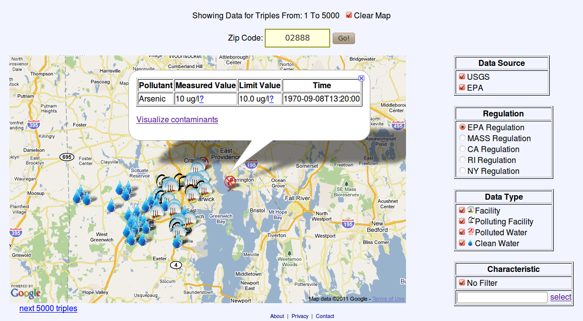
Fig. 4. System Overview
  - Technique Results
During the implementation of the portal, we experienced two issues with the water quality data. The first one is that the datasets are of large size. We have generated 89.58 million triples for the USGS datasets and 105.99 million triples for the EPA datasets for 4 states, which means the water data for the 50 states in the US would generate 1.3 billion triples from the EPA datasets and 1.1 billion triples from the USGS datasets. The sizes of the datasets are summarized in Figure X. Such size suggests that a triple store cluster should be deployed to host the water data.
The number of the threshold classes we generated from the different regulations are listed in Table X.
Table 1. Number of threshold classes convereted from regulations
EPA | CA | MA | NY | RI
83 | 104 | 139 | 74 | 100

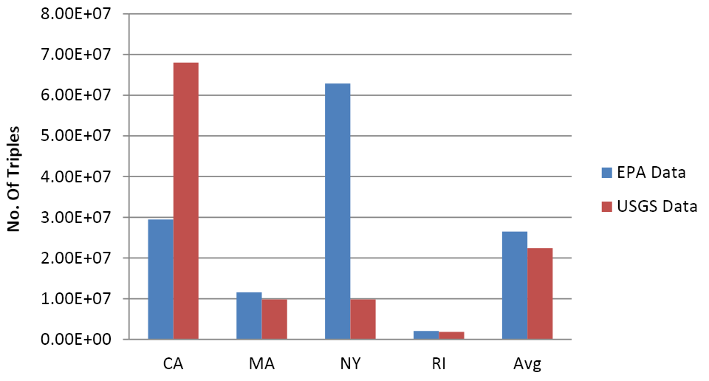
Fig. 5. Number of triples for the four states and the average number
- Discussions

Incrementally connect to health domain
Water quality is a major concern since the water we consume impacts our health. Drinking polluted water can cause acute diseases, like diarrhea, and chronic health effects including cancer, liver and kidney damage. For example, water pollution caused by gas drilling waste endangers the local residents' health in Bradford County, PA. People experienced health symptoms range from rashes to numbness, tingling, and chemical burn sensations, escalating to more severe symptoms including racing heart and muscle tremors.
Aiming at enabling citizens to investigate the health impacts of water pollutions, we extend our ontology to the health domain to model the health effects of the water contaminants. Potential Health impacts from exposure to above threshold concentration of different contaminants on different groups of people are different. For example, according to NPDWR, while excessive lead might cause kidney problems and high blood pressure on adults, it health effects on infants and children are delays in physical or mental development.
To model the health effects, we create an OWL class for each contaminant that stands for it health effect, e.g. LeadHealthEffect. We use the object property "hasSymptom" to connect the classes with their symptoms, e.g. twchealth:high_blood_pressure. The classes of health effects are related to classes of thresholds, e.g. ExcessiveLeadMeasurement, with the object property hasHealthEffect. TODO: more explanation
Based on this modeling, the portal is extended to tackle health concerns: (1) the user can specify his/her health concern and the portal will detect only the water pollution that is related to the particular health concern; (2) the user can query the possible health effects of each contaminant detected at a polluted site or polluting facility, which is useful for identifying potential effects of water pollution and designing compensating strategies.

Scalability
The large size of data also causes long reasoning time. To make the portal more responsive, we design several approaches to speed up the reasoning: data partition by state, reasoning over data tailored by SPARQL queries; and pre-processing. Without these approaches, the reasoning component would take extraordinary long time since the datasets it faces is of quite large amount.
We treat the converted data for each state as a data partition and store the partition in a named graph. The URI of the graph conforms to our data organization model. Then, the reasoning component only needs to reason over the data in a particular named graph.
However, even one data for one state can contain large amount of data, e.g. for CA, the EPA water data has 29.45 million triples, the USGS water data contains 68.03 million triples. To further reduce the amount of data to reason, we use SPARQL queries to tailor the data and feed reasoning component only with the query results. For example, we shrink the range of the data from state level to county level by adding the requirments shown in (X) to the query.
?measurement epa:hasUSGSSiteId ?id.
?site epa:hasUSGSSiteId ?id.
?site epa:hasCountyCode "003".
One more approach to reduce response time is pre-processing. For the EPA datasets, we ran the SPARQL queries to discover the polluting facilities and persistent the query results to the triple store. For example, if we found out that facility-110002370470 is polluting, we insert the triple as shown in (3) to the triple store. This way, the portal can respond the user with polluting facilities in a shorter time. We have not performed pre-processing for the USGS dataset, because the polluted USGS sites are determined by the combination of the USGS water quality data and a water regulation, which means if we are to pre-compute all the polluted USGS sites we need to reason over all the combinations of the USGS water quality data and the regulations.

twcwater:facility-110002370470 rdf:type twcwater:PollutingFacility . (3)
  - Time as Provenance.
One interesting issue we found during modeling the regulations is that they are constrained by time: the thresholds defined in both the NPDWRs MCLs and state water quality regulations became effective nationally at different times for different contaminants. For example, in the "2011 Standards & Guidelines for Contaminants in Massachusetts Drinking Water", the date that the threshold of each contaminant was developed or last updated can be accessed by clicking on the contaminant's name on the list. The effective time of the regulations has semantic implication: if the collection time of the water measurement is not in the effective time range of the threshold constraint, then the threshold constraint should not be applied on the measurement.
To model the time constraints of the thresholds, we add two data properties to each class of threshold: startEffectiveTime, and endEffectiveTime. We also keep the time of the water measurements. With query or ontology, we can guarantee that if the time of a water measurement is out of the effective range of a water regulation class, then the constraint encoded in the class has no effect on the data.

Maintenance Costs
Although government agencies typically publish environmental data on the web and allow citizens to browse and download the data, not all of their information systems are designed to support bulk data query. In our case, our programmed data queries of the EPA dataset has been identified and blocked. From the communication with EPA, we were surprised to find out that our continuous data queries have impacted their operations budget. We have filled an online form to request bulk data transfer from EPA and the form is still under processing. In contrast, the USGS provides web services to facilitate periodical acquisition and processing of their water data via automated means.
- Related Work
Three areas of work are considered related to this paper, namely knowledge modeling, data integration, and provenance tracking of environmental data.
Environmental informatics has always been communities’ interests and the recent trends focus on knowledge-based approaches. Chen et al. [5] proposed a prototype system that integrates water quality data from multiple sources and retrieves data using semantic relationships among data. Chau et al. [6] presented an ontology-based KM system (KMS) that can be integrated into the numerical flow and water quality modeling to provide assistance on the selection of a model and its pertinent parameters. OntoWEDSS [7] is an environmental decision-support system for wastewater management, which augments classic rule-based and case-based reasoning with a domain ontology. Scholten et al. [34] developed the MoST system to facilitate the modeling process in the domain of water management. A comprehensive state-of-the-art review of environmental modeling approaches could be found in [33]. SWQP differs from these projects in that it supports provenance based query and data visualization. Moreover, SWQP is built upon standard semantic technologies (e.g. OWL, SPARQL, Pellet, Virtuoso) and thus can be easily replicated or expanded.
The general data integration problem has been studied for decades by database researchers. Such work as [26,27,28] follow the paradigm of using a global mediated schema to provide a unified interface for all data sources. The major problem of this approach is that it may be difficult to let all the data sources agree on a single schema. An alternative to this approach is decentralized data sharing [29,30]. The problem of this approach is that sometimes the users find themselves too many hops away from the intended data sources. In the area of ecological and environmental research, shallow integration approaches are taken to store and index metadata of data sources in a centralized database, so that users can search for data sources in the database. This kind of approaches are applied in systems such as KNB and SEEK. Our integration scheme combines a limited set of data sources under a common ontology, so reasoning is supported on the integrated data set, and complicated data integration issues are not involved.
There also has been considerable amount of research efforts in semantic provenance, especially in the field of e-Science. myGrid [8] proposes the COHSE open hypermedia system, which generates, annotates and links provenance data to build a web of provenance documents, data, services and workflows for experiments in biology. The Multi-Scale Chemical Science [9] (CMCS) project develops a general-purpose infrastructure for collaboration across many disciplines. It also contains a provenance subsystem for tracking, viewing and using data provenance. Taxonomy of the provenance techniques used in e-science projects is presented in [24].
- Conclusions and Future Work
We presented the Tetherless World Constellation Semantic Water Quality Portal that facilitates non-expert users to monitor water quality data and investigate water pollution events. We described the semantic web approaches to develop the portal including: the design of our water ontology, the methodology of our automatic data integration, the semantic reasoning for identifying water pollution events according to multiple perspectives, and the capture and usage of knowledge provenance. The portal example demonstrates the benefits and potential of applying semantic web technologies to environmental information systems.
In the future, we plan to extend the portal from the following aspects. 1) We will incorporate the water data and encode the water regulation for the remaining states. 2) We will add interesting applications by integrating data from other sources, e.g. weather forecasts. Severe weather conditions can exacerbate pollution impacts when contaminant control strategies fail due to floods and when a polluted water source is mingled with a non-polluted water source because of storms. Fed with weather data, the portal can highlight water pollution events located in regions that will be affected by the severe weather conditions and identify the potential risks (e.g. the exposure to excessive amount of certain toxins) to help citizens come up with compensating strategies more timely. 3) Since SWQP is built upon standard semantic technologies (e.g. OWL, SPARQL, Pellet, Virtuoso), thus we can be easily reuse its architecture and workflow to build or augment other semantic web portals. For example, the TWC Clean Air Status and Trends demo has been updated to expose provenance and could be expanded to support the regulation views.

Reference TODO: remove not referenced
- Lebo, T., Williams, G.T., 2010. Converting governmental datasets into linked data. Proceedings of the 6th International Conference on Semantic Systems, I-SEMANTICS ’10, pp. 38:1–38:3. doi:http://doi.acm.org/10.1145/1839707.1839755.
- Sirin, E., Parsia, B., Cuenca-Grau, B., Kalyanpur, A., and Katz, Y. 2007. Pellet: A practical OWL-DL reasoner. Journal of Web Semantics 5(2): 51-53. doi:10.1016/j.websem.2007.03.004
- Carroll, J. J., Dickinson, I., Dollin, C., Reynolds, D., Seaborne, A., and Wilkinson, K. 2004. Jena: Implementing the semantic web recommendations. Proceedings of the 13th International World Wide Web Conference, pp. 74-83. doi: 10.1145/1013367.1013381
- McGuinness, D. L., Ding, L., Pinheiro da Silva, P., and Chang, C. 2007. PML 2: A Modular Explanation Interlingua. Workshop on Explanation-aware Computing, July 22-23, 2007.
- Chen, Z., Gangopadhyay, A., Holden, S. H., Karabatis, G., McGuire, M. P., 2007. Semantic integration of government data for water quality management. Government Information Quarterly 24(4): 716–735. doi: 10.1016/j.giq.2007.04.004.
- Chau, K.W., 2007. An Ontology-based knowledge manage ment system for flow and water quality modeling. Advances in Engineering Software 38(3): 172-181.
- Ceccaroni, L., Cortes, U. and Sanchez-Marre, M., 2004.OntoWEDSS: augmenting environmental decision-support systems with ontologies, Environmental Modelling & Software 19(9): 785-797.
- Zhao, J., Goble, C. A., Stevens, R. and Bechhofer S., 2004. Semantically linking and browsing provenance logs for e-science. Semantics of a Networked World 3226: 158-176. doi: 10.1007/978-3-540-30145-5_10
- Myers, J., Pancerella, C., Lansing, C., Schuchardt, K., and Didier, B., 2003. Multi-scale science: Supporting emerging practice with semantically derived provenance. ISWC workshop on Semantic Web Technologies for Searching and Retrieving Scientific Data.
- Manola, F., Miller, E., McBride, B., 2004. RDF Primer, <http://www.w3.org/TR/rdf-syntax/>
- Hitzler, P., Krotzsch, M., Parsia, B., Patel-Schneider, P., Rudolph, S., (2009) OWL 2 Web Ontology Language Primer. <http://www.w3.org/TR/owl2-primer/>
- Raskin, R. and Pan, M., 2005. Knowledge representation in the semantic web for Earth and environmental terminology (SWEET). Computers & Geosciences 31(9): 1119-1125. doi: 10.1016/j.cageo.2004.12.004.
- Hobbs, J. and Pan, F., 2006: Time Ontology in OWL, <http://www.w3.org/TR/owl-time/>
- McGuinness, D.L., Ding, L., Silva, P., and Chang, C. 2007. PML 2: A Modular Explanation Interlingua. In Proceedings of Workshop on Explanation-aware Computing, July 22-23, 2007.
- Krotzsch, M., Vrandecic, D., Volkel, M., 2006. Semantic MediaWiki, The Semantic Web - ISWC 2006 4273: 935-942.
- Prud’hommeaux, E., Seaborne, A., 2008. SPARQL Query Language for RDF. W3C Recommendation 15 January 2008, http://www.w3.org/TR/rdf-sparql-query/.
- Pinheiro, P., McGuinness, D. L., and McCool, R. 2003. Knowledge Provenance Infrastructure. IEEE Data Engineering Bulletin, vol. 26.
- Lausen, H., Ding, Y., Stollberg, M., Fensel, D., Hernandez, R., and Han, S. 2005. Semantic web portals: state-of-the-art survey. Journal of Knowledge Management 9(5): 40-49. doi: 10.1108/13673270510622447
- Ding, L., Lebo, T., Erickson, J. S., DiFranzo, D., Williams, G. T., Li, X., Michaelis, J., Graves, A., Zheng, J. G., Shangguan, Z., Flores, J., McGuinness, D. L., and Hendler, J. 2010. TWC LOGD: A Portal for Linked Open Government Data Ecosystems, JWS special issue on semantic web challenge’10, accepted.
- Ding, Y., Sun, Y., Chen, B., Borner, K., Ding, L., Wild, D., Wu, M., DiFranzo, D., Fuenzalida, A., Li, D., Milojevic, S., Chen, S., Sankaranarayanan, M., and Toma, I., 2010. Semantic Web Portal: A Platform for Better Browsing and Visualizing Semantic Data. International Conference on Active Media Technology 6335: 448-460.
- Maedche, A., Staab, S., Stojanovic, N., and Studer, R., 2001. SEAL - A Framework for Developing SEmantic portALs. Advances in Databases 2097: 1-22.
- Suominen, O., Hyvönen, E., Viljanen, K. and Hukka, E., 2009. HealthFinland-A National Semantic Publishing Network and Portal for Health Information. Web Semantics: Science, Services and Agents on the World Wide Web, 7(4): 287-297.
- Parekh V., 2005. Applying Ontologies and Semantic Web technologies to Environmental Sceiences and Engineering. Mater Thesis, University of Maryland, Baltimore County.
- Simmhan, Y. L., Plale, B., and Gannon, D., 2005. A survey of data provenance in e-science. ACM SIGMOD Record 34(3): 31-36.
- McGuinness, D. L., and Pinheiro da Silva, P., 2004. Explaining answers from the semantic web: The inference web approach. Journal of Web Semantics 1:397-413.
- Levy, A. Y., Rajaraman, A., and Ordille, J. J., 1996. Querying heterogeneous information sources using source descriptions. VLDB 1996: 251-262.
- Miller, R. J., Hernandez, M. A., Haas, L. M., Yan, L., Ho, C. T. H., Fagine, R., and Popa, L., 2001. The Clio Project: Managing Heterogeneity. SIGMOD Record 30(1): 78-83.
- Papakonstantinou, Y., Garcia-Molina, H., and Ullman, J., 1996. MedMaker: A Mediation System Based on Declarative Specifications. ICDE 1996: 132-141.
- Halevy, A. Y., Ives, Z. G., Suciu, D., and Tatarinov, I., 2003. Schema Mediation in Peer Data Management Systems. ICDE 2003: 505-516.
- Tatarinov, I., and Halevy A. Y., 2004. Efficient Query Reformulation in Peer-Data Management Systems. SIGMOD Conference 2004: 539-550.
- Graves, A., 2010. POMELo: A PML Online Editor. IPAW 2010: 91-97
- Tochtermann, K., and Maurer, H. A., 2000. Knowledge Management and Environmental Informatics. J. UCS 6(5): 517-536.
- Villa, F., Athanasiadis, I. N., and Rizzoli, A. E., 2009. Modelling with knowledge: A Review of Emerging Semantic Approaches to Environmental Modelling. Environmental Modelling and Software 24(5): 577-587.
- Scholten, H., Kassahun, A., Refsgaard, J. C., Kargas, T., Gavardinas, C., and Beulens, A. J. M., 2007. A Methodology to Support Multidisciplinary Model-based Water Management. Environmental Modelling and Software 22(5): 743–759.
- Batzias, F. A., and Siontorou, C. G., 2006. A Knowledge-based Approach to Environmental Biomonitoring. Environmental Monitoring and Assessment 123: 167–197.
- David M. Holland, Peter P. Principe and Lorraine Vorburger, Rural Ozone: Trends and Exceedances at CASTNet Sites, Environmental Science & Technology 1999 33 (1), 43-48
- Qing Liu, Quan Bai, Li Ding, Huong Pho, Yun Chen, Corne Kloppers, Deborah McGuinness, David Lemon, Paulo de Souza, Peter Fitch and Peter Fox, Linking Australian Government Data for Sustainability Science - A Case Study, Linking Government Data (chapter), 2011, accepted

Appendix: Ontology -- complete

Appendix: Conversion Process Details
Our data integration approach conforms to the data organization and integration methodology formed and practiced in the LOGD project [19]. This methodology integrates data using the open source tool csv2rdf4lod in four stages: catalog, retrieval, conversion and publish.
Catalog: we create an inventory of the datasets. We assign two identifiers for each dataset: the source_id that identifies the source of the dataset, the dataset_id that identifies the dataset within its source. We also generate URIs for the datasets by appending the identifiers of the datasets to a base URI. The URIs of our datasets are in listed Table 2.
Retrieve: we build a dataset version, which is a snapshot of the dataset's online data files downloaded at a certain time. Each dataset version is identified by a version_id and linked to the URI that is the concatenation of the dataset URI and the version_id.
The water datasets from USGS are organized by county, i.e. the data about the sites located in one county is in one file and the corresponding measurements are in other file. To retrieve the data for one state, we call the web service that USGS provides to serve data using the FIPS code of the counties of the state.
The EPA facility dataset is available at the IDEA (Integrated Data for Enforcement Analysis) downloads page. The data for all the EPA facilities are in one file. The EPA measurement dataset is organized by permit, i.e. the water measurements for one permit is in a file. As one state can contain thousands of facility permits, there are thousands of files for EPA measurements. To crawl the measurements for one state, we wrote a script to query the web interface provided by EPA using all the permits of the state, which can be found in the EPA facility dataset.
Pre-process: Environmental datasets can contain incomplete or inconsistent data. In our case, a large amount of the rows that describe facilities have missing values. Some records have facility addresses, but no valid latitude and longitude values. Others have latitude and longitude values, but no valid addresses. One way to fix incompleteness or inconsiscy of the datasetsis to leverage data from additional sources. We use the Google Geocoding service as the source to get extra data. For the former type of the incomplete facility records, we call the Google Geocoding service to get the latitudes and longitudes from the facility addresses. For the latter former type, we invoke the Google Reverse Geocoding service to obtain the facility address from the geographic coordinates.
Convert: During conversion, we create configurations and convert the dataset versions to conversion layers, which are our representations of the datasets. csv2rdf4lod provides the basic conversion configuration and can automatically generate the corresponding raw layer, in which each table cell is converted into a triple in the form of (Row URI, Column URI, Cell Value). Row URI is generated by appending the row id to the URI of the dataset version. Column URI is generated in the same way.
Enhance: While the raw layer minimizes the need for human involvement for data conversion, we need to further enhance the conversion configurations to resolve the issues posed by the heterogeneous datasets so that the converted data are ready to be consumed by the water information system. We can enhance the conversion syntactically and semantically.
Syntactical enhancement
File format: While the datasets of the USGS sites, USGS measurements, and EPA measurements are in the format of CSV, which is the default input format of the converter, the dataset of the EPA facility is a big TXT file. Fortunately, the TXT file is well formatted, in which each row describes one facility and the cells are separated by "|". We specify the character that delimits cells as "|" in the enhancement configuration so that the converter can separated the cells properly.
Semantic enhancement
Vocabulary: Another challenge in integrating the datasets is to establish mappings between properties within the water information system and from external vocabulary. It is common that multiple datasets use different names for one concept. For instance, the USGS measurement dataset uses the property "CharacteristicName" for contaminant name while the EPA measurement dataset uses "Name". To model that the two properties are the same, we use the "conversion:equivalent_property" enhancement to map both of them to a common URI "conversion:equivalent_property twcwater:hasCharacteristic". Some properties in the water datasets are for describing general concepts like latitude, longitude, time, and existing well known ontologies have modeled them. We also use the "conversion:equivalent_property" enhancement to map the local properties to their correspondents in existing best practice ontologies, e.g. wgs1:lat, time2:inXSDDateTime. This way, we use vocabulary that is known to a large community to capture the semantics of our datasets.
Datatype: In the default configuration, the values of the cells are interpreted as literals. To better model the data values of the domain objects, we specify the datatypes of some property ranges. For example, we state that the datatype of the water measurement values is xsd:decimal. The explicit datatype is required to use the Pellet reasoner to enforce the numerical range constraints from the water regulations.
Data linking: We also promote some property values to RDF resource and assign them URIs. We promote each characteristic in the water datasets from literal to URI, e.g. "Arsenic" is promoted to "twcwater:Arsenic", which then can be linked to external resources like "http://en.wikipedia.org/wiki/Arsenic" using owl:sameAs. In another case, we promote the permit of a facility to URI to connect the water measurements to their facilities properly. If a water measurement points to the same permit as the facility, the measurement is for the facility.
Cell based conversion: With the default conversion, each table cell is converted into a triple in the form of (Row URI, Column URI, Cell Value). Such conversion is row-base, since the row URI is the common subject for all the triples generated from the row. However, in the EPA measurement dataset, one row contains test results for up to five test options as shown in Table 2. It is more natural to create multiple subjects to model the distinct tests than using the row URI as the only subject. To interpret the tests in one row properly, we switch from row-based interpretation to a cell-based interpretation. Then, for the 2 tests in our example, we generate 2 subjects and the measurement values, limit operators, limit values will be bundled to the subjects properly.
Table 2. Cell-based conversion example: two tests appear in one row
C1_VALUE | C1_UNIT | C1_LSENSE | C1_LVAL | C1_LUNIT
34.07 | MPN/100ML | <= | 200 | MPN/100ML
C2_VALUE | C2_UNIT | C2_LSENSE | C2_LVAL | C2_LUNIT
53.83 | MPN/100ML | <= | 400 | MPN/100ML

Appendix: Misc

Batzias et al. [35] proposed a knowledge-based approach to environmental bio-monitoring. Scholten et al. [34] developed the MoST system to facilitate the modeling process in the domain of water management. Chen et al. [5] proposed a prototype system that integrates water quality data from multiple sources and retrieves data using semantic relationships among data. Villa et al. reviewed the state of the art of environmental modeling approaches in [33].
Such systems face several common challenges: these datasets are usually large, diverse, and distributed; environmental applications are often complex and require in depth domain knowledge, sometimes in multiple areas. Simultaneously there is growing interest in making environmental data continuously accessible to all citizens on demand [32].

The primary purpose of the water information system is to discover water pollution events. However, its responses may not be trusted by some users if it does not provide users with the option to examine how the responses are obtained. As pointed out in [12], knowledge provenance can be used to help users understand where responses come from, and what they depend on, and thus allow users to determine for themselves whether they trust the responses they received.

Thus, to fulfill the purposes of pollution detection, control and remediation, environmental information systems should include the abilities to model the complex domain knowledge, integrate data from distributed data sources, support provenance and provide user-friendly data presentation. To the best of our knowledge, none of the existing environmental systems meets all these requirements. For example, the system developed by Chen et al. [5] provides the user with relevance among multiple data sources to facilitate data set discovery, but it does not integrate the contents of the data sets, so reasoning on the data is not possible. The OntoWEDSS system [7] uses a static ontology, namely WaWO, to model the domain of wastewater treatment, so the system can just work on a fixed set of water quality measurements. Furthermore, none of these systems provides a provenance facility, so there is no way for the end user to know where the data s/he is looking at come from or how the system comes to a particular conclusion, especially if the data have been combined and/or converted, or gone through the calculating and/or reasoning processes.

Confusing, we are not using SPARQL to model regulations even though that is possible.
One interesting thing we found during the processing of the EPA measurement data for water facilities is that threshold values and comparison operators (e.g. <, <=) are put together with the measured values of facilities in the EPA data set. What’s more, the threshold for the same characteristic varies not only from facility to facility, but from time to time. So instead of comparing the measurements with a fixed threshold found in a certain regulation, we compare them with their corresponding threshold values using the corresponding comparison operators. Statement (1) shows one query to detect water polluting facilities in the EPA data set. The detection task can be simplified on the EPA data set in this way because this data set encodes both the measurements and a dynamic regulation together.

SELECT * WHERE {
?watersource twcwater:hasMeasurement ?measurement.
?measurement twcwater:hasValue ?value;
twcwater:hasCharacteristic ?charactericsitc;
twcwater:hasUnit ?unit. (1)
?regulation twcwater:hasValue ?limit;
twcwater:hasCharacteristic ?characteristic;
twcwater:hasUnit ?unit.
?watersource geo:lat ?lat; geo:long ?long.
FILTER( ?value > limit )
}

  - Regulation comparison
The majority of the domain knowledge of the portal comes from the water regulations that stipulate contaminants, thresholds for pollution, and pollutant test options. Besides using the semantic of the water regulations for reasoning, we also generate a comparison table of the federal and state limits for different contaminants, and visualize the comparison table as a bar chart. Not only does such a comparison of regulations help portal users better understand the water regulations in the country, the knowledge embedded in the comparison table could be utilized to speed up reasoning. Given the fact that the CA regulation is stricter than the EPA federal regulation concerning Methoxychlor, we can derive two rules: 1) with respect to Methoxychlor, if a water size is identified as polluted according to the EPA regulation, it is polluted according to the CA regulation; and 2) with respect to Methoxychlor, if a water size is identified as clean according to the CA regulation, it is clean according to the EPA regulation. A reasoner could spare some reasoning time if it is able to make use of these rules. However, the Pellet reasoner does not support importing and using such rules. One direction of our future work is to implement a reasoner customized to our context and to compare the pros and cons of developing an ad-hoc reasoner and using a general-purpose reasoner.

Provenance Motivation.
SWQP brings together seemingly disparate regulatory and measurement data from multiple sources and, through classification and visualization, it enables the public to discover water pollution and review historical water quality data in an efficient way. Provenance is especially critical in such a portal since users may request to examine how the portal manipulates the data to obtain responses so that they can make their own decisions about if they trust the responses and take actions upon the responses. Further, we can easily envision scenarios when concerned citizen groups contribute their own data about samples and values and provenance becomes even more critical as these potential diverse groups perform data collection and measurement.

Provenance Visualization.
Most of the portal users do not have semantic background, which means they could neither retrieve the provenance data in the triple store nor understand the provenance data in the format of PML. Therefore, we augment the portal with provenance visualization to give users more convenient access to the provenance data. As we shown before, the captured provenance data are in segments, we link the provenance segments into a provenance trace that describes a continuous data flow using SPARQL. We then give the provenance trace to POMELo [31], which in turn visualizes the provenance trace.

Appendix: References

- Lebo, T., Williams, G.T., 2010. Converting governmental datasets into linked data. Proceedings of the 6th International Conference on Semantic Systems, I-SEMANTICS ’10, pp. 38:1–38:3. doi:http://doi.acm.org/10.1145/1839707.1839755.
- Sirin, E., Parsia, B., Cuenca-Grau, B., Kalyanpur, A., and Katz, Y. 2007. Pellet: A practical OWL-DL reasoner. Journal of Web Semantics 5(2): 51-53. doi:10.1016/j.websem.2007.03.004
- Carroll, J. J., Dickinson, I., Dollin, C., Reynolds, D., Seaborne, A., and Wilkinson, K. 2004. Jena: Implementing the semantic web recommendations. Proceedings of the 13th International World Wide Web Conference, pp. 74-83. doi: 10.1145/1013367.1013381
- McGuinness, D. L., Ding, L., Pinheiro da Silva, P., and Chang, C. 2007. PML 2: A Modular Explanation Interlingua. Workshop on Explanation-aware Computing, July 22-23, 2007.
- Chen, Z., Gangopadhyay, A., Holden, S. H., Karabatis, G., McGuire, M. P., 2007. Semantic integration of government data for water quality management. Government Information Quarterly 24(4): 716–735. doi: 10.1016/j.giq.2007.04.004.
- Chau, K.W., 2007. An Ontology-based knowledge manage ment system for flow and water quality modeling. Advances in Engineering Software 38(3): 172-181.
- Ceccaroni, L., Cortes, U. and Sanchez-Marre, M., 2004.OntoWEDSS: augmenting environmental decision-support systems with ontologies, Environmental Modelling & Software 19(9): 785-797.
- Zhao, J., Goble, C. A., Stevens, R. and Bechhofer S., 2004. Semantically linking and browsing provenance logs for e-science. Semantics of a Networked World 3226: 158-176. doi: 10.1007/978-3-540-30145-5_10
- Myers, J., Pancerella, C., Lansing, C., Schuchardt, K., and Didier, B., 2003. Multi-scale science: Supporting emerging practice with semantically derived provenance. ISWC workshop on Semantic Web Technologies for Searching and Retrieving Scientific Data.
- Manola, F., Miller, E., McBride, B., 2004. RDF Primer, <http://www.w3.org/TR/rdf-syntax/>
- Hitzler, P., Krotzsch, M., Parsia, B., Patel-Schneider, P., Rudolph, S., (2009) OWL 2 Web Ontology Language Primer. <http://www.w3.org/TR/owl2-primer/>
- Raskin, R. and Pan, M., 2005. Knowledge representation in the semantic web for Earth and environmental terminology (SWEET). Computers & Geosciences 31(9): 1119-1125. doi: 10.1016/j.cageo.2004.12.004.
- Hobbs, J. and Pan, F., 2006: Time Ontology in OWL, <http://www.w3.org/TR/owl-time/>
- McGuinness, D.L., Ding, L., Silva, P., and Chang, C. 2007. PML 2: A Modular Explanation Interlingua. In Proceedings of Workshop on Explanation-aware Computing, July 22-23, 2007.
- Krotzsch, M., Vrandecic, D., Volkel, M., 2006. Semantic MediaWiki, The Semantic Web - ISWC 2006 4273: 935-942.
- Prud’hommeaux, E., Seaborne, A., 2008. SPARQL Query Language for RDF. W3C Recommendation 15 January 2008, http://www.w3.org/TR/rdf-sparql-query/.
- Pinheiro, P., McGuinness, D. L., and McCool, R. 2003. Knowledge Provenance Infrastructure. IEEE Data Engineering Bulletin, vol. 26.
- Lausen, H., Ding, Y., Stollberg, M., Fensel, D., Hernandez, R., and Han, S. 2005. Semantic web portals: state-of-the-art survey. Journal of Knowledge Management 9(5): 40-49. doi: 10.1108/13673270510622447
- Ding, L., Lebo, T., Erickson, J. S., DiFranzo, D., Williams, G. T., Li, X., Michaelis, J., Graves, A., Zheng, J. G., Shangguan, Z., Flores, J., McGuinness, D. L., and Hendler, J. 2010. TWC LOGD: A Portal for Linked Open Government Data Ecosystems, JWS special issue on semantic web challenge’10, accepted.
- Ding, Y., Sun, Y., Chen, B., Borner, K., Ding, L., Wild, D., Wu, M., DiFranzo, D., Fuenzalida, A., Li, D., Milojevic, S., Chen, S., Sankaranarayanan, and M., Toma, I., 2010. Semantic Web Portal: A Platform for Better Browsing and Visualizing Semantic Data. International Conference on Active Media Technology 6335: 448-460.
- Maedche, A., Staab, S., Stojanovic, N., and Studer, R., 2001. SEAL - A Framework for Developing SEmantic portALs. Advances in Databases 2097: 1-22.
- Suominen, O., Hyvönen, E., Viljanen, K. and Hukka, E., 2009. HealthFinland-A National Semantic Publishing Network and Portal for Health Information. Web Semantics: Science, Services and Agents on the World Wide Web, 7(4): 287-297.
- Parekh V., 2005. Applying Ontologies and Semantic Web technologies to Environmental Sceiences and Engineering. Mater Thesis, University of Maryland, Baltimore County.
- Simmhan, Y. L., Plale, B., and Gannon, D., 2005. A survey of data provenance in e-science. ACM SIGMOD Record 34(3): 31-36.
- McGuinness, D. L., and Pinheiro da Silva, P., 2004. Explaining answers from the semantic web: The inference web approach. Journal of Web Semantics 1:397-413.
- Levy, A. Y., Rajaraman, A., and Ordille, J. J., 1996. Querying heterogeneous information sources using source descriptions. VLDB 1996: 251-262.
- Miller, R. J., Hernandez, M. A., Haas, L. M., Yan, L., Ho, C. T. H., Fagine, R., and Popa, L., 2001. The Clio Project: Managing Heterogeneity. SIGMOD Record 30(1): 78-83.
- Papakonstantinou, Y., Garcia-Molina, H., and Ullman, J., 1996. MedMaker: A Mediation System Based on Declarative Specifications. ICDE 1996: 132-141.
- Halevy, A. Y., Ives, Z. G., Suciu, D., and Tatarinov, I., 2003. Schema Mediation in Peer Data Management Systems. ICDE 2003: 505-516.
- Tatarinov, I., and Halevy A. Y., 2004. Efficient Query Reformulation in Peer-Data Management Systems. SIGMOD Conference 2004: 539-550.
- Graves, A., 2010. POMELo: A PML Online Editor. IPAW 2010: 91-97
- Tochtermann, K., and Maurer, H. A., 2000. Knowledge Management and Environmental Informatics. J. UCS 6(5): 517-536.
- Villa, F., Athanasiadis, I. N., and Rizzoli, A. E., 2009. Modelling with knowledge: A Review of Emerging Semantic Approaches to Environmental Modelling. Environmental Modelling and Software 24(5): 577-587.
- Scholten, H., Kassahun, A., Refsgaard, J. C., Kargas, T., Gavardinas, C., and Beulens, A. J. M., 2007. A Methodology to Support Multidisciplinary Model-based Water Management. Environmental Modelling and Software 22(5): 743–759.
- Batzias, F. A., and Siontorou, C. G., 2006. A Knowledge-based Approach to Environmental Biomonitoring. Environmental Monitoring and Assessment 123: 167–197.

http://was.tw.rpi.edu/swqp/map.html
Semantic Web for Earth and Environmental Terminology. http://sweet.jpl.nasa.gov/
http://purl.org/twc/id/software/csv2rdf4lod
http://purl.org/twc/vocab/conversion/
conversion:equivalent_property twcwater:hasCharacteristic .
http://protectingourwaters.wordpress.com/2011/06/16/black-water-and-brazenness-gas-drilling-disrupts-lives-endangers-health-in-bradford-county-pa/
Personal communication with Office of Research and Standards, Massachusetts Department of Environmental Protection
Knowledge Network for Biocomplexity Project. http://knb.ecoinformatics.org/index.jsp
The Science Environment for Ecological Knowledge. http://seek.ecoinformatics.org
http://qwwebservices.usgs.gov/portal.html
http://www.epa-echo.gov/echo/idea_download.html

