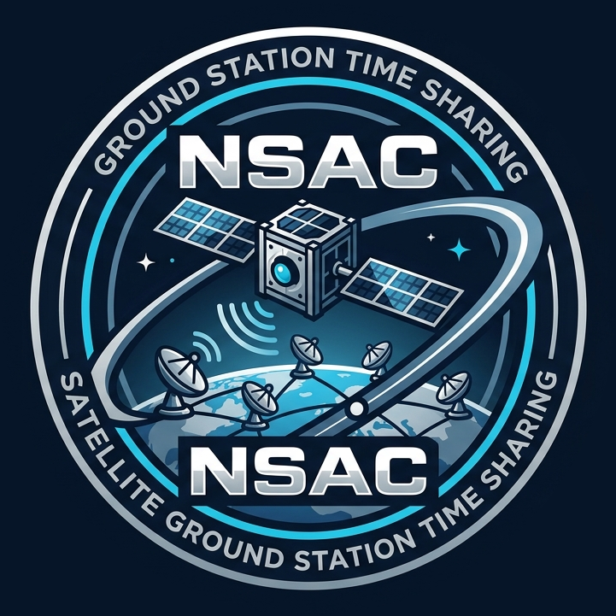

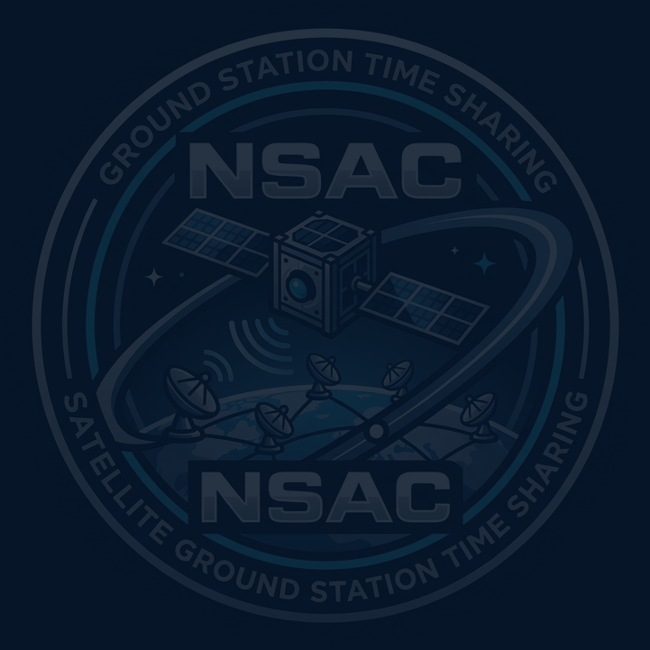
System Vision Document
Satellite Ground Station Time Sharing
Problem Description
Egyptian and African universities are building small satellites called CubeSats that need access to ground stations for communication. NSAC currently schedules satellite passes using a spreadsheet, and conflicts happen every week because many universities share a limited network of ground stations. The scheduling process must also consider satellite orbit data, frequency licensing, station capabilities, contact requirements, weather risks, credits, and operational constraints.
It is recommended that a new system be developed and deployed so NSAC can coordinate and share ground-station time fairly and run each scheduled contact. The system should provide a reliable way to calculate available passes, manage contact requests and conflicts, and support communication between the center, remote stations, and university mission operators.
System Capabilities
The new system should be capable of:
▪ Registering and storing university and satellite information, including orbit data, frequencies, data rate, and mission priority
▪ Checking frequency licensing and preventing scheduling when a license is invalid
▪ Downloading fresh TLE orbit data and calculating satellite passes over stations for the next seven days
▪ Managing ground stations, their supported frequency bands, locations, and status
▪ Allowing operators to submit contact requests with minimum passes, minimum duration, and mandatory passes
▪ Detecting conflicts and resolving them by moving a contact, splitting a pass when accepted, or applying mission priority
▪ Managing contact credits, free passes for new science missions, compensations, and weather-risk flags
▪ Sending pass plans to remote stations before scheduled contacts and allowing already received plans to execute if the link fails
▪ Storing telemetry files and linking them to contacts for university access
▪ Supporting secure remote commanding with target-satellite verification, confirmation, approved access, and command logging
Business Benefits
It is anticipated that the deployment of this new system will provide the following business benefits to NSAC and participating universities:
▪ Increase fair and transparent use of limited ground-station time among university satellite missions
▪ Reduce weekly scheduling conflicts and the manual negotiation currently required between operators and universities
▪ Improve the reliability of satellite contacts and reduce missed communication opportunities
▪ Provide clearer information about scheduling decisions, including why a contact request was rejected
▪ Improve operational safety by preventing commands from being sent to the wrong satellite
▪ Give universities faster access to their telemetry and scheduled pass information
▪ Provide better monitoring of station usage, successful and failed contacts, credits, and conflict resolution
▪ Support future growth as additional ground stations and CubeSat missions are added

