Functional Requirements 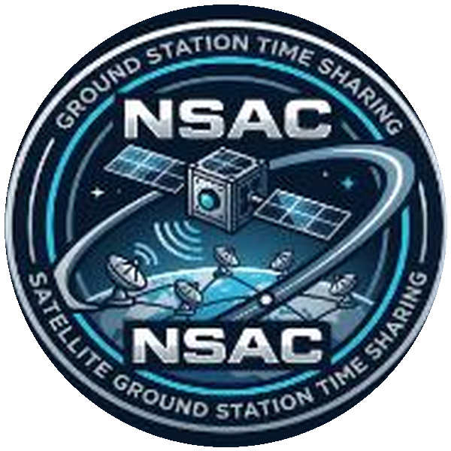
Satellite Ground Station Time Sharing Initiative
Func Req No | Category | Description / Rules
FR-01 | Registration & Interface | - The operator shall register each satellite by providing its orbit data, radio frequencies, data rate, and mission priority (science, education, or technology test).  - The planning tool shall display all times in the local time zone to avoid confusion with UTC.  - The interface shall be readable on a mobile phone.
FR-02 | Frequency Licensing | - The system shall verify that a satellite's frequencies are licensed. A satellite without a valid license shall not be scheduled.  - The license shall be valid on the date of the pass.
FR-03 | Orbit Data Prediction | - The system shall download TLE orbit data from an external tracking service at least once a day.  - Pass prediction for 7 days ahead, covering 15 satellites and 7 stations, shall be completed in under 10 minutes.
FR-04 | Contact Requests | - Operators shall submit contact requests specifying the minimum number of passes per day, the minimum duration, and any mandatory passes.  - A request shall be frozen 24 hours before its pass, except in an emergency.  - Emergency mode shall give a satellite in trouble all available passes for 24 hours. The mode shall activate quickly, preferably within one hour.
FR-05 | Conflict Resolution | - When a conflict occurs, the system shall first try to move one satellite to another station. If this fails, it shall split the pass into two halves, provided both operators accept. If this also fails, the conflict shall be decided by priority.  - A satellite that loses a contact shall receive a higher priority in the next conflict, so that no satellite is starved.  - When a request is rejected, the system shall show which satellite was given the slot.
FR-06 | Credits & Budgets | - Each university shall receive 600 credits per year. One minute of contact shall cost one credit.  - A new science mission shall receive 50 free passes during the first 30 days after launch.  - Passes lost because of a station failure shall be compensated within the following 7 days.  - Passes shall be flagged as a weather risk when dust storms are forecast.
FR-07 | Station Operations | - Each station shall receive its pass plan at least 30 minutes before the pass.  - If the link to the center fails, the station shall still execute the plans it has already received.  - Operators shall be notified by email or SMS 15 minutes before each of their passes.  - Universities shall be able to export their pass plan to their own calendar.
FR-08 | Telemetry Storage | - Telemetry shall belong to the satellite owner and shall be kept by the center for 1 year.  - Universities shall be able to download their telemetry data at any time, without waiting for an email.  - The received telemetry files are expected to be between 5 MB and 200 MB per pass.
FR-09 | Commanding Security | - Every command shall be signed with the university's key, sent only from approved IP addresses, and protected by two-factor login.  - Commanding shall be allowed only during that university's own passes.  - Every command shall be logged.  - The university's operators shall be able to block commanding immediately.
FR-10 | Command Safety | - Every command shall contain the ID of the target satellite, which shall be checked against the satellite in view.  - A confirmation step shall be required before a command is sent.
FR-11 | System Questions / Reporting | - How many successful contacts did each satellite get this week?  - Which stations are most overloaded?  - How many conflicts were solved by moving, splitting or priority?  - How many credits has each university used?
FR-12 | Emergency Mode | - An emergency mode that gives a satellite in trouble all available passes for 24 hours.
FR-13 | Data Sharing | - A data sharing area where universities publish Earth images for other researchers.
NFR-01 | Constraints | - Two new CubeSats launch in eight months. The system must be ready before their first pass.  - Commands must be secure, so no university can ever send commands to another university's satellite.

