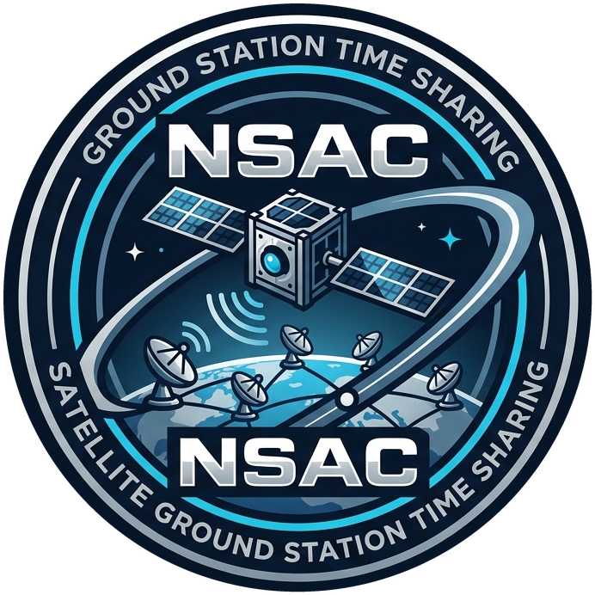
NATIONAL SPACE & ASTRONAUTICS CONSORTIUM (NSAC)
STAKEHOLDER MAP & REGISTRY
Satellite Ground Station Time Sharing Initiative

1. Stakeholder Classification Map
Classification | Operational | Executive
Internal | Eng. Dina Hosny  Station Operations Lead  Eng. Ahmed Kamel  Frequency Coordinator | Dr. Yasser Elnaggar  Ground Segment Manager, Sponsor  Dr. Samir Ezzat  Head of Information Security
External | Dr. Lamia Rashad  Mission Operator, Cairo University CubeSat  Mr. Sani Bello  Mission Operator, Partner University in Nigeria | University / Mission Management  Participating universities and missions
2. Comprehensive Stakeholder Registry & System Interests
Category | Stakeholder | Role | Primary Interests & System Requirements
Internal – Operational | Eng. Dina Hosny | Station Operations Lead | Reliable passes, no missed contacts, station operation, pass plans, and handling scheduling changes.
Internal – Operational | Eng. Ahmed Kamel | Frequency Coordinator | Ensuring that only satellites with valid licensed frequencies are scheduled.
Internal – Executive | Dr. Yasser Elnaggar | Ground Segment Manager, Sponsor | Fair use of ground stations, overall scheduling, resource allocation, university usage, and successful operation of the system.
Internal – Executive | Dr. Samir Ezzat | Head of Information Security | Preventing unauthorized satellite control and ensuring secure remote commanding.
External – Operational | Dr. Lamia Rashad | Mission Operator, Cairo University CubeSat | Getting enough passes, especially after launch, requesting contacts, and accessing telemetry and remote commanding.
External – Operational | Mr. Sani Bello | Mission Operator, Partner University in Nigeria | Access to ground-station time across time zones and avoiding UTC/time-zone scheduling problems.

