K53 Help Content

Distance Test
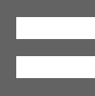
Optotype is latter that is used on eye screening. On this test we use optotype letter E (Tumbling E), as indicated on figure below.

Optotype is rotated on each level to face on of the four directions (Left, Right, Down, Up). The goal of each level is swipe on the direction on which the letter is facing. Figures below shows four directions of the optotypes:
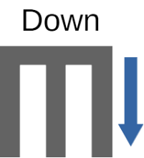
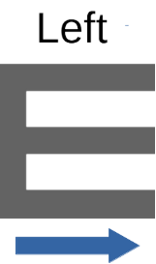
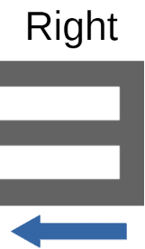
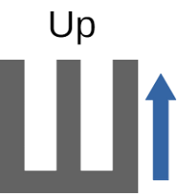

User is required to determine the direction of the optotype by swiping the optotype screen region to correct direction. The size of the optotype get reduce as you proceed to the next levels. You get the reward of 100% when you complete all levels, it is worth your effort.

Beware of timeout test termination condition, you need to complete every level within a time span indicated by slider on a screen of a device. The figure below show the timeout slider used on the test.
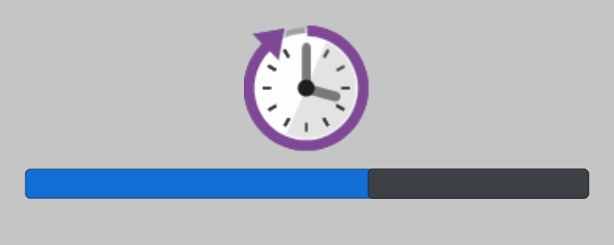

The result will be displayed once is completed or terminated, represented in percentage. The higher you score, it is more likely that you have a proper vision. Figure below shows the snapshot of result taken from the app.
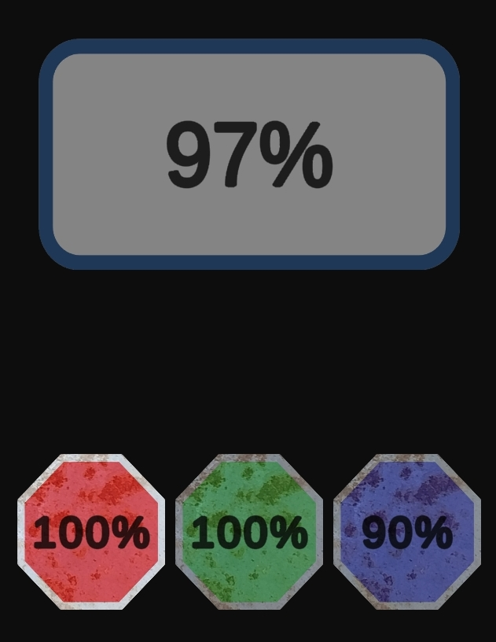
Upper score indicate the overall percentage earned in all primary colors. Whereas the lower three scores indicate the percentage of the correct choices you made per primary color.

How to use the app on distance test:
- You need to look on the direction of the optotype latter.
- Once you decide the direction, swipe the screen to direction of choice.
- Make sure you swipe to the direction of choice before timeout time expires.
- Test end when you swipe to wrong direction or in completion of all levels.

The test termination conditions:
- The test complete once the you complete all the levels.
- The test will be terminated once to swipe to the wrong direction of the optotype.
- The test will be terminated once to slider timer reaches zero before completion of the level.

Recommended environment to conduct the test:
- You should conduct the indoor, make sure no additional light source enter the room during the test.
- You should keep the same distance between your eyes and devices through out the test, recommended distance is 30 cm, about the size of your class ruler.
- You make sure that you swipe towards direction (up, down, left, right) of choice, without sloppy angle.

NOTE:
The app aid you to prepare for the K53 Eye Test, it does not claim to use the screening strategy use on traffic department. The app is distance test is derived from medical visual acuity test. The purpose of this app is to get you familiar with K53 eye testing, so you can know what to expect. If you are not satisfied with your score, please consult to medical doctor to conduct certified eye test. Clinical visual acuity may be measured in a variety of ways and for a variety of purposes.

Color Test
Color test focus on your ability to determine the color of the object, in this test a vehicle is used. On each the vehicle is given distinct color. The figure below show the image of the vehicle used to conduct the color test.
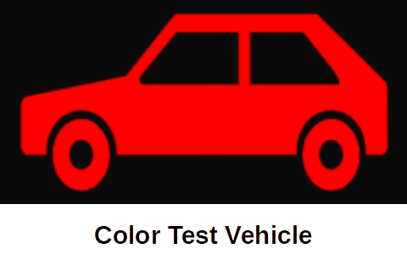

All the colors you know, are made up by combining of primary colors (red, green and blue). The goal is each level, is for you determine if the color is more close either red, green or blue color component. The intensity of the color decreases as you complete more levels, approaching more transparent colors like a that of a glass. You have to select the button with the color close to the car, you have option to click on a red button, a green button, or a blue button.
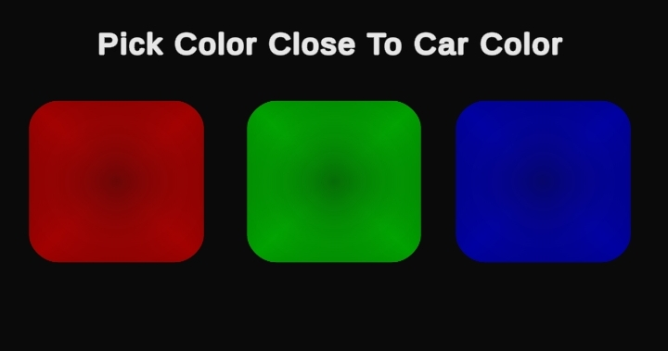

Figures below show examples of the colors with associated closest color, you might come them across on different levels during the test session.
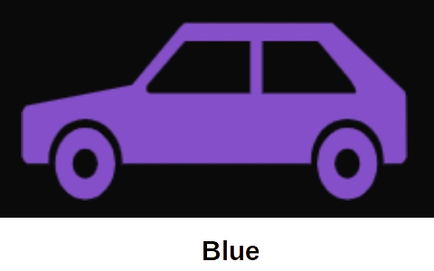
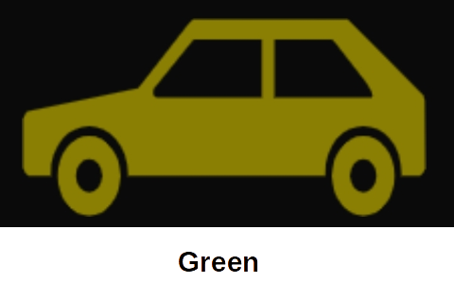
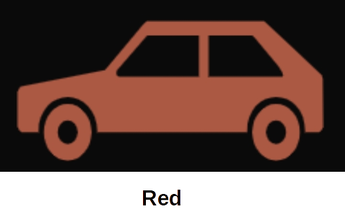

Beware of the timeout, complete every level before the timeout expires. Figure below show snapshot of the timeout slider used in the game.
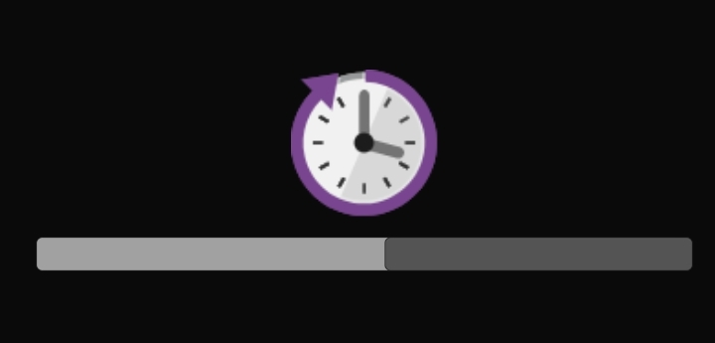

How to use the app on color test:
- The goal to is determine the dominant primary color from a displayed vehicle color.
- If red primary color is dominant color, press red button.
- If green primary color is dominant color, press green button.
- If blue primary color is dominant color, press blue button.
- Make sure you make a choice on every before the timeout expires.

Test termination conditions:
- The test terminate once the timeout is expired, that is when the slider reach left end.
- The test terminate when all levels are completed.
- The test will not terminate when you make a wrong choice like distance test, instead device will be play audio and vibrate.

Recommended environment to conduct the test:
- You should conduct the indoor, make sure no additional light source enters the room during the test.
- You should keep the same distance between your eyes and devices through out the test for accurate result, recommended distance is 30 cm, about the size of your class ruler.

NOTE:
The app aid you to prepare for the K53 Eye Test, it does not claim to use the screening strategy use in traffic department or in clinical visual test. The app is distance test is derived from visual acuity test. The purpose of this app is to get you familiar with K53 eye testing, so you can know what to expect. If you are not satisfied with your score, please consult to medical doctor to conduct certified eye test. Clinical color test may be measured in a variety of ways and for a variety of purposes.

