  w | National University  of Computer and Emerging Sciences  Chiniot-Faisalabad Campus  Department of Artificial Intelligence and Data Science | 

Name: Qamar Abbas

Roll No: 23F0027

Subject: NLP ASSIGNMENT 4 REPORT

Date: 02– 05 - 2026

Title:
Transformer-Based Sentiment Analysis with Explainability

Abstract
This project implements a Transformer-based Natural Language Processing model for sentiment classification using the Amazon Polarity dataset. A fine-tuned BERT model is used to classify text into positive and negative sentiments. The study further analyzes attention mechanisms and applies explainability techniques such as SHAP and LIME to interpret model predictions. Experimental results demonstrate high classification performance, while explainability methods provide insights into model behavior and limitations.

Introduction
Sentiment analysis is a fundamental NLP task used to determine the emotional tone behind text data. With the advancement of deep learning, Transformer-based models have significantly improved performance in NLP tasks.
This project focuses on:
- Implementing a Transformer-based sentiment classifier
- Analyzing attention mechanisms
- Applying explainability methods (SHAP & LIME)

Dataset Description
- Dataset: Amazon Polarity
- Source: Hugging Face
- Type: Binary classification (Positive / Negative)
Dataset Size:
- Training: 3,240,000 samples
- Validation: 360,000 samples
- Test: 400,000 samples

Features:
- Text (review)
- Label (0 = negative, 1 = positive)
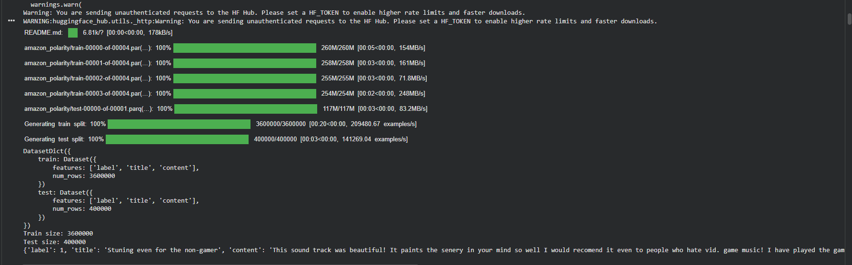
Methodology
Data Preprocessing
- Tokenization using BERT tokenizer
- Padding and truncation (max length = 128)
- Conversion into tensors
Model Architecture
- Pre-trained BERT model
- Fine-tuned for classification
- Output layer: Softmax
Training Setup
- Epochs: 2
- Optimizer: AdamW
- Loss: CrossEntropy
- GPU: CUDA enabled
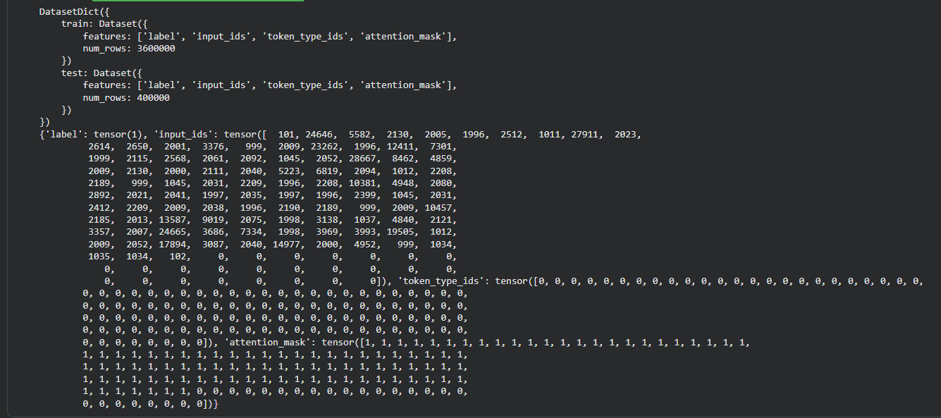
Model Performance
Metric | Value
Accuracy | 94.86%
Precision | 94.93%
Recall | 94.89%
F1 Score | 94.91%

Observation:
The model achieves high accuracy, indicating strong performance on sentiment classification.
Attention Analysis
Attention maps were extracted from multiple layers and heads of the Transformer.
Observations:
- Early layers capture local word relationships
- Deeper layers capture semantic meaning
- Important words receive higher attention weights
Example Insight:
Words like “great”, “love”, “excellent” showed strong attention influence.
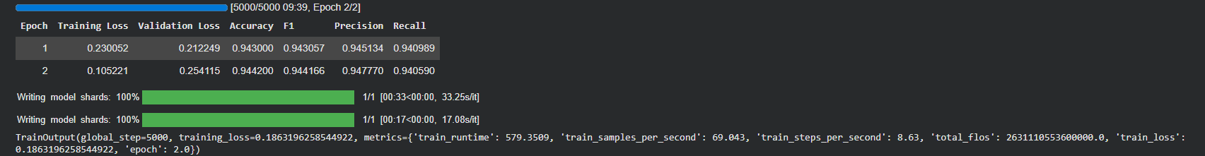
Push Model to hugging faces
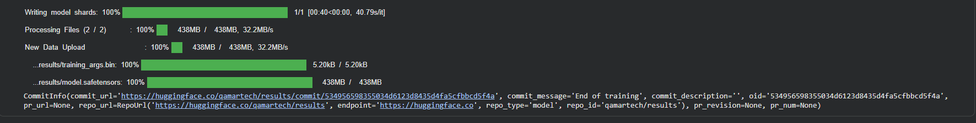
Explainability Techniques
SHAP
SHAP explains predictions by assigning importance values to each token.
Observations:
- Positive words contribute positively (blue)
- Negative words contribute negatively (red)
Example:
Words like “great”, “stunning” increased positive prediction.
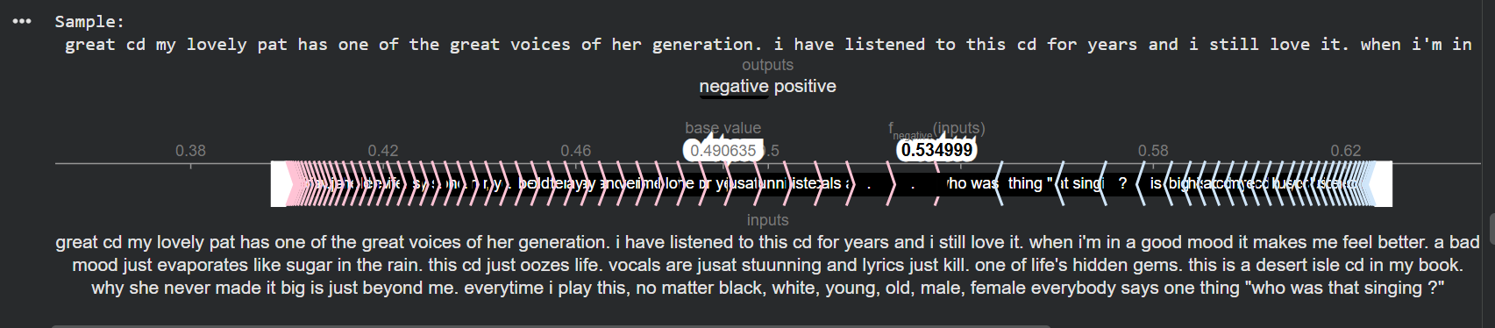
LIME
LIME explains predictions locally using interpretable models.
Observations:
- Provides simpler explanations
- Faster than SHAP
- Focuses on local decision boundaries
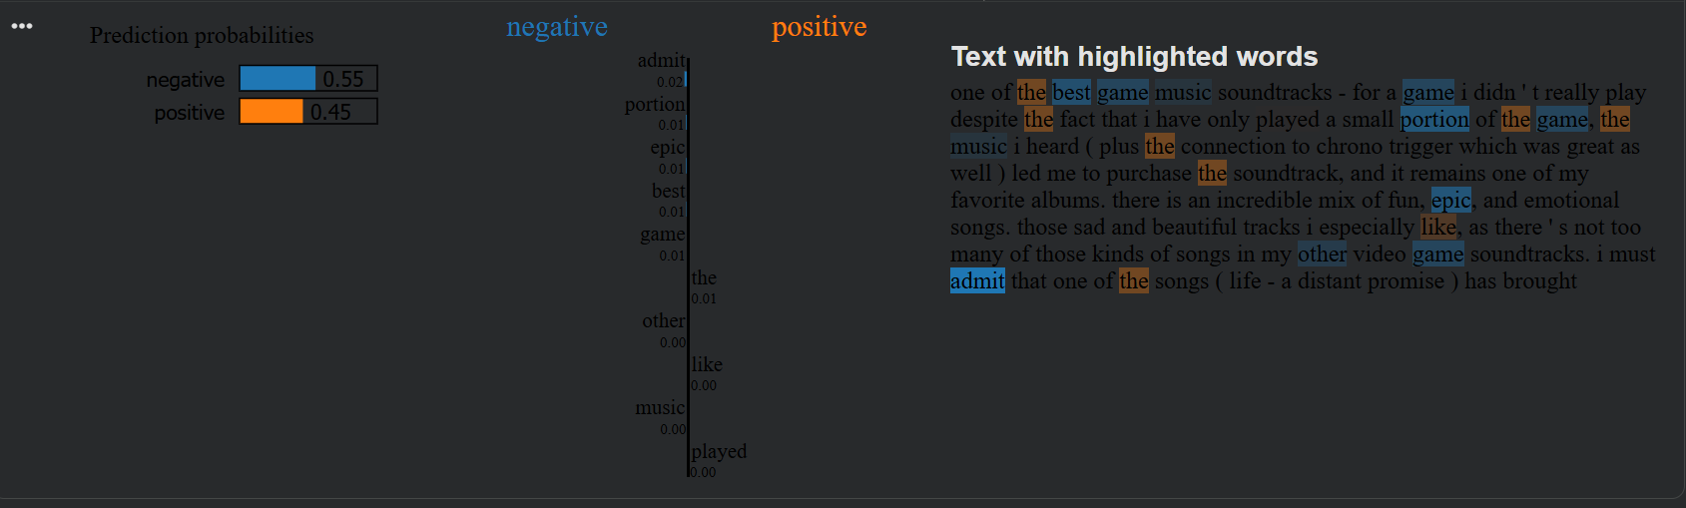
SHAP vs LIME Comparison
Feature | SHAP | LIME
Type | Global + Local | Local
Speed | Slow | Fast
Stability | High | Medium
Interpretability | Strong | Moderate
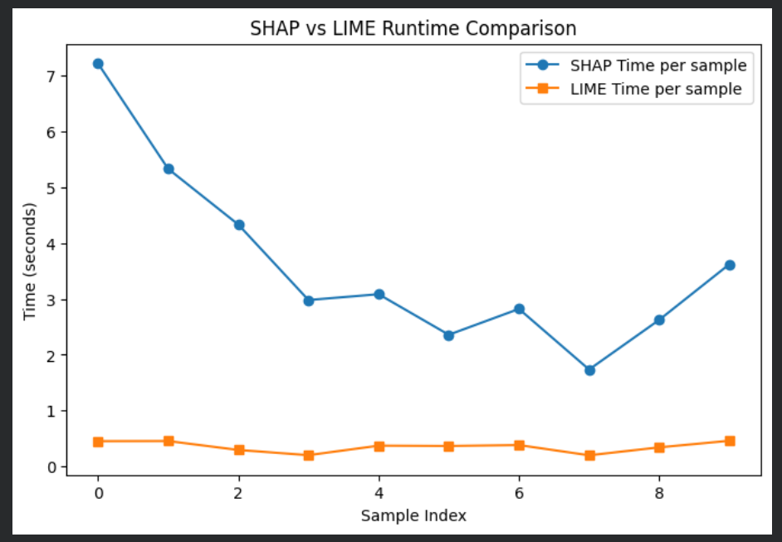
Visualization Results
Included:
- Attention heatmaps
- SHAP explanation plots
- LIME explanation outputs
- Confusion matrix
- Runtime comparison graph
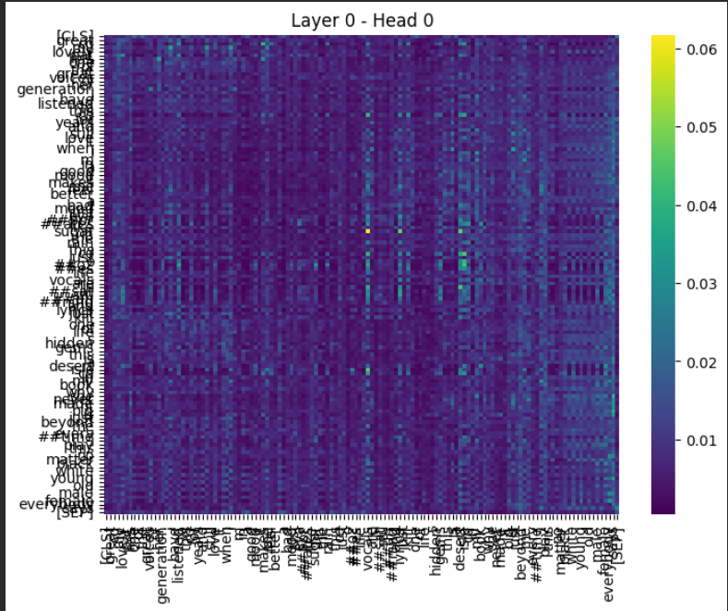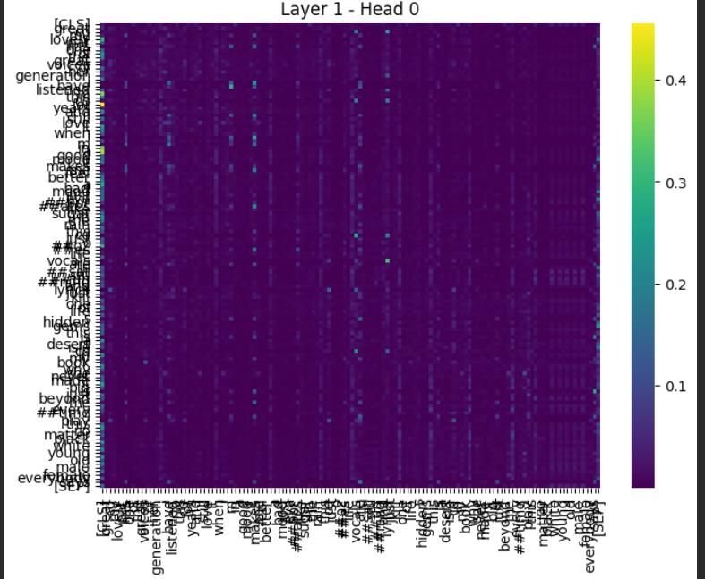
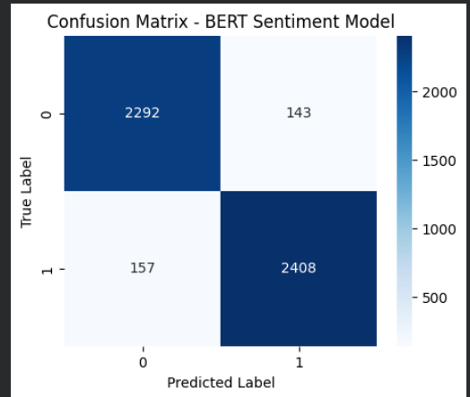
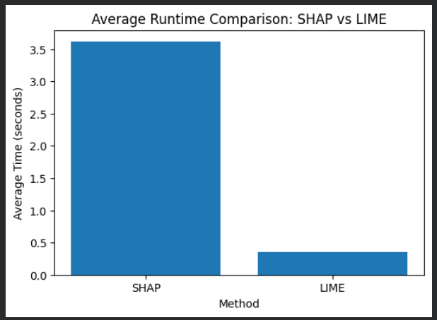
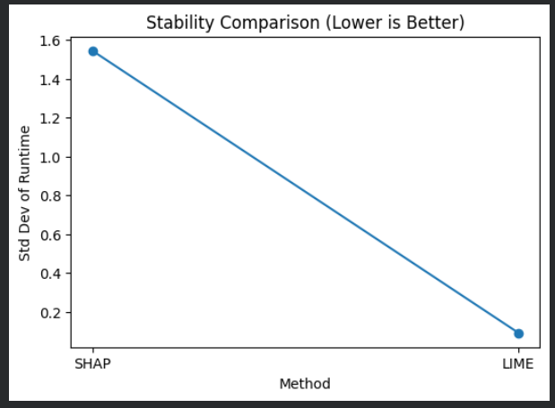

Error Analysis
Some misclassified examples were analyzed.

Example:
“Not bad at all, actually quite good.”
Prediction: Negative
Reason:
- Model misinterprets negation (“not bad”)
- Focuses on negative word “bad”
Insight:
Transformer models may struggle with:
- Negation
- Sarcasm
- Context ambiguity
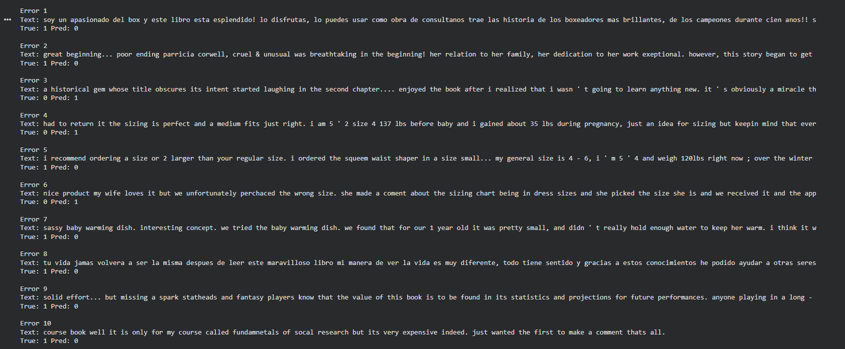
Real-Time Interface
A simple user interface was developed using interactive widgets to allow real-time sentiment prediction.
Features:
- User input text
- Instant prediction
- Confidence score
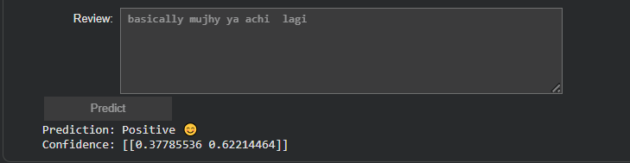
Conclusion
This project demonstrates the effectiveness of Transformer-based models for sentiment analysis. The BERT model achieved high accuracy and provided strong classification performance.
Explainability methods such as SHAP and LIME helped interpret model decisions and revealed important insights about model behavior and limitations.

GitHub README
Include:
- Setup instructions
- Dataset loading
- Training command
- Evaluation
- Explainability steps

