  w | National University  of Computer and Emerging Sciences  Chiniot-Faisalabad Campus  Department of Artificial Intelligence and Data Science | 

Name: Qamar Abbas

Roll No: 23F0027

Subject: NLP Assignment 1 Report

Date: 02- 03 - 2026

1. Introduction
E-commerce companies receive thousands of customer reviews daily. Analyzing this feedback manually is time-consuming and often ineffective due to:
- Mixed English and Roman Urdu text
- Short and informal reviews
- Feedback where sentiment and intent may not align (e.g., positive review but refund request)
- Important complaints hidden in neutral feedback
This project develops an NLP-based Customer Reviews Intelligence System that automatically:
- Cleans and preprocesses raw textual data
- Extracts numerical features from text (Bag of Words, TF-IDF)
- Performs sentiment analysis using rule-based and machine learning models
- Classifies customer intent (Complaint, Refund Request, Delivery Issue, General Query)
- Extracts key topics/themes using NMF topic modeling
- Provides an interactive Gradio interface to analyze new reviews
Dataset Used: SNAP – Amazon Fine Food Reviews (568k+ reviews)
- Selected columns: Text and Score
- Score converted to sentiment:
  - 4–5 → Positive
  - 3 → Neutral
  - 1–2 → Negative
- Added 10 Roman Urdu noisy reviews to simulate real-world mixed-language input
Like
"Text": [
"taste bohat acha tha lekin thora zyada meetha tha",
"product bura tha smell ajeeb thi",
"flavor acha nahi laga dubara nahi loonga",
"quality theek thi but price zyada hai",
"snack fresh nahi tha thora purana lag raha tha",
"chai ka taste zabardast hai",
"coffee ka flavor strong aur acha hai",
"biscuit soft nahi tha hard tha",
"packing theek thi lekin andar ka product pasand nahi aya",
"bohat maza aya taste karke" ]

2. Methodology

2.1 Text Preprocessing
- Cleaning: Removed URLs, HTML tags, numbers, special characters, extra spaces
- Lowercasing: Standardized text to avoid duplication (Good ≠ good)
- Tokenization & Stopwords Removal: Used NLTK tokenization; removed English stopwords + custom Roman Urdu stopwords (hai, tha, ki, etc.)
- Roman Urdu Normalization: Replaced common words with English equivalents using dictionary:
roman_dict = {
"acha": "good", "bura": "bad", "bohat": "very",
"zabardast": "excellent", "ajeeb": "strange",
"meetha": "sweet", "purana": "old", "pasand": "like"
}
Before preprocessing:
"Taste bohat acha tha lekin thora zyada meetha tha"
After preprocessing:
"taste very good sweet"

2.2 Feature Extraction
- Bag of Words (BoW): Counts word frequency; simple but does not consider importance
- TF-IDF (Term Frequency-Inverse Document Frequency): Highlights important unique words; reduces weight of common words
TF-IDF is preferred for sparse datasets like Amazon reviews with noisy multilingual text.

2.3 Sentiment Analysis
Implemented two approaches:
- Rule-based: VADER from NLTK
  - Score > 0 → Positive
  - Score < 0 → Negative
  - Score = 0 → Neutral
  - Pros: Fast, no training required
  - Cons: Weak on Roman Urdu
- Machine Learning: Logistic Regression (best for sparse text)
  - Split data: 80% train, 20% test
  - TF-IDF features used
  - Evaluated using: Accuracy, Precision, Recall, F1 Score

Results :
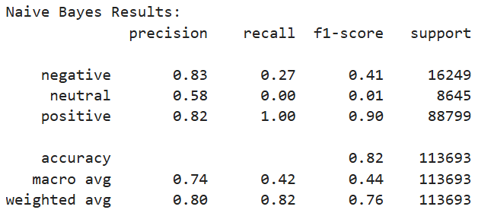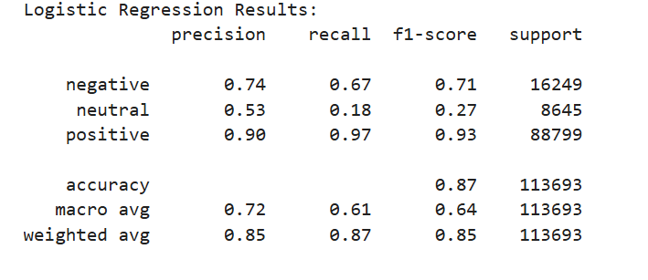

2.4 Intent Classification
- Labels: Complaint, Refund Request, Delivery Issue, General Query
- Labeled small subset manually + rule-based logic:
  - "refund" → Refund Request
  - "taste not good" / "flavor ajeeb" → Complaint
  - "packing problem" → Delivery Issue
- Trained Logistic Regression using TF-IDF features
- Confusion Matrix used for evaluation
VADER :
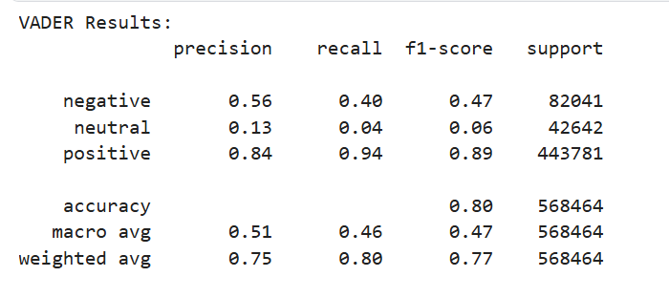
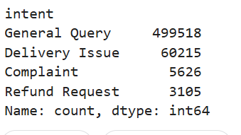
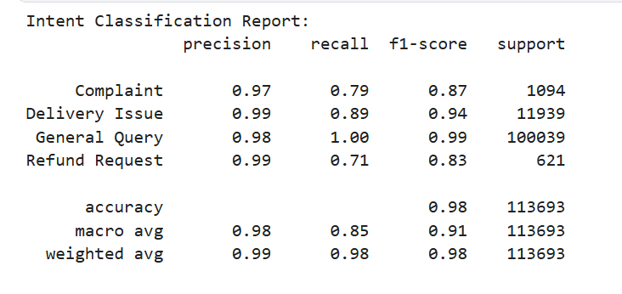

2.5 Topic Modeling (NMF)
- Used TF-IDF features + NMF(n_components=5)
- Extracted top 10 words per topic
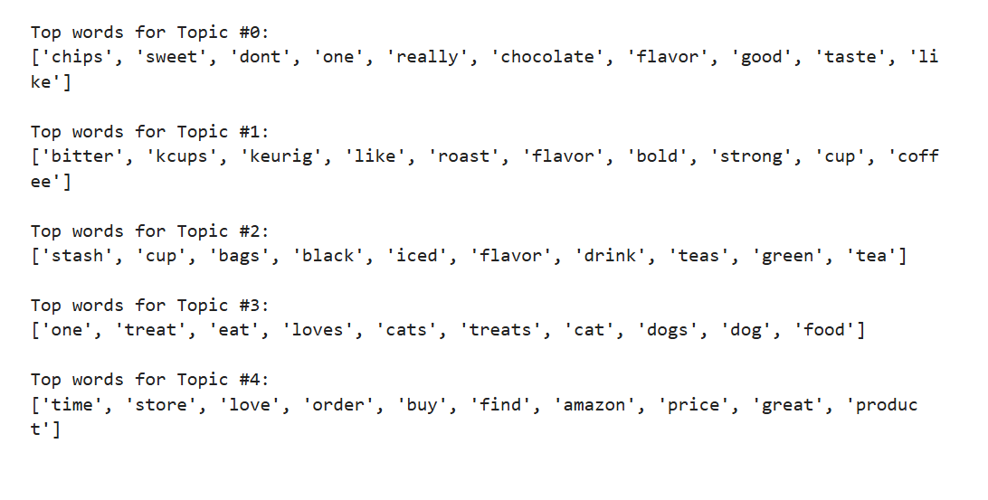

3. Results & Discussion
- TF-IDF outperforms BoW in all models
- Logistic Regression better than Naïve Bayes for multiclass sentiment classification
- Recall-focused evaluation ensures hidden negative reviews are detected
- Adding Roman Urdu reviews demonstrates multilingual preprocessing and normalization
- Topic modeling identifies business-relevant themes: taste, freshness, packaging, pricing
Confusion matrix example (intent classification):
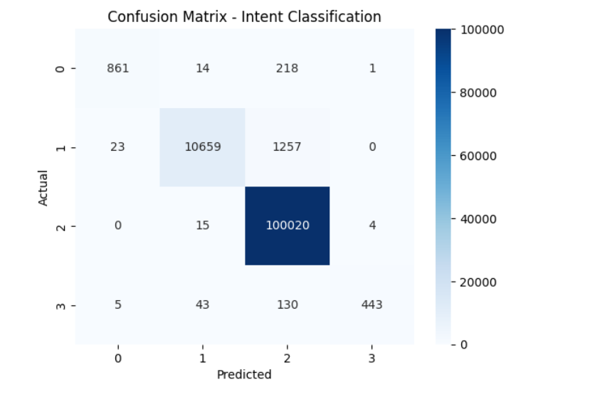

4. Conclusion
- Developed an end-to-end NLP pipeline for customer review analysis
- Preprocessing handled mixed-language text, Roman Urdu normalization, and stopwords removal
- TF-IDF + Logistic Regression provides best sentiment classification performance
- Intent classification detects hidden customer complaints
- NMF extracts meaningful topics to guide business decisions
- Gradio interface allows real-time prediction of sentiment, intent, and topic
Key Business Insights:
- Critical negative reviews are captured early
- Hidden refund or complaint intents in positive sentiment reviews can be flagged
- Product quality, taste, and packaging themes help prioritize improvements
System demonstrates real-world applicability for e-commerce analytics.
