**Project: Health care Data Analysis**

1. **Data Ingestion:**

The 1st step in the project is Data Ingestion. Sample data files are provided and they have to be ingested in to HDFS in to the project’s location.

**City Report**









**Prescriber Report:**







1. **Pre-Processing:**

**The 2nd step is to cleanse the data and use only the data that is required for analysis/reports using pyspark.**

**Clean City Data:**

* + Select only required Columns in city data file like city, state_id,state_name,county_name,population,zips

* + **Convert city, state and county fields to Upper Case**

**Clean Prescriber Data:**

* + Select only required fields such as npi, nppes_provider_last_org_name, nppes_provider_first_name, nppes_provider_city, nppes_provider_state, specialty_description, drug_name, total_claim_count, total_day_supply, total_drug_cost

* + **Rename the above fields to shorter names.**

* + **Add a Country Field 'USA' to the above data.**

* + **Clean the “years_of_exp” to extract only the numbers.**

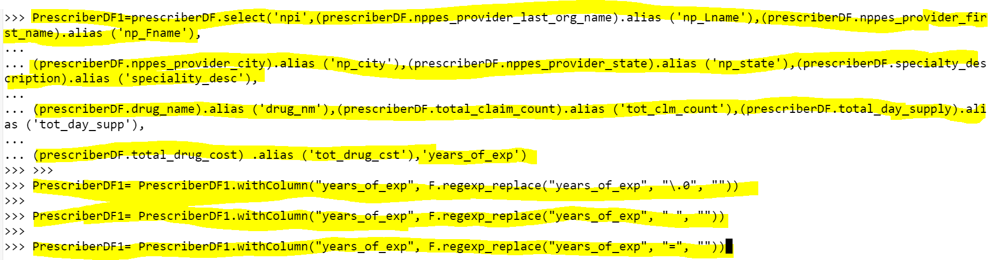

* + **Convert the years_of_exp field to integer.**

* + **Combine First Name and Last Name into a single field and remove the individual columns.**

* + **Count the number of null values for each column.**

* + **Clean all the Null/Nan Values.**

**The 3rd step is to transform the cleansed data in to the required reports using pyspark.**

**Transform Logic: City Report**

* + **Calculate the Number of zips in each city.**

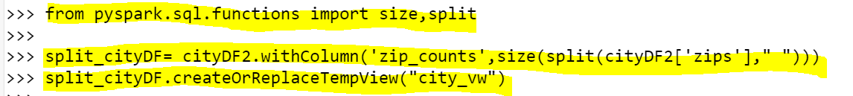

* + **Calculate the number of distinct Prescribers assigned for each City.**

* + **Calculate total TRX_CNT prescribed for each city.**

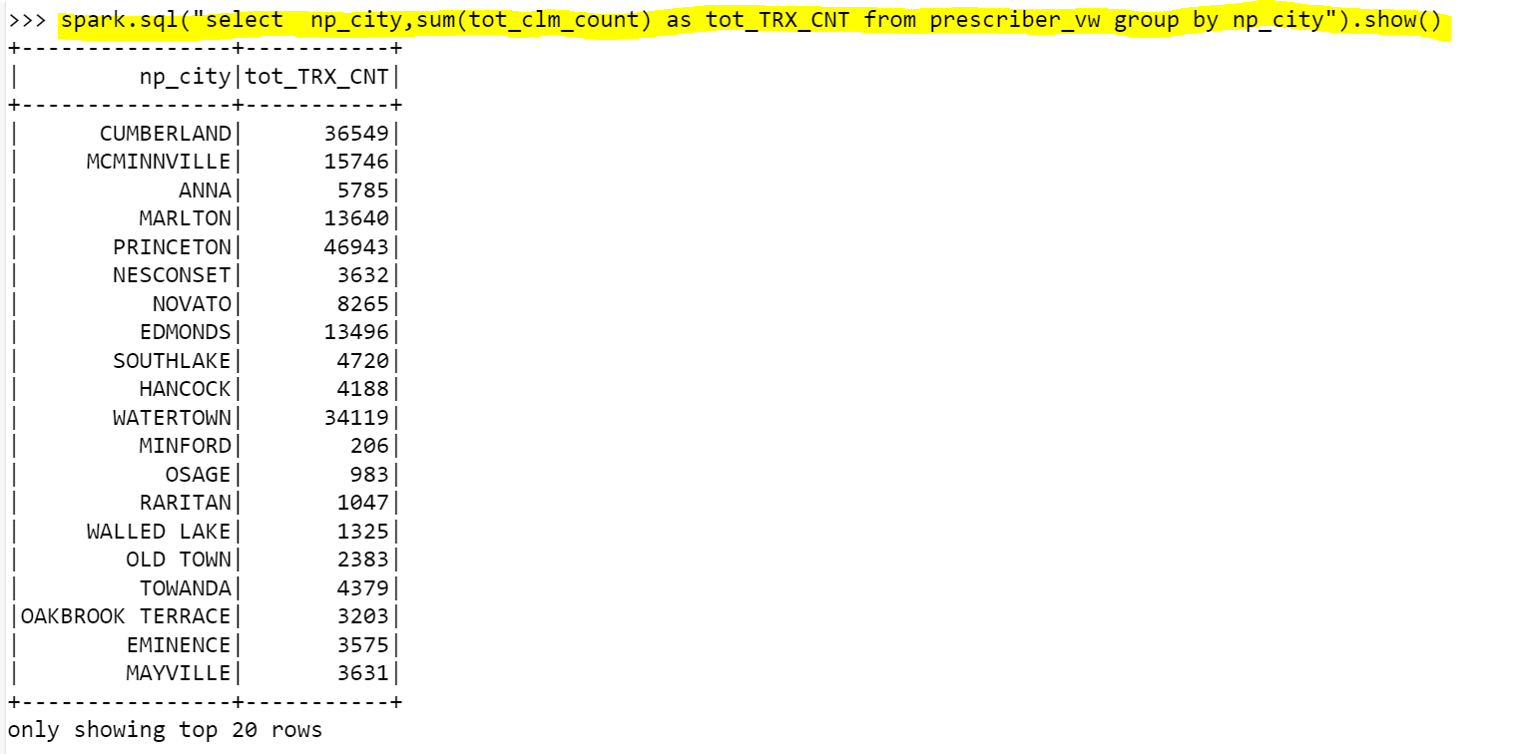

* + **Do not report a city in the final report if no prescriber is assigned to it.**

**Transform logic: Prescriber Report:**

* + **Top 5 Prescribers with highest total_claim_count per each state.**

* + **Consider the prescribers only from 20 to 50 years of experience.**

**Output City report Layout:**

**Hive storage:**

**Pyspark:**

**Output Prescriber report layout**

**Hive storage:**

**Pyspark:**



