Aurora  Holiday  Resort  Switzerland |  |  |  | About Us  Aurora Holiday Resort is a luxury mountain holiday resort located in the scenic regions of Switzerland. Surrounded by snow-covered peaks, emerald valleys, and serene natural landscapes, the resort offers an ideal escape for tourists seeking peace, comfort, and elegance. The resort is designed to serve families, honeymoon couples, and high-end travelers by providing premium hospitality and unforgettable experiences. | Facilities and Services  - Luxury mountain-view suites  - Central heating system  - Free high-speed Wi-Fi  - Fine-dining restaurant with Swiss and international cuisine  - Spa, sauna, and wellness center  - Infinity heated pool  - Conference and meeting halls  - 24/7 room service  - Secure parking and electric transfers  - 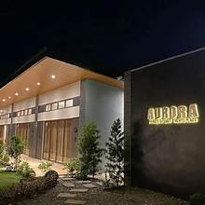

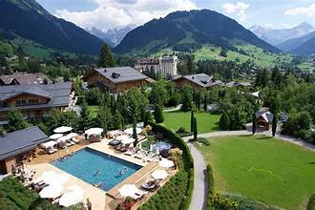  Holiday Packages  - Matterhorn Signature Escape  - Ultra-Luxury Alpine Experience  - Honeymoon in the Clouds .  - Matterhorn Star Gala Package  - Swiss Heritage Rail Journey | A Place where Luxury meets Glance  Location Description  Aurora Holiday Resort is situated in the Swiss Alpine region near Zermatt, one of the most iconic mountain destinations in the world. The location is renowned for the Matterhorn, fresh alpine air, and breathtaking views. It is ideal for winter sports, luxury tourism, cultural exploration, and year-round vacations, attracting both local and international visitors  ___________________________  Aurora Holiday Resort represents the perfect blend of luxury, nature, and elegance. With its breathtaking alpine location, exclusive packages, and professional services, the resort offers a memorable holiday experience for travelers seeking relaxation, romance, or premium mountain adventures in Switzerland  ________________________________ | Why Choose Aurora Holiday Resort  - Prime mountain location near the Matterhorn  - Luxury services and premium facilities  - Personalized guest experience  - Suitable for all seasons  - High standards of comfort and hospitality  Contact Us  - Email: info@auroraholidayresort.com  - Contact Number: +41 000 000 000

