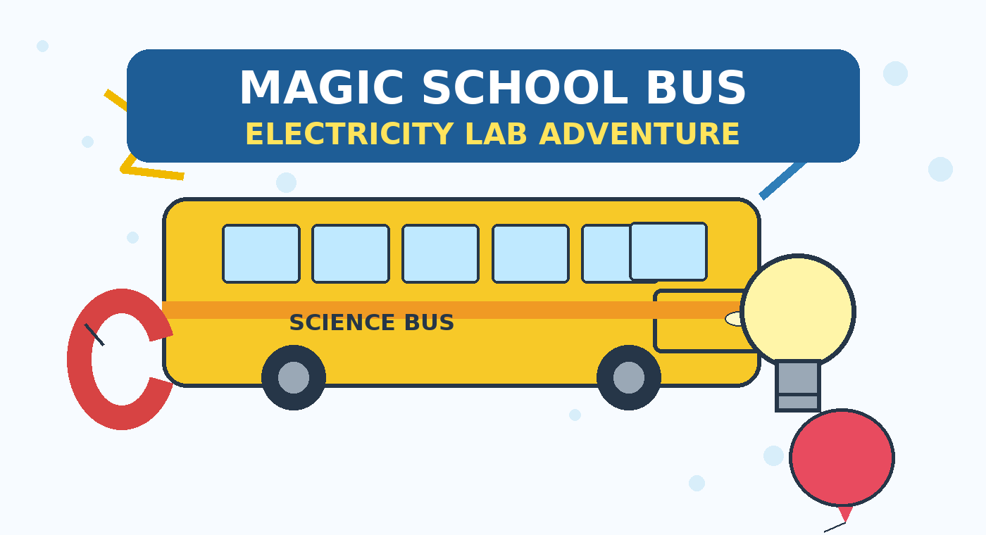
Electricity Lab Guide + Instructions
4 hands-on stations • materials for 10 setups each
Welcome to the Lab! Get ready to take chances, make mistakes, and get messy. Students will build a circuit, test conductors, create an electromagnet, and explore static electricity.
Ms. Frizzle's Kickoff Script
“Seatbelts, everyone! Please let this be a normal field trip... With the Friz? No way! Today, we are taking a shocking journey into the invisible world of electrons! We're going to build glowing circuits, test mystery materials, and even create our own magnets out of thin air. So, take chances, make mistakes, and get messy!”
Before students begin
- Set up four stations and divide materials into 10 student setups per station.
- Use the circuit from Lab 1 again in Lab 2 for the conductor test.
- Provide adult supervision at the electromagnet station. The wire can become warm when connected to the D battery.

LAB 1
Simple Circuits “Gets Charged”
Objective: Students will create a closed loop to light a miniature bulb.
Materials for 10 setups
Material | Qty (10x) | Notes
Batteries (AA/D) | 10 | 1 per setup
Battery Holders | 10 | 1 per setup
Small Light Bulbs | 10 | 1.5V–3V miniature bulbs
Bulb Holders | 10 | To match bulbs
Alligator Clip Wires | 30 | 3 per setup
Do the experiment
1. Clip one end of the first wire to the positive side of the battery.
2. Clip the other end of that wire to the light-bulb holder.
3. Use a second wire to connect the bulb back to the negative side of the battery.
4. Watch the bulb. When the path is complete, it should light up.
 | 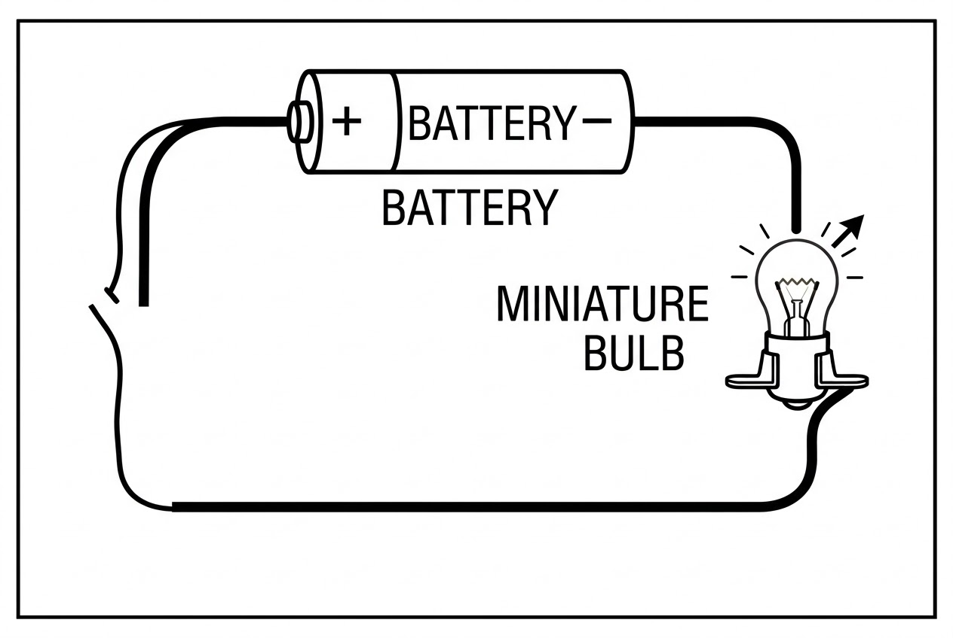
What did you notice? What changed when the circuit was closed or opened? _________________________________________________

LAB 2
Conductors & Insulators
Objective: Test household items to see whether they allow electricity to flow.
Materials for 10 setups
Material | Qty (10x) | Notes
Test Material Bags | 10 | Coin, paperclip, rubber band, spoon
Existing Circuit Setup | 10 | Reuse from Lab 1
Do the experiment
1. Start with the working circuit from Lab 1.
2. Unclip one wire from the battery to create a gap in the circuit.
3. Place one mystery item between the two connection points so it bridges the gap.
4. Watch the bulb. If it lights, the item lets electricity flow. Test each item in the bag.
 | 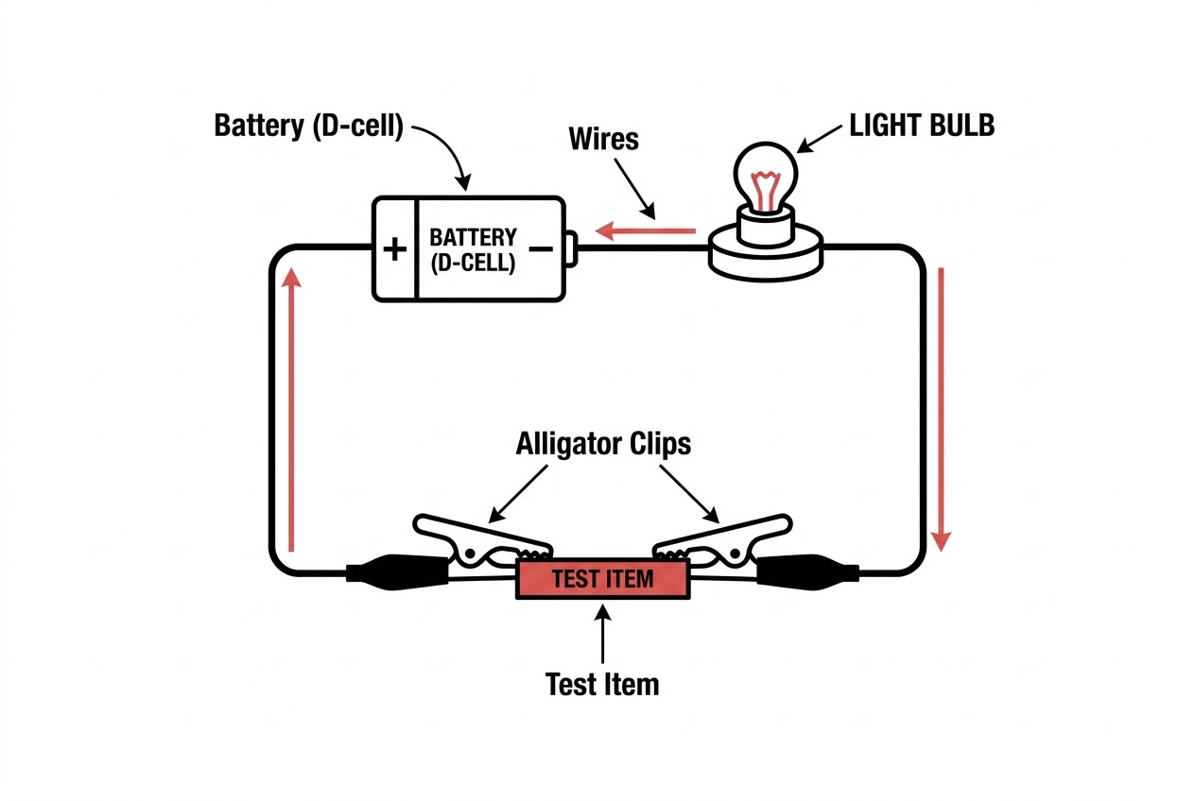
What did you notice? Which test items made the bulb light? _________________________________________________

LAB 3
Electromagnets “Electric Field Trip”
Objective: Use an electrical current to create a magnetic field around an iron core.
Materials for 10 setups
Material | Qty (10x) | Notes
Large Iron Nails | 10 | 1 per setup
Copper Wire | 10 strands | Thin/insulated, about 3 ft per setup
D Batteries | 10 | Stronger battery needed
Metal Paperclips | 10 small boxes | To test magnetic strength
Do the experiment
1. Tightly wrap the copper wire around the iron nail at least 20 times. Leave both wire ends loose.
2. Carefully connect the wire ends to the D battery. An adult should supervise because the wire can get warm.
3. Bring the wrapped nail close to the paperclips and see how many it can pick up.
4. Disconnect the battery after the trial, especially if the wire begins to feel warm.
Safety note: The source guide specifically warns that the electromagnet wire can get warm. Keep an adult at this station and disconnect the battery when the trial is finished.
 | 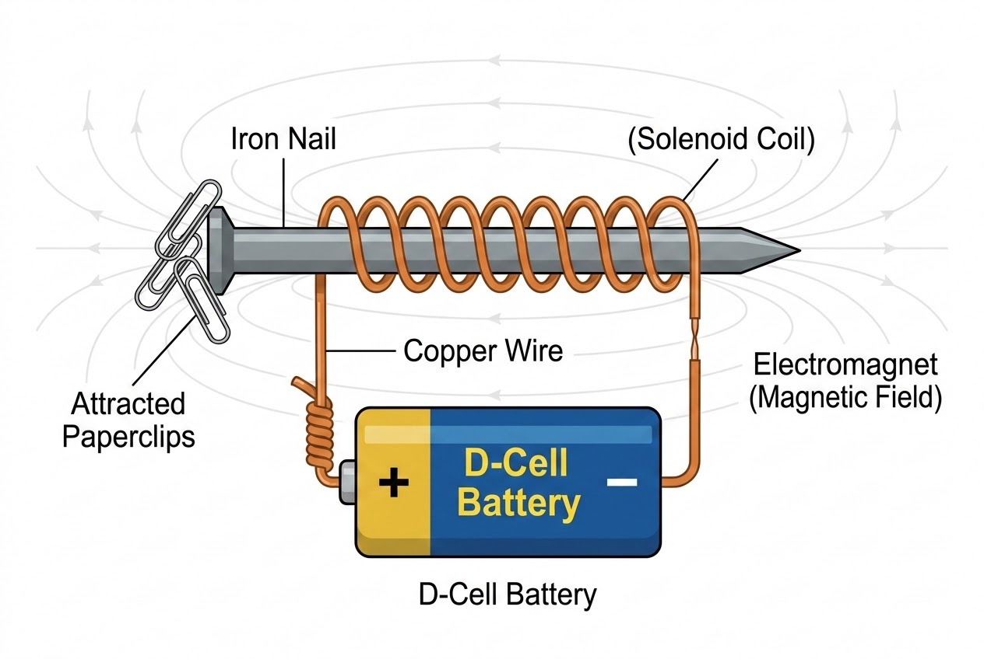
What did you notice? How many paperclips did the electromagnet pick up? _________________________________________________

LAB 4
Static Electricity “Jumping into Electricity”
Objective: Generate a static charge through friction to attract lightweight objects.
Materials for 10 setups
Material | Qty (10x) | Notes
Balloons | 10 | To generate static charge
Wool or Felt Pieces | 10 | To rub against balloons
Tissue Paper Chunks | 10 small bowls | To attract with static balloon
Do the experiment
1. Rub the balloon quickly on a piece of wool or felt for 15 seconds.
2. Hold the charged balloon just above the tissue-paper pieces without touching them.
3. Watch the lightweight paper jump up and stick to the balloon.
 | 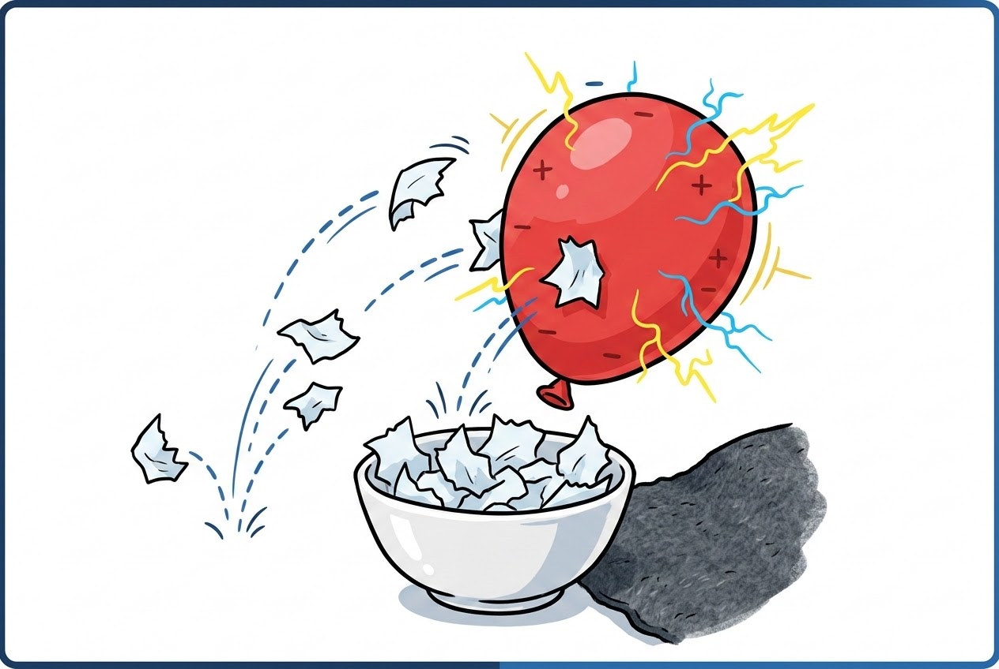
What did you notice? What happened as the balloon moved closer to the tissue paper? _________________________________________________
Take chances • make mistakes • get messy • talk about what you observed!

