- Docker installation: Install Docker on your local system (Windows, macOS, or Linux). Verify the installation by running the docker --version and docker info commands.
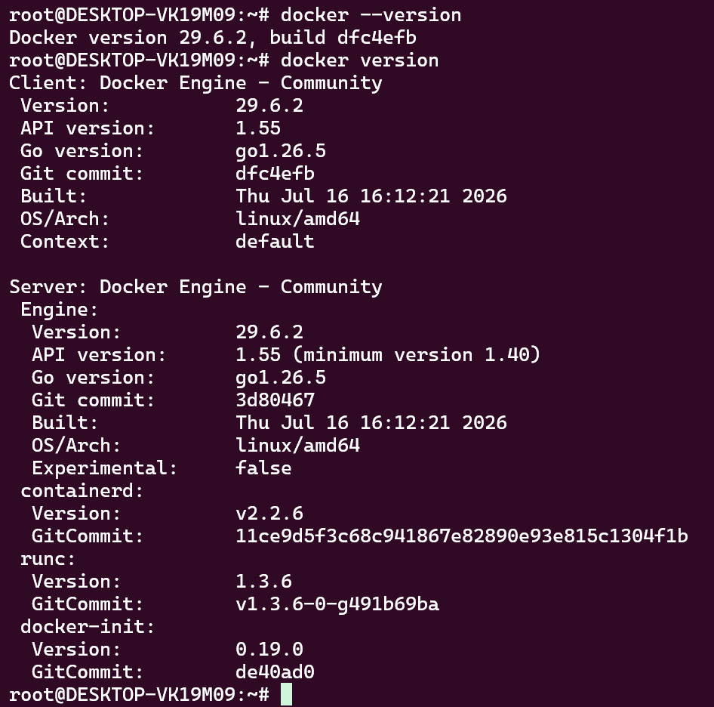
============================================================

- Working with Docker images: Search for the official Ubuntu image on Docker Hub, pull it to your local system using docker pull, and list all available images on your system using docker images.

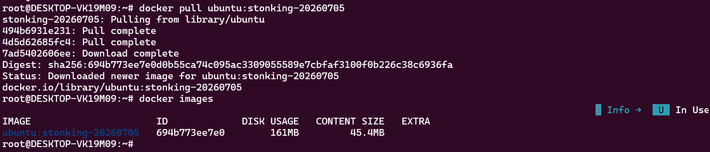
============================================================
- Creating a Docker container: Run a Docker container using the Ubuntu image, and execute a command inside the container (e.g., echo "Hello, Docker!").
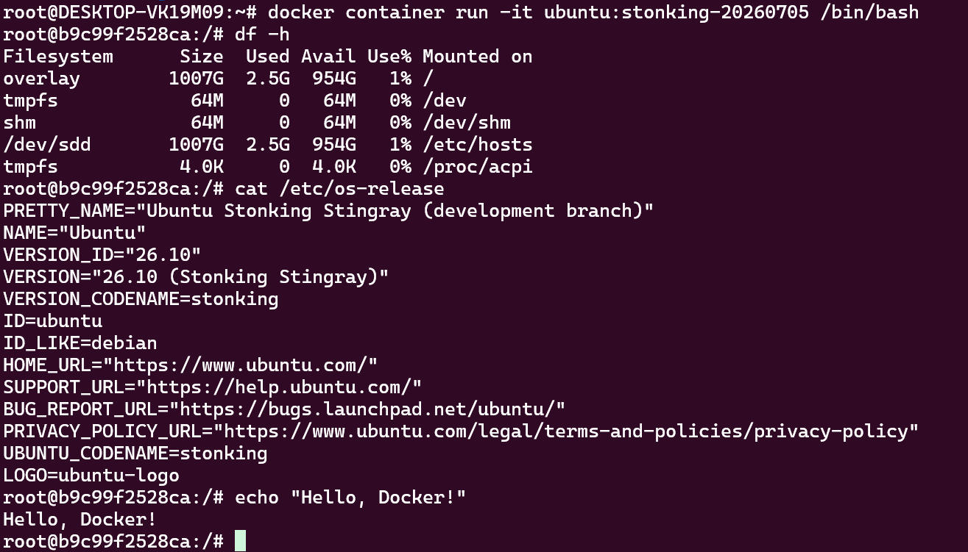
============================================================

- Inspect the Ubuntu Docker container to ensure it is in the "created" state only.
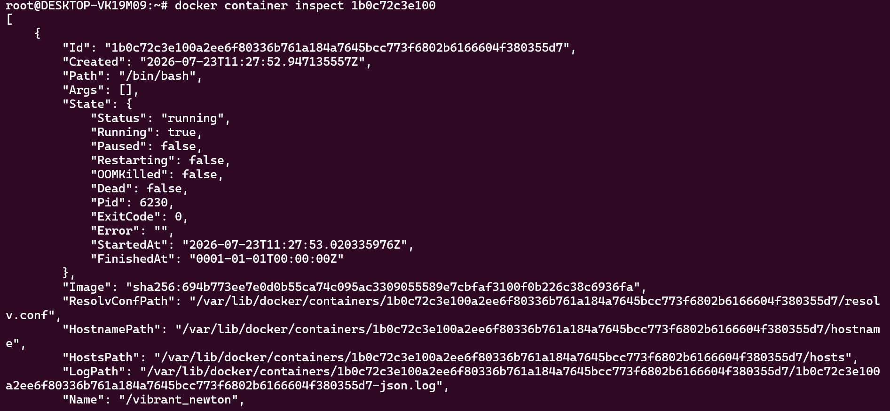
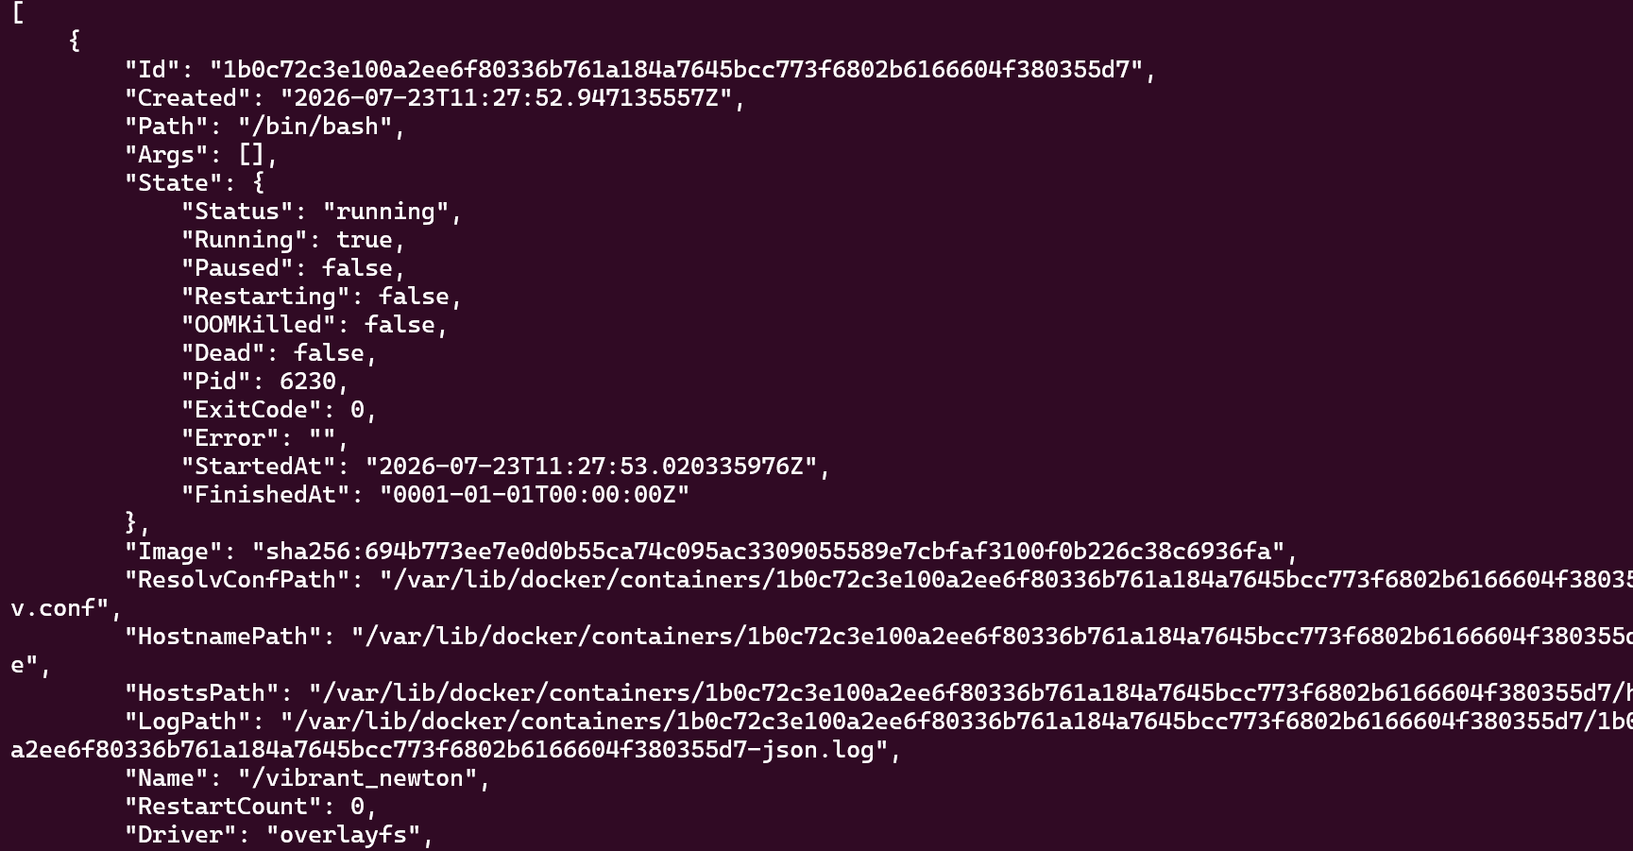
============================================================

- Execute the Ubuntu Docker container and confirm that the container's state is "running."
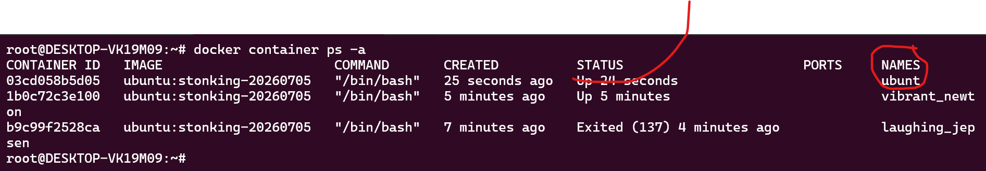
============================================================
- Launch an HTTP container, verify its state, and then remove the container and image from your local system.
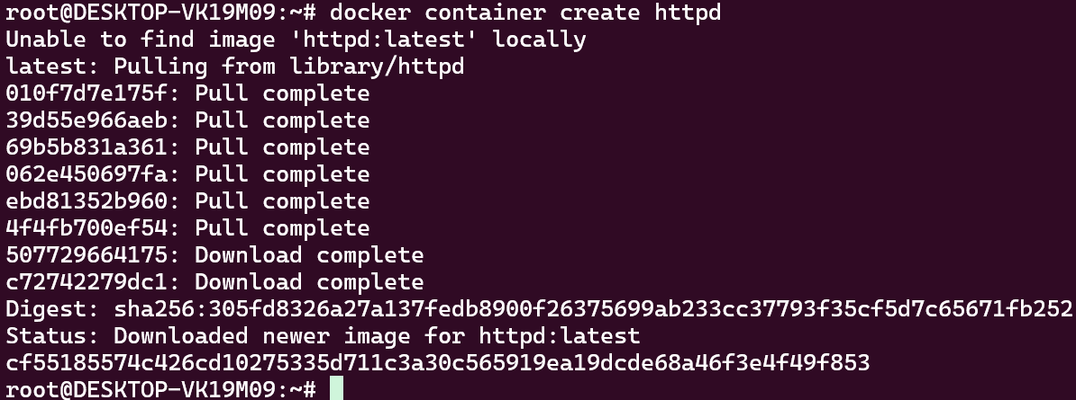
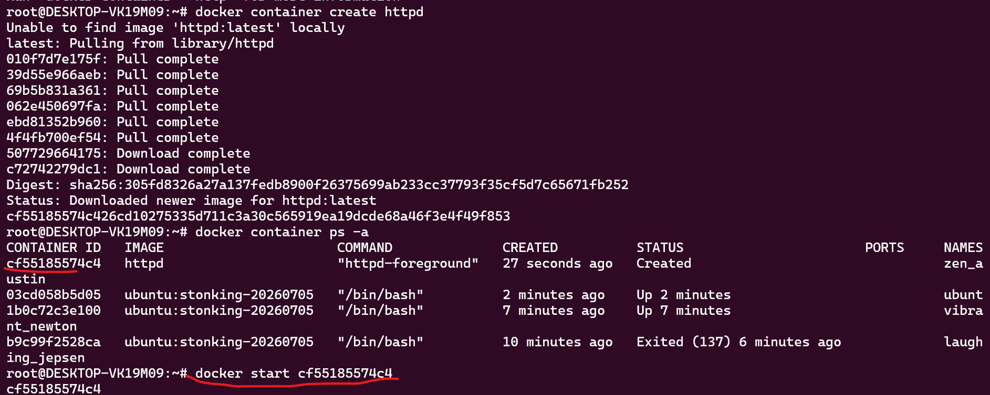
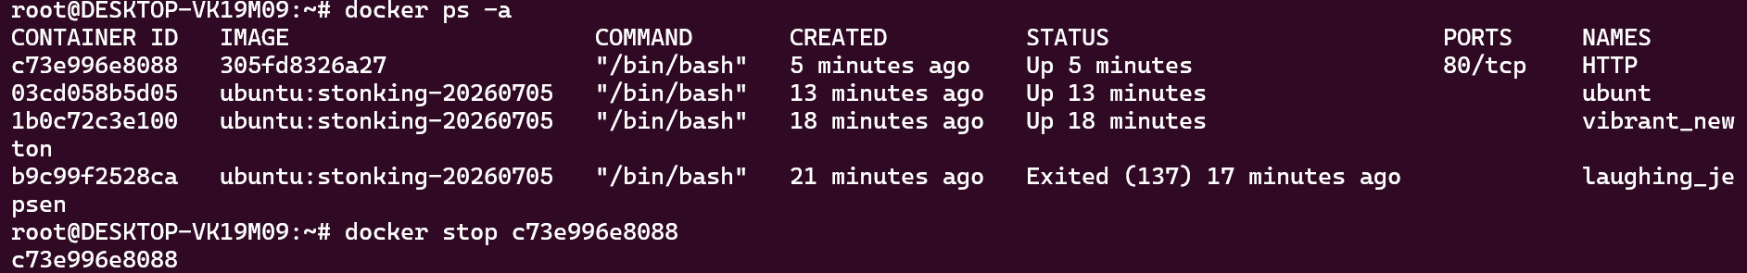
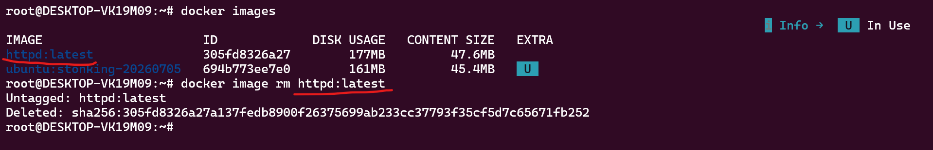
============================================================
- Execute a command to display a filtered list of containers, showing only their short container IDs.
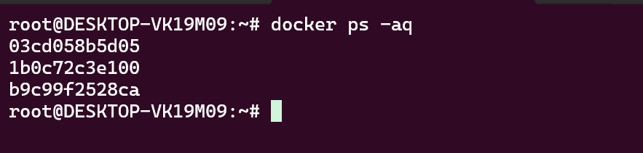
============================================================
- Clone the lancachenet/ubuntu-nginx Git repository locally and build a Docker image from the provided Dockerfile. Be sure to add relevant tags when building the image.
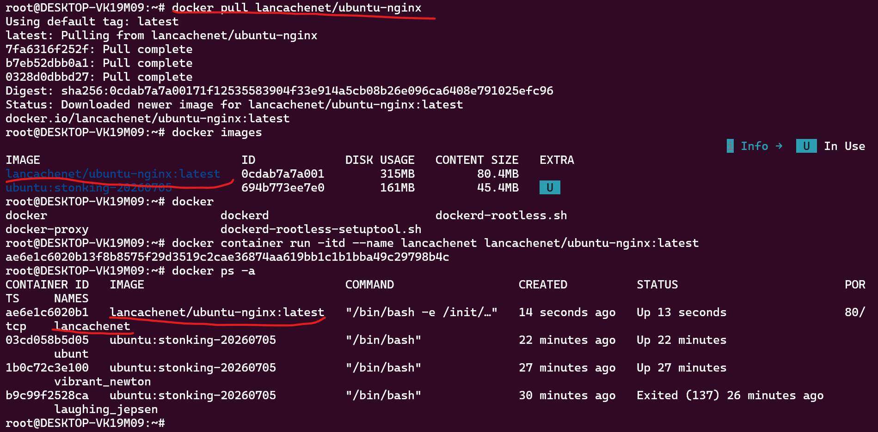
============================================================
- After building the image, run a Docker container using the image and check the webpage using the curl command to ensure it's accessible.
Taken the IP from inspect
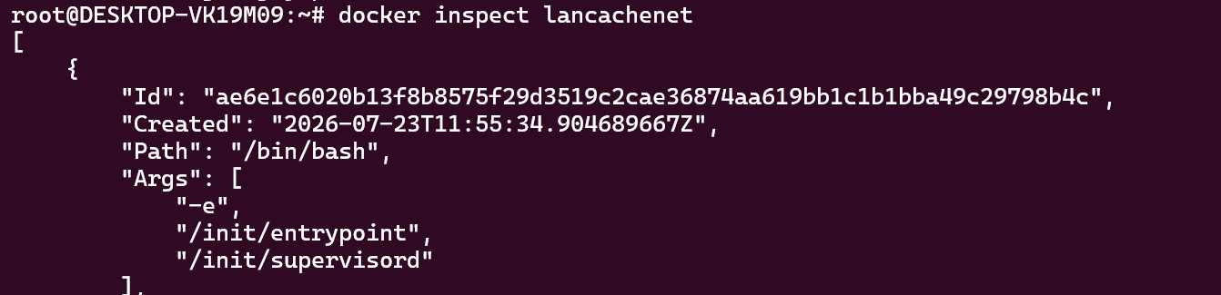
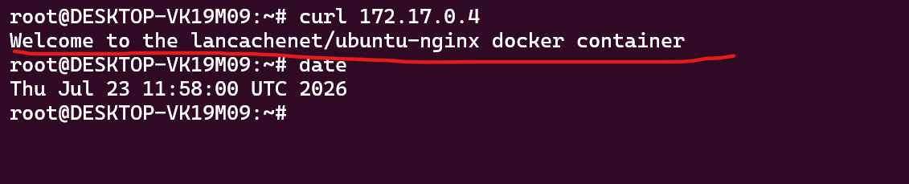
============================================================
- Create a DockerHub account, set up a repository, and tag the locally created Docker image using your_repo_name/application_name:version_number.
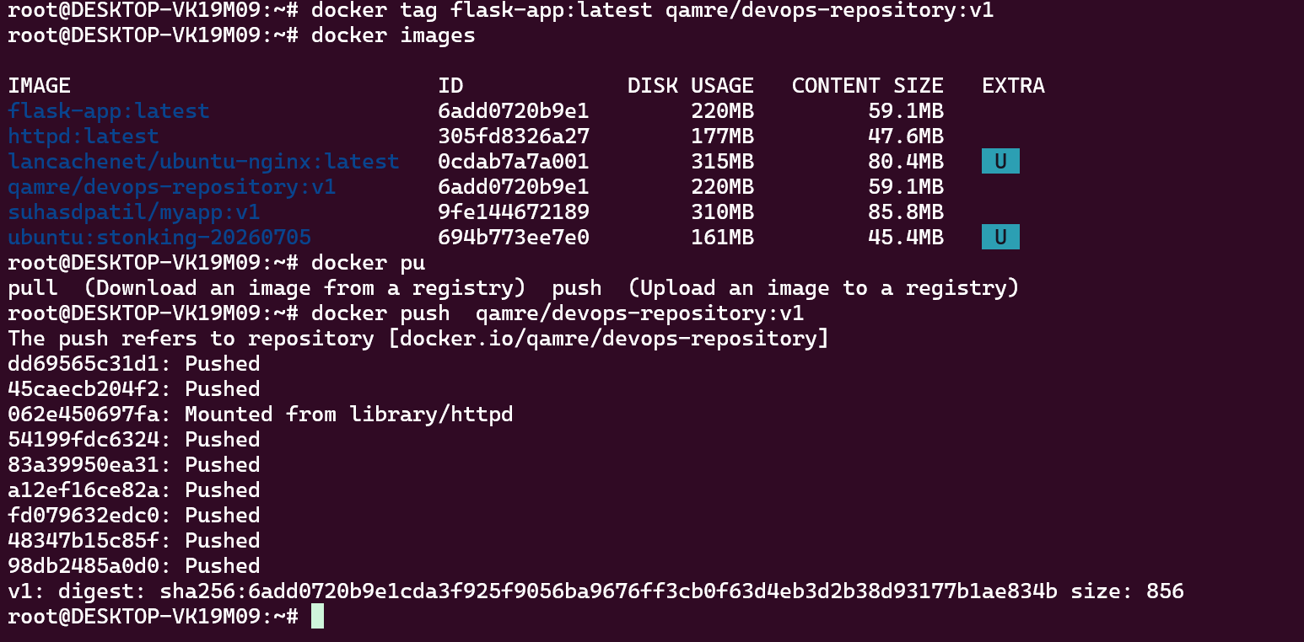
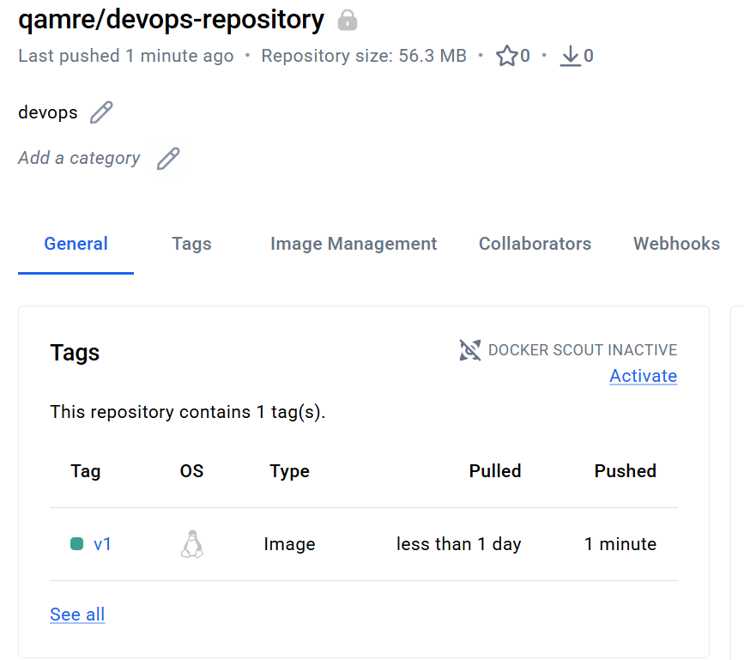
============================================================
- Launch an Ubuntu container, demonstrate that the escape sequence is functional, and reattach the container after detaching it with the escape sequence. Then, check the container's IP address.
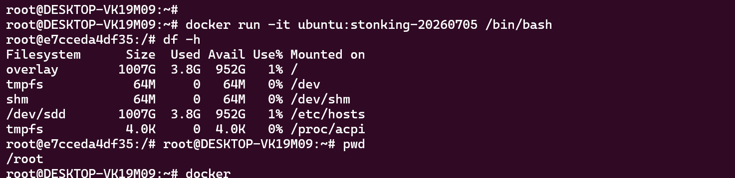
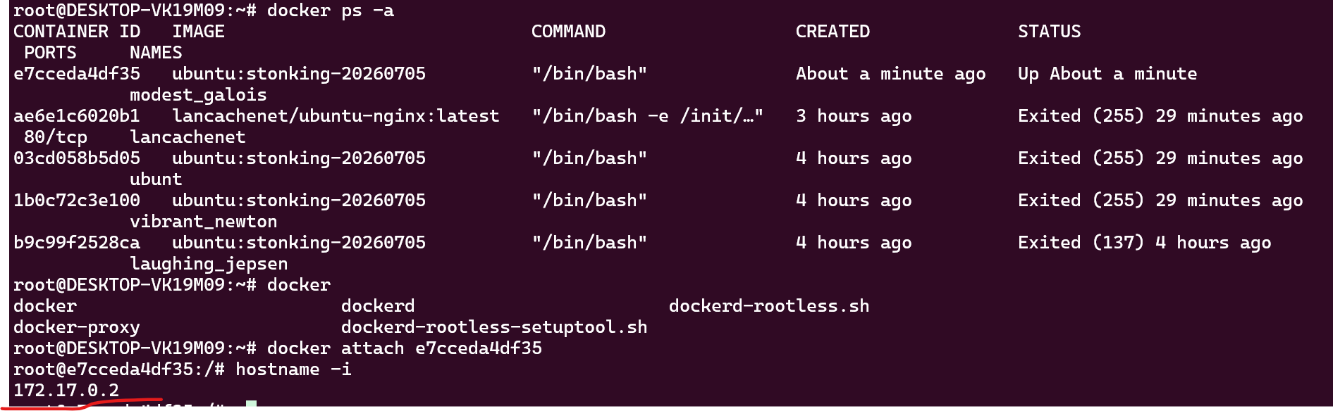
============================================================
- Use a Docker command to inspect the hostname and /etc/hosts file of the httpd container.
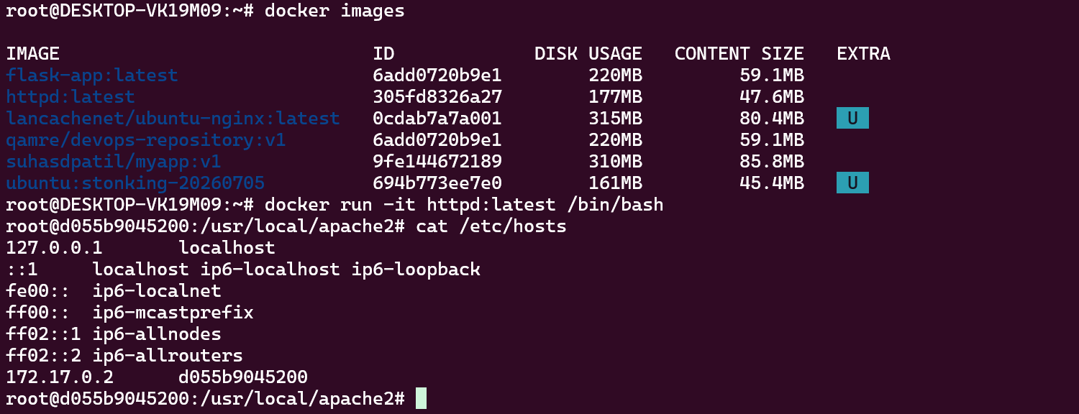
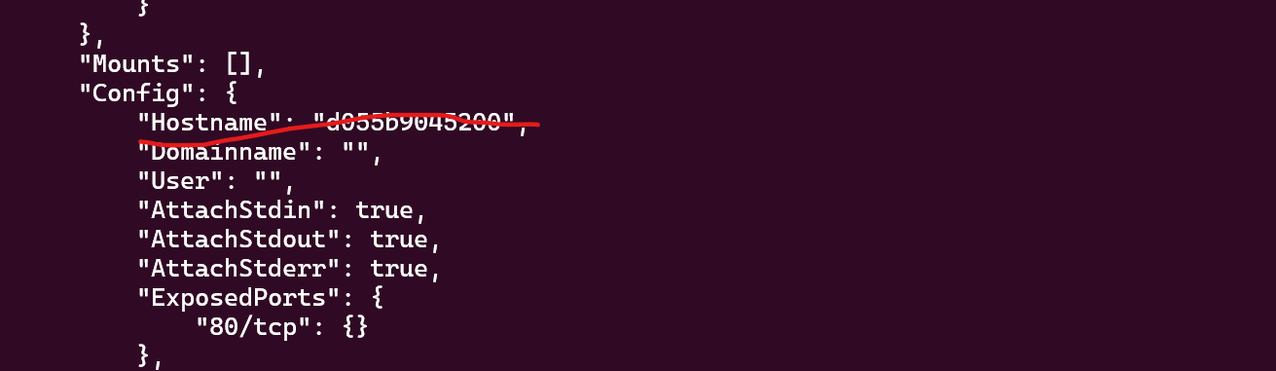
============================================================

- Run a Docker command to inspect a container created with the lancachenet/ubuntu-nginx repository, and monitor the container's resource usage and stats with the TOP command.
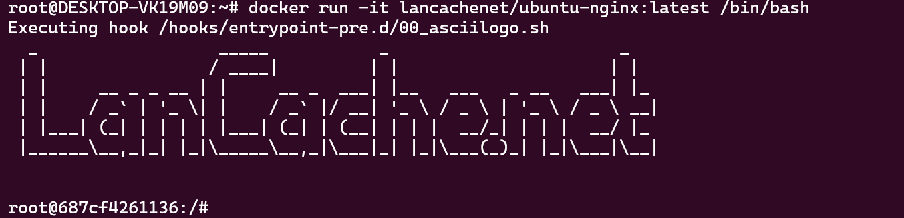
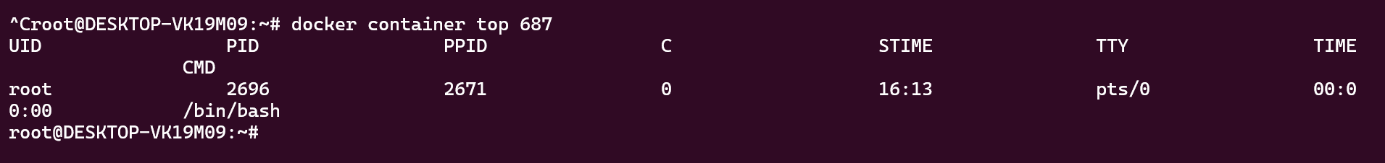
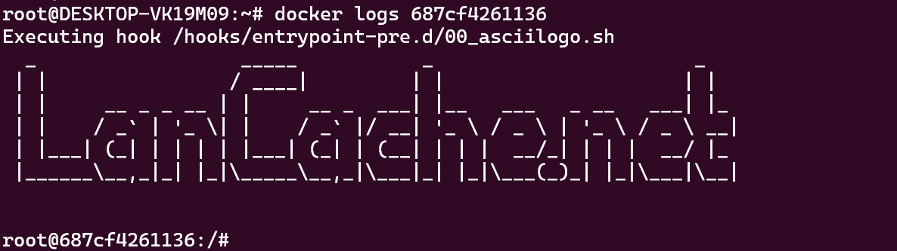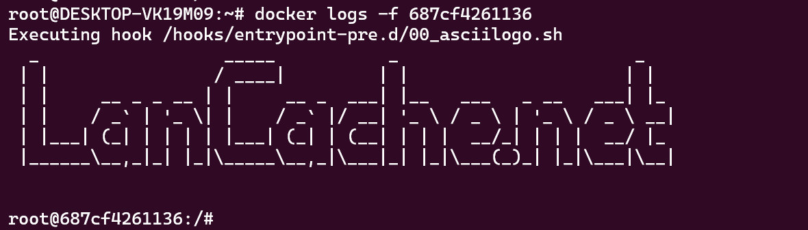
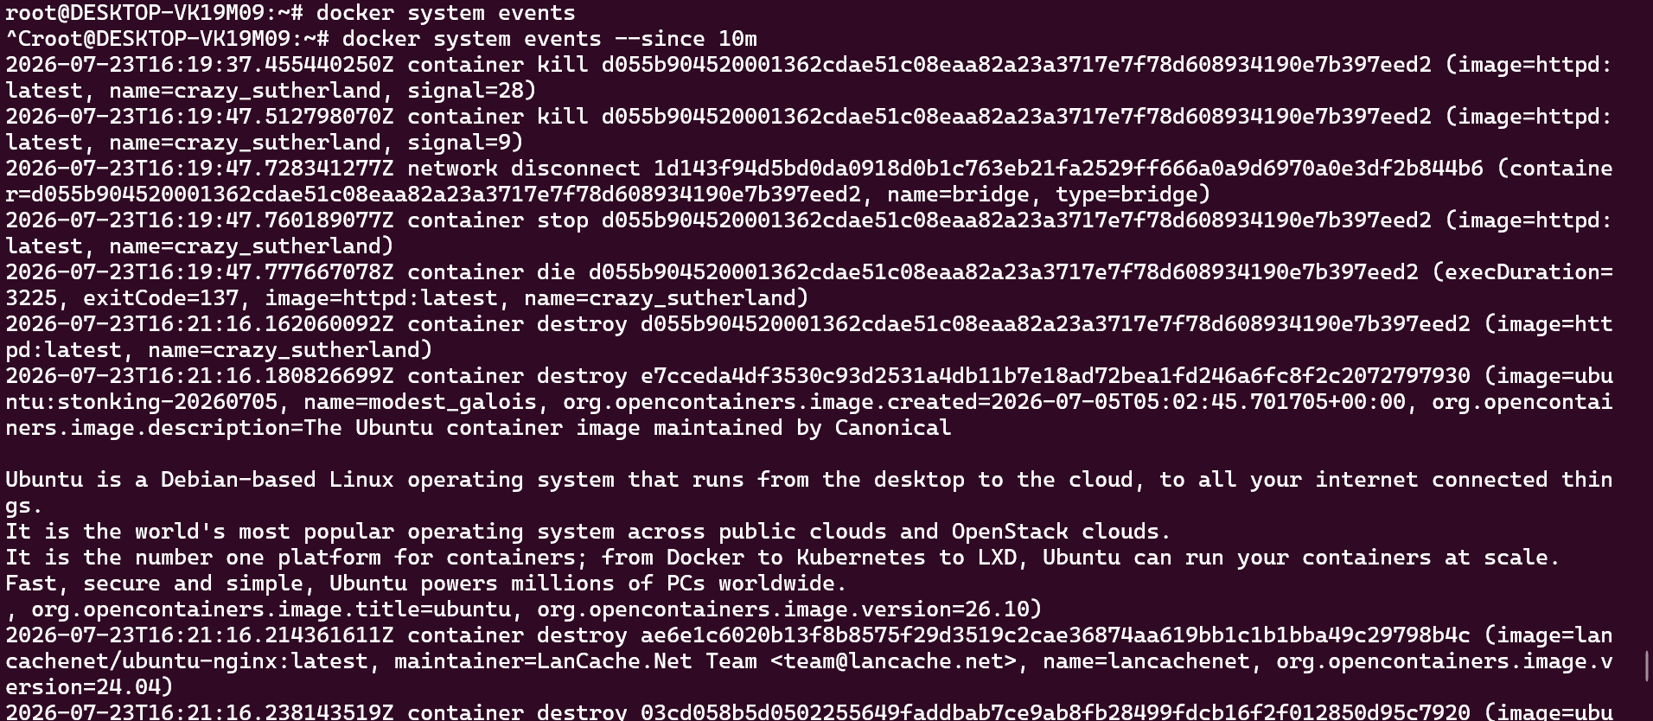

============================================================
- Start a new Nginx container and review the logs for both Nginx containers.
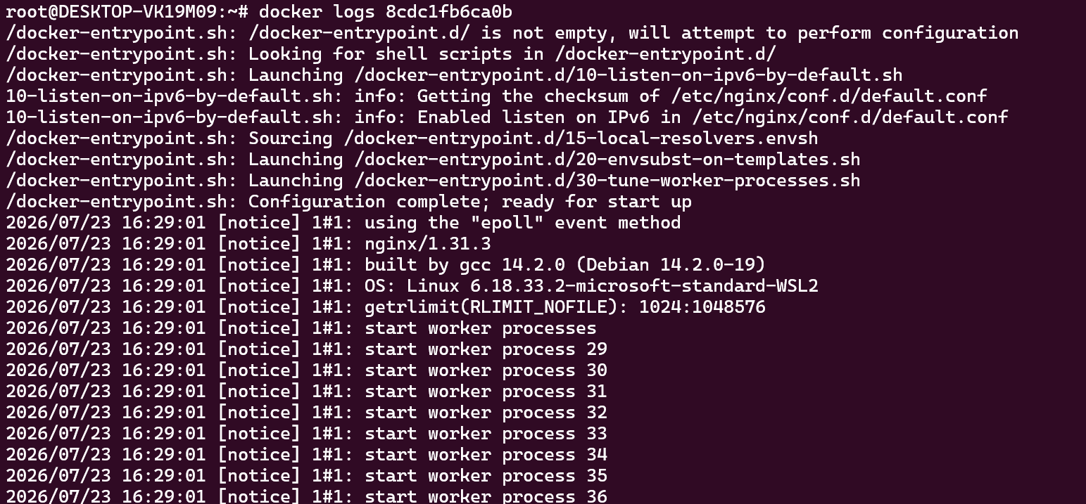
============================================================
- Examine system events, filtering them by date and the last 30 minutes. Additionally, apply two filters simultaneously using name and event. 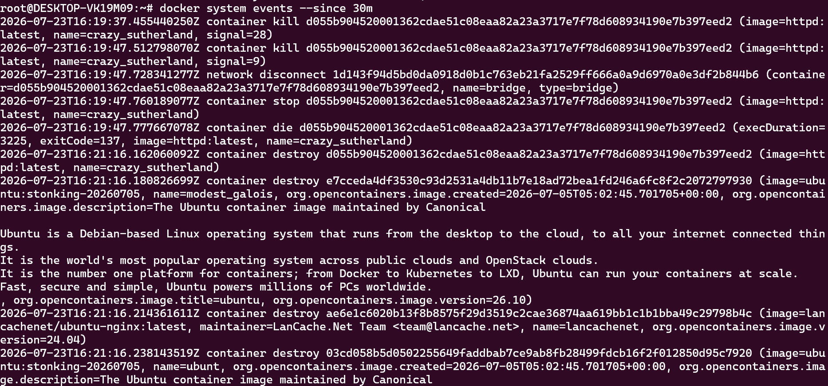

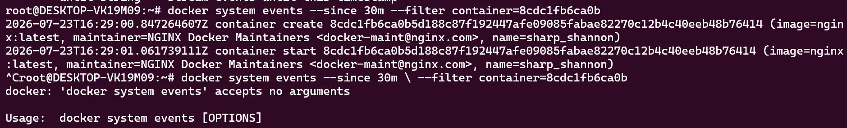============================================================
- Create a Docker container using the Ubuntu image, assign it a meaningful name, and set the hostname to "cloudethix.com." Stop or kill the container, check its exit code, and examine the container's log for more information.
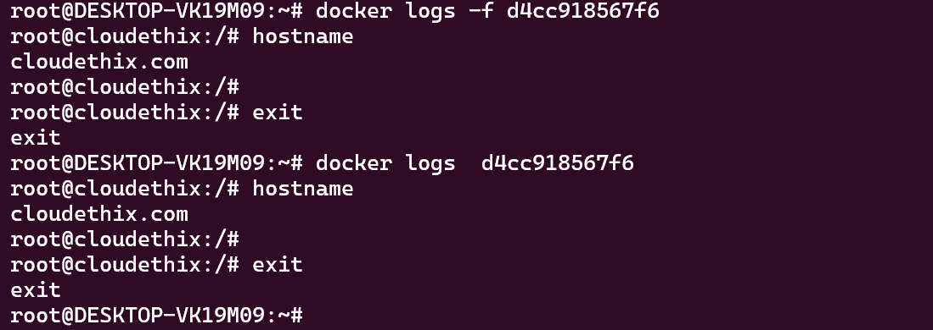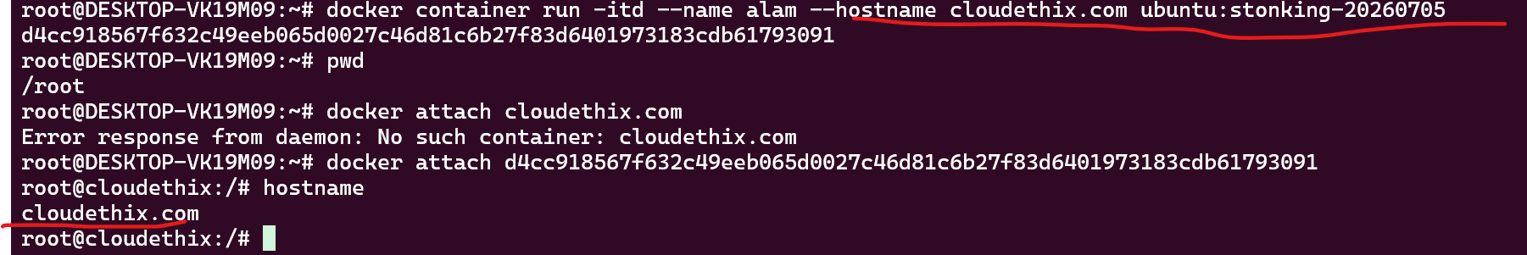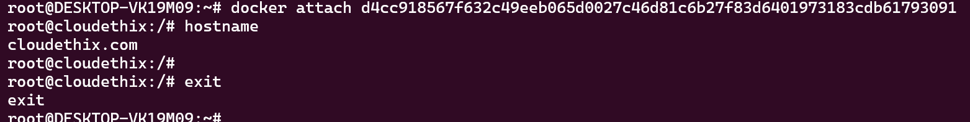

============================================================
- Instantiate and start an Ubuntu container with a random name, then rename it to "Ubuntu01." Launch another container named "Ubuntu02" and check the hostname of both containers. Pause and un-pause the "Ubuntu02" container, and stop, start, and restart the "Ubuntu01" container. Inspect the stats and system events of both containers, then kill and delete them, ensuring that directories created by the containers are removed.
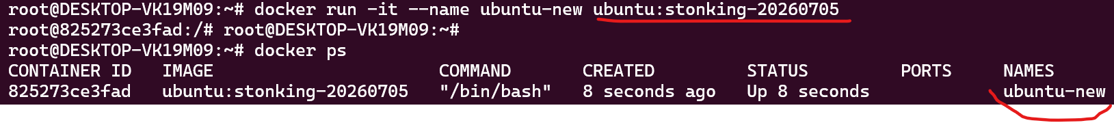
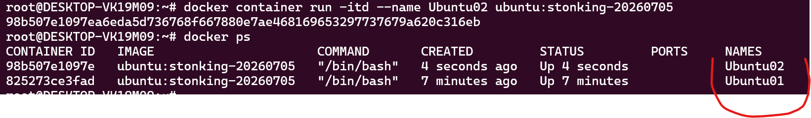
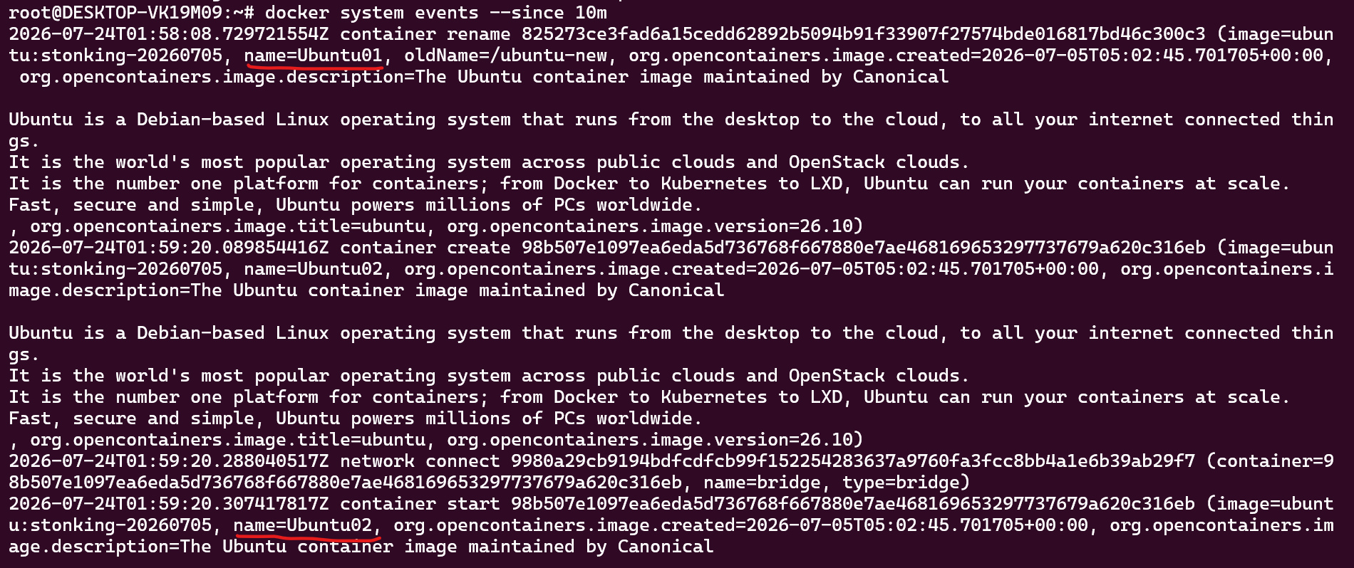
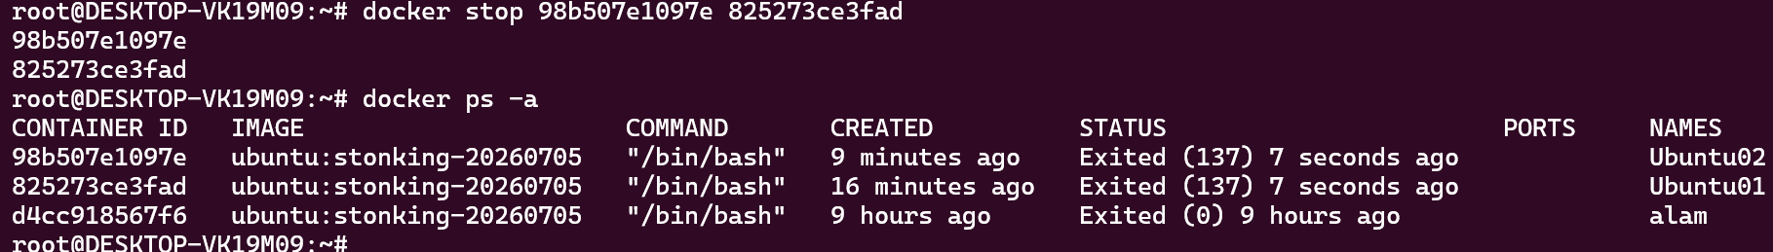
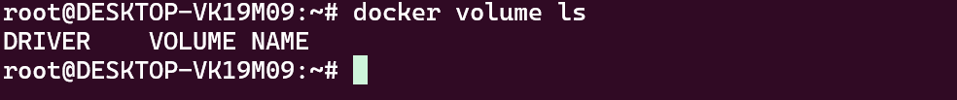
============================================================
- Run four HTTPD Docker containers with distinct, meaningful names, and apply restart policies (NO, On-Failure, Always, and Unless-Stopped) to each of the four containers, respectively. Demonstrate that the restart policies function as expected.
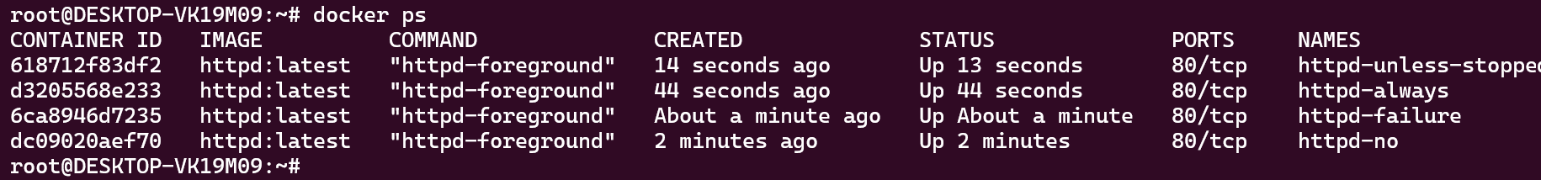
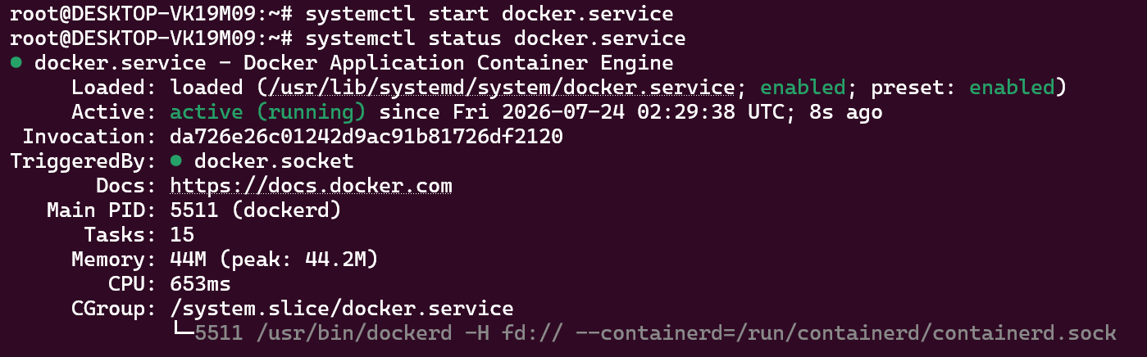
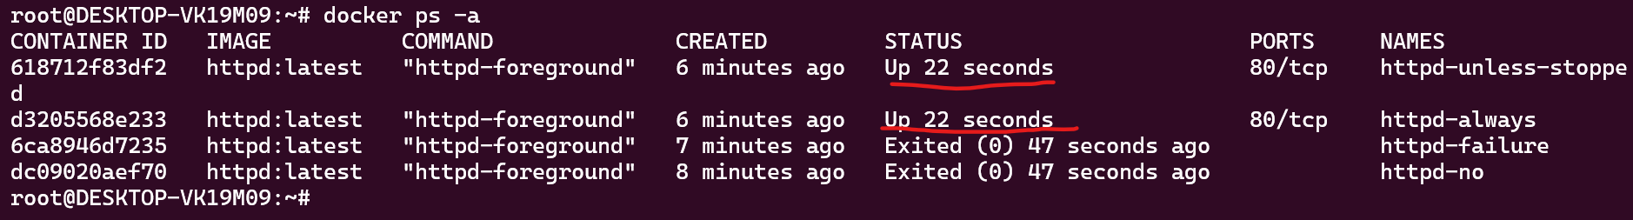
============================================================
- Launch an NGINX container with a meaningful name and expose it on the host's port 80. Create an "index.html" file containing the text "Hello there, Let's be the Team CloudEthiX," and copy the file to the container's "/usr/share/nginx/html/" location. Access the container in a browser to verify that the webpage displays correctly.
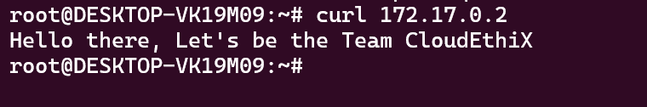
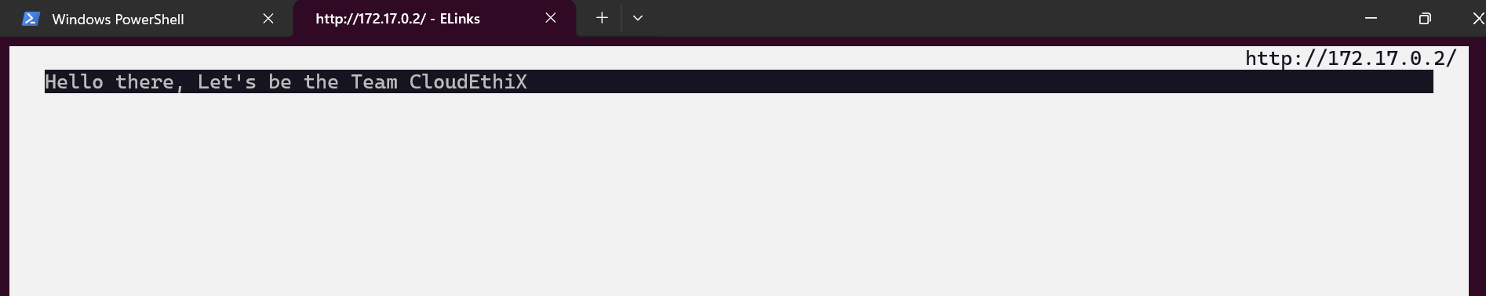

- Pull the Redis image and tag it as "yourname_redis:version 1." Create two additional tags, "yourname_redis:version 2" and "yourname_redis:version 3." Run two Docker containers from the tagged images named "redis01" and "redis02," then delete the "yourname_redis:version 2" image.
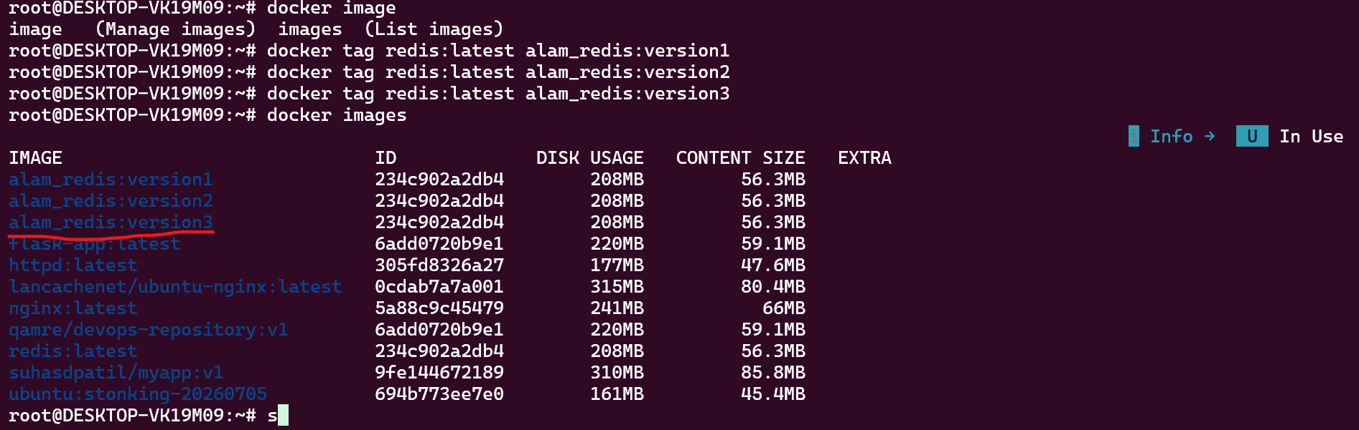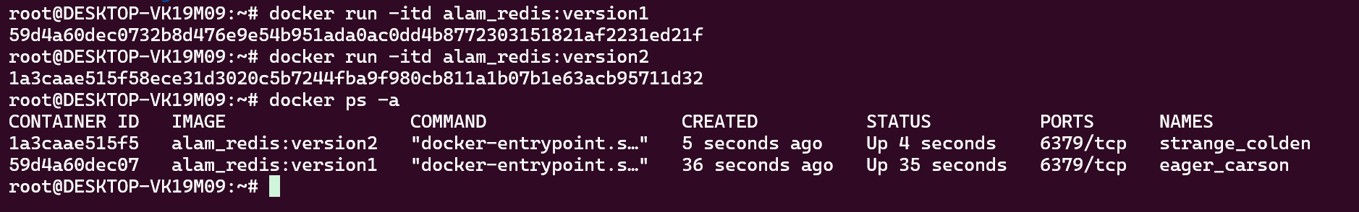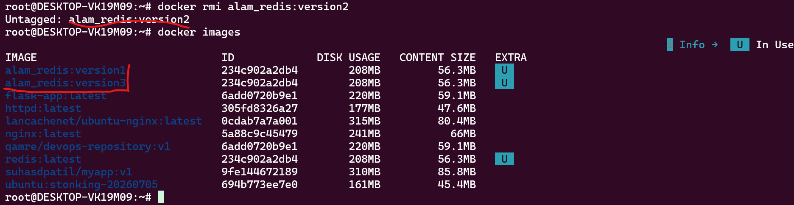
============================================================
- Clone the GitHub - docker-library/httpd: Docker Official Image packaging for Apache HTTP Server Git repository locally and build the httpd Docker image from the Dockerfile at the "httpd/2.4/Dockerfile" path. Run and expose a Docker container from this image with a meaningful name on port 8181, then access the webpage in a browser. Afterward, tag the image as V1.
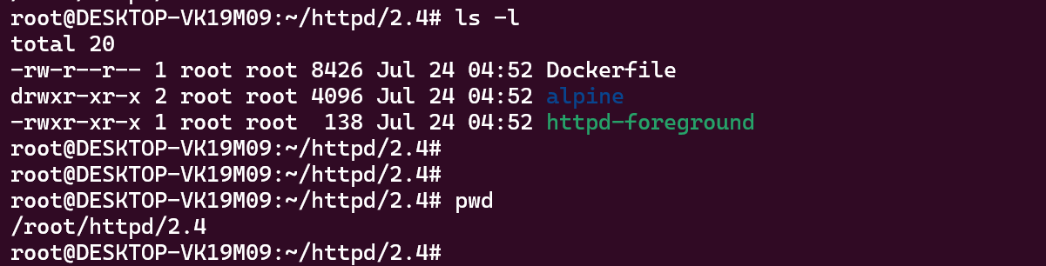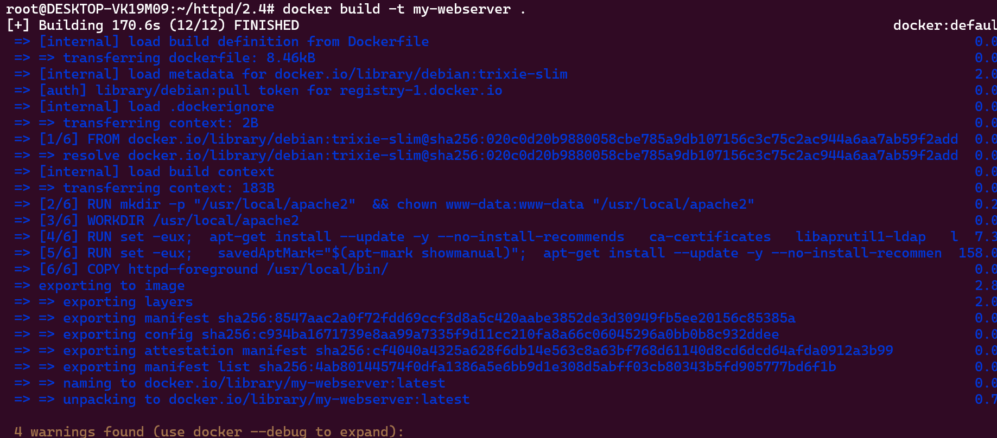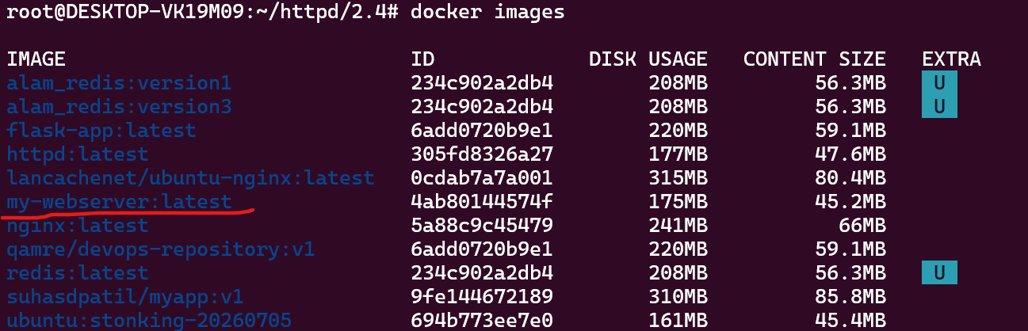
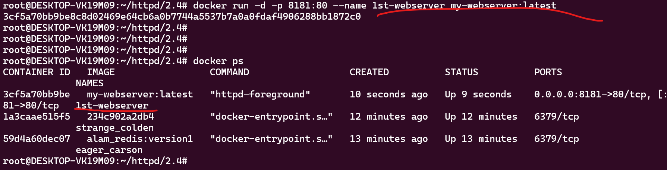
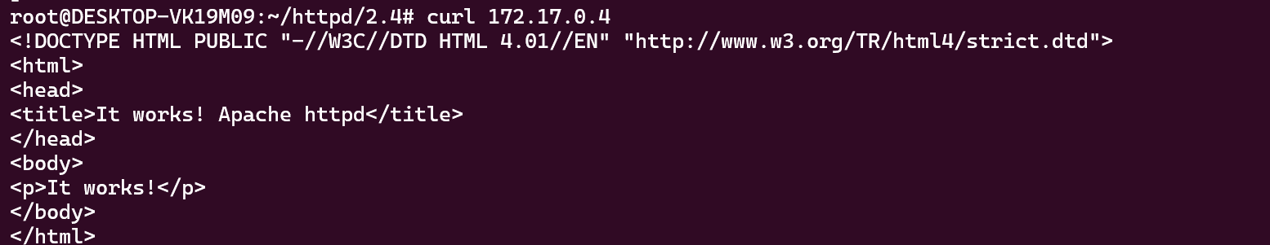
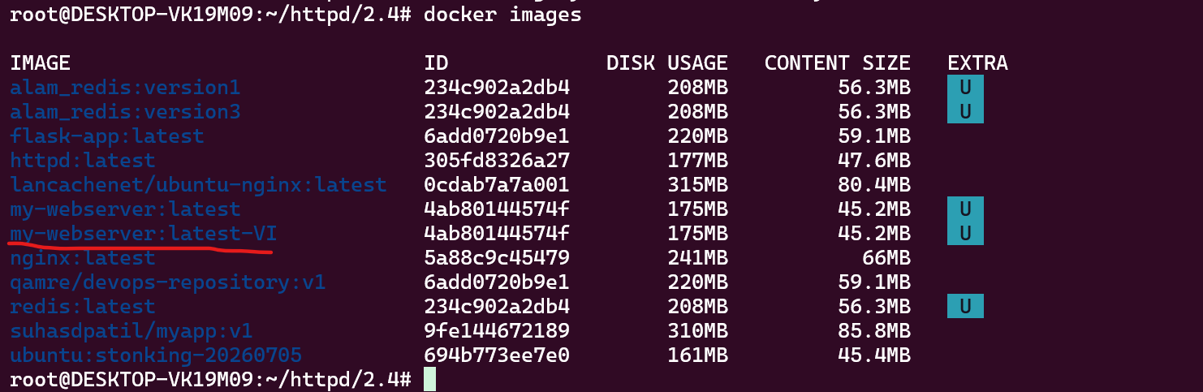
============================================================
- Create a Docker Hub account and generate a security token. Establish a Docker Hub repository named "yourname_cloudethix_httpd." Log in to Docker Hub and push the previously tagged httpd image to your repository.
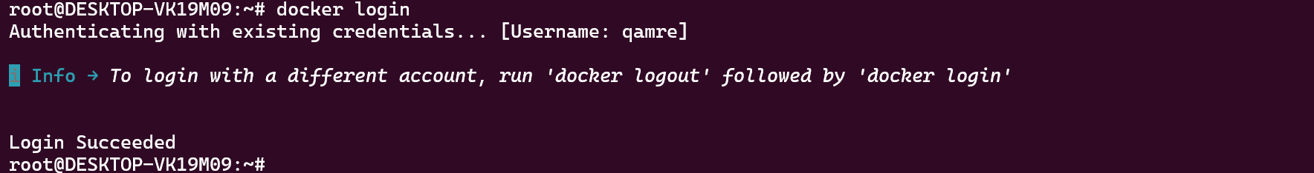
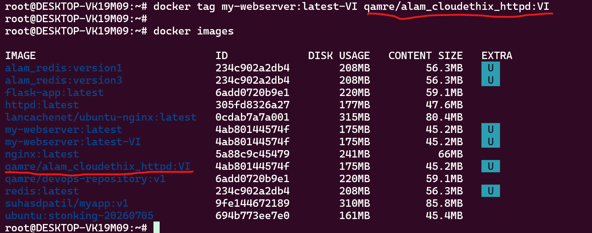
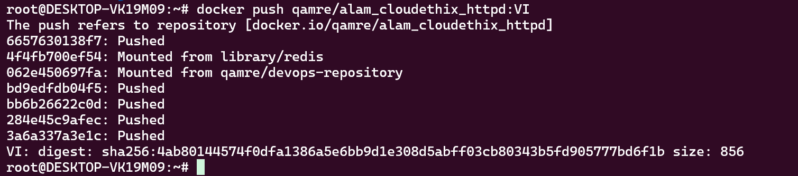
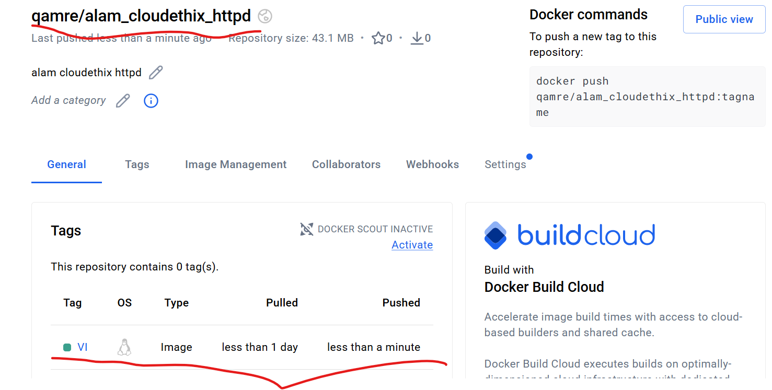
============================================================
- Push the Redis images tagged as version 1 and 3 to your Docker Hub repository, named "yourname_cloudethix_redis."
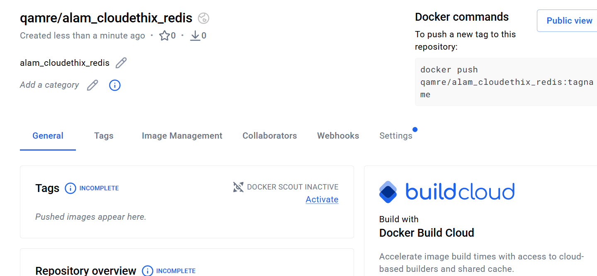
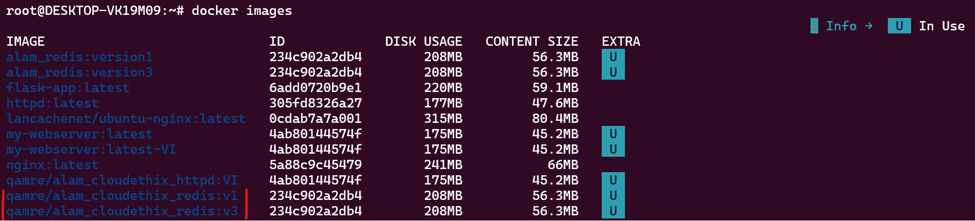
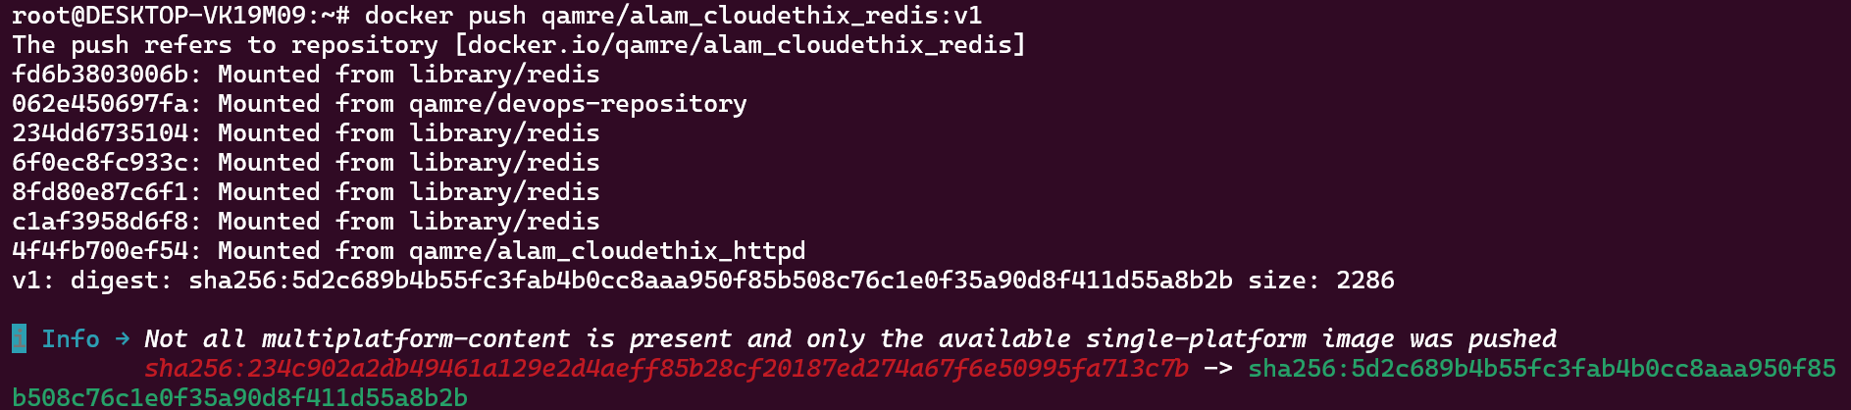
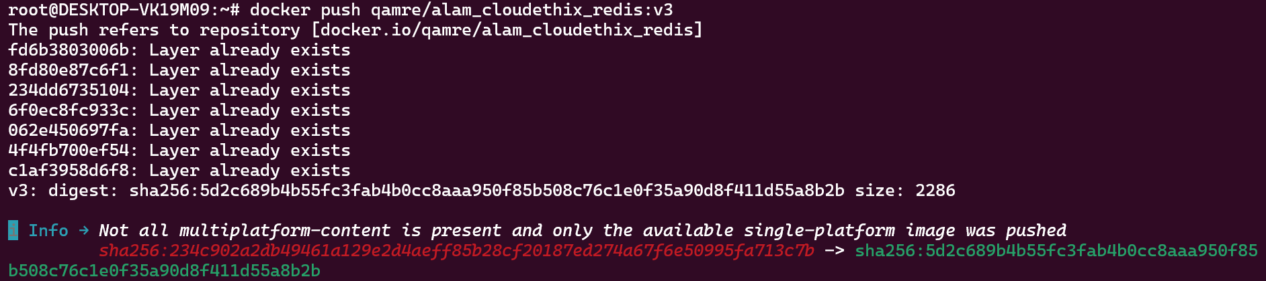
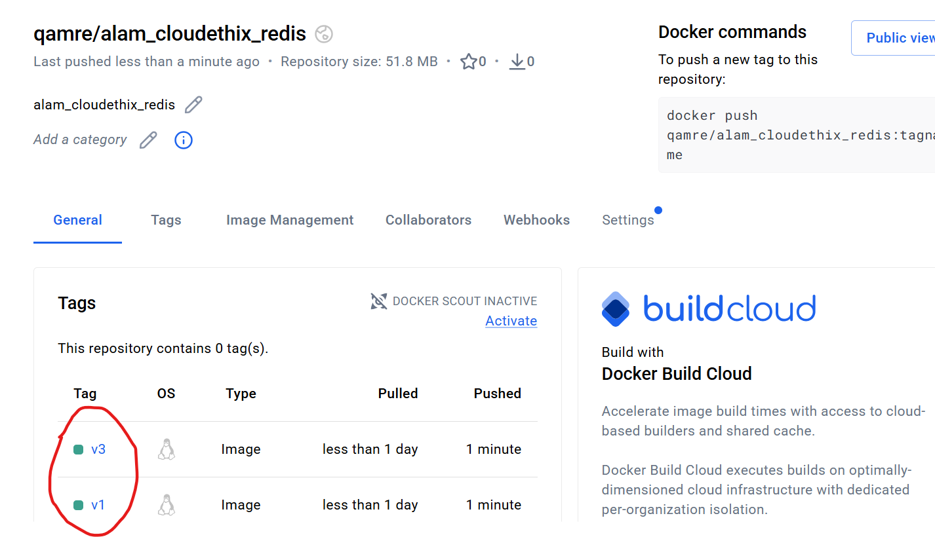
============================================================
- Create a remote Git repository and add the Dockerfile and index.html files.
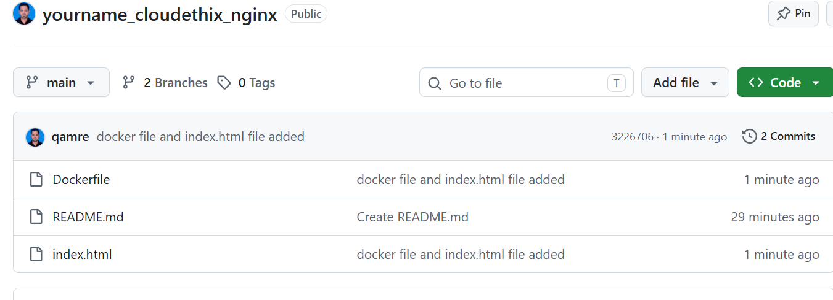
Clone the repository locally and create a release branch. Build the Docker image from the release branch with a meaningful tag,
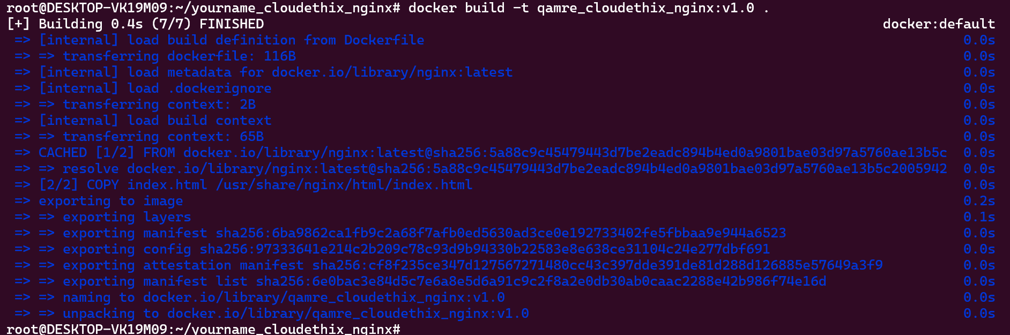
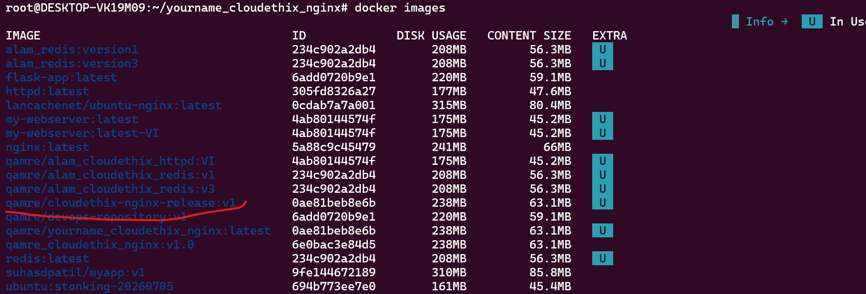
then run a container from the image and expose it on host port 8383. Check the webpage in a browser, and upon success,
push the image to your Docker Hub repository named "yourname_cloudethix_nginx. 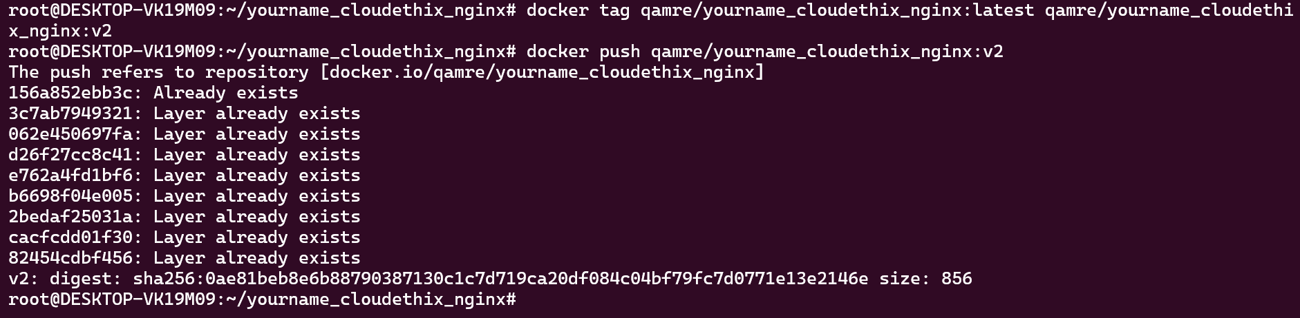
" Finally, push the release branch to the remote Git repository and merge it by creating a pull request. 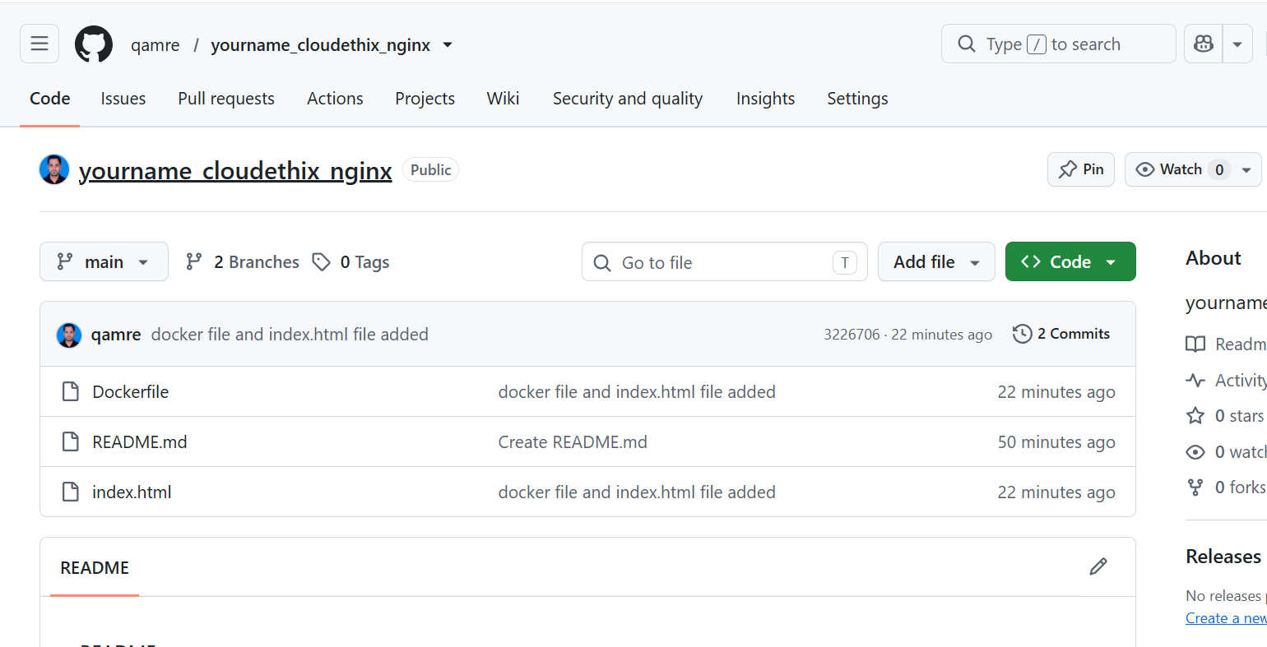
============================================================
- Save all local Redis images as a .tar file in the master branch of your local repository.
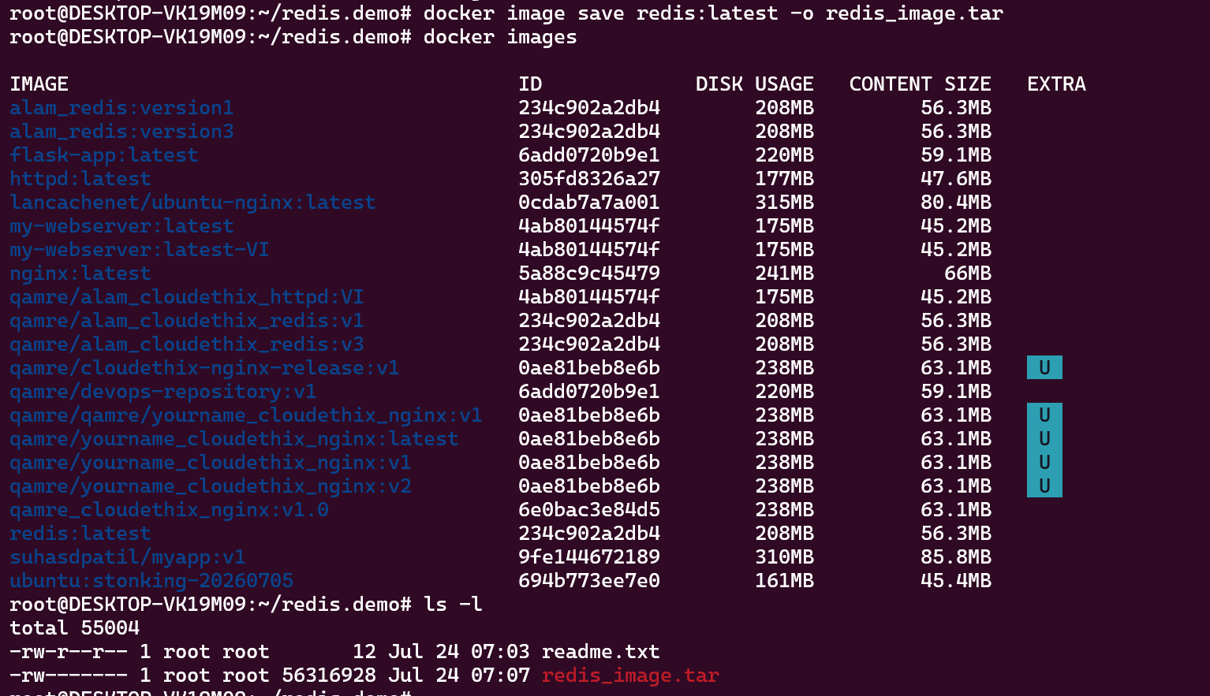
Delete all Redis images from your local system
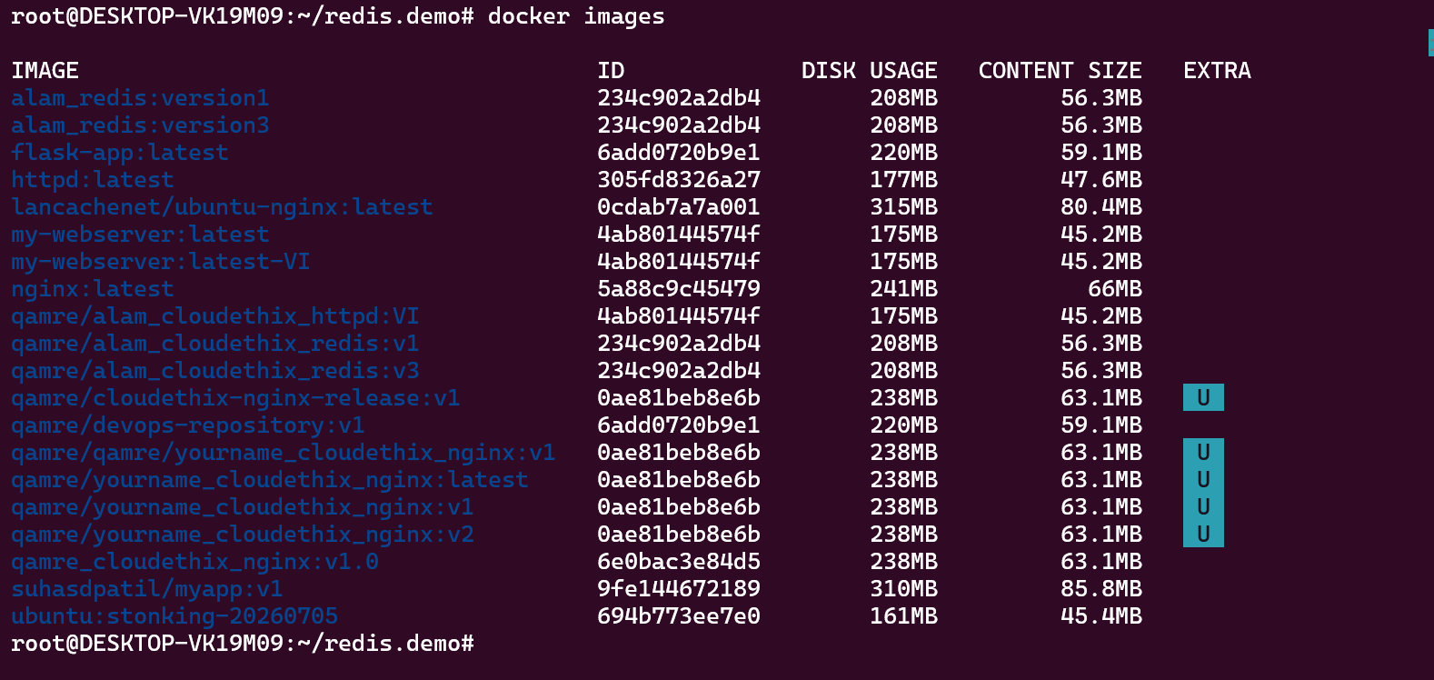
and push the master branch to the remote repository. 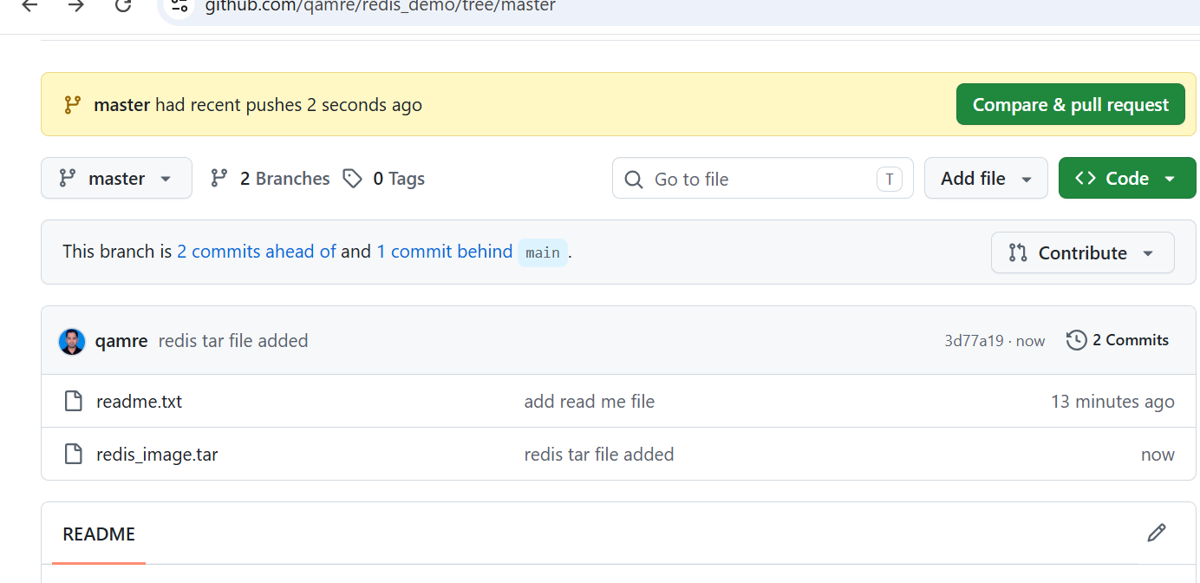
Load the Redis images from the tar file to your local system, and verify that all images have been loaded correctly.
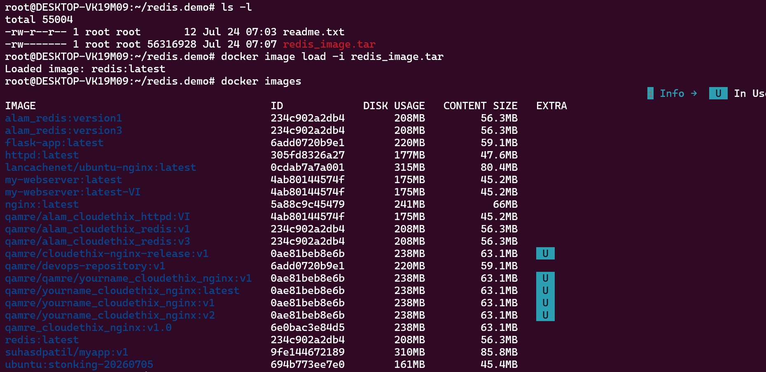
============================================================
- Pull the busybox image to your local system, tag it, and push it to the Docker Hub repository "yourname_cloudethix_busybox.
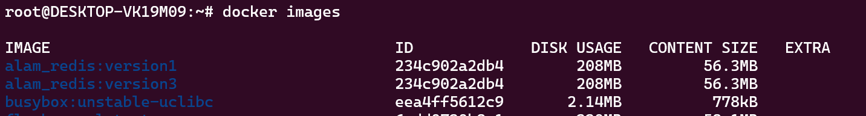
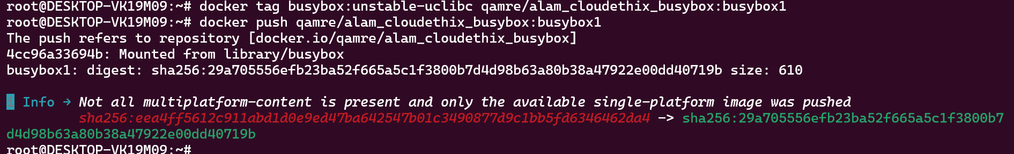
" Export the Docker image from the NGINX container, create a .tar file, and import the tar file to create a Docker image with a meaningful name. After importing the image, tag it and push it to the "yourname_cloudethix_busybox" Docker Hub repository.
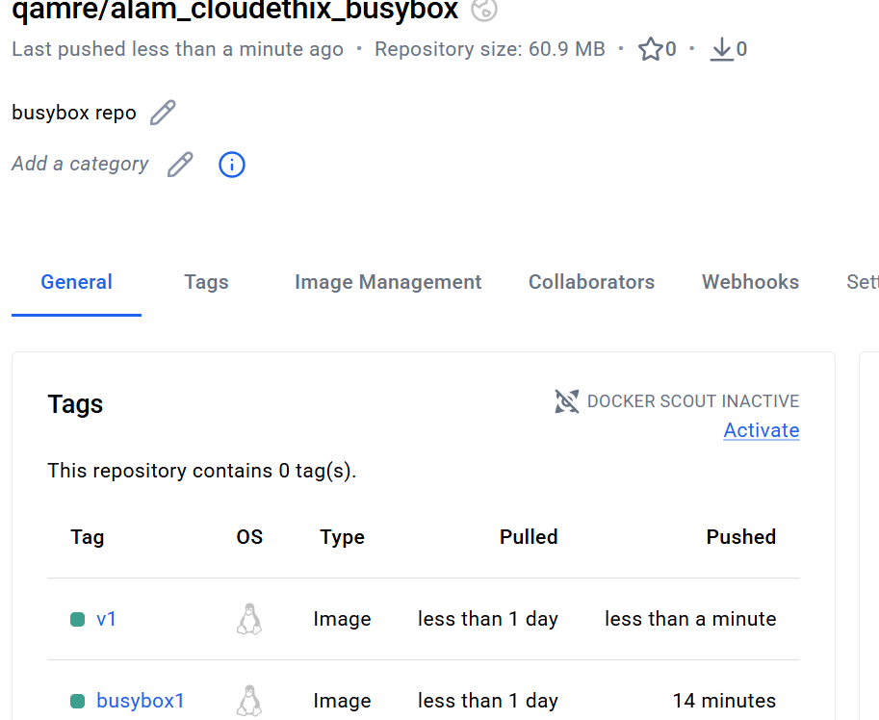

============================================================
- Dockerfile creation: Create a simple Dockerfile to build a custom image with the following specifications:
  - Base image: Ubuntu
  - Install packages: curl, vim, and git
  - Set an environment variable: MY_NAME=Your_Name
  - Build the custom image using docker build and list all available images using docker images.
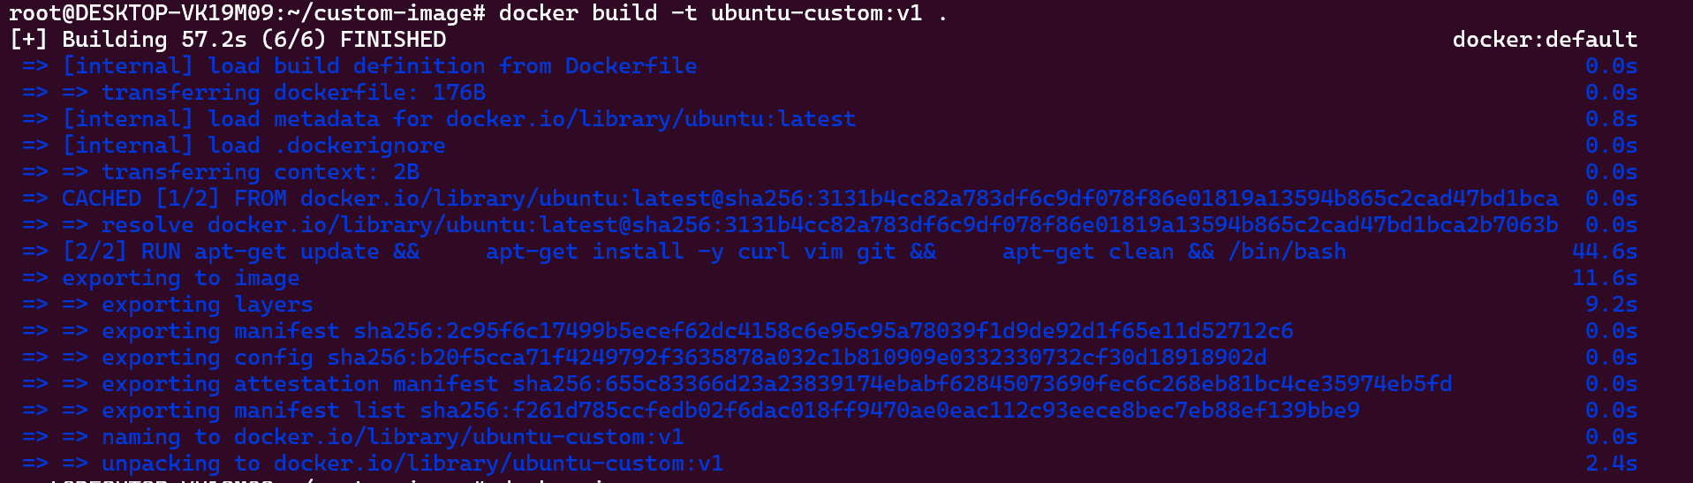
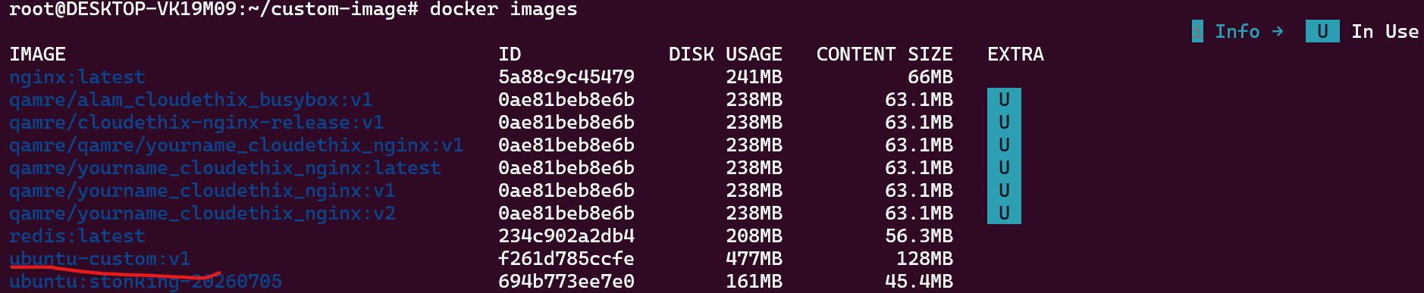
============================================================
- Docker networking: Create two Docker containers with different names, and add them to the same custom network. Verify that the containers can communicate with each other using their names as hostnames.
# docker run -dit --name container1 --network custom_network busybox sh
e494f4c7a6cf5bbf00ff079d2f6cd1abc6e4fe133d75e8d7d4ca868f6e2db961
# docker run -dit --name container2 --network custom_network busybox sh
7ef445d15aa6671ca701b2c8bab265169b478ce7700efcd2b301e22bd92adcc5
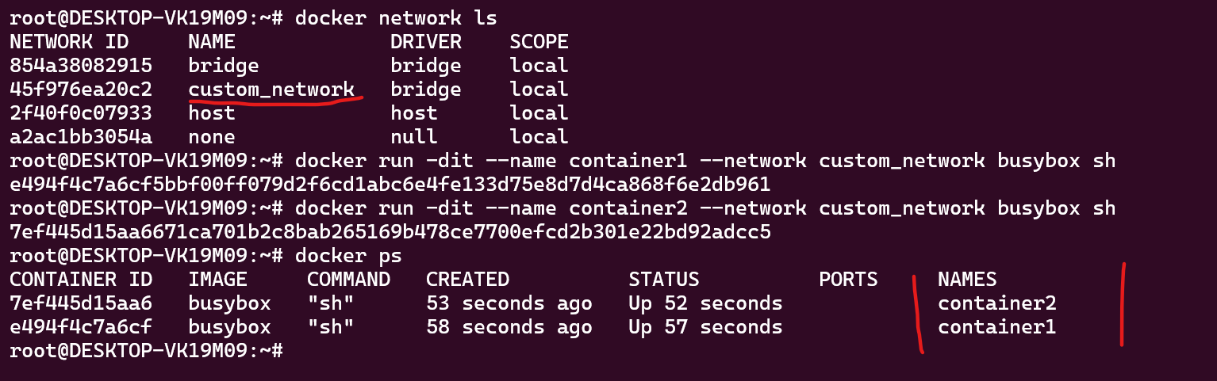
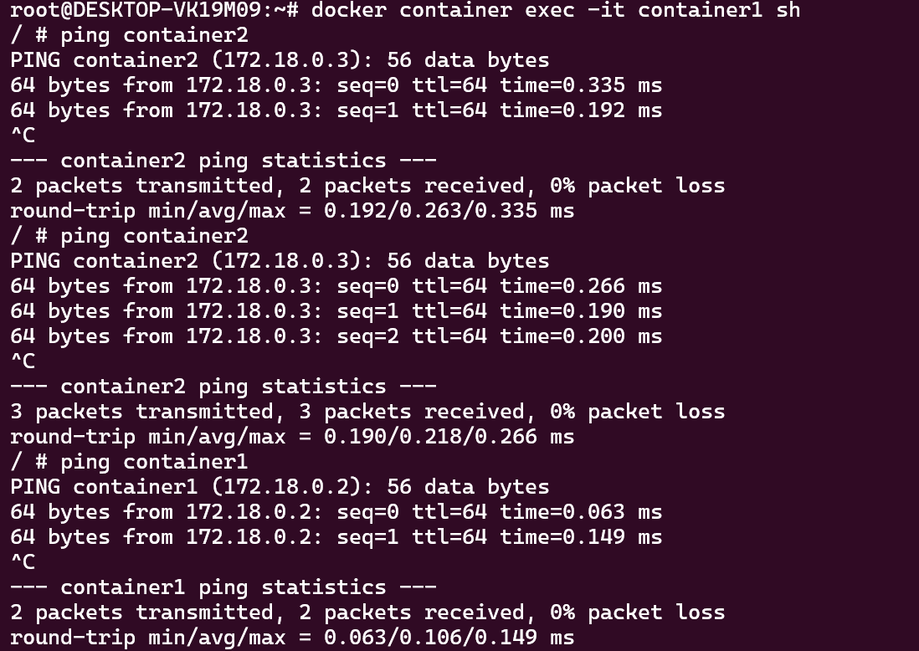
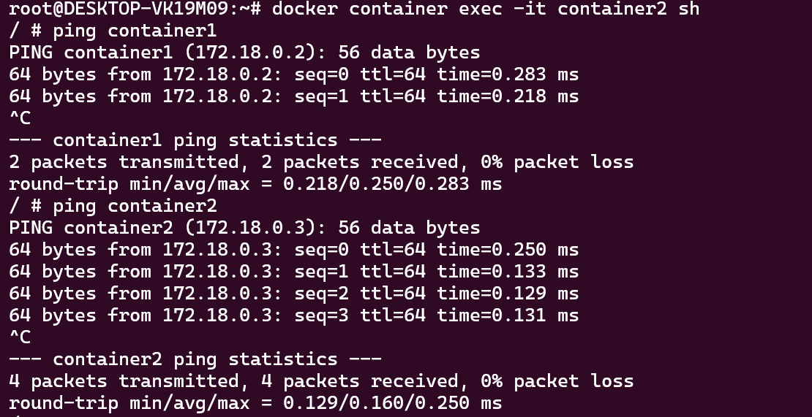

- Data persistence with volumes: Run a Docker container with an attached volume, create a file inside the volume, and verify that the file persists after the container is stopped and removed.
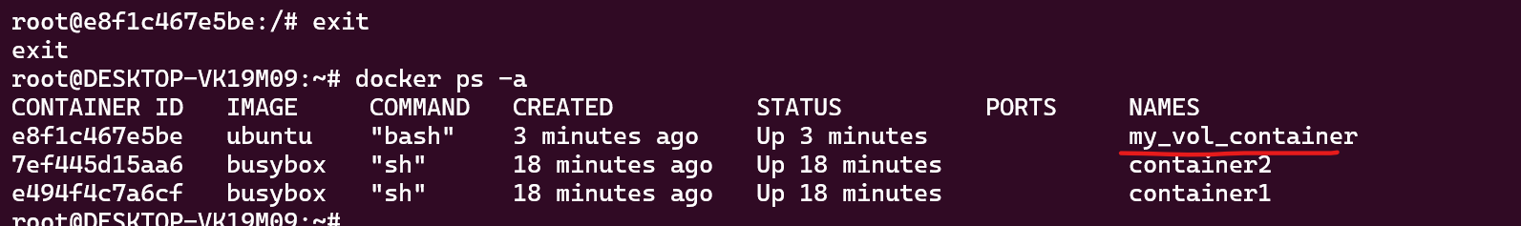
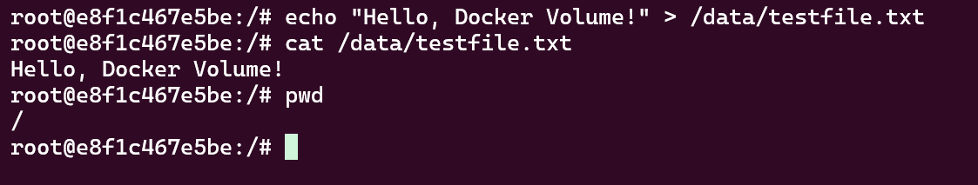
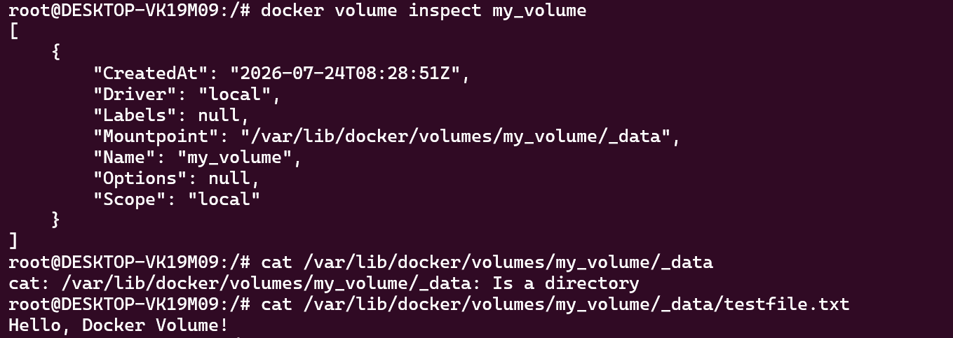
============================================================
- Docker Compose: Create a docker-compose.yml file to run a multi-container application consisting of a web server (e.g., Nginx) and a database server (e.g., MySQL). Ensure that both containers are connected to the same network.
root@DESKTOP-VK19M09:~/multi-container-application# cat docker-compose.yml
services:
web:
image: nginx:latest
container_name: web_server
ports:
- "8080:80"
volumes:
- ./html:/usr/share/nginx/html:ro
networks:
- app_network
depends_on:
- db

db:
image: mysql:8.0
container_name: mysql_database
environment:
MYSQL_ROOT_PASSWORD: rootpassword
MYSQL_DATABASE: appdb
MYSQL_USER: appuser
MYSQL_PASSWORD: apppassword
ports:
- "3306:3306"
volumes:
- mysql_data:/var/lib/mysql
networks:
- app_network

networks:
app_network:
driver: bridge

volumes:
mysql_data:

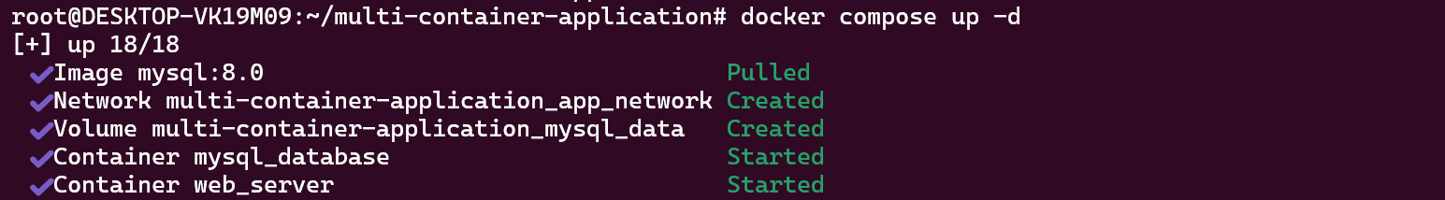
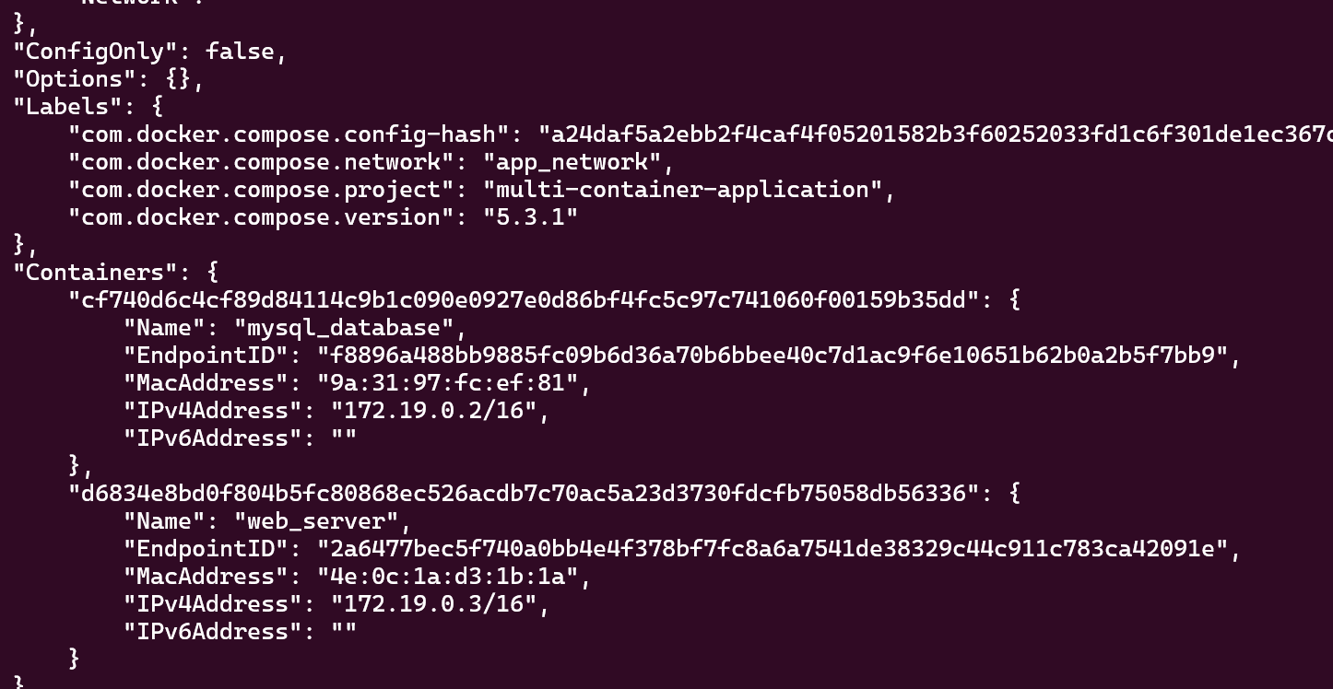
============================================================
- Container logging: Run a Docker container that generates log output, and practice using docker logs to view and analyze the logs.
# # docker run -d --name log-generator busybox sh -c 'while true; do echo "Application log: $(date) - Service is running"; sleep 5; done'
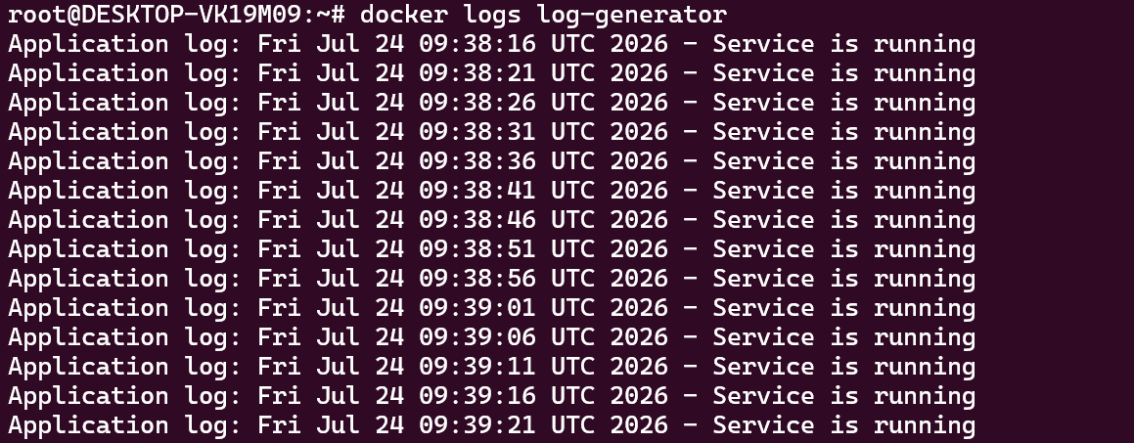
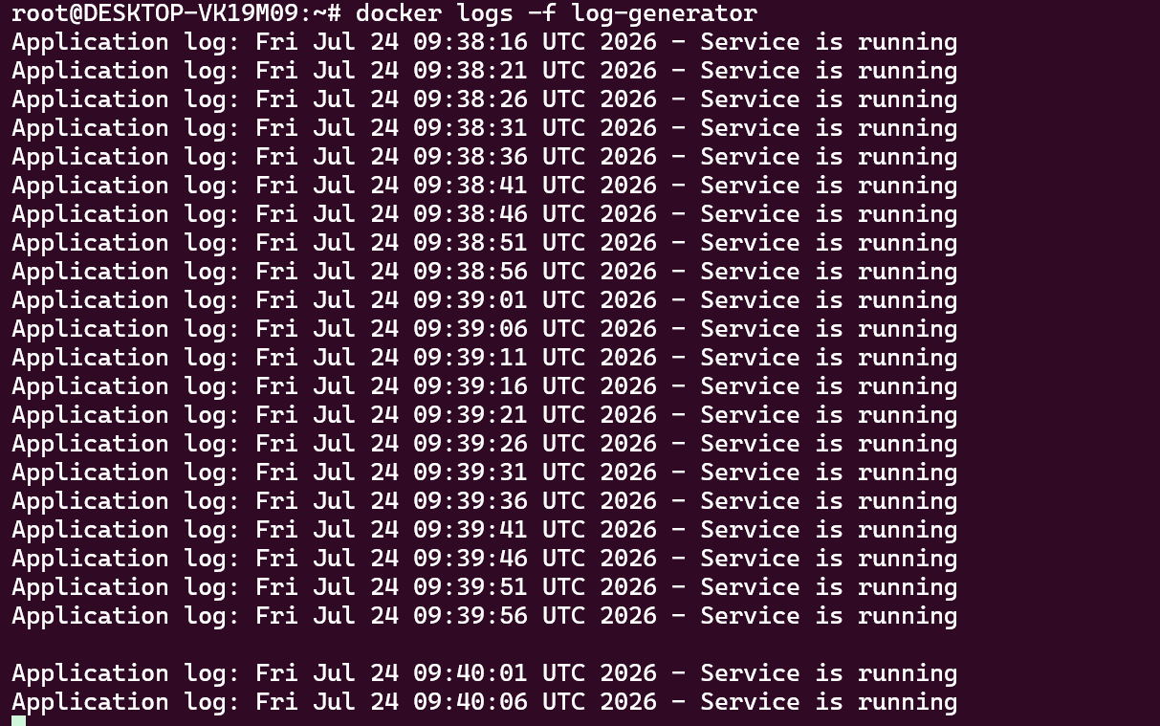
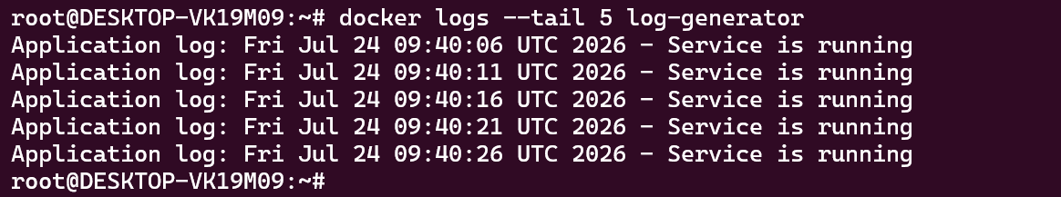
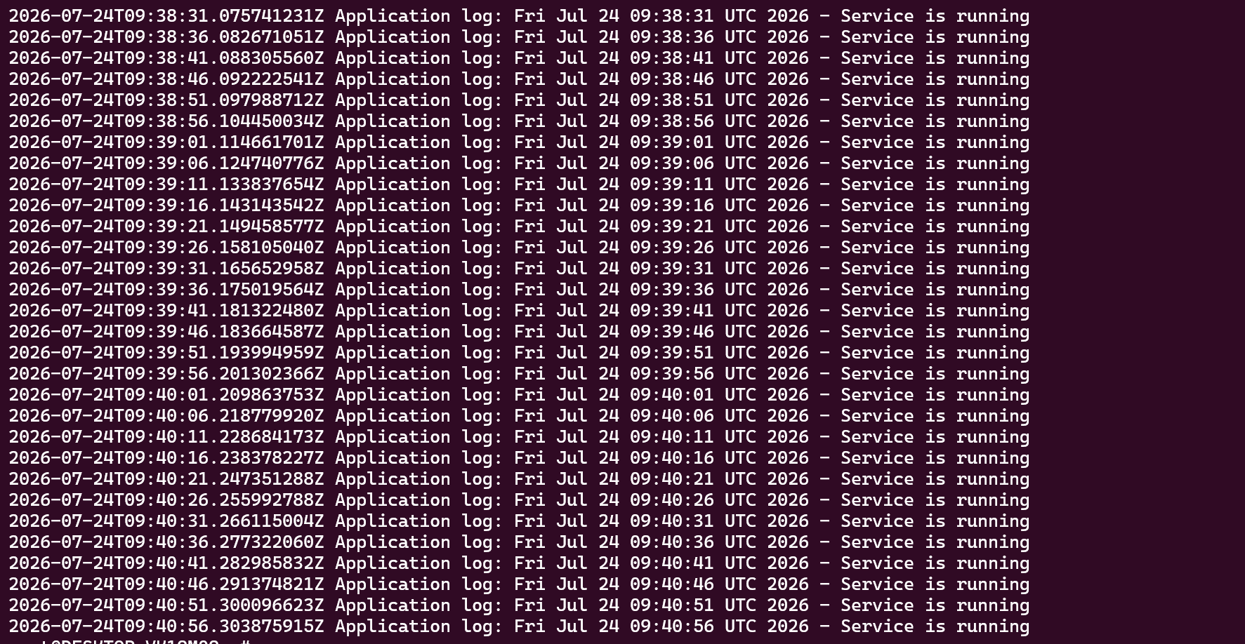
============================================================
- Container resource monitoring: Run a Docker container that consumes system resources (e.g., CPU or memory) and practice using docker stats and docker top to monitor the container's resource usage.
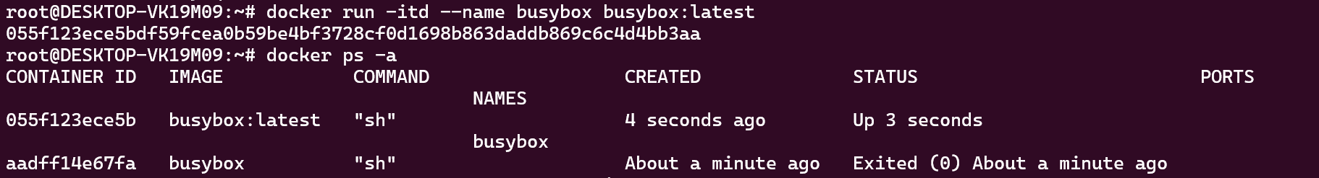
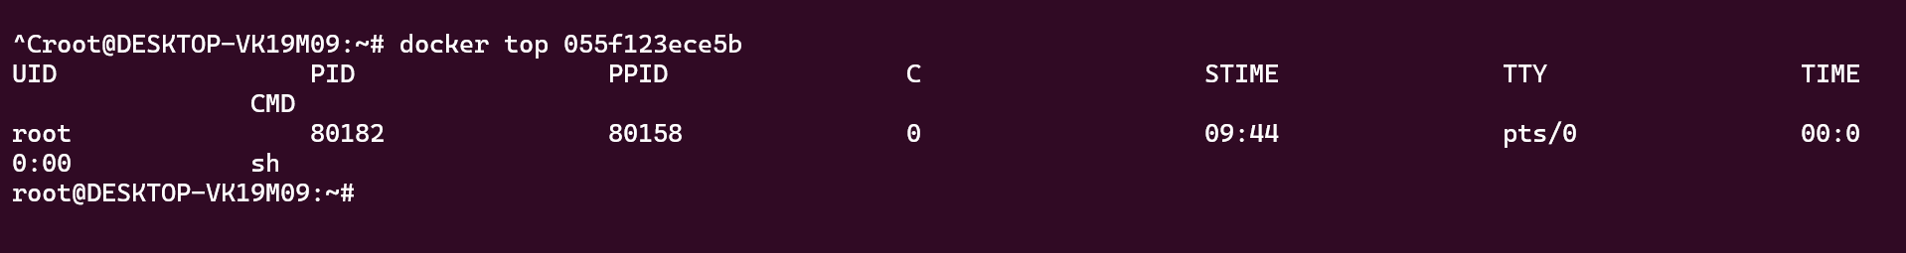
============================================================
34 Updating a containerized application: Update the source code of a simple containerized application, rebuild the Docker image, and deploy the updated version while minimizing downtime.

Step 1: Create the Application

app.js
const express = require("express");

const app = express();

const PORT = 3000;

app.get("/", (req, res) => {
res.send("Hello from Version 1");
});

app.get("/health", (req, res) => {
res.status(200).json({
status: "UP"
});
});

app.listen(PORT, () => {
console.log(`Application running on port ${PORT}`);
});

-rw-r--r-- 1 root root 356 Jul 25 06:45 app.js

package.json
{
"name": "docker-node-demo",
"version": "1.0.0",
"description": "Simple Docker Demo",
"main": "app.js",
"scripts": {
"start": "node app.js"
},
"dependencies": {
"express": "^4.19.2"
}
}

-rw-r--r-- 1 root root 211 Jul 25 04:58 package.json

Dockerfile
FROM node:20-alpine

WORKDIR /app

COPY package*.json ./

RUN npm install

COPY . .

EXPOSE 3000

CMD ["npm", "start"]

-rw-r--r-- 1 root root 119 Jul 25 04:59 Dockerfile

.dockerignore
node_modules
npm-debug.log
.git

-rw-r--r-- 1 root root 32 Jul 25 06:37 .dockerignore

Step 2: Build Docker Image
docker build -t node-demo:v1 .

Check image
docker images
node-demo:v1 --- created

Example
REPOSITORY TAG
node-demo v1

Step 3: Run Container
#docker run -d --name node-app -p 3000:3000 node-demo:v1

Build image node-demo:v1
Verify
docker ps
Open browser
http://localhost:3000
Output
Hello from Version 1
Health Check
http://localhost:3000/health
Output
{
"status":"UP"
}

Verify
docker ps

Open browser
http://localhost:3000
Output
Hello from Version 1 or

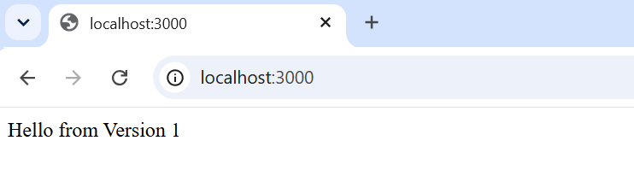
Health Check
http://localhost:3000/health Or

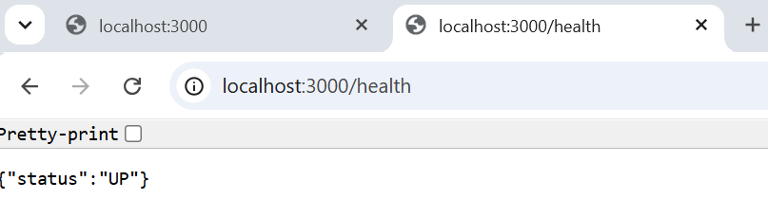
Output
{
"status":"UP"
}

=========== > here docker node1 completed

Step 4: Update the Application
Modify app.js
const express = require("express");

const app = express();

const PORT = 3000;

app.get("/", (req, res) => {
res.send("Hello from Version 2 - Application Updated");
});

app.get("/health", (req, res) => {
res.status(200).json({
status: "UP"
});
});

app.listen(PORT, () => {
console.log(`Application running on port ${PORT}`);
});

Updated the app.js file as above added ("Hello from Version 2 - Application Updated")

Step 5: Build New Image
#docker build -t node-demo:v2 .

Image node-demo:v2 created as below

node-demo:v2
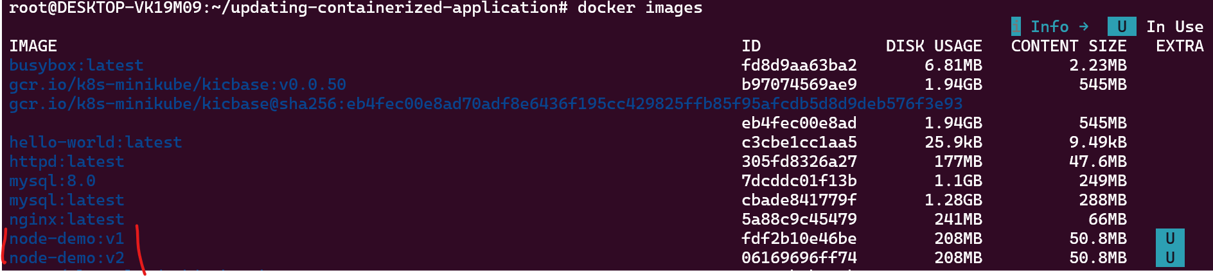

http://localhost:3001/
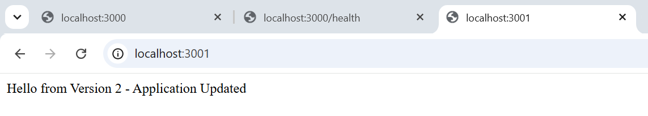
http://localhost:3001/health
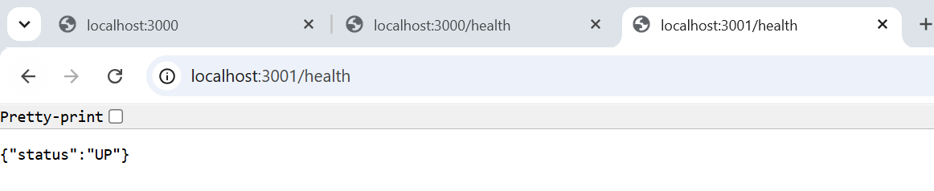

Step 6: Build New Image
Instead of stopping the old container first:
We have run version 2 another port 3001

Once above version 2 is verified
• Update your Load Balancer or Nginx to point to port 3001
• Confirm traffic is reaching Version 2
• Stop Version 1

#docker stop node-app
#docker rm node-app
Rename if required
docker rename node-app-v2 node-app

Step 8: Push Image to Docker Hub
Login
docker login
Tag image
docker tag node-demo:v2 yourusername/node-demo:v2
Push
docker push yourusername/node-demo:v2

Step 9: Deploy on Another Server
Pull image
docker pull yourusername/node-demo:v2
Run
docker run -d \
--name node-app \
-p 3000:3000 \
yourusername/node-demo:v2

Step 10: Rollback
If Version 2 has issues:
Stop it
docker stop node-app
docker rm node-app
Start Version 1
docker run -d \
--name node-app \
-p 3000:3000 \
node-demo:v1
Application is restored immediately.

Complete Deployment Workflow
Developer
│
▼
Modify Source Code
│
▼
Run Local Tests
│
▼
Build Docker Image
│
▼
Tag Image (v2)
│
▼
Push Image to Docker Registry
│
▼
Pull Image on Target Server
│
▼
Start New Container
│
▼
Perform Health Check
│
▼
Switch User Traffic
│
▼
Stop Old Container
│
▼
Monitor Application
│
▼
Rollback if Required

============================================================
- Bridge network: Create two Docker containers using different images, such as NGINX and MySQL. Connect them using a user-defined bridge network and ensure they can communicate with each other.
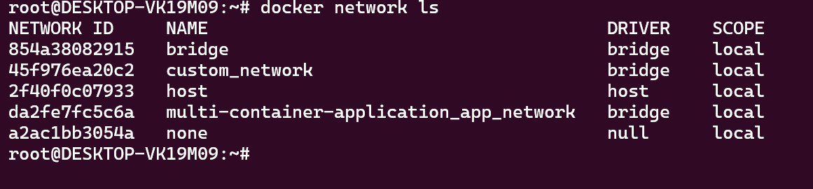
# docker run -dit --name container1 --network custom_network nginx
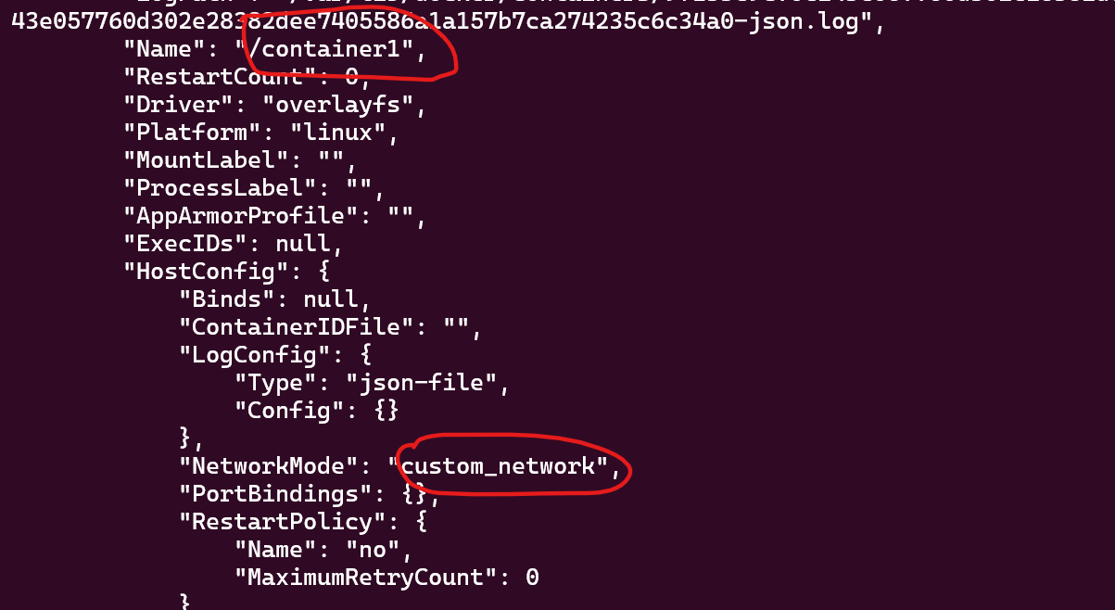
# docker run -dit --name container2 --network custom_network mysql
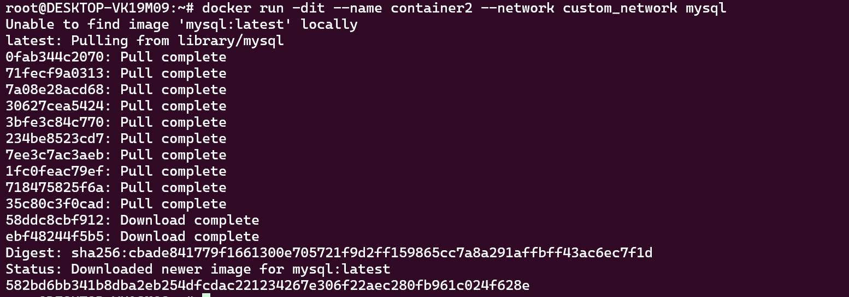
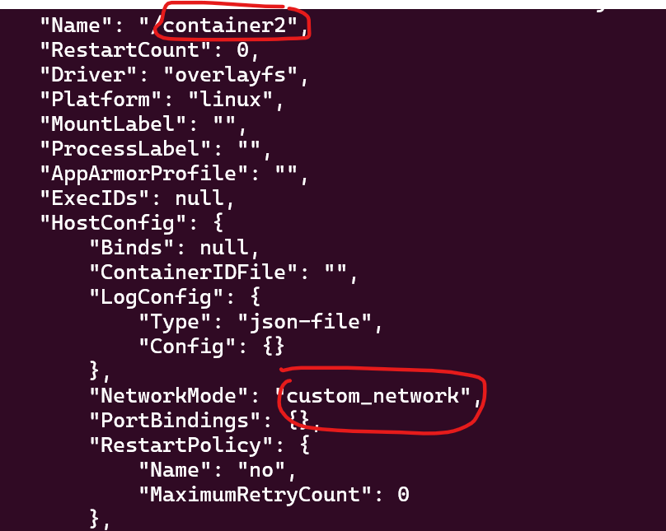
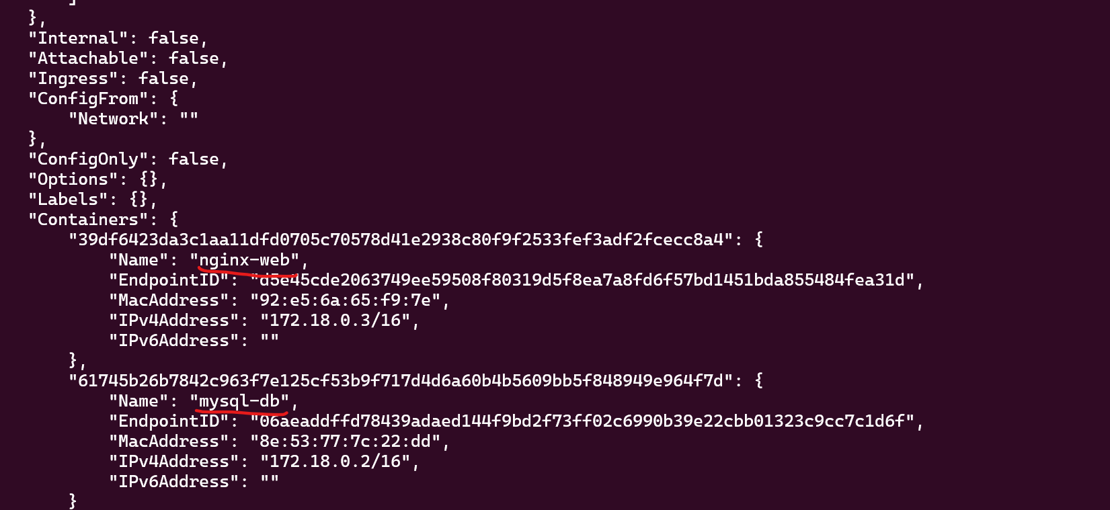
============================================================
- Port mapping: Run a containerized web server (e.g., NGINX or Apache) and map its default port (80 or 443) to a custom port on the host machine. Verify that the web server is accessible through the custom port on the host.
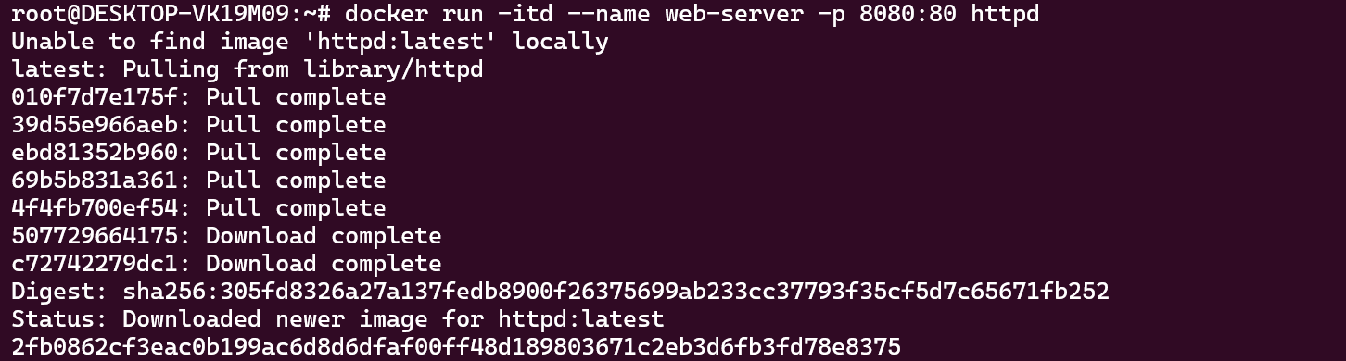
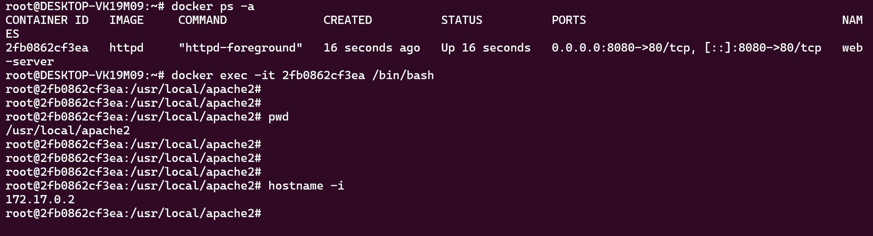
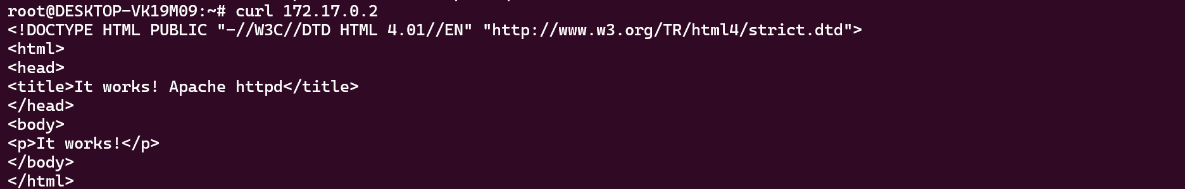
============================================================
- Host networking: Run a container with the host networking mode and compare its network configuration with that of the host machine. Explain the advantages and disadvantages of using host networking for containers.
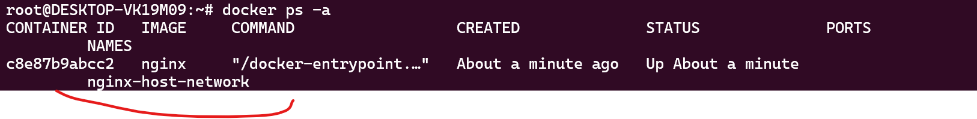
Advantages of Host Networking
Remove Dockers virtual networks and NAT
Reduce network latencies
Advantage of high network throughput and low latency
Examples:
Network monitoring tools, Real-time communication systems, High-performance servers
Disadvantage of Host networking

Reduced Network Isolation
Containers share the host's network namespace. The container can see the host's network interfaces and ports.
Example:
Host:
eth0 → 192.168.1.10

Container:
eth0 → 192.168.1.10
Both use the same network identity.

- Named volume: Launch a containerized database (e.g., MySQL or PostgreSQL) using a named volume to store its data. Stop and remove the container, then recreate it using the same named volume. Verify that the data persists across container recreations.
# Launch a containerized database (e.g., MySQL or PostgreSQL) using a named volume to store its data. Stop and remove the container, then recreate it using the same named volume. Verify that the data persists across container recreations.

Objective
- Launch a MySQL container using a named volume
- Create a database and table
- Insert sample data
- Stop and remove the container
- Recreate the container with the same named volume
- Verify that the data still exists

Step 1: Pull the MySQL Image
docker pull mysql:8.0
Verify:
docker images
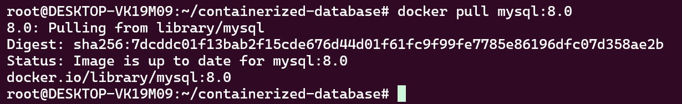

# docker volume create mysql_data
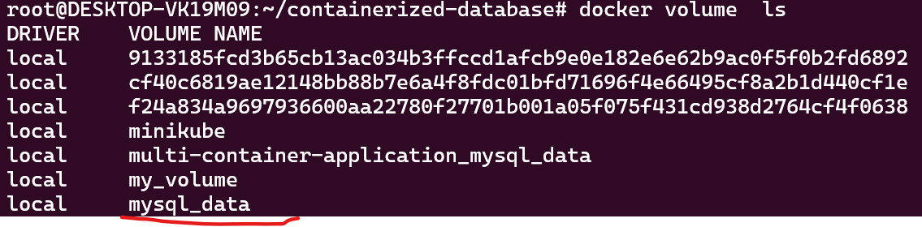

Step 3: Run the MySQL Container
docker run -d --name mysql-db -e MYSQL_ROOT_PASSWORD=Password123 -e MYSQL_DATABASE=companydb -v mysql_data:/var/lib/mysql -p 3306:3306 mysql:8.0

Step 5: Connect to MySQL
docker exec -it mysql-db mysql -u root -p
Enter password:
Password123
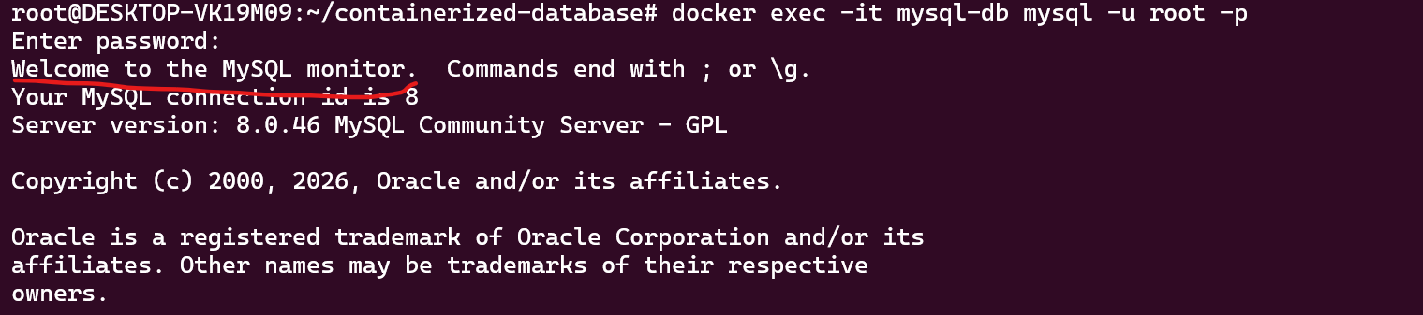

Step 6: Create a Table
USE companydb;

CREATE TABLE employees (
id INT PRIMARY KEY AUTO_INCREMENT,
name VARCHAR(100),
department VARCHAR(100)
);

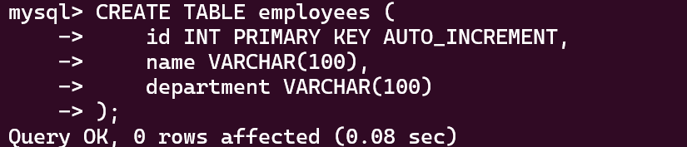

Step 7: Insert Data
INSERT INTO employees(name, department)
VALUES
('John', 'IT'),
('Alice', 'HR'),
('David', 'Finance');
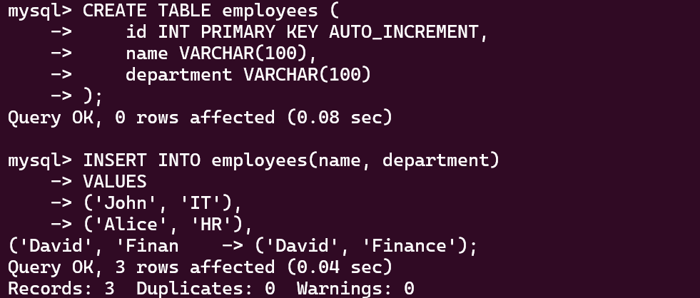

Step 9: Stop the Container
docker stop mysql-db
Docker is stopped but docker volume is still available.
#### Now as per the scenario recreate the docker container with the same name and check the volume data is persisted.
Here container stopped and re-create with same name as below.
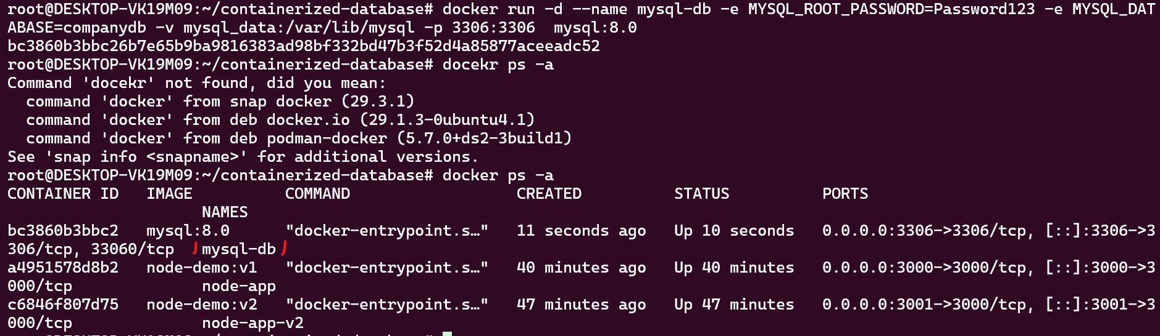
#Now check go to the my sql and check the available data again as inserted.
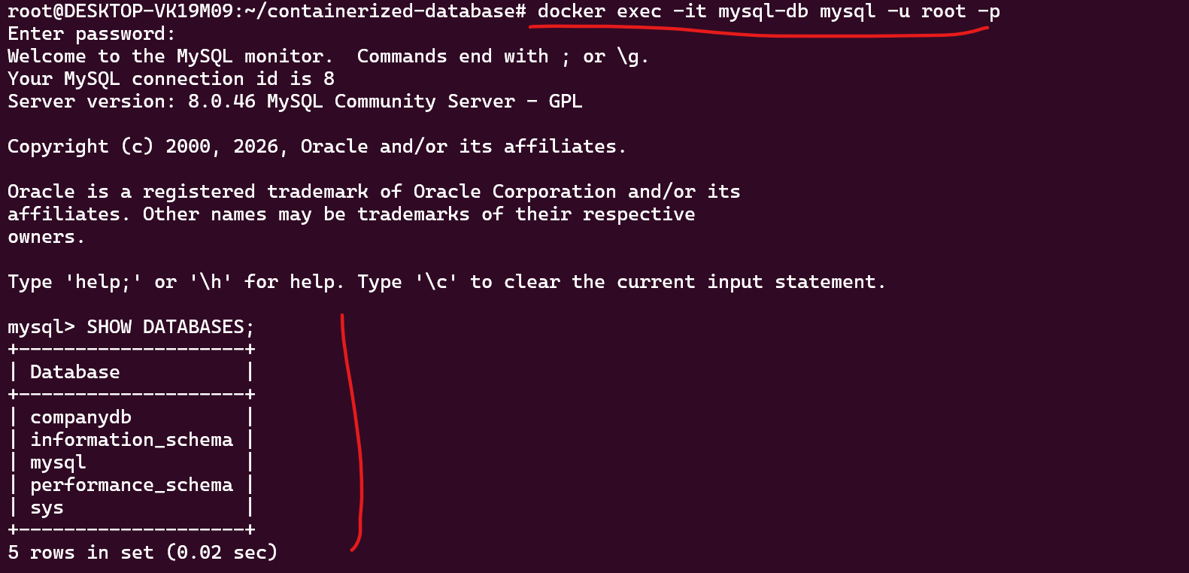
See the above data is available. This means the new started docker is using same data volume and have the old data.
============================================================
- Bind mount: Create a simple web application with a local directory containing HTML, CSS, and JavaScript files. Run a web server container (e.g., NGINX or Apache) and bind mount the local directory to the container's webroot. Verify that the web application is accessible and update the local files to see if changes are reflected in the container.

Objective
- Create a simple HTML/CSS/JavaScript website.
- Store the files on your local machine.
- Run an NGINX Docker container.
- Bind mount the local folder to the NGINX web root.
- Access the website in your browser.
- Modify the local files and verify that changes are reflected instantly.
#File structure
Create the following directory:
docker-bindmount-demo/
│
├── index.html
├── style.css
└── script.js

Step 1: Create index.html
<!DOCTYPE html>
<html lang="en">
<head>
<meta charset="UTF-8">
<meta name="viewport" content="width=device-width, initial-scale=1.0">
<title>Docker Bind Mount Demo</title>
<link rel="stylesheet" href="style.css">
</head>
<body>

<div class="container">
<h1>Docker Bind Mount Demo</h1>

<p>This website is running inside an NGINX Docker container.</p>

<button onclick="showMessage()">
Click Me
</button>

<h2 id="message"></h2>
</div>

<script src="script.js"></script>

</body>
</html>

Step 2: Create style.css
body{
margin:0;
font-family:Arial;
background:#f4f4f4;
}
.container{
width:60%;
margin:100px auto;
text-align:center;
background:white;
padding:40px;
border-radius:10px;
box-shadow:0 0 10px gray;
}

button{
padding:12px 25px;
font-size:18px;
background:green;
color:white;
border:none;
cursor:pointer;
}
button:hover{
background:darkgreen;
}

Step 3: Create script.js
function showMessage(){

document.getElementById("message").innerHTML =
"Congratulations! Your website is running from Docker using a Bind Mount.";
}

root@DESKTOP-VK19M09:~/docker-bindmount-demo# ls -l
total 12
-rw-r--r-- 1 root root 546 Jul 25 08:01 index.html
-rw-r--r-- 1 root root 150 Jul 25 07:51 script.js
-rw-r--r-- 1 root root 425 Jul 25 07:51 style.css

Steps 4: Pull NGINX image

docker pull nginx:latest
Verify:
docker images

#docker images
nginx:latest 5a88c9c45479 241MB 66MB
Sterps 6 start the docker nginx:latest
# docker run -d --name mywebsite -p 8080:80 -v $(pwd):/usr/share/nginx/html nginx:latest

Steps 5 Test the file
http://localhost:8080
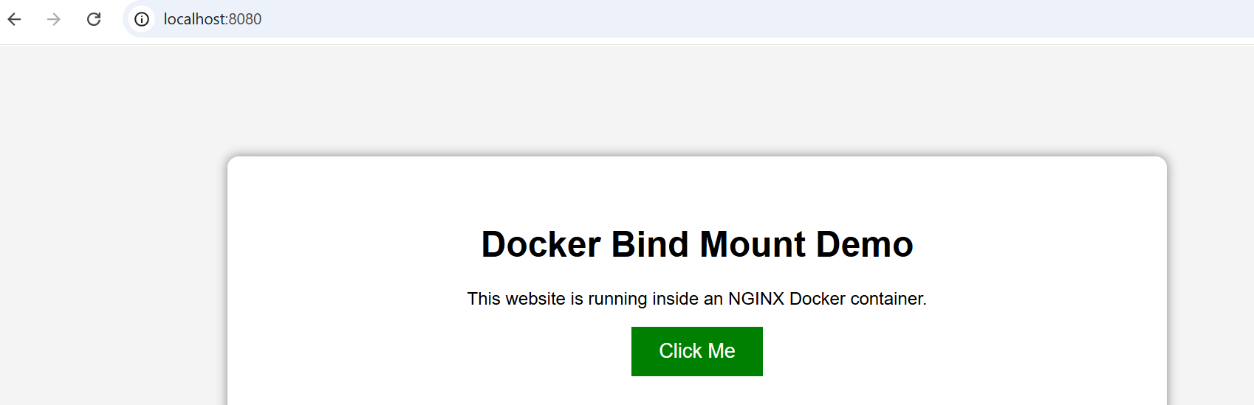
docker inspect mywebsite

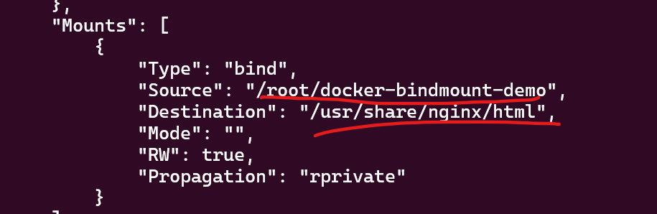

Steps 5 Update local files to get the changes reflects
Open index.html
Change
<h1>Docker Bind Mount Demo</h1>
to
<h1>Welcome to My Updated Docker Website</h1>
Also update the paragraph:
<p>
This page was updated without rebuilding the Docker image.
</p>
Save the file.
Step 6: Refresh Browser
http://localhost:8080
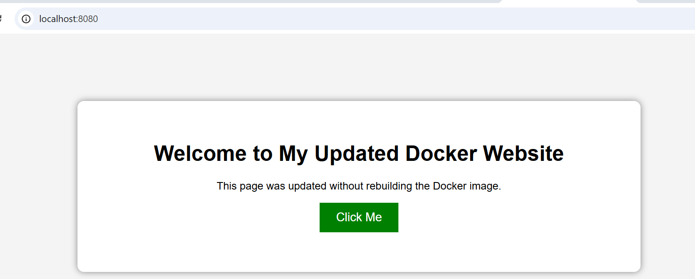

Here no need to restart once the changes done to because it is reading the file directly.
============================================================
- Volume backups: Using a container with a named volume, create a backup of the volume's data by either exporting it as a tarball or copying the data to a host directory. Restore the data to a new container and verify that the restoration was successful.
#Break the the question.
* Create a named volume
* Create a container app1 and Store data in the volume
* Verify Data
* Back up the volume as a .tar file
* Restore the backup into a new volume
* Launch a new container using the restored volume
* Verify that the data has been restored successfully

• Create a named volume
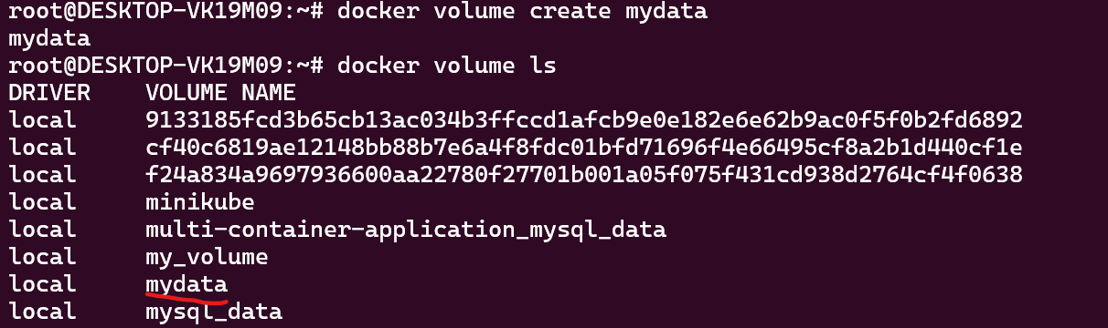

Create a container app1 and Store data in the volume, Storing data inside volume

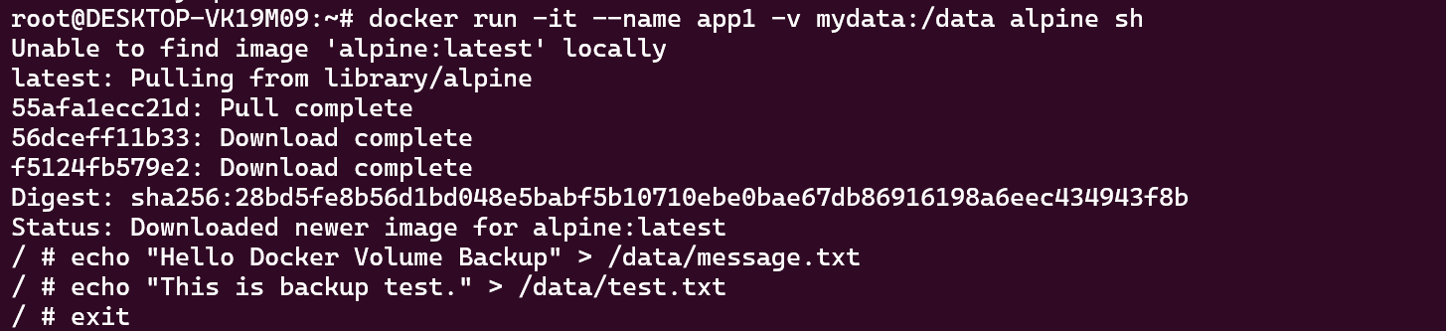

- Verify Data

- Back up the volume as a .tar file
# mkdir backups

Run a temporary container to create a tar archive.
# docker run --rm -v mydata:/volume -v $(pwd)/backups:/backup alpine tar czf /backup/mydata-backup.tar.gz -C /volume .

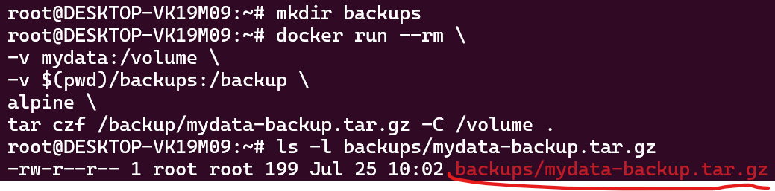

Create a new Volume to restore the data
# docker volume create restoreddata
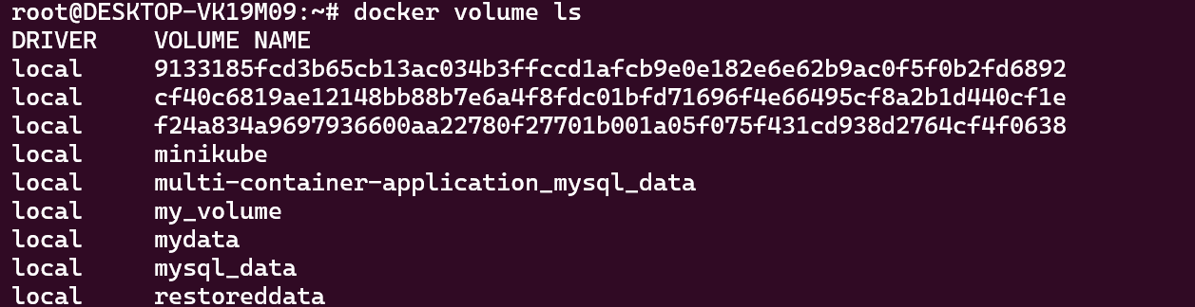

* Restore the backup into a new volume
#docker run --rm -v restoreddata:/data alpine sh -c \ 'echo "<h1>Backup Restored Successfully</h1>" > /data/index.html'

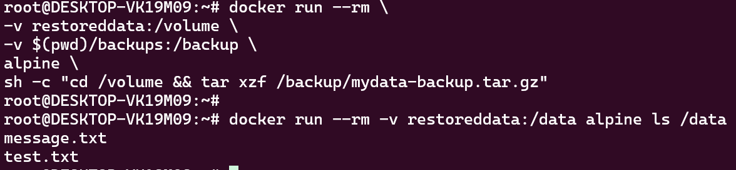

============================================================
- Docker Compose networking: Create a Docker Compose file that defines a multi-container application with a frontend, backend, and database. Set up custom networks and volumes for the services and ensure that they can communicate with each other and store data persistently
A Student Record Application/ Application consist of below
Frontend: nginx
Backend: flask
DB: MySQL
Network: custom bridge network
Volume: Named volume for persistent MySQL data
#mkdir student-app/
1: docker-compose.yml
version: "3.9"

services:
frontend:
image: nginx:latest
container_name: student-frontend
ports:
- "8080:80"
volumes:
- ./frontend:/usr/share/nginx/html
depends_on:
- backend
networks:
- student-network

backend:
build: ./backend
container_name: student-backend
ports:
- "5000:5000"
environment:
DB_HOST: database
DB_USER: root
DB_PASSWORD: root123
DB_NAME: studentdb
depends_on:
- database
networks:
- student-network

database:
image: mysql:8.0
container_name: student-db
restart: always
environment:
MYSQL_ROOT_PASSWORD: root123
MYSQL_DATABASE: studentdb
ports:
- "3306:3306"
volumes:
- mysql-data:/var/lib/mysql
networks:
- student-network

volumes:
mysql-data:

networks:
student-network:
driver: bridge
2: frontend/index.html
#mkdir frontend/index.html
<!DOCTYPE html>
<html>
<head>
<title>Student Management</title>
</head>
<body>

<h1>Student Management System</h1>

<p>Frontend is running successfully.</p>

<p>Backend URL:</p>

<a href="http://localhost:5000">
Visit Backend
</a>

</body>
</html>

# 3: backend/Dockerfile
#mkdir backend/Dockerfile
FROM python:3.11-slim

WORKDIR /app

COPY . .

RUN pip install -r requirements.txt

EXPOSE 5000

CMD ["python", "app.py"]

4: backend/requirements.txt
#mkdir backend/requirements.txt
Flask
mysql-connector-python

5: backend/app.py
from flask import Flask
import mysql.connector
import os

app = Flask(__name__)

@app.route("/")
def home():

try:
conn = mysql.connector.connect(
host=os.environ.get("DB_HOST"),
user=os.environ.get("DB_USER"),
password=os.environ.get("DB_PASSWORD"),
database=os.environ.get("DB_NAME")
)

return "Backend Connected to MySQL Successfully!"

except Exception as e:
return "Database Connection Failed"

app.run(host="0.0.0.0", port=5000)

6: Build and Run
root@DESKTOP-VK19M09:~/student-app# pwd
/root/student-app
root@DESKTOP-VK19M09:~/student-app#
6: Build and Run
root@DESKTOP-VK19M09:~/student-app# pwd
/root/student-app
# docker compose up –build
8: Test the Application
Frontend
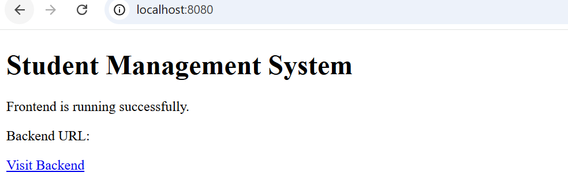
Backend

9: Verify Network
#docker network ls
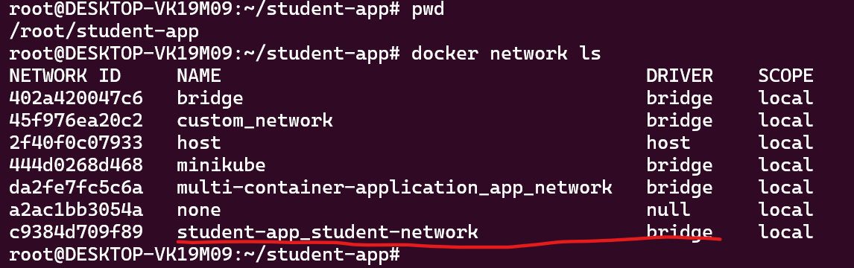
10: Verify Persistent Volume
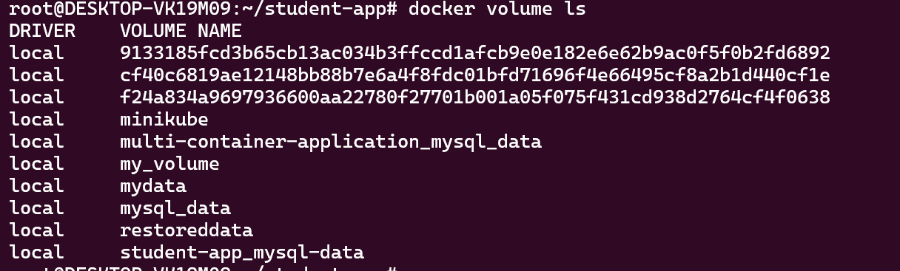
The MySQL data remains because it is stored in the named volume mysql-data.

