CLOUDETHIX
Que 1 →
● Create 2 Public Docker Hub registries named
cloudethix_master_nginx_yourname & cloudethix_release_nginx_yourname.

#cloudethix_master_nginx_qamre
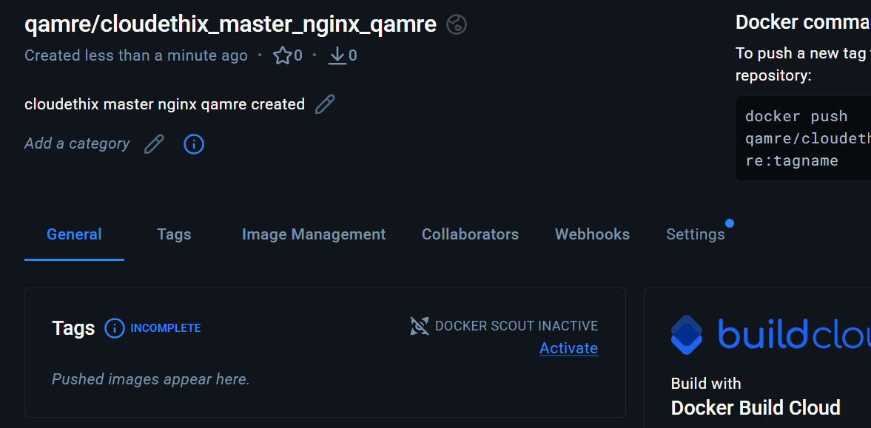
#cloudethix_release_nginx_qamre
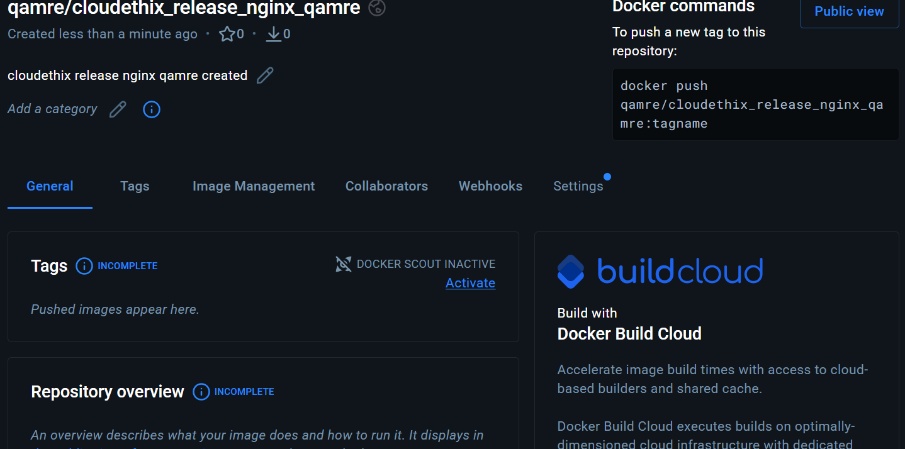

● Clone below repository on your system.
https://github.com/zembutsu/docker-sample-nginx.git
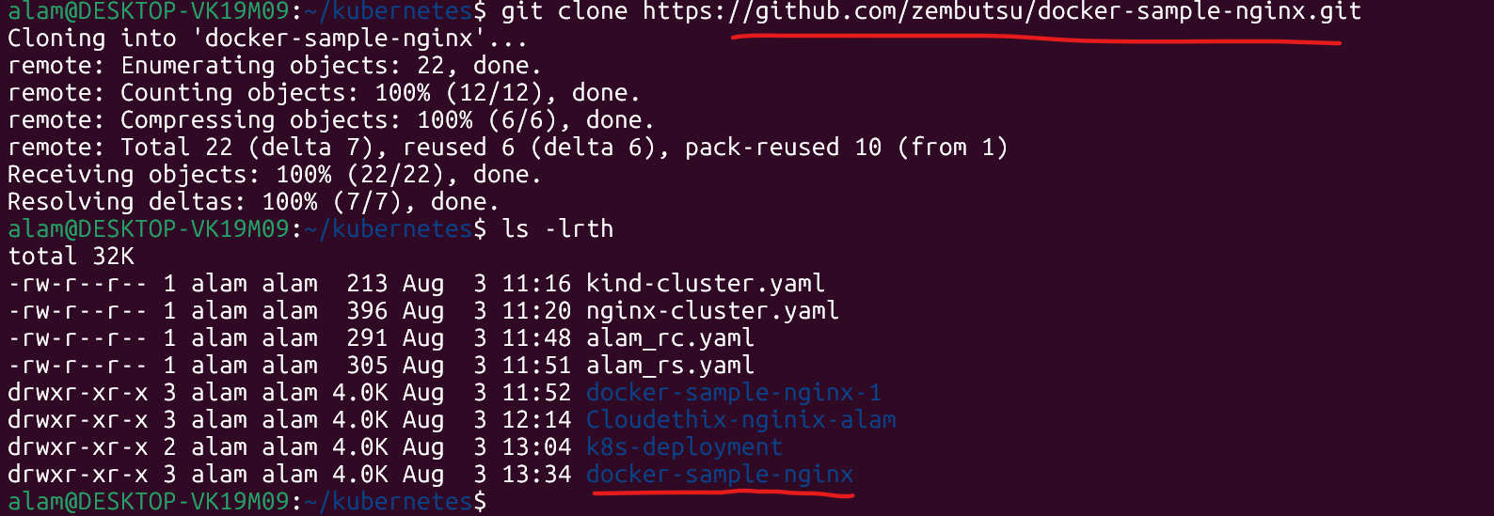

● Initialize a local repository & copy the code from above repo to your local
repository in master branch and then create below branches.
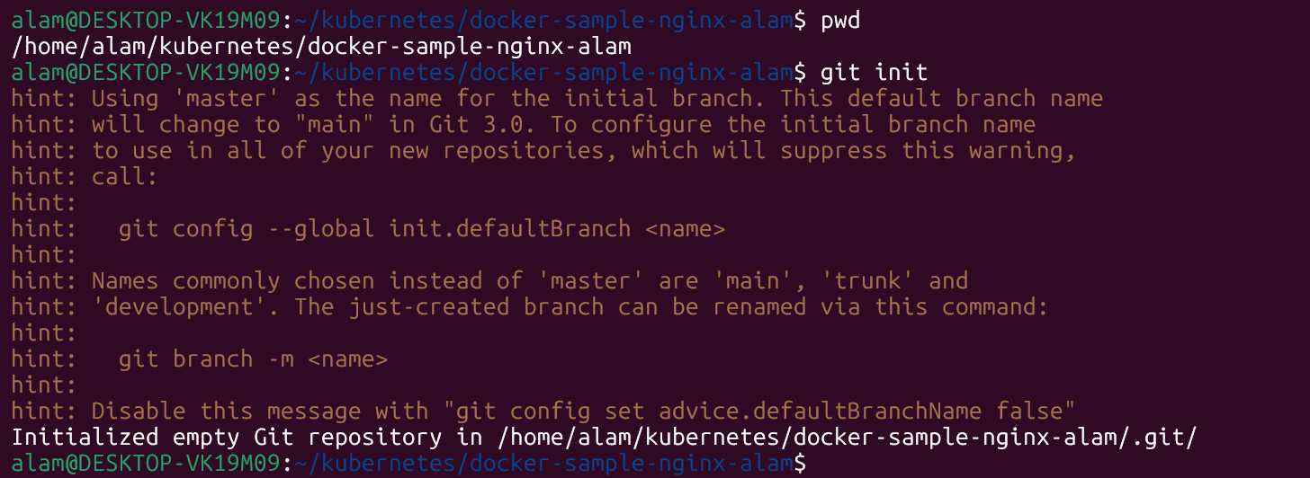
and then create below branches.
release
main
hotfix
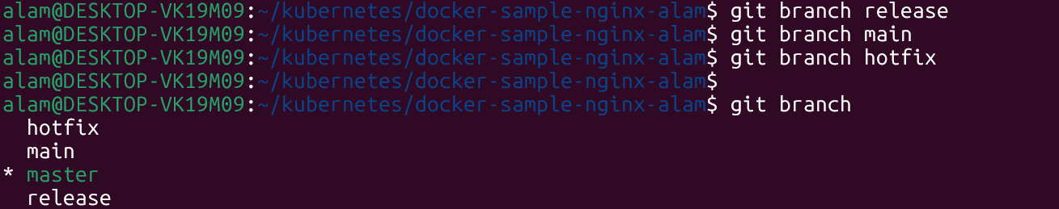

● Once code is copied to local repository,from master branch update the
index.html and add word "Cloudethix Master Branch Nginx"
and build the docker image & add meaningful tags and push to Docker Hub registry
cloudethix_master_nginx_qamre.

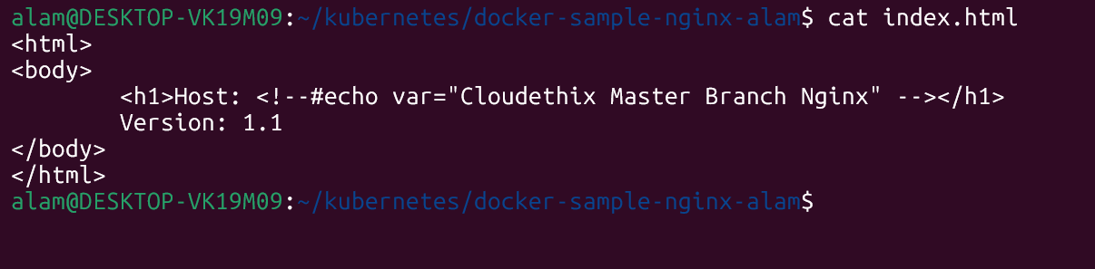

and build the docker image & add meaningful tags
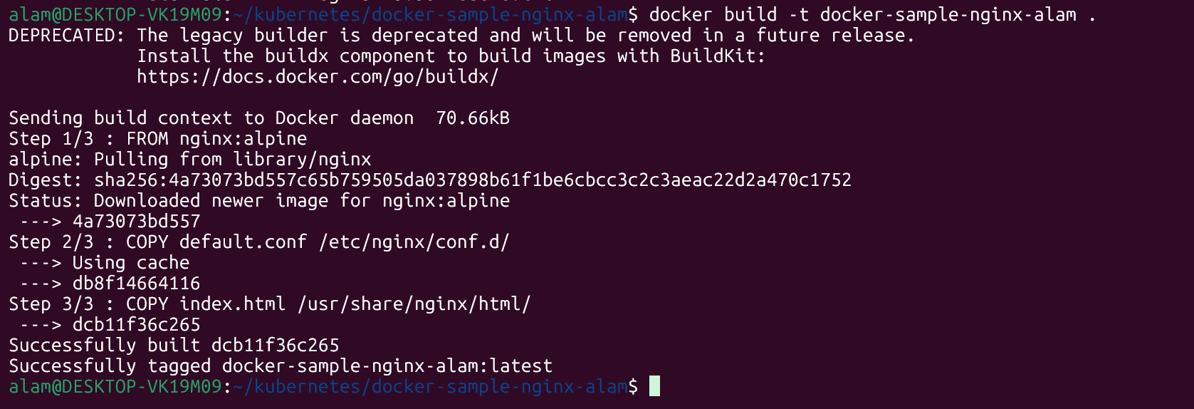

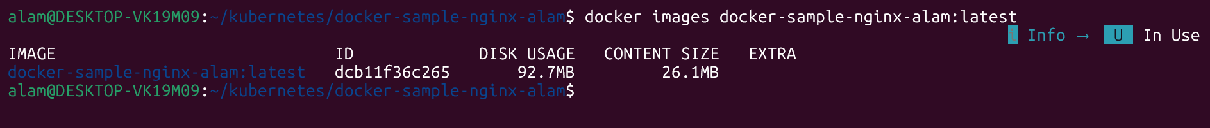

and push to Docker Hub registry cloudethix_master_nginx_qamre.
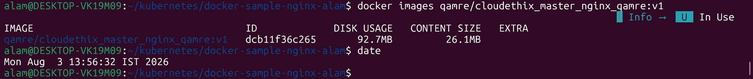

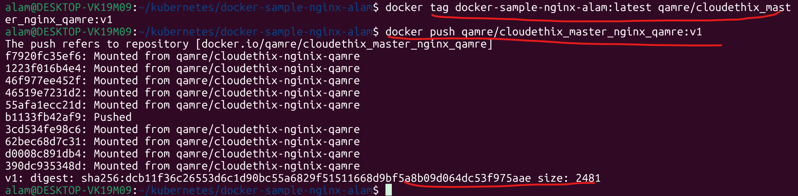

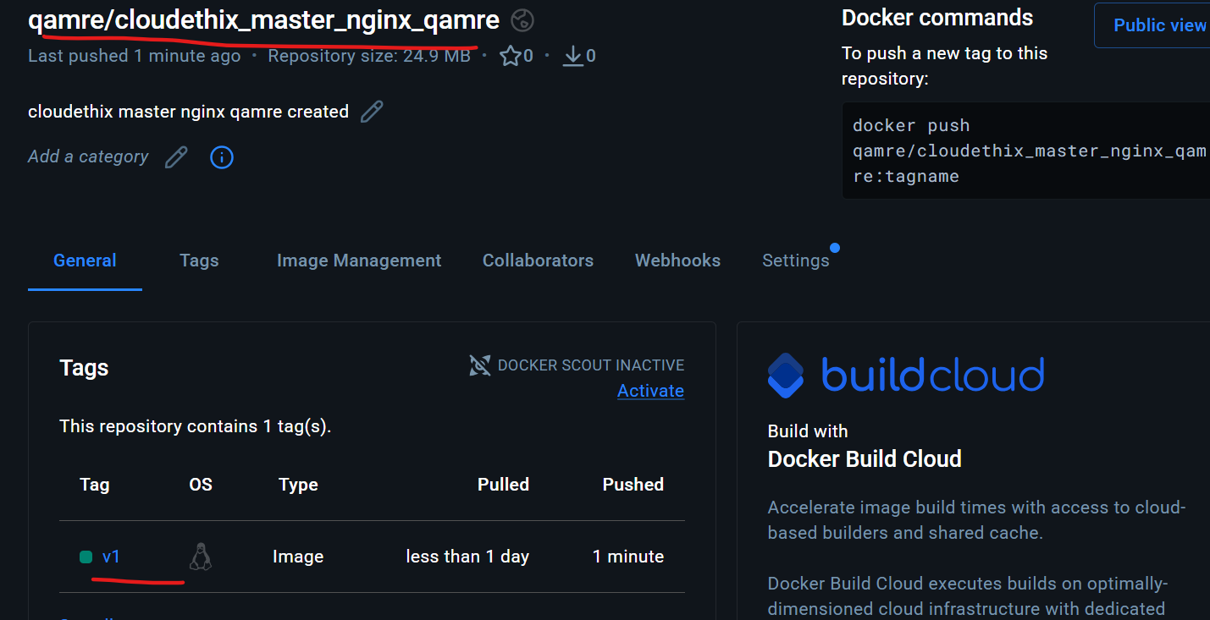

● Also from release branch update the index.html and add word "Cloudethix
Release Branch Nginx" and build the docker image & add meaningful tags
and push to Docker Hub registry cloudethix_release_nginx_yourname.
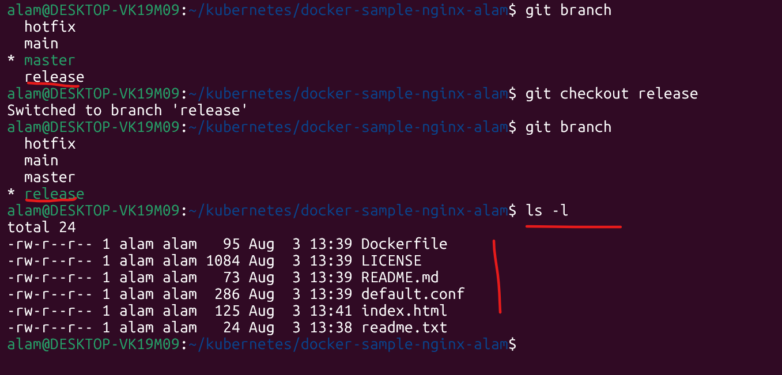

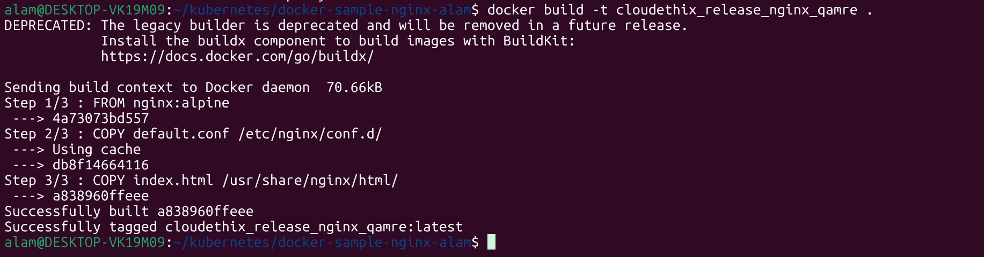

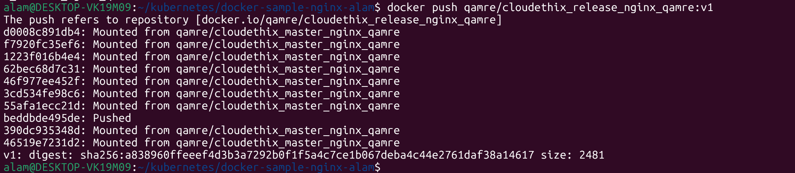

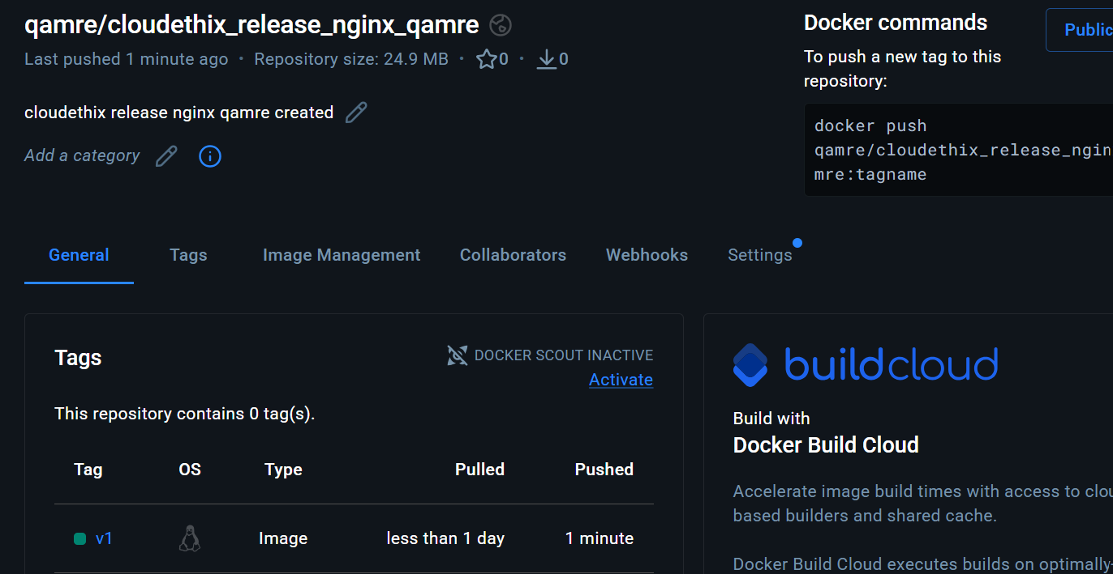

● Once Images are copied to Docker hub registries, switch to the main
branch.
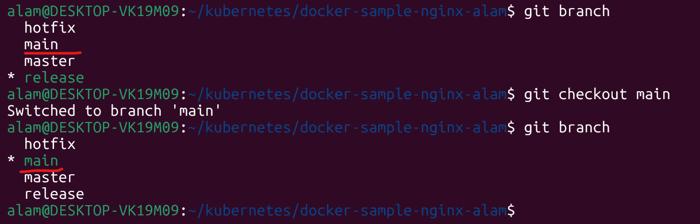

● In main branch create directory named kube/clusterIP & inside kube
directory create file named master_pod.yaml with pod name master_nginx &
with label master_nginx & add image that you have pushed in Docker Hub
registry cloudethix_master_nginx_yourname.

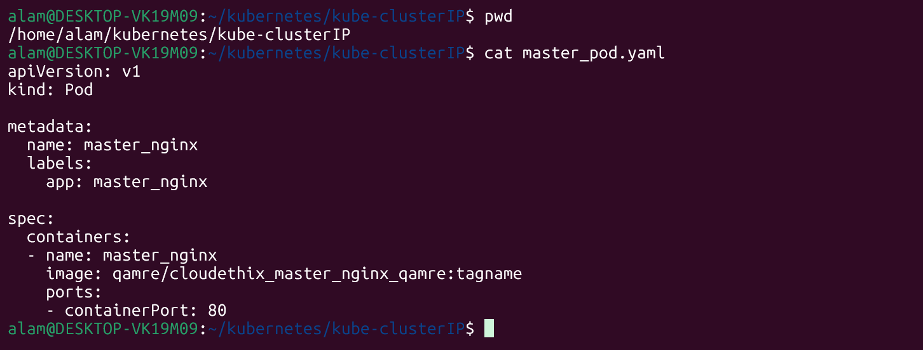
● Also create a file release_pod.yaml with pod name release_nginx & with
label release_nginx & add image that you have pushed in Docker Hub
registry cloudethix_release_nginx_yourname.
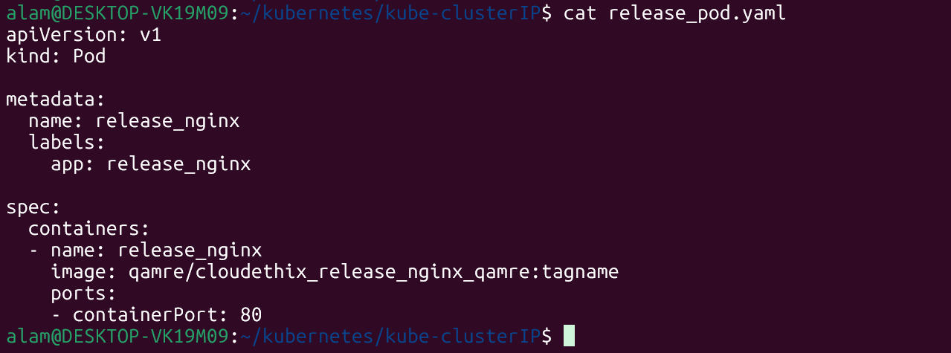

● Create a file called cluster_ip-service.yaml with service name
cloudethix_clusterip and with Type clusterIP.
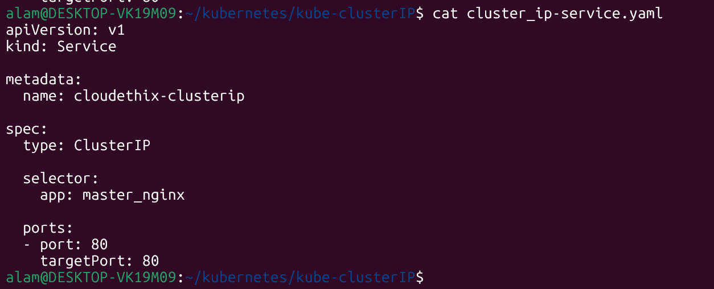

● Then, select the pod with label release_nginx in service.
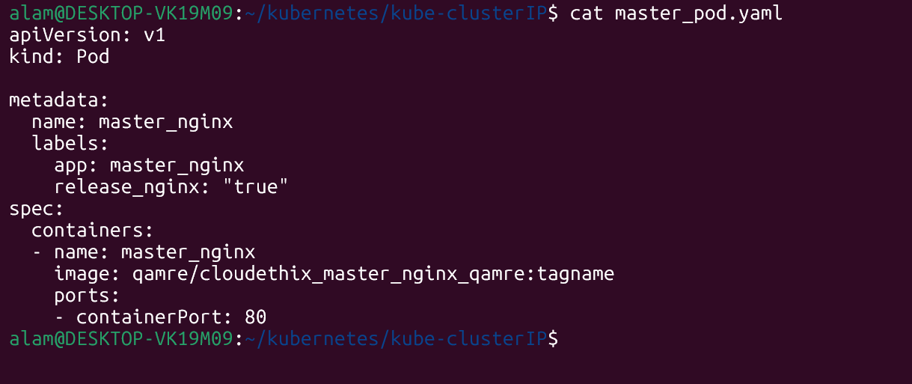

● Create all these three resources in your k8s cluster.

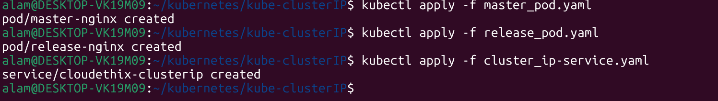

# kubectl get pods --show-labels
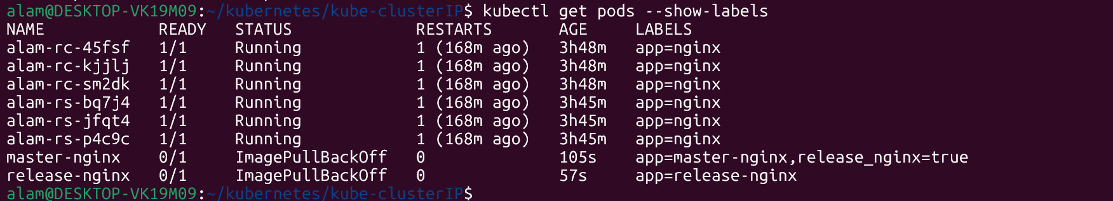

● Now, access master_nginx pod shell & curl the master_nginx pod & check
the result.

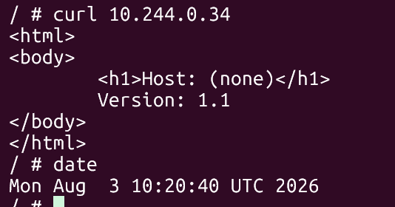

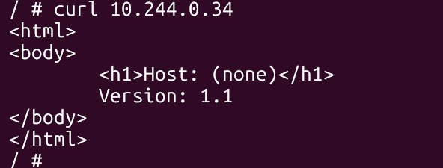

● Also try to curl release_nginx pod with DNS name & check the result.
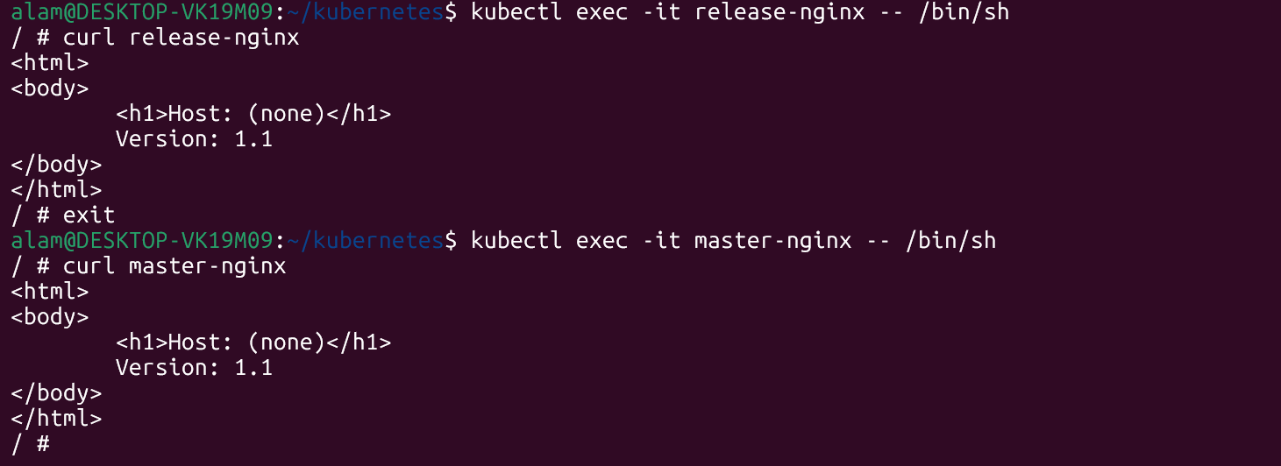

● Then curl the clusterip service with its name and check the result.
Run a temporary pod with curl installed:
# kubectl run curl-test --image=curlimages/curl -it --rm – sh You will get a shell inside the pod.
Tehn do curl
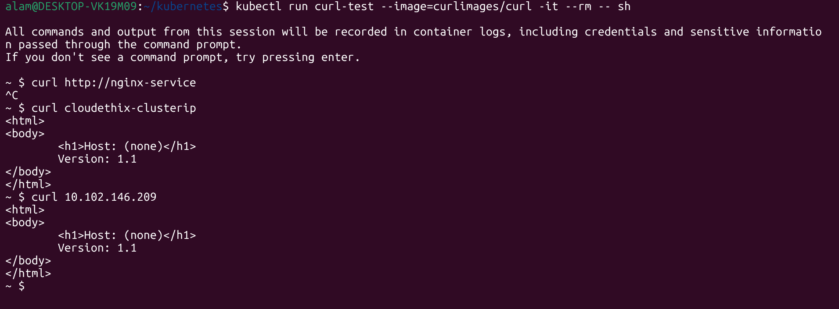

● Finally, create a GITHUB remote repository named
cloudethix-k8s-yourname and push all the branches to the remote
repository.
# Qamre/cloudethix-k8s-alam
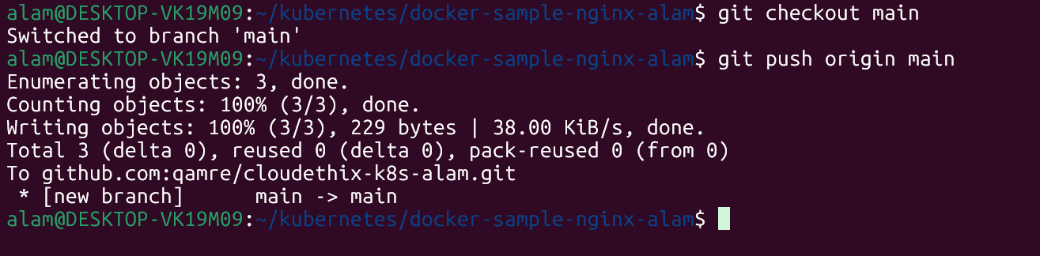

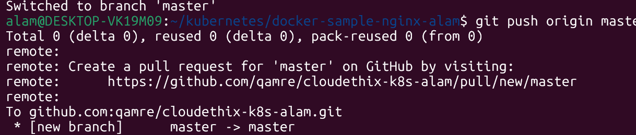

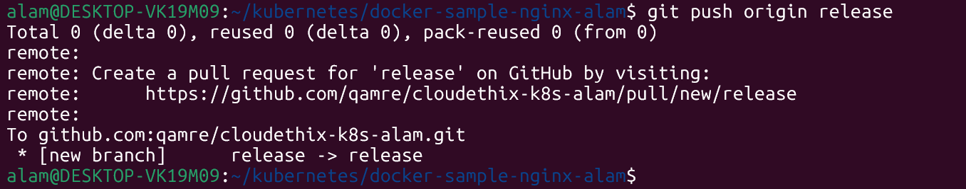

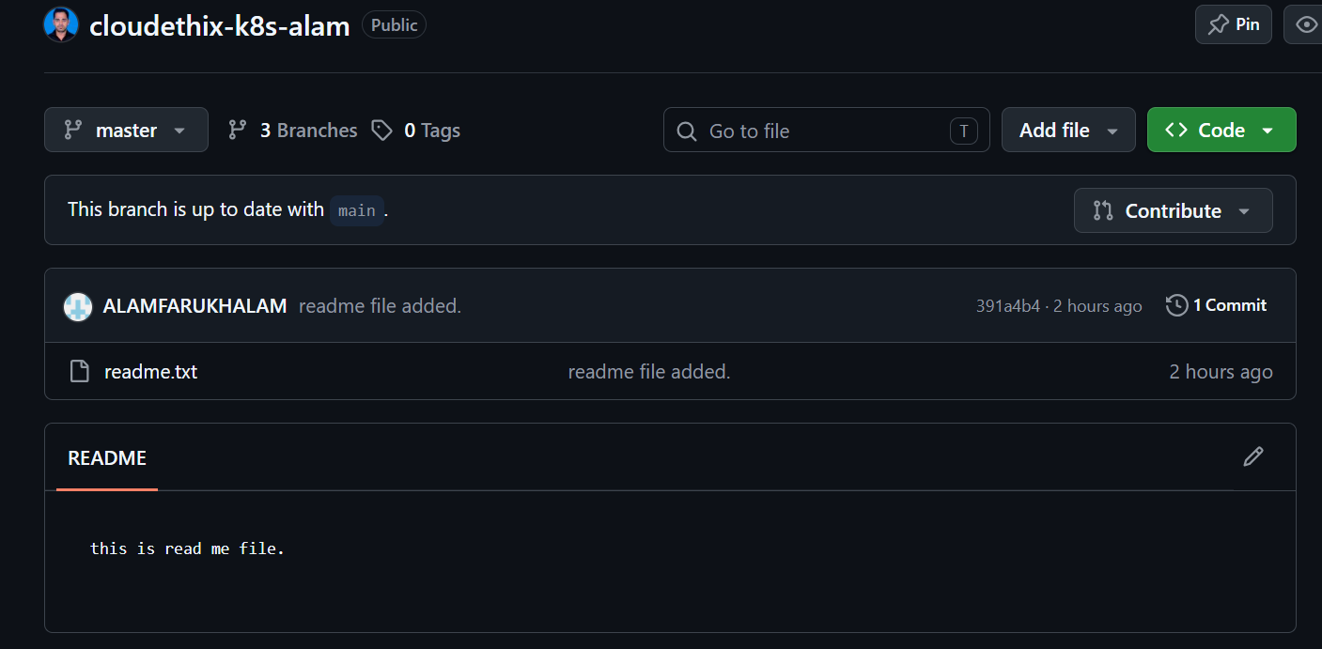

● Take all screenshots and create a well formatted document.
========================================================
Que 2 →
● In the main branch of your local repository create a directory
kube/NodePort.
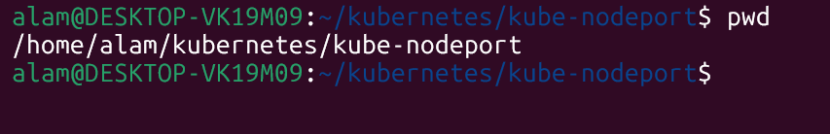

● Create below files from below url. Please make sure you will create
NodePort service with port 30008 instead of loadbalancer.
https://kubernetes.io/docs/tasks/access-application-cluster/connec
ting-frontend-backend
backend-deployment.yaml
backend-service.yaml
frontend-deployment.yaml
frontend-NodePort-service.yaml

● Once files are created , create all the resources in your k8s cluster.
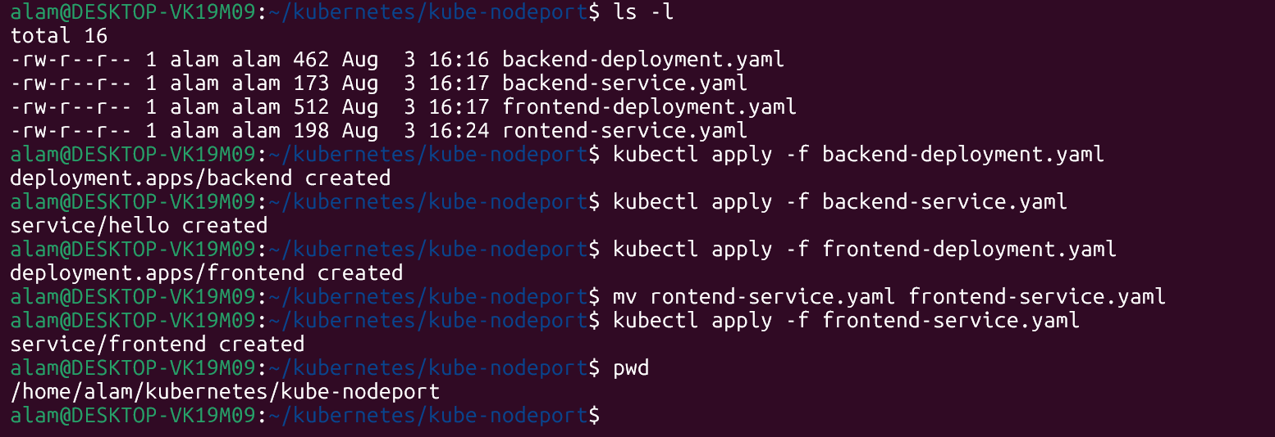

● Access all public ips with port 30008 in the browser and then check the
result.
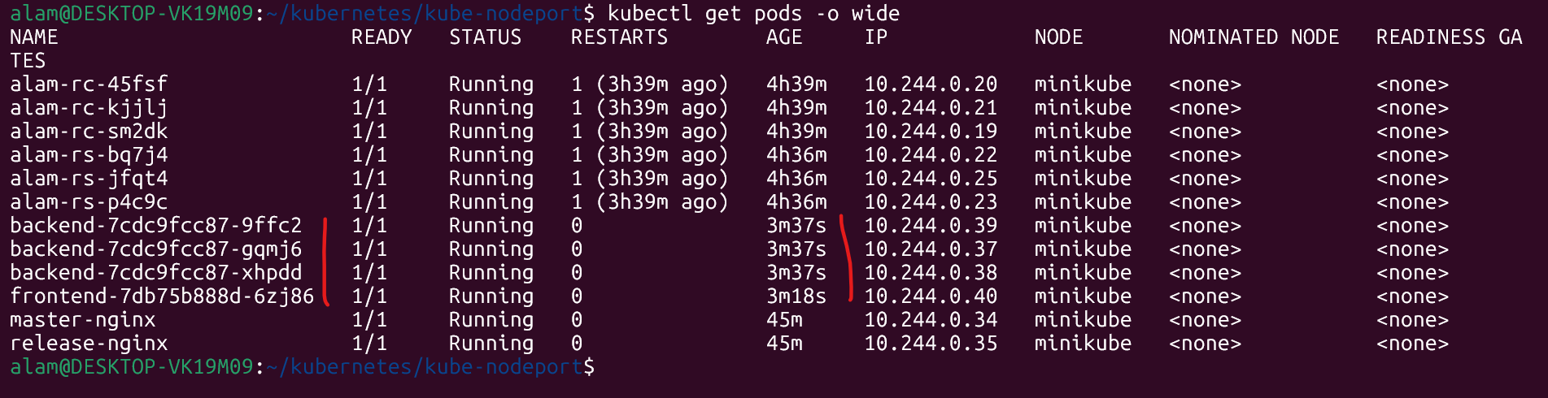

● Finally, push all the latest code to the remote repository.
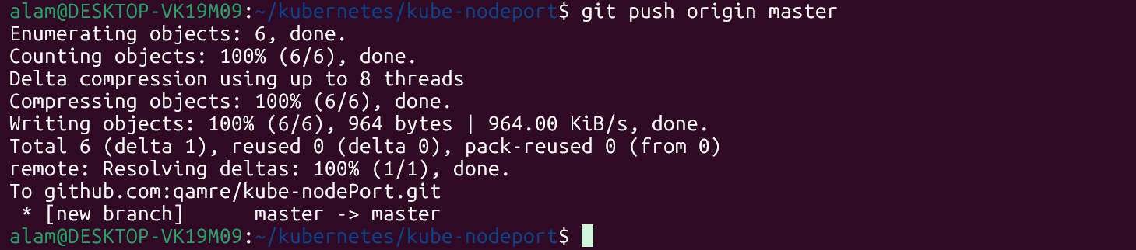

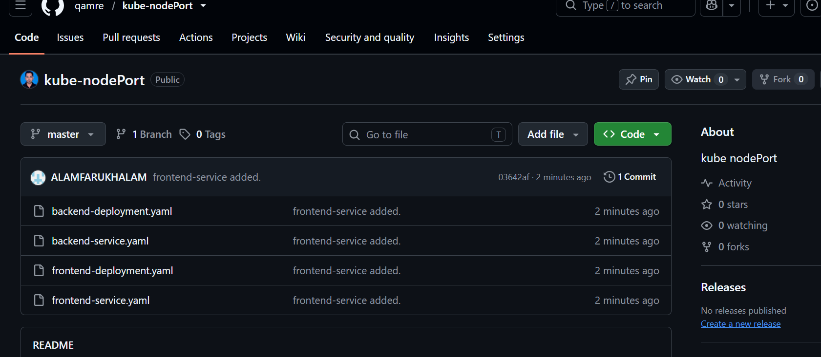

● Take all screenshots and create a well formatted document.
========================================================
Que 3 →
● Create any 2 pods and assign them to different worker nodes with
#nodeName property
apiVersion: v1
kind: Pod
metadata:
name: nginx-pod-worker0
spec:
nodeName: worker-0
containers:
- name: nginx
image: nginx:latest
---
apiVersion: v1
kind: Pod
metadata:
name: nginx-pod-worker1
spec:
nodeName: worker-1
containers:
- name: nginx
image: nginx:latest

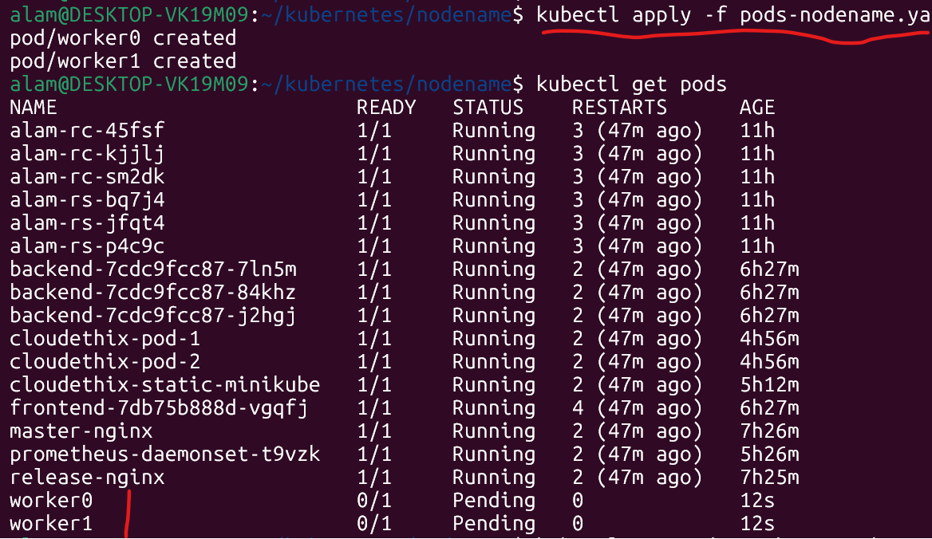

========================================================
Que 4 →
● Label both worker nodes such as worker-0 node as cloudethix-k8s-00 &
worker-1 node as cloudethix-k8s-01.

kubectl label nodes worker0 node-name=cloudethix-k8s-00
kubectl label nodes worker1 node-name=cloudethix-k8s-01

# pods-nodename.yaml
apiVersion: v1
kind: Pod
metadata:
name: cloudethix-k8s-00
spec:
nodeName: worker-0
containers:
- name: nginx
image: nginx:latest
---
apiVersion: v1
kind: Pod
metadata:
name: cloudethix-k8s-01
spec:
nodeName: worker-1
containers:
- name: nginx
image: nginx:latest

● Once nodes are labeled, create pod00.yaml file and schedule the pod on
worker-0 node with nodeSelector property. Also create one more file named
pod01.yaml & schedule the pod on worker-1 node.

# schedule
/home/alam/kubernetes/schedule

========================================================
Que 5 →
● Clone the below repo locally & create DaemonSet from directory
DaemonSet101.
https://github.com/collabnix/kubelabs
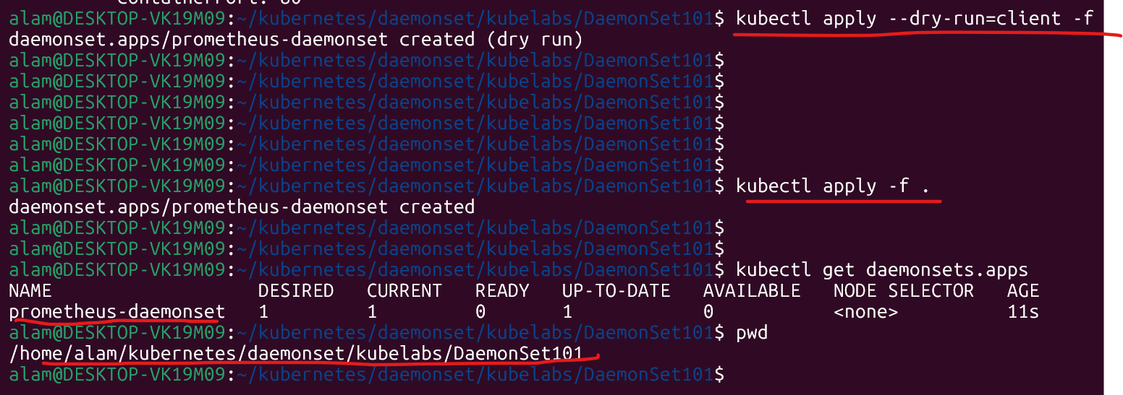
======================================================
Que 6 →
● Create a static pod with name cloudethix-static in your k8s cluster. Refer
below link.
https://kubernetes.io/docs/tasks/configure-pod-container/static-po
d/
#for the static pods choose a specific node to run the static-pods soon as below.

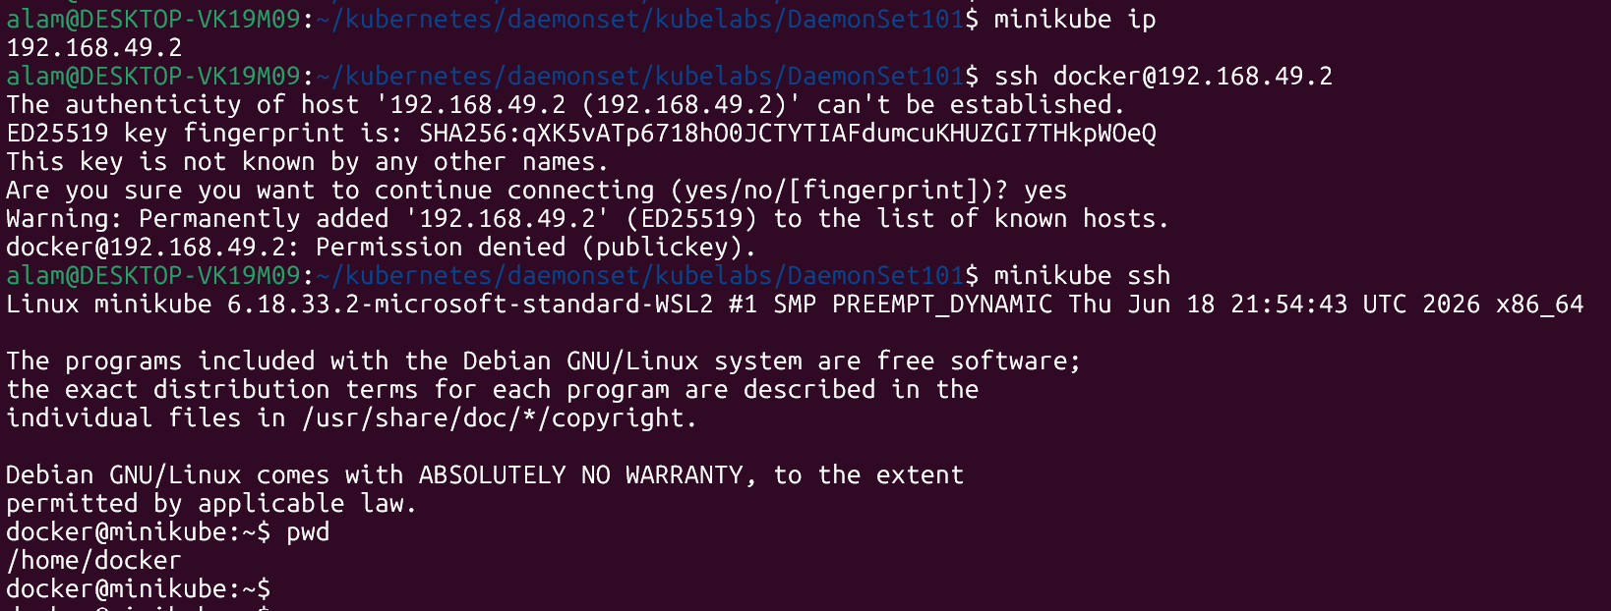
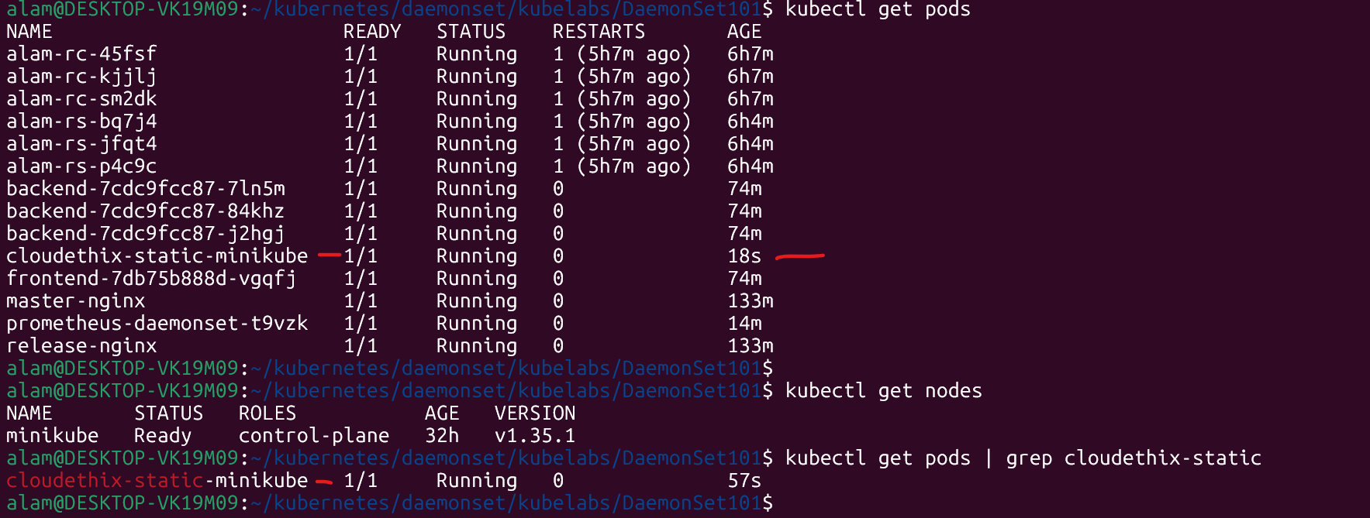

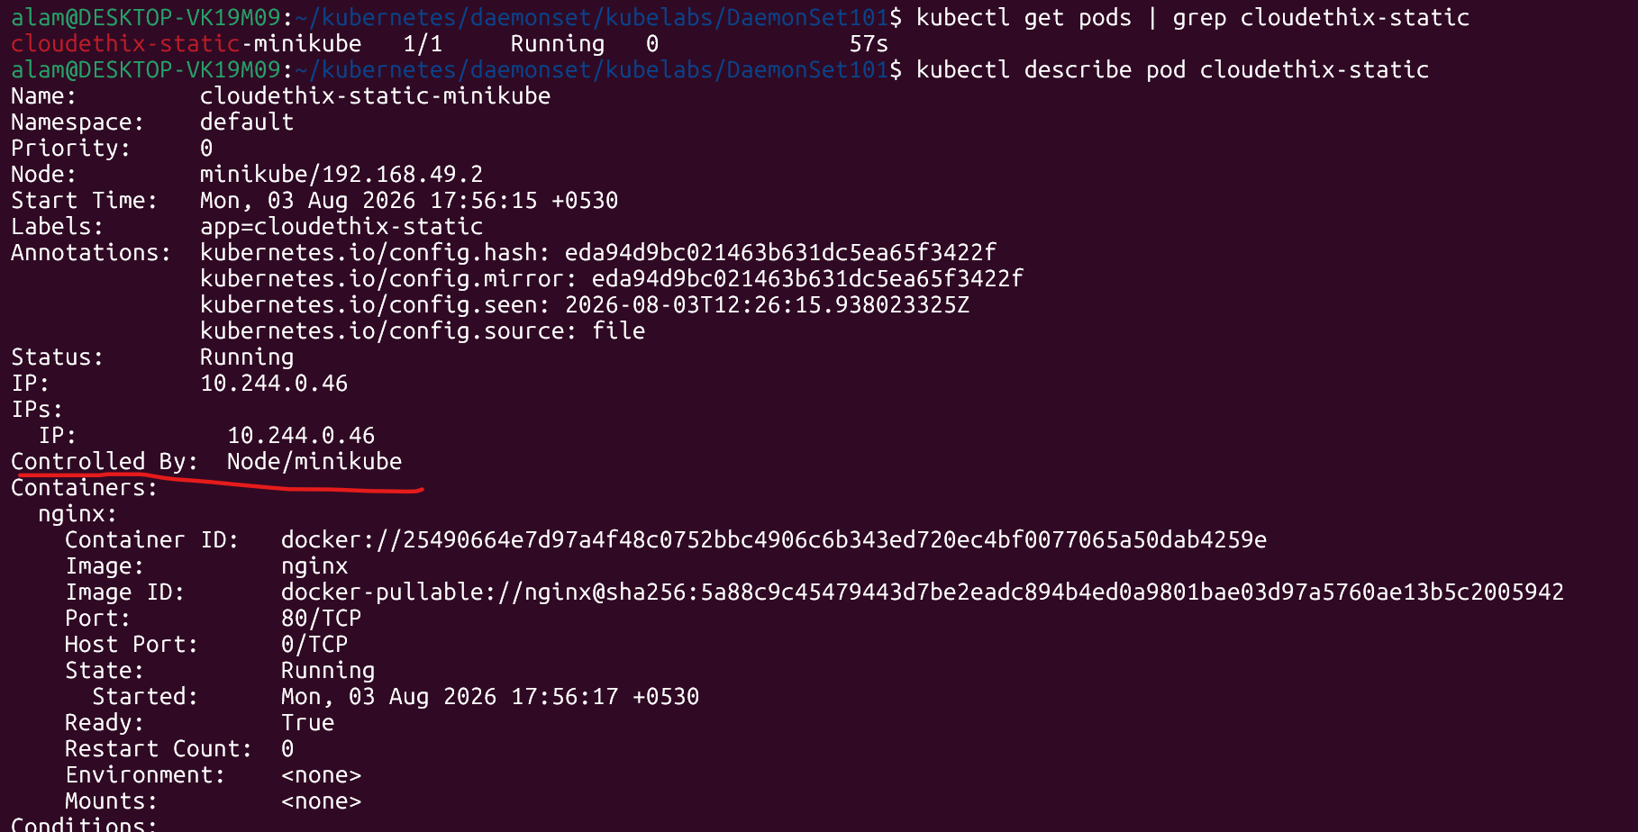

======================================================

Que 7 →
● Install Kubectx & kubens in your k8s cluster.
