Test Account :

<http://1987secondhand.cusc.vn/master>

Account: admin123

Password: 123123

* Update, insert, delete database.
* Database management.
* Can login and use all client features.

<http://1987secondhand.cusc.vn/>

Account : anhdao

Password: 123123

* Profile management like change password, update profile, order detail.
* Go shopping, Add to cart.

\*Note:

* If you want to delete the product you must delete the image first

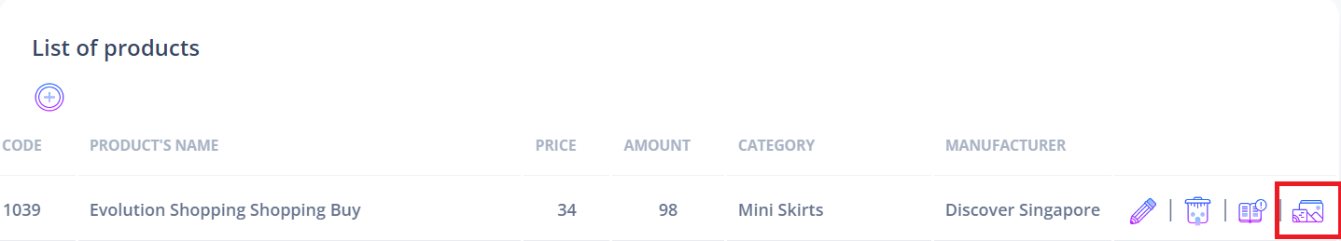

When you click icon, you can insert, update and delete image product