|  |  |  |
| --- | --- | --- |
|  |  |  |
| **CAN THO UNIVERSITY SOFTWARE CENTER**  **MEKONG DELTA - APTECH** |

**TECHWIZ 3**

**Thrift Fashion Web  
Application**

|  |  |
| --- | --- |
| **Instructor:** | **Class: CP2296F02** |
| Ms. Linh Ong Thi My | **Team: New Bie** |
| **Students:**  1. Student1263166 - PHAM QUOC ANH  2. Student1200556 - PHAM THANH DUY  3. Student1276235 - TRANG ANH KHOA  4. Student1276701 - LE THI THUY TRANG |

Can Tho, 15 August 2022

**PROBLEM DEFINITION OF PROJECT**

People often discard clothing items when they are no longer in use. They buy clothing from malls, online retail stores, or regular neighborhood stores and later, when these clothes  
outgrow their utility, they throw them away or dump them in bins. This has even happened  
in the case of high cost clothing. People who can afford expensive fashion typically do not like to repeat their outfits. They move on to buy newer items barely after using current items on two or three occasions. The older ones are then just discarded. This causes burden on the planet because as the number of such discarded fashion (which is still in good condition, nevertheless) increases, the effort to dispose them also increases. These days, recycling, sustainability, and reuse are not just buzzwords, but actionable behaviors to support a better planet. Instead of discarding clothes that are still in good condition, but no longer required by the original buyers, these clothes can be sold as thrift fashion or pre-used clothing. In simple terms, shopping for thrift fashion is second hand purchases for fashionable clothing. This supports the theme of recycling and sustainability and is also affordable by many who could not purchase new fashionable clothing.

**Proposed Solution**

The proposed solution is a Web application titled **ThriftFashion**. It should help individuals with online shopping for pre-used fashionable clothing and provide better access to such products. Users can browse for products, search, filter, and so on. submit their feedback regarding the application using a feedback form. You have been given a contract to design and build this e-commerce based Web application.

**Design specifications**

**Hardware**• Intel Core i5 Processor or higher  
• 8 GB RAM or above  
• Color SVGA  
• 500 GB Hard Disk space  
• Mouse  
• Keyboard  
**Software**• **Frontend**: HTML5, CSS3, Bootstrap, JavaScript, jQuery, AJAX.  
• **Back-end**: Java 8, Spring Boot, JPA.  
• **Database**: SQL Server

**Database Diagram**

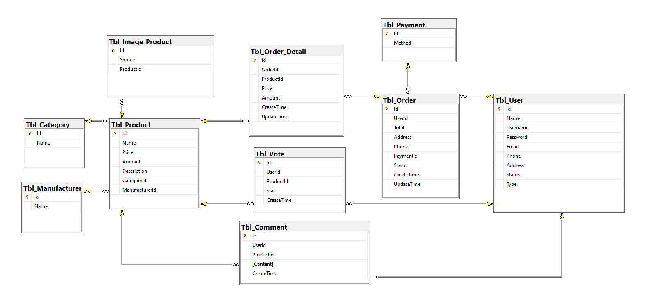

**Site Map**

