**Task 1**

**Login to CleanBooks: The ability to be authenticated by the system as being a valid user of the system.**

User Interface:

h2. User Interface:

!WP_LoginUser.png|thumbnail!

Figure 1: Login

The elements of the interface are as follows:

# _*The user id input box*_

The email address of the user is used as the User ID for logging into the system.

A value is required in this input box.

The value entered in this input box must be validated as being in an email format.

# _*The password input box.*_

The user enters her password into this box.

The password entered is masked.

A value is required in this input box.

# *_The Login Button._*

The user presses this button to submit the username and password to attempt to login to the system.

# *_The Forgot Password link._*

This link transfers the user to a page to deal with a forgotten password.

# *_The URL._*

The URL for displaying this page is

_Server_Web_Address/Home/Login_

h2. Approach:

* The functionality required for this feature is the standard ASP.NET authentication functionality.

* The functionality included in the existing application is to be used.

* The main work in this application is to update the existing login to use the new interface design.

* The user enters the email address in the first input box (1).

* On exiting the email address input box, the system checks that a value has been entered. If a value has not been entered a validation error is shown to the right of the input box to indicate that a value is required.

* If a value has been entered into the email input box, the value entered is validated as being a valid email address. If it is not, then a validation error is shown to the right of the input box.

* The user enters a password in the password input box (2).

* On exiting the password input box, the system checks that a value has been entered. If a value has not been entered a validation error is shown to the right of the input box to indicate that a value is required.

* The user clicks on the Login button (3).

* The system checks that the email combined with the password is linked to a user in the system.

* When a user is found that corresponds to the login information entered the dashboard page of the application is displayed.

* The URL for the dashboard page is

_Server_Web_Address/Home/Dashboard_

* If a user is not found the system displays an error message to indicate that no user was found with the credentials entered and asks the user to try again.

* If the user cannot remember his password, he clicks on the Forgot Password (4) link and is redirected to a page to deal with the issue.

The URL for the Forgot Password functionality is

_Server_Web_Address/Account/ForgotPassword_

h2. Acceptance:

The following are the tests to be carried out on the Login:

* Enter a correct user name and password in the system.

Can the user login?

* Click in the email input box.

Exit the input box without entering any data.

Does the validation error display, indicating that an email address is required?

* Enter an incorrectly formatted email address in the email input box.

Exit the email input box.

Does the correct email validation error display?

* Click in the password input box.

Exit the input box without entering data.

Does the validation error, indicating that a password is required, display?

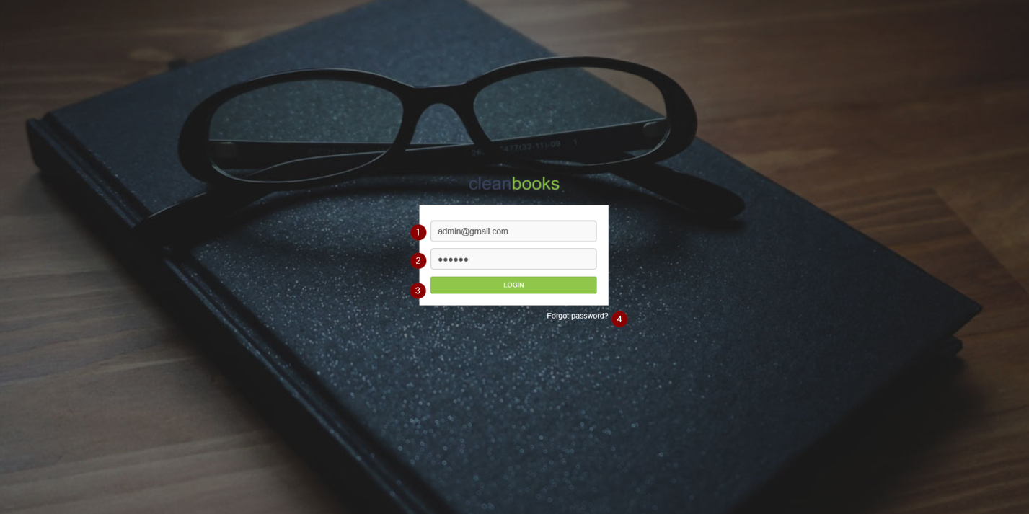

**Task 2**

**Master Page: The master page for the application showing the menus and headings to be displayed on each page in the application.**

h2. User Interface:

!WP_MasterPage.png|thumbnail!

_Figure 1: Master Page_

The elements of the interface are as follows:

# *The logo.*

The CleanBooks logo is displayed in the top left corner of the interface.

Clicking on the CleanBooks logo on any page in the application brings the user back to the dashboard page. (_Server_Web_Address/Home/Dashboard_)

# *Left Screen Menu Toggle*.

If the menu on the left of the screen is fully expanded to show the menu item text, then clicking on this icon collapses the menu on the left of the screen to show only the menu icons. If the menu icons only are showing, then the clicking on the toggle icon will expand the menu to show the menu item text.

# *Dashboard Menu Item*

This will display the Dashboard page.

Not implemented in this work package.

# *Administration Menu Separator*

This is a heading for the subsequent menu items

# *Accounts Menu Item*

This will display the accounts page.

_{color:red}Not implemented in this work package{color}_

# *Transactions Menu Item*

This will display the transactions page.

{color:red}_Not implemented in this work package_{color}

# *Reconciliation Tasks Item*

This will display the reconciliations tasks page.

{color:red}_Not implemented in this work package_{color}

# *Projects Menu Item*

This will display the projects page.

{color:red}_Not implemented in this work package_{color}

# *Users Menu Item*

This will display the Manage Users page. _Server_Web_Address/Administration/ManageUsers_

Please see the Manager Users work package.

# *Permissions Menu Item*

This will display the permissions page.

{color:red}_Not implemented in this work package_{color}

# *CleanBooks Menu Separator*

# *Data Manager Menu Item*

This will display the transactions page.

{color:red}_Not implemented in this work package_{color}

# *Reconciliation Tasks Menu Item*

This will display the reconciliation sub task menu items.

_{color:red}Not implemented in this work package{color}_

# *Projects Menu Item*

This will display the projects page.

_{color:red}Not implemented in this work package{color}_

# *Reports Menu Item*

This will display the reports page.

_{color:red}Not implemented in this work package{color}_

# *Account Management link*

Clicking on the Account Management link will display a reduced set of information about the logged in user as shown in *_Figure 2: Profile displayed from Account management_*.

This dialog is a modal dialog displayed on the client.

!WP_AccMgt_ProfileDialog.png|thumbnail!

_Figure 2: Profile displayed from Account management_

The elements of the profile dialog are as follows:

* *(1) Profile Picture*.

The profile picture of the currently logged user is displayed.

* *(2) User Name.*

The name of the currently logged user is displayed.

* *(3) Role.*

The role of the currently logged user is displayed.

* *(4) The My Profile button*.

This button displays a detailed profile of the currently logged in user as a modal dialog that can be edited by the user.

* *(5) The Logout button.*

The logout button will log out the currently logged in user and display the login page for the application *_Server_Web_Address/Home/Login_*.

h2. Approach:

The master page is a new part of the system. The existing system had a drop down menu bar but this has been rationalized into a compact side menu.

* The master page menu structure will surround each page in the application.

* In this work package only the menu items indicated in the User Interface section will be implemented. Later work packages will require the implementation of more menu items.

* The style and design of the master page will be taken from the new user interface design.

The design folder contains a set of PHP, CSS and other files that have been used to model the user interface for the new application. These files will be converted as required into the views and partial views to be used in the ASP.NET MVC application.

* The left side menu style and design is in the _*inc/sidenav.inc.php*_ file in the design folder.

The top bar style and design of the master page, containing items 2 & 16 on Figure 1, is in the _*inc/head.inc.php*_ file in the design folder.

The footer for the master page is in the _*inc/footer.inc.php*_ file in the design folder.

h2. Acceptance:

The following are the tests to be carried out on the Master Page:

* Click on the Left Screen Menu Toggle (2).

Does the left menu collapse to show only the icons?

* Click on the Left Screen Menu Toggle (2) a second time

Does the left menu expand to full width?

* Click on the Users menu item

Does the Manage Users page display page display?

* Click on the Account Management link.

Does the basic Profile dialog appear?

Does the basic profile dialog show the correct profile picture, name and role for the currently logged in user?

* Click on the My Profile button.

Does the Edit My Profile dialog appear?

* Click on the Logout button.

Does the system log the user out and display the login page? 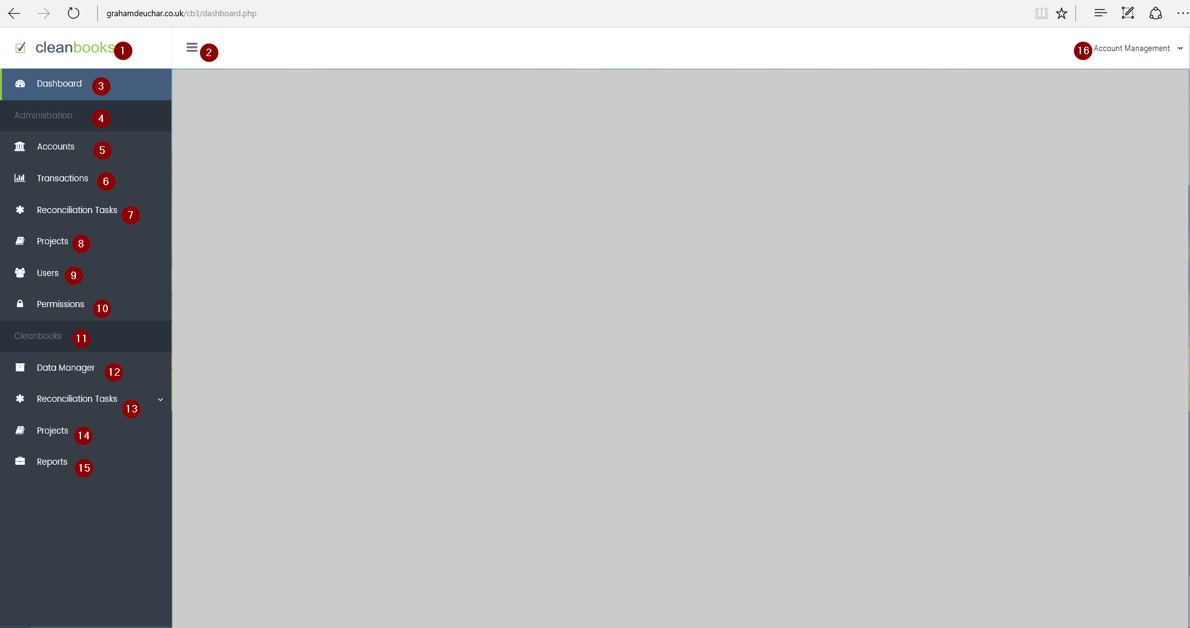

**Task 3**

**Manage Users: The ability to view and manage (add, edit & delete) the users in the system incorporating the new design**

* User Interface:
* Figure 1 shows the interface for managing the user in the system.
* !WP_ManagerUsers.png|thumbnail!
* _Figure 1: Manage Users dialog_
* The elements of the interface are as follows:
* # *The Add a User button.*
* This button will bring up a modal dialog for adding a user to the system.
* # *The Number of Entries per page drop down*.
* This drop down list will contain the values 10, 25, 50 & 100 where each number indicates the maximum number of users to be shown per page of users. Clicking on the drop down list and selecting a new value will cause the list of users to refresh to show a page with a list of users corresponding to the number selected.
* # *The Search control.*
* This will allow a user to search for users based on a full or partial name being typed in. If three or more characters are entered an 'autocomplete' function will be activated to display the names containing the characters entered. If the user presses the Enter button or selects from the list, then any users satisfying the entered or selected value will be displayed in the list. Clearing the Search box of any terms entered will display all the users in the list.
* # *The Name column.*
* This is the column in which the name of the user is displayed.
* Clicking on the word Name will sort the list alphabetically based on the users' names. Clicking a second time will reverse the order of the list.
* # *The Role column.*
* This is the column in which the role that each user has is displayed.
* Clicking on the word Role will sort the list alphabetically based on the users' roles. Clicking a second time will reverse the order of the list.
* # *The eMail column.*
* This is the column in which the eMail associated with each user is displayed. The eMail addresses are shown as links so that if a user clicks on the email address an email client will open with an email address set to the email selected.
* Clicking on the word Email will sort the list alphabetically based on the users' email addresses. Clicking a second time will reverse the order of the list.
* # *The Joined column.*
* This is the column in which the date the user was added to the system is displayed.
* Clicking on the word Joined will sort the list based on the date the user joined. Clicking a second time will reverse the order of the list.
* # *The Admin column*
* This column will show the options to View, Edit or Delete a particular user.
* Clicking on the word Admin will not affect the ordering of the list.
* # *The block of users being shown.*
* This control will indicate which block of users from the entire list of users is currently being shown on the page.
* # *The pagination control.*
* This control will show number of pages of users in the system where each page length corresponds to the number select in element 2 above. On selecting a new page, the corresponding list of users will be displayed.
* # *The Configure Permissions button.*
* This button will display the page where the permissions associated with each role will be displayed and configured.
* # *The URL.*
* The URL for displaying this page is
* _Server_Web_Address/Administration/ManageUsers_
* h2. Approach:
* The UserDetails class, used in the Manage Users page is to be updated as shown [here|https://talisman-innovations.atlassian.net/wiki/x/BAChAQ]
* * This page is displayed when the user clicks on the Users item in the side menu.
* * There is some functionality in the existing application for display of a list of users. Use can be made of this functionality where it is of practical use.
* * All users in the system, whose IsInUse status is true, are displayed in grid format.
* * The grid is to be manipulated on the page through the use of AJAX, i.e. the page will not ‘round-trip’ to the server when any of the functions of the grid, such as sorting by column or moving between pages of rows, are carried out.
* * The design and style of the Manage Users page is found in the file *_admin_users.php_*
* h2. Acceptance:
* The following are the tests to be carried out on the Manage Users page:
* With a set of users in the database, where come of the users have the value IsInUse set to false and some have the value of IsInUse set to true.
* * Can the list of users, excluding those with the IsInUse value set to false, be displayed.
* * Can the number of users shown per page be varied by selecting from the appropriate drop down?
* * Can the search control be used to find a specific user?
* * Can the search control be used with a partial name to produce a selection list?
* * Can clicking on each of the column headings Name, Role, Email and Joined sort the list of users appropriately?
* * Can re-clicking on the column headings reverse the sort order of the list of users once they have already been sorted?
* * Can clicking on the View link for a user display the View page for the user?
* * Can clicking on the Edit link for a user display the Edit page for the user?
* * As the page of users is changed with the pagination control is the block of users control updated?
* * Does the pagination control move up and down through the list of users?
* * Does the Add User button display the Add User dialog?
* 