Python
- What is Python?
Python is a general-purpose, dynamically typed, high-level, compiled, interpreted, garbage-collected, and purely object-oriented programming language that supports procedural, object-oriented, and functional programming.

- Python Hello World Program
print("Hello World!")

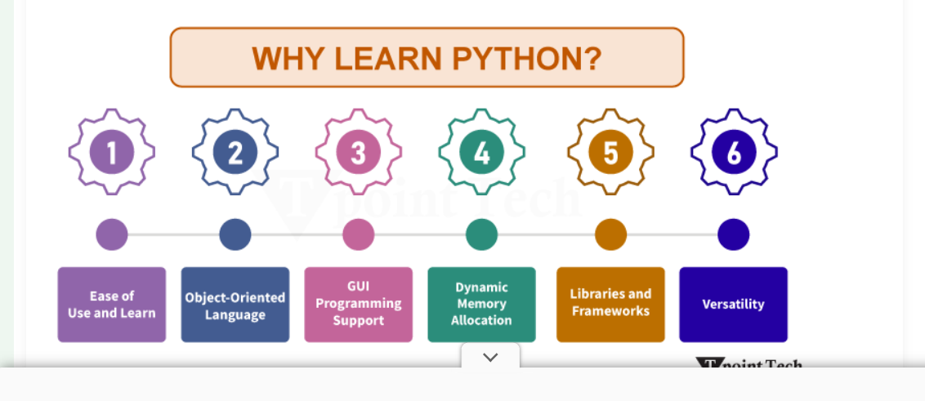

Where is Python Used?
Python is a general-purpose, popular programming language, and it is used in almost every technical field. The various areas of Python use are given below. 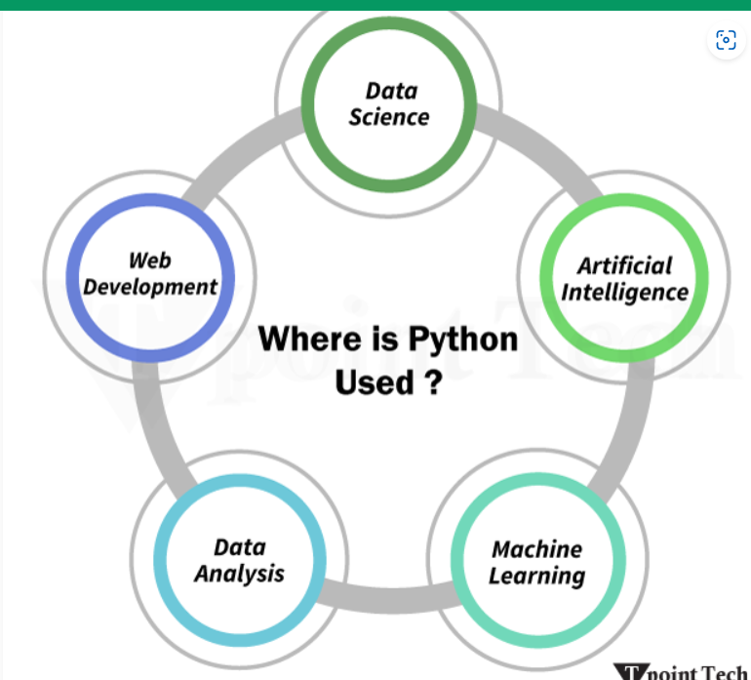

Data Science: Data Science is a vast field, and Python is an important language for this field because of its simplicity, ease of use, and availability of powerful data analysis and visualization libraries like NumPy, Pandas, and Matplotlib.

Artificial Intelligence: AI is an emerging Technology, and Python is a perfect language for artificial intelligence and machine learning because of the availability of powerful libraries such as TensorFlow, Keras, and Pytorch.

Machine Learning: Python is also widely used for machine learning because of its simplicity, ease of use and the availability of powerful machine learning libraries.

Data Analysis: Python is also used to create visualizations of data. It is also used to analyze price trends and market predictions and automate workflows across multiple data sources.

Web Development: Python is used to develop websites and web applications. There are several popular frameworks, like Django and Flask, which are used to build web applications.

Python Popular Frameworks and Libraries
- Web development (Server-side): Django, Flask, Pyramid, CherryPy
- GUI-based applications: Tkinter, PyGTK, PyQt, PyJS, etc.
- MachineLearning: TensorFlow, PyTorch, Scikit-learn, Matplotlib, Scipy, etc.
- Mathematics: NumPy, Pandas, etc.
- BeautifulSoup: This library is used in web scraping and parsing HTML and XML
- Requests: It is used for making HTTP requests
- SQLAlchemy: It is used in SQL databases
- Kivy: It is a framework for building applications
- Pygame: This library is used in the game development field
- Pytest: A testing framework for Python Django
- REST framework: This is a toolkit for creating RESTful APIs
- FastAPI: A modern, fast web framework for creating APIs
- Streamlit: A library for developing interactive web apps for machine learning and data science
- NLTK: It is a library for natural language processing

How to Install Python?
Step - 1: Visit Official Site to Download Python Installer
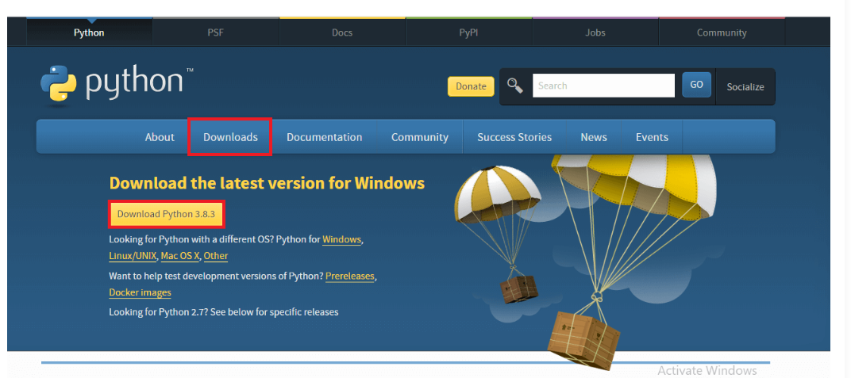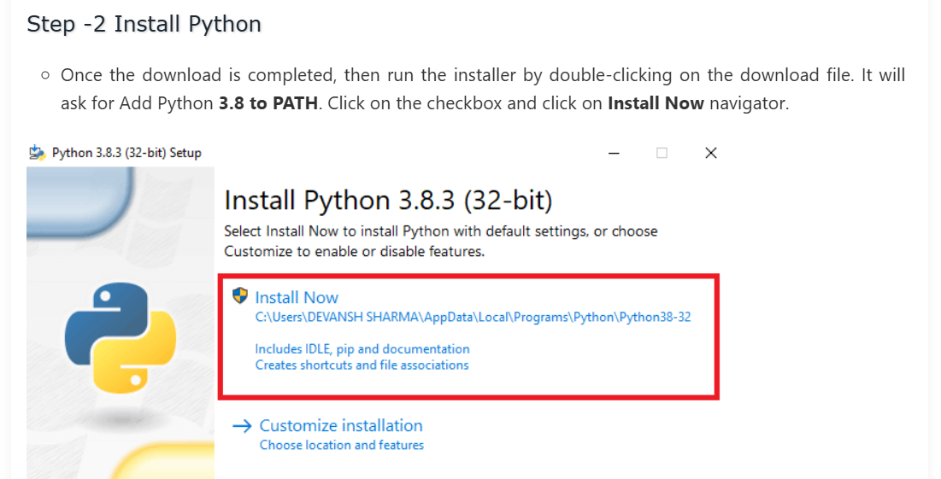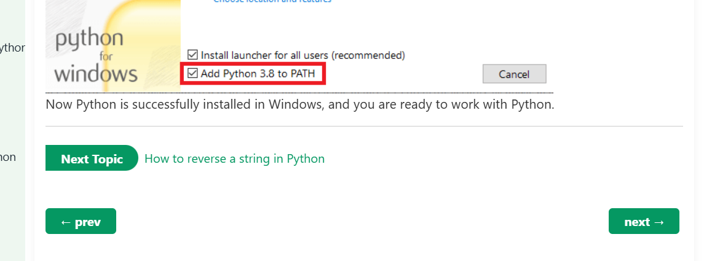

After Installing successfully Python in machine , open command Prompt and type python –version , as per snap below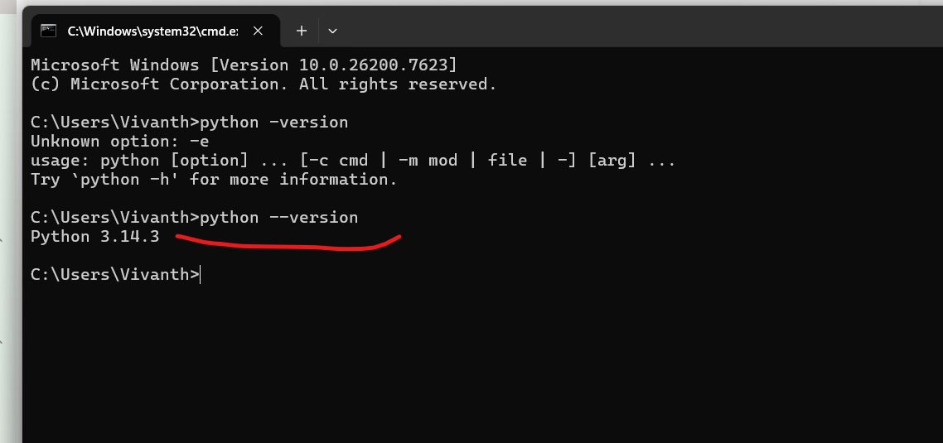

Then Step 5: Verify pip Installation
Pip is known as a package manager, which enables the installation and management of Python libraries.
5.1 Check if pip is Installed
- Command Prompt can be opened by typing:
- $ pip --version
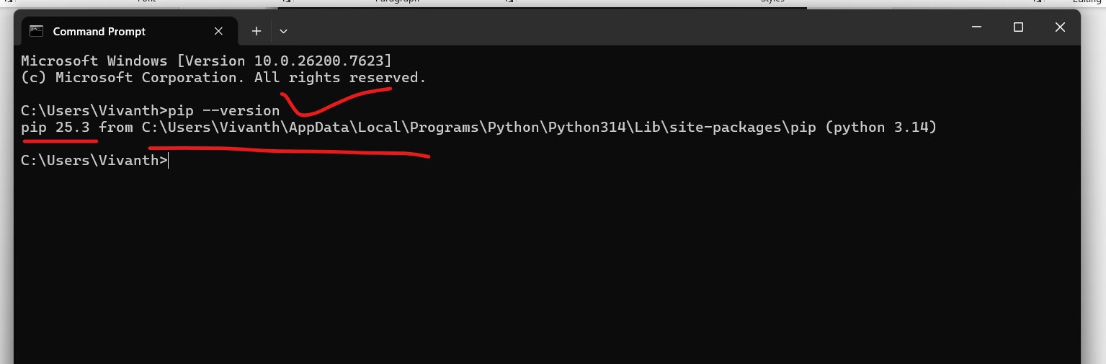

Step 6: Test Python with the Command Prompt
Command Prompt (cmd) can be opened.
2. Type:
- $ python

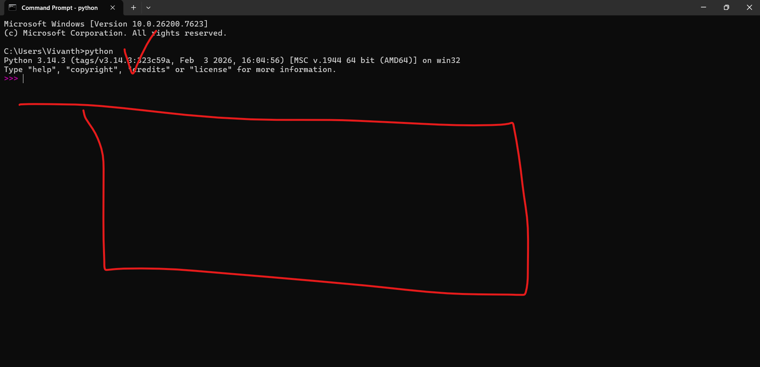

First Program -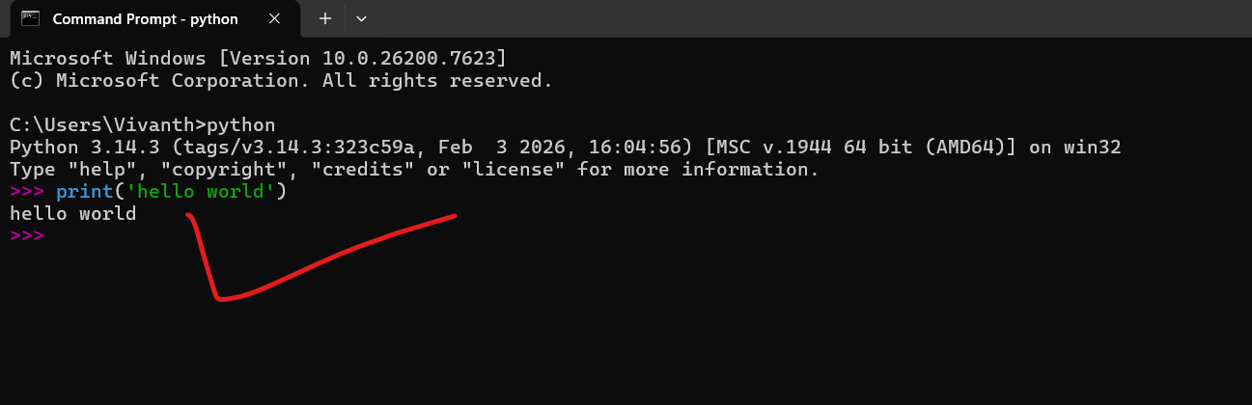

Parentheses is mandatory -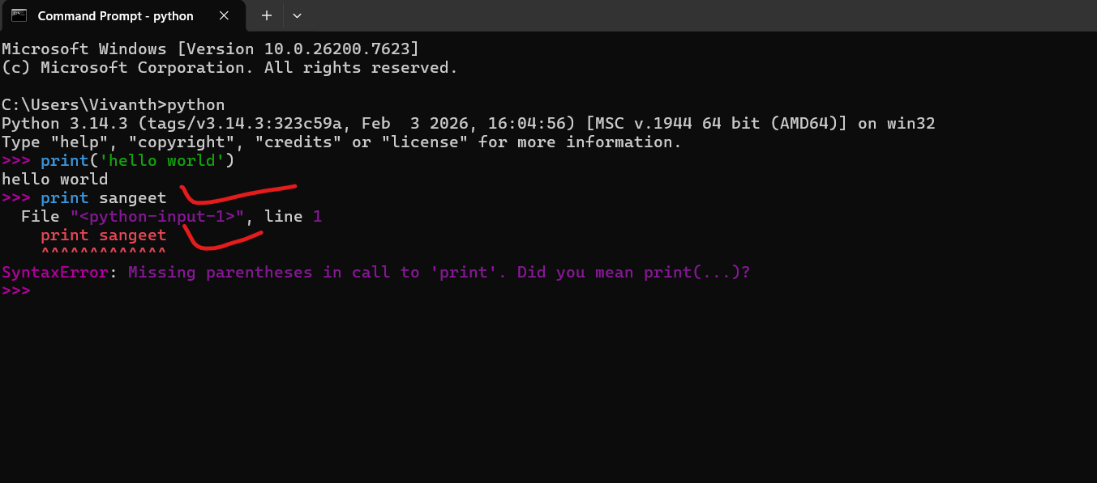

5. To close Python, the following command can be used:
Type “exit()” and hit enter 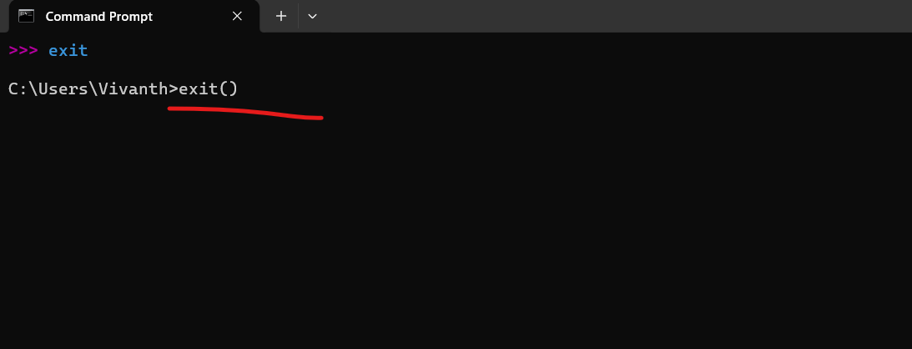

6) To clear the syntax in cmd use “clear” and hit enter

Python Syntax
Python Syntax acts as grammar, with the set of rules defining the way of writing and organizing code so that the Python interpreter can understand and execute it properly.
These rules ensure that the code is well-written, structured, and error-free.

First Program in Python
We will now look at the basic Python program to print "Hello, world!" in two different modes:
- Interactive Mode [cmd]
Directly writing in cmd
Python Interactive Mode
We can use Python interpreter from command line by simply typing 'python' as shown below:
>>> print("Hello, World!")

- Script Mode
Another method to use Python Interpreter is by using the Python Script mode. In script mode the code is written in a .py file and then executed from the command prompt.
print("Hello, World!")

Different Aspects of Python Syntax:
- Variables
- Indentation
- Identifiers
- Keywords
- Comments
- Multiline Statements
- Input from Users

Python Variables:
Variables in Python are used to store data values.
Python variables do not require explicit declaration of type; they are dynamically typed.
a=10;
print(a ,’->’,type(a));

b =’JavaTPoint’;
print(b ,’->’,type(b));
Indentation in Python
Python uses indentation to define blocks of code instead of using curly braces {} as in other languages like C or Java. Indentation enhances code readability and is a crucial part of Python syntax. Every block of code (such as loops, functions, and conditionals) must be indented at the same level
Example
if 9 > 5:
print("9 is greater than 5") # proper indentation
print("This is part of the if block")
print("This is outside the if block")
Output:
9 is greater than 5
This is part of the if block
This is outside the if block
In the above example, we have used the if statement to check if 9 is greater than 5. If true, it will print the indented line of codes.
In case of improper indentation, it will raise an IndentationError. Proper indentation ensures the logical structure of the code is maintained.

Python Identifiers
Identifiers are names used for variables, functions, classes, and other entities in Python. They must follow specific rules to be valid:
- It can contain letters (A-Z, a-z), digits (0-9), and underscores (_).
- It cannot start with a digit.
- We cannot use Python keywords as identifiers.
- Case-sensitive (MyVar and myvar are different identifiers).
- It should be descriptive and follow naming conventions (e.g., using snake_case for variables and functions and CamelCase for class names).

Python Keywords
• and
• as
• assert
• async
• await
• break
• case
• class
• continue
• def
• del
• elif
• else
• except
• False
• finally
• for
• from
• global
• if
• import
• in
• is
• lambda
• match
• nonlocal
• None
• not
• or
• pass
• raise
• return
• True
• try
• while
• with
• yield

Conditional Statements - if, elif, else

if-
This keyword is used to execute a block if the condition is True.

elif-
This keyword is used to specify additional conditions if the previous ones fail.

else-
This keyword is used to execute a block if all previous conditions are False.

Program ==>>>

print('Thank you for taking initial step and working on python');
str =input('enter your name please : ');
if(str == 'sangeet'):
print('sangeet name found');
elif(str == 'sks'):
print('samal name found');
else:
print('sangeet name not found');

Looping Construct - for, while
These keywords are used to execute code repeatedly.

for –
This keyword is used to iterate over a sequence, such as list, tuple, dictionary, etc.

while-
This keyword is used to repeat execution while a condition remains True.

#use keyword for - while

#defining a list
shoppingList =['apple', 'mango','bread','meat','fish','sweet'];
print(shoppingList);

#print items using loop

for item in shoppingList:
print("print items using for loop: ");
print(item);

while loop =

#use keyword for - while

#defining a list
shoppingList =['apple', 'mango','bread','meat','fish','sweet'];
print(shoppingList);

#print items using loop
for item in shoppingList:
print("print items using for loop: ");
print(item);

#print item using while loop
print("print while loop");
index = 0
while index<len(shoppingList):
print(shoppingList[index]);
index =index+1;

Python Operators
In Python, Operators are the symbols used to perform a specific operation on different values and variables.

- Arithmetic Operators
- Comparison Operators
- Assignment Operators
- Logical Operators
- Bitwise Operators
- Membership Operators
- Identity Operators
- Let us now discuss these operators used in Python in the following sections.
- 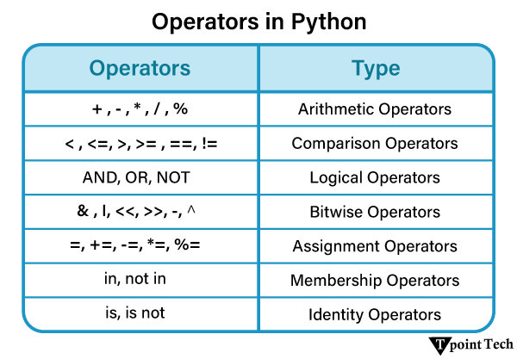

a=46;
b=30;
print(“For a =”,a,” and b =”,b,”\nCalculate the following:”)

comparison operator
==
!=
>=
<=
>
<

A=46;
B =20;
Print(“two numbers are equal or not :”a==b) ;
Print(“two numbers are not equal : “a!=b);

Bitwise Operators
a &b

#use List
myList = [12, 22, 28, 35, 42, 49, 54, 65, 92, 103, 245, 874]

#initalize x and y and some values
x= 100;
y =203;

print('Given List :',myList);

if(x not in myList):
print(x , ': is not present in myList');
if(y in myList):
print(y,":is in the list");
else:
print(x, ': is present in the myList');
print(y,': is not in the list');

Python Variables
In Python, variables are fundamental building blocks that allow developers to store, manage, and manipulate data efficiently. A variable in Python is essentially a symbolic name assigned to a memory location where data is stored.
- Python is dynamically typed.
==
#python is dynamically typed

#employee details save in database to and show the output

name ='hardeep puri';
age =70;
place ='delhi';
occupation ='politician';
status ='corrupted';

namee =input('enter the name: ');
print(namee);

if(name ==namee):
print("he is most corrupted politician");
else:
print('Truth symbol is peace');

Rules and Naming Conventions for Python Variables
Python follows certain rules for naming variables:
- Valid: _var_1
- Valid: var_one

Basic Assignment
var_one = 82
print(var_one)
# dynamic typing
var_one = 21 # integer
print(var_one)

var_one = 'tpointtech' # string
print(var_one)

- Types of Comments in Python
There are primarily three types of comments used in Python, such as:
- Single-line Comments
# this is a single-line comment

- Multi-line Comments
# example of multiline comment

# this is a
# multi-line comment
# added to the code
# by stacking multiple
# single line comments

'''''This is a
multi-line comment
added to the code
using the triple
quoted string
'''

- Docstrings

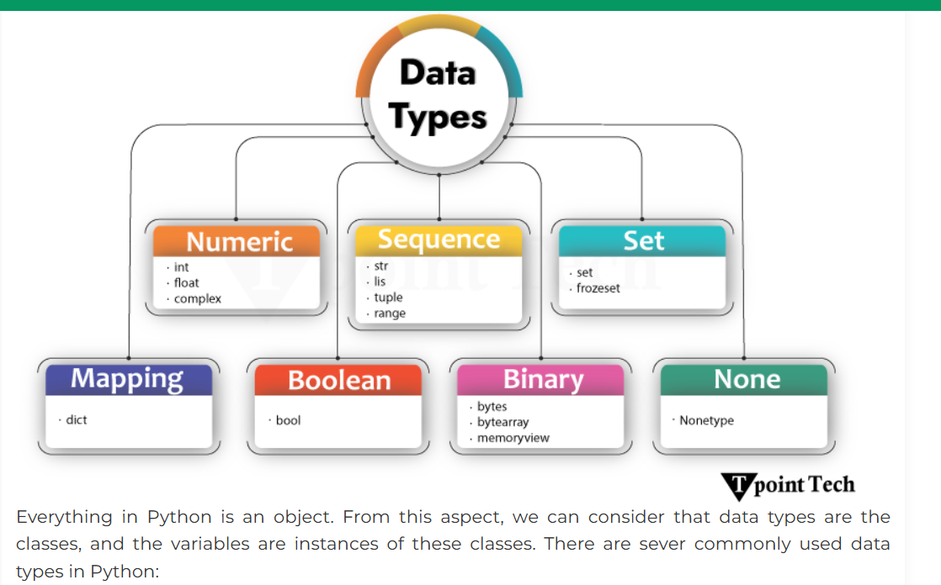

Data Type | Examples
1 | Numeric Types | int, float, complex
2 | Sequence Types | str, list, tuple, range
3 | Set Types | set, frozenset
4 | Mapping Type | dict
5 | Boolean Type | bool
6 | Binary Types | bytes, bytearray, memoryview
7 | None Type | NoneType

# python program to show how to declare complex numbers in Python
Var_1 =3+5j
Here 3 is the Real number and 5j is the imaginary part
Var_2 =-3.4 +2.8j
Here -3.4 is Real Number and 2.8j is imaginary
Var_3 =-5-1.9j
Here -5 is Real Number and -1.9j is imaginary
Var_4 = -6+0j
Here -6 is real number and 0j is imaginary

To learn more about type conversion in Python, visit Type Casting in Python.

Python random Module

Sequence Data Types
Sequence Data Types in Python are used to store multiple elements in an ordered manner. There are mainly three types of sequence data types available in Python:
S. No. | Sequence Data Type | Description
1 | list | Ordered, mutable, and heterogeneous collection of elements
2 | tuple | Ordered, and immutable collection of elements
3 | str | Sequence of characters

Python math Module

# importing the required module
import math
print(‘value of pi’, math.pi)

Implicit Type Conversion (Automatically)
Python converts smaller data types to larger ones automatically.
# defining variables
a = 13 # int
b = 4.6 # float
c = 5 # int

sum = a + b # int + float -> float
print(a, "+", b, "=",sum)
print(type(sum))

Explicit Type Conversion (Manually)
Programmers use Python's built-in functions like int(), float(), complex() and more, to manually convert one data type into another.

Functions of Python Type Casting
int() | This function converts specified variable or value to an integer (truncates decimals if x is a float).
float() | This function is used to convert specified variable or value to a floating-point number.
complex() | This function converts specified variable or value to a complex number.
str() | This function is utilized to convert specified variable or value to a string.
bool() | This function converts given variable or value to a Boolean value (True or False)
list() | This function is used to convert the given iterable (like string, tuple, set) to a list.
tuple() | This function converts the given iterable (list, string, etc.) to a tuple.
set() | This function is used to convert the given iterable (list, tuple, etc.) to a set.
dict() | This function is used to convert the given sequence of the key-value pairs to a dictionary.
Integer Conversion (int())
The int() function is used to convert the variable or value to an integer.

Python Strings

A String in Python is a sequence of characters.
For example, "welcome" is a string consisting of a sequence of characters such as 'w', 'e', 'l', 'c', 'o', 'm', 'e
Anything, including letters, numbers, symbols, and even whitespaces, within the quotation marks is treated as a string in Python.'.
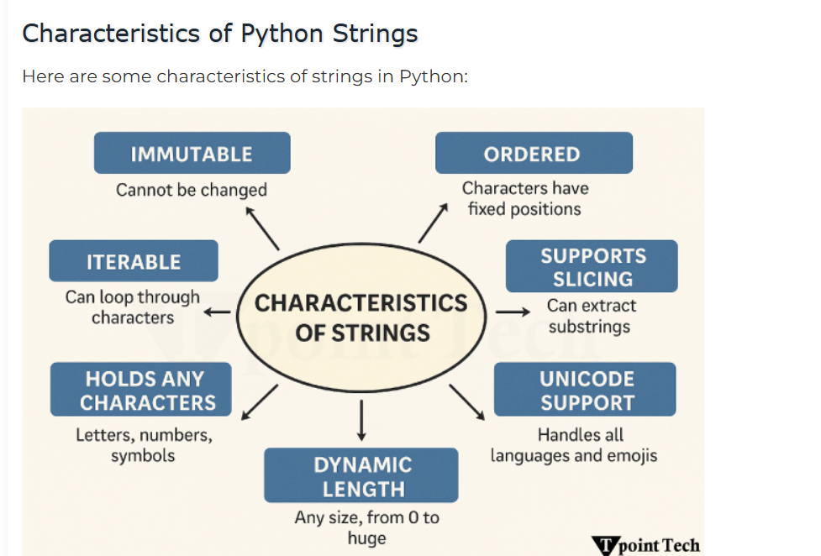

Creating a String
We can create strings using either single quotation marks ('…') or double quotation marks ("…").

Accessing Characters in a String
In Python, strings are sequences of characters that can be accessed individually with the help of indexing. Strings are indexed 0 from the start and -1 from the end. This indexing helps us retrieve particular characters from the string effortlessly.
str_1 ="sangeet kumar samal";
print(str_1[0]);
print(str_1[-1]);

Access String with negative scenarios
Str_5 =’Tpoint_Tech’
Print(Str_5);

Slicing a string
Slicing is a way in Python that allows us to extract a portion of a string by specifying the start and end indexes.
The format for slicing a string is string_name[start : end]

String Immutability
String in Python is an immutable data type that cannot be changed after creation. However, we can manipulate strings using various methods like slicing, concatenation, or formatting in order to create new strings on the basis of the original one.

Deleting a String
Since Python strings are immutable, we can't delete individual characters from a string. However, Python provides accessibility to delete an entire string variable using the del keyword.

message =”tpointtech”;
del(message);
print(message);

# DELETING STRING in python and confirm its not present

message ="I am a man of 40 years";
del(message);
try:
message
print("message still exists");
except NameError:
print("message is deleted");

MultiLine String

String_name =’’’ Learning python is Fun’’’;

String_name2 = “””Learning the point “””

given_str = "welcome learners"
print("Given String:", given_str)

#length function in python

givenString ='tpoint in software industry';
print('Given String : ',givenString);

#using the len() function
numberOfCharacters =len(givenString);
print("length of word :",numberOfCharacters);

#-------------------------------------------------------------------

#upper and lower string

givenString ='I am staying in bangalore for more than 15 years';

newUpperString =givenString.upper();
print(newUpperString);

newLowerString =givenString.lower();
print(newLowerString);

#-----------------------------------------------------------

strip() and replace()
String Concatenation and Repetition
Formatting Strings
There are several ways in Python that allow us to include variables inside strings. Some of these methods are discussed below:
Using f-strings

Python String Methods to Search and Find Substrings

- str.find(substring)
- str.index(substring)
- str.rfind(substring)

String Membership Test
given_str = 'Tpoint Tech'
in and not in

if statement
#if statement

age =18;

if age>=18:
print('you are eligible for vote');

If condition:
# Code to execute if condition is True
else:
# Code to execute if condition is False

