实验四 内核线程管理实验

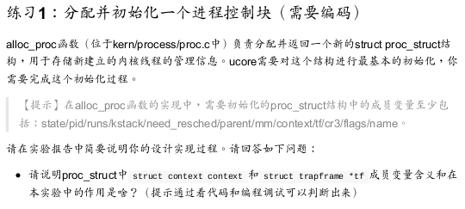

struct proc_struct {

enum proc_state state; // Process state

int pid; // Process ID

int runs; // the running times of Proces

uintptr_t kstack; // Process kernel stack

volatile bool need_resched; // need to be rescheduled to release CPU?

struct proc_struct *parent; // the parent process

struct mm_struct *mm; // Process's memory management field

struct context context; // Switch here to run process

struct trapframe *tf; // Trap frame for current interrupt

uintptr_t cr3; // the base addr of Page Directroy Table(PDT)

uint32_t flags; // Process flag

char name[PROC_NAME_LEN + 1]; // Process name

list_entry_t list_link; // Process link list

list_entry_t hash_link; // Process hash list

};

static struct proc_struct *

alloc_proc(void) {

struct proc_struct *proc = kmalloc(sizeof(struct proc_struct));

if (proc != NULL) {

//LAB4:EXERCISE1 YOUR CODE

/*

* below fields in proc_struct need to be initialized

* enum proc_state state; // Process state

* int pid; // Process ID

* int runs; // the running times of Proces

* uintptr_t kstack; // Process kernel stack

* volatile bool need_resched; // bool value: need to be rescheduled to release CPU?

* struct proc_struct *parent;

* struct mm_struct *mm;

* struct context context;

* struct trapframe *tf;

* uintptr_t cr3;

* uint32_t flags;

* char name[PROC_NAME_LEN + 1];

proc->state = PROC_UNINIT;

proc->pid = -1;

proc->runs = 0;

proc->kstack = 0;

proc->need_resched = 0;

proc->parent = NULL;

proc->mm = NULL;

memset(&(proc->context), 0, sizeof(struct context));//进程上下文初始化

proc->tf = NULL;

proc->cr3 = boot_cr3;//设置内核页目录表的基址

proc->flags = 0; //标志位初始化

memset(proc->name, 0, PROC_NAME_LEN); //进程名初始化

}

return proc;

}

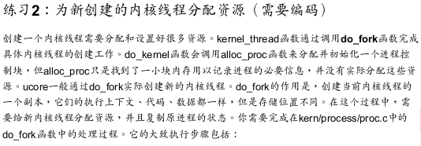

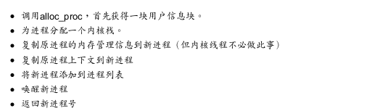



int

do_fork(uint32_t clone_flags, uintptr_t stack, struct trapframe *tf) {

int ret = -E_NO_FREE_PROC;

struct proc_struct *proc;

if (nr_process >= MAX_PROCESS) {

goto fork_out;

}

ret = -E_NO_MEM;

/*

* Some Useful MACROs, Functions and DEFINEs, you can use them in below implementation.

* MACROs or Functions:

* alloc_proc: create a proc struct and init fields (lab4:exercise1)

* setup_kstack: alloc pages with size KSTACKPAGE as process kernel stack

* copy_mm: process "proc" duplicate OR share process "current"'s mm according clone_flags

* if clone_flags & CLONE_VM, then "share" ; else "duplicate"

* copy_thread: setup the trapframe on the process's kernel stack top and

* setup the kernel entry point and stack of process

* hash_proc: add proc into proc hash_list

* get_pid: alloc a unique pid for process

* wakup_proc: set proc->state = PROC_RUNNABLE

* VARIABLES:

* proc_list: the process set's list

* nr_process: the number of process set

*/

bool intr_flag;

local_intr_save(intr_flag);

{

proc->pid = get_pid();

hash_proc(proc);

list_add(&proc_list, &(proc->list_link));

nr_process ++;

}

local_intr_restore(intr_flag);

wakeup_proc(proc);

ret = proc->pid;

fork_out:

return ret;

bad_fork_cleanup_kstack:

put_kstack(proc);

bad_fork_cleanup_proc:

kfree(proc);

goto fork_out;

}

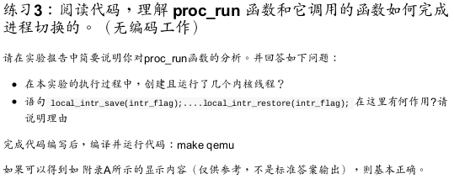

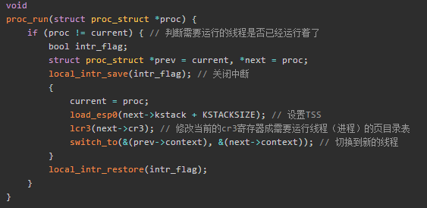

问题回答：

1. 总共创建了两个内核线程，分别为：

* idleproc: 最初的内核线程，在完成新的内核线程的创建以及各种初始化工作之后，进入死循环，用于调度其他线程；
* initproc: 被创建用于打印"Hello World"的线程；

1. 语句 local_intr_save(intr_flag);....local_intr_restore(intr_flag);

的作用

* 这个语句的左右是关闭中断，使这个语句块内的内容不会被中断打断，是一个原子操作；
* 这使得一些关键的代码不会被打断，从而引起不必要的错误；
* 如在proc_run函数中，将current指向了要切换到的线程，但是此时还没有真正将控制权转移过去，如果在这个时候出现中断打断这些操作，就会出现current中保存的并不是正在运行的线程的中断控制块，从而出现错误；

编译make qemu

