|  |  |  |  |
| --- | --- | --- | --- |
| **Test Scenario** | **Test Case** | **Type of Execution** | **Test Status** |
| Verify initial list of Marvel characters upon page load on desktop | Verify that the thumbnail image is displayed for each character on the initial list. | Automation | **Pass** |
| Verify that the name is displayed for each character on the initial list. | Automation | **Pass** |
| Verify that the number of comics is displayed for each character on the initial list. | Automation | **Pass** |
| Verify that the published date is displayed for each character on the initial list. | Automation | **Pass** |
| Verify user scroll functionality | Verify that additional character’s load on scrolling down | Manual | **Pass** |
| Verify that all characters are load on reaching the page end. | Automation | **Pass** |
| Verify that user cannot scroll down after reaching the page end | Manual | **Pass** |
| Verify search and filter functionality | Verify that on searching a character name, the character list gets updated to display matching results | Automation | **Pass** |
| Verify that on searching a character name with no matching results, the message "No characters found." is displayed | Automation | **Fail** |
| Verify that on deleting the search term, the initial list of characters load on the page. | Manual | **Fail** |
| Verify Character page | Verify user is navigated to correct character page on clicking any character | Automation | **Pass** |
| Verify thumbnail image loads on the character page | Manual | **Fail** |
| Verify character name displays as heading on the character page | Manual | **Pass** |
| Verify initial list loads when user navigates back from character page to dashboard homepage. | Manual | **Fail** |

**Test Report**

**Summary of Test Results**:

**Key Risks:**

* **Performance**
  + Initial page load and further loading of characters upon scroll is very slow and thus it is not performant enough.
* **Scrolling load behaviour**
  + When the user scrolls down the homepage, there is no indications that a new set of results are being loaded.
* **Character page doesn’t load occasionally**
  + On certain occasions, character page doesn’t load after selecting a character from the dashboard, and only loads after a refresh.
* **Broken images**
  + Although the image URLs are correct – they appear broken on thumbnail in the homepage dashboard
  + For many characters, the Image shows properly on dashboard, but shows broken on the character page

**Failed Test Cases:**

|  |  |  |  |  |
| --- | --- | --- | --- | --- |
| **Test Case** | **Test Steps** | **Expected Result** | **Actual Result** | **Priority** |
| On searching a character name with no matching results, the message "No characters found." is displayed | Open the website<https://marvel-dashboard-seven.vercel.app/characters>  On the search box type superman | The message "No characters found." should be displayed | The message "No characters found." is not displayed | Low (Although the expected message is not displayed but no results are displayed) |
| On deleting the search term, the initial list of characters load on the page. | Open the website <https://marvel-dashboard-seven.vercel.app/characters>  On the search box type spider-man  Let the search results load  Delete the search term from the search box | The initial list of characters should load back on the page. | The message " Loading more ..." is displayed and the list is empty | High  (user has to reload the page every time after deleting the search term for the application to work) |
| The thumbnail image loads on the character page | Open the website <https://marvel-dashboard-seven.vercel.app/characters>  Click on the character name Abyss | The thumbnail image does not loads on the character page | The thumbnail image should loads on the character page | Medium |
| The initial list loads when user navigates back from character page to dashboard homepage. | Open the website <https://marvel-dashboard-seven.vercel.app/characters>  Click on any character name to navigate to the character page  After the page loads, click on the browser back button to navigate to dashboard homepage | The initial list should load on the dashboard homepage | The message " Loading more ..." is displayed and the list is empty | High  (user has to reload the page every time after deleting the search term for the application to work) |

**Automated Test Run Report**:

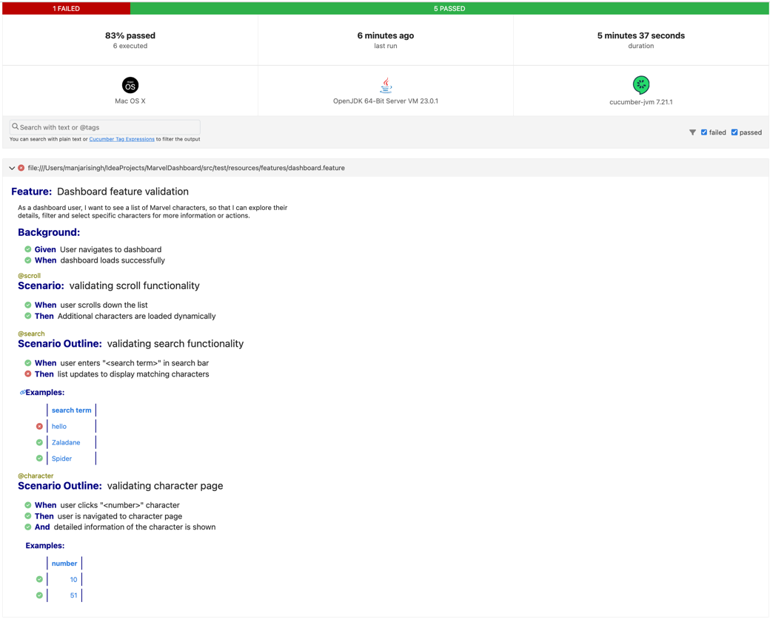

**Overall Readiness:**

Project is not ready for delivery

* Due to the inconsistent behaviour and slow performance, the project requires attention to the items identified under “Key Risks” section and needs fixes to address high and medium priority test-cases.