SyncWeave Sharing

The SyncWeave sharing option will give users the ability to share a directory and all of its content with one or more other users. The shared content will be both readable and editable by the users (collaborators) it is shared with. However, primary ownership of the files, which includes the ability to hard deleted files and to prevent other users from accessing the files, will be granted to only one person at a time.

Contents

Questions & Answers 2

Roles and Permissions 2

Actions 3

Non-File Information 6

Misc 6

Shared Folder Design – Competitor Study 8

Creating a Shared Folder 8

From Windows Explorer 8

From Cabinet Browser 9

From Shared Content Page 11

Viewing Existing Shared Folders 18

From Windows Explorer 18

From Cabinet Browser 19

From Shared Content Page 19

Managing User Access 20

Sharing With Others 20

Kicking People Out 25

Collaborators Leaving a Shared Folder 27

Owners Leaving a Shared Folder 31

Owners Un-Sharing a Shared Folder 33

SparkWeave Differentiation 34

Stage 2 and Beyond 35

# Questions & Answers

black = Question  
green = Dropbox’s answer  
purple = potential changes for SyncWeave’s answer.

## Roles and Permissions

1. Can users other than the owner add new users to the group? If A shares the folder with B, can B share it with C?

Yes, ability to share is fully transitive. Collaborative users can share as easily as owners. The owner’s permission is not required, and the owner is not notified (of the invitation or of its acceptance)

1. Can recipient users make a request to the owner that new users be added to the group? In a way that makes the request a 1-click process to “grant” or “deny”?  
     
   No. This process is not necessary if all users have permission to invite.  
   However, if we would rather leave that responsibility to the owner, then going this route would be a good alternative.  
   Most team members prefer this idea. However, we can wait until phase #2 to implement this more-complex idea. Allow owner users to choose “allow any users to add collaborators” or “check with me first” option when first sharing the folder.
2. What if the collaborative users the folder is being shared with don’t really want access to the content or for the content to clutter up their SyncWeave folder? Do they have a choice in the matter?
   1. How are they prompted to join in the shared folder?
   2. How can they leave once they have joined?

The user must choose to “accept” or “reject” the folder invitation before the shared folder content appears anywhere on their interface. The user can leave the shared folder by visiting the shared folder options page and clicking “leave folder”.

1. How can the owner boot people out? What prevents the user from being added to the group again by another user afterwards?   
     
   Only the folder owner can kick a collaborative user out of the folder. Even if a different user added the bootable user, still only the owner can remove him. The process is:  
    a) The owner visits the sharing options page for the folder in question.  
    b) The owner clicks the “Kick Out” option for the user who needs to be removed.  
    c) The owner confirms the removal.  
     
   Nothing prevents the user from being added to the group again after being removed by the owner.  
   We may want to provide a “ban” options for our owners to use in addition to or as a replacement to the “kick out option”. The “ban” option would prevent users from being added back in.   
   Brandon thinks we should provide the “ban” option in phase #1.
2. Are there any permission restrictions for the following actions *inside* a shared folder: create-file, create-folder, rename, copy, move, delete, hard-delete, restore, download?   
     
   All folder and file actions are allowed by all shared folder users. The one exception is hard-delete which only the owner can perform. This prevents malicious or confused users from irrevocably removing content that many other users may be depending on.  
     
   create-file: no, no restrictions.  
   create-folder: no, no restrictions.  
   rename: no, no restrictions.  
   copy: no, no restrictions.  
   move: no, no restrictions.  
   delete: no, no restrictions.  
   hard-delete: yes, this is restricted. The “permanently delete” option shows up, but shows a permission failure if a collaborator tries to use it.  
   restore: no, no restrictions.  
   download: no, no restrictions.
3. Are there different roles / user types (owner, read/write, read-only, hidden)?  
     
   Yes; owner and collaborator. All users can alter the contents of the shared folder and add new collaborators on the folder. Only the owner can kick users out or unshare the contents.

## Actions

1. What happens (as an owner) if you try to delete a shared folder while it is still shared with other users?  
     
   In Dropbox, if the owner deletes the shared folder rather than explicitly “unsharing” the folder and rather than setting a new owner and then leaving /deleting the folder, the folder enters a bad state where it has no owner.  
   In the SparkWeave system, this would mean that no one can remove or ban users, and no one is accountable for the space the folder consumes. We probably do not want to allow this. If the owner deletes their shared folder, it should probably unshare the folder and convert it to a normal (not shared) folder before deleting it. It’s important that the deletion process not require any additional input from users; for example, requiring them to select a new owner for the content would be out of the question. Deletion must remain a single-step simple action to maintain compatibility with the Windows Explorer plugin.
2. If a collaborative user deletes the shared folder from their SyncWeave cabinet, what happens? Does this remove their access to the shared folder? Or can they just bring it back at a later point (assuming it still exists on the owner’s side)

If a user deletes a folder through their Windows Explorer plugin, the folder is marked as deleted and moved into the “past folders” list in the shared content page.  
If deleted via Windows Explorer by the owner, it will do whatever we decide the delete action should do for owners – probably unshare and then soft-delete the directory. See the previous question.

1. Can users move a shared folder around anywhere they want inside their SyncWeave cabinet? Can they rename it?  
     
   Yes, the folder can be moved and renamed independently by each individual user. These changes do not affect other users – they are just local aliases. When a shared folder is renamed in a user’s cabinet browser page, its name also changes on the shared content page which provides a flat-list of the top-level shared folders.  
     
   Shared folders cannot be copied – the reason for this is unknown as all of the shared folder’s sub-contents can be copied to outside the shared directory.
2. Can you “soft-delete”, “view deleted” and “restore” shared folders themselves? From the shared content page?  
     
   soft-delete: Yes, though this action is rebranded as “leave folder”.

view –deleted: Yes and no.

* You cannot explore contents inside a deleted shared folder.
* You can view deleted contents inside a non-deleted shared folder.

restore: Yes, though this action is rebranded as “rejoin folder”.

1. Can you move files from inside a shared dir to outside? How about copy to an outside location?  
     
   Yes, both are allowed. There are no restriction on the flow of files between a shared folder and a user’s personal folders. The system does not even warn users when told to move a file out of a shared directory that that file will be lost by other people who may be depending on it.

We may at least want more harshly-worded confirmation dialogs for the SyncWeave product.

1. What happens to collaborative users with read/write permission to a shared folder if the owner deletes said folder?

That depends. There are 3 ways for the owner to delete their copy of a shared folder.

* The owner can delete the directory from the cabinet browse page. In this case, the other users will still have access to the content and it will still be marked as a shared folder for them, but the folder won’t have an owner!  
  We are hoping to avoid this option entirely in our product. We do not want drifting ownerless folders.  
  It came out during the group meeting that it will be impossible to 100% avoid ownerless owners as users can be deleted without the shared resources they are involved with being deleted. We will need to provide a page through which admins can assign owners to orphaned group folders.
* The owner can “unshared” the folder and then delete it. In this case, all collaborative users lose access to the content.
* The owner can transfer ownership of the folder to someone else and then delete it. In this case, the collaborators notices no difference other than that the folder has a new owner.

1. How are conflicts handled? For the following situation, how can both users’ changes be seen rather than being lost:
   1. The file “expense.xls” is create and shared
   2. The same base copy of the file is downloaded by Sara and Tim near the same time.
   3. Tim adds an expense report from his sales trip and re-uploads the file.
   4. Sara adds in a new computer and monitor she had to buy and re-uploads the file, stomping over Tim’s changes.

Will Tim’s changes be preserved? How?  
Read <https://www.dropbox.com/help/36>  
IF the changes are made through Tim and Sara’s Windows explorer plugins, then a “conflicted copy” of Sara’s file should be kept under a special name. This is possible because the Windows explorer plugin always knows the base version of the file that Tim and Sara each when they started editing.

However, if Sara were to upload her file through the web interface, her file would overwrite Tim’s file rather than being renamed. This is because the web interface has no way of tracking the base version of the file that Sarah was using when she started her changes. In the future, if Sarah’s changes stomped over Tom’s, anyone in the group could use the file’s “revision history” to find the older copy of the file containing Tom’s changes. We do not support file revision history at this time, but we will in the near future.

## Non-File Information

1. What sorts of notifications are sent out from the shared folder?
   1. Notifications when someone other than yourself has changed or added a file?  
      No. There are no options whatsoever for receiving notifications when files have changes – neither for all files, nor for a hand-selected subset.
   2. Notifications when a new user is added? Removed?  
      You are automatically notified when a user you invited to the shared folder has accepted the invitation. The notification does not go out to all users of the group and it is not guaranteed to go out to the owner; it *only* goes out to the inviter.  
      No notifications are sent if the invitee declines the invitation.  
      Leave this as-is for now (don’t report adds to owners as there may be hundreds of sub-users). However, do report declines of invitations.
   3. Notifications when you yourself have been added or booted from the folder?  
      You are notified when you have been invited to join a shared folder and you are prompted to accept or decline the invitation. However, you are not notified when you are kicked out of a shared folder nor when a shared folder you used to have access to is unshared.  
      Do send out a “you have been booted from folder X” notification.
2. Are users able to toggle their interest in receiving such notifications? On a per-file level?  
   No.
3. Is there any access log of when users have joined and left the group folder?  
   No.
4. Who can see the list of all users currently granted access to the folder?  
   All users with access to a shared folder – owner and collaborators – can see this list. However, only owners can kick users out.

## Misc

1. How does a user see a folder that has been shared with them? Where does it appear and what distinguishes it as different? Does this change when it is first shared with it vs. after they have accepted the share or started interacting with it?

A user’s shared folders appears in two places as soon as they accept their group invitation.

* On their “shared content” page they will see a flat list of all folders that have been shared with them.
* In their cabinet they will see their shared folders alongside all of their other content wherever they chose to place them (directly under root by default).

Before the user accepts their invitation to the folder, they do not see the folder listed anywhere, except for their “outstanding invitations” page.

1. Do the files in the shared folder consume the quota of any user other than the owner?

For Dropbox, yes. The files inside shared folders are fully deducted from each user’s available quota. However, Dropbox’s help page for their “Teams” feature says “There's only one difference between your everyday [shared folder](https://www.dropbox.com/help/19) and the ones found on the [Dropbox for Teams](https://www.dropbox.com/teams) product: the storage quota for shared folders amongst Team members only counts once”.

SparkWeave will only deduct the files inside the shared folder from the owner’s quota. This is more in keeping with our general policy of holding only the user responsible for the data accountable for the space it takes up.   
Open for discussions: how can the owner reassign the shared folder to a new owner if this is the case? Does he need to wait for an approval process to go through before he himself can leave the folder?

1. Can shared folders contain shared folders? Can shared folders contain each other in a circular manner (a contains b contains a)?  
     
   Shared folders cannot contain other shared folders. There are no exceptions.
2. What happens when an owner of shared content tries to add a user who doesn’t exist on the SparkWeave system to a shared folder? Does it put that user through an onboarding process? Would there be any point to doing so since as a guest user they likely would not have SyncWeave permission? What should happen if the invited user exists but doesn’t have SyncWeave permission?  
     
   Only users who already have an account and the appropriate permissions can have folders shared with them. Dropbox’s solution for users who want to grant read-only access to someone who falls outside this category is “public links” – but that’s an entirely different project.  
   For SyncWeave, users will be added one-at-a-time the same way they are added on the compose page. If they do not exist or do not have SyncWeave permission, they will be rejected and highlighted in red.

# Shared Folder Design – Competitor Study

Here is a good introduction on how the Dropbox folder sharing feature works:  
<https://www.dropbox.com/help/19>

## Creating a Shared Folder

There are three ways to share contents with other SyncWeave users:

* From Windows Explorer
* From cabinet browser
* From “shared content” page.

### From Windows Explorer

To share new content via your Windows Explorer plugin:

1. Open your SyncWeave folder.
2. Right-click on the folder you want to share. This displays a drop-down menu.  
   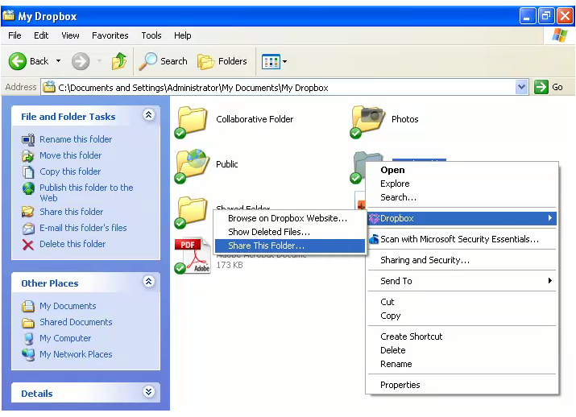
3. Select *SyncWeave > Share This Folder...* This will send you to the sharing page on the SparkWeave website.  
   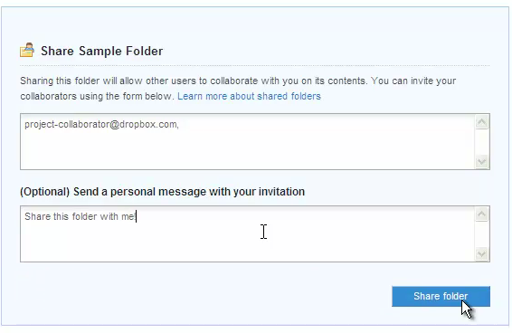
4. Enter the email addresses of whomever you want to add to your shared folder.
5. Add a personal message if you'd like and click *Share folder*.

### From Cabinet Browser

To share new content through the sync cabinet browser page:

1. Visit the “Sync Cabinet” page of the SparkWeave’s web interface.
2. Identify and click on any existing folder that you wish to share. (share options do not appear if more than one folder is clicked, or if the folder is soft-deleted, or if the folder is inside an existing shared folder)
3. Click the “Invite to Folder” button to share the folder with other users. This will send you to the sharing page on the SparkWeave website.

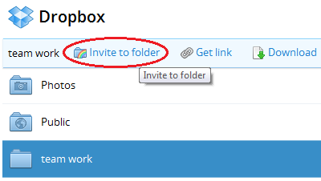

This will open up the sharing options dialog

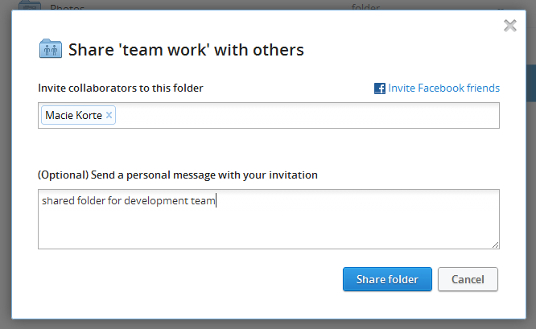

1. Enter the email addresses of whomever you want to add to your shared folder.
2. Add a personal message if you'd like and click *Share folder*.

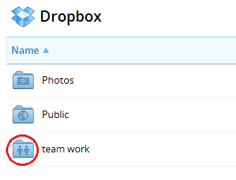

1. At this point the folder icon changes on the cabinet browse page to indicate that the folder is shared.

### From Shared Content Page

The shared content page is a new page created for this feature. It provides a flat list of all shared folders removed from the browsable-folder context. To share new content through the shared content page:

1. Start by clicking on the “New Shared Folder” button.

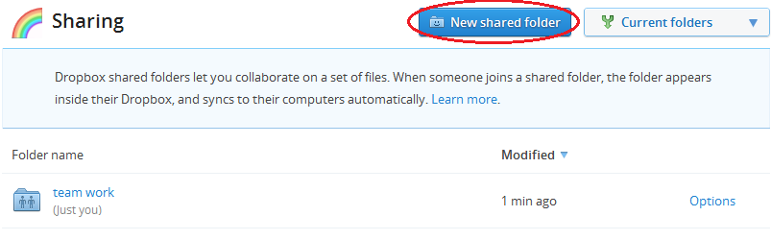

1. A sharing dialog will pop up giving you two options:
   1. Create a new folder.
   2. Share an existing folder.

To begin with, we will create a new folder to share.

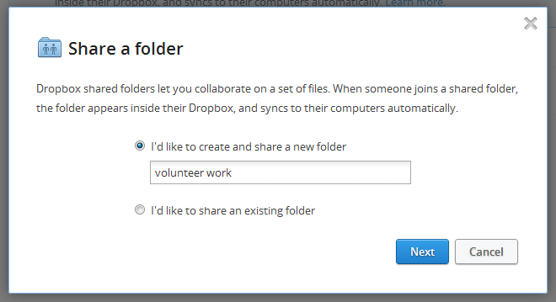

1. Type in the name of the folder you want to create and hit “next”.

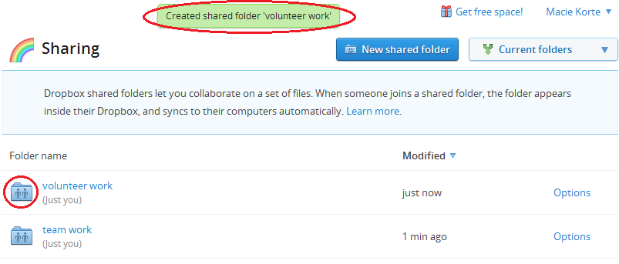

1. Your new folder now shows up under the shared content page. It also shows up under the main root of the cabinet browsing page.
2. Alternatively, if you want to share an existing folder, you can click the “New shared folder” button and go through the process again.

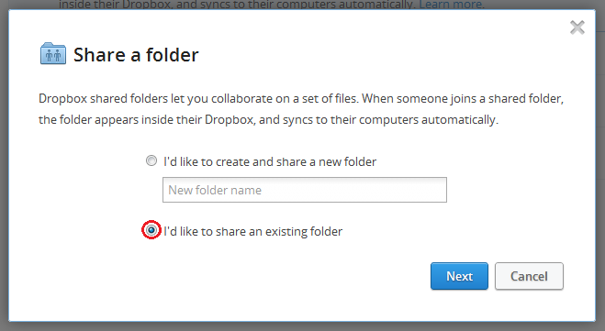

1. Choose “I’d like to share an existing folder” and continue.

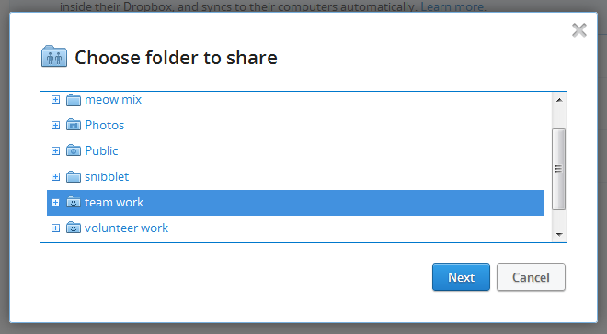

1. Browse through the existing folders and choose one.

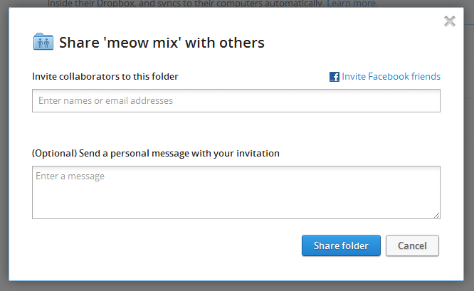  
  
For the SparkWeave project, this will actually look more like:  
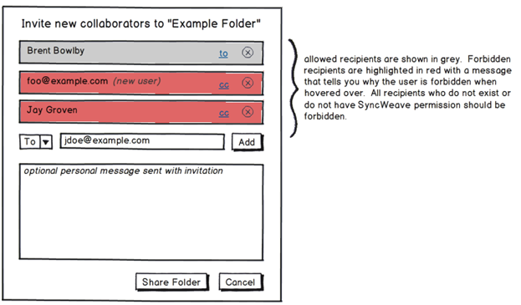

1. The usual initial sharing dialog will pop up to be filled out.
   1. Enter the email addresses of whomever you want to add to your shared folder.
   2. Add a personal message if you'd like and click *Share folder*.
2. Alternatively, you could have chosen a folder that was already shared in the past.



1. In which case the sharing options dialog will show a count of the members currently on the shared folder with options for adding more.

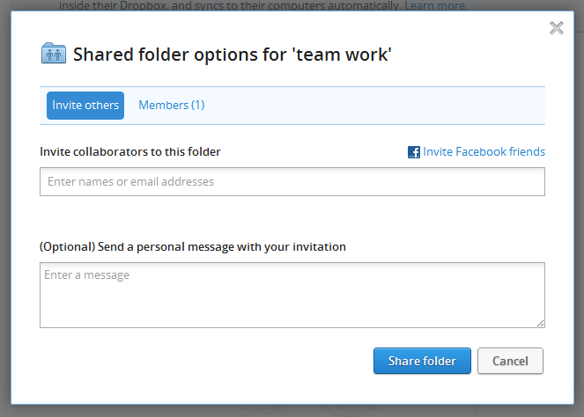

1. If you click on the “Members” tab of this dialog, you can manage the existing members of the group.

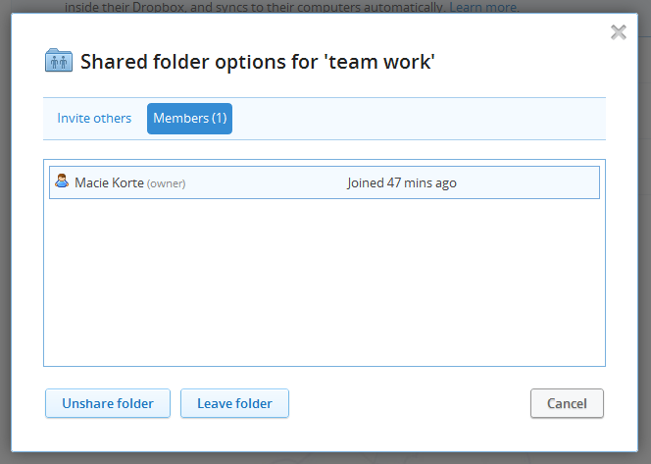

## Viewing Existing Shared Folders

### From Windows Explorer

Shared folders inside the Windows SyncWeave plugin will indicate that it is shared with a changed icon.

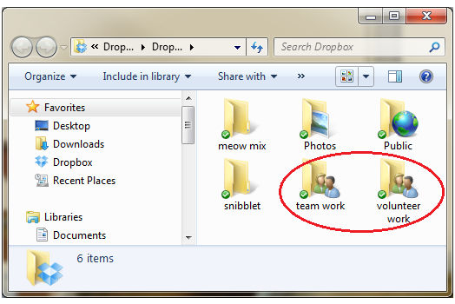

If I look inside one of the shared directories - “volunteer work” – I do not see any internal clues that the files are shared files:

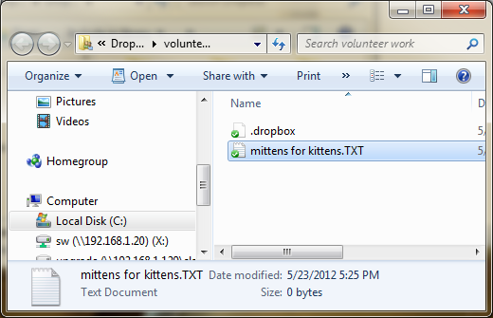

### From Cabinet Browser

Notice on the cabinet browser page, the shared folder shows up with a special folder icon and type designation.

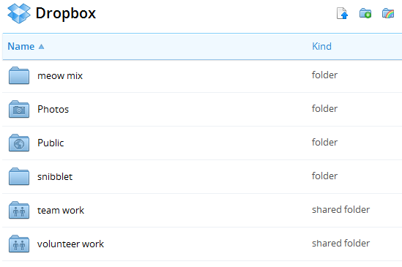

Files and folders inside the shared folder do not appear any different than normal files and folders through this interface.

### From Shared Content Page

The shared contents page provides a flat list of all shared folders removed from the browsable-folder context.

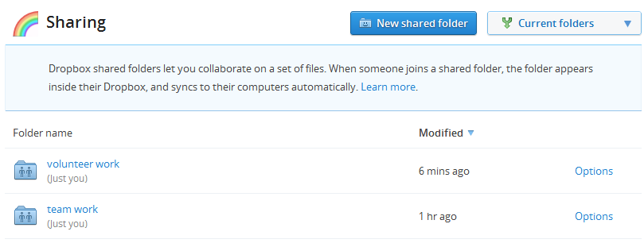 From here the contents of the shared folder can be changed, or the user access list can be changed.

## Managing User Access

This section covers adding and removing collaborative users from a shared folder, the notification emails sent during the process, and the permissions given to the users in the group.

### Sharing With Others

1. There is only one “owner” of a shared folder – this is the user who originally shared the folder. Ownership *is* transferrable, but there cannot be more than one owner.
2. Users can be added to an existing shared folder or one that is being newly created in the same way; the user chooses new collaborators and optionally types in a message explaining what content is being shared with them.  
     
   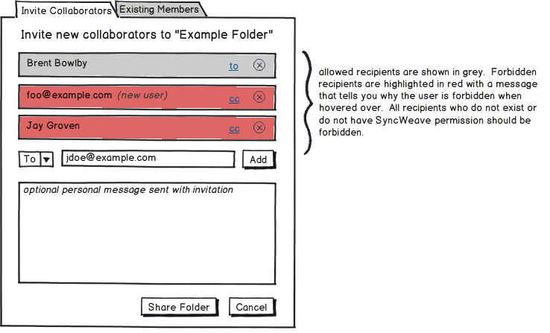
3. When a new user is added to a folder, the contents of the folder and not added to the user’s SyncWeave cabinet or made visible to the user until the user accepts the content. The collaborating user receives a notification email that asks them to accept or reject access to the content.  
     
   The invitee will receive the following message is no custom message was sent by the owner:

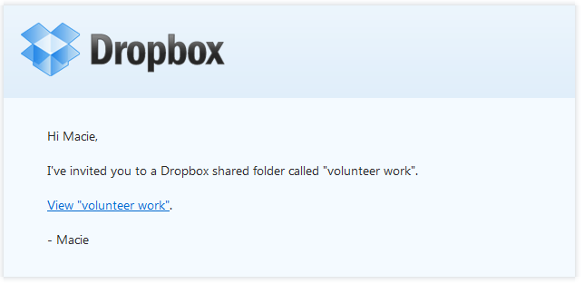

Or alternatively an email like this is a custom message was typed in by the owner:

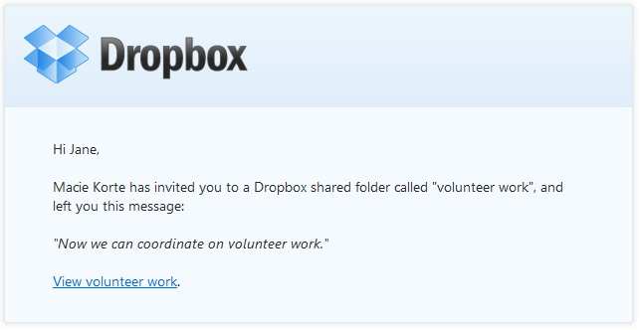

1. When the invited user clicks the “View volunteer work” link, they are brought to the following page where they can accept or deny being added as a collaborator on the folder.  
   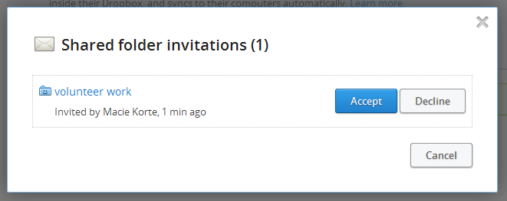  
   If the user declines the invitation, they see:  
   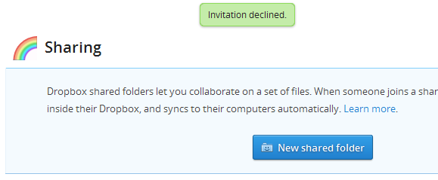  
   If the user tries to view their invitation again after rejecting it in the past, they see:  
     
     
   If the user accepts the invitation, they are shown inside of the directory that is being shared.  
   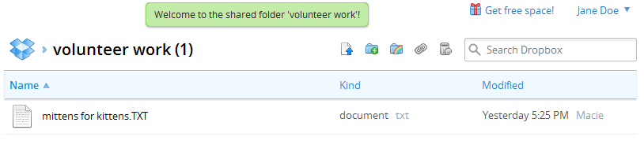
2. If the user has more than one outstanding invitation to join a folder, they are show together on the invitations page:  
   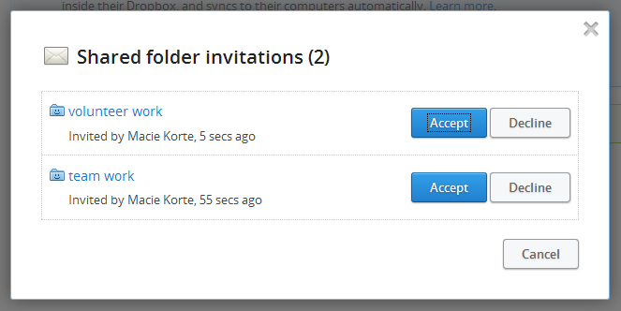  
   The “Shared Contents” page show an alert if there are any outstanding invitations  
   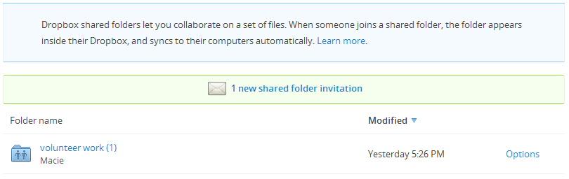
3. When the collaborating user accepts their member invitation, the owner of the group is sent the following notification email:  
   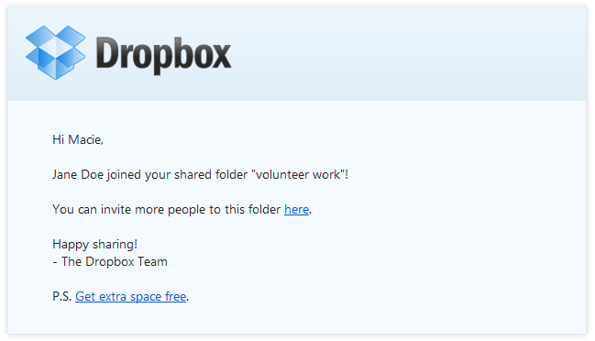
4. Existing member can be kicked out of the folder or elevated to the folder owner by visiting the “existing members” tab. The following view is seen if the logged in user is the owner.  
   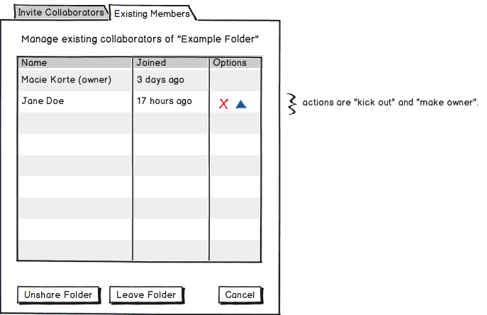  
   Alternatively, a more limited view of the “Existing Members” options page is seen if the logged in user is a collaborative users and not an owner:  
   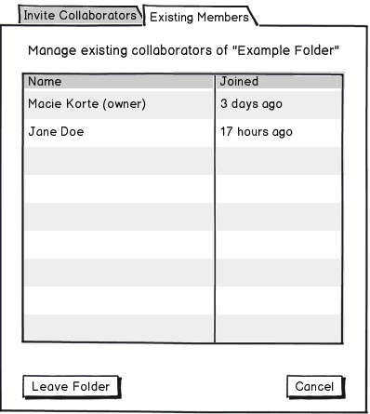

### Kicking People Out

Various reasons for kicking users out of a shared folder include: They no longer work for the company or department. The content in the folder no longer needs to be shared with the user for some reason, the user was acting maliciously in the shared folder and overwriting / renaming content without reason, or they were added accidentally in the first place.

Only the folder owner can kick a collaborative user out of the folder. Even if a different user added the bootable user, still only the owner can remove him. The process is:

1. The owner visits the sharing options page for the folder in question.
2. The owner clicks the “Kick Out” option for the user who needs to be removed.

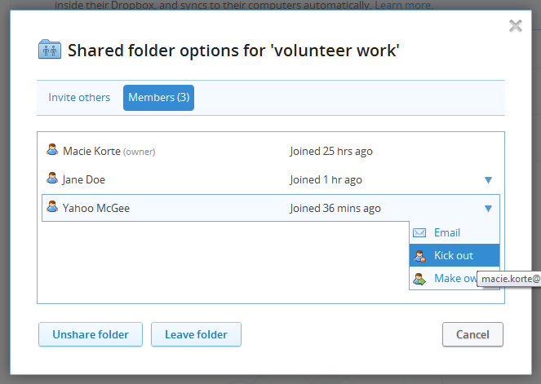

1. The owner confirms the removal of the user.

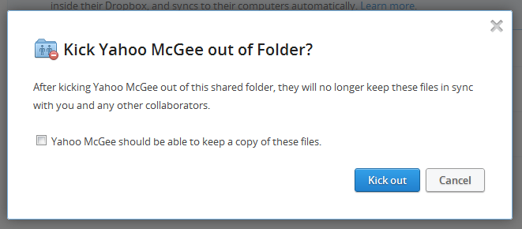  
Notice that the owner is given the option of letting the collaborative user keep historical versions of the documents. This may not be possible (or at least may not be a good idea) for the SparkWeave product. The SparkWeave always has the policy that files only consume the quota of the user who owns them. Therefore only the owner of a shared folder would have space taken up by the contents of that folder. If we kept this options, it would give the owner the ability to force another user to accept files that they don’t want, potentially consuming all of their allotted quota in the process. We could possibly save this options for round #2 of sharing where we could do something clever to get around this.

There is absolutely nothing preventing other collaborative users on the folder from adding the kicked-out user back into the group at any time.

### Collaborators Leaving a Shared Folder

When a collaborator no longer wants access to a shared folder set up by another user, the first step to removing that access is to “soft-delete” or “leave” the folder. The second and final step is to “permanently delete” or “remove” the folder. Just like a normal folder can be “restored”, a shared folder that you have left but not fully removed can be “rejoined”.

You can delete the shared folder from your cabinet browse page using the “delete” option. Immediately after you delete the shared folder, other users will see that you are no longer a member of the group if they check.

When you delete the shared folder, the folder continues to show up when “show deleted files” is toggled on (the same as normal folders would other than that its icon and type indicate it is a shared folder).



Unlike a normal soft-deleted folder, if you do try to click on the folder to explore its contents, you will not be able to. The page it links to will tell you the directory is empty.

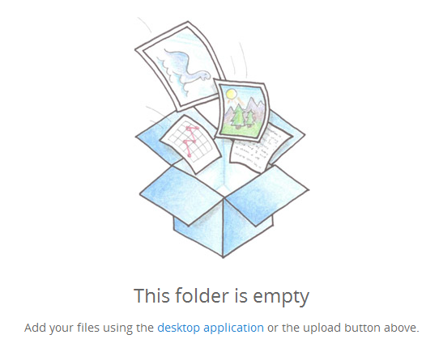

If you do add new content to this empty directory, a normal (i.e. not shared) “team work” folder is created which stomps over the empty shared directory that used to exist in its place.

If you visit the “sharing” page afterwards, the directory can be re-joined or permanently removed from here. Just choose “Past Folders” instead of “Current Folders” from the top-right dropdown, and you will see it.

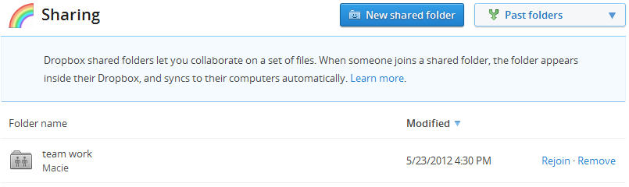

If you choose to rejoin the folder, you will see:

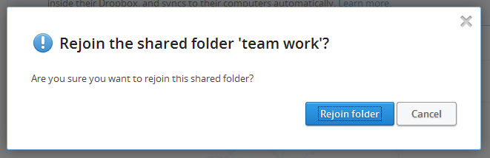

After rejoining the folder, the shared folder will appear in your list of current shared content once again. In this case, the “team work” folder has been renamed to “team work (1)” due to the naming conflict caused by the normal (not shared) team work folder that was recently created.

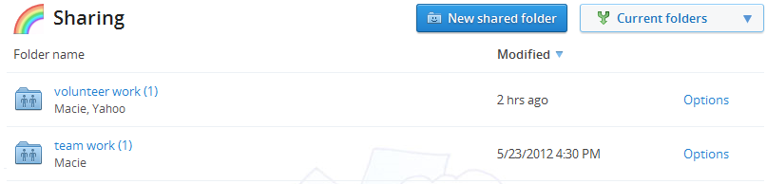

Alternatively, if you had chosen to “Remove” the soft-deleted “team work” directory rather than “Rejoining” it, you would see the following dialog:

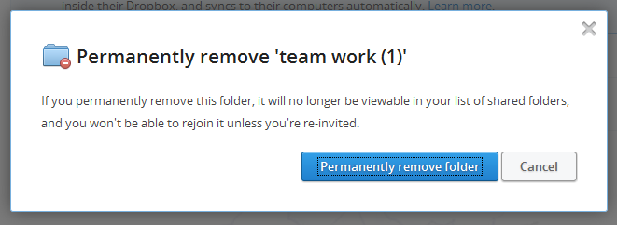

This option is the same as hard-delete. After permanently removing the shared folder, you can no longer see any evidence that it ever existed anywhere, but you can be re-invited to the group at a later time.

The same rejoin vs. remove options can be seen from the cabinet browse page. The text “Rejoin Shared Folder” replaces the usual “Restore” text.

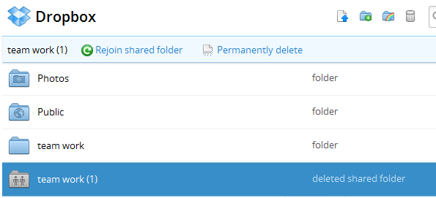

The final way that you can delete a shared folder is to visit the “shared content” page and then click the link for the sharing options on the folder in question.

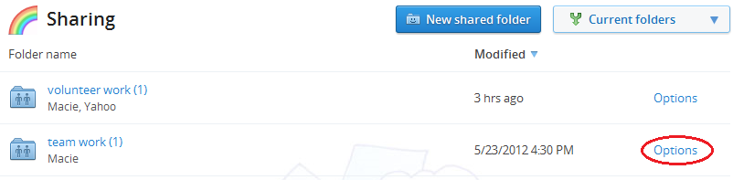

This will bring up the “Members” dialog where you can choose to “Leave Folder”

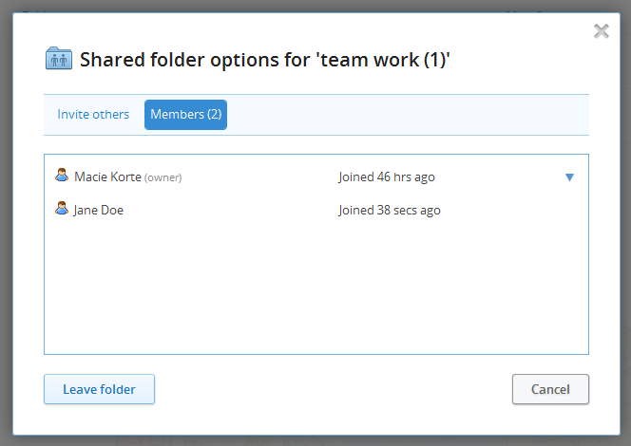

Confirm that you want to leave / soft-delete the folder. The text of this dialog is inaccurate. You will not need to be reinvited back to the folder if you change your mind – You can “rejoin” the group after following through with this action.

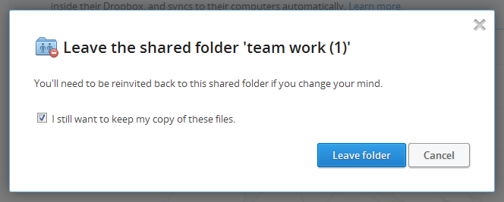

### Owners Leaving a Shared Folder

If the owner of a shared folder wants to leave the folder without removed collaborators’ access to the folder content, they need to start by making someone else the owner. After the new owner accepts their promotion, the old owner can then cut all ties to the shared folder by “leaving” the folder following the same steps a collaborator would (see the previous section).

1. Visit the sharing options on the folder that you want to leave.
2. Click on the “Members” tab.
3. Identify the user in the list whom you would like to transfer ownership to and press the “Make owner” icon next to their name.

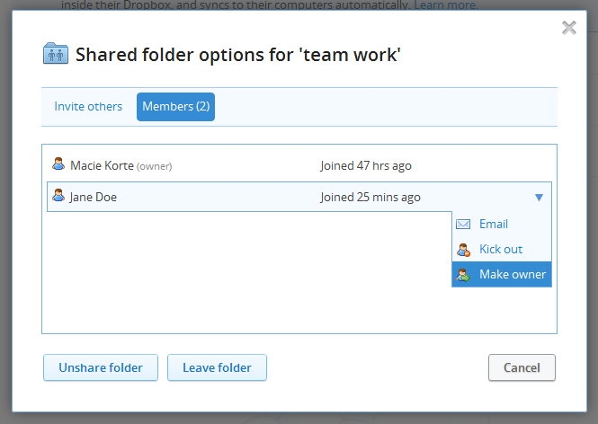

1. Confirm your intentions.

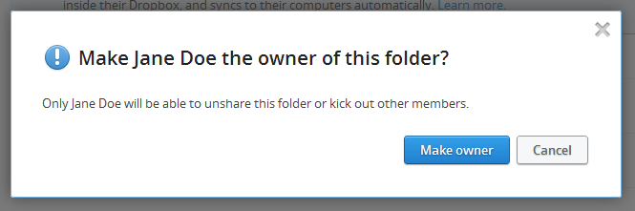

1. You are now officially a collaborator and not the owner of the folder. You can leave the folder any time you want without consequences for other users – see the above section entitled “Collaborators Leaving a Shared Folder”.

### Owners Un-Sharing a Shared Folder

For some reason, you’re sick of sharing your content with other people and want to convert a shared folder back into a private folder. Follow these steps:

1. Locate the folder in question on your “shared content” or cabinet browsing page.
2. Access the shared folder options for this folder.
3. Click on the “Members” tab
4. Click the “Unshare folder” button.

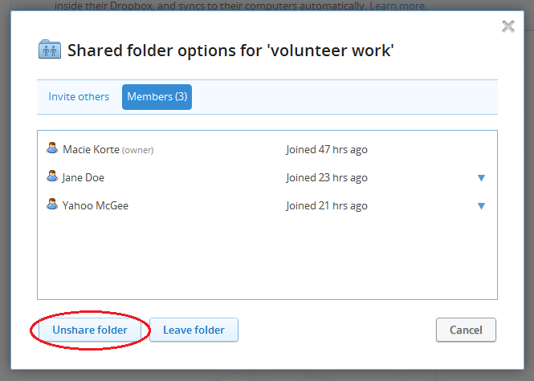

1. This will pop up a confirmation dialog. Click “Unshare folder” again to continue.

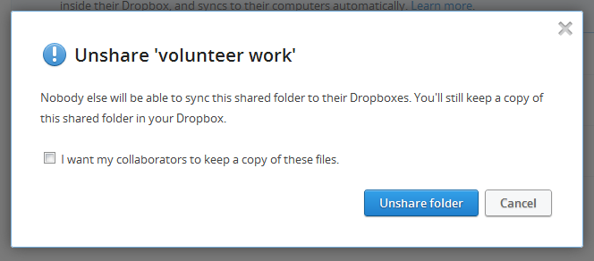

1. At this point, the folder resides on your cabinet browse page as a normal (not shared) folder. There is no indication anywhere that the folder ever was a shared folder. If you or any of the past collaborators visiting the “shared content” page and toggle the view to show “Past folders”, the folder will not be listed there. Collaborators are not notified when they lose access to the folder.

# SparkWeave Differentiation

There are a couple of areas where the SparkWeave shared folder design needs to differentiate from Dropbox’s.

1. Quota Accounting – should only count towards owner’s account
   1. Therefore cannot forcibly update another user to owner without their permission as this may fill up their quota.
2. Cannot get a shared folder in a state where it has no owner. Deleting must either require a new owner to be chosen, or must unshared the folder before deleting it.
3. Rather than only allowing a folder owner to “kick out” a bad user, we may want to allow them to “ban” the user. The difference here would be that the user would be placed on a blacklist and could not be granted access to the folder immediately after being kicked out by a collaborator.
4. An admin-accessible page for identifying and reassigning orphaned shares folders will be made.

# Stage 2 and Beyond

The following brainstormed features will be added after stage #1 of the shared folders project is complete:

1. Provide a guide for users on how to sync a drive to a shared folder which then distributes the files to all users who have access to the folder.
2. Provide some way for admins to auto-provision which users are given access to which shared folders through the user template engine.
3. Give folder owners the options of having all user access decisions go through them or not
   1. If yes, owner should make the accept/deny decision for all users other collaborators ask to add.
   2. If yes, owner should be notified of all accepted folder invitations; even if they did not prompt the original invitation.
4. Read-only users and/or other permission settings.
5. Rather than allowing any user with access to the shared folder to grant new users access, we may want to give the owner final say in all of these decisions. We could design a process for recipient users to make a request to the owner that new users be added to the group. This could prompt the owner through email to “grant” or “deny” the access with one click.
6. Provide additional options for shared-folder-based notifications (following files, and more notifications when users have been added or removed).