The Sequencer Bake-Off
Which platform is telling the truth? Illumina, PacBio HiFi and Oxford Nanopore benchmarked on Genome in a Bottle HG002 (chr20:10-15 Mb)
Introduction to Bioinformatics, Course Project 11. Authors: [Gulnaz SURNAME] and [Inkar SURNAME]. Repository: https://github.com/qasholiq/giab-sequencer-bakeoff. Date of analysis: 6 October 2026.

Summary of the result
We scored three sequencing platforms against a known answer. On a 5 Mb window of human chromosome 20 (7,055 curated true variants), PacBio HiFi recovered almost everything (F-measure 0.9986), Illumina was close behind (0.9903), and Oxford Nanopore, on 2019-era chemistry, lagged clearly (0.9126). The overall numbers hide the real story. Inside repeats, homopolymers and poorly mappable sequence the platforms diverge sharply: Nanopore recovers only 23% of true variants in 7-11 bp homopolymers and 6% in homopolymers of 12 bp or longer, Illumina loses 12% of variants in low-mappability regions where HiFi loses none, and Illumina and HiFi tie on easy sequence.
Re-aligning the same reads with a different aligner changed Illumina's score by 0.007 (almost as much as the entire Illumina-HiFi gap of 0.008) but changed HiFi and Nanopore by less than 0.001. So the Nanopore deficit belongs to the instrument/basecalling/caller chain, whereas part of any Illumina comparison depends on pipeline choices. Per correctly called variant, Illumina is cheapest by roughly an order of magnitude on consumables. All conclusions apply to the high-confidence regions of one sample and one 5 Mb window.

1. Problem and biological framing
Why variant calling matters. Almost every genomic application, from diagnosing inherited disease to tracking tumour evolution and studying populations, starts by finding where an individual's DNA differs from the reference genome. These differences are single-nucleotide variants (SNVs) and short insertions or deletions (indels). A missed variant can be a missed diagnosis; a false variant can send a clinician after a mutation that does not exist.
Why the platform question is hard. Each technology reads DNA in a different physical way and therefore makes characteristic mistakes. Illumina reads are short (here 2 x 250 bp) and very accurate per base, but a short read can map equally well to several places in repetitive sequence. PacBio HiFi reads are long (about 14 kb) and, because each molecule is read many times and collapsed into a consensus, accurate (about Q20 or better). Oxford Nanopore reads can be extremely long (tens of kb here) but infer bases from an electrical signal, which makes insertions and deletions in runs of identical bases (homopolymers) the dominant error. Vendors report accuracy mostly on easy regions, which does not tell a laboratory which platform to trust for which purpose.
Our question. Using the Genome in a Bottle (GIAB) reference individual HG002, for whom the National Institute of Standards and Technology has curated a set of high-confidence variants, we ask: (1) how accurately does each platform recover true variants; (2) in which genomic contexts does each one fail (homopolymers, tandem repeats, low-mappability regions, extreme GC content, segmental duplications); and (3) how much of the observed difference is caused by the aligner rather than by the instrument. A call counts as correct only if it matches the truth set inside the benchmark's high-confidence regions, which deliberately exclude the hardest parts of the genome. Our conclusions therefore apply to those regions and not to the whole genome.
Why these data can answer it. HG002 has been sequenced on all three platforms, the truth set (GIAB v4.2.1) was built by integrating many technologies, and GIAB publishes stratification files that label every position by genomic context. This lets us measure errors rather than quote them.
Predictions. Before interpreting the results we wrote down where each platform should fail (docs/predictions.md, nine predictions P1-P9, scored in Section 5.6). Honest disclosure: that file was committed after the first end-to-end run existed, so it is not blind pre-registration. It is derived from instrument physics and published knowledge, and we judge each prediction on whether the mechanism explains it rather than only whether it matches.

2. Data sources and database work
All data are public and were retrieved on 6 October 2026 (download timestamps 18:04-18:44 in our logs). Retrieval is scripted (scripts/config.sh, get_slices.sh, get_reference.sh, get_truth.sh). Large files are streamed by region from the remote server rather than downloaded in full, and are never committed to Git.
Item | Source and exact file | Release / version
Sample | HG002 (NA24385), Ashkenazi trio son, Coriell GM24385 | GIAB
Illumina | https://ftp-trace.ncbi.nlm.nih.gov/ReferenceSamples/giab/data/AshkenazimTrio/HG002_NA24385_son/ NIST_Illumina_2x250bps/novoalign_bams/HG002.GRCh38.2x250.bam | Novoalign BAM, GRCh38
PacBio HiFi | same base / PacBio_CCS_15kb_20kb_chemistry2/GRCh38/HG002.SequelII.merged_15kb_20kb.pbmm2.GRCh38.haplotag.10x.bam | Sequel II, pbmm2 BAM
Nanopore | same base / UCSC_Ultralong_OxfordNanopore_Promethion/HG002_GRCh38_ONT-UL_UCSC_20200508.phased.bam | PromethION, Guppy 3.2.5 flip-flop, 2020-05-08
Truth variants | https://ftp-trace.ncbi.nlm.nih.gov/ReferenceSamples/giab/release/AshkenazimTrio/HG002_NA24385_son/NISTv4.2.1/GRCh38/HG002_GRCh38_1_22_v4.2.1_benchmark.vcf.gz | GIAB v4.2.1 (not the 2016 v3.2.1 and not the draft v5.0q)
Benchmark regions | same folder: HG002_GRCh38_1_22_v4.2.1_benchmark_noinconsistent.bed, clipped to chr20:10-15 Mb (621 intervals, 4,914,359 bp) | v4.2.1
Reference | GIAB release/references/GRCh38/GCA_000001405.15_GRCh38_no_alt_analysis_set.fasta.gz, chr20 only (64,444,167 bp) | GRCh38 no-ALT analysis set
Stratifications | release/genome-stratifications/v3.6/GRCh38@all/ (LowComplexity: SimpleRepeat_homopolymer_4to6, 7to11, ge12, AllTandemRepeats, notinAllTandemRepeatsandHomopolymers; Mappability: lowmappabilityall, notinlowmappabilityall; GCcontent: gclt25orgt65, gc30to55; SegmentalDuplications: segdups, notinsegdups; Union: alllowmapandsegdupregions) | v3.6; satellites stratum empty in our window and skipped
Window | chr20:10,000,000-15,000,000; 7,248 truth records in the window, 7,055 inside benchmark regions | -
Table 1. Data provenance. Cost inputs (TGen price list, NIH NISC platform yields) are listed in docs/instruments.md with access date 2026-10-06.

2.1 Metadata problems we found and how we handled them
Public archives do not agree with themselves, and checking this is part of the analysis:
- Three BAMs, three different processing histories. The Illumina BAM was aligned with Novoalign to GRCh38_full_plus_hs38d1_analysis_set_minus_alts (its header says so), the PacBio BAM with pbmm2, and the Nanopore BAM with minimap2 using -a -z 600,200 -x map-ont followed by WhatsHap haplotagging. Comparing them as delivered would confound instrument with aligner. We therefore extracted reads and re-aligned all three ourselves to one reference (GRCh38 no-ALT chr20). Contig name (chr20) and length (64,444,167) were identical in all three headers and the reference, which we verified before slicing.
- Internal inconsistency in the Nanopore README. The processing section states Guppy 3.2.5, while the read-group description states Guppy v3.2.4. The README also lists SRA accessions as placeholders (SRX#####) and a data-collection date of 2019-01 for files dated 2020-05-08. We cite the processing section (3.2.5, dna_r9.4.1_450bps_flipflop_prom.cfg) and flag the discrepancy; because no SRA accession exists in the README we could not cross-reference the run in SRA.
- Folder names versus content. The PacBio folder name says chemistry2 and 15kb_20kb; the BAM is Sequel II. We recorded both and measured the actual read-length distribution (mean 14.2 kb, N50 13.6 kb) instead of trusting the label.
- Truth set versions. Three versions are on the server (v3.2.1 from 2016, v4.2.1, draft v5.0q). We chose v4.2.1, the stable release with matching GRCh38 stratifications, and the _noinconsistent benchmark BED.
- Chromosome naming. The stratification files, truth set, reference and BAMs all use the chr20 convention, so no renaming was needed (verified, not assumed).
Honest scope note. This project uses one curated archive family (GIAB hosted on the NCBI FTP, plus GRCh38 under GenBank accession GCA_000001405.15) rather than several independent archives, so the cross-database identifier mapping asked for in the handbook is limited to the checks above. The sample identifier chain we could verify is HG002 / NA24385 / GM24385 across the READMEs.

3. Platform and throughput reasoning
 | Illumina | PacBio HiFi | Nanopore (ultra-long)
Data used | 2 x 250 bp paired-end, Novoalign BAM | CCS 15-20 kb library, Sequel II | UCSC ultra-long, PromethION, R9.4.1, Guppy 3.2.5
Read length (our 30x subsample) | 249 bp mean; insert 407 +/- 89 bp | mean 14.2 kb, N50 13.6 kb (10,434 reads) | mean 19.2 kb, N50 52.5 kb (8,223 reads)
Dominant error | substitutions, low rate | rare and random (consensus) | indels, especially in homopolymers
Mean base quality in slice (samtools coverage) | 37 | 81.3 | 31.2
Original depth in window | 69.36x | 57.25x | 44.66x
Depth used (measured) | 30.0x | 29.4x | 29.6x
Bases in subsample | 0.152 Gb | 0.148 Gb | 0.158 Gb
Cost per Gb (derived) | ~3.14 USD | ~20-30 USD | ~37 USD
What it makes possible / impossible | cheap and accurate on unique sequence; cannot span repeats longer than the read; mapping ambiguous in low-mappability sequence | accurate and long: resolves repeats and phases variants; costs 6-10x more per Gb | spans very long repeats and structural events; 2019 chemistry cannot count homopolymer length
Table 2. Instrument characteristics behind each dataset. The mean base quality values are Phred scores reported in the source BAMs (PacBio values are consensus qualities).
Throughput shapes cost. Equal 30x coverage of a 5 Mb window needs about 0.15 Gb from each platform, but a Nanopore flow cell yields about 40 Gb and a PacBio SMRT cell 60-90 Gb, against about 1 Tb for an Illumina lane. We equalised depth rather than cost, because the project asks what the data can resolve at equal information; Section 5.5 then converts the result to cost per correct variant. Depth equality matters because sensitivity depends on coverage, so unequal depth would have been a confounder.

4. Methods

4.1 Extraction and equal-depth subsampling
For each platform we streamed chr20:10,000,000-15,000,000 from the remote BAM with samtools view (the server's index makes this a few hundred MB, not the 100+ GB file). Slices contained 1,415,738 (Illumina), 20,484 (PacBio) and 13,100 (Nanopore) records. Mean depth was measured with samtools coverage (69.36x, 57.25x, 44.66x). To equalise to 30x we subsampled with samtools view -s using seed 42 and fractions 30/measured depth (0.4325, 0.5240, 0.6717), after removing secondary and supplementary records (-F 0x900). For Illumina, -s hashes the read name, so both mates of a pair are kept together; 496 singleton mates were discarded and 305,447 pairs written. The result was converted to FASTQ (scripts/make_fastq.sh). Measured depth after re-alignment was 30.0x, 29.4x and 29.6x, so the comparison is fair to within about 2%.

4.2 Quality control of short reads
Quantities we measured directly from the data and the threshold decisions they support:
- Insert size and orientation (bwa-mem2 log). Insert size percentiles (25/50/75) were 349/403/464 bp, mean 407 and standard deviation 89 (low/high bounds for proper pairs 4-809 bp). With 2 x 250 bp reads and a 400 bp insert, mates overlap, so overlap-aware handling and a maximum insert well above 500 bp are justified.
- Mapping rate. 99.94% of Illumina records mapped (612,598 of 612,994; 2,100 supplementary), i.e. no read-level filtering was needed to remove unmapped reads.
- Base quality. The slice's mean base quality was 37 and mean mapping quality 69.9 (Novoalign scale). We did not filter on base quality because Clair3 uses base quality as a model input; trimming would change its input distribution.
[TO COMPLETE] Run bash scripts/qc.sh (fastp, FastQC, NanoPlot, seqkit; report-only) on Gulnaz's machine and paste into this section: Illumina Q30 fraction, adapter-trimmed read fraction, duplication rate, and the insert-size peak from fastp, plus FastQC per-base quality at read ends (250 bp reads usually show decay in the last 30-50 cycles and read-through adapter on inserts shorter than 250 bp). For each number state the threshold it implies (for example: trim to Q20 only if more than X% of bases fall below it) and why we did or did not apply it. The handbook gives 7 points to NGS QC with numeric justification, and this is the one section that cannot be written from existing logs.

4.3 Quality control of long reads
Measured: PacBio mean length 14,218 bp and N50 13,606 bp; Nanopore mean 19,237 bp and N50 52,539 bp (results/read_stats.txt). The very different N50/mean ratios (0.96 for HiFi, 2.7 for Nanopore) reflect the size-selected HiFi library versus the ultra-long Nanopore library with a heavy tail of very long reads. Long reads were not trimmed or length-filtered because the aligner's chaining already handles chimeric segments (we kept secondary and supplementary records out of FASTQ), and because a minimum-length cut-off would preferentially drop reads in repeats-rich regions.
[TO COMPLETE] Paste from results/qc/qc_summary.txt: mean and median read quality and the fraction of reads above Q10/Q15 for Nanopore and PacBio (NanoStats.txt), and one sentence comparing the Nanopore quality distribution (about Q10-12 expected for Guppy 3.2.5 flip-flop) against the HiFi consensus.

4.4 Alignment
Platform | Main aligner and parameters (why) | Swap aligner and parameters (why)
Illumina | bwa-mem2 2.2.1 mem, defaults, 8 threads. Seed-and-extend with FM-index; the standard for 100-250 bp reads (insert 407 bp, proper-pair bounds estimated from data). | Bowtie2 2.5.5 --very-sensitive, 4 threads. Different algorithm (end-to-end FM-index with no soft clipping by default), reaching 99.13% overall alignment but only 80.3% concordant unique pairs.
PacBio HiFi | minimap2 2.31 -ax map-hifi: minimizers k=19, w=19; designed for reads at about 99.9% accuracy. | Winnowmap 2.03 -ax map-pb -W repetitive_k15.txt: k=15 with weighted minimizers that down-weight 8,543 high-copy k-mers. We could not verify that map-pb is the optimal Winnowmap preset for HiFi; treat as a limitation.
Nanopore | minimap2 -ax map-ont: k=15, w=10; tolerates 5-10% error. | Winnowmap -ax map-ont -W repetitive_k15.txt. Repetitive k-mer list built with meryl (k=15, top 0.02% of distinct k-mers, count threshold 175) from chr20 only.
Table 3. Aligners. Read groups were set per run; all alignments sorted and indexed with samtools 1.24.

4.5 Variant calling
All three call sets were produced with Clair3 v2.0.3, restricted to the window (--bed_fn, --ctg_name=chr20), using the platform-matched model: ilmn, hifi_sequel2 and ont. Using a single caller family removes caller identity as a variable, while the per-platform model (necessary because the long-read error profile differs) is part of what a platform comparison legitimately includes.

4.6 Benchmarking against truth
Calls were compared with the GIAB v4.2.1 truth using RTG Tools 3.13 vcfeval, which matches variants by haplotype rather than by string and so does not penalise equivalent representations of an indel. Evaluation was restricted to the benchmark BED. For each call set vcfeval selects the QUAL threshold that maximises F-measure (Illumina 5, PacBio 7, Nanopore 13). Precision = TP/(TP+FP), sensitivity = TP/(TP+FN), F = harmonic mean. We also report the unfiltered ("None") row. The selected thresholds use the truth set, so the F-measures are optimistic; the unfiltered rows are the unbiased alternative.
For stratified results the same filtered call sets were scored inside the intersection of the benchmark BED and each stratification BED (merged with bedtools). We use Wilson 95% intervals on sensitivity, computed from the truth-variant counts, to show which differences exceed sampling noise. Strata overlap each other (for example, homopolymers of 4-6 bp lie inside the 'not in repeats' stratum), so strata must not be summed.

4.7 Separating aligner error from sequencer error
The same FASTQ files (identical reads) were aligned by a second aligner (Table 3), called with the same Clair3 model, scored with vcfeval and stratified identically. Any change in F is attributable to the aligner. A control was needed for Bowtie2: Clair3's log showed that its full-alignment step produced no output for one chunk, so only pileup calls were finalised. To test whether this, rather than the aligner, caused the drop, we scored the pileup-only VCF of the BWA-MEM2 run. It gave exactly the same result as the merged BWA-MEM2 output (TP 6,969, FP 50, FN 86, F 0.9903), so the missing full-alignment step is not what separates Bowtie2 from BWA-MEM2. Why Clair3's full-alignment step returned nothing for the Bowtie2 BAM remains unexplained.

4.8 Engineering, resources and reproducibility
Everything runs on a laptop-class WSL2 machine (16 logical cores, 7.4 GB RAM). Region streaming and subsampling keep the working set to about 0.5 GB of BAM per run. Runtime and peak memory were measured with /usr/bin/time -v (Table 4).
Step (platform) | Wall time | Peak memory | Threads
bwa-mem2 index chr20 (once) | 21 s | - | 8
bwa-mem2 mem (Illumina) | 14.6 s | - | 8
minimap2 map-hifi (PacBio) | 8.2 s | 1.18 GB | 8
minimap2 map-ont (Nanopore) | 16.1 s | 3.34 GB | 8
Winnowmap map-pb / map-ont | 14.1 s / 38.5 s | 0.82 GB / 3.94 GB | 4
Clair3, Illumina (30x, 5 Mb) | 60.8 s (99 s CPU) | 0.33 GB | 4
Clair3, PacBio | 38.1 s (55 s CPU) | 0.56 GB | 4
Clair3, Nanopore | 392 s (955 s CPU) | 0.93 GB | 4
Table 4. Measured resource use. Clair3 on Nanopore takes 6.4x the wall time of Illumina and 10x that of PacBio at equal depth, plausibly because noisy long reads yield many more candidate sites for the full-alignment network (9,138 PASS calls versus 7,802 and 8,001), though we did not isolate the cause. Scaling linearly, a full 3.1 Gb genome is about 600 times the window.
Reproducibility. Conda environments are exported in envs/ (bake.yml, calling.yml). A Snakemake workflow (Snakefile) encodes the call, evaluate, stratify and plot dependencies. A 200 kb test dataset (chr20:10.0-10.2 Mb; 18 MB of BAMs, truth subset and benchmark BED) is in test_data/, and one command, `bash scripts/run_test.sh`, re-runs calling and scoring for all three platforms in about 70 seconds (Illumina F 0.9942, PacBio 1.0000, Nanopore 0.9289 on the test slice). Appendix A lists the full run order.

5. Results

5.1 Overall accuracy
Call set | QUAL cut | TP | FP | FN | Precision | Sensitivity | F
Illumina (BWA-MEM2) | 5 | 6,969 | 50 | 86 | 0.9929 | 0.9878 | 0.9903
PacBio HiFi (minimap2) | 7 | 7,044 | 9 | 11 | 0.9987 | 0.9984 | 0.9986
Nanopore (minimap2) | 13 | 6,066 | 173 | 989 | 0.9723 | 0.8598 | 0.9126
Illumina, unfiltered | none | 6,969 | 53 | 86 | 0.9925 | 0.9878 | 0.9901
PacBio, unfiltered | none | 7,046 | 13 | 9 | 0.9982 | 0.9987 | 0.9984
Nanopore, unfiltered | none | 6,331 | 2,104 | 724 | 0.7506 | 0.8974 | 0.8174
Table 5. Benchmark of 7,055 truth variants. TP = true positives (counted against the truth), FP = false positives, FN = missed truth variants. The Nanopore F-measure drops from 0.913 to 0.817 without a QUAL filter because precision falls to 0.75: the platform's raw calls contain a large number of false indels, and its usable accuracy depends on a quality filter.

5.2 Where each platform fails
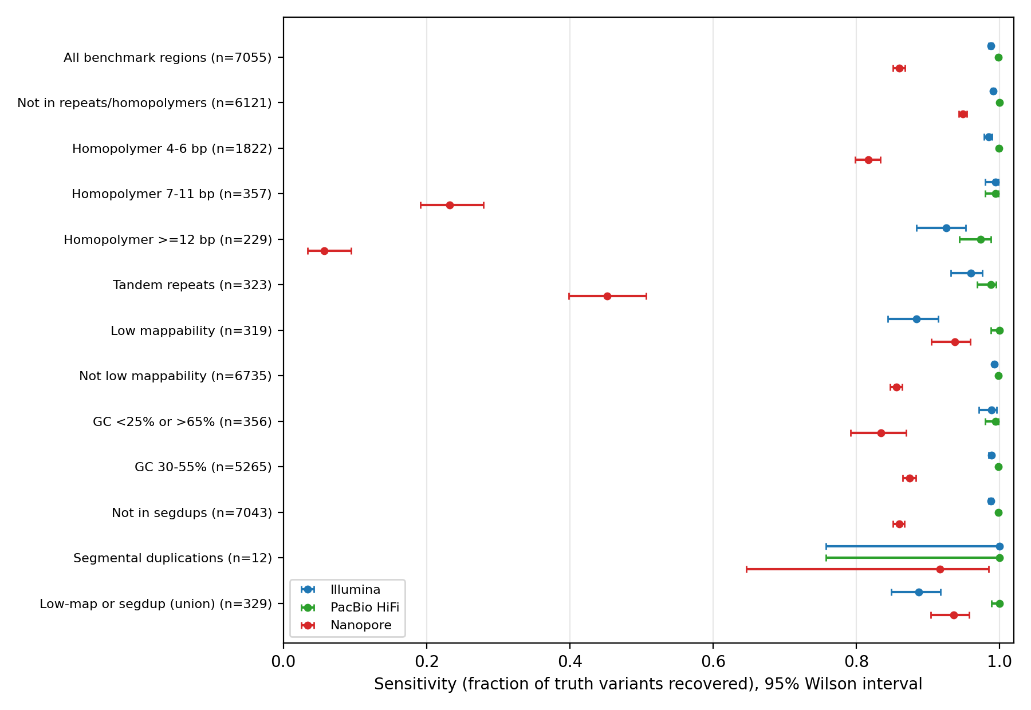
Figure 1. Sensitivity (recovered fraction of truth variants) by genomic context, with 95% Wilson intervals. n = number of truth variants in the stratum. The segmental duplication stratum has only 12 variants and its intervals are too wide to support any conclusion.
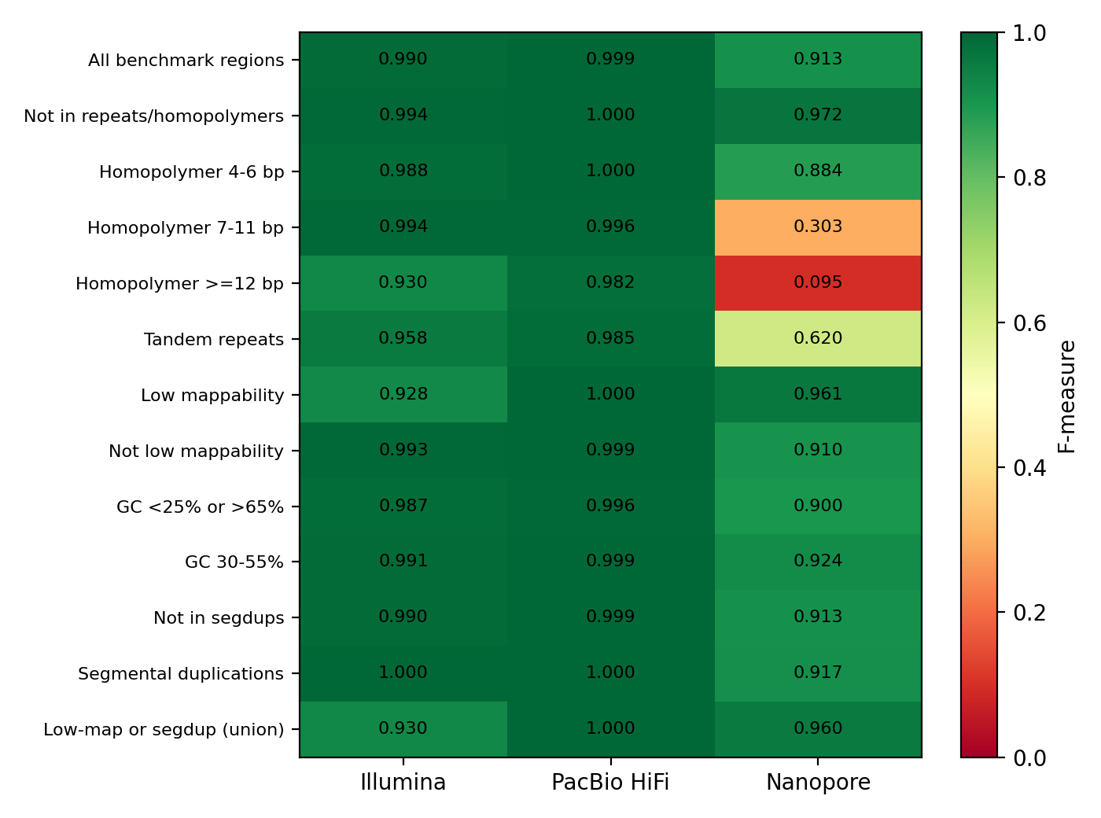
Figure 2. F-measure by context and platform. Strata overlap, so rows are not independent.
Four patterns stand out:
- Easy sequence is a tie at the top. Outside repeats and homopolymers, Illumina F is 0.9940 and HiFi 1.0000 (6,121 variants); even Nanopore reaches 0.9715. Most of the headline gap is therefore made in hard contexts.
- Nanopore collapses in homopolymers. Sensitivity is 0.817 in 4-6 bp runs, 0.232 in 7-11 bp (95% interval 0.19-0.28) and 0.057 in runs of 12 bp or more (0.03-0.09); F falls to 0.304 and 0.095. HiFi (0.996, 0.982) and Illumina (0.994, 0.930) hold up. For Nanopore this is a signal-to-base-calling limit, and the aligner swap leaves it unchanged (Section 5.3).
- Short reads lose ground where mapping is ambiguous. In low-mappability regions Illumina sensitivity is 0.884 (0.844-0.915) against 1.000 (0.988-1.000) for HiFi and 0.937 for Nanopore. In tandem repeats Nanopore has high precision (0.986) but only 0.452 sensitivity, since indel errors in repeat units hide true variants, while Illumina (0.960) and HiFi (0.988) are similar, with overlapping intervals.
- GC extremes barely matter in this window. Illumina F is 0.987 in extreme-GC regions against 0.991 in normal GC (intervals overlap), so we cannot claim GC bias here.

5.3 How much is the aligner, how much the instrument?
Platform | Main -> swap | TP | FP | FN | F (main) | F (swap) | Change
Illumina | BWA-MEM2 -> Bowtie2 | 6,969 -> 6,867 | 50 -> 43 | 86 -> 188 | 0.9903 | 0.9835 | -0.0068
PacBio HiFi | minimap2 -> Winnowmap | 7,044 -> 7,046 | 9 -> 10 | 11 -> 9 | 0.9986 | 0.9987 | +0.0001
Nanopore | minimap2 -> Winnowmap | 6,066 -> 6,104 | 173 -> 220 | 989 -> 951 | 0.9126 | 0.9125 | -0.0001
Table 6. Aligner swap on identical reads (same caller and model).
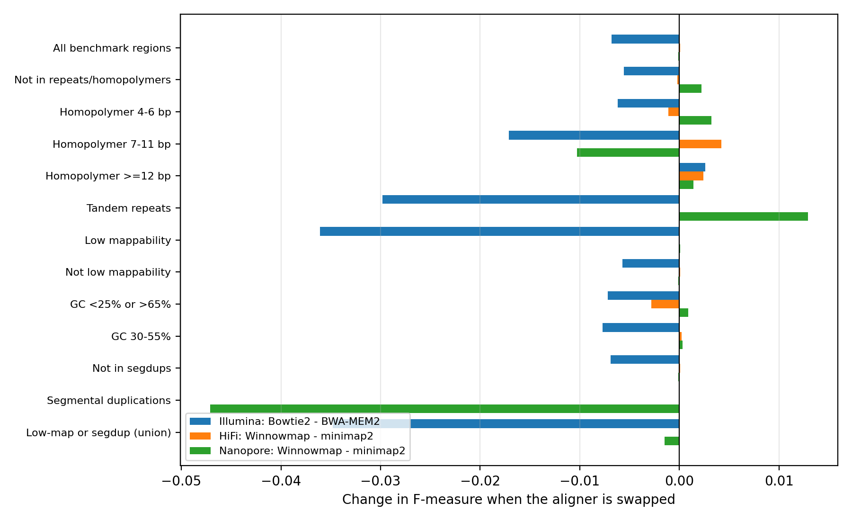
Figure 3. Change in F-measure when the aligner is replaced, by context.
Illumina depends on the aligner; the long-read results do not. Bowtie2 lost 102 additional true variants (FN 86 to 188) while removing seven false positives. The loss was concentrated where mapping is hard: F fell by 0.036 in low-mappability regions, 0.035 in the low-mappability-or-segdup union, 0.030 in tandem repeats and 0.017 in 7-11 bp homopolymers, but only 0.006 in easy sequence. This is the mechanistic signature expected if reads are placed less reliably in ambiguous regions. Part of this deficit may be our untuned Bowtie2 run: 17.3% of pairs aligned non-concordantly (of which 86% discordantly), a pattern typical of mates that overlap or extend past each other because the 250 bp reads exceed a 407 bp insert's half-length; Bowtie2's --dovetail option was not used and is the first thing we would try.
For HiFi and Nanopore the swap moved F by 0.0001, and per-stratum changes were mostly within 0.003, except the tiny segmental duplication stratum (12 variants; Nanopore 0.917 to 0.870 is a change of one variant). Interpretation: the Nanopore deficit of 0.086 relative to HiFi is not an alignment artefact; it belongs to the instrument, its base calling (Guppy 3.2.5, 2019) and the caller's model. In contrast, a change of aligner on Illumina (0.007) is almost as large as the Illumina-HiFi difference (0.008), so a published Illumina-versus-HiFi ranking depends on which aligner was used.

5.4 Resource use
See Table 4. All steps ran on a laptop in minutes for 5 Mb; Nanopore consistently needs the most memory and CPU time, in alignment (3.3-3.9 GB) as well as calling (392 s).

5.5 Cost per correctly called variant
Multiplying bases used (0.152, 0.148 and 0.158 Gb) by the derived cost per Gb and dividing by true positives gives roughly USD 0.07 per 1,000 correct variants for Illumina, 0.42-0.64 for PacBio HiFi and 0.97 for Nanopore (scripts/cost_per_variant.py). Illumina is 6-14 times cheaper than the long-read platforms on consumables.
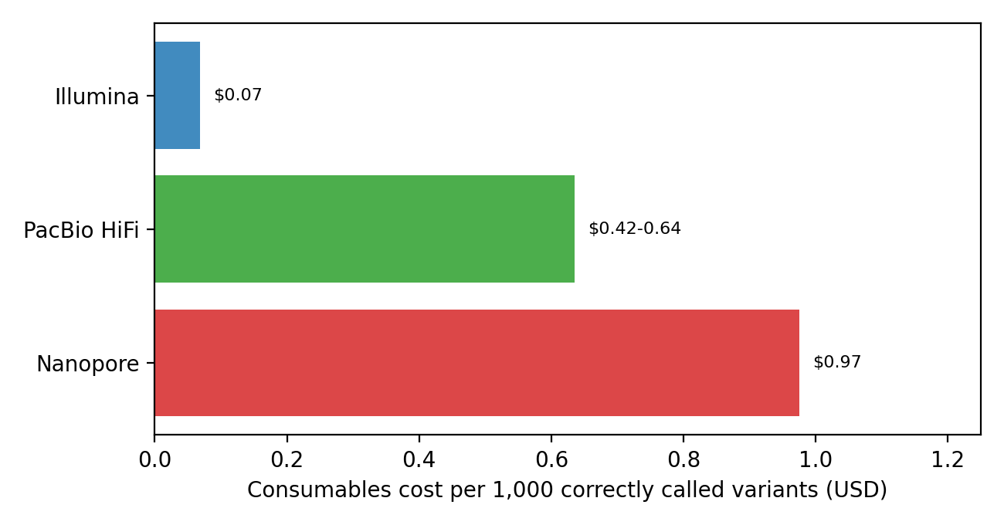
Figure 4. Consumables cost per 1,000 correct variants. Cost per Gb is our own calculation (price / yield from two core facilities); it excludes library preparation, labour and compute, and the Nanopore price is for newer R10.4.1 flow cells while our data are 2019-20 chemistry. Treat the order of magnitude, not the decimals, as the result.

5.6 Scorecard of our predictions
# | Prediction | Verdict | Evidence
P1 | Overall F: HiFi >= Illumina > ONT | Confirmed | 0.9986 >= 0.9903 > 0.9126
P2 | Easy regions: Illumina and HiFi both >0.99; ONT lower but decent | Confirmed | 0.9940 / 1.0000 / 0.9715
P3 | Homopolymers >=7 bp: ONT collapses; Illumina degrades mildly; HiFi high | Mostly | ONT 0.304; HiFi 0.996; Illumina 0.994 (no degradation at 7-11 bp)
P4 | Homopolymers >=12 bp: ONT near failure; Illumina worse than in short runs | Confirmed | ONT 0.095; Illumina sensitivity 0.926 vs 0.994 (intervals do not overlap)
P5 | Tandem repeats: Illumina loses sensitivity; HiFi best; ONT precise but low recall | Mostly | ONT precision 0.986, sensitivity 0.452; Illumina 0.960 vs HiFi 0.988 (intervals overlap)
P6 | Low mappability: Illumina loses sensitivity; long reads far better | Confirmed | Illumina 0.884; HiFi 1.000; ONT 0.937
P7 | GC extremes: Illumina drops, HiFi unaffected | Rejected | Illumina F 0.987 vs 0.991 in normal GC
P8 | Part of the Illumina and ONT deficit comes from the aligner | Partly | Illumina yes (-0.007); ONT no (-0.0001)
P9 | Cost per correct variant: Illumina cheapest; HiFi most expensive per Gb; ONT in between | Partly rejected | Illumina cheapest, but ONT (USD 0.97) costs more than HiFi (0.42-0.64) per 1,000 correct
Table 7. Predictions versus measurements. Falsification criteria we set in advance (ONT beating Illumina in homopolymers, Illumina matching HiFi in low mappability and tandem repeats, aligner swap changing no calls) were not met.
Negative results explained: P7 failed most likely because this 5 Mb window contains few extreme-GC variants (356 in total) and because GC bias in modern PCR-free Illumina libraries is small; we cannot tell which. P9 failed because Nanopore's derived price per Gb exceeds PacBio's in our price lists while its lower sensitivity reduces the number of correct variants per Gb.

5.7 The consumer-report verdict
If you need... | Choose | Evidence and caveat
Highest accuracy for small variants anywhere in the benchmark, especially repeats and poorly mappable regions | PacBio HiFi | F 0.9986 overall, 1.000 in low-mappability, 0.985 in tandem repeats; 6-9x higher cost per correct variant than Illumina
Cost-efficient SNV/indel calling in unique sequence | Illumina 2x250 with BWA-MEM2 | F 0.994 outside repeats; USD ~0.07 per 1,000 correct variants; accept losing about 12% of variants in low-mappability regions
Anything involving homopolymer-rich sequence or small indels | Not 2019-era Nanopore | F 0.30 and 0.095 in homopolymers of 7-11 and >=12 bp; newer R10.4.1 chemistry was not tested
Structural variants, very long repeats, phasing | Long reads (not tested here) | Our design covers small variants only; Nanopore's ultra-long reads (N50 52.5 kb) are its strength
Table 8. Which platform for which purpose, limited to the evidence in this project.

6. Limitations
These are listed without being prompted, because several of them could change the ranking.
- One sample and one 5 Mb window of one chromosome (chr20:10-15 Mb), inside the benchmark's high-confidence regions only. The hardest genome (centromeres, segmental duplications, major histocompatibility region) is excluded by construction.
- Reads were derived from existing alignments, not raw instrument output. We extracted reads that the original aligners placed in the window. Reads from regions the original aligners failed to place, or placed elsewhere, are missing, which can bias hard regions in favour of whichever original aligner placed the most reads. This is the same selection effect for all three platforms but it is not identical in size.
- Optimistic thresholds. QUAL cut-offs were chosen by maximising F against the truth, so reported F-measures are upper bounds; the unfiltered rows are shown for Nanopore, where the difference is large (0.913 versus 0.817).
- Possible training overlap. Clair3's pre-trained models were trained on GIAB samples, possibly including HG002 and possibly with chr20 held out. We could not verify this; if HG002 was in training, all F-measures are optimistic, possibly by different amounts per model.
- Model/data mismatch. The ilmn model is not documented here as trained on 2 x 250 bp reads, and the ont model matches R9.4.1 data but not necessarily Guppy 3.2.5 flip-flop output, so the Illumina and Nanopore numbers may understate what a better-matched caller could achieve.
- Nanopore data are 2019-20 chemistry (R9.4.1, Guppy 3.2.5). Current R10.4.1 duplex or super-accuracy data improve homopolymer accuracy substantially, so the Nanopore verdict must not be extrapolated to today's product.
- Aligner swap tested one alternative per platform, with untuned Bowtie2 (no --dovetail), an unverified Winnowmap preset for HiFi, and a repetitive-k-mer list built from chr20 only. A negative effect for Bowtie2 is partly a tuning effect. The unexplained empty full-alignment chunk in Clair3's Bowtie2 run is unresolved.
- Small strata. Homopolymers of 12 bp or longer (229 variants) and segmental duplications (12 variants) are too small for firm conclusions; strata overlap; no multiple-testing correction was applied; and differences of two or three variants (all HiFi aligner comparisons) are noise.
- Single subsample replicate. We used one seed (42); variance across subsamples was not measured, so differences of a few variants between runs should not be over-read.
- Cost estimates are derived from two core-facility lists, exclude library preparation, labour and compute, and the Nanopore price is for newer chemistry.
- Predictions were not truly pre-registered (Section 1).
- Short-read QC numbers pending in Section 4.2 and 4.3 until scripts/qc.sh is run.

7. Conclusion
On the high-confidence regions of chr20:10-15 Mb of HG002, PacBio HiFi is the most accurate platform for small variants (F 0.9986), Illumina is nearly as good on unique sequence (0.994) at a fraction of the cost per correct variant, and 2019-era Nanopore data are markedly less accurate (0.913), mainly because of homopolymers (F 0.30 at 7-11 bp) and repeats. Platforms tie on easy sequence and diverge in hard contexts, so a single accuracy figure is misleading. Re-aligning the same reads showed that Illumina's result depends on the aligner (by 0.007, comparable to the Illumina-HiFi gap), while the Nanopore deficit is not an alignment artefact. We cannot generalise beyond one sample, one window and the call-set chain used here, and a second sample (HG003 or HG004) plus a current Nanopore dataset are the obvious next experiments. Our practical advice is to stratify before comparing platforms, to hold the aligner constant or test it, and to report unfiltered as well as optimised scores.

8. Contribution statement
Written from the commit history at the time of writing (25 commits: 18 by Gulnaz, 7 by Inkar; the initial repository commit under the account name qasholiq belongs to Gulnaz, see .mailmap). Gulnaz led the data and analysis pipeline: remote region slicing and depth measurement, subsampling and FASTQ conversion, alignment with BWA-MEM2 and minimap2, truth-set retrieval, Clair3 calling, vcfeval scoring, stratified benchmarking and its figure, the Bowtie2 and Winnowmap aligner swap and its control, timing measurements, the 200 kb test dataset and one-command test script, and the first README. Inkar set up the WSL2 and Miniforge environment and the Bowtie2/QC/hap.py tool installations, wrote the Snakemake workflow, the instrument table with the sourced cost-per-Gb figures, the prediction document and the Problem and Data sections of the report outline. The final report text, figure and cost calculations, and repository fixes were drafted with AI assistance (Appendix B) and reviewed by both authors. [Edit this paragraph so it matches what each of you did before submission; both of you must be able to explain every part.]

Appendix A. Reproduction
- Clone the repository and create the environment: conda env create -n calling -f envs/calling.yml && conda activate calling.
- Fetch the reference: bash scripts/get_reference.sh (chr20 only, streamed).
- Quick verification (about 70 s, headline command): bash scripts/run_test.sh.
- Full run: bash scripts/get_slices.sh, bash scripts/get_truth.sh, bash scripts/make_fastq.sh, bash scripts/align.sh, bash scripts/qc.sh, then snakemake -c4 (calling, evaluation, stratification, plot) and bash scripts/align_winnowmap.sh plus the Bowtie2 commands for the swap.
- Report figures: python scripts/make_report_figures.py; cost: python scripts/cost_per_variant.py.

Appendix B. AI assistance disclosure
We used Claude (Anthropic) throughout the project for: explaining the handbook and choosing a topic; generating and debugging shell, Snakemake and Python scripts (data slicing, subsampling, alignment, Clair3 and vcfeval commands, stratification, plotting); resolving Git and conda problems; interpreting results and suggesting controls (the Bowtie2 pileup control, Wilson intervals); and drafting this report, the README and the scorecard from our measured outputs. All commands were run by us on our own machines and all numbers in this report come from our logs and result files. Both authors take responsibility for every line and can explain it. [Add any other tool one of you used, for example a second AI assistant, a translation tool or a grammar checker, and for what.]

Appendix C. Provenance of cost inputs
Illumina: NovaSeq X Plus 25B lane, 300 cycles, USD 3,136.63 (TGen academic price list 2026-27), yield about 1 Tb (NIH NISC platforms page). PacBio: Revio SMRT cell USD 1,809.43 (TGen 2026-27), 60-90 Gb per cell (NIH NISC). Nanopore: PromethION R10.4.1 flow cell USD 1,494.63 (TGen 2024-25), about 40 Gb per cell for ultra-long libraries (NIH NISC). Access date 2026-10-06; derived values: USD 3.14, 20.10-30.16 and 37.37 per Gb.

