Prove Phase 1 is working
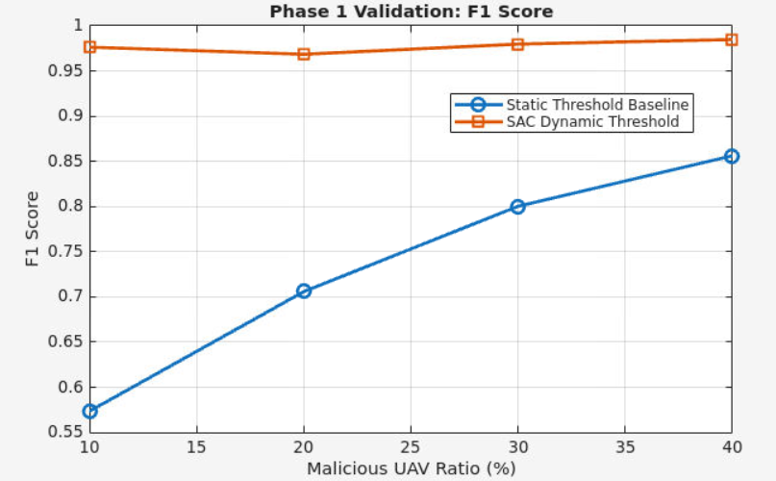
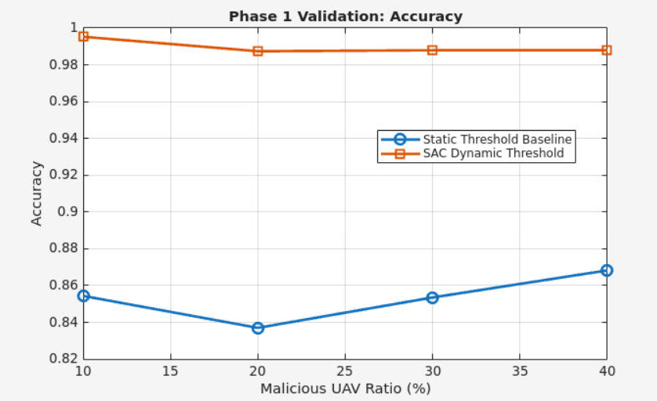
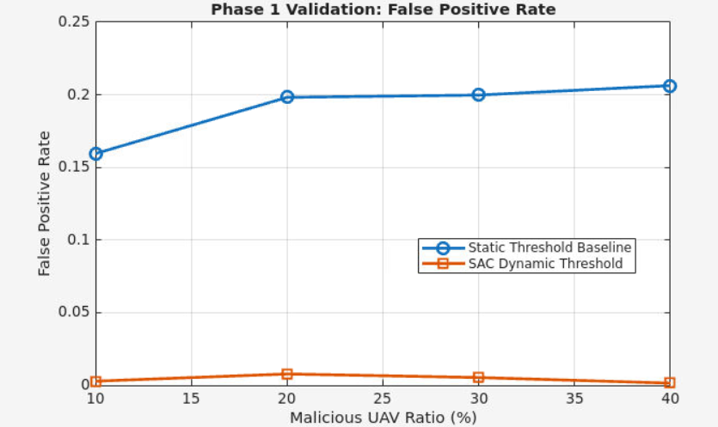
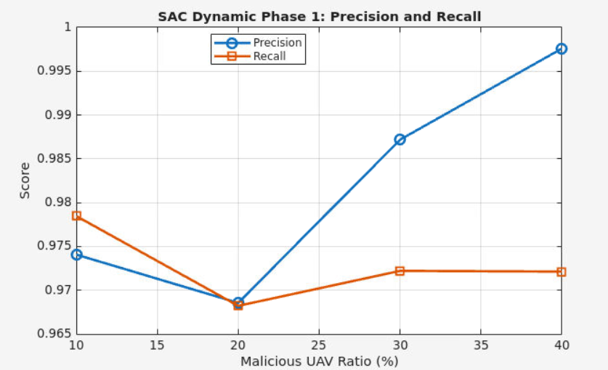
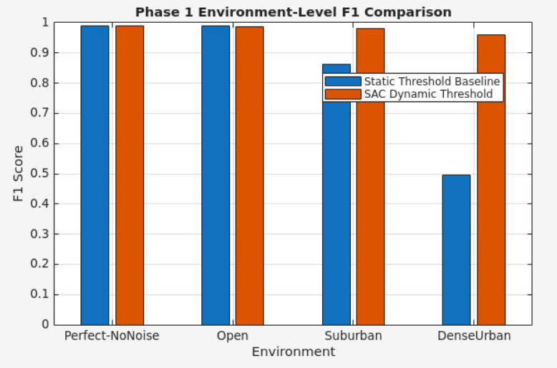

Phase 1 Validation: Static Threshold vs SAC Dynamic Threshold
Overall results by malicious ratio
Malicious UAV Ratio | Method | Accuracy | Precision | Recall | F1 Score | FP Rate | FN Rate
10% | Static Threshold Baseline | 0.85437 | 0.40552 | 0.97917 | 0.57352 | 0.15949 | 0.02083
10% | SAC Dynamic Threshold | 0.99524 | 0.97408 | 0.97847 | 0.97627 | 0.00289 | 0.02153
20% | Static Threshold Baseline | 0.83701 | 0.55225 | 0.97795 | 0.70589 | 0.19822 | 0.02205
20% | SAC Dynamic Threshold | 0.98736 | 0.96857 | 0.96823 | 0.96840 | 0.00786 | 0.03177
30% | Static Threshold Baseline | 0.85354 | 0.67719 | 0.97801 | 0.80027 | 0.19980 | 0.02199
30% | SAC Dynamic Threshold | 0.98788 | 0.98719 | 0.97222 | 0.97965 | 0.00541 | 0.02778
40% | Static Threshold Baseline | 0.86826 | 0.76003 | 0.98012 | 0.85616 | 0.20631 | 0.01988
40% | SAC Dynamic Threshold | 0.98792 | 0.99759 | 0.97214 | 0.98470 | 0.00156 | 0.02787

The SAC dynamic threshold greatly improves F1 score and reduces false positives compared with the static threshold baseline. For example, at 10% malicious UAVs, the F1 score improves from 0.57352 to 0.97627, while the false-positive rate drops from 0.15949 to 0.00289. At 40% malicious UAVs, SAC still maintains a high F1 score of 0.98470 and a very low false-positive rate of 0.00156.
Improvement table: SAC minus static baseline
Malicious UAV Ratio | Δ Accuracy | Δ Precision | Δ Recall | Δ F1 Score | Δ FP Rate | Δ FN Rate
10% | +0.14087 | +0.56855 | -0.00069 | +0.40275 | -0.15660 | +0.00069
20% | +0.15035 | +0.41631 | -0.00972 | +0.26251 | -0.19036 | +0.00972
30% | +0.13434 | +0.31000 | -0.00579 | +0.17938 | -0.19439 | +0.00579
40% | +0.11965 | +0.23757 | -0.00799 | +0.12854 | -0.20475 | +0.00799

The improvement table shows the main tradeoff. The static threshold has slightly higher recall in some cases, but it creates many false positives. SAC slightly reduces recall in some ratios, but it strongly improves precision, accuracy, F1 score, and false-positive rate. This means SAC is less aggressive and more reliable for avoiding incorrect malicious labels on benign UAVs.
Environment-level Phase 1 results
Environment | Method | Accuracy | Precision | Recall | F1 Score | FP Rate | FN Rate
Perfect-NoNoise | Static Threshold Baseline | 0.99420 | 1.00000 | 0.97681 | 0.98827 | 0.00000 | 0.02319
Perfect-NoNoise | SAC Dynamic Threshold | 0.99486 | 1.00000 | 0.97944 | 0.98962 | 0.00000 | 0.02056
Open | Static Threshold Baseline | 0.99458 | 1.00000 | 0.97833 | 0.98905 | 0.00000 | 0.02167
Open | SAC Dynamic Threshold | 0.99299 | 0.99309 | 0.97875 | 0.98587 | 0.00227 | 0.02125
Suburban | Static Threshold Baseline | 0.92188 | 0.77037 | 0.97944 | 0.86242 | 0.09732 | 0.02056
Suburban | SAC Dynamic Threshold | 0.99045 | 0.98285 | 0.97889 | 0.98086 | 0.00569 | 0.02111
DenseUrban | Static Threshold Baseline | 0.50253 | 0.33236 | 0.98125 | 0.49654 | 0.65704 | 0.01875
DenseUrban | SAC Dynamic Threshold | 0.98010 | 0.96887 | 0.95097 | 0.95984 | 0.01019 | 0.04903

The environment-level results show why a dynamic threshold is needed. In clean environments, such as Perfect-NoNoise and Open, the static threshold already performs well. However, as the environment becomes noisier, the static threshold fails. In DenseUrban, the static threshold produces a false-positive rate of 0.65704, meaning many benign UAVs are incorrectly marked as malicious. SAC reduces the DenseUrban false-positive rate to 0.01019 while maintaining an F1 score of 0.95984.
Conclusion:
To validate Phase 1, we compared a fixed static threshold baseline against the proposed SAC-based dynamic threshold. The static baseline uses a fixed GPS/RSSI mismatch threshold, while the SAC method dynamically adjusts the threshold based on the current receiver state and environmental conditions.

The results show that the SAC dynamic threshold significantly improves the detection balance compared with the static baseline. Across malicious UAV ratios from 10% to 40%, SAC consistently achieves higher accuracy, precision, and F1 score. For example, at 10% malicious UAVs, the F1 score improves from 0.57352 with the static threshold to 0.97627 with SAC. At 40% malicious UAVs, SAC maintains an F1 score of 0.98470, compared with 0.85616 for the static baseline.

The most important improvement is the false-positive rate. The static threshold incorrectly flags many benign UAVs as malicious, especially in noisy environments. At 40% malicious UAVs, the static threshold has a false-positive rate of 0.20631, while SAC reduces it to 0.00156. This shows that SAC is much better at controlling false alarms while still maintaining high recall.

The environment-level results further support this conclusion. In Perfect-NoNoise and Open environments, both methods perform well because measurement noise is low. However, in Suburban and DenseUrban environments, the static threshold becomes too strict and produces many false positives. In DenseUrban, the static threshold has a false-positive rate of 0.65704 and an F1 score of 0.49654, while SAC reduces the false-positive rate to 0.01019 and improves the F1 score to 0.95984. Therefore, the SAC dynamic threshold is more robust to changing RSSI/GPS uncertainty and is better suited for dense or noisy UAV environments.

Stats:
For Phase 1 validation, each simulation was run for 120 time steps. For each malicious UAV ratio, the evaluation covered four environments and three formations with 20 UAVs. This produced 28,800 target-level decisions per malicious ratio and 115,200 total target-level decisions per method.

SCENARIO 2.1 OVERALL RESULT
