Software Design Specifications

SQA BankPro

Version: [1.0]

Project Code | N/A
Supervisor | Mahrukh Khan
Co Supervisor | N/A
Project Team | Arsalan (22K-4614) - Project Lead  Sadaan Qureshi (22K-4196) – Developer  Qasim Naveed (22K-4380) - UI/UX Designer
Submission Date | 07/05/2025

Document History
Version | Name of Person | Date | Description of change
1.0 | Arsalan |  | Created the initial draft of the document. Set up the project title, team details, and document structure. Included project overview and general details.
  22/02/2025
1.0 | Arsalan | 13/03/2025 | Added Overall System Description section, covering project background, scope, and objectives. Prepared initial assumptions and dependencies.
1.0 | Sadaan Qureshi | 02/04/2025
  Added Assumptions & Dependencies section detailing the system's operational and technical assumptions, including mock data usage and simulated banking transactions due to the project's academic nature
1.0 | Sadaan Qureshi | 04/04/2025
  Included updates in Functional Requirements: Defined key functionalities such as account management, loan processing, and customer service features.
1.0 | Qasim Naveed | 02/05/2025 | Updated the Non-functional Requirements section, emphasizing security measures like encryption, user authentication, and system performance expectations (response time for transactions and concurrency support).
1.0 | Qasim Naveed | 04/05/2025
  Finalized the Document History section with all updates provided by each member, detailing specific contributions and updating the dates of change.

Distribution List

Name | Role
Mahrukh Khan |  | Supervisor
N/A |  | Co- Supervisor

Document Sign-Off
[Following table will contain sign-off details of document. Once the document is prepared and revised, this should be signed-off by the sign-off authority.
Any subsequent changes in the document after the first sign-off should again get a formal sign-off by the authorities.]

Version | Sign-off Authority | Project Role | Signature | Sign-off Date
1.0 | Mahrukh Khan | Supervisor

Document Information

Category | Information
Category | Information
Customer | FAST-NU
Project | SQA BankPro
Document | Software Design Specification
Document Version | 1.0
Status | Draft
Author(s) | Arsalan, Sadaan Qureshi, Qasim Naveed
Approver(s)
Issue Date
Document Location
Distribution | Advisor, Project Coordinator’s Office

Definition of Terms, Acronyms and Abbreviations
[This section should provide the definitions of all terms, acronyms, and abbreviations required to interpret the terms used in the document properly. ]

Term | Description
API | Application Programming Interface
UI/UX | User Interface/User Experience
SQA | Software Quality Assurance
DB | DataBase
JWT | JSON Web Token

Table of Contents
1 Introduction 8
1.1 Purpose of Document 8
1.2 Intended Audience 8
1.3 Document Convention 8
1.4 Project Overview 8
1.5 Scope 8
2 Design Considerations 9
2.1 Assumptions and Dependencies 9
2.2 Risks and Volatile Areas 9
3 System Architecture 10
3.1 System Level Architecture 10
3.2 Software Architecture 10
4 Design Strategy 11
5 Detailed System Design 12
5.1 Database Design 12
5.1.1 ER Diagram 12
5.1.2 Data Dictionary 12
5.1.2.1 Data 1 12
5.1.2.2 Data 2 12
5.1.2.3 Data n 12
5.2 Application Design 14
5.2.1 Sequence Diagram 14
5.2.1.1 <Sequence Diagram 1> 14
5.2.1.2 <Sequence Diagram 2> 14
5.2.1.3 <Sequence Diagram n> 14
5.2.2 State Diagram 14
5.2.2.1 <State Diagram 1> 14
5.2.2.2 <State Diagram 2> 14
5.2.2.3 <State Diagram n> 14
6 References 15
7 Appendices 16

Introduction

Purpose of Document
This document outlines the Software Requirements Specification (SRS) for SQA BankPro, which aims to modernize banking operations through automation and digitization. It describes the functionalities, constraints, and technical details required for developing and deploying the system.

Intended Audience
- Project Team: Developers, Designers, and Managers involved in the project.
- Supervisors and Co-Supervisors: To review and approve the system's requirements.
- End-Users (Banks, Financial Institutions): To understand system functionalities

Document Convention
This document uses standard formatting with Arial font, size 10 for body text, and 16 for headings and 14 for subheadings. Headings and subheadings are clearly defined, and all sections will follow a consistent style.

Project Overview
SQA BankPro is a web-based banking management system that automates customer account management, transaction processing, loan handling, and customer query management. The system will allow customers and administrators to interact with the bank's operations seamlessly through an intuitive interface.

Scope
The system will support core banking functionalities like account creation, deposit, withdrawal, and loan management. Advanced features like investment management or cryptocurrency transactions are outside the scope of this project.

Design Consideration

Assumptions and Dependencies
The project assumes:
- The system will be deployed in a cloud environment to ensure scalability.
- Users will access the system through modern web browsers or mobile devices.
- The project does not involve real bank API integrations; mock data will be used for demonstrating core functionalities.

Risks and Volatile Areas
Potential risks include:
- New requirements or changes in regulations that might require changes to the design.
- Technology dependencies, especially related to cloud hosting or web-based interfaces.
The design is flexible to accommodate changes in features as necessary.

System Architecture

System Level Architecture
The system will be divided into:
- Frontend: The user interface layer, developed using React.js, where customers and bank employees interact with the system.
- Backend: The business logic layer, built with Node.js, which processes user requests and manages transactions.
- Database: The data layer, using MySQL for storing customer data, transactions, and loan information.
Component Diagram:
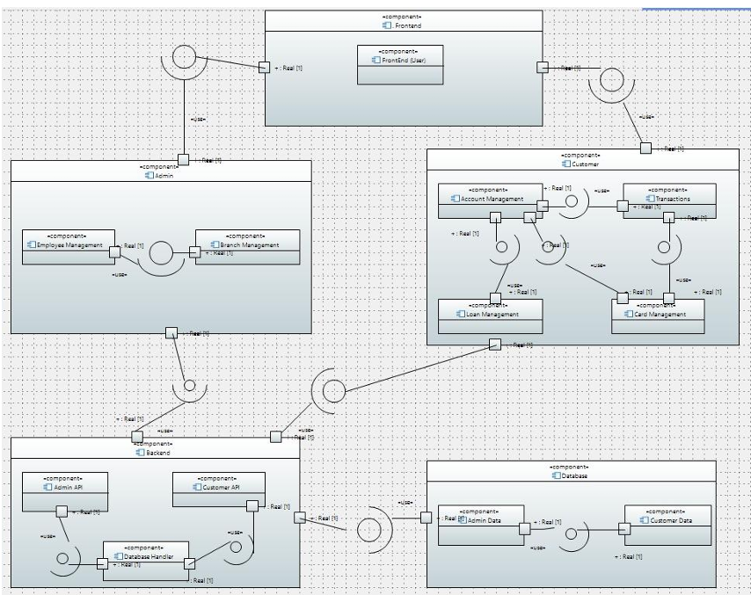

Software Architecture
- The SQA BankPro system is designed using a layered architecture with the following key components:
1. User Interface Layer (Frontend)
- Responsibilities: Interacts with users (customers and bank employees).
- Technologies: React.js, HTML, CSS.
- Functions: Collects user input, displays information, communicates with the backend.
2. Middle Tier (Business Logic)
- Responsibilities: Handles core processing like transactions, loan processing, and user validation.
- Technologies: Node.js, Express.js.
- Functions: Processes requests from the UI, manages logic, and communicates with the database.
3. Data Access Layer (Database Layer)
- Responsibilities: Manages data storage and retrieval.
- Technologies: MySQL, Sequelize ORM.
- Functions: Handles CRUD operations, stores customer, transaction, and loan data.

Interaction Between Layers
- User Interface Layer communicates with the Middle Tier through HTTP requests (REST APIs).
- Middle Tier interacts with the Data Access Layer to fetch/store data in MySQL.
- Data flows from the Data Access Layer to the Middle Tier, and the results are sent back to the UI.
System Architecture (2-tier,3-tier,N-tier) Diagram:
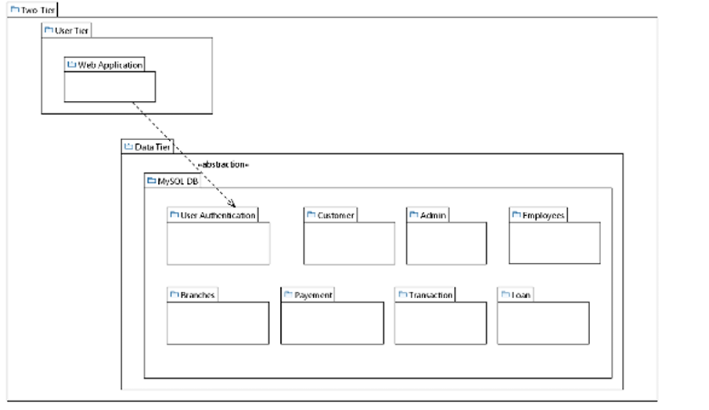
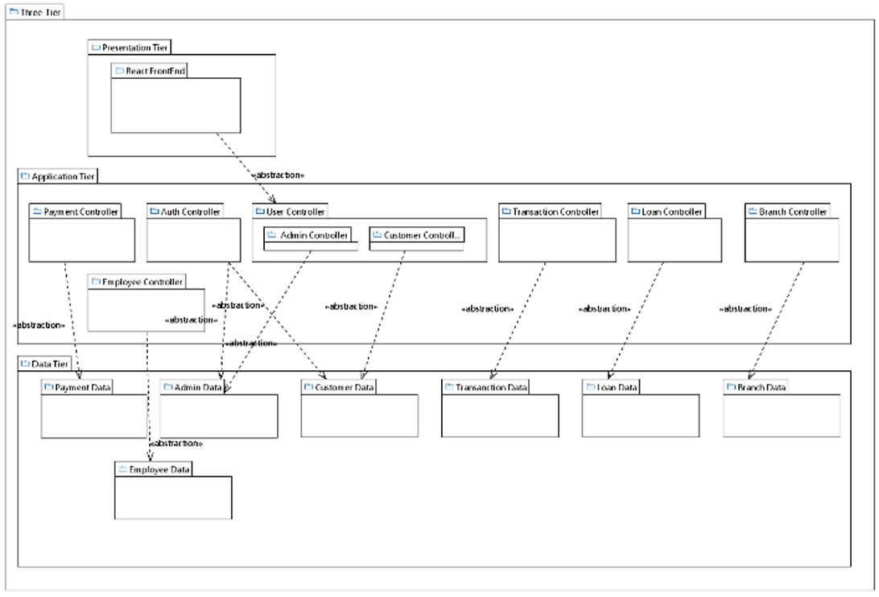
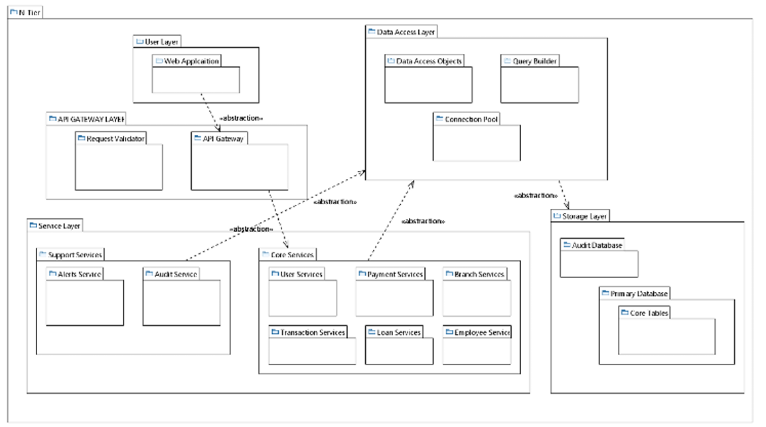

Design Strategy
The SQA BankPro system is designed for scalability, modularity, and ease of maintenance:
1. Future System Extension
- Modular design for easy feature additions (e.g., investment management, multi-currency).
- Scalable architecture to handle increasing traffic through horizontal scaling.
2. System Reuse
- Reusable components (authentication, transactions) to save development time.
- Use of third-party libraries (React.js, Node.js) for stability and efficiency.
3. User Interface
- Fully responsive design for compatibility with desktops, laptops, and mobile devices.
- Focus on user-friendly interfaces for both customers and employees.
4. Data Management
- MySQL for storing customer and transaction data with data integrity and backup strategies.
- Cloud-based hosting for redundancy and high availability.
5. Concurrency & Synchronization
- Proper handling of concurrent transactions and real-time updates.
- Asynchronous processing for long-running tasks to ensure smooth user experience.

Detailed System Design
Class Diagram:

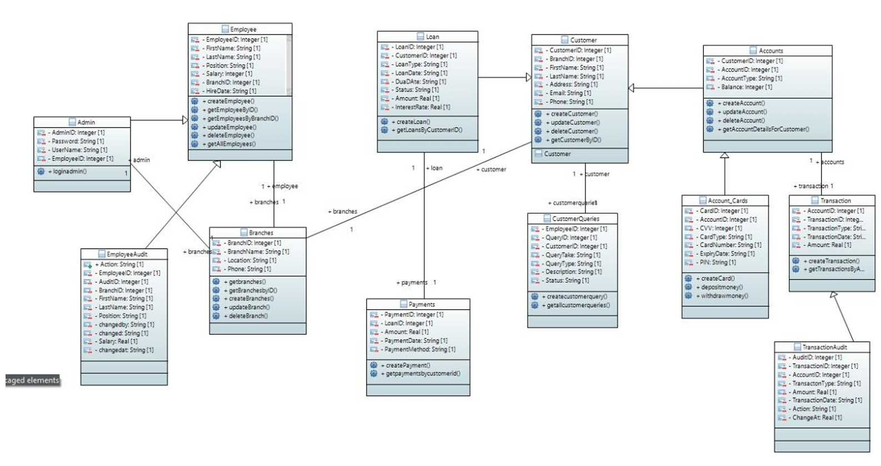

Database Design

ER Diagram
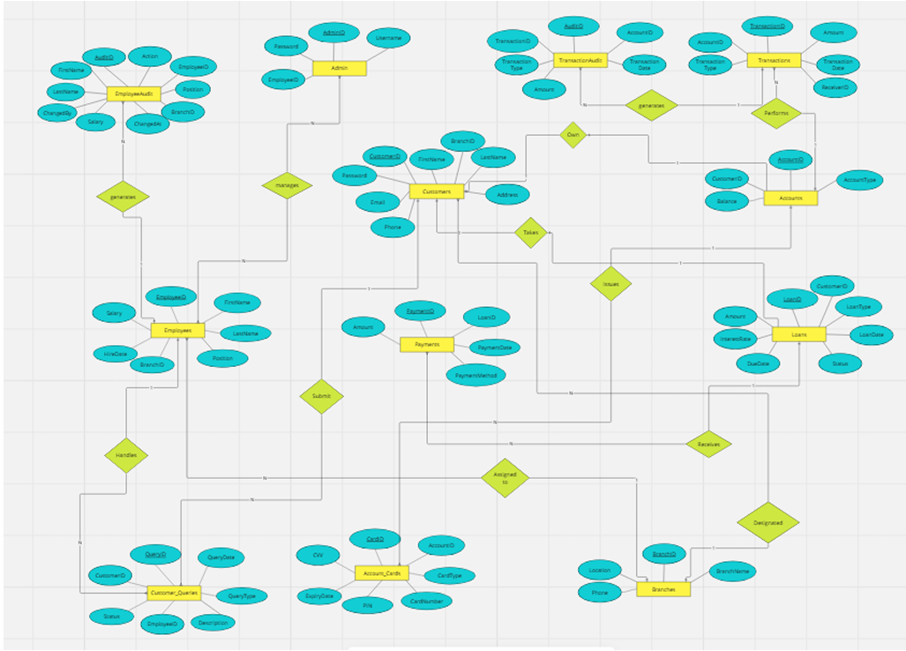

Data Dictionary
[The convention recommended for writing the data dictionary is as follows.]

Data 1
Customer Table
Name |  | Customers
Alias |  | Customer Information
Where-used/how-used |  | Used for customer management, account association, and communication.
Content description |  | Contains personal and contact information of the customers.
Column Name | Description |  | Type | Length | Null able | Default Value | Key Type
CustomerID | Unique identifier for each customer |  | VARCHAR | 20 | No | None | PK
FirstName | Customer's first name |  | VARCHAR | 50 | No | None
LastName | Customer's last name |  | VARCHAR | 50 | No | None
Email | Customer's email address |  | VARCHAR | 100 | Yes | None
Phone | Customer's phone number |  | VARCHAR | 15 | Yes | None
Address | Customer's address |  | VARCHAR | 100 | Yes | None
BranchID | Foreign key referring to Branches table |  | INT | 11 | No | None | FK

Data 2
Accounts Table
Accounts TableName |  | Accounts
Alias |  | Bank Account Details
Where-used/how-used |  | Used for handling account-related operations like deposits, withdrawals, and balance checking.
Content description |  | Stores information related to individual bank accounts.
Column Name | Description |  | Type | Length | Null able | Default Value | Key Type
AccountID | Unique identifier for each account |  | VARCHAR | 20 | No | None | PK
CustomerID | Foreign key referring to Customers table |  | VARCHAR | 20 | No | None | FK
AccountType | Type of account (e.g., savings, checking) |  | VARCHAR | 20 | No | None
Balance | Current balance of the account |  | DECIMAL | 15, 2 | No | 0.00

Data 3
Transactions Table
Accounts TableName |  | Transactions
Alias |  | Transaction Records
Where-used/how-used |  | Used to process and track all transactions made to customer accounts.
Content description |  | Logs all transaction details related to customers' bank accounts.
Column Name | Description |  | Type | Length | Null able | Default Value | Key Type
TransactionID | Unique identifier for each transaction |  | INT | N/A | No | None | PK
AccountID | Foreign key referring to Accounts table |  | VARCHAR | 20 | No | None | FK
TransactionType | Type of transaction (e.g., deposit, withdrawal) |  | VARCHAR | 20 | No | None
Amount | Amount involved in the transaction |  | DECIMAL | 15, 2 | No | None
TransactionDate | Date of the transaction |  | DATE | N/A | No | None

Data 4
Loans Table
Accounts TableName |  | Loans
Alias |  | Loan Information
Where-used/how-used |  | Used to manage loan applications, statuses, and repayment tracking.
Content description |  | Stores details about loans taken by customers.
Column Name | Description |  | Type | Length | Null able | Default Value | Key Type
LoanID | Unique identifier for each loan |  | INT | N/A | No | None | PK
CustomerID | Foreign key referring to Customers table |  | VARCHAR | 20 | No | None | FK
LoanType | Type of loan (e.g., personal, mortgage) |  | VARCHAR | 20 | No | None
Amount | Loan amount |  | DECIMAL | 15, 2 | No | None
InterestRate | Interest rate for the loan |  | DECIMAL | 5, 2 | No | None
LoanDate | Date the loan was issued |  | DATE | N/A | No | None
DueDate | Due date for loan repayment |  | DATE | N/A | No | None
Status | Status of the loan (e.g., active, paid) |  | VARCHAR | 20 | No | None

Data 5
Payments Table
Payments TableName |  | Payments
Alias |  | Payment Transactions
Where-used/how-used |  | Used to track all payments made towards loans.
Content description |  | Contains records of loan payments made by customers.
Column Name | Description |  | Type | Length | Null able | Default Value | Key Type
PaymentID | Unique identifier for each payment |  | VARCHAR | 20 | No | None | PK
LoanID | Foreign key referring to Loans table |  | INT | N/A | No | None | FK
Amount | Payment amount |  | DECIMAL | 15, 2 | No | None
PaymentDate | Date the payment was made |  | DATE | N/A | No | None
PaymentMethod | Method used for the payment (e.g., credit card, cash) |  | VARCHAR | 20 | No | None

Data 6
Branches Table
Payments TableName |  | Branches
Alias |  | Branch Locations
Where-used/how-used |  | Used to identify and manage branches in the system.
Content description |  | Contains data about the bank's branches.
Column Name | Description |  | Type | Length | Null able | Default Value | Key Type
BranchID | Unique identifier for each branch |  | INT | N/A | No | None | PK
BranchName | Name of the branch |  | VARCHAR | 50 | No | None
Location | Location of the branch |  | VARCHAR | 100 | No | None
Phone | Branch's contact number |  | VARCHAR | 15 | No | None

The notation to develop content description is given below:

Data construct | Notation | Meaning
 | = | is composed of
Sequence | + | And
Selection | [|] | either-or
Repetition | {}n | n repetitions of
 | ( ) | optional data
 | * … * | delimits comments
]

Application Design

Sequence Diagram
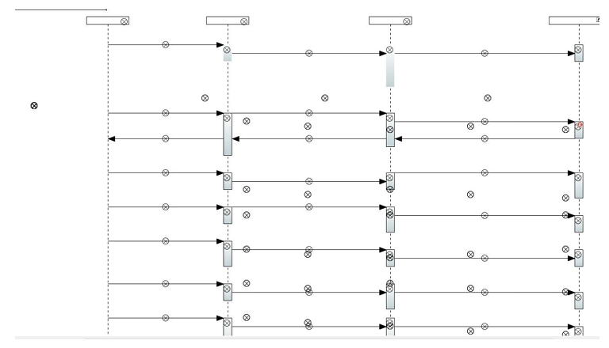

State Diagram
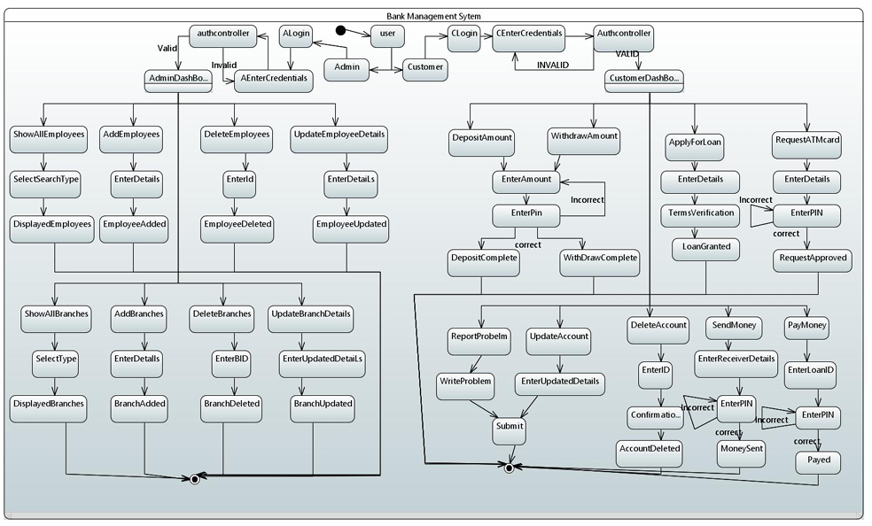

References
This section provides a comprehensive list of the sources and documents referenced during the development of the SQA BankPro project. These references cover technologies, frameworks, best practices, and security guidelines used in building the system.
- Node.js Documentation
  - Title: Node.js Documentation
  - Date: Ongoing
  - Publisher: Node.js Foundation
  - URL: https://nodejs.org/en/docs/
  - Description: Official documentation for Node.js, the backend framework used for building the server-side logic and API for the SQA BankPro system.
- React.js Documentation
  - Title: React.js Documentation
  - Date: Ongoing
  - Publisher: Facebook, Inc.
  - URL: https://reactjs.org/docs/getting-started.html
  - Description: Official documentation for React.js, the frontend framework used for building the user interface (UI) of the SQA BankPro application.
- MySQL Documentation
  - Title: MySQL Documentation
  - Date: Ongoing
  - Publisher: Oracle Corporation
  - URL: https://dev.mysql.com/doc/
  - Description: Documentation for MySQL, the database management system used in SQA BankPro to store and manage data such as user accounts, transactions, and loan information.
- OWASP Security Principles
  - Title: OWASP Top 10 - Security Risks
  - Date: 2021
  - Publisher: OWASP Foundation
  - URL: https://owasp.org/www-project-top-ten/
  - Description: The OWASP Top 10 is a widely used resource for web security. This guide identifies the most critical web application security risks, and its principles were applied during the development of SQA BankPro to ensure secure coding practices.

Appendices
[The appendices provide supplementary details that support the main body of the SQA BankPro project. These include diagrams, code snippets, and additional resources that are too detailed for the main document but essential for full understanding.

Appendix A: System Architecture Diagrams
- Includes high-level architecture and data flow diagrams showing the interaction between system components.

Appendix B: ER Diagram
- Entity Relationship diagram illustrating the relationships between key entities like Customers, Accounts, Loans, etc.

Appendix C: Code Snippets
- Key code excerpts demonstrating core functionality like login, transaction processing, and database queries.

Appendix D: User Interface Screenshots
- Screenshots of the SQA BankPro UI, including login, dashboard, transaction, and loan application screens.

Appendix E: Test Cases and Results
- List of test cases and testing outcomes (e.g., passed cases, bug reports, resolved issues).

Appendix F: Additional Resources
- Documentation for tools, frameworks, and external resources referenced in the project.

