JUNIOR DATA SCIENCE ANALYST INTERNSHIP
Agriculture & Agribusiness
Week 2
Strategic Analysis of the Wheat Supply Chain
A data-driven strategy to raise efficiency and cut waste between the Punjab farm gate and the consumer
Prepared by: Qasim Ali Shahid
Internship period: 09 October 2026 to 20 November 2026
Project: Punjab Wheat Analytics

1. Introduction
Wheat reaches consumers through a chain of farmers, traders, procurement agencies, storage operators, flour mills and retailers. Each hand-over adds cost, delay and the risk of loss. Because wheat is a staple, even a small loss rate removes a large tonnage from the food supply. This report designs a data analysis strategy that an agribusiness could implement to find where grain and money leak out of the chain, and to decide which fixes to try first.

1.1 The business case
I frame the work as a realistic business case. Punjab Grain is a hypothetical mid-sized agribusiness that buys wheat from growers in central and southern Punjab, stores it at procurement centers and mandi yards, mills it into flour, and sells to wholesalers and retailers. Punjab Grain’s management asks three questions: where does the chain lose the most wheat, what data would prove it, and which improvements pay back first? The company is fictional, but every statistic about Punjab's wheat supply in this report comes from real data or a cited source, and every assumption is labelled.

1.2 Scope and method in brief
- I describe the stages of the chain and mark the points where analytics can change decisions.
- I measure the shape of Punjab's wheat supply with real district data from the Pakistan Bureau of Statistics (PBS), which tells the company where wheat comes from and how stable the supply is.
- I build a stage-by-stage loss model with explicitly assumed loss rates, because open data on wheat losses by stage in Punjab do not exist. I test how much the answer depends on those assumptions with a Monte Carlo simulation.
- I design the data collection plan, the visualizations and the analytical methods that would replace my assumptions with measurements.
- I propose five data-guided initiatives, estimate their benefits, and discuss risks.

2. Overview of the Wheat Supply Chain
Punjab grows wheat as a winter (Rabi) crop: farmers sow from late October to December and harvest from March to May, so supply arrives in a short window and must be stored for the rest of the year. That seasonality shapes every stage below.
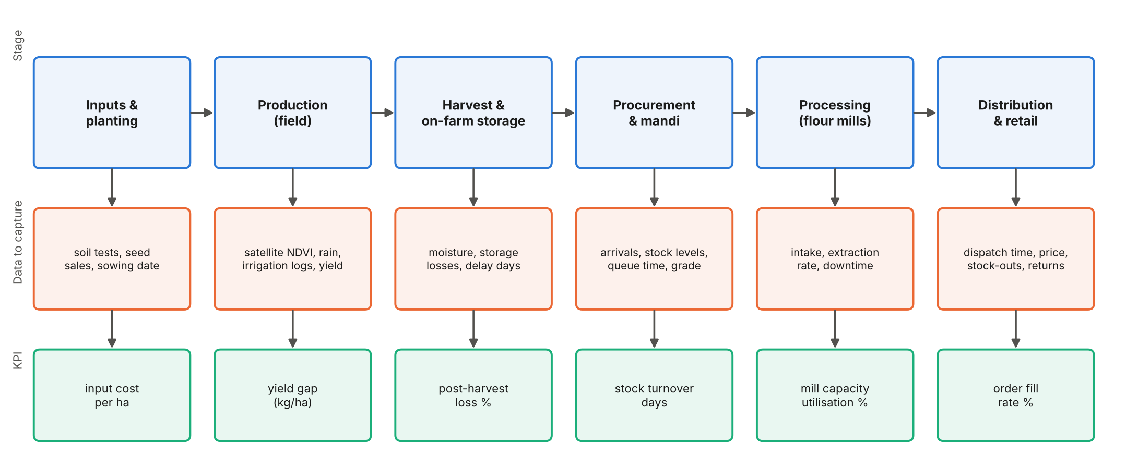
Figure 1. The six stages of the chain, the data to capture at each stage, and one KPI per stage.
Table 1. Stages, typical problems and where analytics helps
Stage | What happens | Typical problems | Where data helps
1. Inputs & planting | Farmers buy seed and fertilizer, prepare land, sow | Late sowing, uneven input quality, high input cost | Link seed lots and sowing dates to yield; forecast input demand
2. Production | Crop grows under irrigation or rain | Heat and water stress, disease, low yield in some districts | Yield-gap maps; early warning on weather and crop condition
3. Harvest & on-farm storage | Cutting, threshing, drying, bagging or bulk storage | Harvest and threshing losses; moisture and pests in farm stores | Moisture logs, losses per harvest method, storage condition sensors
4. Procurement & mandi | Purchase, grading, weighing, bulk storage at yards or centers | Queues, price disputes, storage losses, uneven stock between sites | Arrival forecasts, queue-time tracking, stock balancing between sites
5. Processing | Cleaning and milling into flour, bran and by-products | Idle capacity, quality variation in incoming grain, extraction losses | Intake quality control, production planning, downtime analysis
6. Distribution & retail | Transport to wholesalers and shops | Delays, damaged bags, stock-outs and overstock | Route optimization, demand forecasting, order-fill tracking

2.1 Critical points where analytics changes outcomes
- The harvest peak. Most supply arrives in a few weeks. Forecasting arrivals by district lets the company book storage space and trucks before the peak.
- Storage. Moisture, insects and rodents destroy grain slowly and silently. Storage data (temperature, humidity, stock age) turns this hidden loss into a measurable one.
- Hand-over points. Every transfer from field to truck to yard to mill is a point of delay and weighing disputes. Time stamps at each transfer reveal the slowest links.
- Variability of supply. A bad season shrinks the crop for everyone. Knowing how large a bad season can be sets the size of the buffer stock.

3. What Real Data Say about Supply

3.1 Where the wheat comes from
Using PBS district data for the three seasons 2017-18 to 2019-20, I ranked the 37 districts by average production. Supply is spread widely, not concentrated. The ten largest districts supply 44.1 percent of Punjab's wheat, 12 districts together make up half, and 23 districts make up 80 percent. A concentration index (the Herfindahl-Hirschman index, which runs from near 0 for perfectly spread supply to 10,000 for a single supplier) comes to 342, which signals very low concentration.
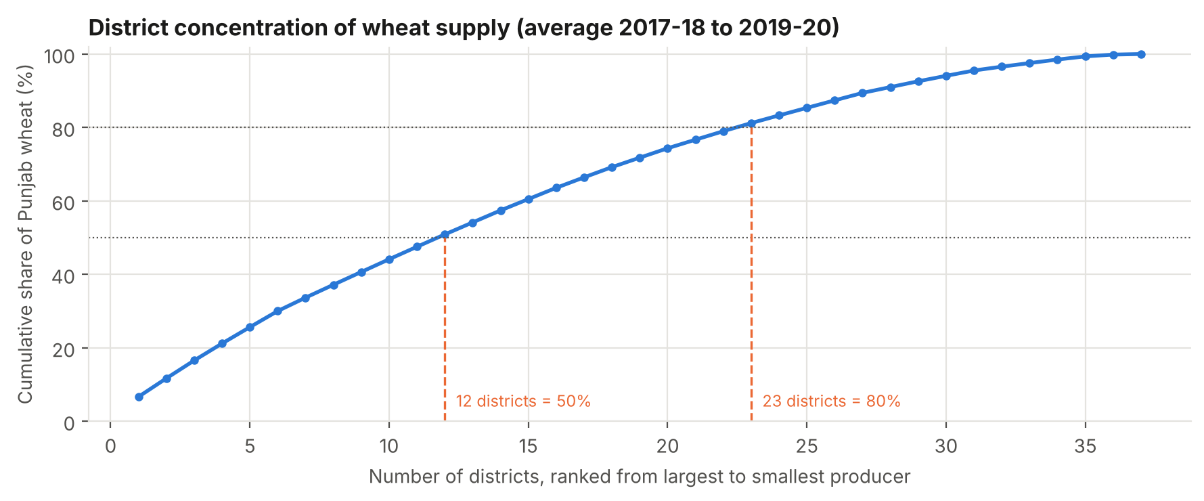
Figure 2. Cumulative share of Punjab wheat production by number of districts, 2017-18 to 2019-20 average.
By division, Bahawalpur contributes the largest share (16.6 percent), followed by D.G. Khan (14.6), Multan (13.6), Gujranwala (13.5) and Faisalabad (13.2). The largest single districts are Bahawalnagar (6.7%), Rahim Yar Khan (5.0%), Bahawalpur (4.9%), Muzaffargarh (4.6%), Jhang (4.5%).
Implication. A company cannot depend on a few supplier districts, and it also cannot cover all 37 with equal intensity. A sound design places procurement hubs where several large districts sit close together, such as the southern belt of Bahawalnagar, Bahawalpur and Rahim Yar Khan, and uses data to decide how many hubs the volumes justify.

3.2 How stable is the supply?
Punjab's wheat production fell in 5 of the 12 year-to-year comparisons between 2007-08 and 2019-20. The worst fall came in 2011-12: 1,302 thousand tonnes (6.8 percent). In the years with a fall, the average drop was 870 thousand tonnes. A buffer-stock and sourcing plan has to survive a shock of that size, and Week 4 quantifies the risk more fully.

4. Where the Chain Loses Wheat

4.1 Published anchors
FAO's 2019 State of Food and Agriculture report estimates that about 14 percent of the world's food is lost between harvest and retail, and that the figure reaches 20 to 21 percent in Central and Southern Asia. Those figures cover all food commodities, and fruit and vegetables lose much more than cereals, so wheat should sit below the regional average. At the consumer end, a UN report (Food Waste Index 2024) finds that about a fifth of the food available to consumers goes to waste. These anchors tell me the magnitude to expect, but not the loss at each stage of the Punjab wheat chain.

4.2 A stage-by-stage loss model (assumptions)
Assumption notice: Open data on wheat loss by stage in Punjab are not available to me. I therefore assume a loss rate for each stage, chosen so that the total sits below FAO's 14 percent global and 20 to 21 percent regional all-food figures, as expected for a cereal. These numbers are placeholders that the data collection plan in Section 5 replaces with measurements.
Table 2. Assumed loss rate per stage, applied to the 2019-20 Punjab crop (19,402 thousand tonnes)
Stage | Assumed loss (% of grain reaching the stage) | Loss ('000 tonnes)
Harvest and threshing | 3.0 | 582
On-farm storage | 2.5 | 470
Transport to market | 1.0 | 183
Mandi / procurement storage | 3.0 | 545
Milling and processing | 2.0 | 352
Wholesale and distribution | 1.5 | 259
Total (compounded) | 12.3 | 2,392

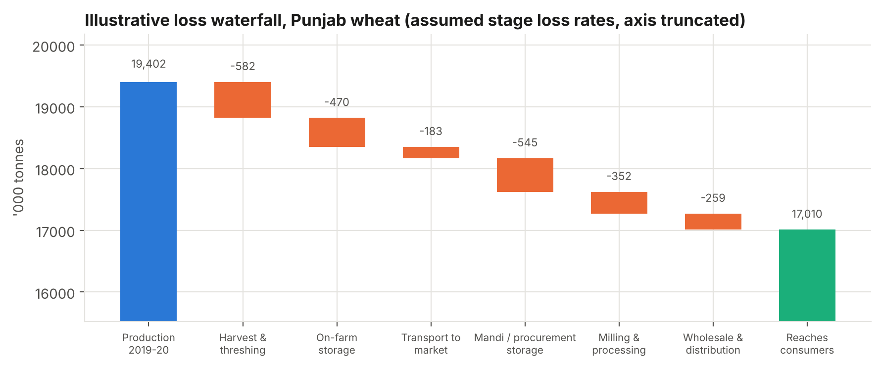
Figure 3. Waterfall of the assumed losses. The vertical axis starts at 16,000 so that the steps are readable.
Under these assumptions the chain loses 12.3 percent of the crop, about 2,392 thousand tonnes in a season like 2019-20. Every percentage point of loss removed is worth 194 thousand tonnes of wheat.

4.3 How much do the assumptions matter?
I repeated the calculation 20,000 times, drawing each stage's loss rate from a triangular distribution that runs from half to 1.8 times my assumed value. The total loss then lies between 11.3 and 15.7 percent in 90 percent of runs, with a median of 13.5 percent. The rank correlation between each stage's rate and the total shows which stage's uncertainty matters most (Figure 4).
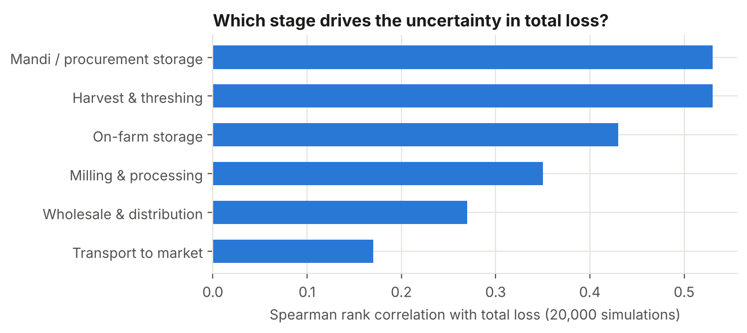
Figure 4. Sensitivity of total loss to uncertainty in each stage's loss rate.
Harvest and threshing (0.53) and mandi or procurement storage (0.53) drive most of the uncertainty, followed by on-farm storage (0.43). These stages deserve measurement first, because a wrong assumption there changes the answer most.

5. Data Analysis Strategy

5.1 What to collect, where and how often
Table 3. Data collection plan by stage
Stage | Data to capture | Source | Frequency
Inputs & planting | Seed lot, variety, sowing date, fertilizer dose, field location | Farmer app or dealer records; sample survey | Per season
Production | Rainfall, temperature, canal water, crop condition index, yield by field | Weather stations and satellites; farmer reports; crop cuts | Weekly in season
Harvest & on-farm storage | Harvest date and method, grain moisture, storage type, loss per lot | Field staff with moisture meters; storage checks | Per lot; monthly in storage
Procurement & mandi | Arrival tonnage, grade, truck wait time, stock by site, storage temperature and humidity | Weighbridge and gate systems; sensors | Daily
Processing | Intake quality, extraction rate, downtime, energy use | Mill control records | Per shift
Distribution & retail | Orders, dispatch and delivery times, damage, stock-outs, returns | Dispatch system; retailer feedback | Daily

5.2 Analytical methods
Table 4. Methods matched to questions
Question | Method | Output
Where is grain lost, and how much? | Mass balance by stage (tonnes in, tonnes out, tonnes explained); lot tracing | Measured loss rate per stage with confidence intervals
Which sites or routes are slow? | Time-stamp analysis and process mapping; control charts for waiting time | Bottleneck list; alerts when wait time leaves normal range
How much will arrive next week? | Forecasting from sowing area, crop condition and weather; time series models | Arrival forecast by district
Where should hubs and trucks go? | Network analysis: model districts, hubs and mills as nodes and truck routes as edges; compute shortest paths and a p-median location (choose k hubs that minimize production-weighted distance) | Hub shortlist; route plan
What drives storage loss? | Regression of loss on moisture, storage age, temperature and humidity; survival analysis of lot age | Risk score for each lot; rule for fumigation and rotation
Which fix pays back first? | Scenario and sensitivity analysis; Monte Carlo (as in Section 4.3) | Ranked initiatives with ranges

5.3 Visualizations I recommend
- Process map of the chain (Figure 1), annotated with measured loss and median waiting time on each link.
- Loss waterfall (Figure 3) updated each season with measured values, so managers see leakage in one picture.
- Network diagram of districts, hubs and mills, with edge thickness showing tonnes moved and color showing delay.
- Pareto charts of loss causes and of delay causes, to focus action on the few causes that drive most of the loss.
- Control charts of truck waiting time and grain moisture at intake, which flag abnormal days automatically.
- Map of yield gap and supply by district, which Week 6 develops.

5.4 Data quality rules
My Week 1 analysis found an error in an official table: the published area values for Kasur and Lahore in 2009-10 were swapped, which produced a yield of 8,906 kg per hectare. I take two lessons from this. First, every dataset the company uses should pass automatic consistency checks, such as production equals area time’s yield and stock out never exceeds stock in. Second, every figure should carry a source and a date, so that an analyst can trace and correct an error quickly.

6. Data-Enabled Solutions
I propose five initiatives. Each targets one stage, rests on a data feed, and has an estimated effect on the 2019-20 base. The effectiveness figures are assumptions: they state the share of that stage's loss each initiative removes, and field pilots would replace them with measured values.
Table 5. Initiatives, assumed effectiveness and estimated benefit
Initiative | Stage | Assumed share of stage loss removed | Wheat saved ('000 t per season)
Hermetic or metal on-farm storage, targeted by moisture and storage-risk data | On-farm storage | 50% | 218
Covered mandi storage plus fumigation scheduled by lot age and humidity | Mandi / procurement | 40% | 210
Harvest set-up and thresher calibration, with moisture-based harvest timing | Harvest and threshing | 30% | 158
Mill intake quality control and moisture checks | Processing | 15% | 52
Route planning and covered transport using arrival forecasts | Transport | 25% | 43

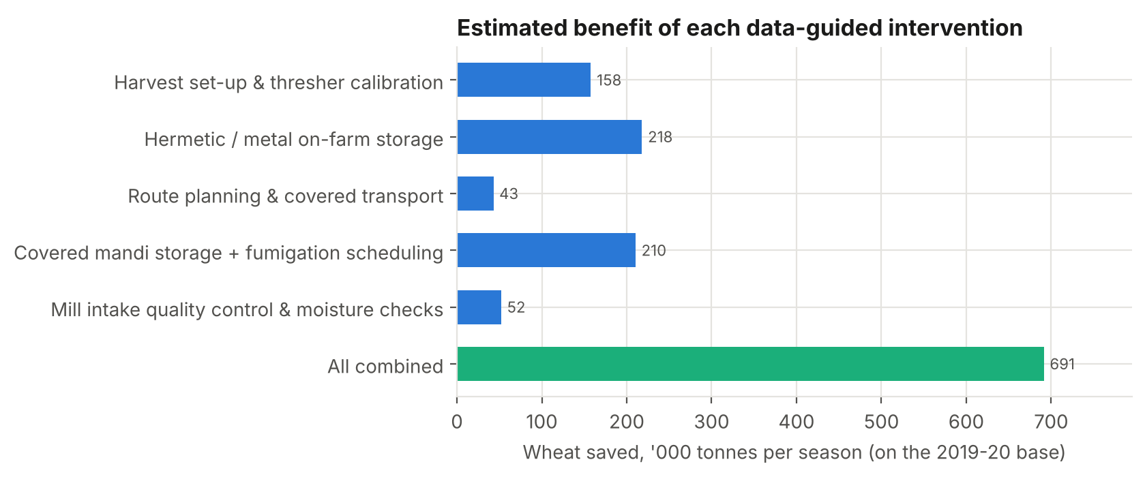
Figure 5. Estimated wheat saved by each initiative and by all five combined (2019-20 base).
Together the five initiatives save about 691 thousand tonnes a season (3.6 percent of production). Total loss then falls from 12.3 to 8.8 percent. The combined effect is slightly smaller than the sum of the parts because each initiative saves a share of a smaller remaining quantity. Storage-related initiatives rank first and second, followed by harvest practices; transport and milling have less to give in my model because their assumed loss rates are lower.

6.1 Expected benefits
- More grain reaches the market from the same crop, which raises the company's saleable volume without buying more land or inputs.
- Lower quality claims and disputes, because moisture and grade are recorded at every hand-over.
- Better use of trucks, storage and mill capacity, because arrivals are forecast.
- A measured baseline that supports credit, insurance and sustainability reporting.

6.2 Risks and how to manage them
Table 6. Principal risks of the data programme
Risk | Why it matters | Mitigation
Assumed effectiveness proves too high | Benefit estimates would shrink | Run paired pilots (treated vs untreated lots) and measure savings before scaling
Poor data quality | Wrong decisions and lost trust | Automatic validation rules, source and date on every record, regular audits
Farmer or trader reluctance to share data | Gaps in the earliest stages | Offer clear benefits (price transparency, faster payment), keep data private, start with volunteers
Connectivity and device limits | Sensors and apps fail in rural areas | Allow offline capture and later sync; use simple paper-to-app entry at first
Upfront cost | Storage and sensors need capital | Rank by saved tonnes per rupee of cost once real costs are known; stage the roll-out
Weather shocks overwhelm gains | A bad season can cut supply by more than the savings | Treat loss reduction and risk management as separate programmes (see Week 4)

7. Recommendations and Implementation Plan
Table 7. Phased plan
Phase | Actions | Success measure
Months 0-3: measure | Set up the data pipeline and quality rules. Start weighing and moisture logging at procurement sites. Sample 100 farm stores for losses. | A measured loss rate for each stage with a confidence interval
Months 3-9: pilot | Pilot hermetic storage and covered mandi storage in two districts, with paired control lots. Test arrival forecasts for route planning. | Measured saving per initiative against the assumed effectiveness
Months 9-18: scale | Scale what worked. Add network analysis for hub locations. Retrain forecasts each season. | Total loss reduced toward the 8.8 percent target; KPIs reported monthly

I recommend starting with storage, because it ranks highest in benefit, falls under the company's direct control, and has a clear data signal (moisture, temperature and humidity).

8. Limitations
- The stage loss rates and initiative effectiveness are assumptions, not measurements. The ranking of initiatives is therefore provisional.
- I use the 2019-20 crop as the base because it is the last season in the PBS table; production has changed since, and national statistics show higher output in 2023-24.
- Punjab Grain is hypothetical. A real company would also weigh cost, financing, policy and prices, which I did not model.
- Open data cannot show the flow between districts and mills, so the network analysis remains a design here.

9. Conclusion
Punjab's wheat supply comes from many districts (23 supply 80 percent), so the supply chain needs wide coverage and hubs placed by data. Supply can drop by roughly 1,302 thousand tonnes in a bad year, so buffers matter. Under cautious assumptions, the chain loses about 12.3 percent of the crop between harvest and consumer, and the biggest and most uncertain losses sit at harvest and in storage. Five data-guided initiatives could save about 691 thousand tonnes a season. The first step is to measure, because measurement turns assumptions into evidence and shows which initiative to fund first.

References
Pakistan Bureau of Statistics, _Social Indicators of Punjab_. District-wise wheat area, production and yield per hectare, 2007-08 to 2019-20, republished at opendata.com.pk (yield: opendata.com.pk/dataset/area-sown-production-and-yield-per-hectare-of-wheat-by-districts-punjab; production and area datasets under the same title).
FAO (2019). _The State of Food and Agriculture 2019: Moving forward on food loss and waste reduction_ (about 14% of food lost between harvest and retail; 20-21% in Central and Southern Asia). Summary at https://www.globalagriculture.org/?p=7825
UN DESA / UNEP (2024). Food Waste Index Report 2024 - about a fifth of food available to consumers goes to waste. https://social.desa.un.org/sdn/with-783-million-people-going-hungry-a-fifth-of-all-food-goes-to-waste
Government of Pakistan, Finance Division. _Pakistan Economic Survey 2023-24_, Chapter 2: Agriculture. https://www.finance.gov.pk/survey/chapter_24/2_agriculture.pdf

