JUNIOR DATA SCIENCE ANALYST INTERNSHIP
Agriculture & Agribusiness
Week 1
Exploratory Data Analysis of Crop Yield Factors
Evidence from 37 Punjab districts (2007-08 to 2019-20) and a simulated farm-level dataset
Prepared by: Qasim Ali Shahid
Internship period: 09 October 2026 to 20 November 2026
Project: Punjab Wheat Analytics

1. Introduction
Wheat anchors Pakistan's food supply and its rural economy. The Pakistan Economic Survey 2023-24 reports that wheat covered 9.6 million hectares and produced 31.4 million tonnes in 2023-24, an average yield of 3,264 kg per hectare, up from 3,117 kg per hectare a year earlier. The same survey reports that agriculture contributes 24 percent of GDP and 37.4 percent of employment. A small change in wheat yield therefore moves national food security, farm incomes and the supply of the raw material that flour mills and traders depend on.
This report is the first deliverable of my six-week internship as a junior data science analyst in agriculture and agribusiness. I ask one practical question: which factors explain differences in wheat yield between places and between seasons, and how strong is the evidence for each factor? To answer it, I run an exploratory data analysis (EDA) on two datasets, describe the methods step by step, and state clearly how much confidence each conclusion deserves.

1.1 Objectives
- Collect and describe publicly available data on wheat yield and its main determinants: soil quality, rainfall, temperature and agricultural practices.
- Explore the data with summary statistics, scatter plots, box plots, correlation matrices and trend tests.
- Identify the primary factors that influence yield, and separate conclusions that rest on real data from conclusions that rest on simulated data or published literature.
- Evaluate the challenges in the evidence and recommend the next studies that would strengthen it.

1.2 How the project is organized
I built one reproducible Python project, called Punjab Wheat Analytics, that supports all six weekly reports. Week 1 uses the project's data and exploration code. Later weeks reuse the same data to study the supply chain, markets, risk, prediction and an integrated decision-support view. The code, the raw data and every figure in this report are in the accompanying GitHub repository, so any reader can rerun the analysis and obtain the same numbers.

2. Research and Data Gathering

2.1 What I searched for
I looked for open, citable data on crop yield and its determinants. District-level wheat statistics for Punjab, which produces most of Pakistan's wheat, are available from the Pakistan Bureau of Statistics (PBS). Farm-level records that combine soil tests, weather and management practices are not openly available for Pakistan. I also reviewed published research on how temperature affects yield, and national statistics from the Economic Survey, to give the data a factual frame.

2.2 Datasets used
Table 1. Data sources and how I use each one
Source | Type | Content | Role in this report
PBS, Social Indicators of Punjab (via opendata.com.pk) | Real | Wheat area ('000 ha), production ('000 t) and yield (kg/ha) for 37 districts, 13 seasons (2007-08 to 2019-20) | Main evidence on trends, spatial differences, variability and data quality
Pakistan Economic Survey 2023-24, Chapter 2 | Real | National wheat area, production, yield; agriculture's share of GDP and jobs | Context and scale
Zhao et al. (2017), PNAS | Published research | Global wheat yield falls about 6.0% per +1 degC of warming, without CO2 fertilisation, adaptation or breeding gains | Anchors the temperature effect
Simulated farm dataset (my own, 1,500 farms) | Simulated | Rainfall, irrigations, grain-fill temperature, nitrogen, phosphorus, soil organic matter, pH, texture, sowing delay, variety, weed control, yield | Demonstrates the EDA method for soil, weather and practice factors

Important: The simulated dataset is hypothetical. The task brief allows hypothetical data, and I built it for one reason: open farm-level data do not exist for the factors the brief names. I wrote the yield equation myself from agronomic principles, and I anchored only one coefficient, the temperature effect, to published research. Every result in Section 5 therefore shows how I would explore real farm data. None of it proves how real farms behave.

2.3 Structure of the real data
The PBS tables hold 481 district-year yield cells for 37 districts, plus Punjab totals. I rebuilt division totals from district rows. I treat Rawalpindi Division (Attock, Chakwal, Jhelum, Rawalpindi) and Islamabad as rain-fed (barani) zones and every other district as canal- or tubewell-irrigated. This is my assumption, based on the Potohar plateau's dependence on rainfall; the PBS tables do not record irrigation type, so I flag the assumption wherever it matters.

3. Methodology
I followed a fixed sequence so that each step builds on a clean foundation.

Step 1: load and structure
I read the three PBS tables, converted thousands separators and marked the symbols ** and - as missing. I then built a long district-by-season table with columns for area, production, yield, division and zone.

Step 2: check data quality
I ran three checks. First, I counted missing values. Second, I tested internal consistency: yield should equal production divided by area, so I recomputed it for every cell and flagged differences above 3 percent. Third, I searched for outliers with a robust z-score, which compares each yield with the median and median absolute deviation of the same district across seasons. A robust score resists distortion by the very outliers I want to find.

Step 3: describe
I computed means, standard deviations, ranges and the coefficient of variation (CV, standard deviation divided by mean) for every district and for the Punjab totals. CV makes variability comparable across districts with different yield levels.

Step 4: test trends and differences
I fitted a straight-line trend to Punjab's yield with ordinary least squares and read the slope, R-squared and p-value. To learn whether production changes come from area or from yield, I took year-on-year log differences of area, production and yield and correlated them. I compared rain-fed and irrigated districts with the Mann-Whitney test, which does not assume a normal distribution and suits small groups.

Step 5: look for common shocks
I computed each division's yield per season and correlated the year-on-year changes of the irrigated divisions with each other. A high average correlation means divisions move together, which points to shared causes such as weather.

Step 6: explore the simulated farm data
For the 1,500 simulated farms I produced summary statistics, a Pearson correlation matrix, scatter plots of yield against four candidate drivers, box plots by category, and a standardized multiple regression. Standardizing every variable puts the coefficients on one scale so I can rank the factors. I treat this regression as an exploratory ranking tool and not as proof of causation.

Tools
I wrote the analysis in Python with pandas, NumPy, SciPy and Matplotlib. The scripts are numbered by week (src/w1_eda.py for this report) and a fixed random seed makes the simulated data reproducible.

4. Analysis of the Real Data (Punjab, 2007-08 to 2019-20)

4.1 Data quality: one real error found and corrected
The PBS tables are mostly clean. Only 4 of 481 yield cells are missing: Chiniot in 2007-08 and 2008-09 (the district was created later, and its area sits inside Jhang's figures in those years) and Islamabad in 2012-13 and 2013-14. The consistency check covered 490 cells that have all three values. Only 2 differ by more than 3 percent (Islamabad, a tiny district where rounding matters), and the largest difference is 5.7 percent. Because three separately published tables agree this closely, I also gain confidence that I transcribed them correctly.
The outlier search found one serious error. The published yield for Kasur in 2009-10 is 8,906 kg/ha, almost three times the Punjab average, and the published yield for Lahore in the same season is 781 kg/ha. Both values are agronomically impossible. The cause is visible in the area table (Figure 1): Kasur's area for 2009-10 is 64 thousand hectares, against a median of 174 in other years, while Lahore's is 210, against a median of 58. The two values appear to be swapped. Production figures for both districts look normal, so the error sits in the area column.
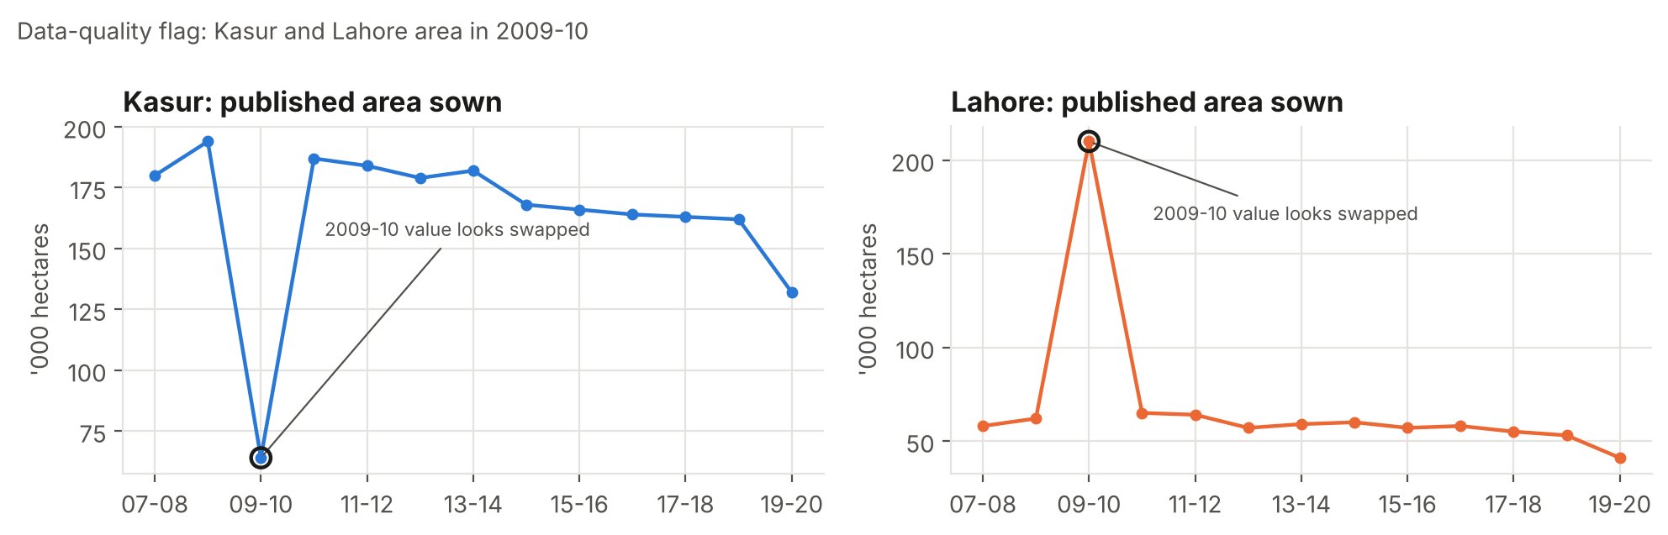
Figure 1. Published wheat area for Kasur and Lahore. The circled 2009-10 values look swapped.
I swapped the two area values back and recomputed yield as production divided by area. The corrected yields are 2,714 kg/ha for Kasur and 2,563 kg/ha for Lahore, which fit each district's history. Every later calculation uses the corrected data. The remaining flags from the robust z-score (absolute value between 3.5 and 5.5) are ordinary good and bad seasons, such as Bhakkar in 2016-17, and I keep them.
Table 2. Outliers in the published data (robust z-score above 10)
District | Season | Published yield (kg/ha) | Robust z | Action
Kasur | 2009-10 | 8,906 | 42.4 | Area swapped back; yield recomputed
Lahore | 2009-10 | 781 | -10.2 | Area swapped back; yield recomputed

4.2 Punjab-level trends
Punjab's yield rose from 2,438 kg/ha in 2007-08 to 2,978 kg/ha in 2019-20, a gain of about 22 percent. The fitted trend adds 33.0 kg/ha per year (R-squared 0.61, p = 0.002). Yield peaked at 3,073 kg/ha in 2016-17 and bottomed at 2,438 kg/ha in 2007-08.
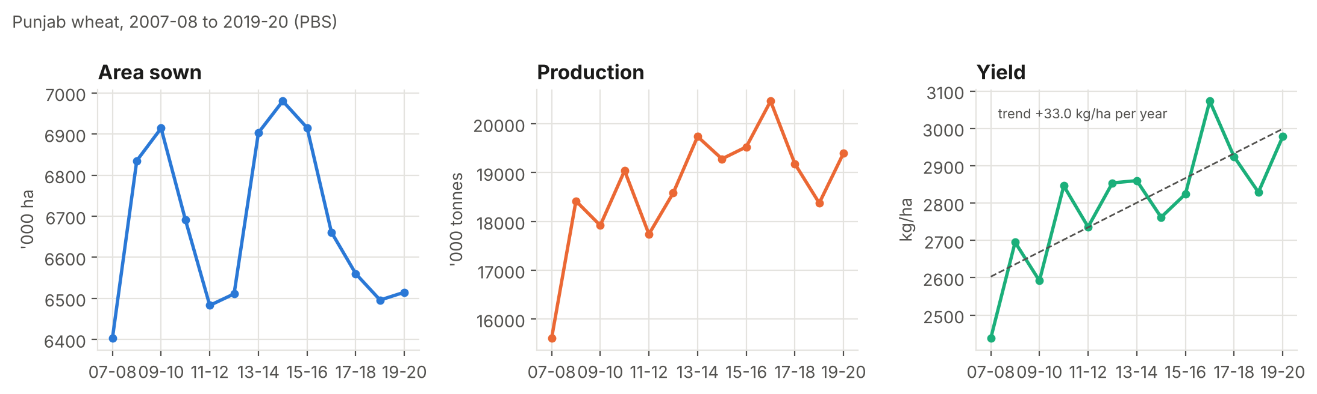
Figure 2. Punjab wheat area, production and yield, 2007-08 to 2019-20. The dashed line is the fitted yield trend.
Area sown stayed in a narrow band (6,403 to 6,980 thousand hectares, CV 3.0 percent), while production ranged from 15,607 to 20,466 thousand tonnes (CV 6.4 percent). The log-difference analysis shows that yield drives production far more than area does: the correlation between year-on-year changes in production and yield is 0.88, against 0.56 for area. Higher output therefore depends on raising yield per hectare, because the land base is not growing.

4.3 Differences between districts
District mean yields span a wide range, from 1,315 kg/ha (Chakwal) to 3,493 kg/ha (Pakpattan). The five highest districts are Pakpattan (3,493), Okara (3,422), T.T.Singh (3,257), Lodhran (3,224), Sahiwal (3,187). The five lowest are Jhelum (1,726), Rawalpindi (1,480), Attock (1,460), Islamabad (1,402), Chakwal (1,315).
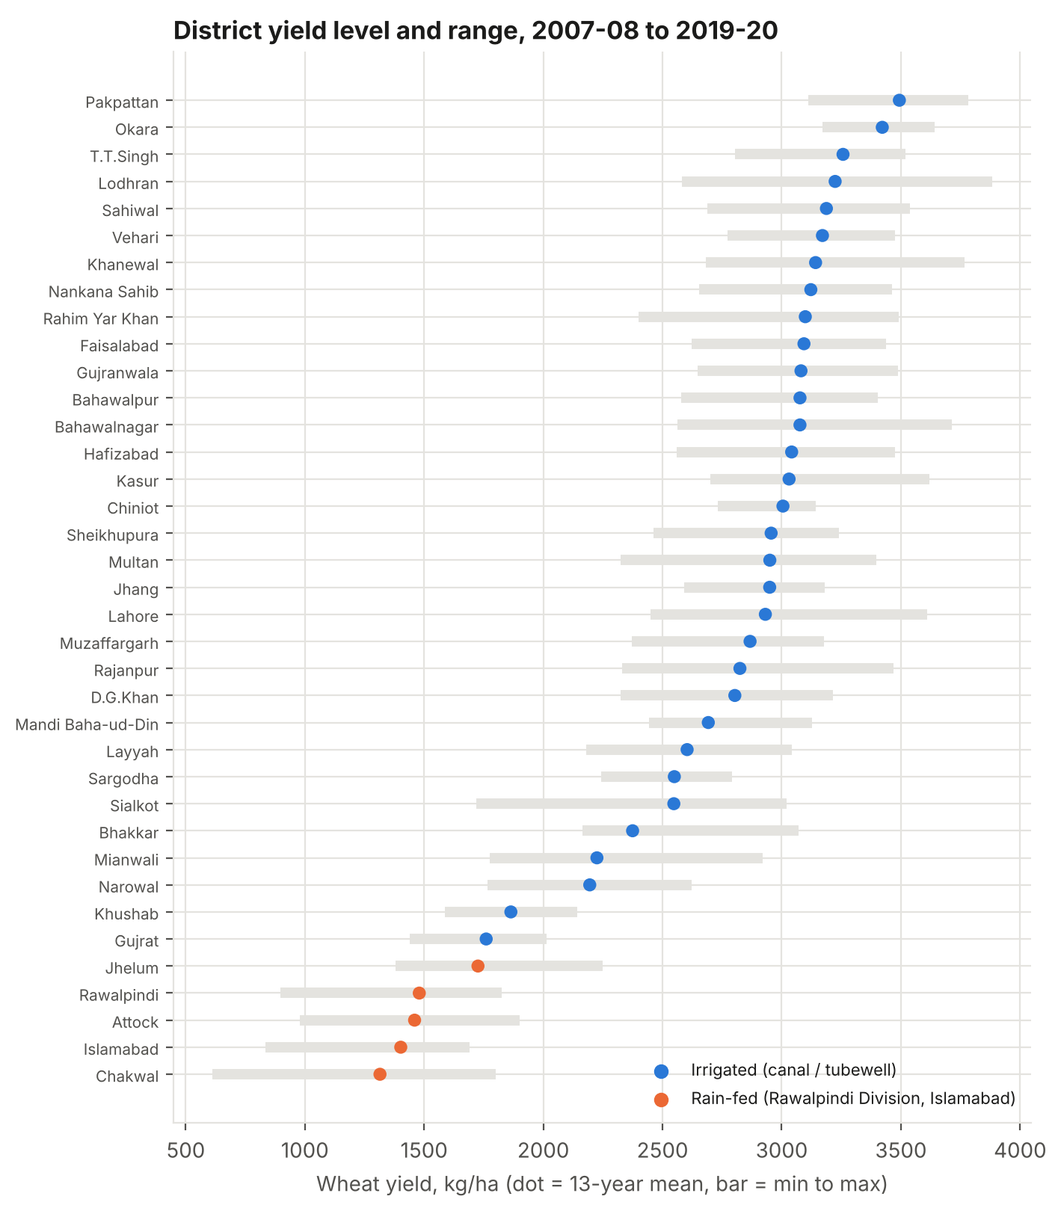
Figure 3. Mean yield (dot) and minimum-to-maximum range (bar) of each district. Orange dots mark the assumed rain-fed zone.
The gap between zones is large. The 32 irrigated districts average 2,863 kg/ha, while the 5 rain-fed districts average 1,477 kg/ha, about 48 percent lower (Mann-Whitney p < 0.001). Rain-fed districts are also far less stable: their average CV is 19.5 percent, against 8.5 percent for irrigated districts. Chakwal (CV 25.4 percent) and Attock (20.6 percent) top the variability ranking, whereas Chiniot, Okara and Pakpattan stay between 4.3 and 5.0 percent. The median CV across districts is 8.7 percent.
Several irrigated districts also yield well below the leaders: Gujrat, Khushab, Mianwali, Narowal and Bhakkar sit between roughly 1,760 and 2,380 kg/ha. These districts probably rely partly on rainfall or face soil and water constraints, which the PBS data cannot show. I return to this point in Section 7.

4.4 Do districts move together?
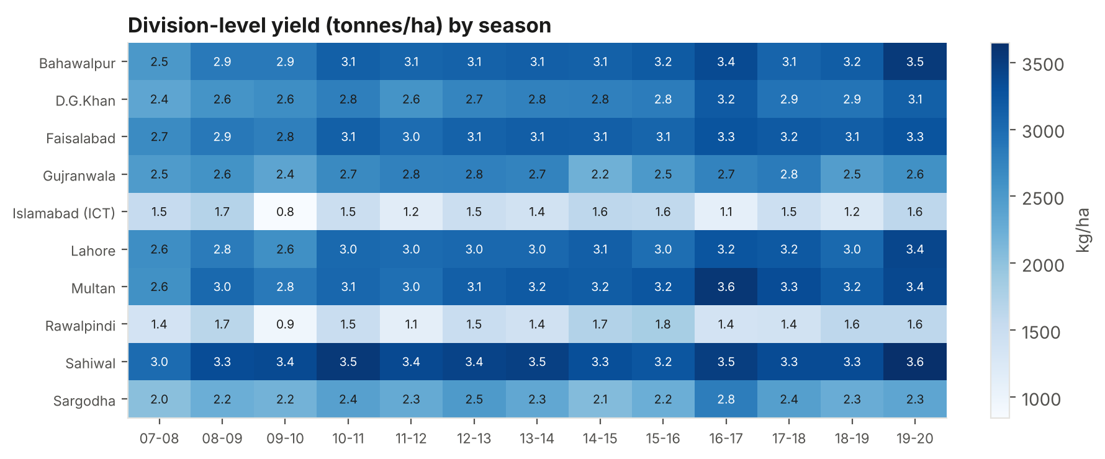
Figure 4. Division-level yield (tonnes per hectare) by season. Darker cells mean higher yield.
The heat map shows vertical stripes: good and bad seasons recur across many divisions at once. I quantified this by correlating the year-on-year yield changes of the irrigated divisions, which gives an average pairwise correlation of 0.59. Seasons therefore carry a shared signal, which fits weather as a common cause, because weather is the one input that all districts share and farmers cannot control. Rawalpindi Division stands out in 2009-10, when its yield fell to 947 kg/ha, 37 percent below its average of 1,502 kg/ha in other seasons. That pattern fits a rainfall shortfall in a rain-dependent zone, but the PBS data contain no weather variables, so I cannot confirm the cause. I record it as a hypothesis to test with rainfall data.

5. Exploring Soil, Weather and Practice Factors (Simulated Farms)
This section shows how I would explore a farm-level dataset. All numbers come from my simulated data, so they illustrate the method and my assumptions, not facts about real farms.

5.1 Summary statistics and data preparation
The dataset holds 1,500 farms drawn from real districts in proportion to each district's wheat area. Yield averages 3,091 kg/ha with a standard deviation of 541; the middle 90 percent of farms lie between 2,186 and 3,953 kg/ha. I introduced about 2 percent missing values in soil organic matter and pH (1.9 and 1.6 percent), to practise the standard fix: fill gaps with the median inside a modelling pipeline, and never drop whole farms. Irrigated farms average 3,169 kg/ha and rain-fed farms 2,395 kg/ha.

5.2 Correlation matrix
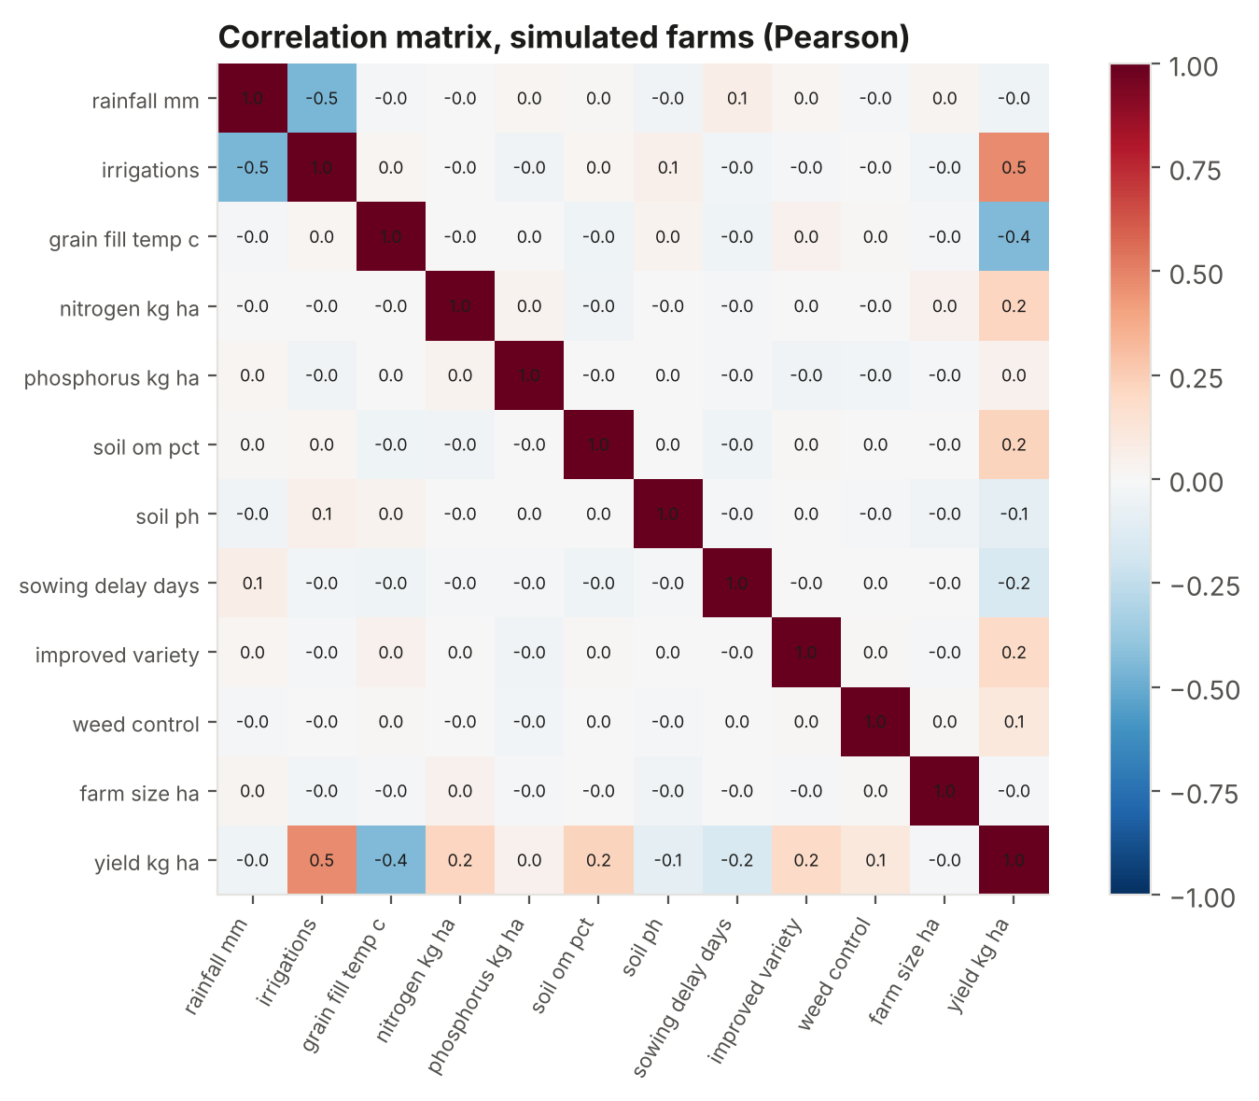
Figure 5. Pearson correlation matrix of the simulated farm variables.
Yield correlates most strongly with the number of irrigations (+0.47) and with grain-fill temperature (-0.44). Nitrogen (+0.21), soil organic matter (+0.22), improved variety (+0.19) and sowing delay (-0.15) follow. Rainfall shows almost no raw correlation with yield (-0.04). That result looks surprising until I read the matrix again: rainfall correlates with irrigations at -0.5, because rain-fed farms receive more rain but fewer irrigations. The raw correlation hides rainfall's effect, because water source confounds it. This is why I never rank factors by simple correlation alone.

5.3 Scatter plots of the main drivers
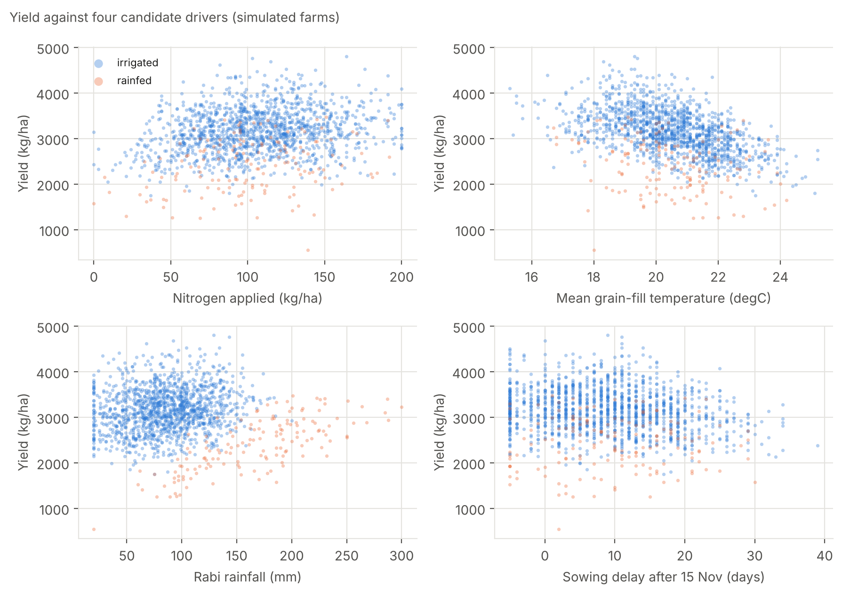
Figure 6. Yield against nitrogen, grain-fill temperature, rainfall and sowing delay. Blue dots are irrigated farms; orange dots are rain-fed.
Four patterns stand out. Nitrogen raises yield steeply at low doses and then flattens, the classic diminishing-returns shape: farms below 60 kg N/ha yield 13 percent less than farms at or above 120 kg N/ha. Yield falls as grain-fill temperature rises: the 262 farms at 22 degC or hotter yield 20 percent less than the 397 farms at 19.5 degC or cooler. Rain-fed farms form their own orange cloud, lower and more spread out. Late sowing trims yield, but only a minority of farms (54 farms) sow more than 25 days after 15 November, so that pattern is hard to see by eye.

5.4 Categorical factors
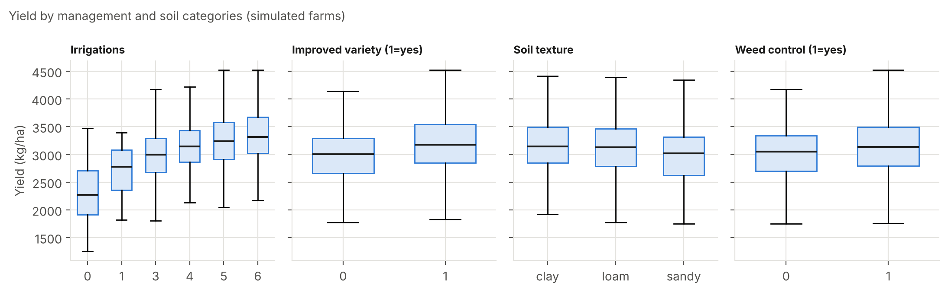
Figure 7. Yield by number of irrigations, variety, soil texture and weed control.
Yield rises with every additional irrigation, from 2,307 kg/ha with none to 3,366 kg/ha with six. Improved varieties yield 7.0 percent more than older varieties, and weed control adds 4.2 percent. Clay (3,161 kg/ha) and loam (3,104) outperform sandy soil (2,980), consistent with better water and nutrient holding capacity.

5.5 Ranking the factors together
A standardized regression that includes all factors at once explains 64 percent of the variance in yield. It removes the confounding I noticed above: rainfall now shows a positive coefficient (+0.22) once irrigations enter the model.
Table 3. Standardized regression coefficients (simulated data; larger absolute value = stronger association)
Factor | Coefficient | Reading
Irrigations | +0.58 | Strongest positive factor
Grain-fill temperature | -0.45 | Strongest negative factor
Rainfall | +0.22 | Positive once irrigation is controlled
Nitrogen | +0.21 | Positive, with diminishing returns
Improved variety | +0.21 | Positive
Soil organic matter | +0.18 | Positive
Sowing delay | -0.16 | Negative
Weed control | +0.11 | Positive, modest
Soil pH | -0.10 | Slightly negative at high pH
Phosphorus | +0.06 | Small

Caution: Because I generated these data, the ranking mostly reflects the weights I chose. A real study could rank the factors differently. The value of this section is the workflow: spot confounding, compare raw and adjusted views, and check shapes such as diminishing returns before fitting any model.

6. Synthesis: Primary Factors Influencing Yield
I combine the three kinds of evidence and label how much weight each deserves.
Table 4. Summary of factors, evidence and confidence
Factor | Direction | Evidence | Confidence
Water supply (irrigation vs rain-fed) | Irrigated yields much higher and more stable | Real PBS data: 2,863 vs 1,477 kg/ha; CV 8.5% vs 19.5% | High (strong, consistent, but zone is my assumption)
Season-to-season weather | Shared good and bad years across divisions | Real PBS data: mean division correlation 0.59 | Medium (cause inferred; no weather data)
Technology and management trend | Yield rises over time | Real PBS data: +33.0 kg/ha per year | Medium (trend is clear; the drivers behind it are not identified)
Heat during grain fill | Higher temperature lowers yield | Published research (about -6% per +1 degC globally); simulated data reproduce it by construction | Medium (literature-based; local size unknown)
Nitrogen | Rises with diminishing returns | Simulated data; agronomic principle | Low to medium (needs real trials)
Soil quality (organic matter, texture, pH) | Better soils yield more | Simulated data only | Low (needs real soil data)
Variety, sowing date, weed control | Improved practice raises yield | Simulated data only | Low (needs real survey data)

My main conclusion is that water supply is the primary and best-supported determinant of wheat yield level and stability, followed by seasonal weather, especially heat and rainfall timing, and then the management practices that farmers control. Over time, a steady technology and management trend lifts yield by roughly one percent a year.

7. Critical Evaluation: Challenges and Opportunities

7.1 Challenges
- No weather or soil variables in the real data. PBS publishes outcomes, not inputs. I can show that seasons move together but cannot attribute the movement to rainfall or temperature.
- District averages hide farm differences. A district-level pattern may not hold for individual farms (the ecological fallacy). Farm surveys would test it.
- Short history. Thirteen seasons cannot separate a long-term trend from a few unusual years. A single poor starting year, 2007-08, also pulls the fitted trend upward.
- Assumed zones. I classify rain-fed and irrigated districts by judgement. Gujrat, Khushab and Mianwali may be partly rain-dependent, and a better classification would change the gap estimate.
- Published errors. The Kasur and Lahore swap shows that official tables need checking. Unnoticed, the swap would have inflated Kasur's variability and distorted any model.
- Simulated data are circular. An analysis of data I generated can only recover the rules I wrote.
- Correlation is not causation. Irrigation and rainfall move together, and the same confounding likely exists in real data.

7.2 Opportunities for further study
- Join the PBS panel to gridded rainfall and temperature records (satellite-based rainfall and reanalysis temperature are free) to test the weather hypothesis directly.
- Add satellite vegetation indices to measure crop condition during the season.
- Add open soil maps (organic carbon, texture, and pH) to bring soil quality into the real analysis.
- Fit panel regressions with district and season effects so that fixed district traits do not confuse the weather signal.
- Run farmer surveys and field trials for nitrogen, sowing date and variety, so that management effects rest on real observations.
- Estimate yield gaps against the best districts in each zone, which Week 6 uses to prioritise districts.

8. Conclusions
- Punjab's wheat yield grew by about 33 kg/ha per year between 2007-08 and 2019-20, while area stayed flat. Production growth therefore depends on yield.
- Water supply separates the high-yield core (about 2,863 kg/ha) from the rain-dependent districts (about 1,477 kg/ha), and the rain-dependent districts swing roughly twice as much from year to year.
- Districts share good and bad seasons (average correlation 0.59), which points to weather as the main driver of seasonal swings. Published research puts the heat penalty near 6 percent of yield per degree of warming.
- Data checking matters: I found and corrected a real swap in the official 2009-10 area figures for Kasur and Lahore.
- The exploration method for soil, weather and management factors works and is ready to reuse on real farm data. Until that data exists, factor rankings beyond water and weather stay provisional.

References
Pakistan Bureau of Statistics, _Social Indicators of Punjab_. District-wise wheat area, production and yield per hectare, 2007-08 to 2019-20, republished at opendata.com.pk (yield: opendata.com.pk/dataset/area-sown-production-and-yield-per-hectare-of-wheat-by-districts-punjab; production and area datasets under the same title).
Government of Pakistan, Finance Division. _Pakistan Economic Survey 2023-24_, Chapter 2: Agriculture. https://www.finance.gov.pk/survey/chapter_24/2_agriculture.pdf
Zhao, C., Liu, B., Piao, S. et al. (2017). Temperature increase reduces global yields of major crops in four independent estimates. _Proceedings of the National Academy of Sciences_, 114(35), 9326-9331. doi:10.1073/pnas.1701762114

