Junior Data Science Analyst: Agriculture & Agribusiness
Week 1 Report (Revised and Expanded)
Agricultural Data Exploration and Strategy Planning
Project: Pakistan Wheat Yield Analysis and Forecasting
Field | Details
Prepared by | Qasim Ali Shahid
Internship period | 09 October 2026 to 13 November 2026 (5 weeks)
Data analysed in this report | FAOSTAT wheat data for Pakistan, 1961 to 2024 (real data, downloaded 9 October 2026)
What is new in this version | Preliminary analysis of real data, worked examples, a completed methods section, a specific analysis plan and evidence-based insights

1. Introduction and Objectives
Pakistan's wheat sector is large, data-rich and economically important, which makes it a good case for a data-driven agribusiness strategy. The business problem addressed in this project is: how has wheat yield and production changed over time, what drives year-to-year differences, and can yield be forecast well enough to support planning for flour mills, traders, input suppliers and policy makers?
The Week 1 task is to identify and explore public datasets and to define a strategy for analyzing them. This report does that in four parts. Section 2 documents three public data sources with concrete examples. Section 3 presents a preliminary analysis of the real FAOSTAT wheat data to show what the data can reveal. Section 4 gives the complete analytical methods, including formulas, tools and a specific analysis plan. Section 5 sets out the strategy, risks and roadmap, and Section 6 states the main insights and their business meaning, with the evidence for each.

2. Dataset Research and Exploration

2.1 Overview of the three sources
Aspect | FAOSTAT (FAO) | PBS / State Bank of Pakistan | NASA POWER
Content | Area harvested, yield and production for crops, including wheat | Area, production and yield by province; wheat by irrigation source; fertiliser; prices | Daily and monthly weather and solar variables for agriculture
Period | 1961 to 2024 (annual) | Annual by crop year; long history across yearbook editions | From 1 January 1981 to near real time
Geography | Country | Pakistan and its four provinces | Global grid, 0.5 x 0.5 degrees
Update | Annual release | Annual yearbook and report cycle | Continuously updated
Format | CSV | PDF tables | CSV or JSON via viewer or API
Role in project | Long yield series (backbone) | Regional and management detail | Climate drivers
Main limitation | No sub-national detail | PDF extraction; provisional figures | Model-based estimates for grid cells

2.2 Dataset 1: FAOSTAT, Crops and Livestock Products
FAOSTAT is the statistical database of the Food and Agriculture Organization of the United Nations. The wheat records for Pakistan were downloaded for the three elements (area harvested, yield, production) for every available year. The file has 192 rows (64 years x 3 elements) and 15 columns. The table below documents each column using a real row from the file (area harvested for 1961).
Column | Example value (real) | Meaning
Domain Code / Domain | QCL / Crops and livestock products | FAOSTAT dataset the record belongs to
Area Code (M49) / Area | 586 / Pakistan | Country code and name
Element Code / Element | 5312 / Area harvested | The measured quantity (the three elements are area harvested, yield, production)
Item Code (CPC) / Item | 111 / Wheat | The crop
Year Code / Year | 1961 / 1961 | Calendar year of the record
Unit | ha | ha for area, kg/ha for yield, t for production
Value | 4,639,000 | The number itself
Flag / Flag Description | A / Official value | Source quality flag; all 192 records are "A"
Note | (empty) | Free-text note, not used

- Granularity and coverage: annual values for the whole country; 64 consecutive years with no gaps.
- Update frequency: FAOSTAT is revised and extended once a year.
- Special feature: for cereals, FAO counts only crops harvested for dry grain, so area and production exclude wheat cut green or used as fodder.
- How to obtain: on the FAOSTAT website open Data, then Crops and livestock products; select Pakistan, the elements Area harvested, Yield and Production, the item Wheat and all years; then download as CSV.
- Potential for the project: forms the backbone of trend, volatility and forecasting analysis (Section 3).

2.3 Dataset 2: Pakistan Bureau of Statistics (PBS) and State Bank of Pakistan (SBP)
PBS publishes the Statistical Yearbook, with an agriculture section built from provincial agriculture departments and the federal food and agriculture ministry. The State Bank republishes the same area, production and yield series in its annual reports and its Handbook of Statistics on Pakistan Economy. Wheat tables include area, production and yield by province, wheat by mode of irrigation, farms by size, fertilizer consumption and wholesale prices. Units are thousand hectares, thousand tonnes and kg/ha.
Concrete examples from the published tables:
- In the 2001-02 season Punjab accounted for about 6,102 thousand of the 8,058 thousand hectares of wheat in Pakistan, about 76 percent of the area (PBS Statistical Yearbook).
- In 1999-00 about 85 percent of the wheat area and about 93 percent of wheat production came from irrigated land (PBS Statistical Yearbook, wheat by source of irrigation).
- The State Bank report for FY05 lists wheat at 8,330 thousand hectares, 21,562 thousand tonnes and 2,588 kg/ha (provisional); for FY02 it lists 8,058, 18,227 and 2,262.
- Granularity and coverage: annual, by province and for selected breakdowns (irrigation, farm size).
- Update frequency: yearly; the most recent values are often provisional and later revised.
- How to obtain: download the agriculture tables from the PBS website (or the SBP statistics pages) as PDF and extract them to CSV, then verify the extracted numbers against the printed totals.
- Potential for the project: provides the regional, irrigation, input and price variables that FAOSTAT lacks.

2.4 Dataset 3: NASA POWER (Agro climatology)
NASA's POWER project provides solar and meteorological data designed for agricultural and energy applications. It has a dedicated Agro climatology community. Data start on 1 January 1981 and are updated close to real time, on a global grid of about 0.5 degrees by 0.5 degrees, with hourly, daily, monthly and climatology outputs depending on the parameter. The values are satellite and model based, not measured at a weather station.
- Planned request (to be confirmed against the POWER documentation in Week 2): daily data for a point in a wheat district, for the agro climatology community, for 1981 to the latest year, with parameters such as mean, maximum and minimum temperature at 2 metres, corrected precipitation and incoming solar radiation, exported as CSV. This can be done in the Data Access Viewer by choosing single point, agro climatology, daily, entering the latitude and longitude and the date range, or through the POWER API from Python.
- Planned processing: convert daily values to wheat-season features (season total rainfall, average temperature, number of hot days during grain filling) and join them to annual yield.
- Potential for the project: tests whether weather explains the years in which yield departs from its long-run trend.
- Main caution: half-degree grid cells average a large area, and the missing-value code stated in the file header must be replaced before any averaging.

3. Preliminary Analysis of the Real FAOSTAT Data
To test the strategy early, the FAOSTAT wheat data was explored in Python (script explore_week1.py in the project repository). The results below are real and are labelled preliminary because only one source has been analyzed so far.

3.1 Data profile and summary statistics
The file contains 64 years (1961 to 2024) for each of the three elements, no missing values, and an official-value flag on every record. As an integrity check, area x yield was compared with production for every year; the largest difference was 0.0065 percent, which is rounding. Summary statistics:
Statistic | Area (million ha) | Yield (kg/ha) | Production (million t)
Mean | 7.54 | 1,957 | 15.66
Median | 7.97 | 1,920 | 15.45
Standard deviation | 1.35 | 715 | 7.74
Minimum | 4.64 (1961) | 760 (1966) | 3.81 (1961)
Maximum | 9.73 (2024) | 3,268 (2024) | 31.81 (2024)

Concrete comparison of the first and last years: in 1961 Pakistan harvested 4.64 million hectares at 822 kg/ha for 3.81 million tonnes; in 2024 it harvested 9.73 million hectares at 3,268 kg/ha for 31.81 million tonnes. The latest year was a record on all three measures: compared with 2023 area rose 7.8 percent, yield 4.8 percent and production 13.0 percent.

3.2 Long-run trend and unusual years
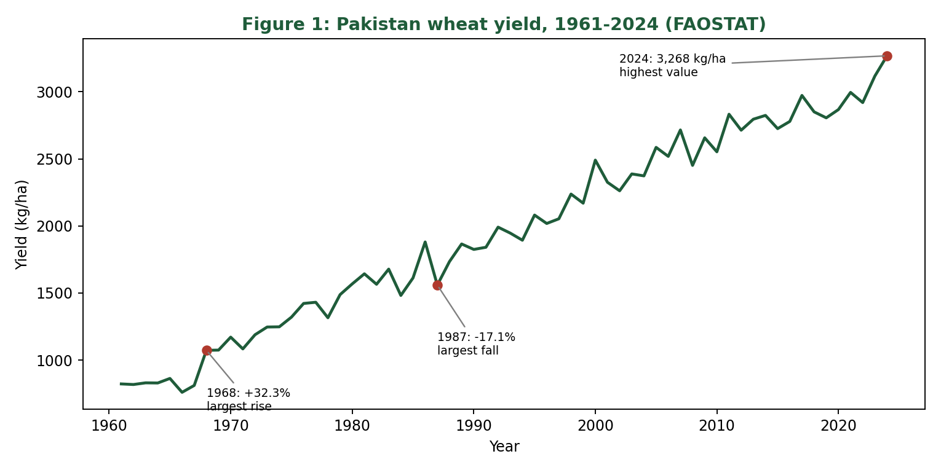
Figure 1: Pakistan wheat yield, 1961-2024, with the largest yearly rise, largest yearly fall and the latest value marked
Yield rose from 822 to 3,268 kg/ha, an average gain of about 38 kg/ha per year on a straight-line fit. The steepest single-year rise was 1968 (+32.3 percent, to 1,073 kg/ha) and the steepest fall was 1987 (-17.1 percent, to 1,559 kg/ha). Nine years changed by 10 percent or more, all in or before 2011. The data identify these years but do not explain them; weather and input data will be needed.

3.3 Where did production growth come from?
Production equals area times yield, so its growth can be split into a part due to more land and a part due to higher yield, using logarithms. Over the whole period production grew 8.3 times, from 3.81 to 31.81 million tonnes (a compound growth rate of 3.42 percent a year). Worked example: ln(31.81 / 3.81) = 2.121; of this, ln(9.73 / 4.64) = 0.741 comes from area (35 percent) and ln(3,268 / 822) = 1.380 from yield (65 percent).
Period | Production growth (% per year) | Yield growth (% per year) | Area growth (% per year) | Share from yield
1961-1980 | 5.66 | 3.46 | 2.13 | 62%
1980-2000 | 3.37 | 2.34 | 1.01 | 70%
2000-2024 | 1.73 | 1.14 | 0.58 | 66%
2010-2024 | 2.25 | 1.78 | 0.46 | 79%
1961-2024 | 3.42 | 2.21 | 1.18 | 65%

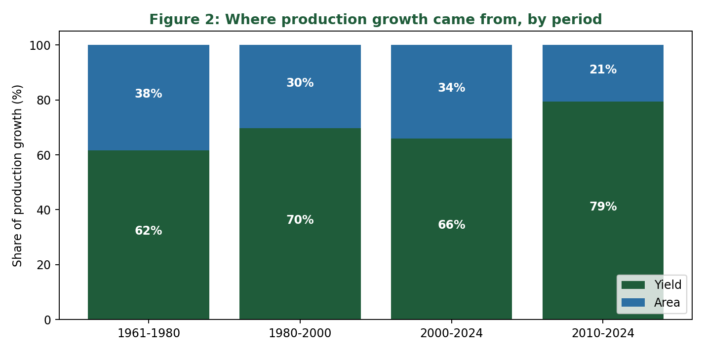
Figure 2: Share of production growth explained by yield and by area in four periods
Two points stand out. Growth rates have fallen over time for all three measures, and since 2010 land has contributed only about 0.5 percent a year, so about four fifths of growth now comes from yield.

3.4 Cross-source check: FAOSTAT against the State Bank figures
Because two sources report the same quantity, they can be compared. The State Bank values for FY02 and FY05 (Section 2.3) were matched with the FAOSTAT values for 2002 and 2005 (crop year 2001-02 and 2004-05, harvested in the later calendar year).
Quantity | SBP FY02 | FAOSTAT 2002 | SBP FY05 (provisional) | FAOSTAT 2005 (difference)
Area (thousand ha) | 8,058 | 8,057.5 | 8,330 | 8,358.0 (+0.34%)
Production (thousand t) | 18,227 | 18,226.5 | 21,562 | 21,612.3 (+0.23%)
Yield (kg/ha) | 2,262 | 2,262.1 | 2,588 | 2,585.8 (-0.09%)

The FY02 figures agree exactly, which confirms the crop-year mapping used (a crop year is matched to the calendar year in which it is harvested). The FY05 figures, which were provisional in the State Bank table, differ from FAOSTAT by less than 0.4 percent, which is consistent with later revision, although the cause has not been confirmed. For this project the two sources can be treated as consistent, and any later conflict should be logged, not silently corrected.

3.5 What the preliminary analysis implies for the strategy
- Yield, not area, is the right target to model, because it carries most of the growth and most of the year-to-year variation.
- Trend must be handled explicitly, since yield rises almost steadily and would otherwise swamp any weather effect.
- A province view is needed, because the national figure hides regional differences (Punjab holds about three quarters of the area).
- The unusual years (1968, 1987, 2000 and others) are natural test cases for weather and input data.

4. Analytical Methods
This section completes the methods plan. Figure 3 summarises the stages, the methods used in each and the outputs; the subsections give the detail.
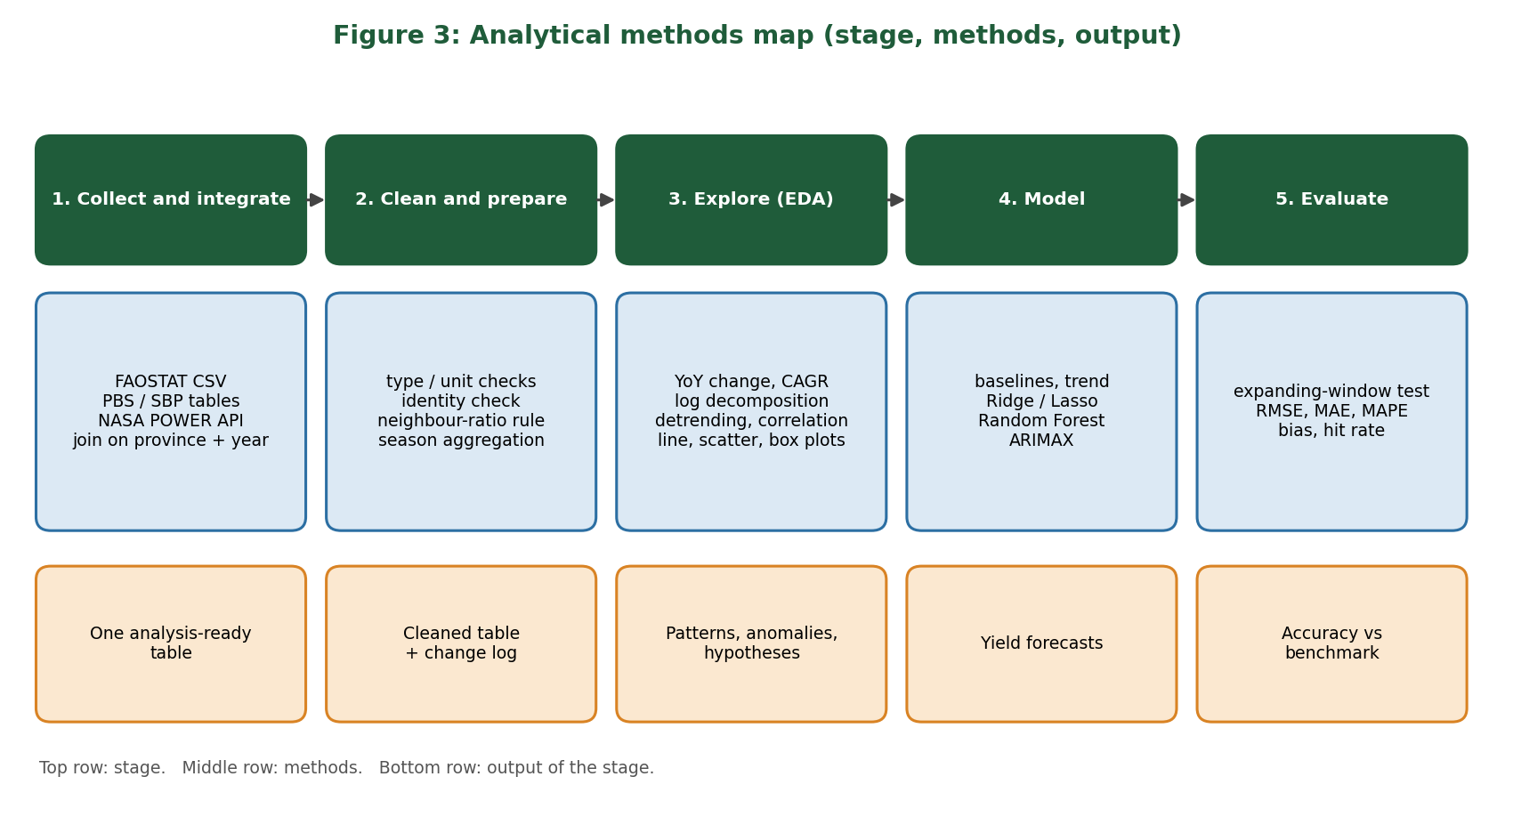
Figure 3: Analytical methods map

4.1 Data collection and integration
- Download each source and store the raw file unchanged in a raw-data folder.
- Convert all values to common units: hectares, tonnes, kg/ha, millimetres, degrees Celsius.
- Define the crop year as the calendar year in which the wheat is harvested (confirmed in Section 3.4).
- Join all tables on province and crop year. The planned analysis table has one row per province and year, as in the example below (values from FAOSTAT are real; the other columns will be filled in later weeks).
Year | Region | Yield (kg/ha) | Area (ha) | Production (t) | Season rain (mm) | Fertiliser (kg/ha), price
2023 | Pakistan | 3,117.6 | 9,032,688 | 28,160,527 | to be added | to be added
2024 | Pakistan | 3,268.3 | 9,734,249 | 31,814,444 | to be added | to be added

4.2 Data preparation
- Type and unit checks; replace any documented missing-value code with a proper missing value.
- Identity check: production must equal area x yield / 1000 (tolerance 1 percent), as passed on the real data.
- Neighbour-ratio check for slips: flag a value if it is more than twice or less than half the median of its three neighbouring years on each side.
- Aggregate daily weather to the wheat season (about November to April): total rainfall, mean temperature, number of days above a heat threshold (to be tuned, for example near 32 degrees Celsius).
- Keep a change log: location, old value, new value and reason for every edit.

4.3 Exploratory methods and formulas
Method | Formula | Worked example (real data)
Year-on-year change | change = (V(t) / V(t-1) - 1) x 100 | 1968 yield: +32.3%; 1987: -17.1%
Compound annual growth rate | CAGR = (V(end) / V(start))^(1/n) - 1 | Yield 1961-2024: (3,268.3 / 822.2)^(1/63) - 1 = 2.21%
Growth decomposition | ln(P2/P1) = ln(A2/A1) + ln(Y2/Y1); share = each term / total | Yield 65%, area 35%
Linear trend and detrending | yield(t) = a + b x t + e(t); analyse e(t) | Trend slope about 38 kg/ha per year
Correlation | Pearson r between two series (also on yearly changes or detrended values) | Area vs yield levels r = 0.96; detrended r about 0.20
Variability | Standard deviation of yearly yield change, by period | 9.8% before 1990, 5.8% since

Example code for the first two methods:
import pandas as pd
d = pd.read_csv("FAOSTAT_data_en_10-9-2026.csv")
w = d.pivot(index="Year", columns="Element", values="Value")
w["yield_yoy_pct"] = w["Yield"].pct_change() * 100
n = w.index.max() - w.index.min()
cagr = (w["Yield"].iloc[-1] / w["Yield"].iloc[0]) ** (1 / n) - 1
print(round(cagr * 100, 2)) # 2.21

4.4 Modelling methods
Model | Form | Why and when
Naive and trend baselines | Forecast = last value; or linear trend fitted to earlier years | The yardstick every other model must beat
Regression on detrended yield | yield dev(t) = b0 + b1 x rain(t) + b2 x heat days(t) + b3 x fertiliser(t) + e | Interpretable effect sizes; good with few observations
Ridge and Lasso | Ridge minimises sum of squared errors + lambda x sum of squared coefficients; Lasso uses the sum of absolute coefficients | Stabilise coefficients when weather variables are correlated; Lasso also selects variables
Random Forest | Average of many decision trees on random subsets of data and variables | Captures non-linear effects and interactions; needs detrended target because it cannot extrapolate
ARIMAX | Time-series model with autoregressive and moving-average terms plus external regressors | Handles time dependence directly

4.5 Validation and evaluation
- Expanding-window validation: for each test year, fit on all earlier years only and forecast that year; never shuffle years.
- Metrics: RMSE = square root of the mean squared error; MAE = mean absolute error; MAPE = mean absolute error as a percentage of the actual value; bias = mean signed error; share of years within 5 percent of actual.
- Benchmark: the naive forecast and the linear-trend forecast. A model is kept only if it is clearly better on the same test years.
- Report error also in tonnes by multiplying the yield error by harvested area (for example 100 kg/ha at the 2024 area of 9.73 million hectares is about 0.97 million tonnes).

4.6 Tools
Python with pandas and NumPy for data handling, matplotlib and seaborn for charts, SciPy and statsmodels for statistics and time series, scikit-learn for regression and Random Forest, Jupyter notebooks for the working, and Git with a GitHub repository for version control and reproducibility. Table-extraction tools may be used for the PDF tables, with results checked against printed totals.

4.7 Specific analysis plan
No. | Question | Data | Method | Output | Status
1 | How much of the growth came from yield and how much from area? | FAOSTAT | Log decomposition by period | Table and chart (Section 3.3) | Done (preliminary)
2 | How unstable is yield and has it changed? | FAOSTAT | Yearly change, standard deviation by period | Volatility chart | Partly done
3 | Do FAOSTAT and PBS / SBP agree? | FAOSTAT, PBS / SBP | Side-by-side comparison, percentage differences | Reconciliation table (Section 3.4) | Started (2 years)
4 | How do provinces and irrigation differ in productivity? | PBS / SBP | Group comparison, box plots | Province yield gap table | Week 2
5 | Which weather variables relate to yield deviations? | NASA POWER, FAOSTAT | Detrending, correlation, regression | Scatter plots, coefficient table | Weeks 2-3
6 | How do fertiliser and prices relate to yield? | PBS / SBP | Lagged correlation, regression | Relationship chart | Week 3
7 | Which forecasting model is most accurate? | Combined table | Expanding-window comparison | Error table versus baseline | Weeks 3-5
8 | What does a bad year cost in tonnes? | FAOSTAT | Sensitivity: 10% shortfall x 2024 production | About 3.2 million tonnes | Done (arithmetic)

5. Strategy, Challenges and Roadmap

5.1 Objectives
- O1: Build one documented, cleaned table linking yield, area, production, weather and inputs, by province and year.
- O2: Describe the trend, variability and regional differences with at least four charts.
- O3: Forecast yield one season ahead and beat the baseline (typical target: error under 5 percent, to be agreed with users).
- O4: Write a repeatable cleaning protocol.
- O5: Communicate results to non-technical stakeholders.

5.2 Anticipated challenges and mitigation
Challenge | Evidence or reason | Mitigation
PDF tables from PBS / SBP | Layouts differ between years; FY05 values were provisional and differ by up to 0.34% from FAOSTAT. | Extract carefully, check against printed totals, record the release used.
Different time and space scales | Daily grid weather versus annual national or provincial yield. | Aggregate weather to the wheat season; use points in main wheat districts.
Trend dominates the data | Area vs yield correlation is 0.96 on levels but about 0.20 once detrended. | Model yield deviation from trend.
Small sample | Only 64 yearly national values. | Provincial panel, simple and regularised models, strict baseline comparison.
Unusual years cannot be explained from yield alone | 1968 and 1987 are the largest swings. | Add weather and input data before drawing conclusions.
Estimated weather data | POWER values are model based on a 0.5-degree grid. | State the limitation and cross-check with a local record where possible.

5.3 Roadmap
Week | Focus | Planned work
1 | Strategy (this report) | Source research, preliminary analysis of FAOSTAT, methods and analysis plan.
2 | Exploratory analysis | Full EDA with at least four charts; provincial and weather data explored if available.
3 | Modelling plan | Variables, method, validation, diagrams, baseline test.
4 | Cleaning | Protocol, scripts and a test on real and simulated errors.
5 | Evaluation | Metrics, insights, recommendations, executive summary.

6. Key Insights and Business Implications
No. | Insight and evidence | Business meaning | Confidence and limits
1 | Growth is yield-led: yield explains 65% of the 8.3-fold production rise, and 79% since 2010 (Figure 2). | Supply growth depends on yield per hectare, so inputs and practices matter more than land. | High for the national figures; cause of yield gains not tested.
2 | Land has levelled: area grew only 0.46% a year since 2010, in a band of about 8.7 to 9.7 million ha since 2013. | Limited room for more output from more land. | High; 2024 area jump of 7.8% should be verified.
3 | Growth is slowing: production growth fell from 5.66% a year (1961-80) to 1.73% (2000-24). | Planning should not assume past growth rates will continue. | High as a description; recent years (2010-24: 2.25%) show some recovery.
4 | Yield swings are smaller recently: standard deviation of yearly change 5.8% since 1990, against 9.8% before. | Supply has become more predictable year to year. | Moderate; based on one national series.
5 | Large one-year swings exist: 1968 +32.3%, 1987 -17.1%. | Buffers are needed for rare bad years. | High that they occurred; causes unknown.
6 | FAOSTAT and State Bank figures agree: FY02 identical, FY05 within 0.4% (Section 3.4). | Either source can be used for national totals; PBS is needed for provinces. | Moderate; only two years compared so far.
7 | The crop is concentrated: Punjab had about 76% of the area (2001-02) and irrigated land produced about 93% of wheat (1999-00). | Province and irrigation strategy should drive any regional analysis. | Moderate; figures are from older years and should be updated.
8 | Each 100 kg/ha of yield is about 0.97 million tonnes at the 2024 area; a 10% yield shortfall is about 3.2 million tonnes. | Gives decision makers a sense of the size of yield risk for stock and import planning. | Arithmetic on 2024 values; assumes area is fixed.

7. Limitations
- Only the FAOSTAT data has been analysed in depth. The PBS / SBP and NASA POWER sources are documented and partly illustrated but not yet fully downloaded.
- All findings are descriptive. Reasons for changes in yield are hypotheses until weather, input and regional data are added.
- The cross-source check covers only two years.
- Provincial and irrigation shares quoted are from older yearbooks and should be updated.

8. Conclusion
Three complementary public sources were documented with concrete examples, and a preliminary analysis of the real FAOSTAT wheat data showed that Pakistan's wheat output has grown 8.3 times since 1961, mainly through higher yield, with land area now levelling off and growth rates slowing. A cross-check against State Bank figures supports the reliability of the national series. The methods section sets out the steps, formulas, models, validation and tools, and the analysis plan links eight specific questions to data, methods and outputs. This gives a clear, evidence-based starting point for the exploratory analysis in Week 2.

References
- FAO, FAOSTAT: Crops and livestock products, wheat, Pakistan, 1961-2024. Downloaded 9 October 2026. https://www.fao.org/faostat
- FAO, FAOSTAT crop production, yield, harvested area metadata. https://data.fao.org/catalog/iso/d24a448b-3b62-4c09-8c1d-4a39bb599876
- Pakistan Bureau of Statistics, Statistical Yearbook, agriculture tables. https://www.pbs.gov.pk/node/249
- Pakistan Bureau of Statistics, Statistical Yearbook 2009, Table 1.7: Area and Production of Wheat Crop by Source of Irrigation. https://www.pbs.gov.pk/sites/default/files/other/yearbooks/yearbook2009/AGRICULTURE/1-7.pdf
- State Bank of Pakistan, Annual Report FY05, Table 2.5: Area, Production and Yield of Important Crops. https://www.sbp.org.pk/reports/annual/arfy05/Stats/2.5.pdf
- NASA POWER, Data Access Viewer Quick Start. https://power.larc.nasa.gov/docs/tutorials/data-access-viewer/quick-start/

