Junior Data Science Analyst: Agriculture & Agribusiness
Week 2 Report
Exploratory Data Analysis (EDA) of Agribusiness Data
Project: Pakistan Wheat Yield Analysis and Forecasting
Field | Details
Prepared by | Qasim Ali Shahid
Internship period | 09 October 2026 to 13 November 2026 (5 weeks)
Dataset | FAOSTAT, Crops and livestock products: wheat, Pakistan, 1961 to 2024 (downloaded 9 October 2026)
Tools | Python (pandas, NumPy, matplotlib, seaborn)

1. Introduction and Objective
Week 1 identified the data sources and set the strategy for a continuous project on wheat in Pakistan. This week moves from planning to analysis. The objective is to carry out an exploratory data analysis (EDA) on real agricultural data, to understand its structure and quality, to find the main patterns in wheat area, production and yield, and to draw out observations that matter for decisions in agribusiness, such as supply planning, input demand and risk assessment.
The report is organized as follows: data acquisition and description (Sections 2 and 3), the methods used and why (Section 4), six visualizations with interpretation (Section 5), a summary of findings and recommendations (Sections 6 and 7), and the steps, challenges and limitations of the work (Section 8).

2. Data Acquisition

2.1 Origin and relevance
The dataset comes from FAOSTAT, the statistical database of the Food and Agriculture Organization of the United Nations (FAO), domain "Crops and livestock products" (code QCL). It was filtered on the FAOSTAT website to a single country (Pakistan), a single crop (wheat) and three elements: area harvested, yield and production, for all available years. The file was exported in CSV format on 9 October 2026.
FAOSTAT was chosen because it provides one of the longest continuous annual series for wheat (64 years), uses consistent units, and carries a quality flag for every value. Wheat is Pakistan's main staple cereal, so its long-run behavior is directly relevant to food security, flour milling, input supply and trade planning.

2.2 Structure of the file
The CSV contains 192 data rows and 15 columns in long format, with one row per year and element (64 years x 3 elements). The columns that carry the analysis are Element, Year, Unit and Value. The remaining columns are identifiers (domain, area, item and their codes), a flag and its description, and an empty note field.

3. Data Familiarization

3.1 Key variables
Variable | Unit | Meaning
Area harvested | hectares (ha) | Land from which the wheat crop was harvested in the year. For cereals, FAO counts crops harvested for dry grain only.
Production | tonnes (t) | Total wheat harvested in the year.
Yield | kg per hectare | Production per unit of harvested area. Reported here directly in kg/ha, so no unit conversion was required.

3.2 Initial data quality checks
- Coverage: 64 consecutive years, 1961 to 2024, with no gaps.
- Missing values: none in the three analysis variables (only the unused Note column is empty).
- Quality flag: every value carries the flag "A" (Official value), so no estimated or imputed entries needed special treatment.
- Internal consistency: area x yield was compared with reported production for every year. The largest difference was 0.0065 percent, which is rounding level. The three series are therefore consistent with each other.

3.3 Summary statistics (1961 to 2024)
Statistic | Area (million ha) | Yield (kg/ha) | Production (million t)
Mean | 7.54 | 1,957 | 15.66
Median | 7.97 | 1,920 | 15.45
Standard deviation | 1.35 | 715 | 7.74
Minimum | 4.64 (1961) | 760 (1966) | 3.81 (1961)
Maximum | 9.73 (2024) | 3,268 (2024) | 31.81 (2024)

Between 1961 and 2024 harvested area grew 2.1 times, yield grew 4.0 times (from 822 to 3,268 kg/ha) and production grew 8.3 times (from 3.81 to 31.81 million tonnes). The compound annual growth rates are 1.18 percent for area, 2.21 percent for yield and 3.42 percent for production. In logarithmic terms, about 65 percent of the growth in production came from higher yield and about 35 percent from a larger area.

4. Choice of EDA Methods
Method | Reason for using it
Line charts with rolling mean and linear trend | The data is a time series. A trend line shows the long-run direction and the rolling mean smooths short-term noise.
Dual-axis chart (area and production) | Shows whether production growth follows land expansion or something else, on a common time axis.
Year-on-year percentage change | Removes the effect of scale, so good and bad years can be compared across decades and extreme years stand out.
Scatter plot with correlation | Checks the relationship between two variables. Colouring points by year shows how it moves over time.
Decade grouping and standard deviation of change | Summarises how the average level and the stability of yield changed over time.
Correlation of yearly changes | Correlating levels of two trending series is misleading because both rise with time. Correlating changes measures the link without the shared trend.
Integrity check (area x yield versus production) | Confirms the data is internally consistent before drawing conclusions.

Only descriptive and visual methods are used this week. No causal claims are made, because the dataset contains no explanatory variables such as weather, irrigation or input use. These are added in the later weeks.

5. Visualizations and Interpretation

5.1 Long-run yield trend
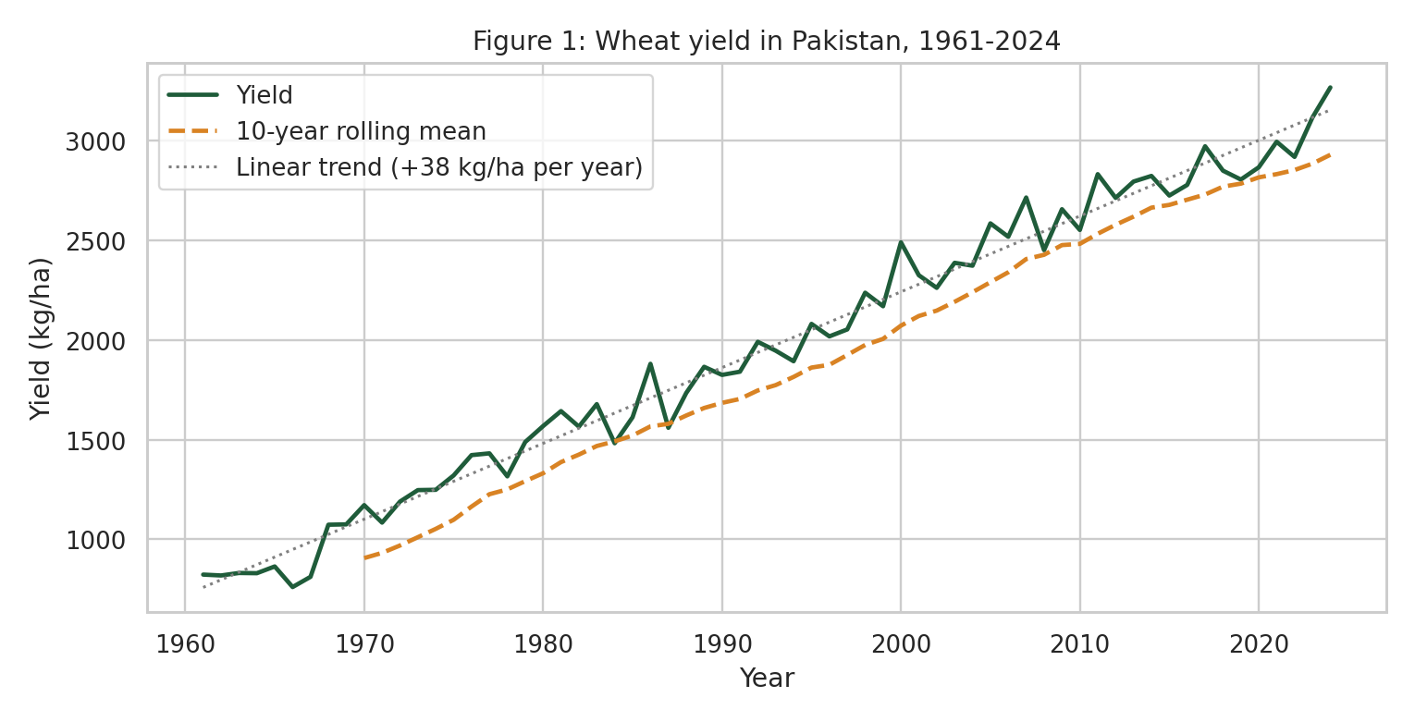
Figure 1: Wheat yield in Pakistan, 1961-2024, with 10-year rolling mean and linear trend
Yield rose from about 820 kg/ha in the early 1960s to about 3,270 kg/ha in 2024. A straight-line fit gives an average gain of about 38 kg/ha per year. The rise is steady but not smooth: there is a sharp step at the end of the 1960s, and several short dips. The linear trend and the actual series cross repeatedly, which means yield is not growing at a perfectly constant rate. The 2024 value is the highest in the series and sits above both the trend line and the rolling mean.
Fitting a straight line separately to different periods shows that the gain per year has gradually weakened: about 42 kg/ha per year for 1961 to 1980, 39 for 1981 to 2000, 33 for 2001 to 2024 and 32 for 2010 to 2024. This suggests that each additional year of progress adds slightly less than before, although the very latest years are strong.

5.2 Area harvested and production
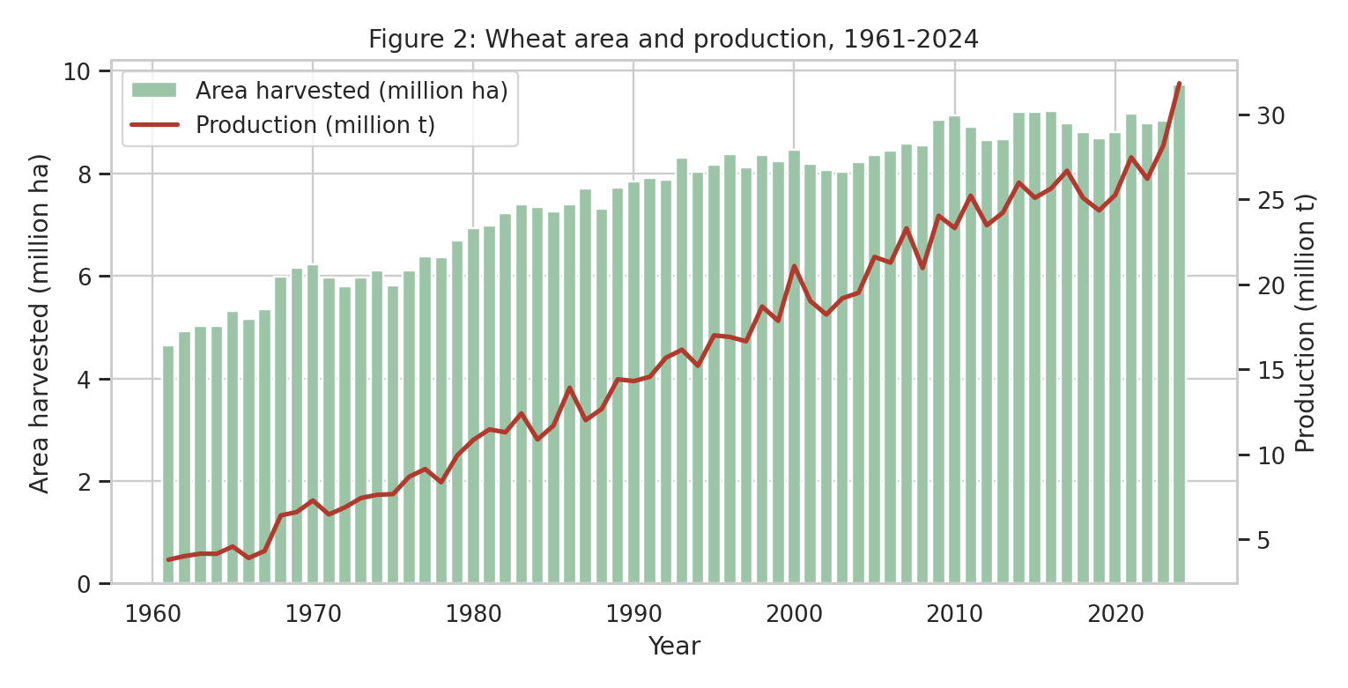
Figure 2: Wheat area harvested (bars) and production (line), 1961-2024
Both series rise over the whole period, but production rises much faster than area. Area grew quickly until the 1990s and then slowed: the decade average rose from 5.3 million ha in the 1960s to 8.1 million ha in the 1990s, and then only to 9.1 million ha in the 2020s. Since about 2013 area has moved within a band of roughly 8.7 to 9.7 million ha. Production kept growing in that period, which shows that recent growth depends mainly on yield. In 2024 both area (+7.8 percent) and yield (+4.8 percent) rose, which together produced the largest production figure in the series.

5.3 Year-on-year changes and unusual years
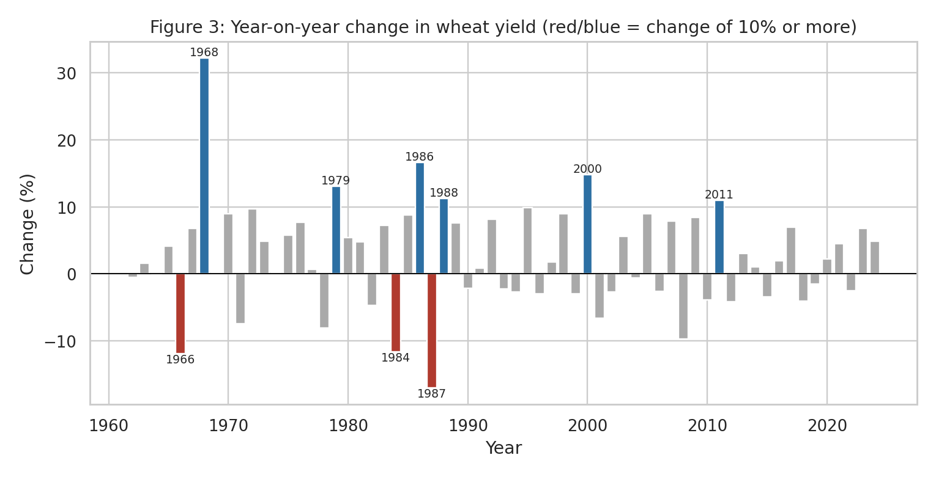
Figure 3: Year-on-year change in wheat yield; red and blue bars mark changes of 10 percent or more
Most years show moderate changes, but nine years changed by 10 percent or more. The largest increase is 1968 (+32.3 percent) and the largest fall is 1987 (-17.1 percent). Other large falls occurred in 1966 (-12.0 percent) and 1984 (-11.7 percent); other large rises in 1979 (+13.1), 1986 (+16.6), 1988 (+11.2), 2000 (+14.8) and 2011 (+11.0). Large swings are concentrated before 1990. After 2011 no yearly change exceeds 10 percent.
A second check used the distance between actual yield and the linear trend. Only two years lie more than two standard deviations from the trend: 2000 (+2.6) and 2007 (+2.2), both above trend. This confirms that yield has not had extreme downward departures from its long-run path in the recent past, although the 1960s and 1980s dips remain the most severe in percentage terms.
The data cannot say why these years were unusual. The 1968 jump falls in a period generally associated with the spread of high-yielding wheat varieties in South Asia, but this is a hypothesis to be checked against the literature, not a finding of this analysis. Explaining the dips (for example 1987) requires weather and input data, which are planned for the modelling stage.

5.4 Relationship between area and yield
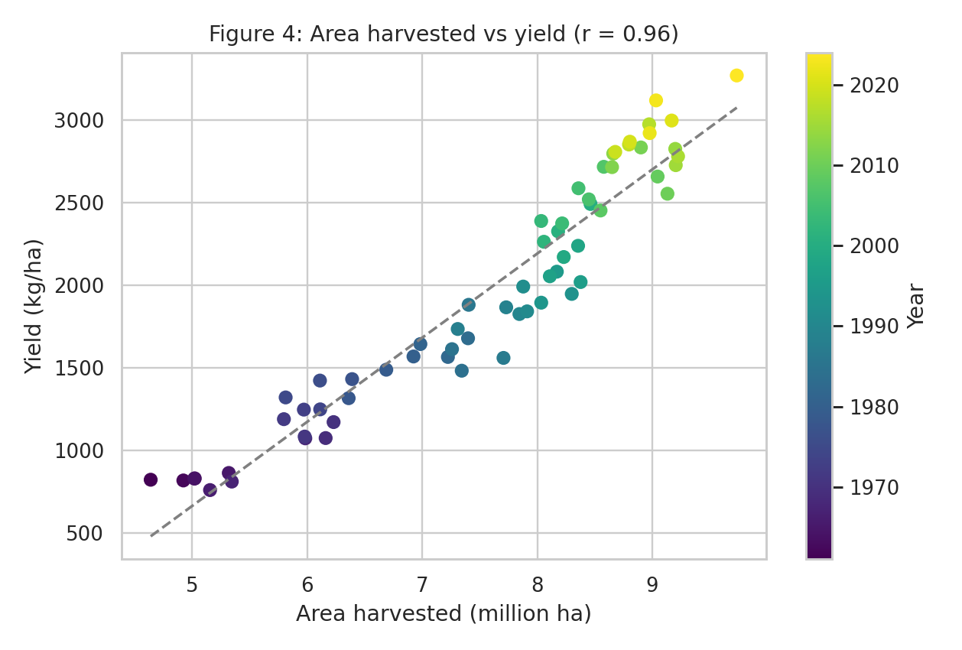
Figure 4: Area harvested versus yield, colored by year
The scatter plot shows a very strong positive correlation (r = 0.96) between area and yield. This should not be read as "more land causes higher yield". The points are ordered by colour from the bottom left (early years) to the top right (recent years), which shows that both variables simply rise with time. When a straight-line time trend is removed from each series, the correlation falls to about 0.20. The apparent link is therefore mostly a shared trend, and this is a useful warning for the modelling stage: variables that both trend over time can look related when they are not.

5.5 Decade comparison
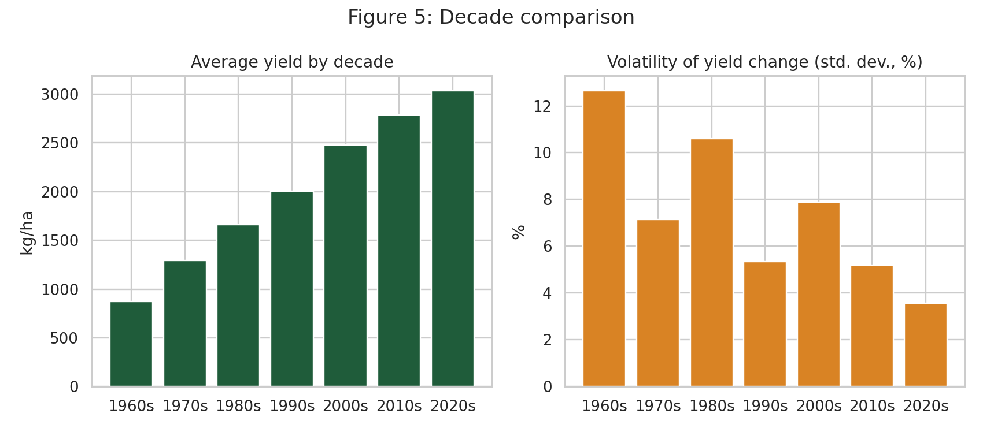
Figure 5: Average yield and volatility of yield change by decade
Decade | Avg area (million ha) | Avg yield (kg/ha) | Avg production (million t) | Volatility of yield change (std. dev., %)
1960s | 5.28 | 876 | 4.67 | 12.65
1970s | 6.14 | 1,291 | 7.96 | 7.15
1980s | 7.33 | 1,659 | 12.17 | 10.61
1990s | 8.12 | 2,006 | 16.30 | 5.35
2000s | 8.39 | 2,477 | 20.82 | 7.89
2010s | 8.94 | 2,785 | 24.90 | 5.20
2020s | 9.14 | 3,034 | 27.78 | 3.57

Average yield rises in every decade, but the step between decades has shrunk: it was about 415 kg/ha from the 1960s to the 1970s and about 250 kg/ha from the 2010s to the 2020s. The volatility of yearly change is also falling overall, from 12.7 percent in the 1960s to 3.6 percent in the 2020s, with a temporary rise in the 1980s and 2000s. Since 1990 the standard deviation of yearly yield change is 5.8 percent, compared with 9.8 percent before 1990. Note that the 1960s and 2020s contain fewer yearly changes (8 and 5) than the other decades, so their volatility values are less reliable.

5.6 What drives changes in production?
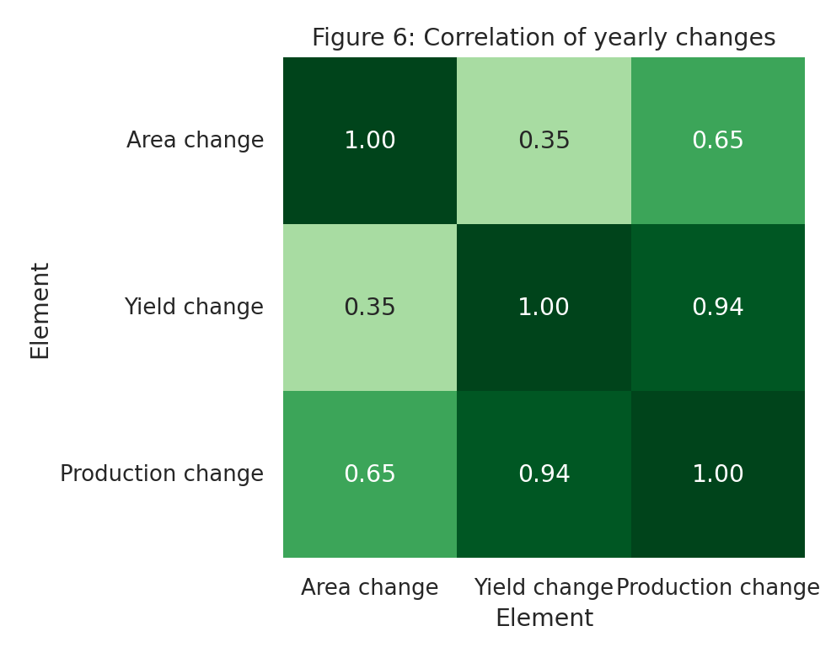
Figure 6: Correlation between yearly changes in area, yield and production
The correlation of yearly changes shows that production moves almost together with yield (r = 0.94) and less so with area (r = 0.65). Area and yield changes are only weakly related to each other (r = 0.35). In other words, a good or bad production year is mainly a good or bad yield year. This points to growing conditions and crop management, rather than the amount of land sown, as the main source of year-to-year variation, which is the reason weather and input variables are the next step.

6. Summary of Key Findings
- Long-run growth. Production grew 8.3-fold in 64 years. About two thirds of the growth came from yield and one third from area.
- Yield-led growth. Area growth has slowed since the 1990s, so recent increases in output depend mostly on yield.
- Slowing but still positive progress. The linear yield gain per year fell from about 42 to about 32 kg/ha across the periods examined, while the last five years show faster growth (about 3.1 percent per year on average) than the 2010s (about 0.7 percent).
- Greater stability. Year-to-year swings in yield have become smaller, particularly after 1990.
- Production tracks yield. Yearly production changes are far more closely linked to yield changes than to area changes.
- Trend caution. Raw correlations between trending variables are inflated by the common time trend.
- Record year. 2024 is the highest value for area, yield and production in the series.

7. Implications and Recommendations for Agribusiness
- Plan around yield, not land. Because area has levelled off, flour mills, input suppliers and traders should treat yield outcomes as the main driver of supply and monitor them each season.
- Use trend plus deviation for forecasting. A simple baseline of the long-run trend, with a range based on past deviations, gives a reasonable first estimate of expected output. More advanced models in Week 3 should be tested against this baseline.
- Treat the 2024 record with care. A single exceptionally high year should not be extrapolated. It should be checked against the national Pakistan Bureau of Statistics series and against season conditions before it is used for planning.
- Expect slower gains from the same practices. The falling yearly gain suggests that further growth needs technology and input-efficiency improvements (seed, fertiliser management, water use) rather than continuing the same approach. Input suppliers can use this to priorities efficiency products.
- Invest in explaining the bad years. Risk management (stock holding, import timing, insurance) depends on understanding what caused the largest falls. Adding weather data is the logical next step.
- Add a provincial view. The national series hides regional differences. The Pakistan Bureau of Statistics tables identified in Week 1 will add province-level detail.

8. Steps Taken, Challenges and Limitations

8.1 Steps taken
- Filtered and downloaded the dataset from FAOSTAT as CSV.
- Inspected columns, data types, missing values, flags and year coverage.
- Reshaped the data from long to wide format (one row per year).
- Checked that area x yield matches production.
- Calculated yearly percentage changes, compound growth rates, a linear trend, a 10-year rolling mean, decade averages and correlations.

8.2 Challenges
- Trending series: because area, yield and production all rise over time, simple correlations of levels are misleading. This was handled by also analyzing yearly changes and detrended values.
- Uneven decade lengths: the first and last decades contain fewer yearly changes, so their volatility figures were flagged as less reliable.
- Limited variables: the dataset has only three variables, so explanations remain hypotheses.

8.3 Limitations
- National level only: no regional, irrigation or farm-size differences can be seen.
- FAOSTAT values are compiled from official country submissions and may differ slightly from the Pakistan Bureau of Statistics series. The two should be compared in a later week.
- No explanatory variables (weather, fertilizer, prices) are included yet.
- A linear trend is a simple summary, and the true growth path is not perfectly straight.

9. Conclusion
The EDA shows that Pakistan's wheat output has grown strongly over six decades, mostly through higher yield, and that growth is now more dependent on yield than on land. Yield has become more stable, but the yearly gain has weakened over time, and the strongest production swings come from yield swings. The next step, in Week 3, is to design a predictive modelling approach that adds climate, input and market variables, and that is tested against the simple trend baseline described here.

References
- FAO, FAOSTAT: Crops and livestock products (QCL), wheat, Pakistan, 1961-2024. Data downloaded 9 October 2026. https://www.fao.org/faostat
- FAO, FAOSTAT crop production, yield, harvested area metadata. https://data.fao.org/catalog/iso/d24a448b-3b62-4c09-8c1d-4a39bb599876

