Junior Data Science Analyst: Agriculture & Agribusiness
Week 3 Report
Predictive Modeling Strategy for Crop Yield Forecasting
Project: Pakistan Wheat Yield Analysis and Forecasting
Field | Details
Prepared by | Qasim Ali Shahid
Internship period | 09 October 2026 to 13 November 2026 (5 weeks)
Region and crop | Pakistan (with Punjab as the main sub-national focus), wheat
Data used this week | FAOSTAT wheat yield, 1961 to 2024 (for baseline testing); other variables are planned, not yet collected

1. Introduction and Objective
Week 1 selected the data sources and Week 2 explored the FAOSTAT wheat series. This week designs the predictive modelling approach for forecasting wheat yield. The task is mainly one of planning and structure: defining the problem, identifying the variables that should drive the model, proposing a step-by-step method, drawing the data pipeline and model workflow, and thinking through the problems that would appear in real use.
To keep the plan grounded, one part of it was tested on real data. The simple baseline forecasting methods that any later model must beat were run on the FAOSTAT yield series using the same validation scheme that is proposed for the full model. Their results are reported in Section 5. The fuller model, which needs weather, soil, input and price data, is a design in this report and is not claimed as a finished result.

2. Problem Definition

2.1 Target variable
Element | Definition
Target | Wheat yield in kilograms per hectare (kg/ha) for a crop year.
Unit of analysis | Pakistan as a whole (annual) for the baseline stage; Punjab and the other provinces (province x crop year) once provincial data from the Pakistan Bureau of Statistics is added.
Forecast type | Regression (continuous value), one season ahead.
Forecast moments | Three issue points are planned: before sowing (trend, prices and inputs only), mid-season (adds weather observed so far) and pre-harvest (adds full season weather).
Why yield and not production | Production equals area times yield, and Week 2 showed that yearly production changes follow yield changes far more closely than area changes (correlation 0.94). Area can be forecast or taken from sowing reports separately.

2.2 Business use
An early and reasonably accurate yield estimate supports flour mills deciding on procurement and stock, traders and government planners deciding on storage and import timing, and input suppliers estimating fertilizer demand. For these users the size of the typical forecast error matters as much as the forecast itself, so the model is judged on error in kg/ha and as a percentage, and always against a simple baseline.

2.3 Raw variable identification
The table lists the raw variables proposed for the model. The expected direction of each effect is a hypothesis taken from general agronomic reasoning. It will be tested in the data and not assumed.
Group | Variable | Source | Expected relationship (hypothesis)
Climate | Seasonal rainfall (total and by growth stage) | NASA POWER | Helps yield where water is limiting; excess rain at harvest may hurt.
Climate | Mean, minimum and maximum temperature; heat-stress days during grain filling | NASA POWER | Heat above the crop's tolerance during grain filling is expected to reduce yield. The threshold will be tuned.
Climate | Solar radiation, growing degree days | NASA POWER | More favorable radiation and a longer cool growing period are expected to raise yield.
Soil and land | Soil texture, organic carbon, pH; irrigated share of wheat area | Public soil database (to be identified, for example a global soil grid); PBS irrigation tables | Better soils and irrigation access are expected to raise and stabilize yield.
Management | Fertilizer use per hectare; variety or seed type | PBS / SBP | Higher nutrient use is expected to raise yield with diminishing returns.
Market and policy | Wheat price and support price at sowing time; fertilizer-to-wheat price ratio | PBS / SBP | Better price signals encourage input use, so lagged prices may affect yield indirectly.
Time and technology | Year (trend); previous-year yield (lag) | FAOSTAT | Captures steady gains from improved seed and practices, shown in Week 2 as about 38 kg/ha per year.
Shocks | Flags for drought, flood, heat-wave, rust or pest outbreak years | Official reports, where available | Large negative departures from trend in flagged years.

Several of these variables are not yet in hand. Only the FAOSTAT yield series has been collected so far, so the modelling plan below is the design that will be followed when the other sources are added.

3. Methodology Design

3.1 Step-by-step approach
- Step 1: Data preparation. Standardize units (kg/ha, millimeters, degrees Celsius), align every source to the same crop year, aggregate daily weather into wheat-season features (the season runs approximately from November sowing to April harvest), and join all tables on province and crop year. Cleaning follows the protocol that will be written in Week 4.
- Step 2: Handling the trend. Week 2 showed that yield rises steadily over time. Two options will be compared: (a) predict yield directly with a time trend included as a feature, and (b) predict the deviation from the long-run trend and then add the trend back. Option (b) focuses the model on what weather and inputs explain, and prevents variables that merely rise with time from appearing important.
- Step 3: Feature engineering. Create season totals and averages, stage-specific weather (for example grain-filling temperature), heat-stress day counts, one-year lags of yield and prices, and fertilizer per hectare. Only information that would genuinely be available at the forecast issue date may be used.
- Step 4: Feature selection. Screen out near-duplicate variables using a correlation matrix and variance inflation checks, then use regularization (Lasso) and tree-based importance to shortlist. Agronomic judgment is applied last, so that every retained variable has a plausible mechanism.
- Step 5: Model selection. Start with baselines, then add progressively more flexible models (Section 3.2). A more complex model is accepted only if it beats the simpler one on validation.
- Step 6: Validation. Use time-ordered, expanding-window validation (Section 3.3), never random shuffling. Tuning is done only inside training years.
- Step 7: Evaluation and interpretation. Report RMSE, MAE and MAPE against the baselines, examine the largest errors year by year, and interpret the model with coefficients or importance plots.

3.2 Candidate models
Model | Strength | Concern
Baselines: naive (last year), 3-year mean, linear trend | Simple, transparent, set the bar every model must pass. | Cannot respond to weather or inputs.
Ridge and Lasso regression | Work with few observations and correlated variables; coefficients are easy to explain to stakeholders. | Assume linear effects.
Random Forest | Captures non-linear effects and interactions such as heat combined with low water; gives importance scores. | Cannot extrapolate beyond the range of training data, which matters for a trending target; needs the detrended approach.
Gradient boosting | Often accurate on tabular data. | Easier to overfit with small samples; needs careful tuning.
ARIMA with external repressors (ARIMAX) | Handles time dependence and trend directly and can include weather as repressors. | Assumes stable relationships over time; more demanding to set up.

With roughly 60 national observations, simpler models are expected to compete well. A provincial panel (several provinces x many years) increases the sample and is the main route to supporting more flexible models.

3.3 Validation strategy
Yield data is a time series, so a random train-test split would let the model learn from future years and would give an overly optimistic score. The plan uses expanding-window validation: for each test year, the model is fitted on all earlier years only and asked to forecast that year (Figure 4). The average error across all test years estimates how the model would have performed in real use. A final check holds out the most recent years entirely, and results are also reported separately for unusual years to see whether the model fails when it matters most.

4. Conceptual Framework and Diagrams
The diagrams below show how the variables, data flow and modelling steps fit together.

4.1 Variable framework
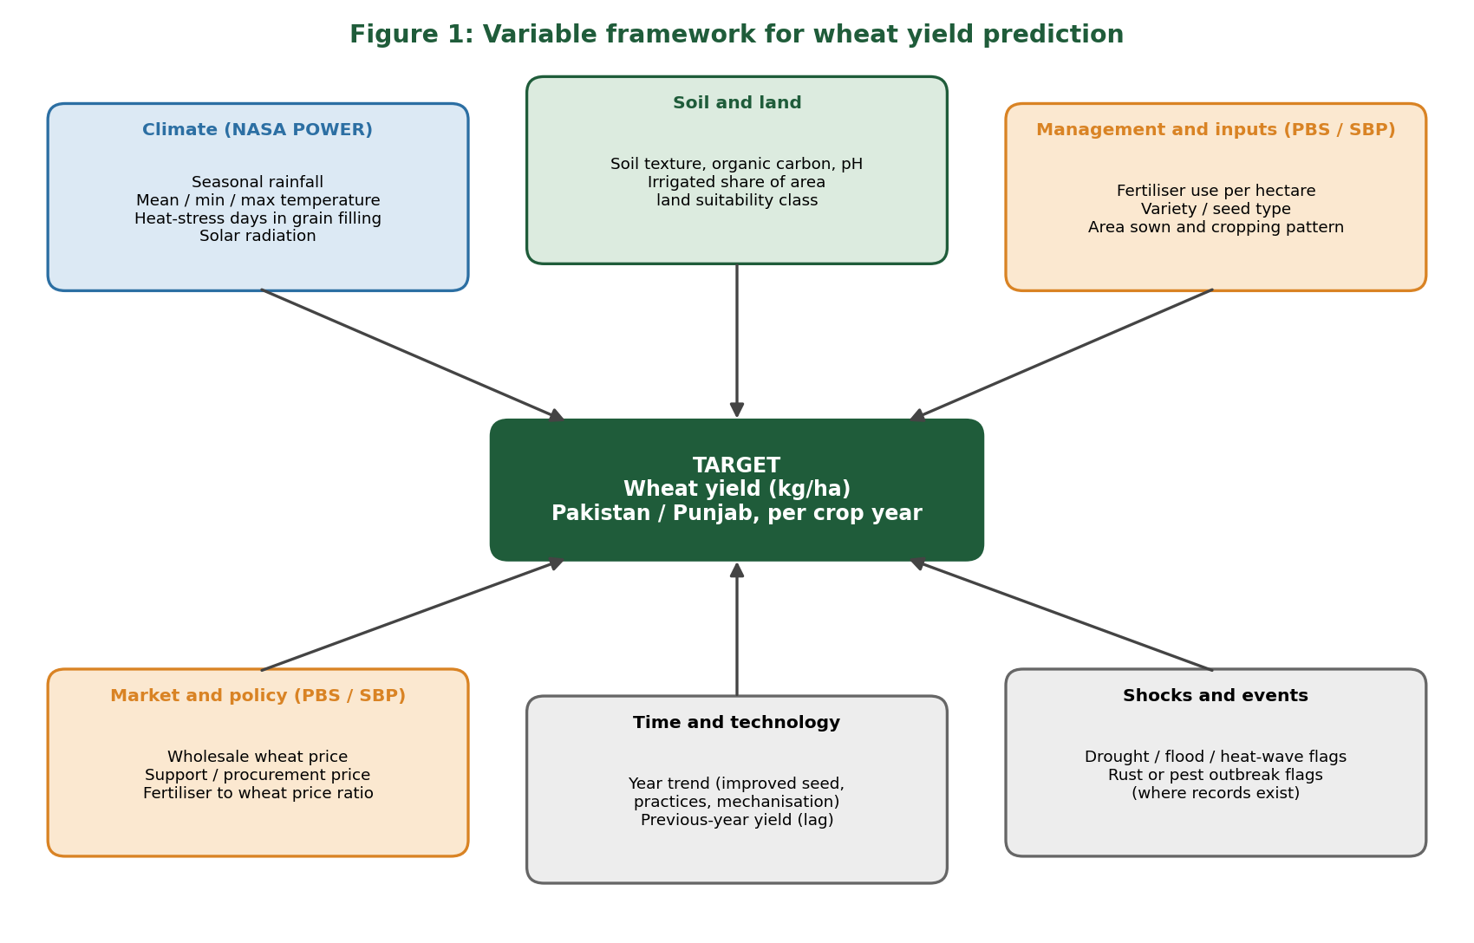
Figure 1: Groups of variables expected to influence wheat yield, with their intended sources
Figure 1 groups the drivers of yield into climate, soil and land, management and inputs, market and policy, time and technology, and shocks. The first four groups come from named data sources. The time and technology group is a control that stops the model from confusing a general upward trend with a real effect, and the shock flags help explain unusual years.

4.2 Data pipeline
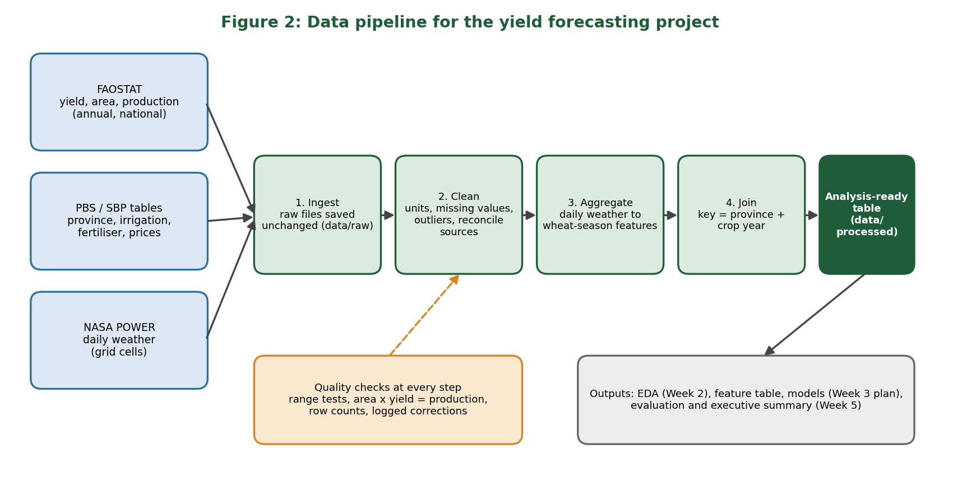
Figure 2: Data pipeline from raw sources to the analysis-ready table
Figure 2 shows the path from three raw sources to one analysis-ready table. Raw files are stored unchanged, cleaned, aggregated to the wheat season, and joined on province and crop year. Quality checks run at every stage, including the check from Week 2 that area times yield matches production.

4.3 Model development workflow
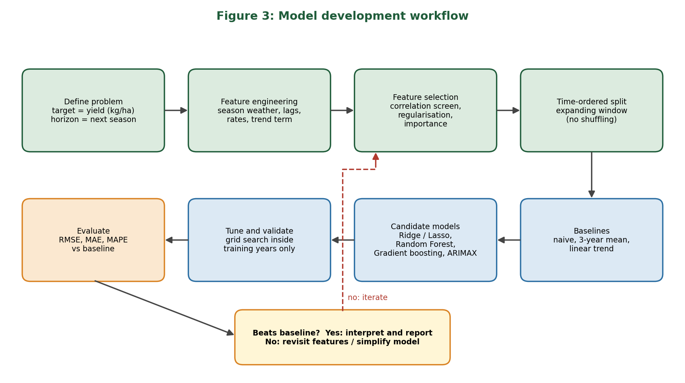
Figure 3: Model development workflow with an iteration loop
Figure 3 lists the steps in order. The loop at the bottom is important: if a model does not beat the baseline, the response is to revisit features or simplify the model, not to add complexity.

4.4 Validation scheme
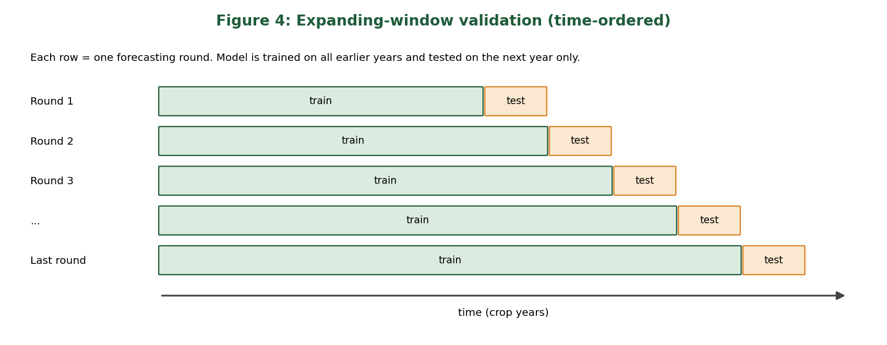
Figure 4: Expanding-window validation, always training on the past and testing on the next year

5. Baseline Test on Real Data
To check that the validation design works and to set the benchmark, four baseline forecasts were run on the FAOSTAT national wheat yield series. Using the expanding-window scheme, each year from 1991 to 2024 (34 test years) was forecast using only earlier years. The four methods were: naive (last year's yield), the mean of the last three years, a linear trend fitted to all earlier years, and a linear trend fitted to the last 20 years.
Method | RMSE (kg/ha) | MAE (kg/ha) | MAPE (%)
Naive (last year) | 145.8 | 122.9 | 4.8
Mean of last 3 years | 135.7 | 104.2 | 4.1
Linear trend (expanding window) | 104.7 | 85.2 | 3.4
Linear trend (last 20 years) | 109.6 | 86.3 | 3.4

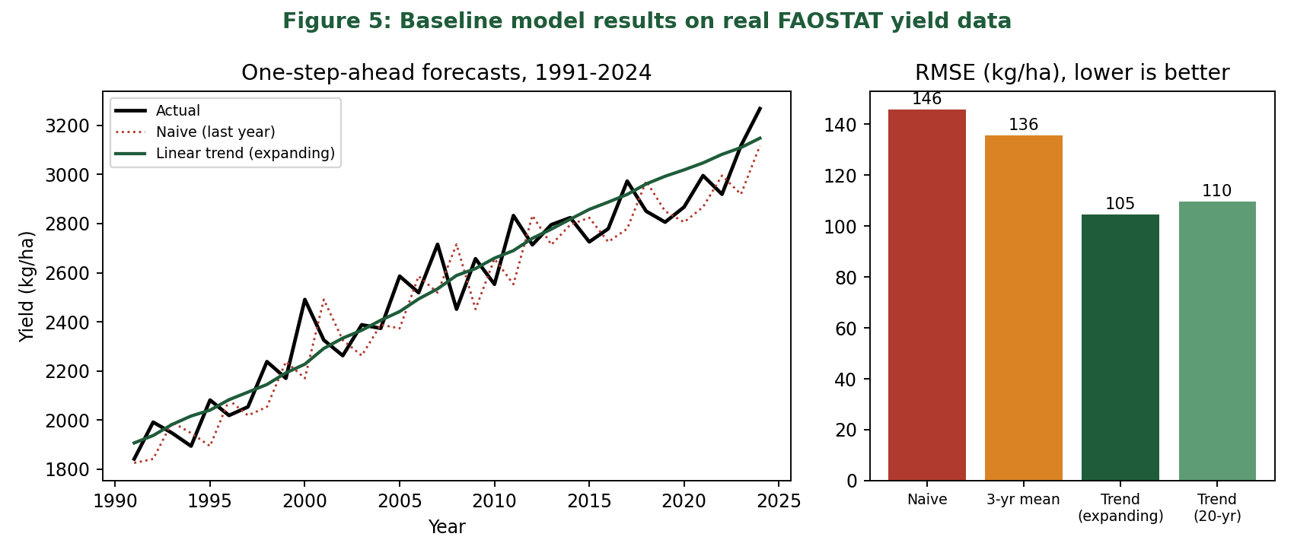
Figure 5: One-step-ahead baseline forecasts and their RMSE on real data
The simple linear trend is the best of the four. It cuts RMSE by about 28 percent compared with the naive forecast (104.7 against 145.8 kg/ha), and its typical error is about 3.4 percent of yield. This is the benchmark that the weather-based model must beat to justify its extra complexity. Even the best baseline makes larger mistakes in particular years: the 20-year trend missed 2000 by about 300 kg/ha, 2024 by about 220 kg/ha and 2008 by about 196 kg/ha, and the naive forecast missed 2000, 2011 and 2008 by 264 to 321 kg/ha. Because these baselines use only past yields, they cannot anticipate a season that is better or worse than usual. Whether weather variables can explain such years is a hypothesis for the full model and has not been tested yet.
The code that produced these results (baseline_models.py) and the forecast table are stored in the project repository.

6. Challenges and Mitigation Strategies
Challenge | Why it matters | Mitigation
Small sample | About 60 national yearly values limit how complex a model can be and invite overfitting. | Use a province x year panel, favour regularised and simple models, and compare every model with the baselines.
Data leakage | Using information not available at issue time, or random splits, produces falsely good results. | Time-ordered validation; build features only from data dated before the forecast issue date.
Trend confusion | Variables that rise over time can appear related to yield (Week 2: area and yield r = 0.96 falls to about 0.20 after detrending). | Model the deviation from trend, or include a trend term, and check results on detrended data.
Correlated predictors | Temperature, radiation and rainfall move together, which makes coefficients unstable. | Correlation and variance inflation checks, Ridge or Lasso, and domain-based feature grouping.
Spatial and temporal mismatch | Daily half-degree grid weather versus annual provincial yield. | Aggregate to the wheat season and use area-weighted points in the main wheat districts.
Estimated weather data | Satellite and model-based values may not match local conditions. | State the limitation, and cross-check against a local station record where one is available.
Rare extreme years | Few droughts or heat waves in the record, so the model sees little of what matters most. | Shock flags, report error separately for extreme years, and give forecast ranges rather than one number.
Changing relationships over time | New varieties and practices can change how yield reacts to weather. | Rolling-window refits, and monitoring of recent errors.
Data revisions and format problems | Official figures are revised and PBS tables are published as PDFs. | Record the release used, log every manual correction and re-check totals.
Interpretability for decision makers | Stakeholders will not trust a model they cannot understand. | Keep a simple model as the reference, and provide importance plots and plain-language explanations.

7. Implementation Considerations in Real Use
- Timeliness: each forecast issue point (pre-sowing, mid-season, pre-harvest) must use only data that is truly available then. Near-real-time weather helps, but official crop statistics arrive with a delay.
- Forecast ranges: reporting a range (for example from past error sizes) is more honest and more useful for risk planning than a single value.
- Maintenance: refit the model each year as a new season is added, and compare its error with the baseline. If it stops beating the baseline, the model should be reviewed.
- Reproducibility: the pipeline is scripted and stored in version control so that any result can be rerun from the raw data.
- Human review: the output is a decision aid and should be read together with local knowledge of the season.

8. Link to the Remaining Weeks
Week | Use of this plan
4 | The cleaning protocol will be written to cover the exact problems named in Section 6 (units, missing values, outliers, source reconciliation) and applied to the real data.
5 | The evaluation framework will use the metrics and baselines set here, review the project end to end, and present the findings to non-technical stakeholders.

9. Conclusion
This report defines wheat yield forecasting as a one-season-ahead regression problem, identifies the climate, soil, management, market, trend and shock variables that should drive it, and sets out a step-by-step method with time-ordered validation, a model ladder from simple to flexible, and a table of risks with responses.
Four diagrams show the variable framework, data pipeline, model workflow and validation scheme. A baseline test on real FAOSTAT data shows that a simple linear trend forecasts national yield with a typical error of about 3.4 percent, which sets a clear benchmark for the full model. The plan is realistic about its limits: the weather, soil, input and price data are still to be collected, and the benefit of adding them is a hypothesis that remains to be tested.

References
- FAO, FAOSTAT: Crops and livestock products, wheat yield, Pakistan, 1961-2024. Downloaded 9 October 2026. https://www.fao.org/faostat
- NASA POWER project, Data Access Viewer. https://power.larc.nasa.gov/docs/tutorials/data-access-viewer/quick-start/
- Pakistan Bureau of Statistics, Statistical Yearbook, agriculture tables. https://www.pbs.gov.pk/node/249
- Hyndman, R.J. and Athanasopoulos, G., Forecasting: Principles and Practice (3rd edition), OTexts, on time series forecasting and time-ordered evaluation.
- Tibshirani, R. (1996), Regression shrinkage and selection via the lasso, Journal of the Royal Statistical Society B.
- Breiman, L. (2001), Random Forests, Machine Learning 45.

