Junior Data Science Analyst: Agriculture & Agribusiness
Week 4 Report
Data Cleaning and Preprocessing in an Agribusiness Context
Project: Pakistan Wheat Yield Analysis and Forecasting
Field | Details
Prepared by | [Your Full Name]
Internship period | 09 October 2026 to 13 November 2026 (5 weeks)
Data used | Real FAOSTAT wheat data for Pakistan, 1961 to 2024; plus a clearly labelled simulated test copy with injected errors
Tools | Python (pandas, NumPy, SciPy, matplotlib)

1. Introduction and Objective
Models and charts are only as reliable as the data behind them. This week sets out a standard data cleaning and preprocessing protocol for agricultural data, which is often incomplete, inconsistently formatted and noisy, and then tests the protocol in code. The report covers typical data problems, the protocol and its checklists, techniques and tools, scripted examples, the results of applying the protocol to the real wheat data, a stress test, and a discussion of how data quality affects decisions.
Two kinds of evidence are used and kept separate. The first is the real FAOSTAT wheat series used in Weeks 2 and 3. It turned out to be very clean, so on its own it cannot show whether a protocol works. The second is a simulated test: a copy of the same data into which known errors were deliberately inserted. Because the true values are known, the protocol can be scored on how well it finds and repairs the errors. The simulated data is used only for testing and is never presented as real.

2. Typical Data Issues in Agricultural Datasets
Issue | Examples in agriculture | Effect if ignored
Incomplete entries | A year or district missing from a table; weather sensor gaps; survey questions left blank. | Biased averages, broken time series, models that cannot run.
Inconsistent formats | Numbers stored as text ("2,490.7"); mixed decimal separators; dates written in different styles; crop-year labels such as "1999-00". | Values silently dropped or misread when converted.
Unit and scale differences | FAOSTAT yield in hg/ha, official tables in kg/ha; areas in thousand hectares or acres; local weight units such as the maund (roughly 37 to 40 kg depending on definition). | Errors by a factor of 10 or more.
Duplicates | The same year or farm entered twice when files are merged. | Double counting.
Noise and outliers | Typing slips, an extra zero, estimation error; also genuine extremes such as a drought year. | Distorted trends and averages; but deleting real extremes hides real risk.
Revisions and provisional values | Official yearbook tables mark recent figures provisional and later revise them. | Mixing releases gives inconsistent history.
Format barriers | Official tables published as PDFs with layouts that change between years. | Copy errors when extracting.
Estimated rather than measured data | Gridded satellite and model weather values instead of station readings. | Local conditions may differ from the data.
Fill codes for missing data | Some weather files use a special number as a placeholder for missing values; the file header states which one (for example NASA POWER documents its own fill value). | A placeholder read as a real number (such as -999 degrees) ruins averages.

The three project sources show these issues in different ways. FAOSTAT is tidy, uses one unit system and carries a quality flag, but its yield is in hg/ha and its cereal figures cover dry grain only. Pakistan Bureau of Statistics and State Bank tables are in thousand units, include provisional figures and need to be extracted from PDF. NASA POWER is complete over its period, but the values are estimates for grid cells and missing-value codes must be handled.

3. Data Cleaning Protocol
The protocol has eight ordered steps (Figure 1). The order matters: structural problems are fixed before values are judged, values are flagged before they are changed, and transformations come last so that they act on clean data.
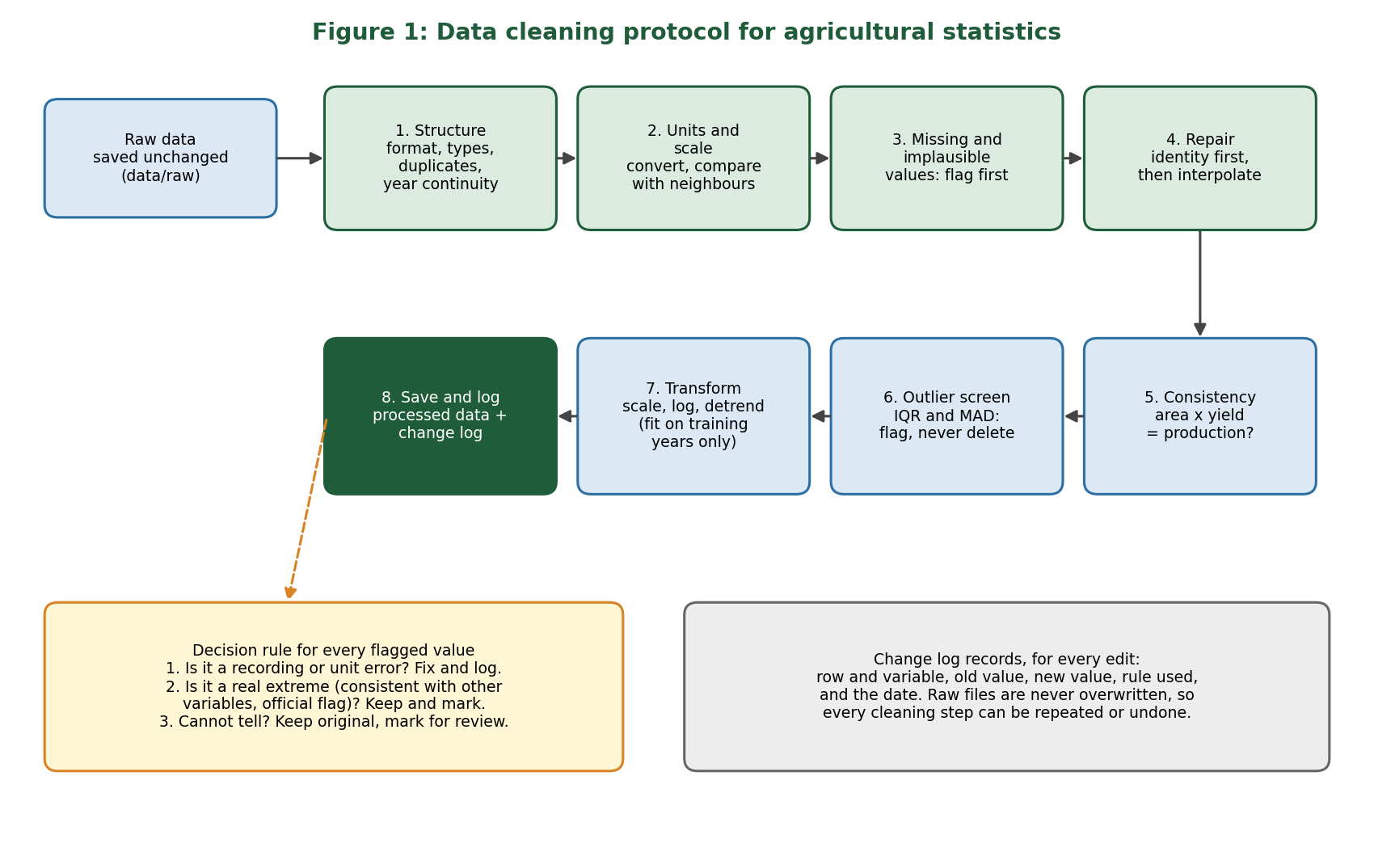
Figure 1: Eight-step cleaning protocol with a decision rule for flagged values

3.1 Master checklist
Step | Task | Checklist questions
1 | Structure | Are all columns the expected type? Are numbers stored as text? Any duplicate keys (year, province)? Are all years present?
2 | Units and scale | Is every variable in the intended unit? Does each value lie in a plausible range, and is it close to neighbouring years?
3 | Missing and implausible values | How many values are missing, which variables, which years? Is there a pattern? Are fill codes present?
4 | Repair | Can the value be derived from other variables? If not, can it be interpolated safely? Is the gap too large to fill?
5 | Consistency | Does area x yield equal production? Do totals match their parts? Do two sources agree?
6 | Outlier screen | Which values are statistical outliers? Is each a recording error or a real event?
7 | Transformation | Is scaling or a log transform needed for the chosen model? Are scaling values taken from training years only?
8 | Save and log | Is the raw file untouched? Is every change recorded with old value, new value and rule?

3.2 Missing data checklist
- Count and map the gaps by variable and year before choosing any fix.
- Replace documented fill codes with proper missing values first.
- Prefer derivation from other variables (for example yield = production / area) because it uses information and invents nothing.
- Use linear interpolation only for short gaps inside a series; do not extrapolate past either end.
- Do not fill long gaps; report them and consider excluding that period.
- Record every filled value so later users can tell real from repaired.

3.3 Outlier handling checklist
- Use more than one detector: a plausible-range rule, comparison with neighbouring years, the interquartile range (IQR) rule and the median absolute deviation (MAD) modified z-score.
- Judge each flagged value against other evidence: is it consistent with the other variables, and does the source flag it as official?
- Correct only clear recording or unit errors. Keep genuine extremes, because drought and heat years are exactly what a yield model must learn from. Mark them rather than delete.
- If unsure, keep the original and mark the row for review.

3.4 Normalisation and transformation checklist
- Scale (min-max or z-score) only when the model needs it, for example distance-based or regularised models. Tree-based models do not need scaling.
- Compute scaling constants from training years only, then apply them to later years, to avoid data leakage.
- Use a log transform when a variable is strongly skewed or when percentage change is the quantity of interest.
- Remove or model the trend when a variable rises steadily with time (see Weeks 2 and 3).
- Aggregate daily weather to the wheat season before joining with annual yield.

4. Techniques and Tools
Technique | How it works | Use in agribusiness data
Type conversion and string cleaning | Strip commas and symbols, convert to numbers, report values that fail conversion. | Spreadsheet and PDF-derived tables.
Cross-variable derivation | Rebuild a missing value from an identity such as production = area x yield / 1000. | Crop statistics where two of three variables are present.
Linear interpolation | Fill a short gap along time between the nearest valid values. | Slowly changing variables such as area or fertiliser use; not for sudden events.
Neighbour-ratio check | Compare each value with the median of the surrounding years and flag large ratios. | Catches x10 unit slips and decimal errors without flagging genuine extremes.
IQR rule | Flag values beyond 1.5 times the interquartile range from the quartiles. | Quick screen on yearly percentage changes.
MAD modified z-score | Uses the median, so extreme values do not hide themselves; values above 3.5 are flagged (Iglewicz and Hoaglin). | More robust than the ordinary z-score for short, trending series.
Min-max and z-score scaling | Rescale to 0 to 1, or to mean 0 and standard deviation 1. | Ridge, Lasso, distance-based models.
Log and log-difference | Compress skew; log differences give growth rates. | Prices, production, growth analysis.
Detrending and differencing | Remove the long-run trend before relating variables. | Yield, which rises over time.

Tools. Python with pandas for table handling, NumPy and SciPy for statistics, scikit-learn for imputers and scalers, and matplotlib for checking results visually. Table-extraction tools (for example Camelot or tabula-py) can speed up reading PDF tables, but the output must be checked against the printed totals. Spreadsheet tools such as Excel and Power Query are suitable for small files, and a short validation script that runs on every new download makes the process repeatable.

5. Scripted Approaches and Pseudo-code

5.1 Pseudo-code for the full protocol
LOAD raw file (never modify it)
FOR each numeric column:
IF stored as text: remove separators, convert to number, log failures
REMOVE duplicate keys (keep first), LOG count
CHECK that every year in the range is present
REPLACE documented fill codes with MISSING
FOR each value:
ratio = value / median(values of +/-3 neighbouring years)
IF ratio > 2 OR ratio < 0.5: FLAG as scale error
SET flagged values to MISSING
FOR each row with exactly one MISSING among (area, yield, production):
derive it from the other two using production = area x yield / 1000
FOR remaining gaps in a series:
IF gap is short AND inside the series: interpolate in time
ELSE: leave missing and report
CHECK |area x yield - production| / production against a tolerance (about 1%)
FLAG (do not delete) statistical outliers by IQR and MAD
FIT scaling constants on training years only; APPLY to all years
SAVE cleaned table and the change log

5.2 Python implementation of the two core steps
The full script (cleaning_pipeline.py) is in the project repository. The two most important functions are shown here.
def flag_scale_errors(df, log, lo=0.5, hi=2.0, half=3):
flags = pd.DataFrame(False, index=df.index, columns=COLS)
for c in COLS:
s = df[c]
for i in df.index:
nb = pd.concat([s.iloc[max(0, i-half):i], s.iloc[i+1:i+1+half]]).dropna()
if pd.notna(s.iloc[i]) and len(nb) >= 3:
ratio = s.iloc[i] / nb.median()
if ratio > hi or ratio < lo:
flags.loc[i, c] = True
return flags

def repair(df, flags, log):
df = df.copy()
for c in COLS: df.loc[flags[c], c] = np.nan
for i in df.index:
miss = df.loc[i, COLS][df.loc[i, COLS].isna()].index.tolist()
if len(miss) == 1:
m = miss[0]
if m == "prod_t": df.at[i, m] = df.at[i,"area_ha"] * df.at[i,"yield_kgha"] / 1000
elif m == "yield_kgha": df.at[i, m] = df.at[i,"prod_t"] / df.at[i,"area_ha"] * 1000
else: df.at[i, m] = df.at[i,"prod_t"] / df.at[i,"yield_kgha"] * 1000
return df

5.3 Pseudo-code for the other two sources
# NASA POWER daily weather
READ file; find the fill value stated in the header
REPLACE fill value with MISSING
IF share of MISSING in the wheat season > 10%: warn and review manually
AGGREGATE to season: total rainfall, mean / min / max temperature, days above heat threshold

# PBS / SBP tables from PDF
EXTRACT table to CSV; ADD columns "release" and "provisional_flag"
CONVERT thousand hectares / thousand tonnes to hectares / tonnes
CHECK extracted totals against printed totals; LOG every manual correction

6. Applying the Protocol to the Real Wheat Data
The protocol was run on the real FAOSTAT wheat series (64 years, three variables).
Check | Result on real data
Structure and types | All values numeric; no text numbers.
Duplicate years | None.
Year continuity | 1961 to 2024, no missing years.
Missing values | None in area, yield or production.
Scale errors (neighbour-ratio rule) | None flagged.
Consistency (area x yield vs production) | Largest difference 0.0065 percent, which is rounding.
Quality flag | Every value is an official value.
Outcome of cleaning | Cleaned table identical to the raw table: no edits were needed.

6.1 Outlier screen
The IQR rule and the MAD modified z-score were applied to yearly percentage changes in yield. Both flagged one year only: 1968, with a yield increase of 32.3 percent (modified z-score 4.1). The jump is consistent with area and production in the same year, and the value carries the official flag, so it is not a recording error. By the decision rule it was kept and marked, not removed. Deleting it would have removed the largest real event in the series and made yield look smoother and more predictable than it is.

6.2 Scaling and transformation
Skewness was checked before deciding on a log transform. The raw series are close to symmetric (skewness 0.08 for production, -0.05 for yield and -0.54 for area), and the log transform made them more negatively skewed (-0.64, -0.57 and -0.78). A log transform of the levels is therefore not needed. The log remains useful for growth rates, and min-max or z-score scaling will be applied inside the training years for the regularised models in the modelling stage.

7. Stress Test on Simulated Errors
Because the real data needed no repairs, the protocol was tested on a copy of the real series into which 14 problems were inserted at known positions. This copy is simulated and is not real data.
Injected problem | Where | Count
Missing yield values | 1975, 1989, 2003, 2011 | 4
Missing production values | 1995, 2016 | 2
Missing area value | 1982 | 1
Unit error, yield x10 (hg/ha instead of kg/ha) | 1998, 2008 | 2
Extra zero in area (x10) | 1993 | 1
Decimal slip in production (/10) | 2019 | 1
Number stored as text with a comma | Yield, 2001 | 1
Duplicate row | 2012 | 1
Small error, yield +25% | 1971 | 1

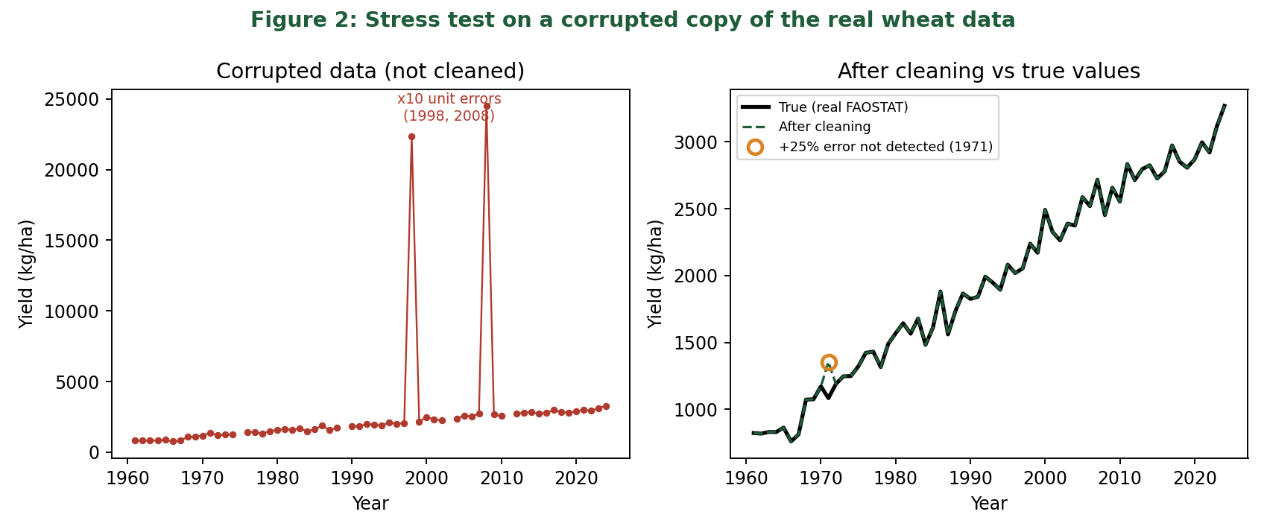
Figure 2: Corrupted yield series before cleaning (left) and cleaned series compared with the true values (right)

7.1 Results
- The protocol handled 13 of the 14 problems: it converted the text number, removed the duplicate year, flagged all four scale errors (1993, 1998, 2008 and 2019), and repaired all seven missing values and four flagged values from the other two variables, with no estimation needed.
- After cleaning, all 64 years of area and production matched the true values to within 0.1 percent, and 63 of 64 yield values did too.
- The one miss was the +25 percent error in 1971. It is too small for the neighbour-ratio rule, so it was not flagged. It was, however, revealed by the consistency check, which reported a difference of about 25 percent between area x yield and production. The check cannot say which variable is wrong, so in practice the row would be marked for manual review.

7.2 Effect on a forecast
To measure what the errors would cost, the same expanding-window linear trend forecast from Week 3 was run on three versions of the data, always scored against the true yield values for 1991 to 2024.
Data used to build the forecast | RMSE (kg/ha) | Comment
Original real data | 104.7 | Week 3 baseline
Corrupted data, not cleaned | 1,947.8 | About 19 times worse
Corrupted data, then cleaned | 104.3 | Back to baseline level

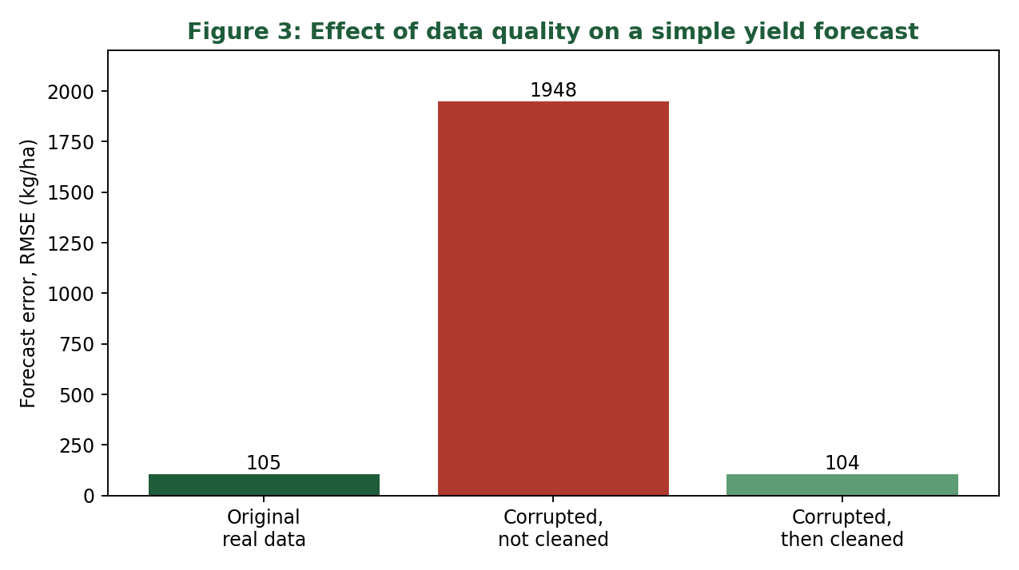
Figure 3: Forecast error using original data, corrupted data without cleaning, and cleaned data
In the uncleaned version, the text number became a blank when converted, the duplicate was dropped, and the two x10 yield values stayed in the series and bent the trend line, so the forecast error grew from about 105 to about 1,950 kg/ha. After cleaning, the error returned to the baseline level (104.3 against 104.7; the small difference is not meaningful).

7.3 Limits of the test
- The injected errors are simple and sit in different years. Real errors are messier, may be clustered, and may involve several variables in one row.
- Repair by identity worked because only one of three variables was bad in each row. If two were bad in the same row, interpolation would be needed and accuracy would fall.
- The neighbour-ratio rule catches large slips only; small errors need other checks such as comparison with a second source.

8. Impact of Data Quality on Analysis and Decisions

8.1 Data quality dimensions
Dimension | Meaning | Check used in this project
Completeness | No required values missing | Missing-value count by variable and year
Validity | Correct type, unit and range | Type conversion; neighbour-ratio rule
Consistency | Variables agree with one another | Area x yield = production
Uniqueness | No repeated records | Duplicate year check
Accuracy | Values match reality | Outlier screen with plausibility review; comparison with a second source (planned)
Timeliness | Data is current and the release is known | Record release and provisional status

8.2 Consequences for agribusiness decisions
The stress test is a small example of a general point. A one-digit unit slip is easy to make and hard to see in a table, but in a model it can change the answer completely. For a decision maker, the size of the consequence can be put in physical terms. A forecast error of about 105 kg/ha over the 2024 harvested area of about 9.7 million hectares corresponds to roughly one million tonnes of wheat, which is already a meaningful planning uncertainty for stock and import decisions. An error of about 1,950 kg/ha, as in the uncleaned simulation, would correspond to roughly 19 million tonnes, which is more than half of 2024 production and would make the forecast useless for planning.
Clean data therefore improves decisions in four ways: forecasts are more accurate, results can be reproduced and audited, genuine extremes are preserved so that risk is not understated, and stakeholders can trust the numbers because every change is logged.

9. Challenges and Limitations
- The real series needed no cleaning, so the protocol's repair steps were demonstrated on simulated errors, not on real ones. The PBS tables and NASA POWER files, which are likely to be messier, have not been downloaded yet; the protocol for them is a design.
- Thresholds (a ratio of 2 and 0.5, a modified z-score of 3.5) are reasonable defaults, not universal truths, and should be reviewed for each dataset.
- Interpolation and identity-based repair assume the other values are right.
- Automated rules cannot replace local knowledge; a flagged value may be a real event that only an agronomist can explain.

10. Conclusion
This report defines an eight-step cleaning protocol with checklists for missing data, outliers and transformations, explains the techniques and tools behind each step, and provides pseudo-code and working Python. Applied to the real FAOSTAT wheat data, the protocol found the data already clean and flagged only the genuine 1968 jump, which it kept. A stress test on 14 inserted errors showed that the protocol repaired 13 of them completely, that the remaining small error was still revealed by the consistency check, and that cleaning brought the forecast error from about 1,950 back to about 104 kg/ha. The final week will use these results, together with the Week 2 findings and the Week 3 plan, to evaluate the project and communicate it to non-technical stakeholders.

References
- FAO, FAOSTAT: Crops and livestock products, wheat, Pakistan, 1961-2024. Downloaded 9 October 2026. https://www.fao.org/faostat
- NASA POWER project documentation and Data Access Viewer. https://power.larc.nasa.gov/docs/tutorials/data-access-viewer/quick-start/
- Pakistan Bureau of Statistics, Statistical Yearbook, agriculture tables. https://www.pbs.gov.pk/node/249
- Iglewicz, B. and Hoaglin, D. (1993), How to Detect and Handle Outliers, ASQC Quality Press (modified z-score).
- Little, R. and Rubin, D. (2019), Statistical Analysis with Missing Data, 3rd edition, Wiley.
- Wickham, H. (2014), Tidy Data, Journal of Statistical Software 59(10).

