Junior Data Science Analyst: Agriculture & Agribusiness
Week 5 Report (Final)
Evaluating, Reporting and Communicating Insights
Project: Pakistan Wheat Yield Analysis and Forecasting
Field | Details
Prepared by | [Your Full Name]
Internship period | 09 October 2026 to 13 November 2026 (5 weeks)
Scope | Evaluation of the full project: data exploration, cleaning, and baseline forecasting of wheat yield
Data | FAOSTAT wheat, Pakistan, 1961 to 2024 (real data)

Executive Summary
For readers who do not work with data. This summary explains what the project did, what it found and what to do next, without technical terms. A short glossary is at the end of the report.

What we did
We studied 64 years of official wheat figures for Pakistan (1961 to 2024) to understand how the wheat harvest has changed and whether next year's yield per hectare can be forecast with a simple method. We checked the data for errors, looked for patterns, and tested how well a simple forecast would have performed in each year from 1991 to 2024, using only information that was known at the time.

What we found
- Wheat output has grown more than eightfold. The harvest rose from about 3.8 million tonnes in 1961 to about 31.8 million tonnes in 2024.
- Most of the growth comes from better yields, not more land. Yield per hectare is about four times higher than in 1961, while the harvested area only doubled. About two thirds of the growth came from yield.
- Land is no longer growing quickly. Since about 2013 the area has stayed in a band of roughly 8.7 to 9.7 million hectares, so future growth depends mainly on yield.
- Yield gains are slowing, but harvests have become steadier. Each year adds a little less yield than in earlier decades, while year-to-year swings are smaller than before 1990.
- A good or bad harvest year is mostly a yield story. When production jumps or falls, it is mainly because yield per hectare changed.

How reliable is a simple forecast?
A simple forecast that extends the long-run trend was typically wrong by about 3.4 percent, which is about 0.7 million tonnes of wheat. In about three years out of four (25 of 34 years tested) it was within 5 percent of the actual yield, and in 33 of 34 years it was within 10 percent. It was clearly better than simply assuming next year equals this year. The largest miss was the year 2000, when the forecast was about 11 percent too low (the only year outside the 10 percent range).

What we recommend
- Use a trend-based forecast as a planning baseline, with a planning range of about 5 percent either side, and a wider 10 percent range for stress planning (stock, imports).
- Plan around yield, not land. Suppliers and mills should watch yield outcomes and efficiency in the use of seed, fertiliser and water.
- Add weather, soil, input and regional data next. These may explain the years that the simple forecast misses, but this has not been tested yet.

What to keep in mind
The results rest on one national data source. The project does not yet explain why bad years happen, and it has not been tested on regional or weather data. The 2024 figure is a record and should be verified against the Pakistan Bureau of Statistics before it is used for major decisions.

1. Introduction and Scope
This final report evaluates the analytical project built over the previous four weeks. It reviews the earlier work, sets out an evaluation framework with metrics and benchmarks, reports the results, identifies insights, strengths and weaknesses, and proposes recommendations for further analysis and for decisions in the agribusiness sector. The work in this report is limited to what the project actually did: exploratory analysis and cleaning of the real FAOSTAT wheat series, and one-year-ahead baseline forecasts tested on that series.

2. Review of Previous Work
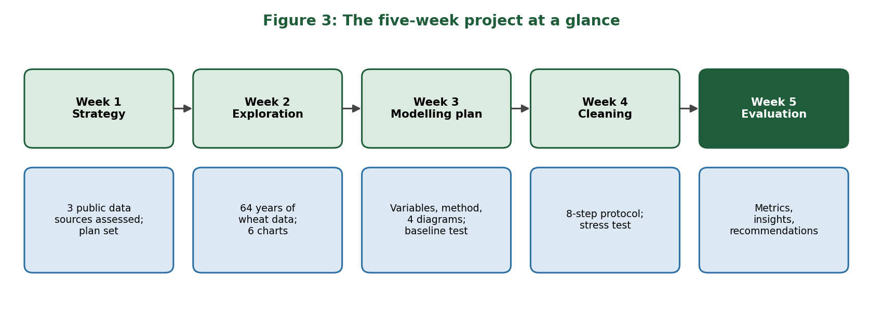
Figure 3: The five-week project at a glance
Week | Task | Main result | Lesson learned
1 | Data exploration and strategy | Three public sources assessed (FAOSTAT, PBS / State Bank of Pakistan, NASA POWER); objectives, methods and risks defined. | Sources differ in time scale and geography, so they must be aligned before joining.
2 | Exploratory data analysis | 64 years of wheat data; production up 8.3 times; yield-led growth; six charts. | Variables that rise with time look strongly related (area and yield r = 0.96, only 0.20 after removing the trend).
3 | Predictive modelling plan | Target, variables, method, validation and four diagrams; baseline forecasts tested. | A simple trend is a strong baseline that any complex model must beat.
4 | Data cleaning | Eight-step protocol; real data already clean; 13 of 14 simulated errors repaired. | Uncleaned errors can multiply forecast error by about 19.

3. Evaluation Framework

3.1 Approach
The project is judged in six areas: data quality, cleaning, analysis, forecast performance, coverage and explanation, and reproducibility and communication. For each area a measurable indicator, a benchmark or target, and the project result are given. The forecasts are compared with a naive benchmark (this year equals last year). The accuracy targets below were chosen by me as reasonable thresholds for planning use. They are not industry standards and should be adjusted to a decision maker's tolerance.

3.2 Metrics and indicators
Area | Indicator | Benchmark / target | Result | Status
Data quality | Missing values; duplicate years; area x yield vs production | None; none; within 1% | 0 missing; 0 duplicates; max 0.0065% difference | Met
Cleaning | Share of simulated errors repaired; forecast error with and without cleaning | All large errors repaired | 13 of 14 repaired, the 14th flagged by consistency check; RMSE 1,948 down to 104 kg/ha | Met on simulated test
Analysis | Number of charts; findings backed by numbers | At least 4 charts | 6 charts; each interpreted with figures | Met
Forecast accuracy | Average error (MAPE) | Target: 5% or less | 3.4% | Met
Forecast accuracy | Gain over naive benchmark (RMSE) | Better than naive (145.8) | 104.7 (28% lower) | Met
Forecast accuracy | Years within 5% of actual | Target: 70% of years or more | 73.5% (25 of 34) | Met
Explanation | Effect of weather, soil, inputs and prices tested | Tested and reported | Not done: data not yet collected | Not yet
Coverage | Provincial or district results | At least provincial | National only | Not yet
Reproducibility | All results rerun from raw data with scripts | Yes | Scripts and data in GitHub repository | Met
Communication | Executive summary and glossary for non-technical readers | Included | Included in this report | Met (self-assessed)

The status column is my own assessment. Four of the six areas are fully met, one is met only on a simulated test, and the explanation and coverage areas have not been reached yet. Section 6 describes how to close these gaps.

4. Evaluation Results

4.1 Forecast performance
Four simple methods forecast each year from 1991 to 2024 using only earlier years (34 test years). The table shows their performance.
Method | RMSE (kg/ha) | MAE (kg/ha) | MAPE (%) | Bias (kg/ha) | Years within 5% | Years within 10%
Naive (last year) | 145.8 | 122.9 | 4.8 | -42.5 | 21 of 34 | 32 of 34
Mean of last 3 years | 135.7 | 104.2 | 4.1 | -78.6 | 22 of 34 | 33 of 34
Linear trend (all earlier years) | 104.7 | 85.2 | 3.4 | +11.8 | 25 of 34 | 33 of 34
Linear trend (last 20 years) | 109.6 | 86.3 | 3.4 | 0.0 | 27 of 34 | 33 of 34

Bias is the average signed error: a negative value means the method on average forecast too low. Naive and three-year-mean forecasts lag behind a rising series, so they are biased low. The trend methods have almost no bias. The two trend methods are close, and the 20-year trend places slightly more years within 5 percent (27 against 25) while having slightly higher RMSE. The all-years trend is used as the main reference because it has the lowest RMSE.
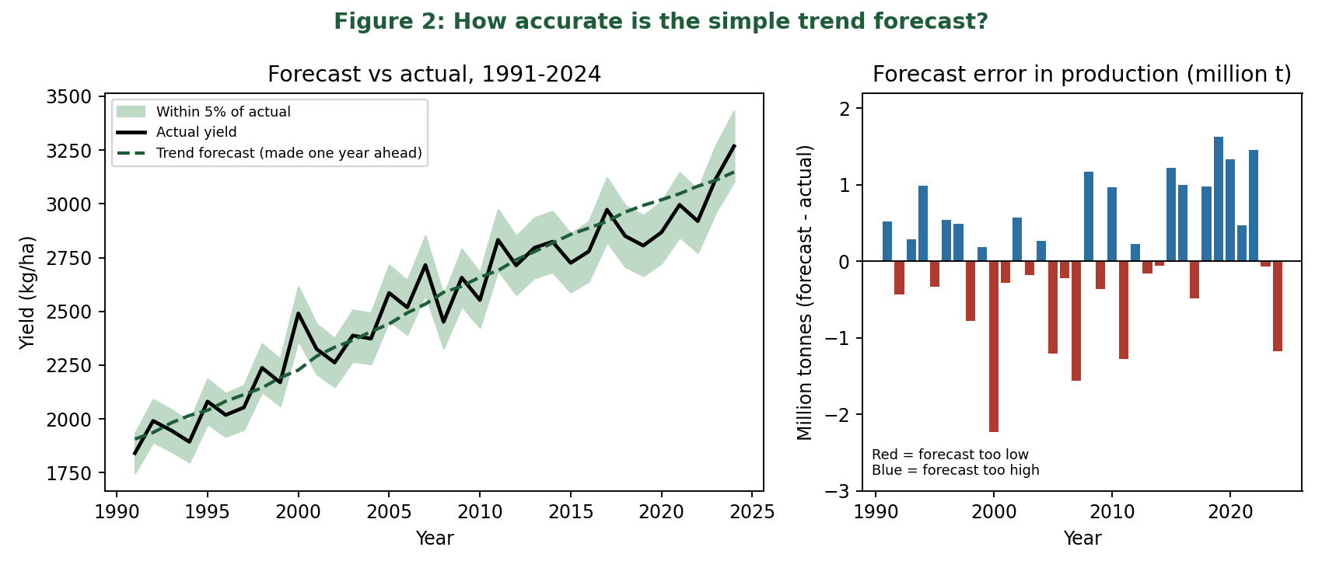
Figure 2: Trend forecast against actual yield (left) and forecast error expressed in million tonnes (right)

4.2 What the errors mean in tonnes
Converted to production using the actual harvested area of each year, the average miss of the trend forecast is about 0.74 million tonnes, or 3.4 percent of production. The conversion assumes the area is known, so it measures the yield error only. The worst year was 2000, when the forecast was about 263 kg/ha too low, followed by 2019 (about 187 kg/ha too high) and 2007 (about 181 kg/ha too low). The 2024 record was under-forecast by about 120 kg/ha, which is roughly 1.2 million tonnes. The errors do not show a clear one-sided pattern: 47 percent of the forecasts were too low.

4.3 Stability over time
Splitting the test years into two halves shows that the trend forecast does not deteriorate: RMSE was 101.0 kg/ha (MAPE 3.45 percent) in 1991 to 2007 and 108.3 kg/ha (MAPE 3.28 percent) in 2008 to 2024. Accuracy in percentage terms is stable, even though yield levels are higher in the second period.

4.4 Data quality and cleaning
The real series had no missing values, no duplicates and consistent figures. In the simulated test, the cleaning protocol repaired 13 of 14 inserted errors, and the 14th (a 25 percent error in one yield value) was revealed by the consistency check. The forecast error was about 1,948 kg/ha with uncleaned corrupted data and 104 kg/ha after cleaning. These results show that the protocol works for the errors tested; they do not prove it will catch every real-world error.

5. Actionable Insights
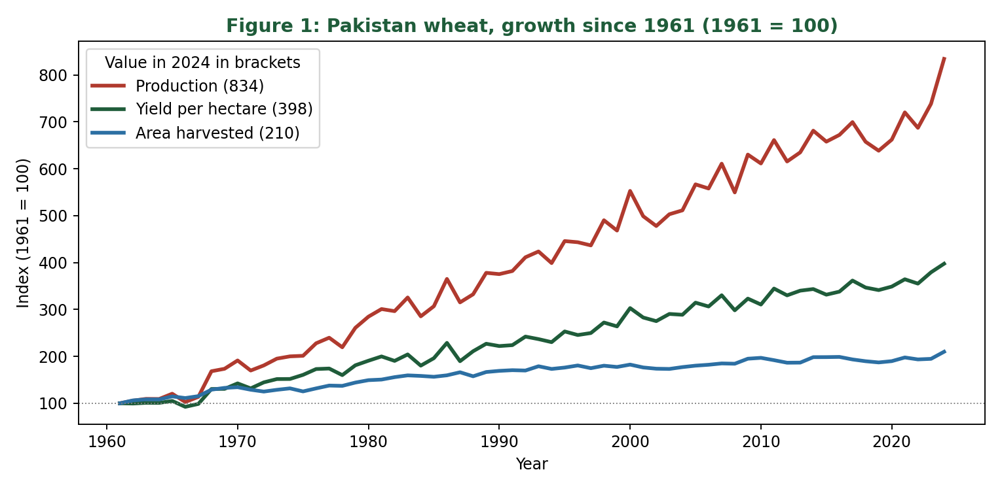
Figure 1: Growth of Pakistan wheat area, yield and production since 1961

5.1 Trends
- Production increased 8.3 times, yield 4.0 times and area 2.1 times between 1961 and 2024. Two thirds of the growth came from yield (Figure 1).
- Area has been in a narrow band since about 2013, so yield is the main lever for growth.
- The linear yield gain per year fell from about 42 kg/ha (1961 to 1980) to about 32 kg/ha (2010 to 2024), although the last few years were strong.
- Year-to-year swings in yield are smaller since 1990 (standard deviation of yearly change 5.8 percent, against 9.8 percent before).

5.2 Strengths of the analysis
- Long, consistent, official data with a quality flag and no gaps.
- A strong, transparent baseline that is easy to explain and to update.
- Time-ordered testing that avoids using future information.
- Fully scripted and reproducible, with every change to the data logged.

5.3 Weaknesses
- Only one source (FAOSTAT, national level) has actually been analysed. PBS tables and NASA POWER weather data were identified but not yet downloaded or used.
- No explanatory variables, so the analysis describes what happened but cannot yet explain why.
- About 64 yearly observations is a small sample for complex models.
- The accuracy targets used in the framework are my own and should be agreed with end users.

5.4 Opportunities and risks
- Opportunity: the years the simple forecast missed most (2000, 2007, 2019) are natural tests for weather data. Whether weather explains them is a hypothesis to test.
- Opportunity: a province-by-year dataset would give more observations and show regional differences.
- Risk: the trend may not continue, especially if yield gains keep slowing or if climate stress rises. A trend forecast cannot anticipate a break in the pattern.
- Risk: a single record year (2024) could be revised or could be an exception, so it should not be extrapolated.

6. Recommendations

6.1 Further analysis
Priority | Action | Reason | Effort | Expected value
1 | Verify the 2024 record and the FAOSTAT series against PBS / State Bank of Pakistan tables. | Checks the one source the whole project rests on. | Low | High
2 | Add provincial wheat data (PBS / SBP), starting with Punjab. | Gives regional detail and more observations. | Medium | High
3 | Download NASA POWER weather for the main wheat districts and build wheat-season features. | Tests whether weather explains the large misses. | Medium | High
4 | Train Ridge / Lasso and Random Forest models on yield deviation from trend and compare with the 3.4 percent benchmark. | Only keep a complex model if it beats the baseline. | Medium | Medium to high
5 | Add fertiliser, irrigation and price variables. | Links yield to management and market signals. | Medium | Medium
6 | Produce forecasts at three points in the season with forecast ranges. | Makes the output usable for planning. | High | High

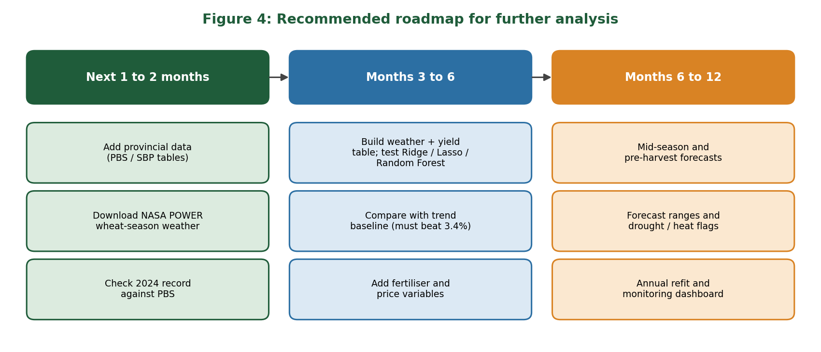
Figure 4: Recommended roadmap for further analysis

6.2 Strategic adjustments for agribusiness
- Flour mills and traders: use the trend forecast as a baseline for procurement planning, with a planning band of about 5 percent either side (about three years in four fell inside it) and a 10 percent band for stress cases (33 of 34 years fell inside it).
- Input suppliers: with land area flat, expect growth in demand to come from yield per hectare. Efficiency products (balanced fertiliser, seed, water management) are the likely growth area. This is an inference from the trend and is not tested against input data.
- Policy and planning bodies: monitor the slowing yield gain, since it implies that the same practices will deliver less each year, and treat the 2024 record cautiously until verified.
- Risk managers: treat the rare large misses as the key risk. Maintain buffers for the roughly one year in four that falls outside the 5 percent band, and invest in explaining those years with weather data.

7. Limitations
- The evaluation covers baseline forecasts only. The weather-based models described in Week 3 were designed but not built.
- The metrics rest on 34 test years, so small differences between methods (for example between the two trend methods) are not conclusive.
- The cleaning protocol was tested on simulated errors; real PBS or weather data may contain other problems.
- The error in tonnes assumes the harvested area is known in advance; area forecasts add further uncertainty.
- Statements about why yields rose or fell (for example new varieties or weather) are hypotheses, not findings of this work.

8. Conclusion
Over five weeks the project moved from identifying data sources, through exploration, a modelling plan and a cleaning protocol, to an evaluation of baseline forecasts on real data. The main results are that Pakistan's wheat harvest has grown eightfold, mostly through higher yield, that land area has levelled off, and that a simple trend forecast achieves an average error of about 3.4 percent, which is a solid benchmark and already useful for planning. The project does not yet explain why yields vary or how they differ between provinces. The recommended next steps are to verify the data against PBS tables, add provincial and weather data, and test whether more complex models can beat the baseline.

Appendix A: Glossary
Term | Plain meaning
Yield | How much wheat is harvested from each hectare of land (kg per hectare).
Hectare | A unit of land area, about 2.5 acres.
Production | The total amount of wheat harvested (tonnes).
Trend | The general direction a number moves over many years.
Baseline | A simple method used as a yardstick; a more complex method is worth using only if it does better.
Forecast error | The difference between the forecast and what actually happened.
MAPE | Average error as a percentage of the actual value. 3.4 percent means the forecast was on average 3.4 percent away.
RMSE | A measure of typical error in the original units (kg/ha) that gives extra weight to large misses.
Bias | Whether a method tends to forecast too high (positive) or too low (negative) on average.

Appendix B: Project deliverables
Week | Deliverable in the project repository
1 | Strategy report (week1_strategy)
2 | EDA report, script and six figures (week2_eda)
3 | Modelling plan report, diagrams, baseline forecast script (week3_modeling_plan)
4 | Cleaning protocol report, scripts, stress test (week4_data_cleaning)
5 | This report, evaluation metrics script and figures (week5_evaluation)

References
- FAO, FAOSTAT: Crops and livestock products, wheat, Pakistan, 1961-2024. Downloaded 9 October 2026. https://www.fao.org/faostat
- Pakistan Bureau of Statistics, Statistical Yearbook, agriculture tables. https://www.pbs.gov.pk/node/249
- NASA POWER project, Data Access Viewer. https://power.larc.nasa.gov/docs/tutorials/data-access-viewer/quick-start/
- Hyndman, R.J. and Athanasopoulos, G., Forecasting: Principles and Practice (3rd edition), OTexts, for forecast accuracy measures and time-ordered evaluation.
- Project Weeks 1 to 4 reports and scripts, GitHub repository pakistan-wheat-yield-analysis.

