**Computer Network Lab**



**Assissment # 03**

Submitted By

QASIM ALI (20P-0070)

Submitted to : Hurmat Hidayat

(INSTRUCTOR CS)

**DEPARTMENT OF COMPUTER SCIENCE**

**FAST NATIONAL UNIVERSITY OF COMPUTER AND EMERGING SCIENCES, PESHAWAR**

Session 2020-2024

**Sharing Files Between Two Computers Using LAN Cable**

**Step1: Connect Both PC’s With LAN Cable**

**The pc is connect with LAN cable:**

**Using Rafay PC as 1st computer P20-0018.**

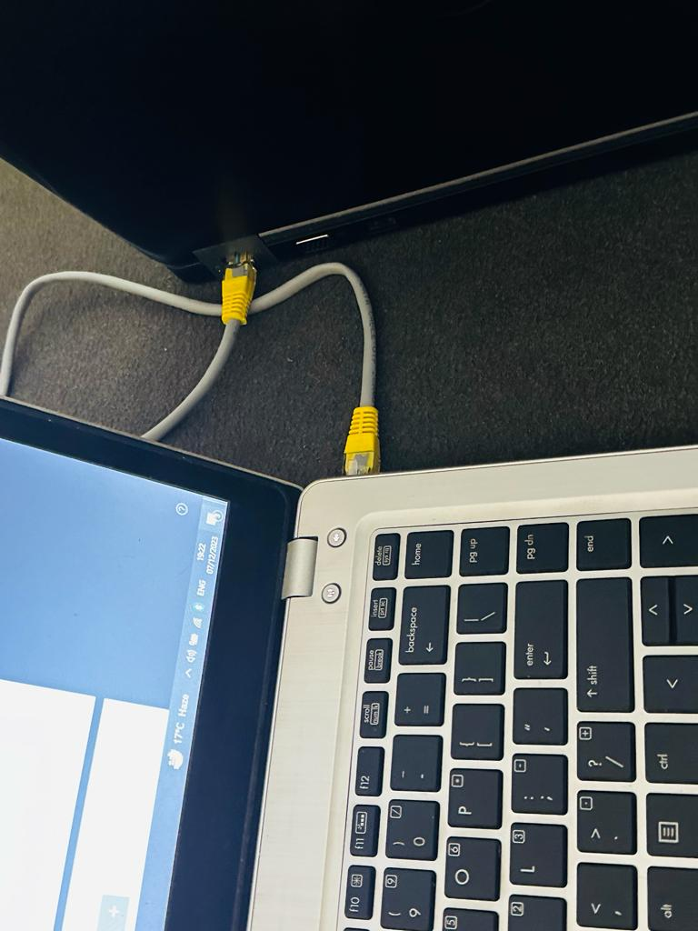

**Step 2:** Enable Network Sharing on Both PCs

To enable sharing, go to the Start menu and search “Control Panel”. Once you see it, click on it, to open it.

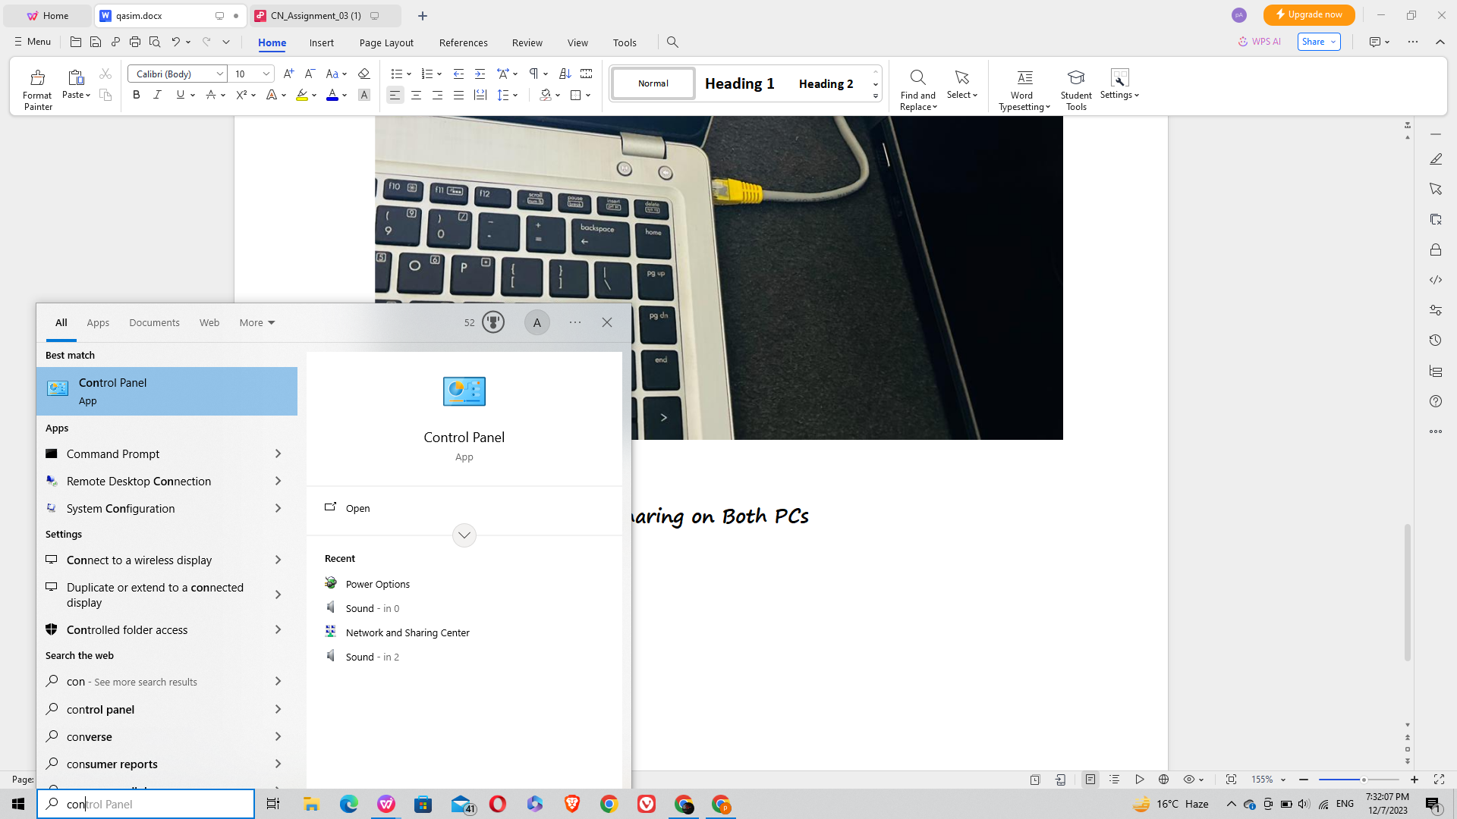

Once the Control Panel window opens, click on Network and Internet

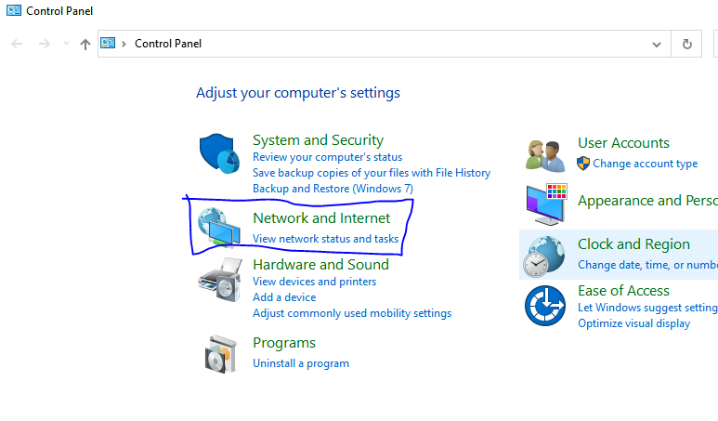

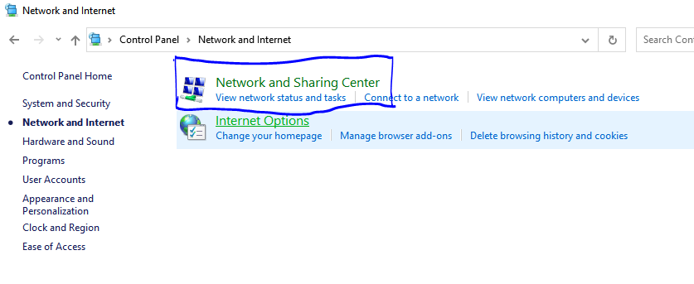

Enter the **Network and sharing centre** after click the **change advanced sharing setting**

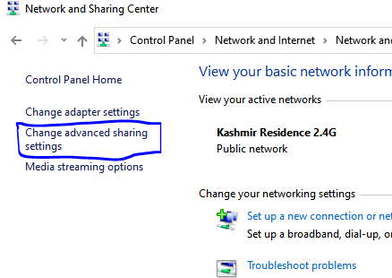

After click he **change advanced sharing setting**

Here, you’ll find three networks – Public, Private and All Network.

Next, expand All Networks by clicking on the drop-down icon. Here, we need to enable Public Sharing so that the PCs can access files from each other over the LAN cable. To avoid more configuration, just Turn off password protected sharing.

By doing so, you enable the other computer to access shared data without providing any credentials. This is not a good security practice by since you are sharing your data with people you trust, you can make this one-time exception. Once you are done with file sharing, make sure you Turn on password protected sharing.

Once done, click Save Changes. Just as I said in the beginning, repeat the same steps for the other PC.

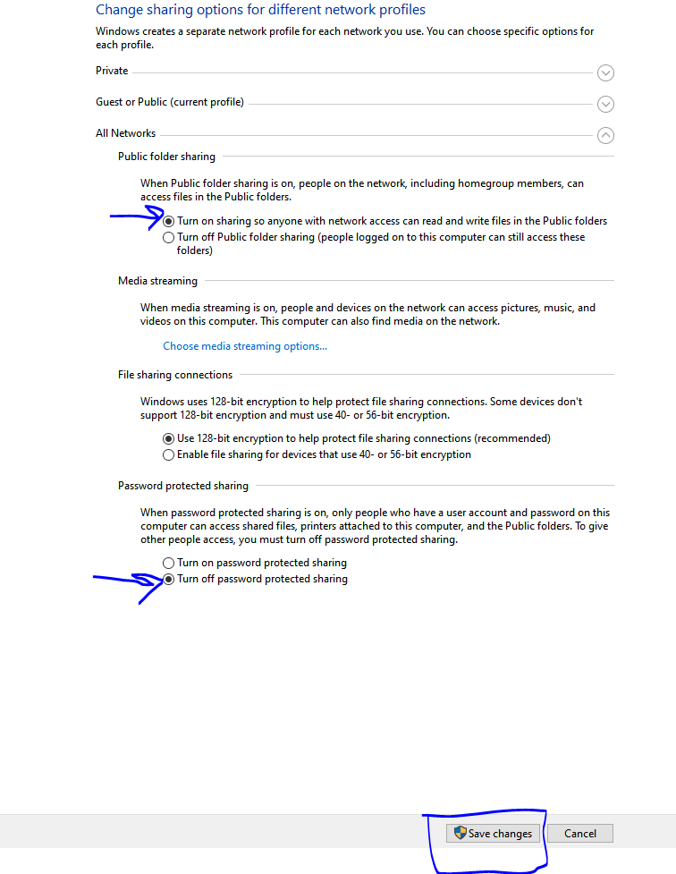

**Step 3: Setup Static IP**

1: To set up a Static IP, open Control Panel, browse to Network and Internet and click

on Network Sharing Center. Alternatively, you can also right-click on the Start Menu and select Network Connections.

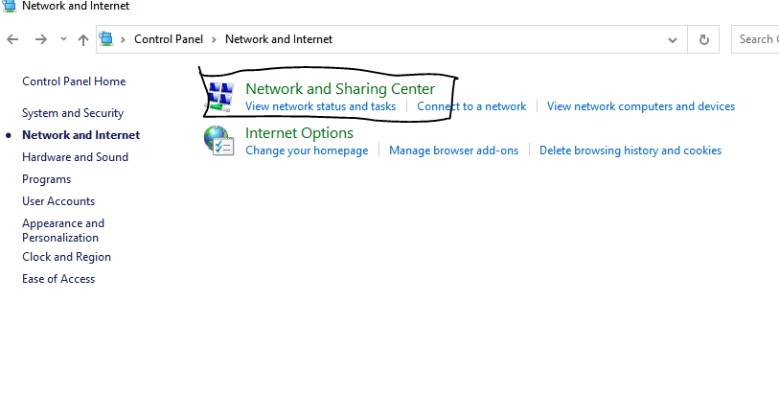

2: On the next window, you will see the active connections which should be Ethernet, since both PCs are connected with a physical LAN cable. Click on the Ethernet link. A new dialog box will open, here click on the Properties button.

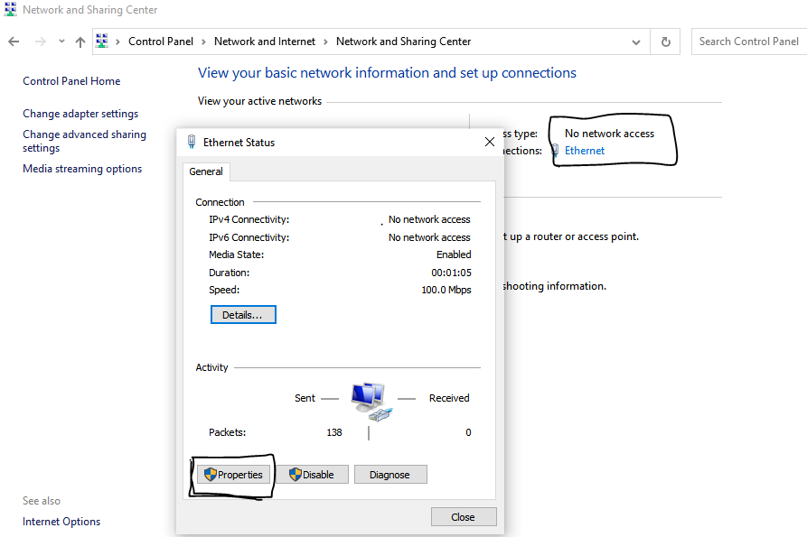

3: In the next pop-up, select “Internet Protocol Version 4 (TCP/IPv4)”. Now, click on

Properties. This will open another dialogue box.

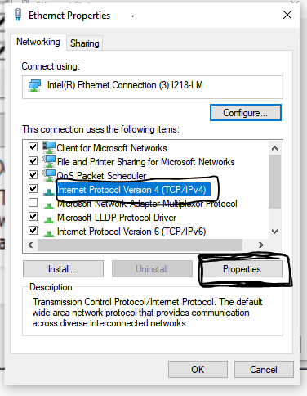

4. now, you need to configure the two PCs with different IP settings.

n computer 1, select the option “Use the following IP address.” and, put the following

values:

IP Address: 192.168.10.10

Subnet mask: 225.225.225.0

Default gateway: empty

Of course, it’s not necessary you use these IP addresses. You can use any Class A or B IP address. In case you are not sure what this all means, better stick with this example. On the second computer, do similar steps, but flip the IP address and Default gateway

values:

IP address: 192.168.10.5

Subnet mask: 225.225.225.0

Default gateway: empty

**Entering LAN cable a IP address is PC-2**

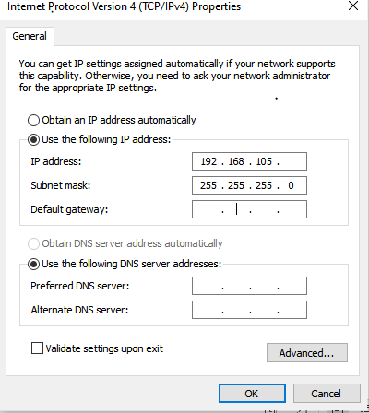

Next, open your Window’s File Explorer and click on Network tab at the left side of the window.

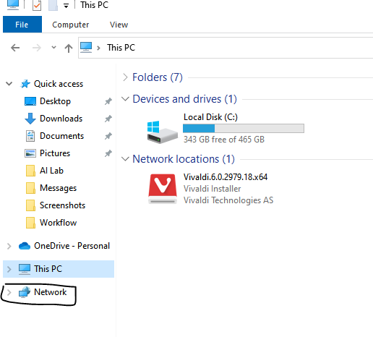

If you have set up everything right, both the PCs should appear in this Network window on both computers. Now, you can just click on the other PC’s icon and browse the file. But wait, you still need to configure one last setting

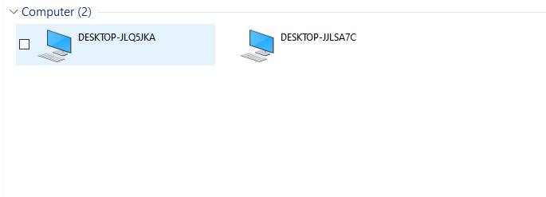

**Step 4: Share a folder**

In the File Sharing window, choose Everyone from the drop-down menu. Click on the Add button next to it and finally hit the Share button

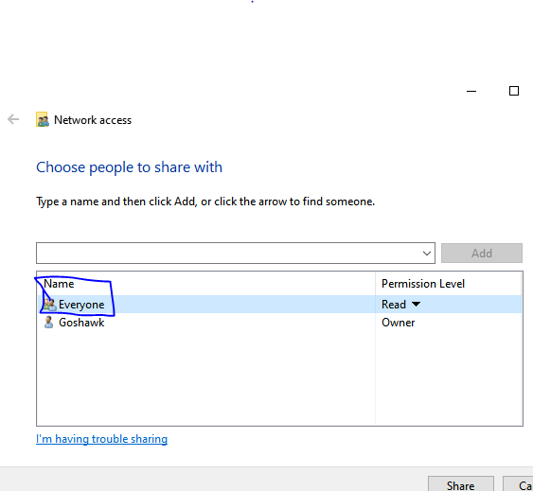

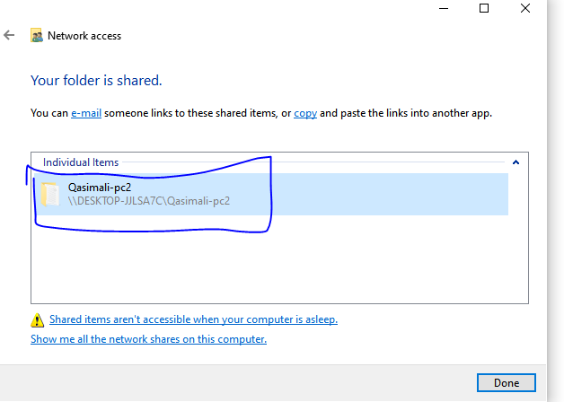

That’s it. Just go back to the other PC from where you want to access the file, open the Networks panel and click on the other computer’s name

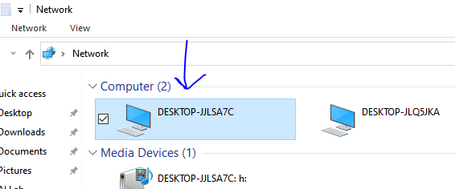

**Two file share :**

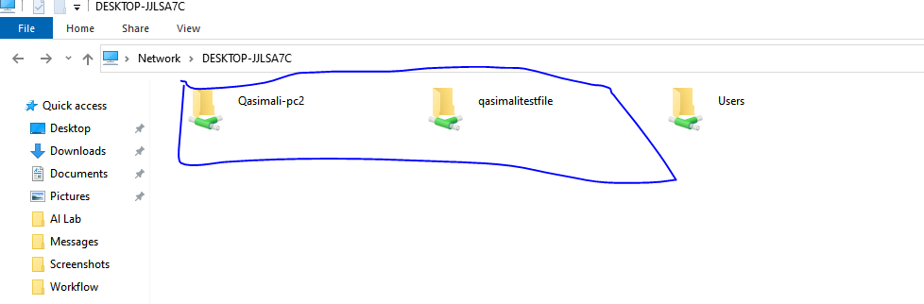

**Inside the Folder:**

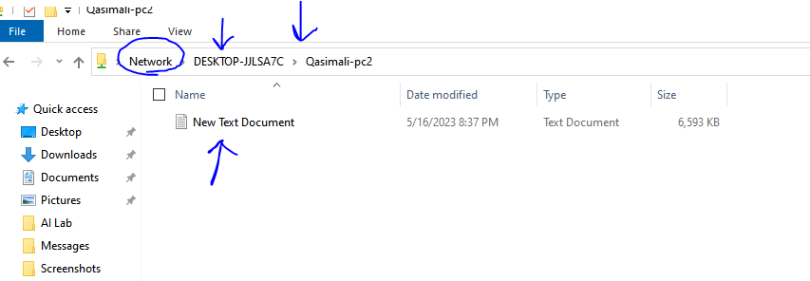

**After we Revert Your Firewall and Network Settings, After completing your file**

**transfer process.**