Computer Network Lab


LAB WORK # 10

Submitted By
QASIM ALI (20P-0070)
Submitted to : Hurmat Hidayat
(INSTRUCTOR CS)

DEPARTMENT OF COMPUTER SCIENCE

FAST NATIONAL UNIVERSITY OF COMPUTER AND EMERGING SCIENCES, PESHAWAR

Session 2020-2024

Q1: What is the source and destination port numbers?

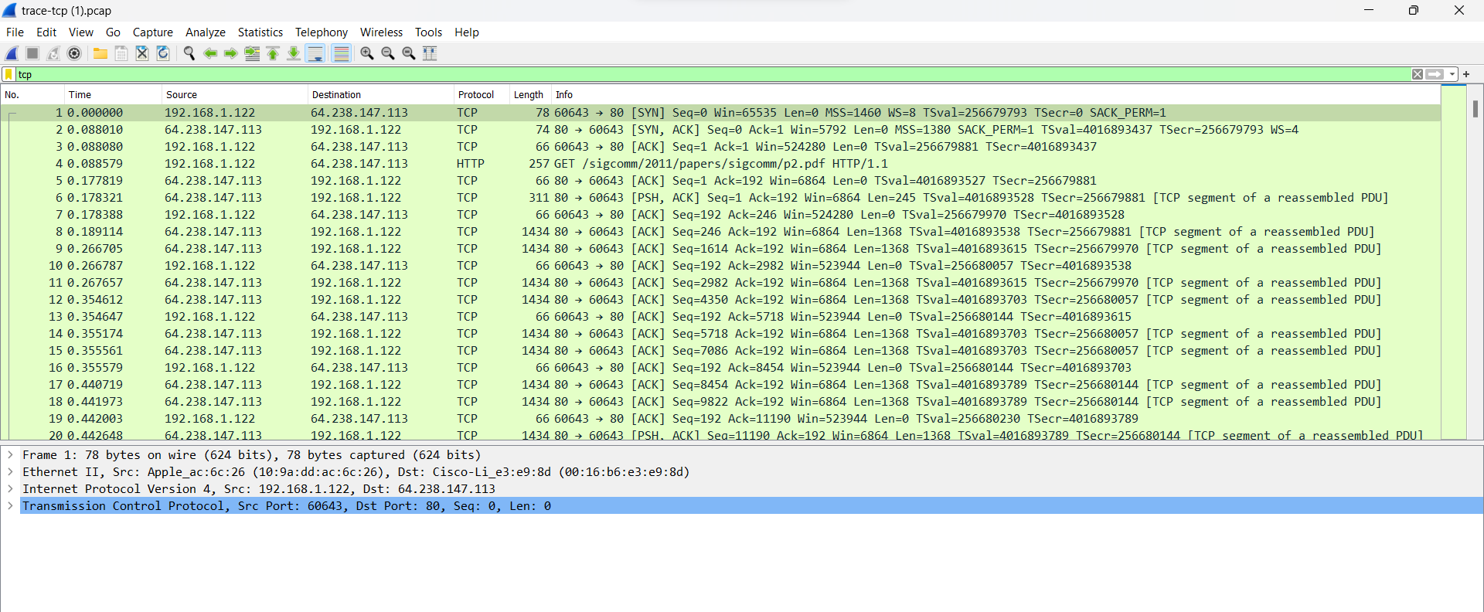

HTTP :
source port numbers = 60643
destination port numbers = 80

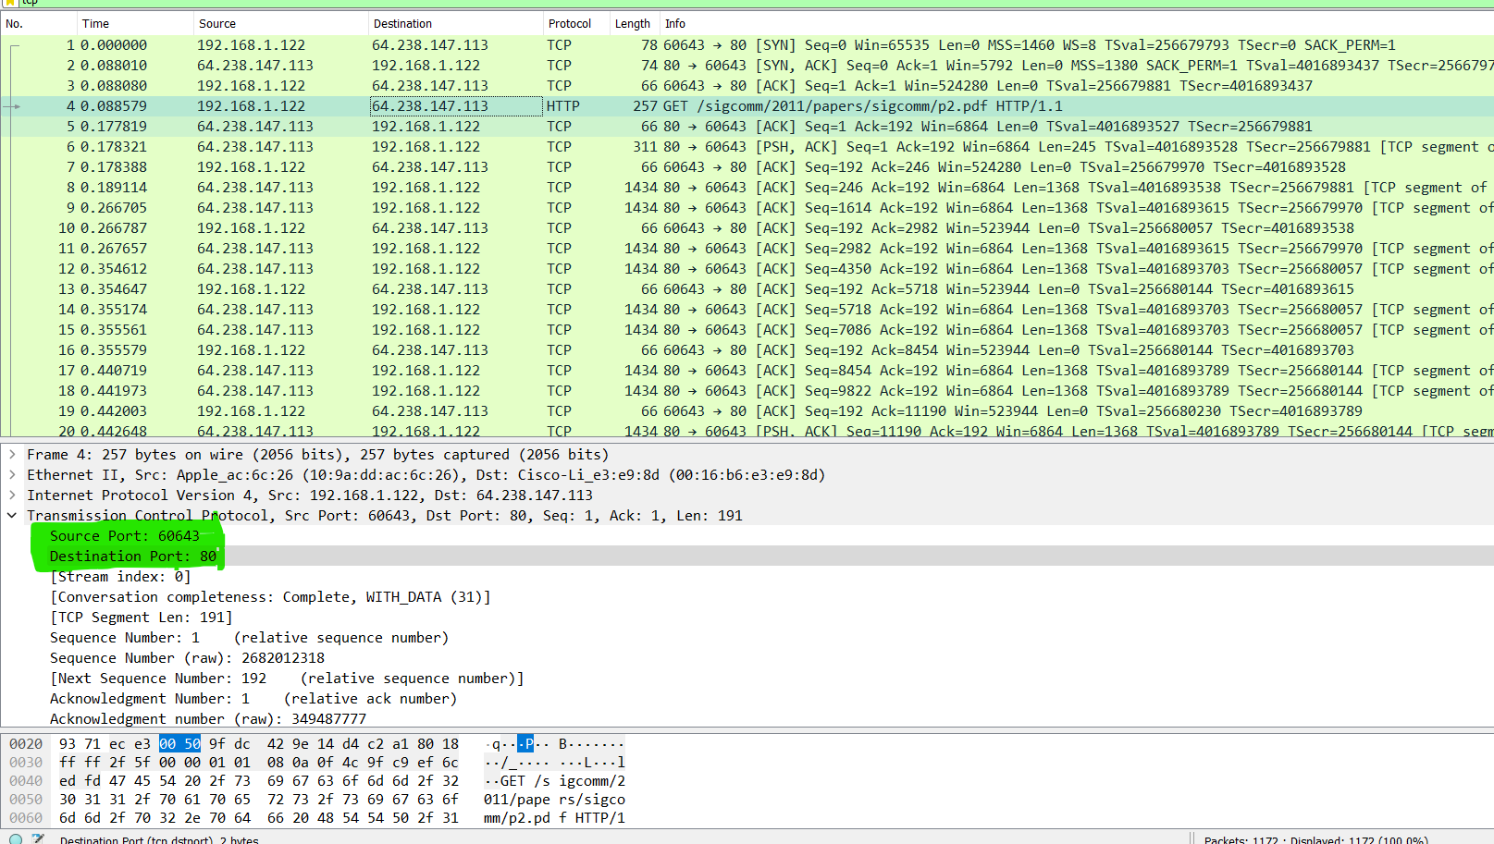

TCP :
source port numbers = 80
destination port numbers = 60643

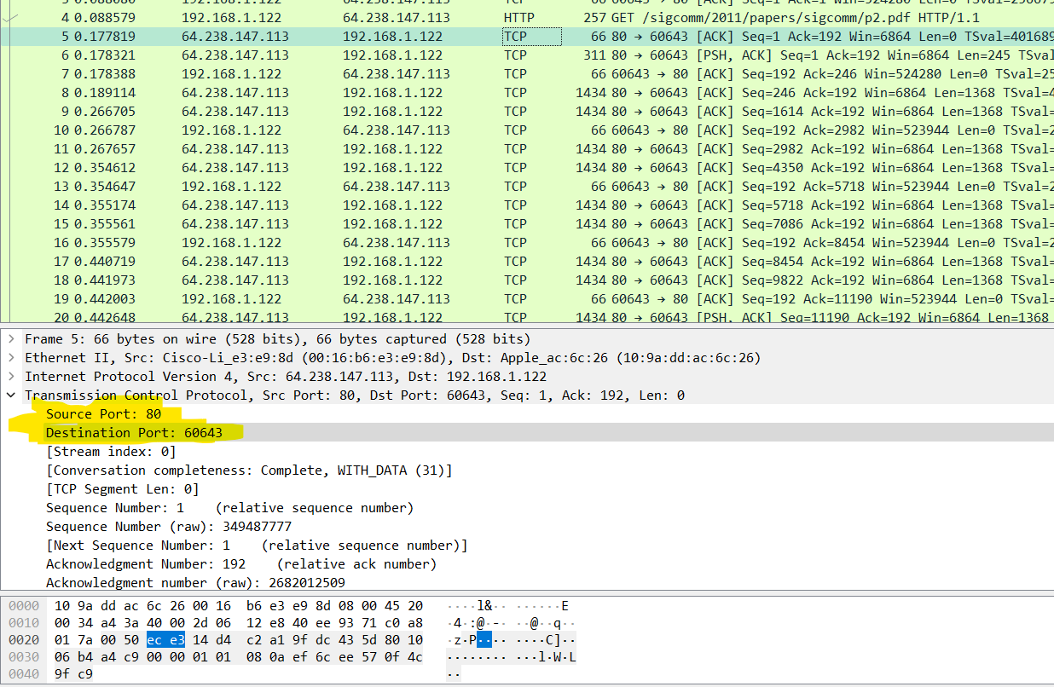

Q2: What is the sequence number of the TCP SYN segment that is used to initiate
the TCP connection? What is it in the segment that identifies the segment as
a SYN segments?

Ans: The (relative) sequence number is zero (Seq=1) and the flags are set such that SYN is set.
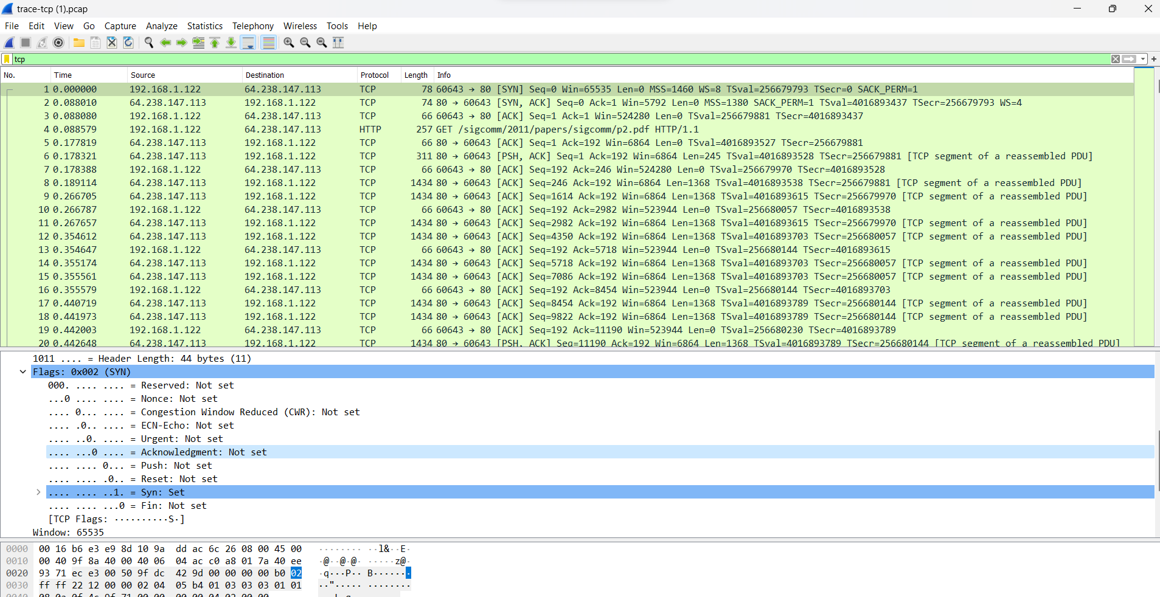

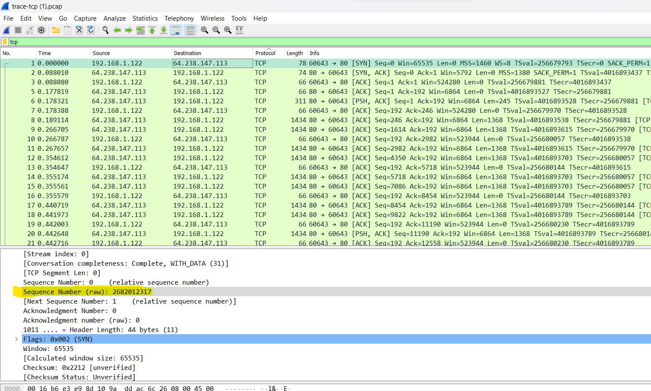

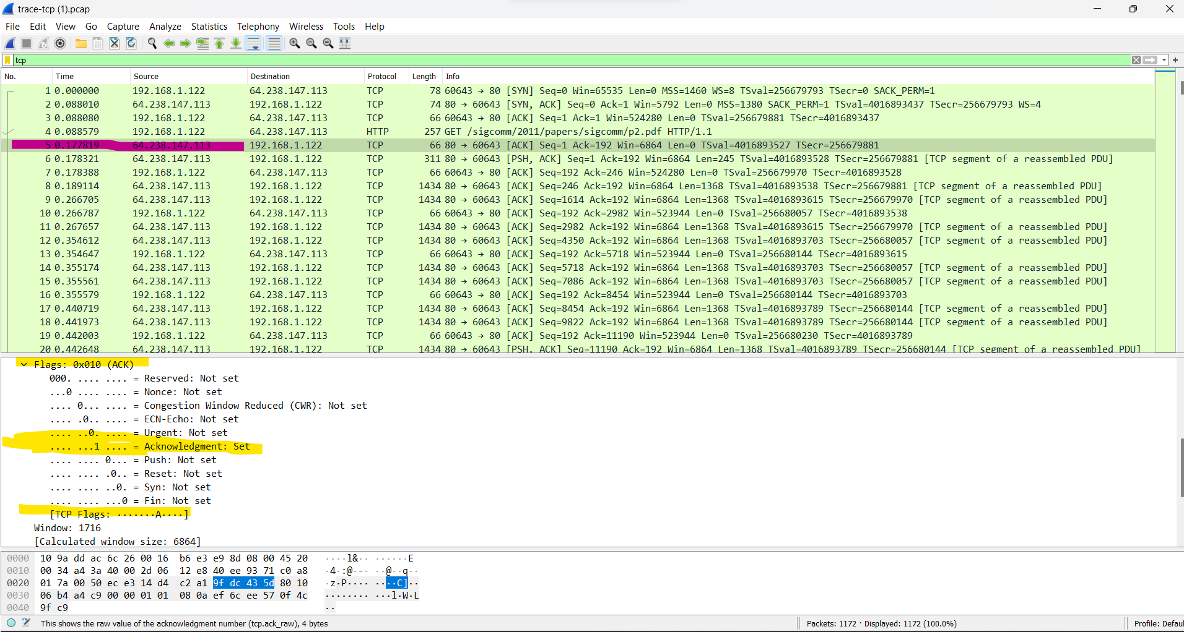

Q4: What is the sequence number of the SYNACK segment sent by the server to the client computer in reply to the SYN? What is the value of the Acknowledgement field in the SYNACK segment? How did server determine that value? What is it in the segment that identifies the segment as a SYNACK segment?

Ans:
The sequence number of the SYNACK segment sent by server to the client computer in reply to the SYN is seq=0

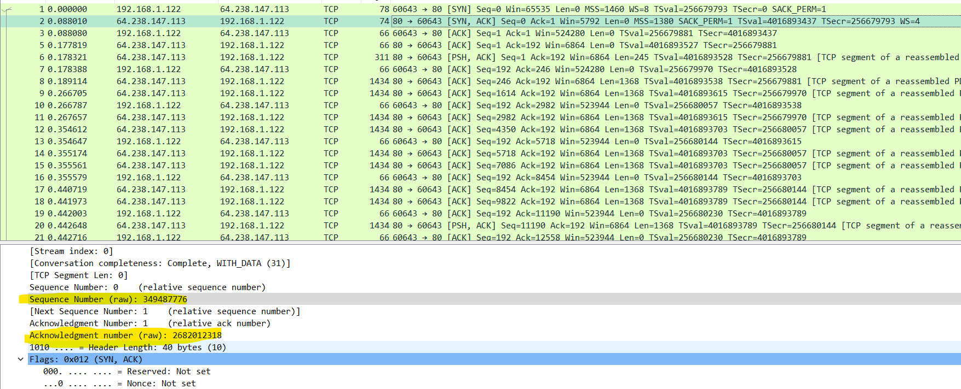

The Sequence number(raw) is = 2682012317

What is the value of the Acknowledgement field in the SYNACK segment?

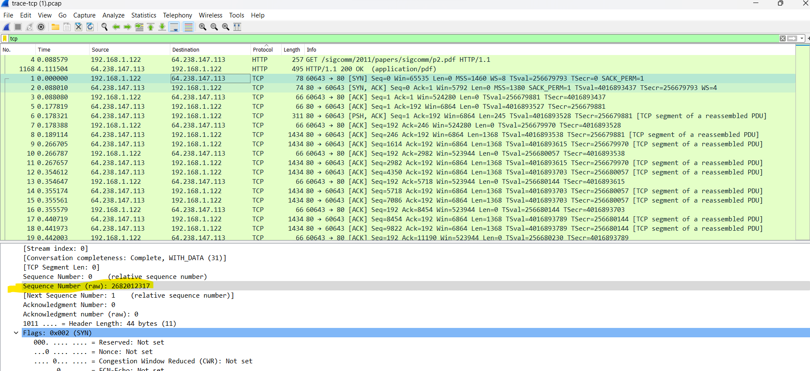
The Sequence number(raw) is = 2682012317
Add 1 into the sequence number in previous sequence number
After add 1 the new sequence number is 2682012318

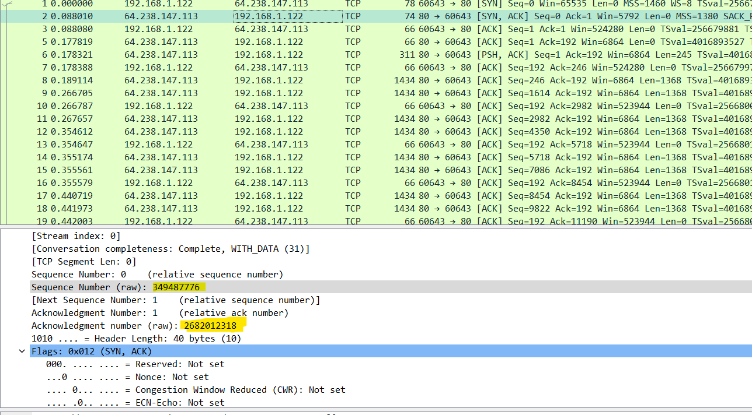

Q4:What is the length of each of the first six TCP segments?

The 1st segment length is 191 bytes
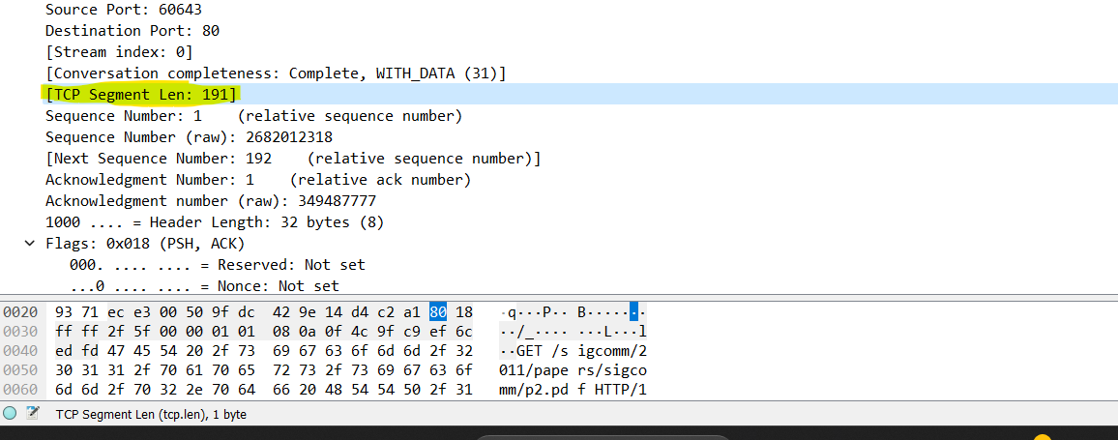

The 2nd segment length is 245 bytes

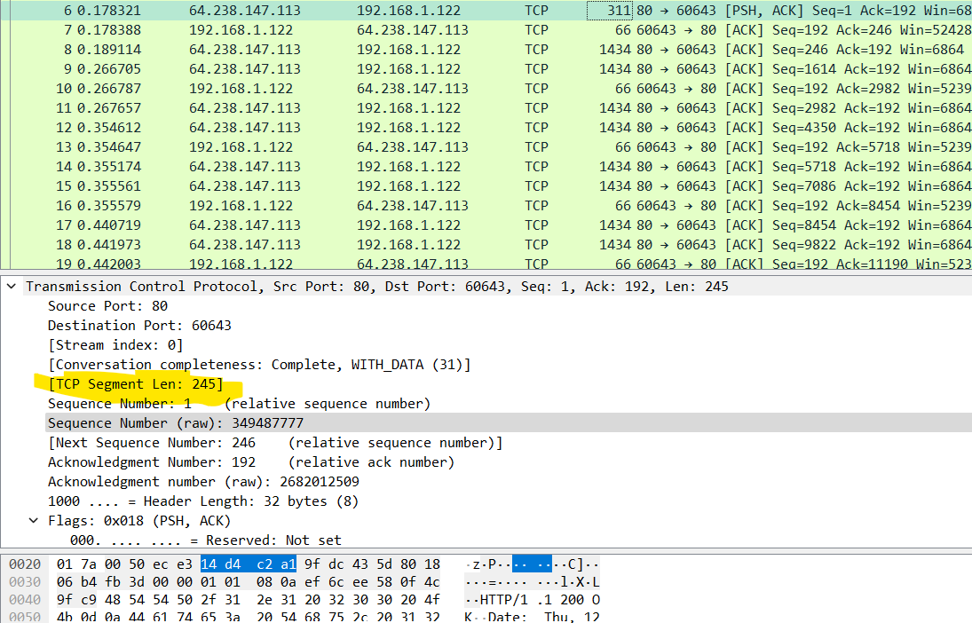

The 3th segment length is 0 bytes
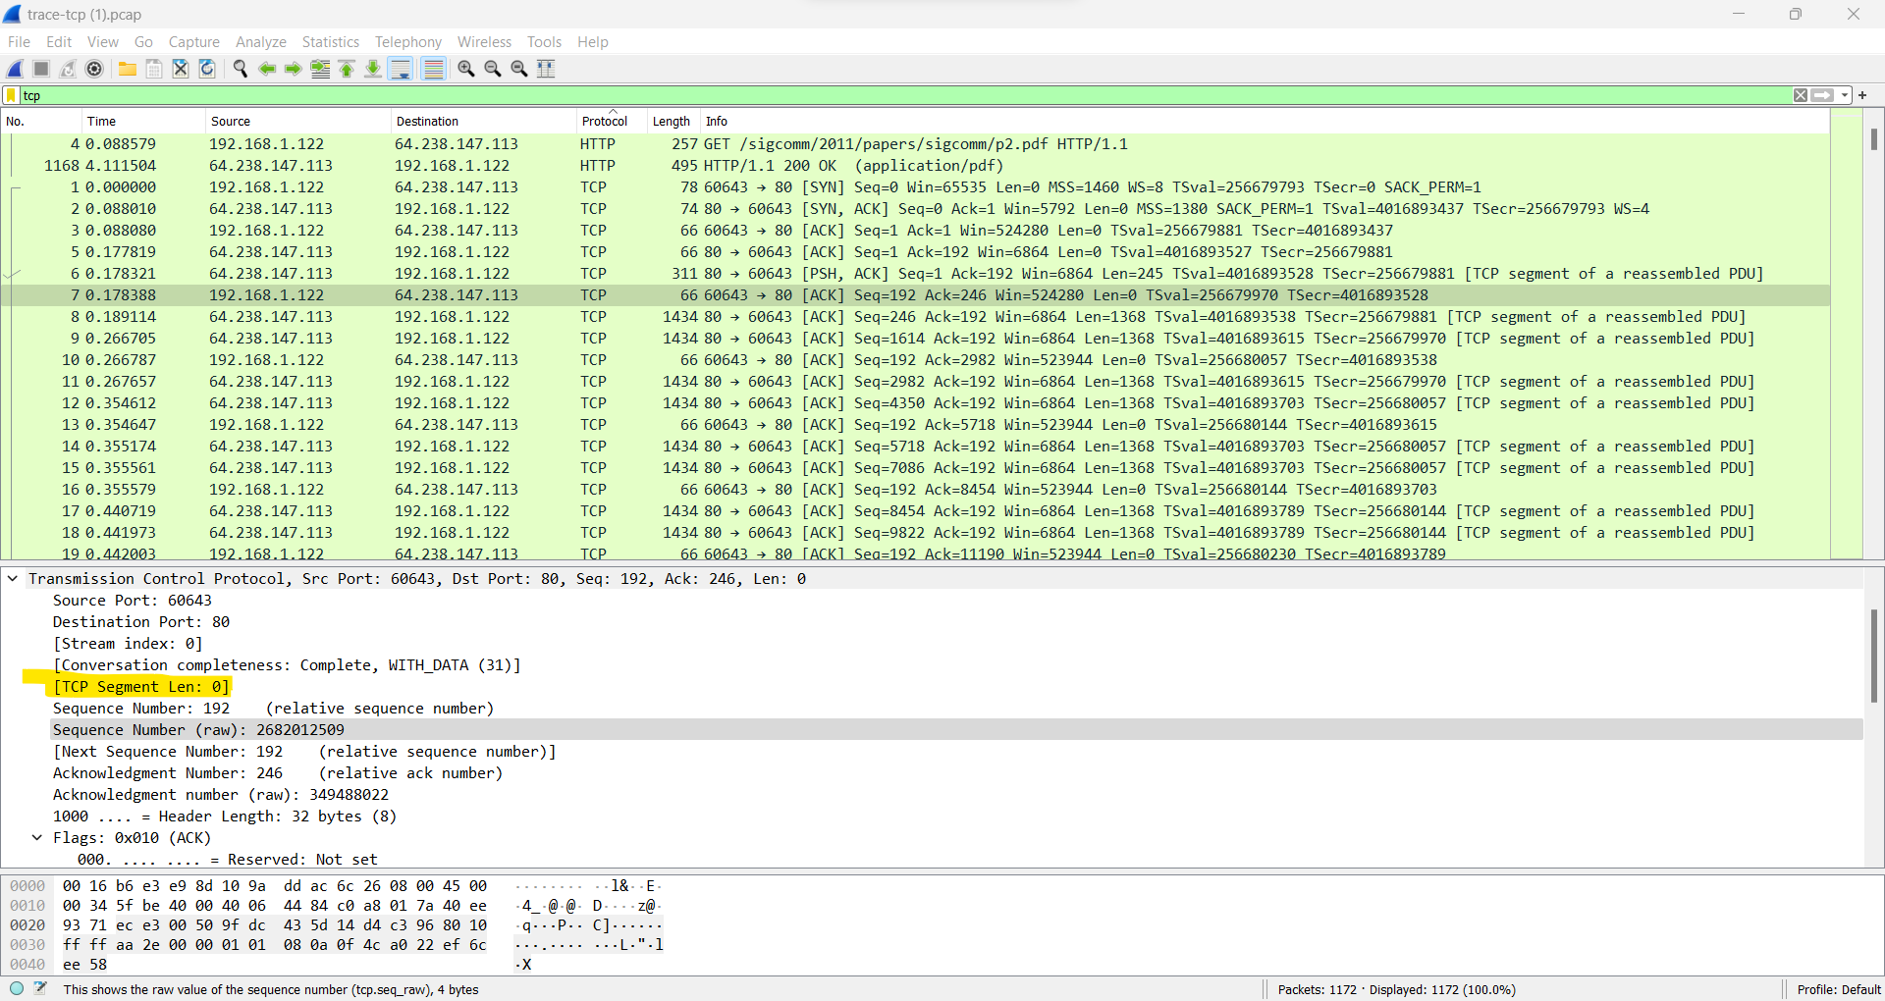

The 4th segment length is 1368 bytes
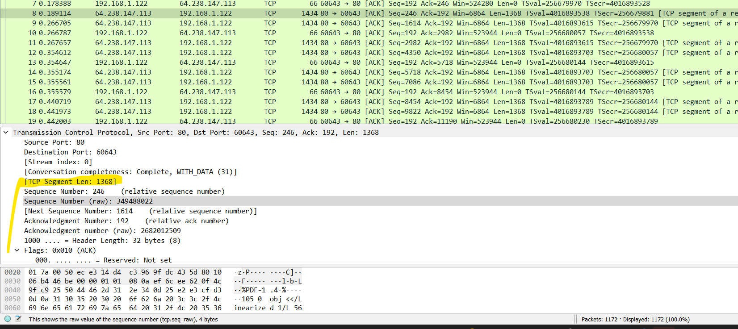

The 5th segment length is 1368 bytes

The 6th segment length is 0 bytes

Q5: Are there any retransmitted segments in the trace file? What did you check
for (in the trace) in order to answer this question?

Ans:
The sequence number is 2682012509 .The ack number is 349488022 this

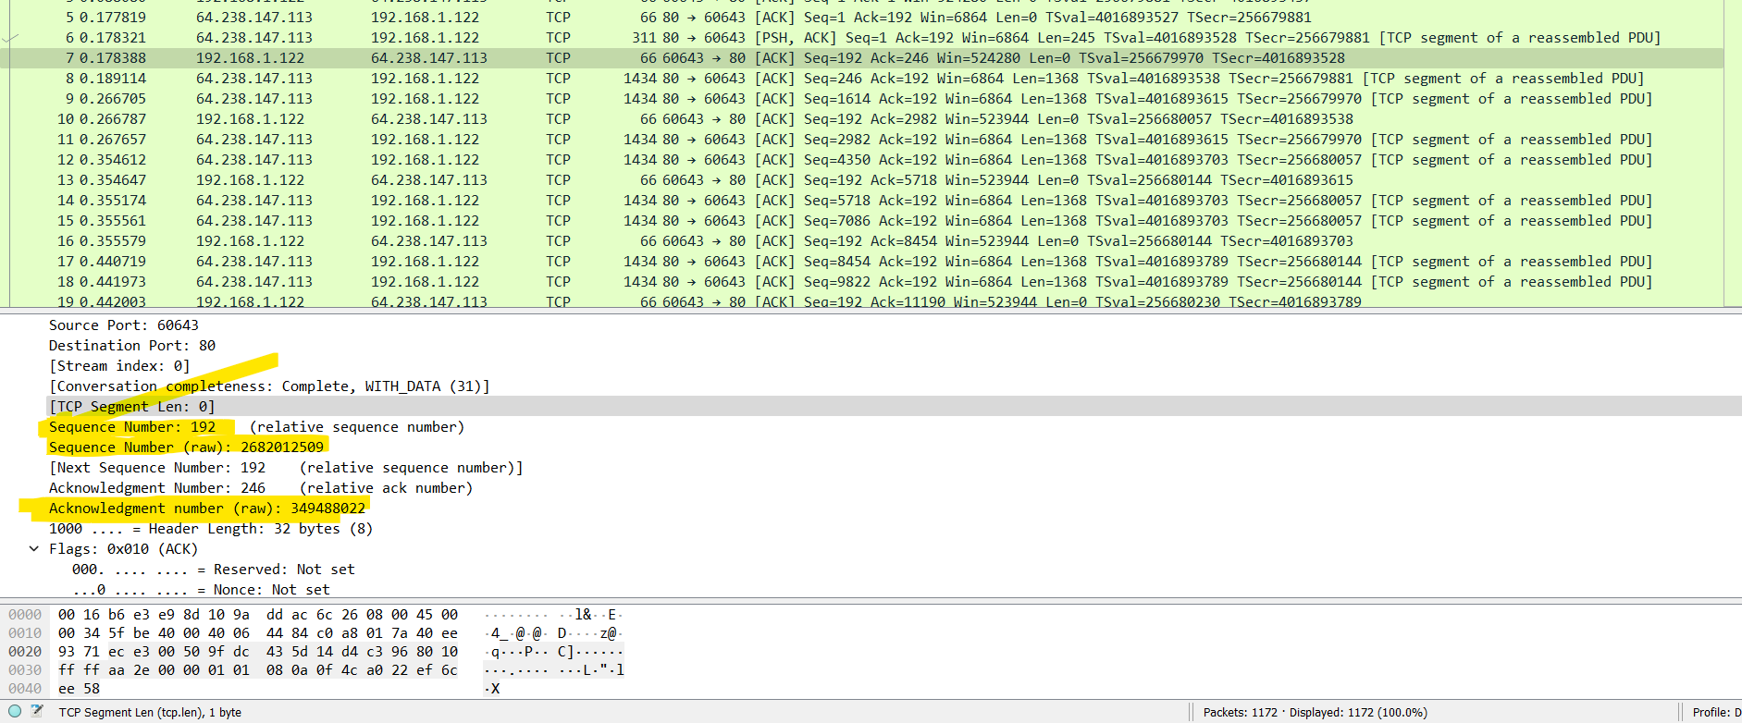

The sequence number is 2682012509. the Ack number is 349490758 this so the both is same so they are retransmitted segments.

