Computer Network Lab


LAB WORK # 12

Submitted By
QASIM ALI (20P-0070)
Submitted to : Hurmat Hidayat
(INSTRUCTOR CS)

DEPARTMENT OF COMPUTER SCIENCE

FAST NATIONAL UNIVERSITY OF COMPUTER AND EMERGING SCIENCES, PESHAWAR

Session 2020-2024

Task 1 : Determine Network Address of the following IP Address
IP address : 10.128.240.50/30. Also, determine broadcast and range of host addresses.

Ip Address : 10.128.240.50
Submet mass : 255.255.255.0 = 30

binary numbers :

10.128.240.50

10.128.240.50 : 000000110. 010000000. 11110000 . 00110010
255.255.255.0 : 11111111 . 11111111 . 11111111 .11111100

Apply the AND Operation :

AND: 000000110. 010000000 . 11110000. 00110000

AND after we want the Network :

Network ip is: 00000110. 10000000. 11110000. 00110000
In decimal: 10.128.240.48

Broadcast address:
Host bit: 32-30 = 2 the host bit
000000110. 010000000. 11110000. 00110011
In decimal: 10.128.240.51

Rang of host: 10.128.240.49
10.128.240.50
Only two networks only

Task 2 : Determine the network and broadcast addresses and number of hosts bits
and hosts for the given IPv4 addresses and prefixes in the following table.

IPv4  Address/Prefix | Network Address | Broadcast Address | Total Number  of Host Bits | Total  Number of  Hosts
192.168.100.25/28 | 192.168.100.16 | 192.168.100.31 | 4 | 14
172.30.10.130/30 | 172.30.10.128 | 172.30.10.131 | 2 | 2
10.1.113.75/19 | 10.1.96.0 | 10.1.111.255 | 13 | 167
198.133.219.250/24 | 192.1233.219.0 | 192.133.219.255 | 8 | 62

192.168.100.25/28 :

192.168.100.25 : 11000000. 10101000. 01100100 . 00011001
255.255.255.0 : 11111111 . 11111111 . 11111111 .11110000

Apply the AND Operation:
Network ip Address is : 11000000. 10101000. 01100100. 00010000
In decimal: 192.168.100.16

Broadcast address:
Host bit: 32-28 = 4 the host bit
11000000. 10101000. 01100100. 00011111
In decimal: 192.168.100.31

Total Number of Hosts
192.168.100.16
^
| the center all ip is Total Number of Hosts
^
192.168.100.31

//============================//==========================================//

2-> 172.30.10.130/30 :

172.30.10.130 : 10101011. 00001110 . 00000110 . 10000010
255.255.255.0 : 11111111 . 11111111 . 11111111 .11111100

Apply the AND Operation:
Network ip Address is : 10101011. 00001110 . 00000110 . 10000000
In decimal: 172.30.10.128

Broadcast address:
Host bit: 32-30 = 2 the host bit
10101011. 00001110 . 00000110 . 10000011
In decimal: 172.30.10.131

Total Number of Hosts
172.30.10.128
^
| the center all ip is Total Number of Hosts
172.30.10.129
172.30.10.130
^
172.30.10.131

//============================//==========================================//

3-> 10.1.113.75/19

10.1.113.75 : 00001010. 00000001 . 01110001 . 01001001
255.255.255.0 : 11111111 . 11111111 . 11100000 .00000000

Apply the AND Operation:
Network ip Address is : 00001010. 00000001. 01100000. 00000000
In decimal: 10.1.96.0

Broadcast address:
Host bit: 32-19= 13 the host bit
00001010. 00000001. 01101111.11111111
In decimal: 10.1.111.255

Total Number of Hosts
10.1.96.0
^
| the center all ip is Total Number of Hosts
^
10.1.111.255

//============================//==========================================//
4->198.133.219.250/24

192.133.219.250 : 00001010. 00000001 . 01110001 . 01001001
255.255.255.0 : 11111111 . 11111111 . 11111111 . 00000000

Apply the AND Operation:
Network ip Address is 00001010. 00000001 . 01110001 . 00000000
In decimal: 192.1233.219.0

Broadcast address:
Host bit: 32-24= 8 the host bit
00001010. 00000001 . 01110001 .11111111
In decimal: 192.133.219.255

Total Number of Hosts
192.1233.219.0
^
| the center all ip is Total Number of Hosts
^
192.133.219.255

//=======================end Q1===================================//
Q3: Network Topology A

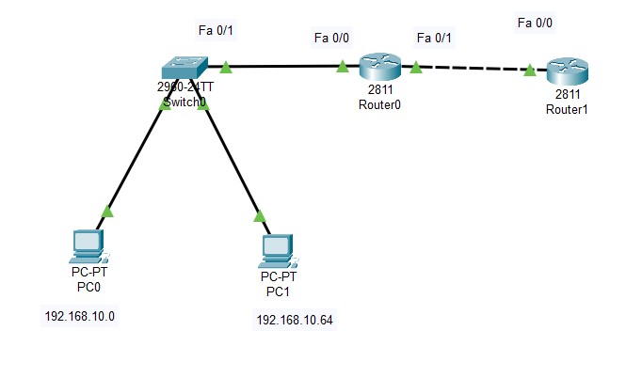

Step 1: Determine the number of subnets in Network Topology A.
a. How many subnets are there? ___2________
b. How many bits should you borrow to create the required number of subnets? ____1_____
c. How many usable host addresses per subnet are in this addressing scheme? ___62________
d. What is the new subnet mask in dotted decimal format? _____255.255.255.129_____
e. How many subnets are available for future use? _______1_____

Step 2: Record the subnet information.
Fill in the following table with the subnet information:

Subnet  Number | Subnet Address | First Usable Host  Address | Last Usable Host  Address | Broadcast  Address
0 | 192.168.10.0 | 192.168.10.1 | 192.168.10.62 | 192.168.10.63
1 | 192.168.10.64 | 192.168.10.65 | 192.168.10.126 | 192.168.10.127
2 | 192.168.10.128 | 192.168.10.129 | 192.168.10.190 | 192.168.10.191
3 | 192.168.10.192 | 192.168.10.193 | 192.168.10.254 | 192.168.10.254
4
5

Q4 :Network Topology B

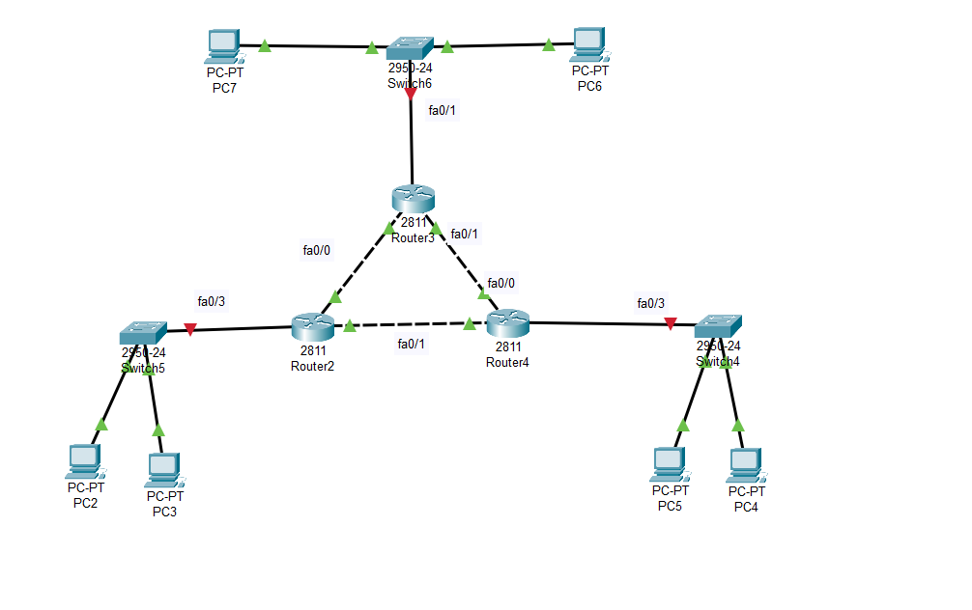

Step 1: Determine the number of subnets in Network Topology B.
a. How many subnets are there? _____9______
b. How many bits should you borrow to create the required number of subnets? ____4_____
c. How many usable host addresses per subnet are in this addressing scheme? ______14_____
d. What is the new subnet mask in dotted decimal format? _______255.255.255.240______
e. How many subnets are available for future use? ______7_________

Step 2: Record the subnet information.
Fill in the following table with the subnet information:

Network Name | Subnet Address | First Usable Host  Address | Last Usable Host  Address | Broadcast  Address
0 | 192.168.10.0/26 | 192.168.10.1 | 192.168.10.30 | 192.168.10.31
1 | 192.168.10.32/26 | 192.168.10.33 | 192.168.10.62 | 192.168.10.63
2 | 192.168.10.64/26 | 192.168.10.65 | 192.168.10.94 | 192.168.10.95
3 | 192.168.10.96/32 | 192.168.10.97 | 192.168.10.98 | 192.168.10.99
4 | 192.168.10.100/32 | 192.168.10.101 | 192.168.10.102 | 192.168.10.103
5 | 192.168.10.104/32 | 192.168.10.105 | 192.168.10.106 | 192.168.10.107
6 | 192.168.10.108/32 | 192.168.10.109 | 192.168.10.110 | 192.168.10.111
7 | 192.168.10.112/32 | 192.168.10.113 | 192.168.10.114 | 192.168.10.115

Step 3: Assign addresses to network devices in the subnets.
- Fill in the following table with IP addresses and subnet masks for the router interfaces:

Device | Interface | IP Address | Subnet Mask
R1 | GigabitEthernet 0/1 | 192.168.10.30 | 255.255.255.224
 | Serial 0/0/0 | 192.168.10.97 | 255.255.255.252
 | Serial 0/0/1 | 192.168.10.101 | 255.255.255.252
R2 | GigabitEthernet 0/1 | 192.168.10.62 | 255.255.255.224
 | Serial 0/0/0 | 192.168.10.98 | 255.255.255.252
 | Serial 0/0/1 | 192.168.10.105 | 255.255.255.252
R3 | GigabitEthernet 0/1 | 192.168.10.94 | 255.255.255.224
 | Serial 0/0/0 | 192.168.10.102 | 255.255.255.252
 | Serial 0/0/1 | 192.168.10.106 | 255.255.255.252

