Computer Network Lab


LAB WORK # 04

Submitted By
QASIM ALI (20P-0070)
Submitted to : Hurmat Hidayat
(INSTRUCTOR CS)

DEPARTMENT OF COMPUTER SCIENCE

FAST NATIONAL UNIVERSITY OF COMPUTER AND EMERGING SCIENCES, PESHAWAR

Session 2020-2024

Configuring DHCP server on a Router

Build the network topology:

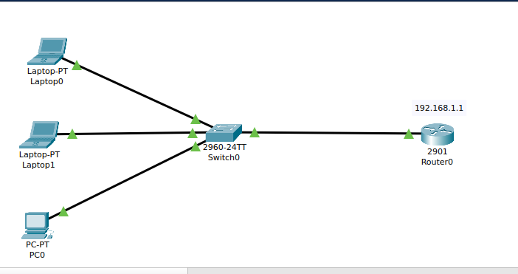

On the router, configure interface fa0/0 to act as the default gateway for our LAN.

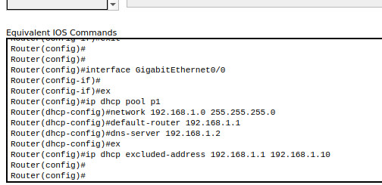

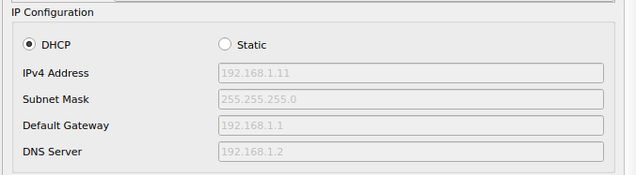

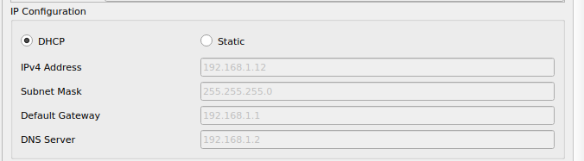

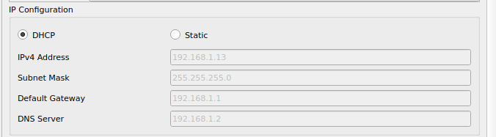

Task 2:

Configuring DHCP server on a Generic server

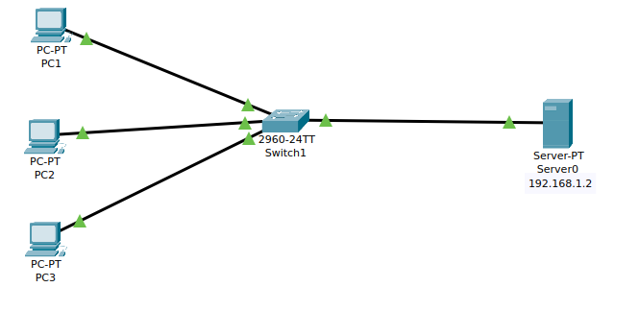

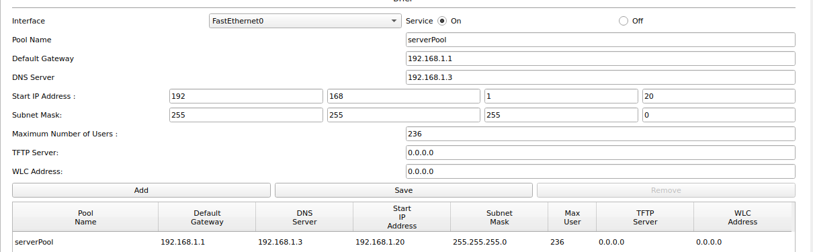

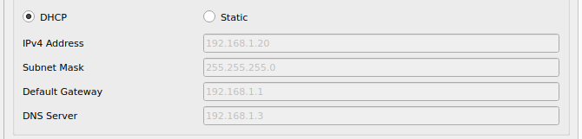

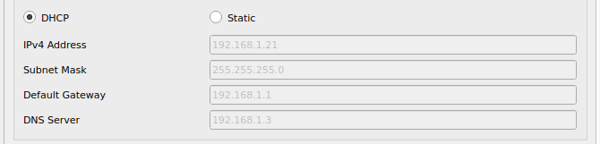

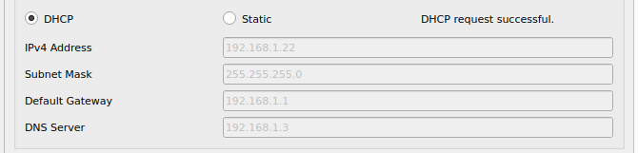

You can test the configuration by pinging PC2 , PC1 and PC3. Ping should succeed.

Task 4:

