Computer Network Lab


LAB WORK # 06

Submitted By
QASIM ALI (20P-0070)
Submitted to : Hurmat Hidayat
(INSTRUCTOR CS)

DEPARTMENT OF COMPUTER SCIENCE

FAST NATIONAL UNIVERSITY OF COMPUTER AND EMERGING SCIENCES, PESHAWAR

Session 2020-2024

Task 1:

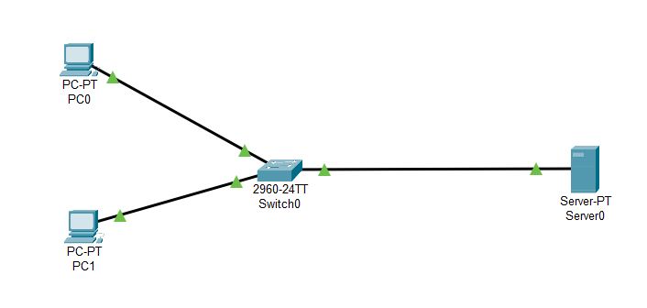

Dns server IP Configure
IP = 192.168.1.2
Subnet mask = 255.255.255.0
Default Gateway = 192.168.1.1
DNS server = 192.168.1.2

PC0 Configure
IP = 192.168.1.3
Subnet mask = 255.255.255.0
Default Gateway = 192.168.1.1
DNS server = 192.168.1.2

PC1 Configure
IP = 192.168.1.4
Subnet mask = 255.255.255.0
Default Gateway = 192.168.1.1
DNS server = 192.168.1.2

DNS Server :
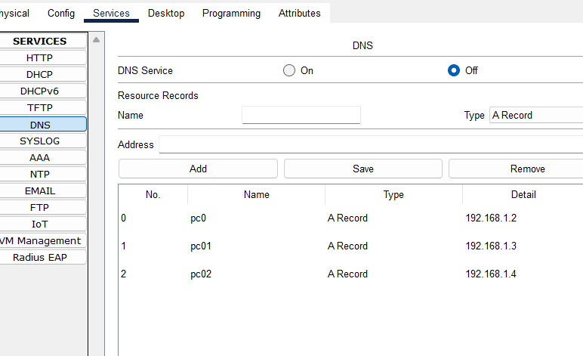

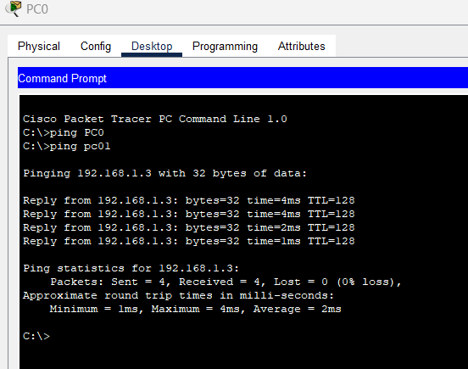

Task 2 :
Topology:

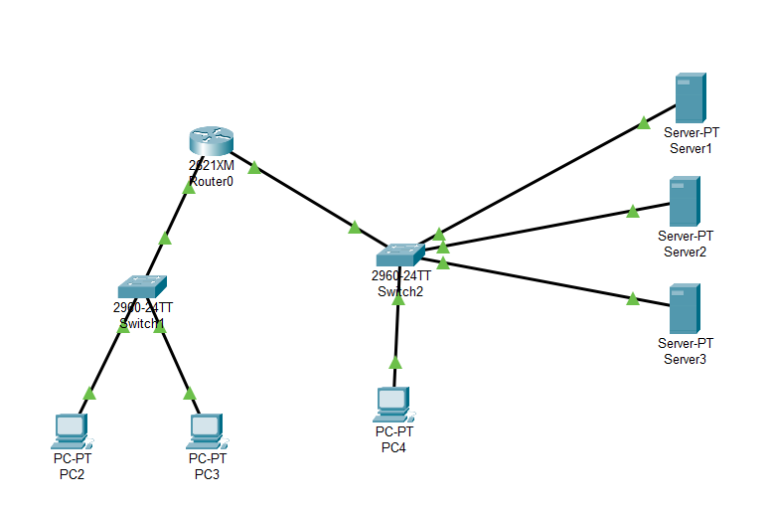

Server 3(Web Server):

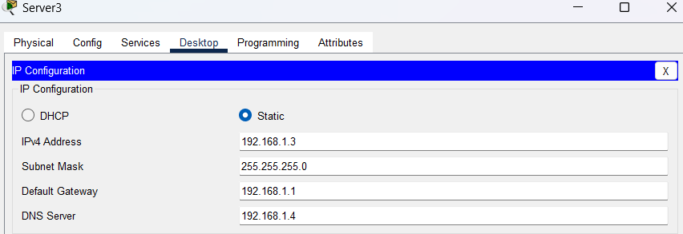

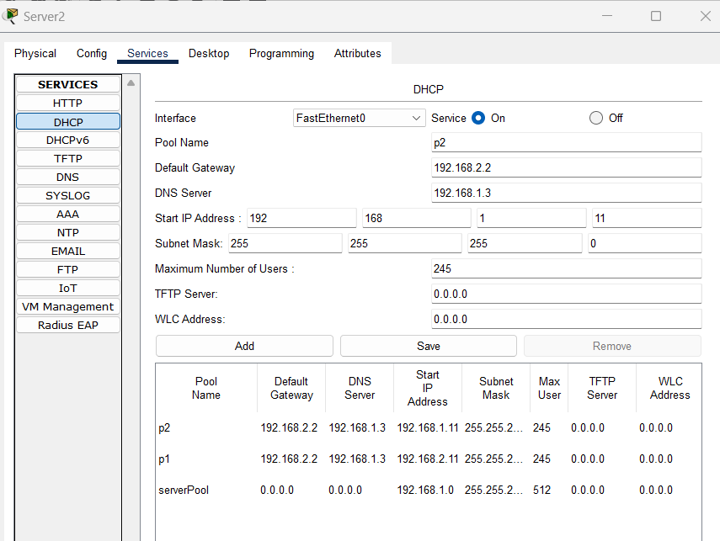

Server 2 (DNS):
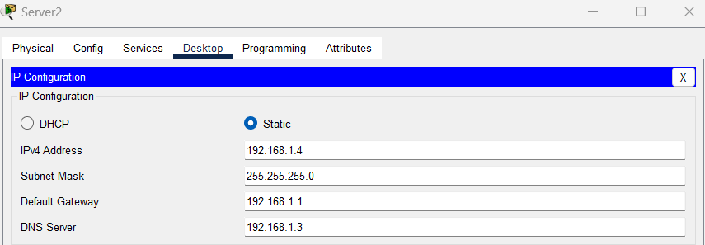

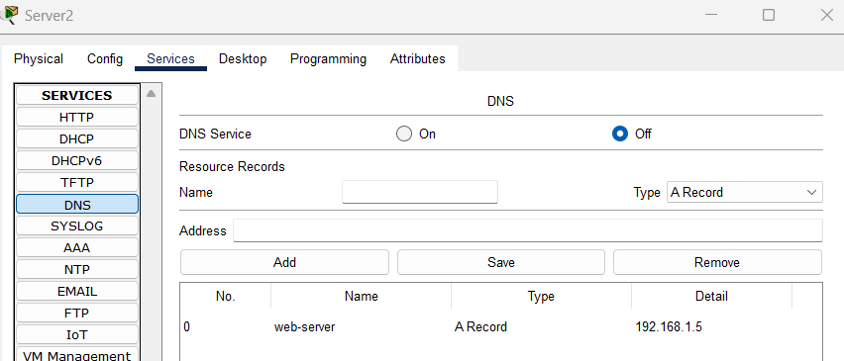

Server 1:
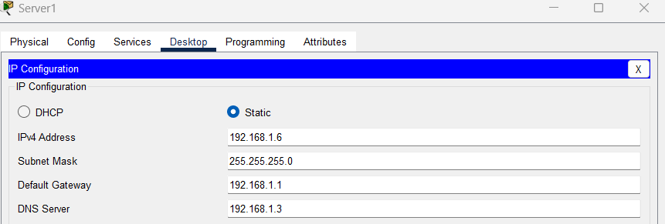

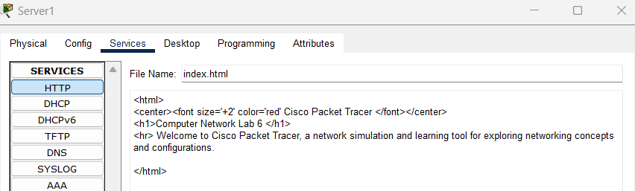

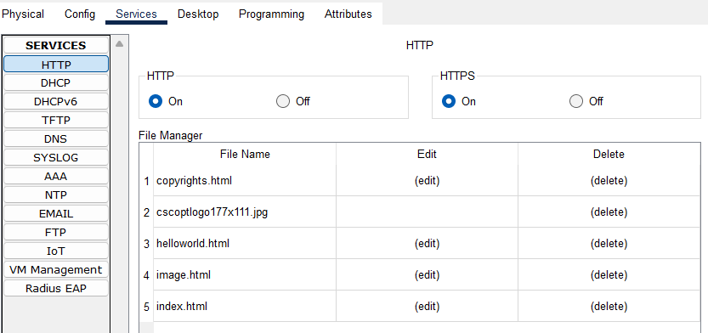

Configuring Router Now & add ip using DHCP

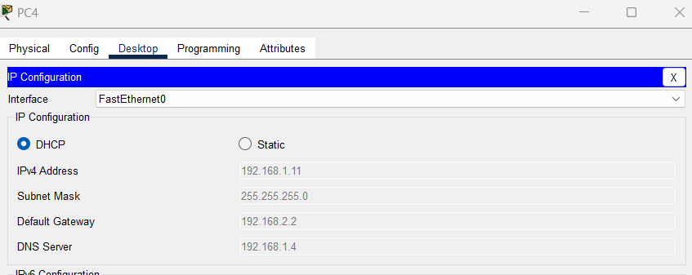

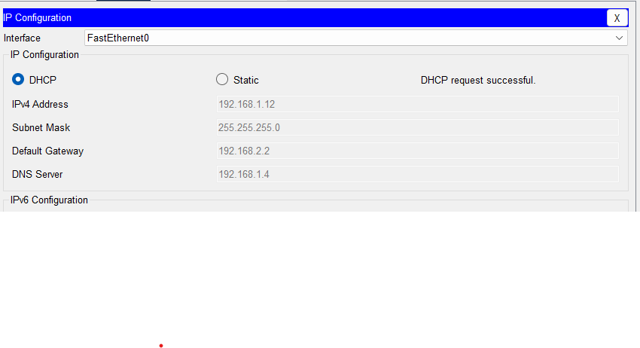

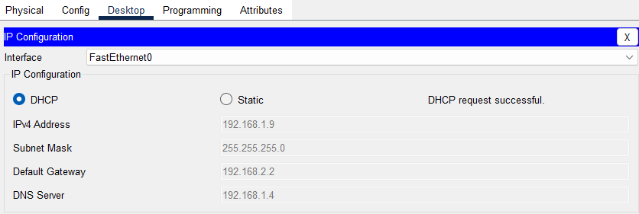

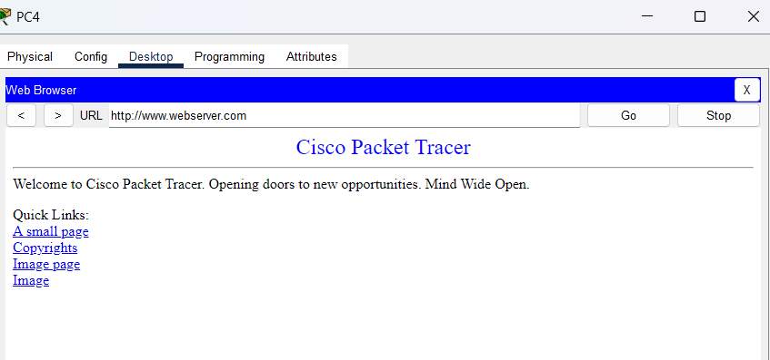

Experiment 1
- Topology

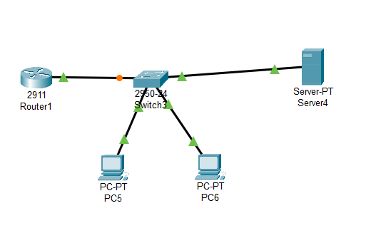

Router :

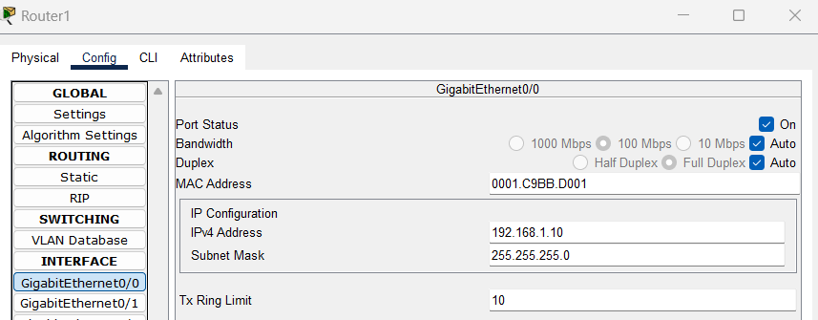

Server :

