Computer Network Lab


LAB WORK # 08

Submitted By
QASIM ALI (20P-0070)
Submitted to : Hurmat Hidayat
(INSTRUCTOR CS)

DEPARTMENT OF COMPUTER SCIENCE

FAST NATIONAL UNIVERSITY OF COMPUTER AND EMERGING SCIENCES, PESHAWAR

Session 2020-2024

Task 1:

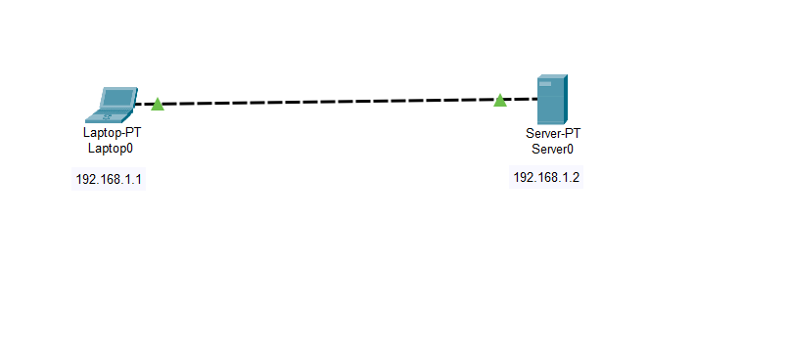

Desktop open :

Laptop 1 :

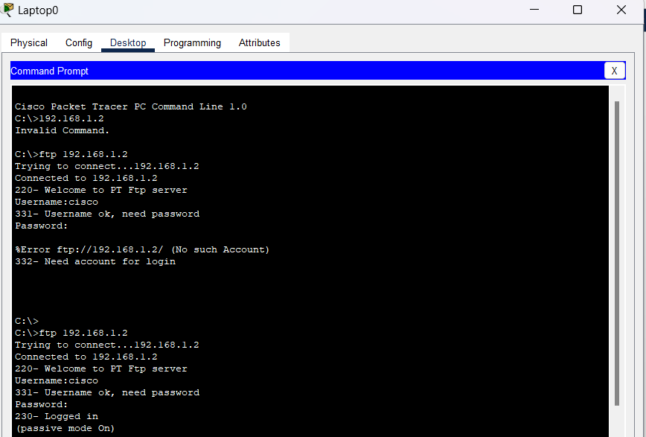

File upload in server

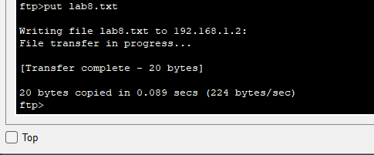

File receive in server:

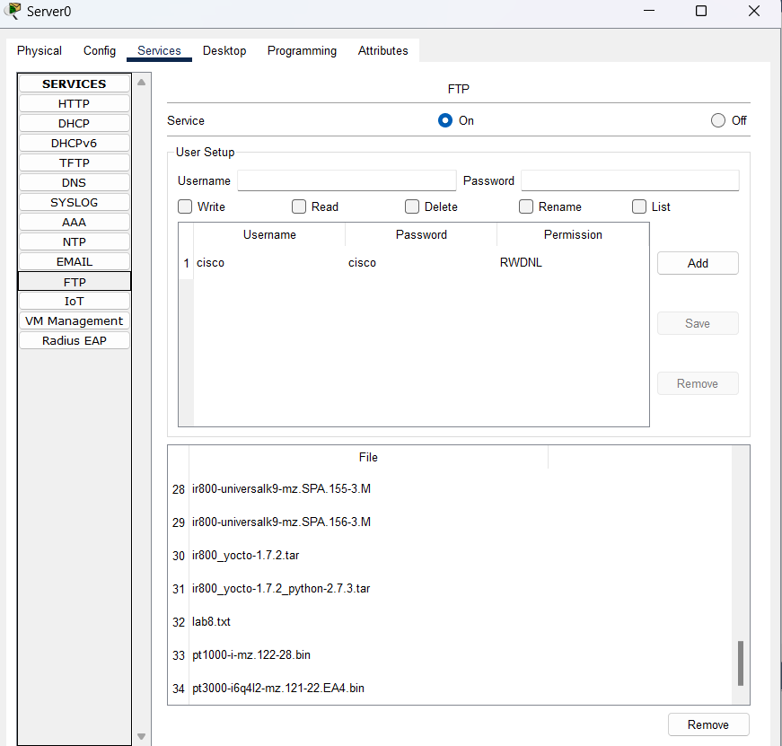

Task 2 :
Create and Upload html file to HTTP server directory Using FTP
We’ll create an html file in our Laptop, upload it to HTTP server directory using FTP, then try
to access the file from the Laptop’s browser.
On the Laptop, open the text editor, then type some markup(html) and save the file with the
extension .html. See all this below:

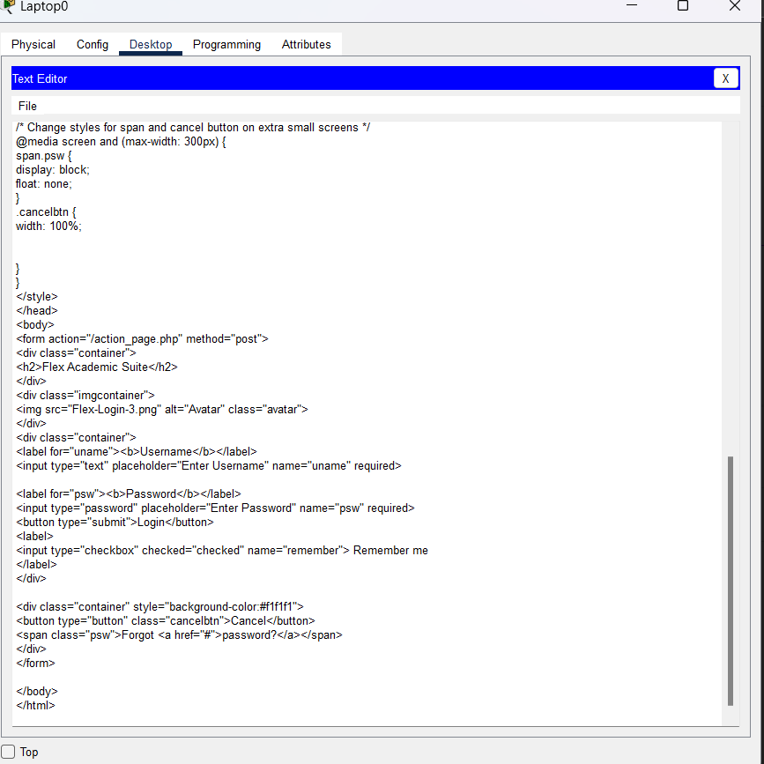

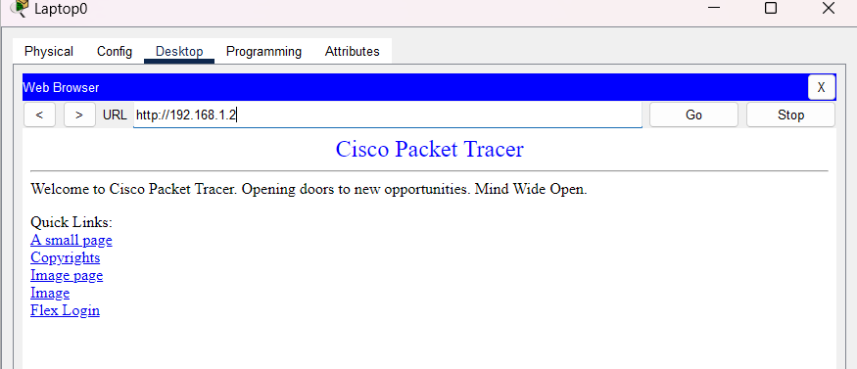

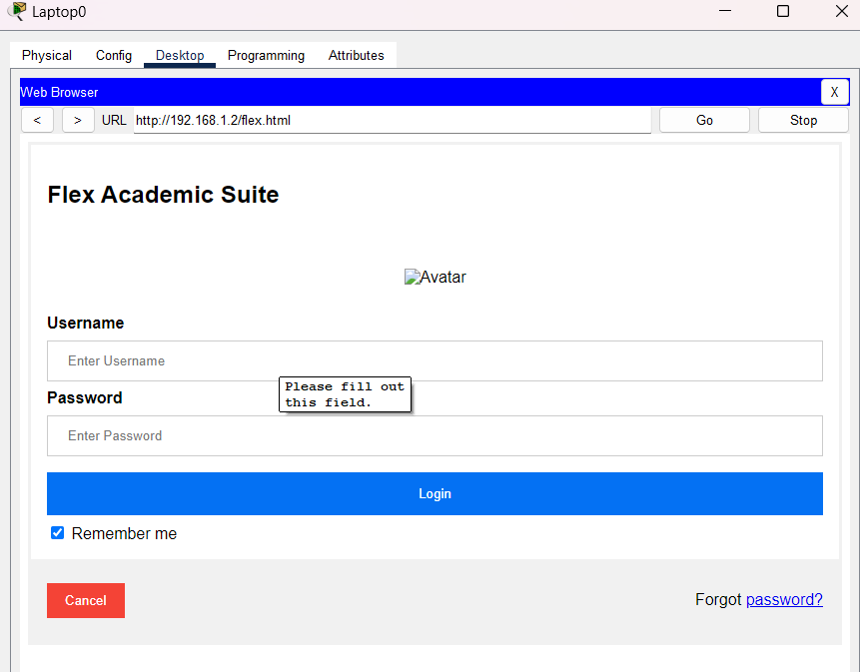

Task 3 :
Topology with FTP Server

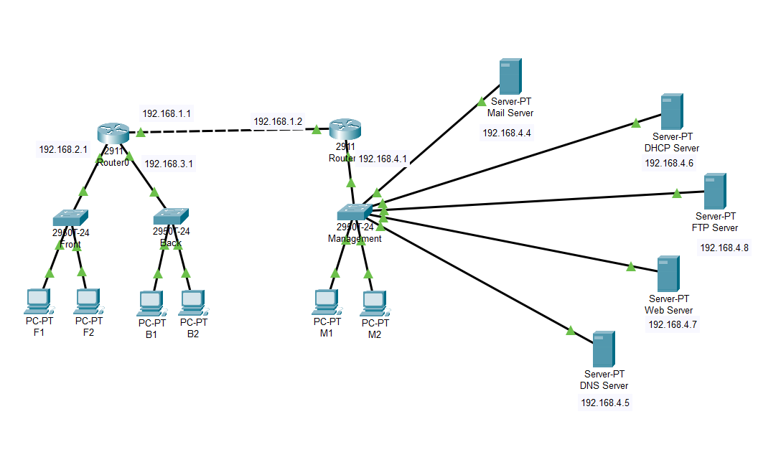

Pc 1 :

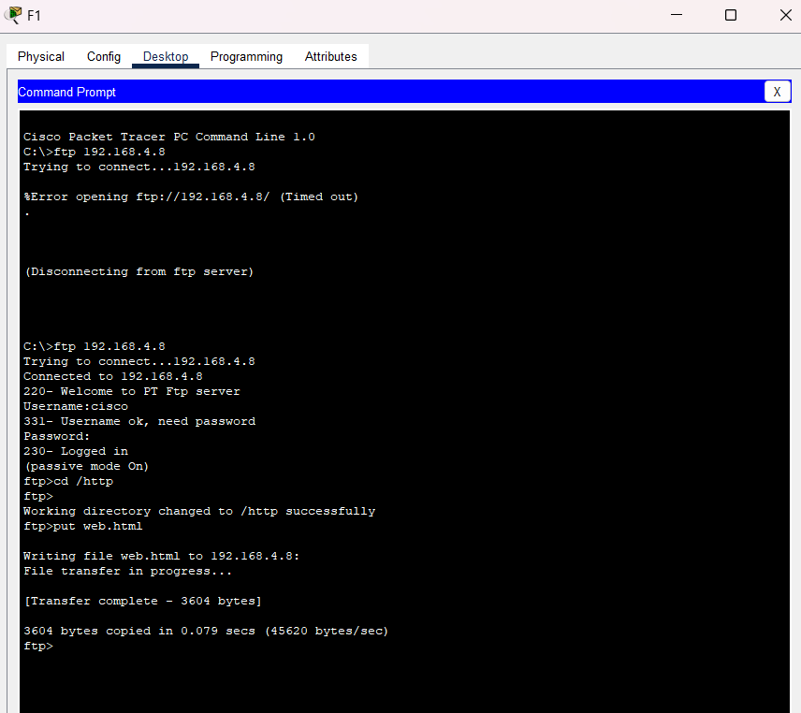

FTP server :

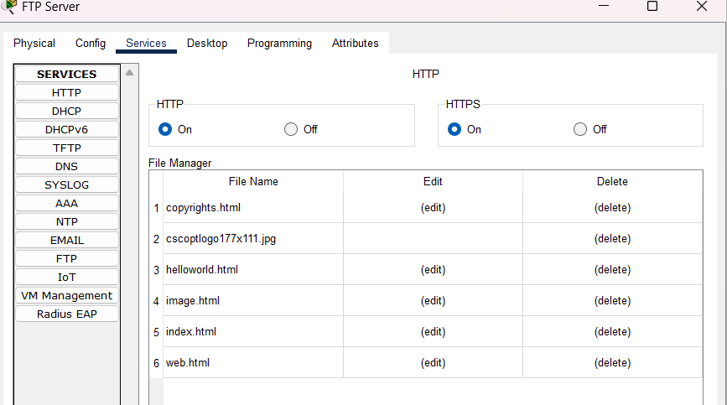

FTP Server :
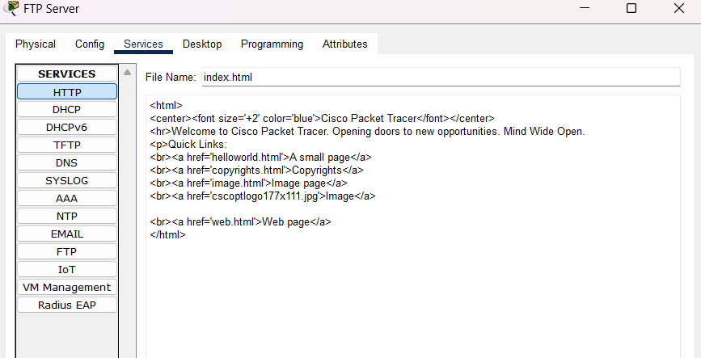

P1: server
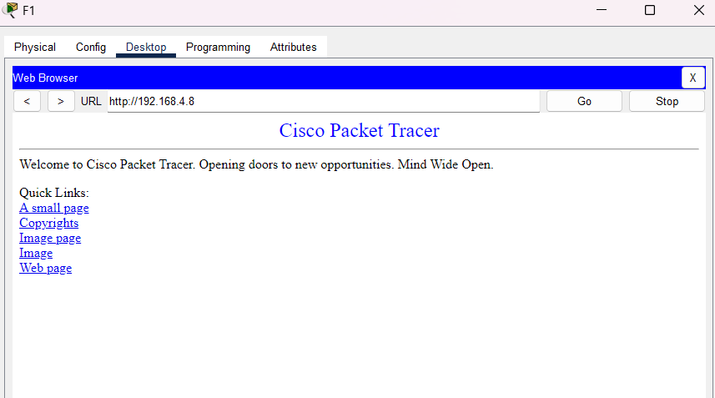
Desktop :
