Computer Network Lab


LAB WORK # 08

Submitted By
QASIM ALI (20P-0070)
Submitted to : Hurmat Hidayat
(INSTRUCTOR CS)

DEPARTMENT OF COMPUTER SCIENCE

FAST NATIONAL UNIVERSITY OF COMPUTER AND EMERGING SCIENCES, PESHAWAR

Session 2020-2024

Task 1:
WLAN Configuration on Packet Tracer
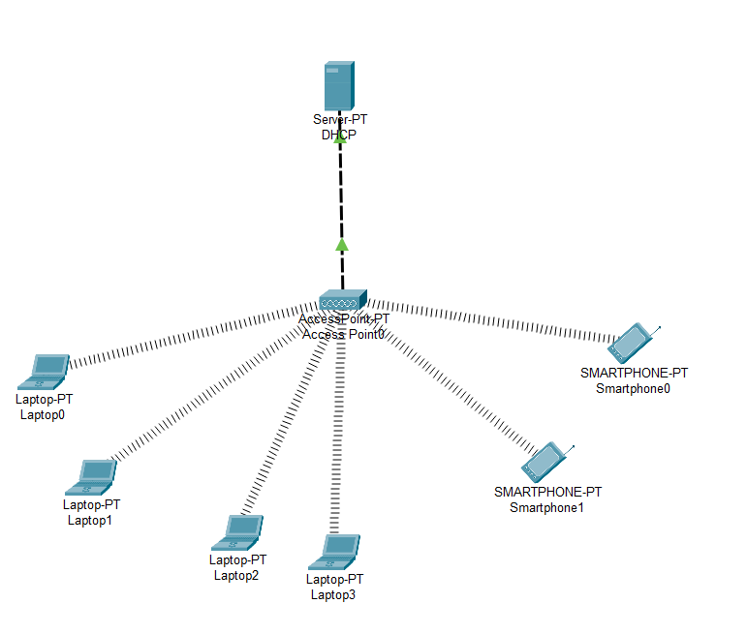

After DHCP Services configuration on DHCP Server, we will configure one more thing on this DHCPServer. This is the IP address and subnet mask of the Server. Here, our Servr IP address will be192.168.1.1 and the mask will be 255.255.255.0.

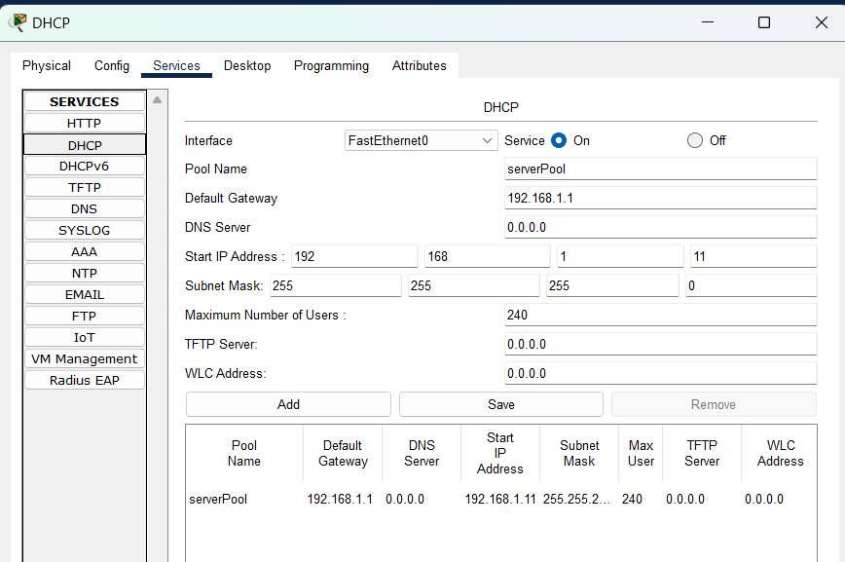

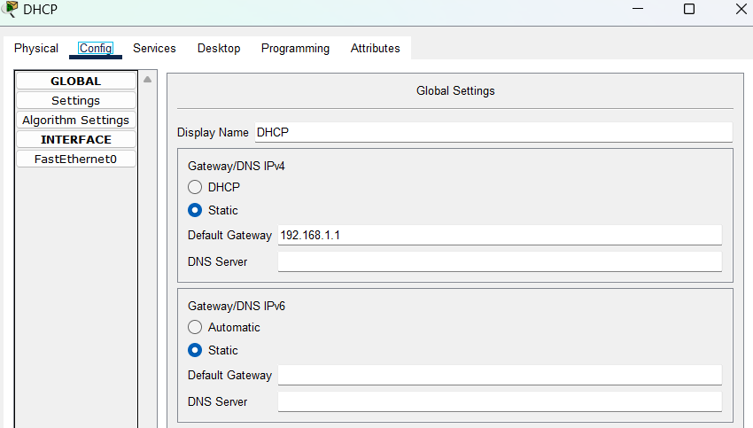

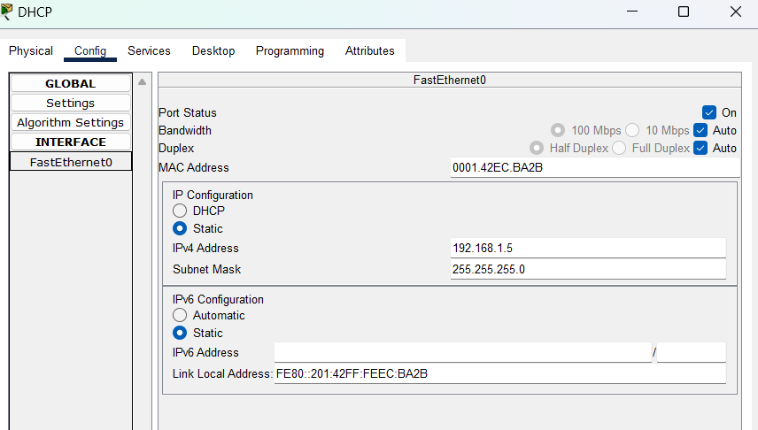

Place Wireless Interface Card to Laptops:
By default laptops has classic Ethernet card. To involve in a wireless network, we should have
wireless interface card. So, in each laptop, we should turn off the laptop, remove the classical
Ethernet, instead of it we place Wireless Interface Card (WPC300N). Then, we power on the laptop again.
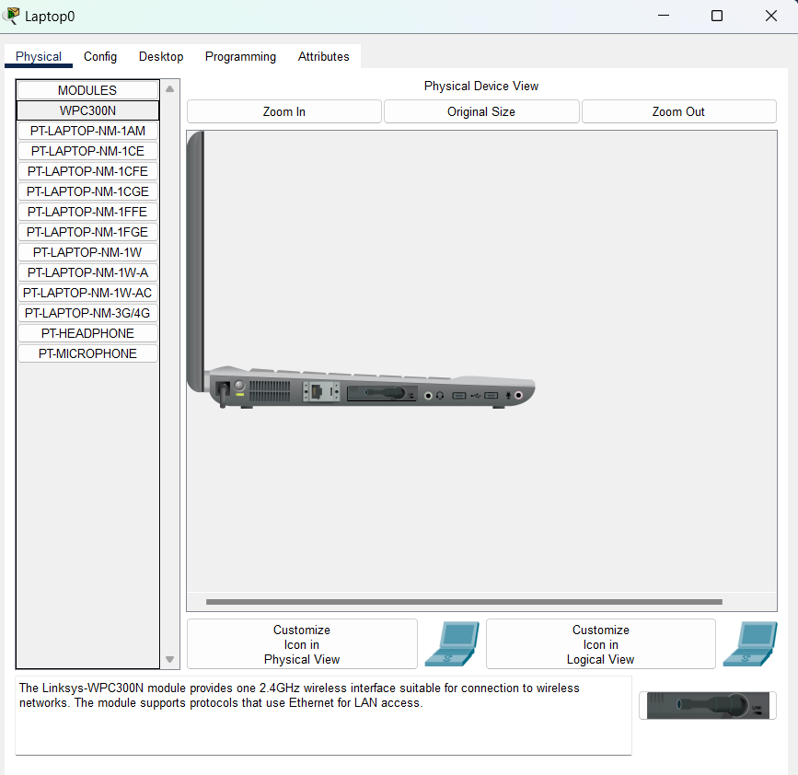

After DHCP Services configuration on DHCP Server, we will configure one more thing on this DHCP Server. This is the IP address and subnet mask of the Server.
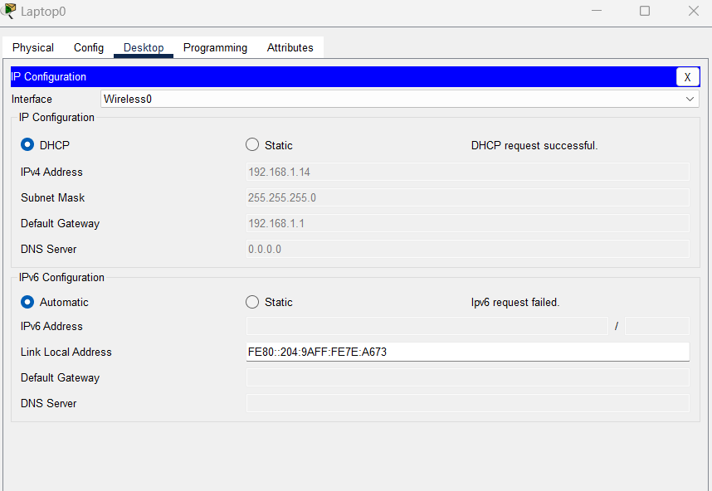

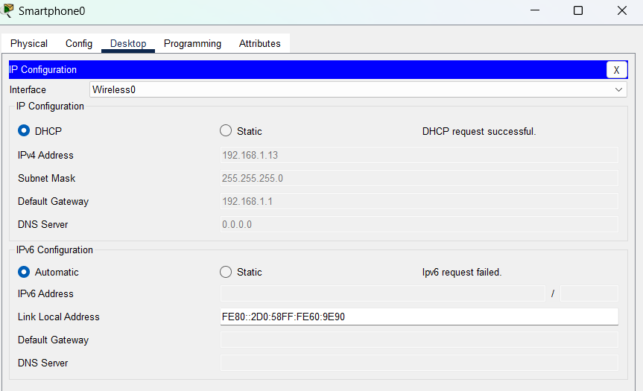

Task 2: Wireless Router configuration in Cisco Packet Tracer

We’ll go through wireless LAN configuration, wireless security and configuring the wireless router for internet connectivity. Briefly, here are the configurations we’ll perform on the wireless router:

• Wireless LAN administration.
• Wireless LAN network setup.
• Securing a wireless network with WPA and WEP security features.
• Setting up internet connectivity on the wireless router.

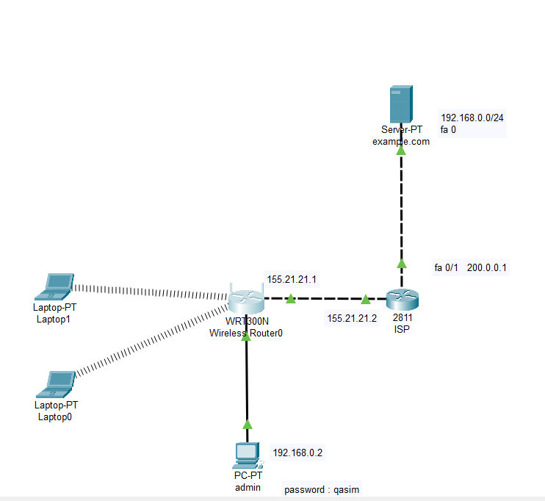
Give Ip in Admin :

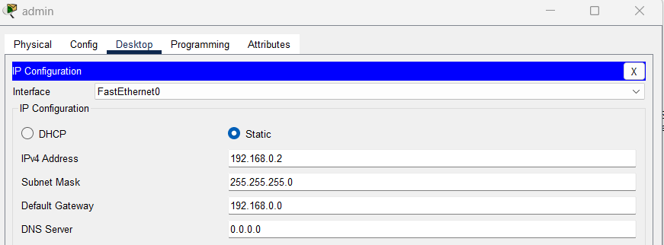

Place Wireless Interface Card to Laptops:
By default laptops has classic Ethernet card. To involve in a wireless network, we should have
wireless interface card. So, in each laptop, we should turn off the laptop, remove the classical
Ethernet, instead of it we place Wireless Interface Card (WPC300N). Then, we power on the laptop again.
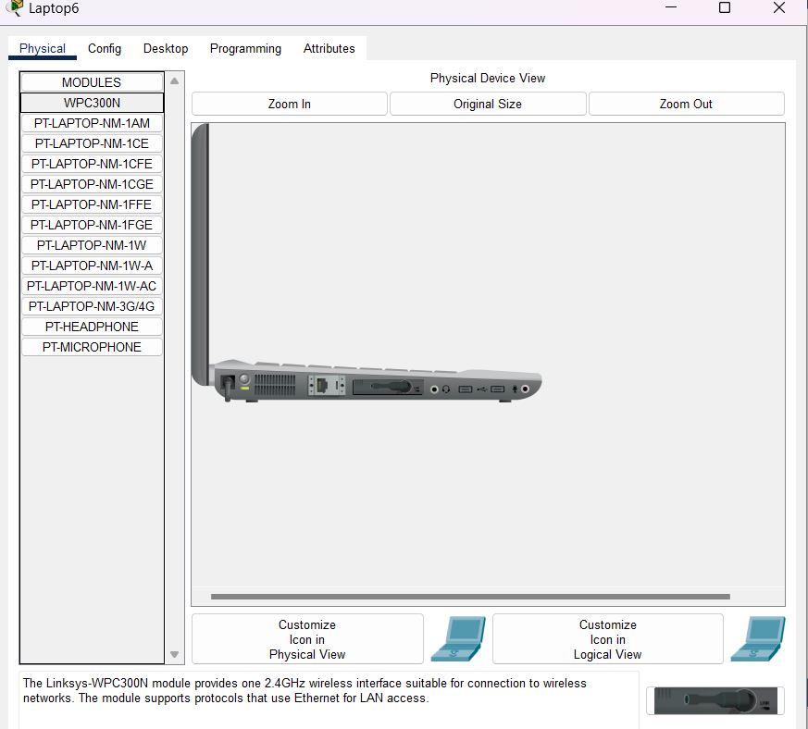

Change the password in GUI:
A login prompt appears. Provide the username (admin) and password (admin) to be allowed into
the GUI of the router.You can always change these settings later.
Click on the Administration tab and set a new password for administrative access. Scroll down and Save settings. You will be prompted for a username and the new password you just set. Type them and click OK. Wait a bit. A new screen appears confirming settings are successful. You can click on continue to continue with configurations.

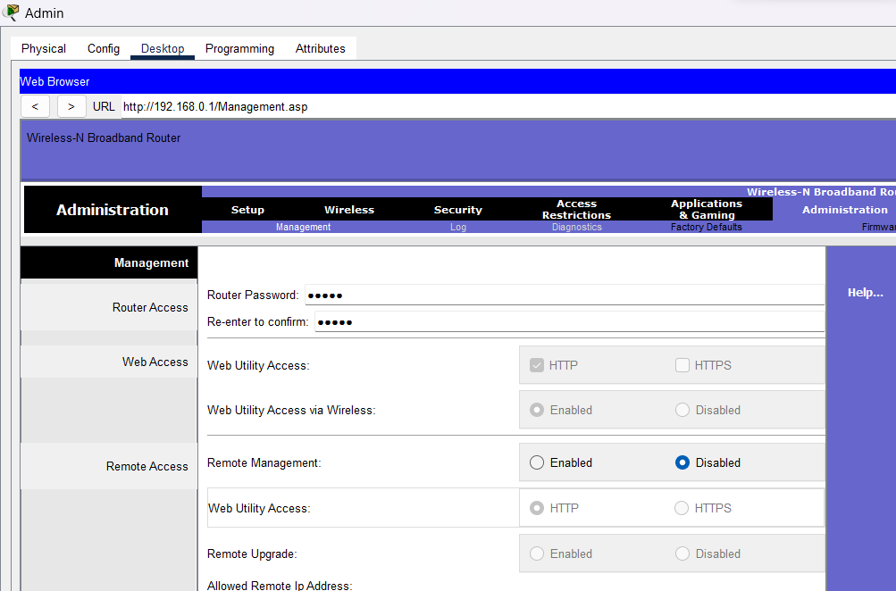

After they change the password and save its :
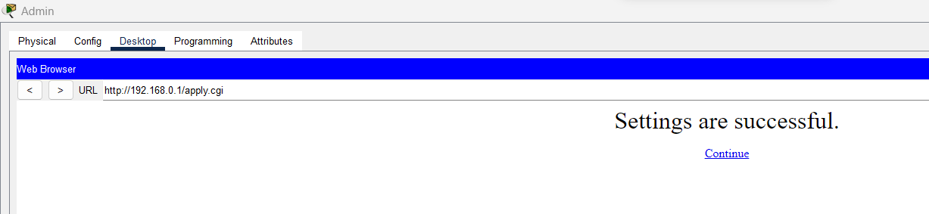

Pool create go to setup:

Network setup : Wireless Router Administration
We’ll begin with Administration in the GUI. Here we’ll simply change the router’s username and
password.
On the browser of Admin PC, type the IP address of the LAN interface of the wireless
router(192.168.0.1, by default). Hit Go to access the GUI of the router. Provide the
default username(admin) and password(admin). Click OK. You’re now on the GUI of the router. See it on the figure below.

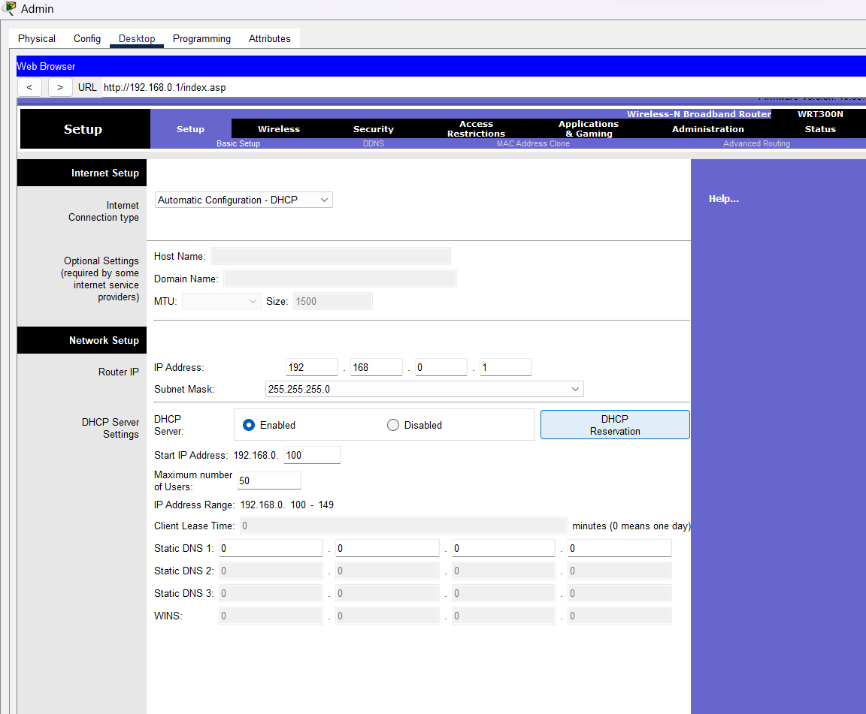

The laptop DHCP network :
Laptop 6:

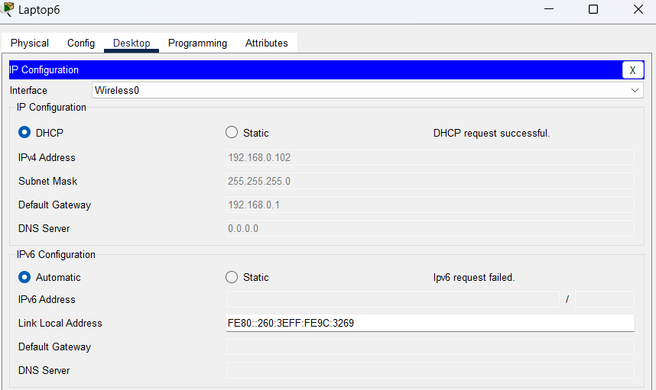

Laptop 4:

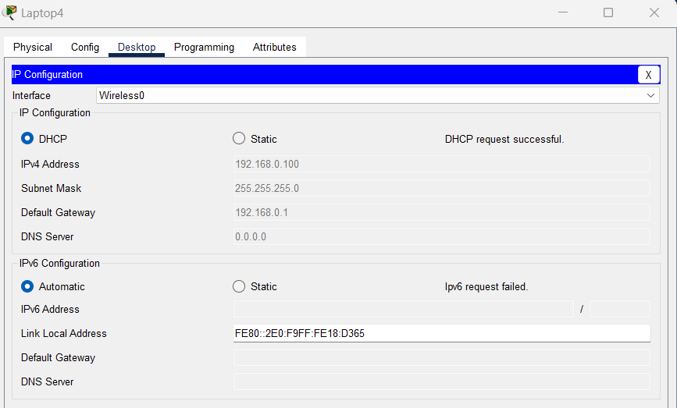

Check the network they are work:
The network are working
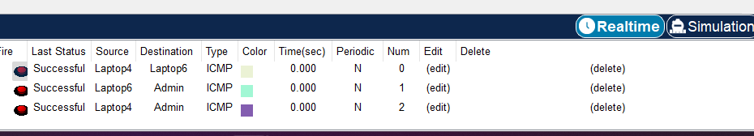

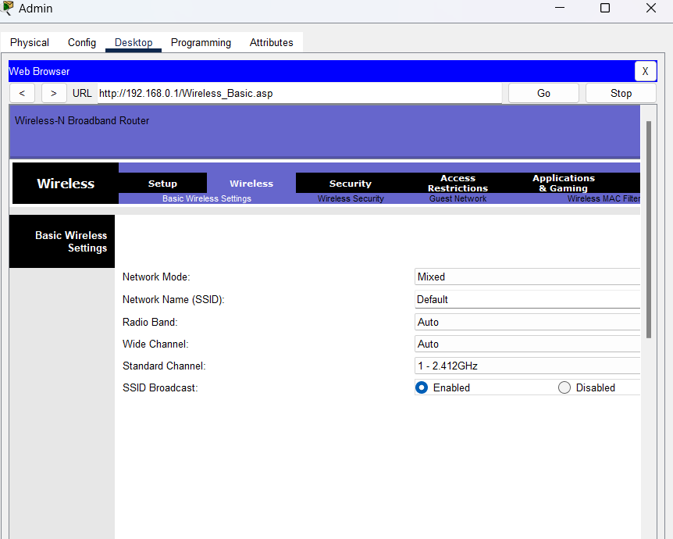

Give

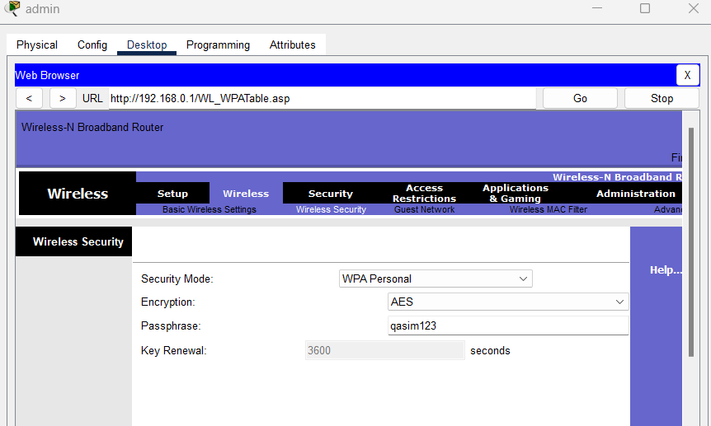

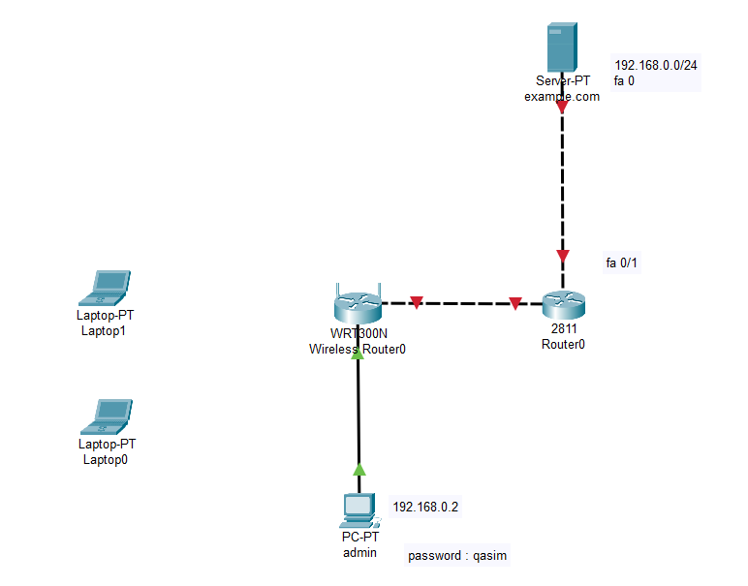

A new window appears that shows the now secured wireless network.
Click connect. You can now see the name of the wireless network( myWIFI , in my
case) and its signal strength. Site features listed include WPA1
PSK security feature.
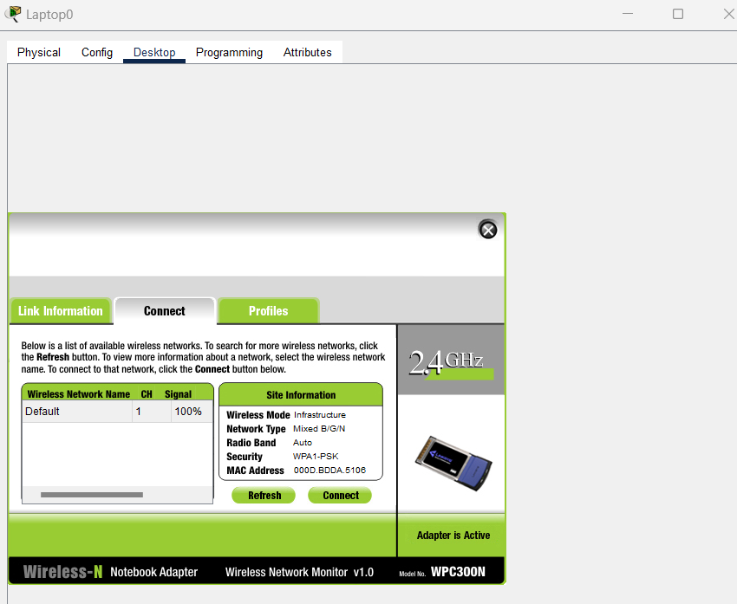

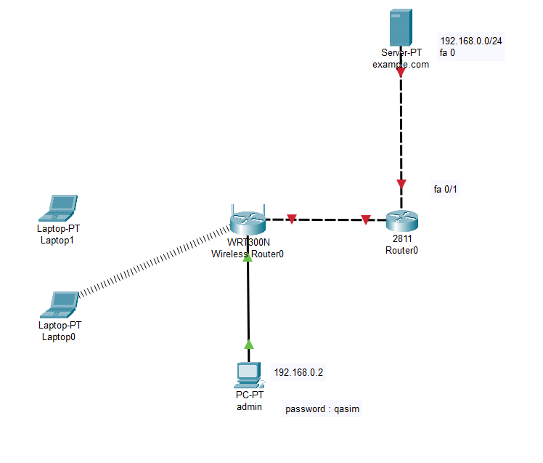

Now, you can change the wireless security mode to any other from the available
options. You may choose WEP security feature for our wireless network, for
example. For WEP, provide a 40-bit (10 hexadecimal digits e.g. A123B456C789)
or 64 -bit key(16 hex characters). WEP and WPA configurations look almost alike.

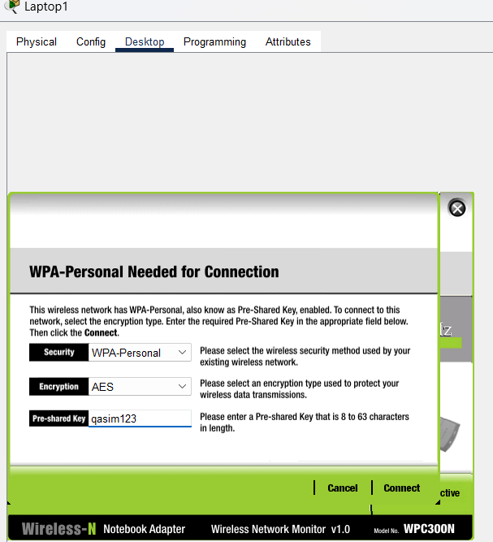

The laptop connects again in wire router

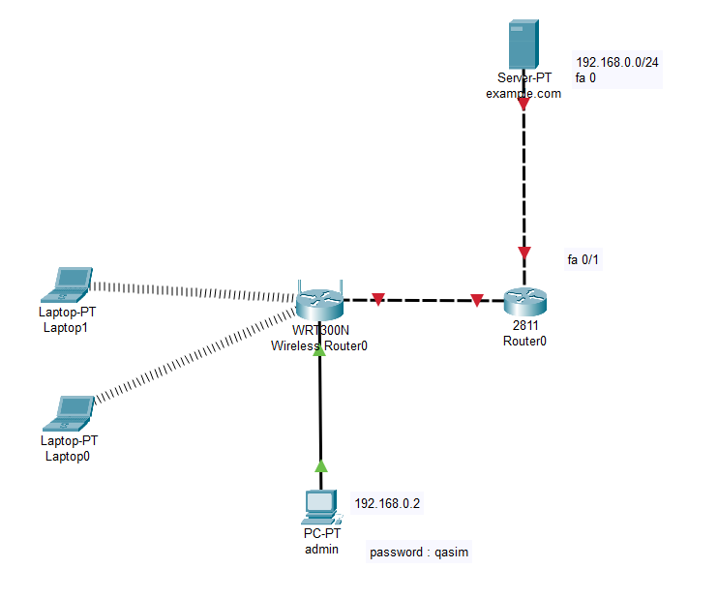

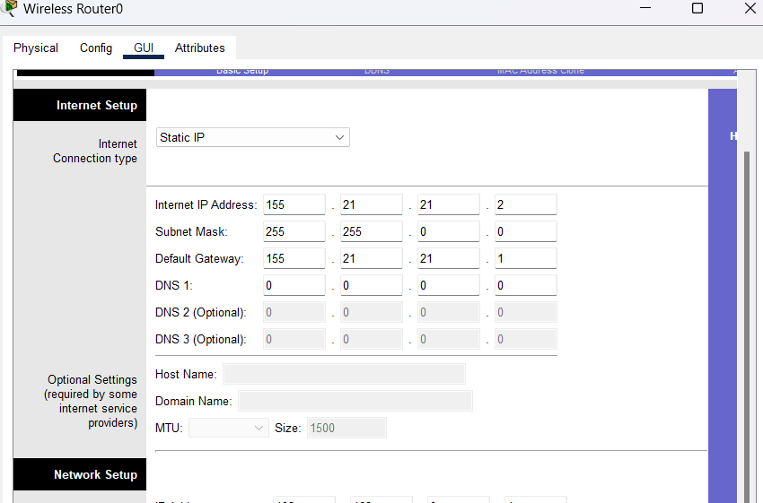

ISP :
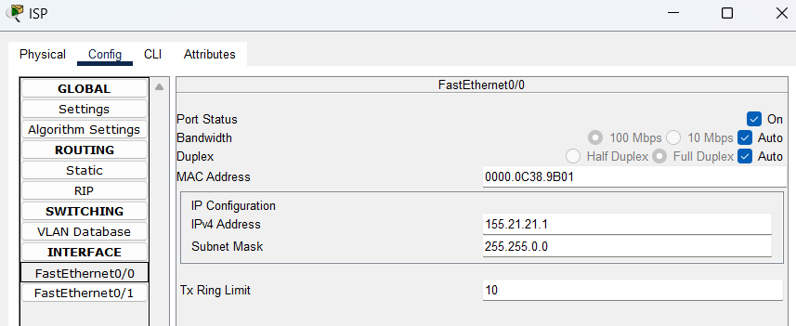

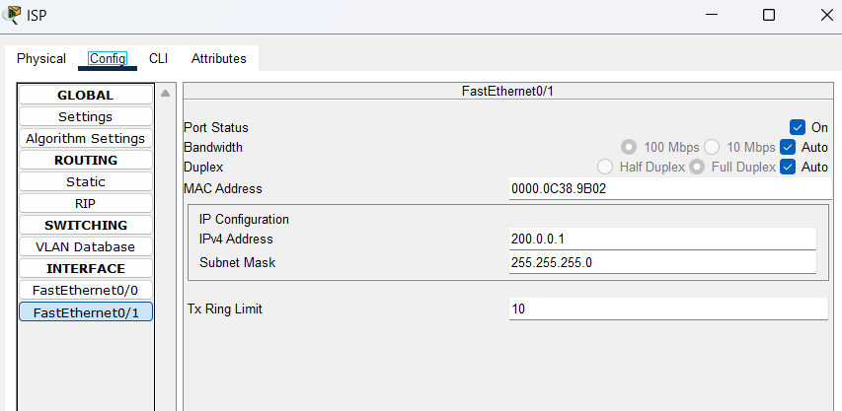

Isp CLI mode run the command: ISP_ROUTER(config)#ip route 192.168.0.0 255.255.255.0 155.21.21.2
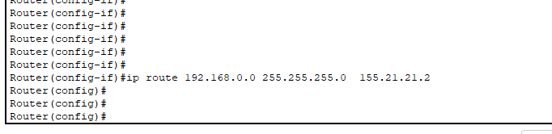

The is done and connect :
Now make the internet interface a DHCP client by enabling DHCP on it.

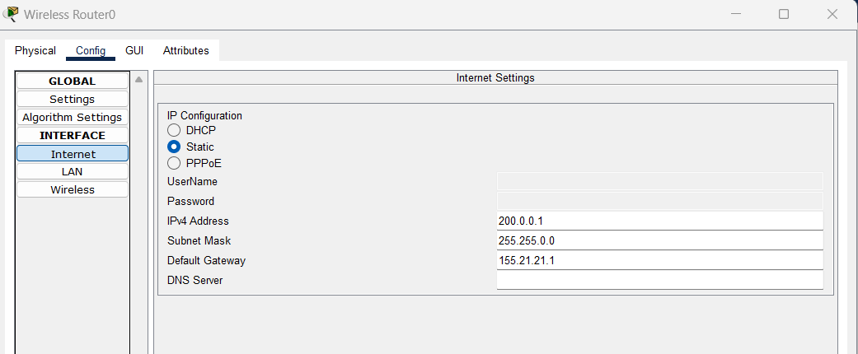

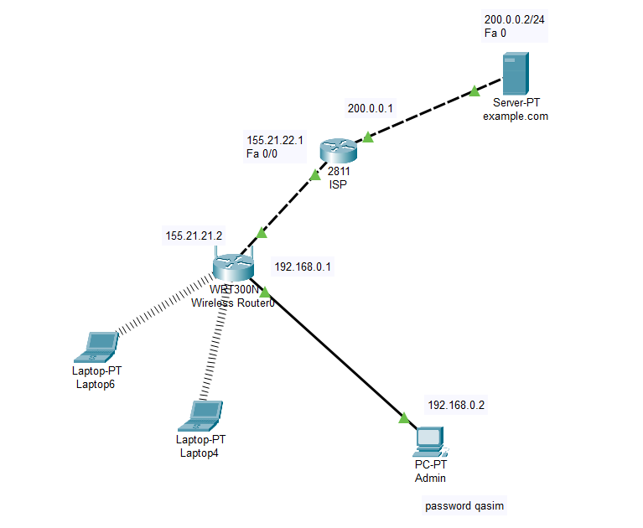

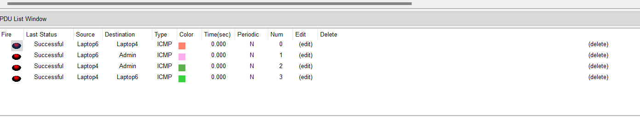

The out in laptop 0 is :

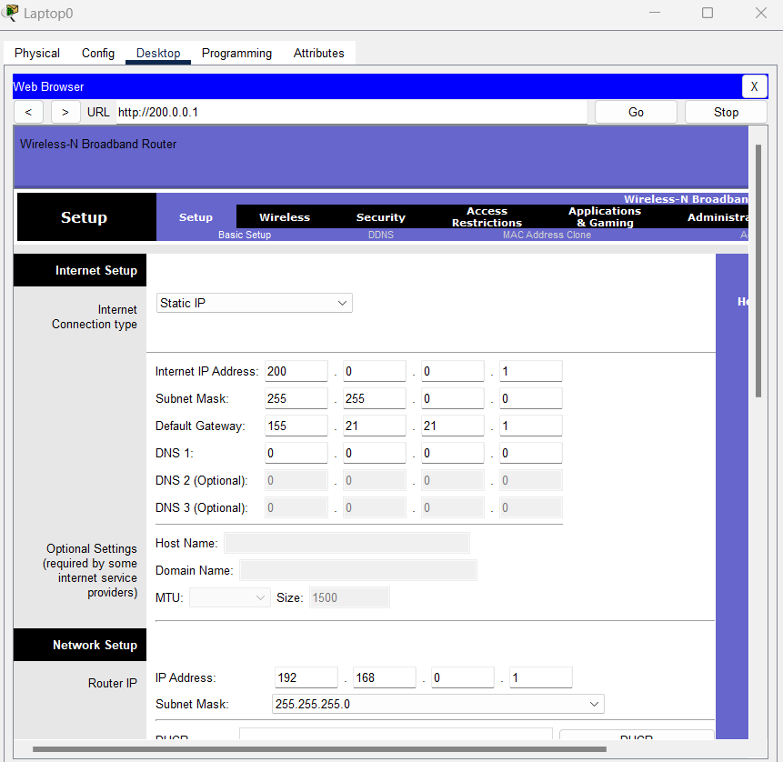

For example, you can ping the server from Laptop1. Ping should succeed.
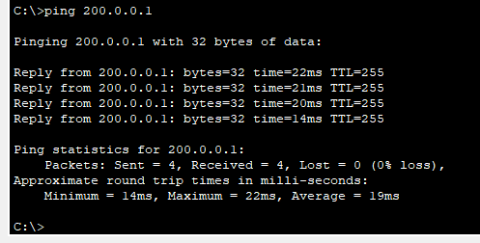

The laptop 1 :

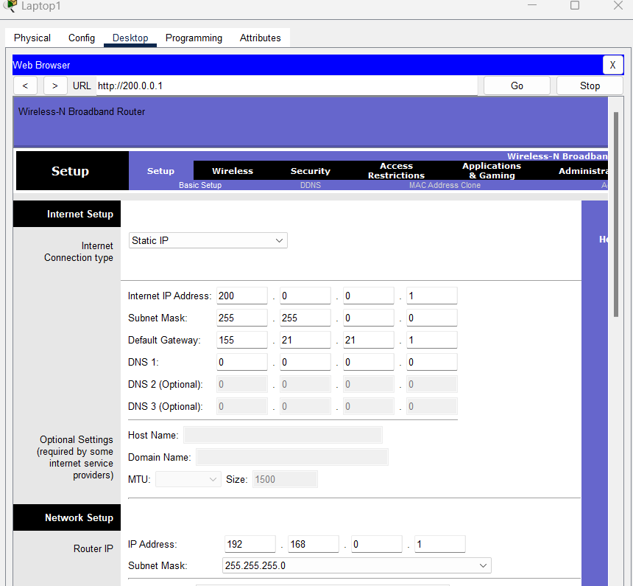

Ping the laptop 1 check :
For example, you can ping the server from Laptop1. Ping should succeed.
