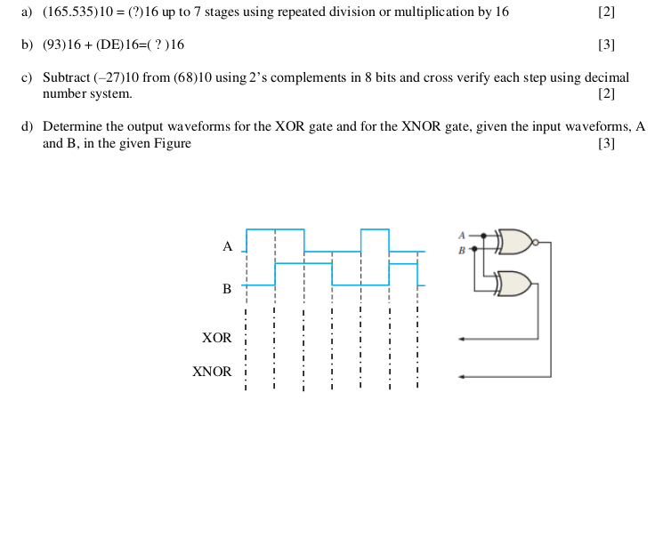
Q1:

Q2: Prove that NAND AND NOR are commutative but not associative using individual truth tables:

Q3:
Simplify the following expression using Boolean algebra and draw circuit before and after simplification.
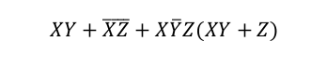

Q4:
Convert the following Boolean expression into:
1. standard POS expression
2. a minimum POS expression,
3. a standard SOP expression, and
4. a minimum SOP



Q5:

Use a Karnaugh map to minimize the following expression
f (A, B, C, D) =∑m (0, 1, 2, 3, 4, 7, 8, 9) + ∑d (10, 11, 12, 13, 14, 15)

