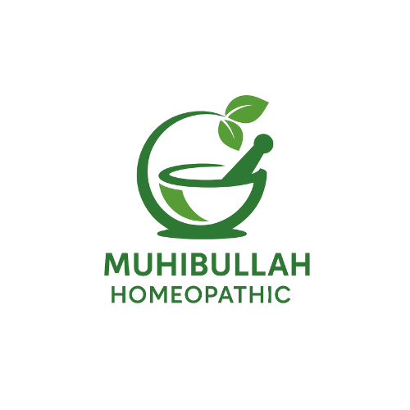

Huhibullah Homeopathic | Near National Bank, Gurra market 2nd floor Thall

Digital markeitng for the sotre of homeopathic

Muhammad Qasim

**2025**

# 1. Why Use Digital Marketing to Grow Business in Thall

**Traditional Marketing in Thall**

* **Posters on Street Walls**  
  Local shops plaster printed posters on walls and kiosks to catch foot traffic.
* **Flyers and Handouts**  
  Door‑to‑door leaflets and flyers introduce promotions directly to homes and shops.
* **FM Radio Advertising**  
  Until recently, unreliable internet meant most residents tuned into local FM stations for news and ads.
* **Local Sports Sponsorships**  
  Sponsoring tournaments like the DPL connects brands with the community through popular events.

**New Era of Marketing Begins**

With reliable internet now reaching areas around Thall, smartphones and social media have overtaken radio as the primary media channel. Many locals have migrated from FM listening to mobile apps, creating a huge opportunity to attract customers or patients online. Social media usage is widespread—often habitual—so businesses that adopt digital strategies can precisely target and engage audiences in real time, track campaign performance, and extend their traditional reach without losing the local trust they’ve earned.

**2. What’s My Motive to Use Digital Marketing for You**

As a passionate Computer Science student, I’m driven by the opportunity to blend my technical expertise with creative strategy to help build and elevate brands online. I’ve studied every stage of brand creation—from defining target audiences to crafting a memorable brand voice—and I’m eager to put that knowledge to work for your business. Digital marketing allows me to design data‑driven campaigns, optimize user experiences, and leverage tools like SEO, social‑media algorithms, and analytics platforms to position your homeopathic shop at the forefront of customers’ minds. In doing so, I both sharpen my own skills and help you stand out in an increasingly competitive digital landscape.

**3. Why I Chose You as My First Client**

Although I’m offering my services for free, I specifically chose your shop because you already appreciate the power of traditional marketing—word‑of‑mouth, local flyers, and community trust—and understand that modern strategies must build on that solid foundation. By partnering with you, I can tailor digital efforts to complement the credibility you’ve earned, ensuring our campaigns resonate with both loyal patrons and new prospects. Together, we’ll bridge the gap between your proven, time‑tested methods and cutting‑edge digital tactics, growing your reach without losing the authenticity that makes your brand uniquely trusted in the community.