^{Restaurant Website}


Submitted By:
- Muhammad Husnain Raza Qadri (2025-CS-465)
- Husnain Ali (2025-CS-453)
- Umar Farooq (2025-CS-437)
Submitted To:
Sir Moazam Ali
Dated: 11/29/2025

Department of Computer Science
University of Engineering and Technology, Lahore.

I

ntroduction:
We have built a website of our culture themed restaurant “Haveli Heritage”, located at the center of old city Lahore.

Objectives:
The main objective of this website is far greater than its scope. In today’s modern era, physical site and ambiance are not only the requirements to run a restaurant. The restaurant should also have a social media appearance including:
- Website
- Social media appearance (Instagram, Facebook etc.)
- Media marketing
So, the website is the basic impression on our costumers who are chasing heritage conservation in this modern society, with a little ‘desi touch’. It is a way to present our sophistication and superiority in the food cum heritage sector to the audience.

Tools Used:
The tools used to create our website is following:
- Html
- CSS
- SQL
- Canva

Website Pages Explanation:

1. Homepage: "A Culinary Journey"
The homepage serves as the primary gateway for customers, designed with a sophisticated aesthetic that balances tradition with modern luxury.
• Hero Section: The top of the page features a high-resolution background image of the restaurant's interior, creating an immediate sense of atmosphere. The primary heading, "Experience the Taste of Royalty," establishes the brand’s value proposition of premium dining. A prominent "Explore the Menu" call-to-action button is placed centrally to drive user engagement.
• Brand Narrative: Under the heading "A Culinary Journey," the site provides a brief introduction to the restaurant’s philosophy. It emphasizes heritage, traditional recipes passed down through generations, and the use of authentic cooking techniques like slow-cooking and hand-crafted breads.
• Chef’s Signature Specials: This section uses a clean, three-column layout to showcase the restaurant’s star dishes. Each entry—Karachi Beef Nihari, Heritage BBQ Platter, and Lahori Tawa Fish—includes a high-quality visual and a descriptive blurb detailing the specific spices and ingredients, such as bone marrow and crushed pomegranate seeds, to entice potential diners.

2. Booking Page: "Book a Table"
The Reservation page is designed for high functionality and a seamless user experience (UX), ensuring that the process of securing a table is effortless for the guest.
• Header Design: The page utilizes a bold red banner with the title "Book a Table," maintaining visual consistency with the restaurant’s branding and color palette.
• Reservation Form: The form is centralized and minimalist to reduce "form fatigue." It captures essential data points required for service management:
• Contact Details: Fields for Name and Email address.
• Scheduling: A dedicated date-picker for selecting the visit date.
• Party Size: A dropdown menu to specify the number of guests (e.g., 1-2, 3-4).
• Special Requests: A "Message" box allows guests to communicate dietary restrictions or special occasions (like birthdays or anniversaries).
• Navigation: The header remains consistent across the site, providing quick links to Home, Services, About, and Contact Us, ensuring the user is never more than one click away from other important information.

3. Visual Identity and Design Language
• Color Palette: The website employs a classic combination of Maroon, Cream, and Charcoal, which evokes a sense of warmth, appetite, and high-end hospitality.
• Typography: Elegant serif fonts are used for headings to reinforce the "Heritage" aspect of the brand, while clean sans-serif fonts are used for body text to ensure readability on all devices.
• Interface: The layout is responsive and organized into clear logical blocks, making it easy for users to find the menu or the booking form quickly.

Data Base Tables:

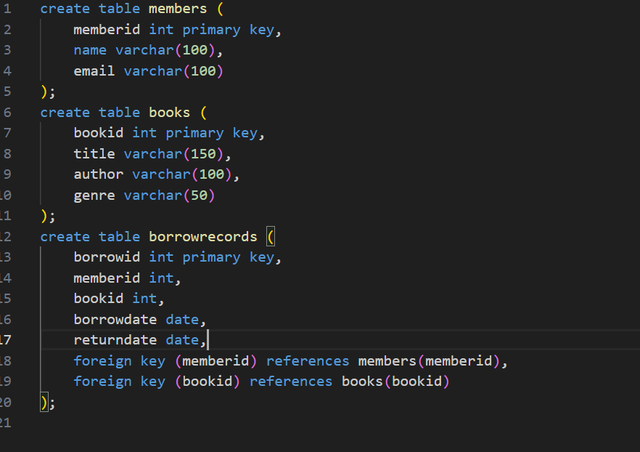

SQL Queries:
The following SQL queries are used:
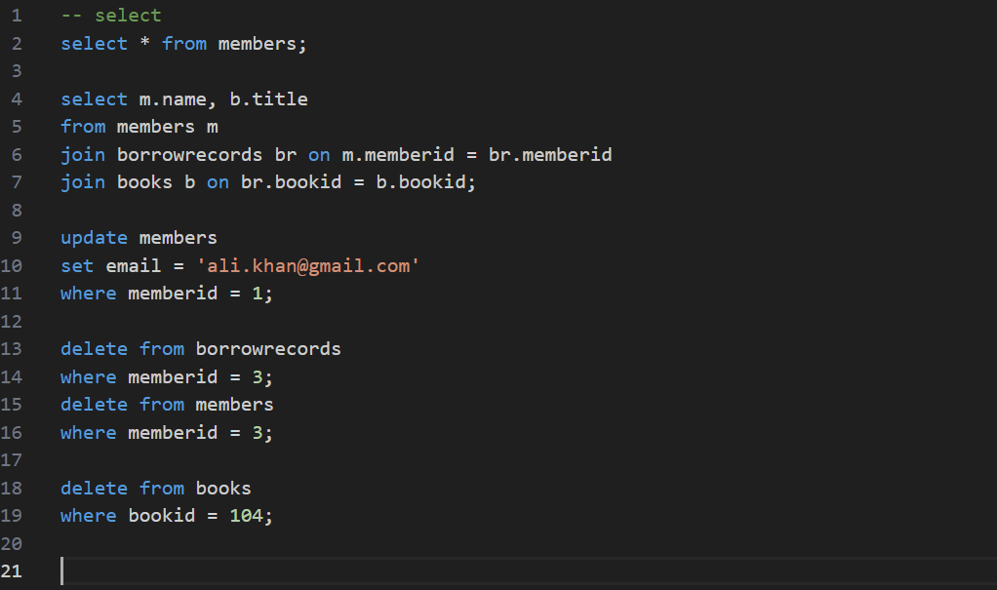

Canva Designs:

1. Logo Design:
• Main Element: Vintage Frame
• Graphic Accents: Filigree Flourish
• Primary Font: Serif Typography
• Secondary Font: Sans-Serif Subheading
• Color Tool: Hex Maroon
• Background Tool: Shape Fill

2. Website Banner:
• Visual Base: Stock Photography
• Logo Placement: Image Overlay
• Text Tool: Heading Style
• Call-to-Action: Button Shape
• Image Filter: Transparency Overlay
• Arrangement: Center Alignment

3. Social Media Post:
• Image Clipping: Circle Frames
• Discount Badge: Graphic Shape
• Border Tool: Stroke Weight
• Icon Library: Contact Symbols
• Layout Tool: Layer Positioning
• Text Formatting: Bold Emphasis

GitHub Link:

Conclusion:
Celebrate the essence of fine dining where history meets hospitality. Haveli Heritage is your destination for premium flavors and an unforgettable atmosphere. Experience royalty, one dish at a time.

