**Bibi-Brands (Testing Report)**

* 1st Test Section demonstrated in the photo

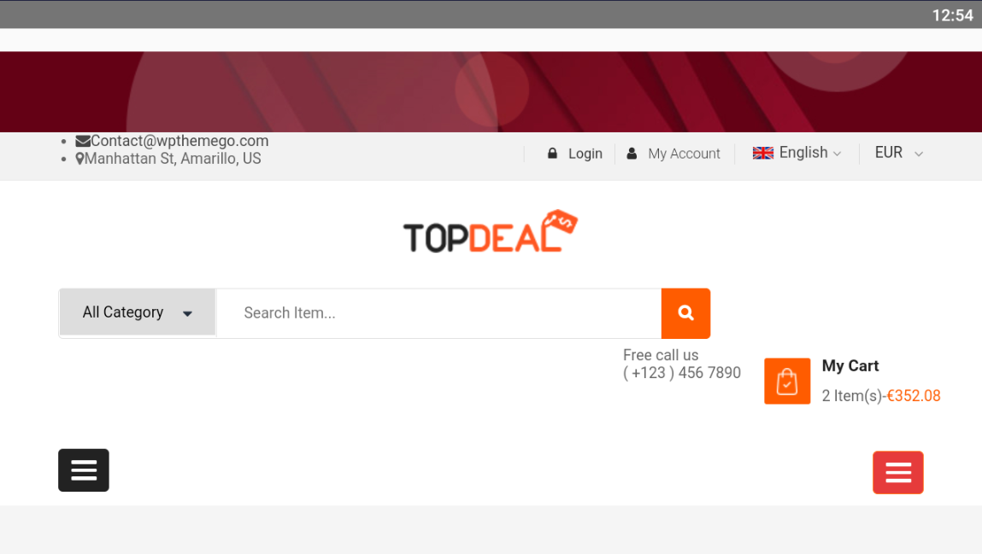

1. There is no register button on this application
2. My Account button should also show user information/Show cart/User login details/register buttons
3. Changing Language from English to Arabic doesn’t change the language of the application instead just takes the user to some other page
4. Changing Currency works fine
5. Why there are 2 Dashboard buttons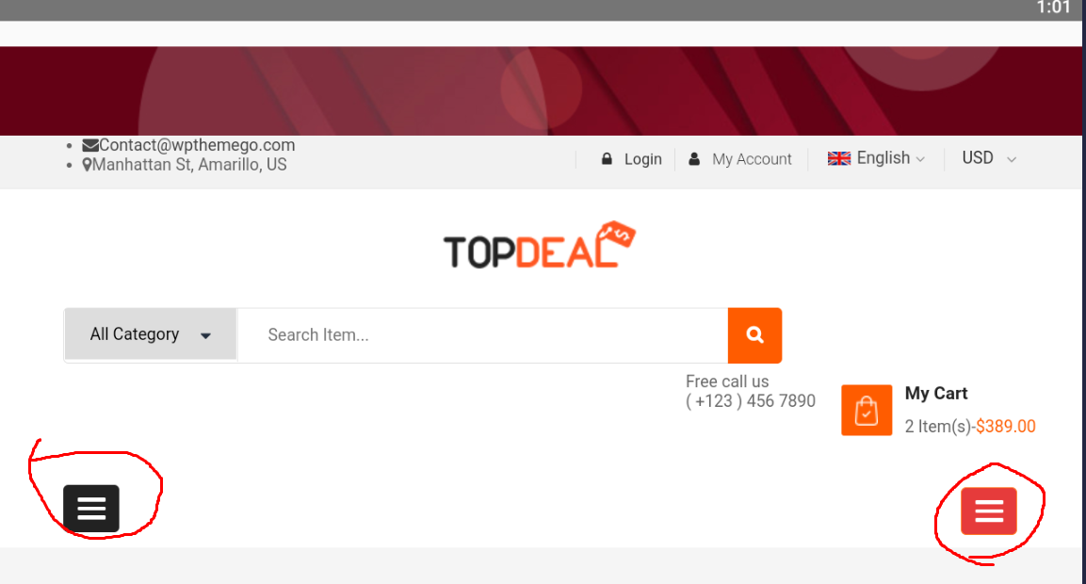
6. Filter Button Doesn’t apply filter to the products
7. Pressing the email on the top left corner doesn’t take me to the Gmail or mail application

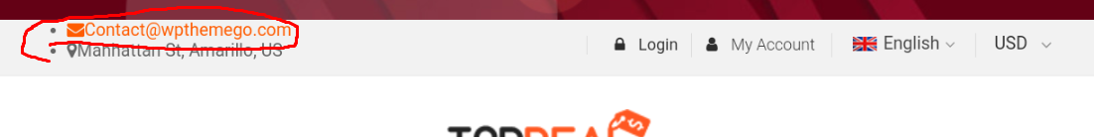

1. Why Create an account button show login form on the top?

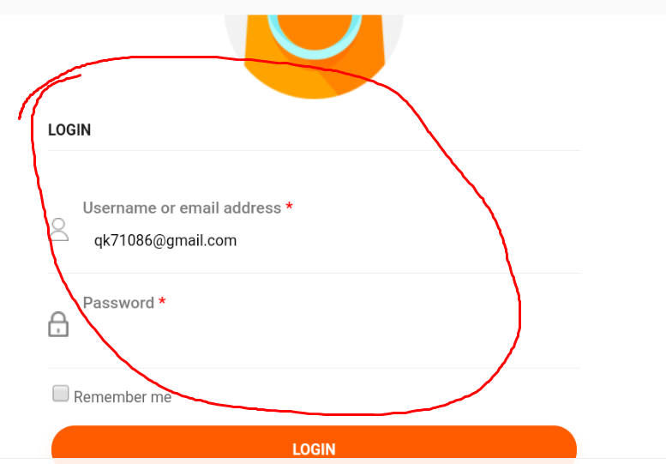

1. Create an Account form works fine and creates an account for me
2. Log out button works fine
3. Log in button also works fine
4. None of the buttons works except for the log out button when logged in

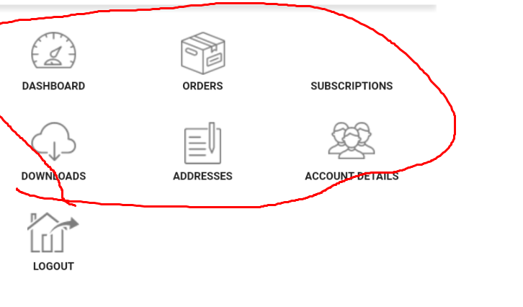

1. The below marked buttons work fine

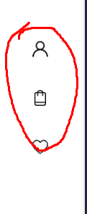

1. The above marked buttons only appear on the My Account Section and nowhere else
2. More Button doesn’t work

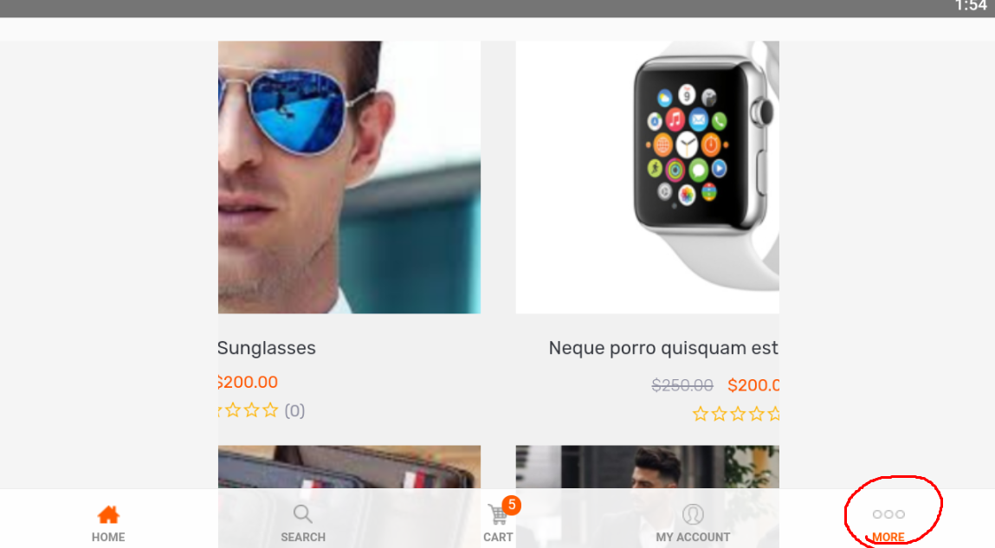

1. When I go to view a product and add it into a cart below different products are shown but when I try to view them it gives me https 404

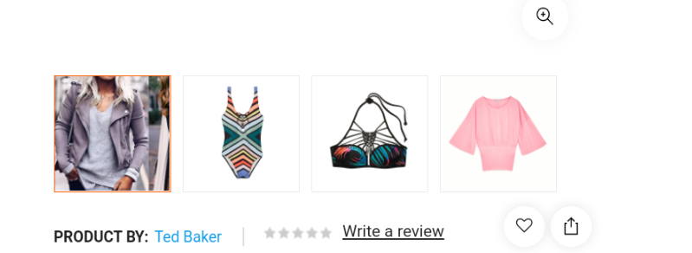

1. When I open cart and press proceed to check out it again gives me an error 404
2. Product images are too big, size cannot be reduced?