**SBEO: Smart Building Evacuation Ontology**

**Introduction:**

Situation awareness is considered as one of the essential concepts in Ambient Intelligence paradigm. Even though the increasing number of smart gadgets and connectivity of users to the internet, open many ways to design smart systems for their ease and betterment. At the same time, the involvement of situation awareness in the safety of human beings and their property, such as health care, aviation, emergency response, military command and control, has made it important, even crucial.

We know that the outdoor navigation systems are different as compare to indoor navigation system by the fact that the outdoor navigation is supposedly based on GPS devices. The objective is either the shortest distance or minimum time or both. On the contrary, in an indoor navigation system, when we introduce the concept of a feasible or suitable path, there come many selection points on which we declare any route best for someone.

Navigation in indoor environments is one of the domains that have much more to be explored yet. Because there are many technologies available in the market for indoor localization. However, it becomes complicated and challenging to handle in real-time when various objectives are added along with localization, for example, the recommendation of routes to users in indoor environments based on their abilities and preferences, during typical or emergency scenarios.

Semantic web technology is a key enabler in this type of applications by the fact that it provides a domain-specific knowledge to represent the metadata. Besides, we use ontologies to describe concepts and relationships between entities. Similarly, in literature, different semantic-based situation-aware indoor navigation systems are proposed. Nevertheless, these are either very specific or have limitations to their usage.

In this document, we explain a vocabulary for situation-aware route recommendation system for smart buildings. More specifically, the proposed ontology describes the concepts required for assigning routes to users or a group of users during normal and emergency conditions.

In the following sections, we highlight some related work in the area of knowledge-based indoor navigation systems. Later, we explain the motivation of proposing this vocabulary in detail as well as some basic competency questions that must be addressed to understand the scope of the proposed vocabulary. In the end, we describe the ontology with the help of a use case.

**Related Work:**

**Emergency management and evacuation**

Onorati et al. (2014), have proposed an evacuation system using an extending version of SEMA4A (Simple Emergency Alerts 4 [for] All) ontology, to describe the concepts for an emergency scenario, accessibility guidelines and related communication technologies. The proposed system provides personalized routes to users based on their physical abilities, familiarity with the environment, preferences, current location, available media for notification, and characteristics of the surrounding. The system is based on a mobile application software named iNERES. The application gets the location of a user and calculates a suitable route concerning one's familiarity with the building.

There are some limitations and shortcomings in this work. These are as follow. The first issue is that the proposed system and the ontology in the system are mainly focused on the notification mediums and guidelines for its users. There are no situation awareness concepts in it. The second issue is that the user has to find and explore the availability of route oneself. In case, if any space is unavailable or inaccessible, the user has to report the operators so that a new route may be assigned to him/her. This approach is risky, rather unsafe for users. Because it is possible that the hazard such as fire, may exist at the already provided route. In this regard, it is necessary that the tracking of provided routes must be checked before-hand as well as on a real-time basis. The third issue we have noticed is that the system is only tested with one type of persons, i.e., unfamiliar with the building. In this regard, scenarios with different kinds of people such as persons with impairments or persons having families or friends may be explored as the criteria for shortlisting the route for them will be different.

Boje and Li (2018), have developed a knowledge-based crowd simulation framework named Ontology Crowd Simulation (ONTOCS). They have proposed a web interface for their simulation, in which data is loaded n the form of an ontology. There are two different types of data; Building (BIM) and Crowd Simulation (CSIM). In BIM, concepts related to building, such as components, geometry and other relevant semantics, are described. In CSIM, concepts related to persons, such as preferences, exit choices, and speed, are described. Later on, time-based static rules are applied over the data such as total time for evacuation or percentage of persons evacuated in a given time.

The first issue with this proposed framework is that it does not work in a real-time manner. Due to this reason, it does not put up concepts related to situation awareness, although the concepts given in this study can be used to develop dynamic building evacuation systems.

**Spatial models and user models for indoor navigation**

Brückner et al. (2004), have proposed an ontology-based data structure to develop a routeing graph from a spatial model for robots and users. The proposed data structure is quite general in nature and can be used for both outdoor as well as indoor navigation systems.

Anagnostopoulos et al. 2005, have proposed an ontological framework for indoor routing based on user-profiles named as OntoNav. More specifically, they presented a user-centric indoor navigation system that finds routes for people depending on their physical and perception capabilities, and their preferences.

The proposed system, OntoNav, is comprised of three building blocks called services, known as Navigation Service (NAV), Geometric Path Computation Service (GEO), and Semantic Path Selection Service (SEM). NAV is an interface for users that takes inputs and show outputs to the users and connected to other services. GEO converts the geometric information into a graph and creates paths for a specific map of the building. SEM chooses appropriate paths by matching them with the preferences and capabilities of users.

They have reused Indoor Navigation Ontology (INO) to represent the concepts of building and users. Furthermore, they defined some rules for defining the criteria for shortlisting the paths for each person, such as age, disabilities, etc. For computing the graphs from the geometry of the building, they have proposed a clustering algorithm that creates one simple node-edge graph for a multi-storey building.

Their proposed system works in the following fashion. First, it determines the starting and ending points as user input. Second, it calculates all possible walkable paths from the starting point to the ending point. Third, it filters out the best traversable path, depending on the preferences mentioned by the user. Fourth, the selection of all the point of interests in the chosen path.

The limitations of OntoNav system us, it computes the paths all over again that is a computational overhead. So, the authors have proposed that all possible paths can be computed and cached and being checked their availability and accessibility limitations in real-time. They have also proposed to mark the most usable paths as high-priority so that those paths can be chosen directly for each type of person rather than computing and calculating again and again.

They have not discussed the criteria for a group of family or friend who prefers to stay together. Also, they have not mentioned either their system work in real-time or computes the routes in real-time. In addition, there is a lack of checking the accommodation capacity and current occupancy of spaces in their model. Due to this reason, in case of any emergency, issues like congestion can occur.

Tsetsos et al. (2005), have also proposed a human-centric ontology-based indoor navigation system. Most of the ideas have been implemented and discussed in their other research articles such as User Ontology, Indoor Ontology, reasoning, pathfinding using existing algorithms, and shortlisting of suitable paths. Nevertheless, they have discussed one different idea that is not available in them, i.e., User Navigation Support using Navigation Aiding Module. The concept of this module is to keep checking some specific users either they are following their assigned paths or not. In case, a user deviates from one's provided path, the system updates one's path from the new location and redirects that user to one's destination with respect to one's preferences and capabilities. Although they have discussed this idea, they have not implemented it in their research.

Kikiras et al. (2006), have presented a user model for navigation in indoor environments using ontologies. Their model is based on different wayfinding theories related to cognitive science, psychology, sensor abilities and physical characteristics of human beings. Based on all these concepts, they have developed User Navigation Ontology (UNO) using Web Ontology having major concepts such as Ability, Demographics, Quality and User.

Dudas et al. (2009), have proposed an ontology-based indoor routing system based on their preferences and needs such as familiarity, disabilities, etc. Their work is motivated by mentioning the difference that the outdoor navigations systems are based on either shortest distance or fastest travel time whereas the criteria for indoor navigation system is different by the fact that it may include routes with respect to the various types of its users. Also, according to the authors, there is no work done so far that deals with the American Disability Act (ADA) standards.

The authors have proposed the concepts in their ontology from ADA standards. Later, they have proposed some algorithms to find routes and explained it using some use-cases. Also, the main focus of this work is to focus on finding the routes for each person, instead of navigating people on a real-time basis. Besides, they have assumed that the people are equipped with phones that are connected to the serve or internet from where they can get the information from their assigned path.

In terms of Ontology, they have covered almost all basic concepts for buildings such as horizontal paths and vertical paths to represent the connection of spaces and floors with each other. Furthermore, they have mentioned a new concept of Point of Interest (POI), that addresses a particular stop or preference of a person that is taken into account while finding a route for a person. Besides these ontology concepts, the authors explicitly mentioned that the intention of their work is not defining a vocabulary, but to introduce ADA standards and integrate it the concepts of buildings such that the routes can be calculated based on the preferences and needs of each person.

In terms of routes, they have divided into two types; comfortable and feasible, which are assigned by the filtration process of each route concerning the requirements of each person.

The issues which authors have not taken into account in this research are, assignment of routes (either comfortable of feasible) w.r.t demand and capacity, the real-time information about each route in terms its situation, the issue of congestion. Also, they have not proposed an algorithm that can convert the graph from CAD/BIM diagram so that it can later be used to calculate the routes.

Tsetsos et al. (2006), have proposed a user-centric knowledge-based indoor navigation system that recommends routes to users with respect to their physical and perceptual capabilities. They have divided the whole system into different parts, for example, ontologies for both users and building space to represent the knowledge, reasoning technologies to infer the user limitations for particular indoor path elements, and finding a suitable route for a user using existing path-searching algorithms.

For that purpose, they have modelled Indoor Navigation Ontology (INO) to represent the building elements and User Navigation Ontology (UNO) to the user and his/her capabilities and limitations. In INO, most of the concepts are described related to a building such as multiple floors, elevators, point of interests, corridors, exits, etc. These concepts are sufficient to design a route graph for finding a path between two points. In UNO, concepts related to users are described. They have reused and formalized the concepts mentioned in Kikiras et al. (2006) and General User Model Ontology (GUMO). These concepts are demographics, cognitive characteristics, sensor abilities, motor abilities, navigational and interface preferences.

The workflow of their system is as follow. Firstly, the system is initiated by a user in which the ontologies and rules engines are loaded. Secondly, the profile of each user is instantiated in the system, and all the shortest routes are calculated and given a score with respect to the profile of that specific user. Lastly, the most appropriate path is assigned to a user.

They have also implemented and evaluated their system based on a time metric. According to the authors, most of the time is taken by reasoner and path searching algorithms.

The issue with their work is, even though they have mentioned it explicitly that their ontologies should have been standardized, but these are still not available on the internet. So, if we want to extend or reuse their work or concepts, we have to develop everything from scratch. In addition, there are two major issues with their work. First, the proposed system doesn't manage to keep on checking if the assigned route is still available until the user reached one's destinations. Second, the system cannot check if the user is following the provided route or not. As a result, there might be chances of congestion at bottlenecks in a case when the users do not follow their provided routes no matter the routes are assigned based on their maximum assignment or usage limit.

Similarly, Kolomvatsos et al. (2009), have explained an infrastructure for indoor navigation for smart-spaces using meta-data. They have used a spatial and geometrical representation of the building for their infrastructure, and they have also used graph and knowledge-based algorithms for their system.

They have explained the motivation of proposing a system that navigates people in indoor environments based on user's preferences and characteristics. They have used an ontology for the concepts of spatial elements of the multi-storey building spaces and user's characteristics. They have used algorithms to generate the instance of the spatial elements of building spaces by dividing them into different layers.

They have also mentioned the several factors to describe the complexity of the problem because according to authors, the problem becomes NP-hard because of many restrictions, and they have used existing Dijkstra algorithms to find the paths for persons in the building. They have used a simple route instead of the shortest routes. The drawback of their proposed architecture using in real-time is an intensive computational process for generating multiple instances.

Kritsotakis et al. (2009), have proposed an ontology-based indoor navigation system named C-INGINE. Their proposed framework assigns a route to its users according to their characteristics and preferences. Also, the provided route is dynamic in nature in case the user deviates from one's assigned route.

They have reused existing ontologies to model the user and buildings concepts. In addition, they have proposed some new ontologies to track users and for context-awareness. They have also used two types of rules; static and dynamic. The static rules are context-free rules that are applied to the user generally, whereas dynamic rules are context-based and may vary with respect to the user's preferences.

They have also introduced a comprehensive ontology to describe the concepts for tracking users either they are following their provided route or not. This deviation is detected by the system automatically by matching the coordinates of the user with the coordinates of a provided path. In case of any deviation, the system re-plans a new path from the new momentary location of the user to the same destination. The users can also put a privacy check on their profile so that only those can see their profile who are allowed by them.

Although their proposed system has various functionalities for navigation and routing, the usage of this system is limited to specific applications. Moreover, the ontology concepts they have discussed in their system are not available online; therefore, it cannot be reused directly. Also, they have not explained how they have tested and evaluated their system in detail.

In Table 1, the summary of the work mentioned in this section is given. We have divided the table into different parts with respect to various topics of indoor navigation domain.

**Table 1 Summary of The Work Done in The Area of Indoor Routing and Navigation Using Ontologies**

|  |  |  |  |  |  |  |  |  |  |  |  |
| --- | --- | --- | --- | --- | --- | --- | --- | --- | --- | --- | --- |
|  |  | Ontology/Vocabulary | | | | Path Finding Algorithm | | Situation Awareness | | Real-time | |
| Sr. No. | Research Articles | Persons | Building | Routes | Emergency Management | Self-Proposed | Used Existing-ones | Person | Environment | Routes | Event-Detection |
| [1] | Brückner et al. 2004 | ✗ | ✓ | ✓ | ✗ | ✗ | ✗ | ✗ | ✗ | ✗ | ✗ |
| [2] | Tsetsos et al. 2005 | ✗ | ✓ | ✓ | ✗ | ✗ | ✓ | ✓ | ✗ | ✓ | ✗ |
| [3] | Anagnostopoulos et al. 2005 | ✓ | ✓ | ✓ | ✗ | ✓ | ✗ | ✗ | ✗ | ✗ | ✗ |
| [4] | Tsetsos et al. 2006 | ✓ | ✓ | ✓ | ✗ | ✗ | ✓ | ✗ | ✗ | ✓ | ✗ |
| [5] | Kikiras et al. 2009 | ✓ | ✗ | ✗ | ✗ | ✗ | ✓ | ✓ | ✗ | ✓ | ✗ |
| [6] | Dudas et al. 2009 | ✓ | ✗ | ✗ | ✗ | ✓ | ✗ | ✗ | ✗ | ✗ | ✗ |
| [7] | Kolomvatsos et al. 2009 | ✓ | ✓ | ✓ | ✗ | ✗ | ✓ | ✗ | ✗ | ✗ | ✗ |
| [8] | Kritsotakis et al. 2009 | ✓ | ­✓ | ✓ | ✗ | ✗ | ✓ | ✓ | ✗ | ✓ | ✗ |
| [9] | Karimi et al. 2010 | ✓ | ✓ | ✓ | ✗ | ✗ | ✓ | ✗ | ✗ | ✗ | ✗ |
| [10] | Boje and Li 2018 | ✓ | ✓ | ✗ | ✓ | ✗ | ✗ | ✗ | ✗ | ✗ | ✗ |
| [11] | Onorati et al. 2014 | ✓ | ✓ | ✓ | ✓ | ✗ | ✓ | ✗ | ✗ | ✗ | ✗ |

**Motivation of the Proposed Ontology:**

In the previous section, we have highlighted some knowledge-based indoor routing and navigation systems that provide routes to the user according to their physical abilities and preferences. These systems use ontologies to develop Spatial models to describe the geometrical information of the buildings, and User models to describe the information about people. Later, various rules and reasoning methods, aligned with the user’s characteristics, are applied to filter out the accessible paths for the user.

Nevertheless, there are some limitations in these existing systems. These are as follow.

1. Most of the systems work in a static manner. For example,
   1. there are no concepts described for dynamic situation awareness in terms of building and users. Although, Kritsotakis et al. 2009 have proposed some concepts of dynamic tracking of users in their system, the scope of their system is limited, i.e. when any user deviates from the provided path, the system only provides that user a new path with respect to one’s new position. It means it is only designed to be used during normal conditions. Due to this reason, in case of any abnormal condition, such as fire, the system can no longer find suitable routes for its users.
   2. Due to the absence of dynamic situation awareness, real-time information about routes, such as immediate occupancy, instant availability, etc., is also not taken into account.
2. The existing systems only calculate the routes for an individual person. It means there are no concepts of handling multiple persons of the same group together, e.g., a group of a family or friends, etc.

To this end, a complete package vocabulary for situation-aware route recommendation in which the concepts required for recommending the routes to users according to their abilities and preferences are described. Furthermore, the concepts related to dynamic situation awareness, such as detection of any hazard, evacuation action plan, movement of people, notifying people, are given. Following are the prime concepts that are covered in the proposed ontology.

1. Geometry of building
2. Devices and components of the building.
3. Route graph
4. Users’ characteristics and preferences
5. Situation awareness
   1. Building (hazard detection, the status of routes in terms of availability and occupancy)
   2. Users (tracking, management of groups, status in terms of fitness)

6. Emergency evacuation

**Competency Questions:**

To determine the scope of the proposed ontology, the following is a set of competency questions that should be addressed.

1. Spatial Information-related competency questions:
   1. Is it possible to mention spaces consists of multiple buildings and connected by roads or footpaths, such as shopping malls, universities, hospitals, etc.?
   2. Are the length and the width of the spaces, especially corridors, mentioned?
   3. Is it possible to mention the specific point of interests in an indoor environment?
   4. Is it possible to find the connected as well as adjacent spaces of any particular space?
2. Devices and components of the indoor environment-related competency questions:
   1. Is the information about the devices of fire incident protection available for users?
   2. Are temperature, smoke or location sensors possible to mention in any space specifically?
   3. How are the special-purpose handheld devices mentioned?
   4. Which properties can be measured by the sensors installed in the building?
3. Route graph-related competency questions:
   1. Is it possible to draw a route graph from the geometry of the building?
   2. Can routes be assigned based on the accommodating capacity of spaces included in them?
   3. How is the travel time from one place to another place is mentioned?
   4. How are the edges and nodes mentioned from the spatial information of an indoor environment?
4. Users’ characteristics and preferences-related questions:
   1. Can occupants of building choose their mode of notification?
   2. Is each person provided by an evacuation route concerning their abilities or preferences or both?
   3. Can people having family or friend ties be coupled as a group?
   4. Is it possible to create and store the profile of a person in which all personal characteristics and preferences are mentioned?
   5. Are people with impairments classified separately so that they can be treated concerning their specific impairments?
   6. Are the responsible and dependent members of a group represented separately?
5. Building situation awareness-related competency questions:
   1. Is any hazardous situation detected in an indoor environment?
   2. Is the information about each activity being done in an indoor environment possible to find?
   3. Building (hazard detection, the status of routes in terms of availability and occupancy)
   4. Are physical spaces become unavailable in case of any issue such as a hazardous situation or out of space?
   5. How is the starting or ending time of any event and activity is mentioned or calculated?
6. Users situation awareness-related competency questions:
   1. How are the occupants of the building localized in an indoor environment?
   2. Can it be possible to find the real-time status of each person?
   3. Is it possible to assign the same route to a group of people?
   4. Is each person assigned by a route (of any type) during normal condition?
   5. Is it possible to keep tracking a person or group of persons either they are following the provided route or not?
   6. Is it possible to check either a person is moving or not?
   7. Is it possible to check either a person is attached to one’s assigned group by following the instructions of one’s group leader?
   8. How is the fitness status of a person mentioned?
7. Emergency evacuation-related competency questions:
   1. Are the provided evacuation routes safe?
   2. Is it possible to have information about other hazardous situations during an emergency such as congestion, panic or stampeding?

**Description:**

In this section, we explain the proposed vocabulary using a scenario so that the given concepts and their usage can be understood easily. As we know that the reusing the existing concepts is promoted and appreciated in ontological engineering, therefore we have used various concepts from existing ontologies such as FOAF (<http://xmlns.com/foaf/spec/>), SEAS Building Ontology (<https://w3id.org/seas/BuildingOntology-1.0>), PROV Ontology (<http://www.w3.org/TR/prov-o/>). On the other hand, some ontologies are not available online, such as Indoor Navigation Ontology (INO)[5], User Navigation Ontology (UNO)[5], User Tracking Ontology(UTO)[8]. Consequently, we have borrowed those concepts with our namespace. Figure 1 shows the core concepts of SBEO ontology, which are divided into three major parts. These are User Model, Building Model, and Context Model. Table 2 shows the summary of the information models that we have reused, borrowed and proposed from scratch.

Table 2 Description of the Concepts Used for Smart Building Evacuation Ontology

|  |  |  |
| --- | --- | --- |
| **Information Model** | **Concepts** | **Description** |
| User Model | Demographics | It includes the concepts related to the personal information of a user such as name, age, information about family and friends, etc. Most of the concepts are borrowed from FOAF, User Navigation Ontology (UNO). The concepts related to family or friend details are defined from scratch. |
| Abilities | It includes the cognitive characteristics, sensor abilities, motor abilities of a user. Most of the concepts are borrowed from User Navigation Ontology (UNO). |
| Preferences | It includes the concepts that describe the navigational and notification preferences of a user. |
| Building Model | Geometry | It is used to describe the concepts related to the geometry of the building. Most of the concepts are borrowed from Indoor Navigation Ontology (INO) and SEAS Building Ontology. Also, there are some new concepts defined in this information model. |
| Components | It is used to describe the concepts related to the external components installed in the building, such as sensors, fire safety equipment, etc. |
| Route graph | These concepts are used to develop traversable node-edge graphs from the building geometry. Most of the concepts are borrowed from Indoor Navigation Ontology (INO). |
| Context Model | User tracking | These concepts are used to track users in indoor environments. Some concepts are borrowed from User Tracking Ontology. |
| Group management | This component is used to express the concepts required to manage the group of users. |
| Emergency management | This component is used to describe the concepts related to emergency management, such as detection of hazard, the situation in the building, emergency evacuation, stance taken by the users, etc. |
| Status | This component is used to describe the concepts related to the status of users and different components in the building such as sensors, routes availability, occupancy and availability of any space, etc. |
| Event and Activities | This component is used to describe the concepts related to events occurred and activities performed by the people of the building. For example, events can be any incidence, whereas an activity can be a visit or exiting of a building either during normal situations or emergencies. |

User Model:

In User Model, there are further three subparts that describe the demographics, physical abilities and preferences of a person. The demographics part includes the basic information about a person such as **foaf:age**, **foaf:firstName**, **foaf:LastName**, **foaf:gender**, **sbeo:hasID**. Besides, it has the information about a person whether (s)he **sbeo:hasMember** of any **sbeo:Family** class or has some friends or acquaintances using **sbeo:acquaintanceOf** property. The physical abilities of a person can also be mentioned using the concepts of **sbeo:ImpairedPerson** in which several types of impairment are given such as, **sbeo:PhysicalImpairedPerson**, **sbeo:SensoryImpairedPerson** or **sbeo:MentalImpairedPerson**. The specific type of impairment among these impairments are also described so that a particular action can be taken. The speed of a person is also proportional to the physical condition of a person. Therefore it is mentioned using **sbeo:hasSpeed** property. The personal preferences of a person can also be described or inferred using some concepts, e.g. **sbeo:Description**, **sbeo:Role**, and properties, e.g. **sbeo:navigationalPreference**, **sbeo:notificationPreference**, **sbeo:familiarWith**.

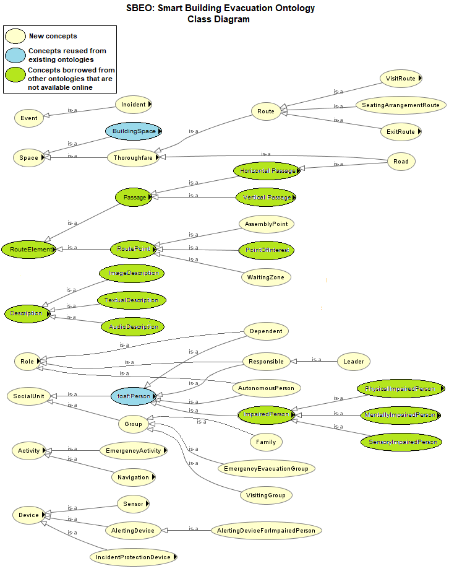Figure Core Concepts of Smart Building Evacuation Ontology (SBEO)

Building Model:

In Building Model, the concepts related to the geometry (or structure) of the building and its components are described. The geometry or structural elements are those elements of the buildings that serve the purpose of supporting enclosing or protecting the building structure. In contrast, the components are those elements which are installed later and perform additional functions.

In the geometrical model, **sbeo:Space** is used as a superclass that represents the physical space. The type of a building and the specific site of any building are described using **seas:Building** and **seas:SiteOfBuilding** respectively. The atomic parts of a building, such as **sbeo:Apartment**, **seas:Room**, **seas:Lobby**, **seas:Elevator**, **seas:Stairs**, **sbeo:Escalator**, **sbeo:MovingPavements**, **sbeo:DayCare**, **sbeo:KidsArea**, etc., are described in **seas:BuildingSpace**. These atomic elements use **sbeo:locatedIn** to mention where these are located in a specific building. **sbeo:partOf** property can be used differently, such as, to mention which building any building element or part belongs to and which building any building belongs to? If any space is connected or adjacent to any other space, **sbeo:connectedTo** and **sbeo:adjacentTo** properties are used to mention about it. Similarly, each space, especially **seas:Corridor**, **seas:Hall**, **seas:Escalator**, etc., has its length and width that can be specified using **sbeo:hasLength** and **sbeo:hasWidth**. It also helps us to find out the **sbeo:accommodationCapacity** of a space in terms of persons at a time. In case of a multi-storey building, **seas:BuildingSpatialStructure** can be used to define each floor.

Building comprises of several others buildings are sometimes connected by civil structural, such as roads or footpaths. This type of connections is generally located outside of the building space. Therefore, these concepts, such as **sbeo:Road** and **sbeo:Footpath** are described in **sbeo:Thoroughfare** class. Similarly, route concept; set of connected spaces, is also described in the same **sbeo:Thoroughfare** class as **sbeo:Route**. The set of connected spaces are mentioned as an ordered **rdf:list** using a **sbeo:hasPath** property. In addition, each instance of **sbeo:Route** class has **sbeo:startsFrom** and sbeo:endsIn statements to represent the starting and ending space of the route respectively. Various types of routes such as **sbeo:ExitRoute**, **sbeo:VisitRoute**, etc, are also described to specify the type of the route that can be useful for different scenarios. The **sbeo:Route** is allocated to any **sbeo:Person** or **sbeo:Group** with the help of **sbeo:assignedRoute** property.

We know that a graph consists of nodes and edges, can be used for routing purposes. It is also possible to present the geometry of a building in the form of the graph. In this regard, **sbeo:RouteElement** class is used to develop a graph-based on building structure. To represent the edges and nodes of a graph, **sbeo:Passage** and **sbeo:RoutePoint** concepts are described respectively. **sbeo:Passage** concept is used to describe both **sbeo:HorizontalPassage** and **sbeo:VerticalPassage** whereas **sbeo:RoutePoint** is used to describe various types of nodes such as **sbeo:PointOfInterest**, **sbeo:Exit**, **sbeo:Entrance**, and other **sbeo:NavigationalPoints**. These concepts also use the same properties to mention the location and connection with others, such as **sbeo:locatedIn**, **sbeo:connectedTo**, **sbeo:partOf**, etc. Besides, **sbeo:leadsTo** property is used to mention those navigational points that are connected directly.

We use **sbeo:Device** concept to represent the components of the building. This concept covers all types of devices that can be useful for the occupants of the building for routing purposes, e.g. such as **sbeo:Sensor**, **sbeo:IncidentProtectionDevice, sbeo:Displayscreen**, etc. If any device is fixed somewhere then the **sbeo:installedIn** property can be used to mention the location of space. On the other hand, if a device is movable such as **sbeo:HandheldDevice**, then any person who is using it, is associated with the that device with help of **sbeo:uses** property. Furthermore, if any handheld device is fixed somewhere for general public and can also be movable, then both **sbeo:installedIn** and **sbeo:uses** properties can be associated with it.

Context Model:

The context model is used to describe the situation in the building and its occupants at a specific time. In this regard, **prov:time**, **prov:endedAtTime**, and **prov:startedAtTime**, properties are used with several concepts to deduce contextual information.

By definition, activities are different from events by the fact that the activity is the happening that is being done by someone whereas an event is the happening of something. Therefore, the information about any event is expressed using **sbeo:Event** concept. The starting and ending time of that event can be mentioned using **prov:endedAtTime**, and **prov:startedAtTime** properties respectively. We have also classified events that can be dangerous for the occupants and the structure of the building. These events are described under **sbeo:Incident** concept. These are **sbeo:ChemicalSpill**, **sbeo:Earthquake**, **sbeo:Fire**, **sbeo:TerroristAttack**. In addition to this, we have also described some incidents that may occur during the time any emergency condition—for example, **sbeo:Panic**, **sbeo:Stempeding**, **sbeo:Congestion**.

Similarly, information about any specific activity is given with the help **sbeo:Activity** concept, in which a person who is involved in that activity is linked with the help of **sbeo:performedBy** property. There can be different types of activities such as **sbeo:Navigation**, **sbeo:EmergencyActivity**, **sbeo:Visit**, etc. The starting and ending time of these activities can also be expressed by using **prov:startedAtTime** and **prov:endedAtTime**. The total time duration of any activity of event can be expressed using **sbeo:hasTimeDuration** property.

Some concepts are related to the dynamics of the of occupants of a building. For example, the momentary location of each person is calculated (at a specific with the help of **prov:atTime**) by **sbeo:LocationSensor** and expressed using **sbeo:locatedIn** property with a range of **sbeo:Space**. Persons who share a common space can be expressed using **sbeo:accompanying** property that has **foaf:Person** as a range. The motion state of a person is also described with the help of **sbeo:motionState** property whose range can be either ‘standing’, ‘walking’ or ‘running’. Similarly, if a route is provided to a person, one’s navigational state is also described with the help of **sbeo:hasNavigationState** property that tells either a person is following the provided path or not. In case, if a person deviates from one’s path, **sbeo:hasDeviationState** and **sbeo:hasXTimesDeviated** properties are described to get more information about deviations. The fitness status of a person is also described using a **sbeo:fitnessStatus** property whose range is either ‘fit’, ‘exhausted’ or ‘injured’.

Furthermore, more than one person can be expressed as a **sbeo:Group** based on any criteria such as family ties, friend or acquaintance, or sharing a common space. When people are involved in a common activity, they are expressed as one **sbeo:Group**. In this group, one or more persons may have a role of a **sbeo:Responsible** or **sbeo:Leader**, while other members have **sbeo:Dependent** roles. The responsible persons or leaders are linked with **sbeo:responsibleTo** property to mention about their dependent persons, which is an inverse of **sbeo:dependentOn** property. On the other hand, if a person is alone and autonomous, then one’s role is express as **sbeo:Autonomous**.

The instantaneous information about an activity being performed by any person is also described using **sbeo:status** property whose range can be according to the requirements, i.e., ‘Visiting’, ‘Evacuating’, ‘Evacuated’, ‘PickUpDependents’, etc.

Similarly, there are different types of navigational activities, i.e. **sbeo:AssistedNavigation**, **AutonomousNavigaton**, **CollborativeNavigation** and **sbeo:MultiObjectiveNavigation**. These types are expressed as the range of **sbeo:navigationalPreference** of each **foaf:Person**.

To notify occupants of the buildings about any information about any specific space, route, or point of interest, etc., **sbeo:Description** concept is used. It is further categorized into **sbeo:TextualDescription**, **sbeo:ImageDescription**, and **sbeo:AudioDescription**. The instances of these concepts use **sbeo:hasStaticDescription** and **sbeo:hasDynamicDescription** properties to express the static and dynamic information about any space, person, group, event or activity.

Devices such as **sbeo:Sensor**, the instances of these classes are associated with a **prov:value** property that gives us a value at a specific time using **prov:atTime**. Furthermore, the instance of **sbeo:SmokeSensor** is also linked with **sbeo:hasSmoke** property whose range is Boolean value that gives a true in the presence of the smoke.

The dynamic information related to building spaces are also described using various properties. For example, the instantaneous habitation of any space can be described using **sbeo:currentOccupancy** property whose range can be integer. Also, availability status of any space or route are expressed using **sbeo:status** property whose range can be either ‘Available’ or ‘UnAvailable’. Spaces that are not suitable or accessible to any specific person or a group are expressed using **sbeo:notAccessibleTo** property. In contrast, if any person does not prefer any specific space in one’s route, **sbeo:excludedFor** property can be used. The total travel time between two spaces can be expressed using **sbeo:hasTravelTime** property that is dependent on the **sbeo:speedFactor** of each space.

**Small Office Scenario – A Use Case:**

Here we describe a simple scenario in which SBEO is used to define the semantics. Let us suppose a two-storey office space located in the big building arcade. It is mentioned using as an instance of **seas:Building** by using a **sbeo:partOf** property. There are two offices, and one restroom located on the ground floor, and there are four offices, a kitchen and a kid’s room are on the first floor. There are an elevator and stairs that are connected to both of the floors. This information is stored by creating the instances of **seas:BuildingSpace** and its sub-classes whereas the **sbeo:connectedTo**, 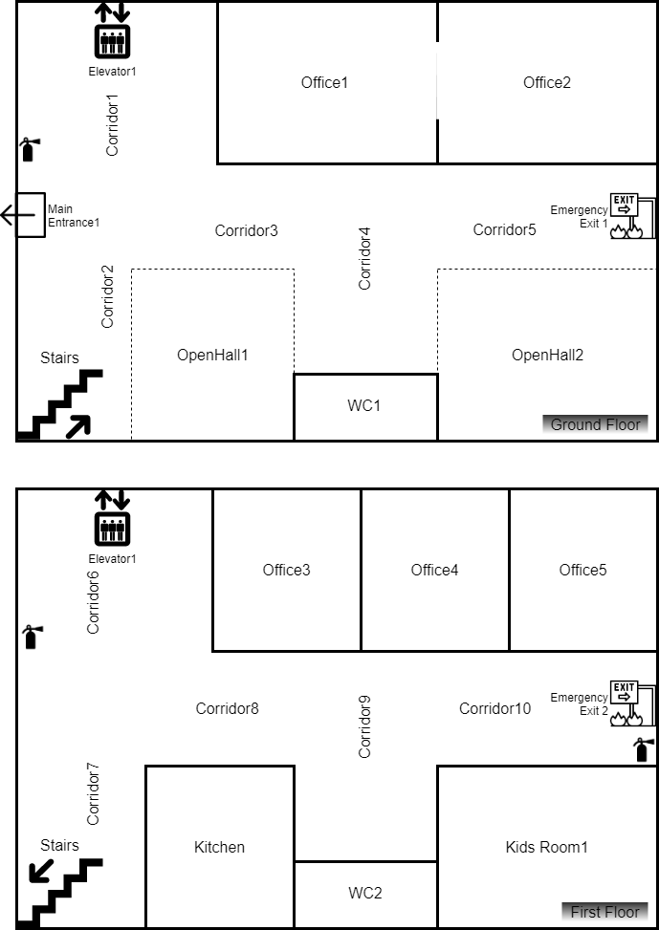**sbeo:locatedIn**, **sbeo:accommodatingCapacity**, **sbeo:hasLength**, and **sbeo:hasWidth** properties are used to describe the details of each space. The ground floor is connected to the main exit of the office space to the building. The office space also has a connection with the emergency exit of the main building, which is based on ramps. It means both the ground and first floor is connected to the emergency exit. This information is described by creating instances using **sbeo:Exit** and **sbeo:Door**. Figure 2 shows the building floor plan for a small office space. All the details are also expressed as the instances of **sbeo:RouteElement** class so that the building floor plan can be represented as a graph. The office space is considered as a *smart space* by the fact that it is equipped with the smoke, temperature and location sensors. These details are mentioned using **sbeo:Sensor** concept with **sbeo:locatedIn** property which has a range as **sbeo:Space**.

Figure Building Floor Plan For a Small Office Space

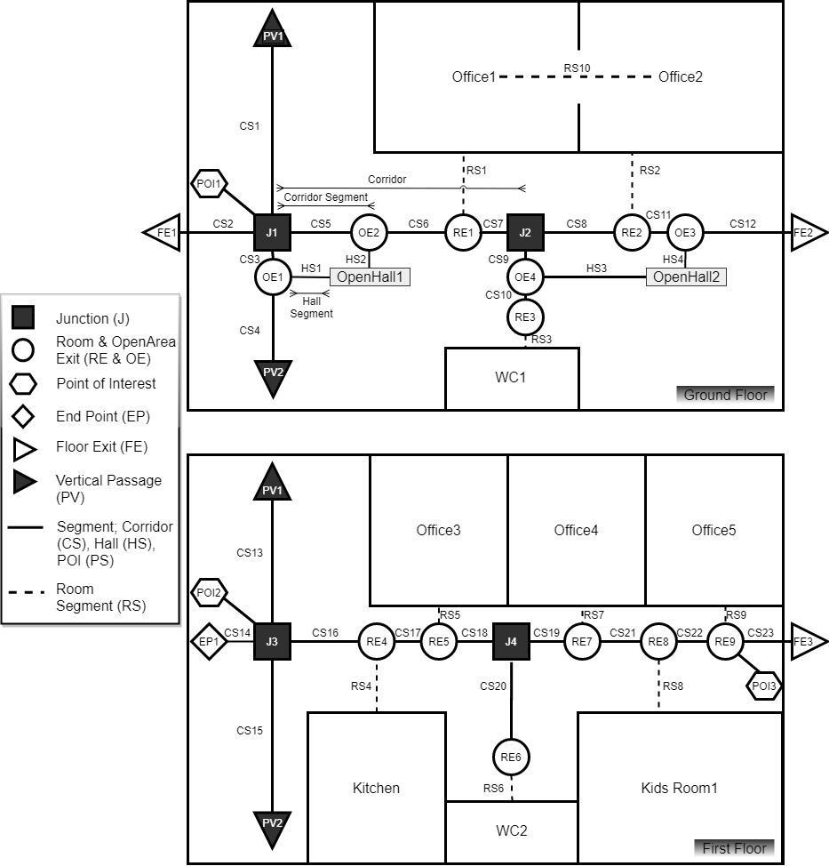Figure Route Graph Overlaid with Building Floor Plan

As it is a working day, therefore seven persons named, Alice (Uses motorized wheelchair), Brian, Chris (family ties with Maria, kid), Dan (Blind Person), Elliot (Deaf Person), Maria (family ties with Chris, Mother), are located in the office space. Six of them are there for work purposes, and one person (Chris) is a child who has an off-day from school today. His mother (Maria) brought him to her office and dropped him at Kids’ Room which is located on the first floor of the office space. Maria’s office is located on the ground floor adjacent to the office of Elliot. The rest of the persons have offices on the first floor. On the meantime, a person named Victor visits the office who has a meeting with Brian on the first floor. Thus, Except Victor and Chris, everyone is familiar with the geometry of the office space. These details are mentioned using by creating the instances of **sbeoFamily**, **foaf:Person**, and **sbeo:ImpairedPerson** class. Also, the **sbeo:Role** class is also instantiated to mention about the role of each person in the building.

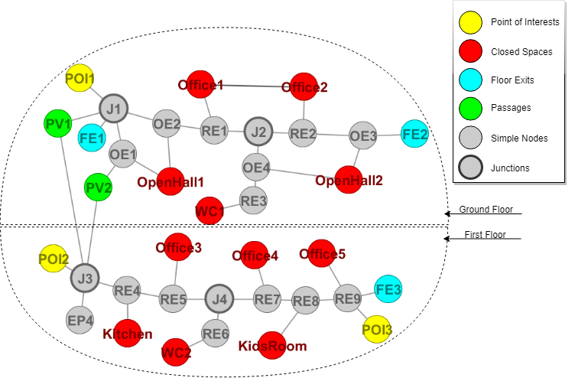Everyone is equipped with the mobile or Personal Digital Assistant provided by their company that can be used during any emergency. This information about the device is described by instantiating the **sbeo:HandheldDevice** class, and each person is associated with the device by with the help of **sbeo:uses** property. These handheld devices have software in which everyone is registered with his or her abilities and preferences. These preferences are expressed using different properties such as **sbeo:navigationalPreference**, **sbeo:notificationPreference**, etc. The Kid’s Room and Kitchen is equipped with a Digital Screens and speakers that can be used to notify people. It is mentioned using **sbeo:AlertingDevice** and **sbeo:DisplayScreen**. The information about the people located in these spaces with specific timestamps is stored in the server with the help of **sbeo:locatedIn** and **prov:atTime** properties.

Figure An Undirected Graph Representation of a Building Floor Plan

Suddenly, the smoke and temperature detect the fire in the kitchen with the help of **sbeo:hasSmoke** and **prov:hasValue** properties. The fire incidence is created as an instance of **sbeo:Fire** (which is a subclass of **sbeo:Incidence** concept). The starting time of this fire event is also stored with the help of **prov:startedAtTime** property whereas the momentary information about the status of the fire and space where it exists using **sbeo:status** and **prov:atTime** properties. Everybody is working in their offices, and Chris is playing in the Kid’s Area. As soon as the fire is detected, everyone is notified about the fire event by a message of their choice using **sbeo:notificationPreference** property, such as email, text, automated call. Everyone has asked to evacuate the office space as soon as possible. The system has blocked access to the kitchen by updating its status from ‘Available’ to ‘UnAvailable’ using **sbeo:status** property. The system has calculated the evacuation routes for each person with respect to their characteristics and preferences. These routes are calculated with the help of generating a graph based on nodes and edges. The graph is shown in Figure 3 that is overlaid with the building floor plan. This graph is generated by mapping the details of the building structure in **sbeo:RouteElement** class in which edges and nodes are represented by **sbeo:Passage** and **sbeo:RoutePoint** respectively. . For a better understanding of Figure 3, a node-edge based graph is shown in Figure 4. The routes are created and selected based on the following criteria.

First of all, the system checks who needs to be stayed at their places without getting panic, such as children, etc. It is done using **foaf:age** as well as **sbeo:familiarWith** properties of a person. The message is displayed on the screen to Chris that his mother; Maria, is coming to pick him up and he has to keep waiting for her. It is done with the help of the **sbeo:hasDescription** property whose domain is **sbeo:Device** and range is **sbeo:Description**.

Maria has become a **sbeo:Responsible** person of this group whereas Chris has become a **sbeo:Dependent** person. The fastest route (in terms of time); an elevator one, is calculated from the location of Maria to the location of Chris and assigned to Maris with the help of **sbeo:assignedRoute**. Besides, Maria has been provided with a **sbeo:Navigation** Once Maria started to follow it, her **sbeo:status** changes to ‘Evacuating’ and ‘PickingUpDependents’. The instances of a **sbeo:EmergencyEvacuation** and **sbeo:MultiObjectiveNavigiation** are generated which are used as domains of **sbeo:perfomedBy** property, whereas the range of this property is **foaf:Person**. As soon as she picks Chris up, both of them have become the instance of **sbeo:EmergencyEvacuationGroup**. Later on, Maria has been provided with a new route for exiting the office space. This route ends at the emergency exit from the first floor, which is mentioned with the help of **sbeo:endsIn** property. Although the emergency exit is a long route for both them in terms of time, the smoke has been spread across the elevator and stairs. Therefore, that area is no longer accessible for this group. It is done using **sbeo:notAccessibleTo** property whose domain is **sbeo:Space** and range is **sbeo:SocialUnit**. Even though the stairs can be used by them, but it was stored in the system (**sbeo:excludedFor**) that the area which has smoke can be dangerous for the group consists of a kid. Therefore, it was automatically filtered out from the list of possible routes. Once, Maria and Chris leave the office space, the **sbeo:status** of both of them turns to be ‘Evacuated’.

Brian and Victor are located at Brian’s office, which is on the first floor of the office space. As Victor is not familiar with the geometry of the building, therefore he is considered as an instance of **sbeo:Visitor** by the system when he created a profile while entering into the office space. In this regard, both of them have also become an instance of **sbeo:EmergencyEvacuationGroup** using a **sbeo:hasMember** property and Brian has become an instance of **sbeo:Leader** and Victor has become an instance of **sbeo:Dependent** member of that group. It means Victor is obliged to follow Brian’s instruction. Brian is shown all the information on his PDA (which is an instance of **sbeo:HandheldDevice**) about their **sbeo:Route**, which is assigned using **sbeo:assginedRoute** property. Although Victor is young, Brian is in his late 50’s (**using foaf:age**). Therefore, both of them are provided by a route that is compromised on an elevator with the help of **sbeo:excludedFor** property in which **sbeo:Stairs** is used as domain and **foaf:Person** (Brian) is used as a range. Note that, in general, the usage of elevators is avoided during hazardous situations such as a fire. But in this scenario, the elevator is not unavailable yet by the fact that the smoke has not been detected in its surroundings. As soon as the smoke will be detected as a specific **prov:atTime**, the **sbeo:Status** of the **seas:Elevator** will become ‘Unavailable’. Once Brian and Victor evacuate the office space from the main exit **sbeo:MainEntrance**, their **sbeo:status** is updated from ‘Evacuating’ to ‘Evacuated’.

Being a blind person, Dan has also become an instance of **sbeo:BlindPerson**. Therefore his **sbeo:notificationPreference** is **sbeo:AudioDescription** about any **sbeo:Incidence** or **sbeo:EmergencyEvacuation**. In this regard, he is also provided by an audio description of his **sbeo:assignedRoute**. In addition, the route assigned to him is the simplest route that leads to evacuate the office space. In his case, the main **sbeo:BuildingExit** is chosen instead of the **sbeo:EmergencyExit** by the fact that he is **sbeo:familiarWith** the **seas:OfficeBuilding**. Also, **sbeo:EmergencyExit** are **sbeo:connected** to **sbeo:Ramp**, therefore it might not be suitable for him. Once the Dan starts his **sbeo:EmergencyEvacuation** activity, the system keeps on tracking his **sbeo:hasMotionState** and **sbeo:hasNavigationalState** either he is ‘Following’ the **sbeo:assignedRoute** or ‘DeviatingFromPath’. In case, if he deviates from his path, the system calculate the number of deviations using **sbeo:hasXTimeDeviated**, and let him know about it and asks him to follow the new **sbeo:assignedRoute** calculated from **sbeo:Space** where he might be **sbeo:locatedIn**.

Alice is a mobility-impaired person and uses a motorized wheelchair. Therefore she is also an instance of **sbeo:MotorisedWheelchairPerson**. As a result, instances of **sbeo:Route**, that consists of **sbeo:Stairs** will be filtered using **sbeo:notAccessibleTo** property, and the **sbeo:Route** assigned to is either using **sbeo:Elevator** or the **sbeo:EmergencyExit**. However, the **sbeo:Elevator** path has already provided and being used (**sbeo:uses**) by Brian and Victor, and once it will get free, the **sbeo:status** of **sbeo:Elevator** may change to ‘Unavailable’ due to the presence of smoke(**sbeo:hasSmoke**) in its surroundings. On the other hand, the **sbeo:EmergencyExit** is nearer as well as accessible to Alice. In this regard, the system assigns Alice a **sbeo:EmergencyEvacuationEoute** that **sbeo:leadsTo** **sbeo:EmergencyExit**.

Elliot is an instance of **sbeo:DeafPerson** but **sbeo:familiarWith** with the **sbeo:Building** geometry. He has been notified (with **sbeo:HandheldDevice**) by an email (**sbeo:TextualDescription**) in which he was informed about the **sbeo:Incidence** and he is asked to **sbeo:performedBy** **sbeo:EmerencyEvaucation**. Also, the system has assigned a **sbeo:EmergencyEvacuationRoute** that **sbeo:leadsTo** main exit (**sbeo:MainEntrance**) using **sbeo:Stairs**, by the fact that he is capable of running as well as the **sbeo:EmergencyExit** is considered time consuming. This time is calculated using **sbeo:hasTravelTime** property.

We have explained a simple scenario for a hazard and route recommendation in a closed multi-storey space, in which there are various types of persons. The above scenario describes how the Smart Building Evacuation Ontology (SBEO) can be used to perform various functions at the same time. Although it is a basic instantiation of the Smart Building Evacuation Ontology, it is easily upgradable according to any specific scenario such as routes in shopping malls to shop concerning the preferences of users or the route to the seating in multi-plex cinemas or stadiums, and so forth.

**References**

1. Krieg-Brückner, B., Frese, U., Lüttich, K., Mandel, C., Mossakowski, T. and Ross, R.J., 2004, October. Specification of an ontology for route graphs. In *International Conference on Spatial Cognition* (pp. 390-412). Springer, Berlin, Heidelberg.
2. Anagnostopoulos, C., Tsetsos, V. and Kikiras, P., 2005. OntoNav: A semantic indoor navigation system. In *1st Workshop on Semantics in Mobile Environments (SME05), Ayia*.
3. Tsetsos, V., Anagnostopoulos, C., Kikiras, P., Hasiotis, P. and Hadjiefthymiades, S., 2005, July. A human-centered semantic navigation system for indoor environments. In *ICPS'05. Proceedings. International Conference on Pervasive Services, 2005.* (pp. 146-155). IEEE.
4. Kikiras, P., Tsetsos, V., Papataxiarhis, V., Katsikas, T. and Hadjiefthymiades, S., 2009. User modeling for pedestrian navigation services. In *Advances in ubiquitous user modelling* (pp. 111-133). Springer, Berlin, Heidelberg.
5. Tsetsos, V., Anagnostopoulos, C., Kikiras, P. and Hadjiefthymiades, S., 2006. Semantically enriched navigation for indoor environments. *International Journal of Web and Grid Services*, *2*(4), pp.453-478.
6. Dudas, P.M., Ghafourian, M. and Karimi, H.A., 2009, May. ONALIN: Ontology and algorithm for indoor routing. In *2009 Tenth International Conference on Mobile Data Management: Systems, Services and Middleware* (pp. 720-725). IEEE.
7. Kolomvatsos, K., Papataxiarhis, V. and Tsetsos, V., 2009. Semantic location based services for smart spaces. In *Metadata and Semantics* (pp. 515-525). Springer, Boston, MA.
8. Kritsotakis, M., Michou, M., Nikoloudakis, E., Bikakis, A., Patkos, T., Antoniou, G. and Plexousakis, D., 2009. Design and implementation of a semantics-based contextual navigation guide for indoor environments. *Journal of Ambient Intelligence and Smart Environments*, *1*(3), pp.261-285.
9. Karimi, H.A. and Ghafourian, M., 2010. Indoor routing for individuals with special needs and preferences. *Transactions in GIS*, *14*(3), pp.299-329.
10. Boje, C. and Li, H., 2018. Crowd simulation-based knowledge mining supporting building evacuation design. Advanced Engineering Informatics, 37, pp.103-118.
11. Onorati, T., Malizia, A., Diaz, P. and Aedo, I., 2014. Modeling an ontology on accessible evacuation routes for emergencies. *Expert systems with Applications*, *41*(16), pp.7124-7134.