 

|  |  |  |
| --- | --- | --- |
| **MCERTS Site Inspection Report EDM** | | |
| **Report prepared by:** | Siris Flow Inspections Ltd | |
| **Inspector:** | {{inspector}} | |
| **Consent/Permit Holder & Company registration:**  **Consent/Permit No:** | {{company_registration}}  {{permit_no}} | |
| **Site Name:** | {{site_name}} | |
| **Site Contact:** | {{site_contact}} | |
| **Site Address:** | {{site_address1}}  {{site_address2}}  {{site_address3}} | |
| **Site Ref or Postcode:** | {{site_ref_postcode}} | |
| **National Grid ref for gate & meter:** | Gate: {{gate_number}}  Meter: {{meter_number}} | |
| **Type of EDM:**    **Make and model of EDM:** | **Type A –** State type from list  Sensor: {{sensor_number}}  Transmitter: {{transmitter_number}} | |
| **Serial number(s) of Level meter(s):** | Sensor:  Transmitter: | |
| **Statement of Compliance:** | **MCERTS: requirements for installing and using event duration monitors**  28th August 2024 | |
| **Uncertainty:** | **± X.XX mm** | |
| **Inspection report No:** | XXXX EDM XX | |
| **Date of Inspection:** | Xth XXXXX 20XX | |

|  |
| --- |
| **Site description** |
| Brief description of site. (Type eg: STW, chemical factory etc). Size and location |

|  |
| --- |
| **Location of EDM device (s)** |
| Describe the location of the EDM device Eg. There is a non-contact radar Vega sensor located above the storm overspill channel. The associated transmitter display is located in a weatherproof kiosk directly adjacent to the channel |

|  |  |
| --- | --- |
| **Overflow point requiring EDM (Spill level & FPF limits)** | |
| Site name  EDM – (Describe the EDM location) | Permit number: 123456789  FPF flow rate: XX.XX l/s  Spill level: XX.XX mm |

|  |
| --- |
| **Method of secondary verification** |
| The sensor is fitted with a built-in calibration mounting bracket to allow a portable datum reference plate to be fitted to validate the level reading. The calibration datum reference is clearly recorded on the level transmitter. The client has a routine procedure for validation of the EDM system. |

|  |
| --- |
| **MCERTS product certification (Cert No & range)* if applicable** |
| The MCERTS-certified product number is MC XXXXXXXX  The device is not MCERTS product certified. |

|  |
| --- |
| **Site maintenance arrangements** |
| The sensor is located such that it can be periodically wiped clear of any fouling or build-up. The weir will need periodic brushing to ensure the weir crest is kept clean and free from significant fouling. The client has a routine procedure for the maintenance of the EDM system. |

**Contents**

**1.0 References**

**2.0 Site review**

**3.0 Site inspection of flow monitoring system(s)**

**4.0 Verification check**

**5.0 Survey measurement equipment**

1. **Conclusions**
2. **Recommendations**

Appendix A Event Duration Monitor (EDM) - Critical site detail

**References 1.0**

● MCERTS: requirements for installing and using event duration monitors – August 2024  
● SIRIS Event Duration Monitor (EDM) - Critical site detail excel sheet

● EDM Site Trello site card – Site Name STW - EDM

● Level data

**Site review 2.0**

The EDM is located upstream of the FPF flume adjacent to the screens and set above the storm overspill weir. The associated display is in a weatherproof kiosk directly adjacent to the overspill weir channel

Aerial view

Site schematic

**Inspection of EDM system 3.0**

There is an ultra-sonic/ radar level sensor above the pump well/ or above the flume approach channel / or storm overflow channel. The sensor is secured to a robust support bracket and has an unobstructed view of the fluid level. The XXXX level transmitter display is in a weatherproof kiosk adjacent to the pump well/ or above the flume approach channel / or storm overflow channel. The level meter provided a clear indication of the fluid level in the sump / channel well. The sensor is shaded from sunlight. At the time of the inspection, the echo profile and temperature was checked and was satisfactory.

Delete if radar – Not applicable

EDM Sensor and EDM Transmitter

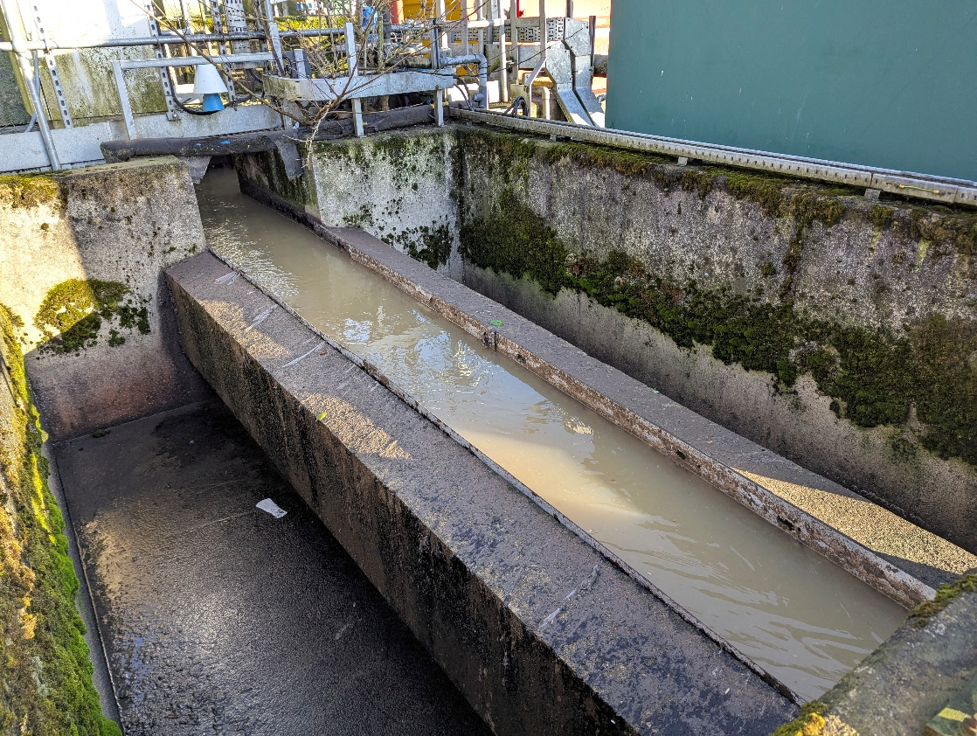

EDM Location

**Verification checks 4.0**

A level validation was taken using a portable bounce plate. 20 separate flow measurement readings were taken and compared against what was being displayed by the meter under test. The level validation was successful.

An end-to-end test was undertaken by noting the EDM level meter value on site and comparison with the recorded data provided by the client. The test was successful. / An end-to-end test could not be undertaken due to no data being provided by the client. The client will therefore need to undertake a validation between the Level meter and the recorded data presented to the EA.

Data check

**Calibration point: 2nd Red collar 1.088meters (or 1088mm)**

Level validation

**Survey measurement equipment 5.0**

The following is a list of critical equipment used during the inspection.



**Conclusions 6.0**

The EDM level meter & sensor under test recorded an uncertainty of **±X.XXmm** at the spill level **XXXmm.**

**Recommendations1 7.0**

There are no recommendations required for the system.

Mention any “Room for improvement” if required or at this point note any fails.

*“1These or any recommendations above are provided, based on information gathered during the site inspection and are not to be considered as detailed design consultancy or as the basis of design or a scope of works to bring this facility into conformity with current MCERTS requirements.”*

Signed,

*Simon Richardson Chris Richardson*

*Alistair Renwick Gavin Smith*

SIRIS Flow Inspections Ltd

**Appendix A**

