**System Design for a Secure Repository for NASA**

**Table of Contents**

Introduction 2

Assumptions, Requirements and Limitations 3

System Requirements 4

Functionality 5

Identified Risks and Vulnerabilities 6

Tools and Code Libraries 9

Diagrams 10

References 16

Appendix 21

**Introduction**

Data sharing is a core premise of scientific computing, and it is becoming increasingly important as we move toward data-intensive sciences and engineering. This extends beyond scientific outputs to include raw and intermediate data used in the scientific process.

In a report of the International Space Station Independent Safety Task Force (NASA, 2007), a strengthening of the program was recommended by increasing the likelihood of success and mitigating risks to crew safety or health.

As the International Space Station (ISS) (NASA, N.D) is a joint international operation consisting of 16 countries, and there is a need to share data and collaborate to achieve its goals. Therefore, a secure repository is being developed and a design proposal report for the application is included below. The application specifically relates to items 5.9 and 5.10 from the report and due to the tight 3-week time constraint imposed, the application will be built using Agile methods rather than the more traditional Waterfall methods (van Casteren, W, 2017).

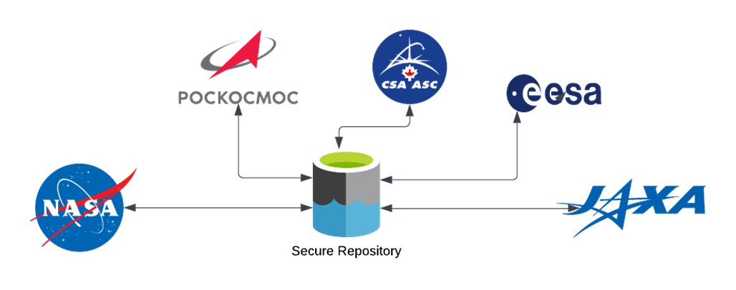

Figure 1: NASA and International Partner Operations Scope

**Assumptions, Requirements and Limitations**

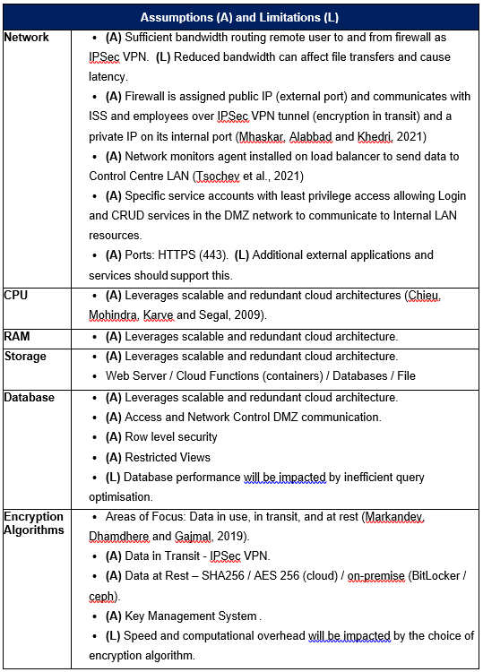Table 1: Assumptions and Limitations

**System Requirements**

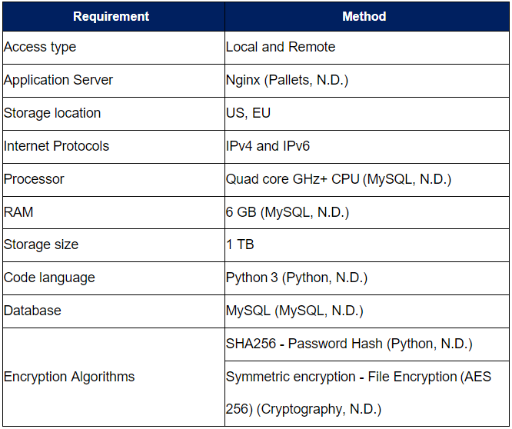

Table 2: System Design requirements

**Functionality**

As the ISS is responsible for human life as well as billions of dollars' worth of equipment, the application must be built with cardinal levels of security. The proposed application meets security and privacy requirements, of which some are mandated by the European Commission’s GDPR (EUR-Lex, 2016). Many further features could be included, such as higher levels of access control granularity, however a prototype model, they are considered out of scope and so Role Based Access Control (RBAC) has been selected.

The system includes the following automatic capabilities:

* Encryption / Decryption
* Account Lockout
* User Notification (of changes)
* Logging

User capabilities include:

* Registration
* Login
* View Files
* Upload
* Download
* Share Files

Administrator capabilities include:

* Login
* Verify User Registration
* Unlock / Disable User
* Update / Delete User Details

**Identified Risks and Vulnerabilities**

Identified risks are identified in Figures 2A and 2B below, according to the STRIDE methodology. Special consideration is made the most prevalent threats identified by OWASP (2022).

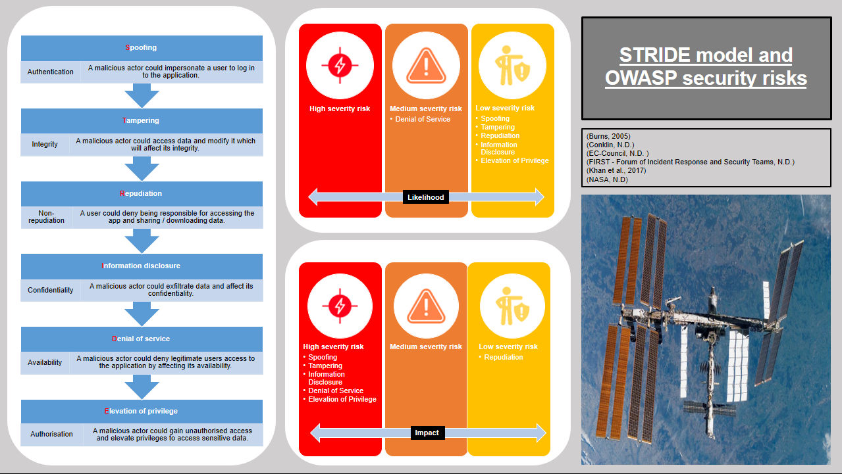

Figure 2A: STRIDE Risks

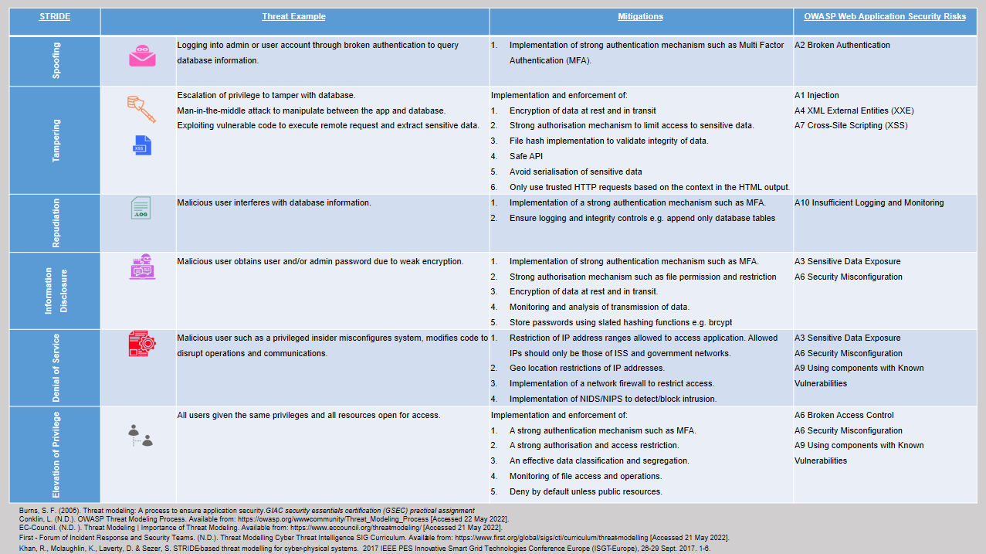

Figure 2B: STRIDE Risks

**Tools and Code Libraries**

Tools and libraries for the prototype are listed below, and Tables 3A and 3B justifying the selection can be found in the appendix.

Tools:

* Python (Code language)
* MySQL (Database)
* Locust (Load tester)
* PyCharm (Editor)

Code Libraries:

|  |  |
| --- | --- |
| Cryptographic:   1. Hashlib (Password encryption) 2. Cryptography (File encryption) 3. Fernet (Key generation) | Database connector:   1. Flask-sqlalchemy (SQL toolkit) 2. Pymysql (MySQL client) |
| Webapp:   1. Flask (Web framework) 2. Flask-login (Session management) 3. Flask-JWT (Web Token) 4. Werkzeug (WSGI utilities) 5. Getpass (Hiding password) 6. Smtplib (SMTP client) | Testing tool:   1. Pylint (Syntax checker) 2. Flake8 (Syntax checker) 3. Pytest (Function tester) |

**Diagrams**

Finally, figures 2 to 7 describe interactions between the application and its users:

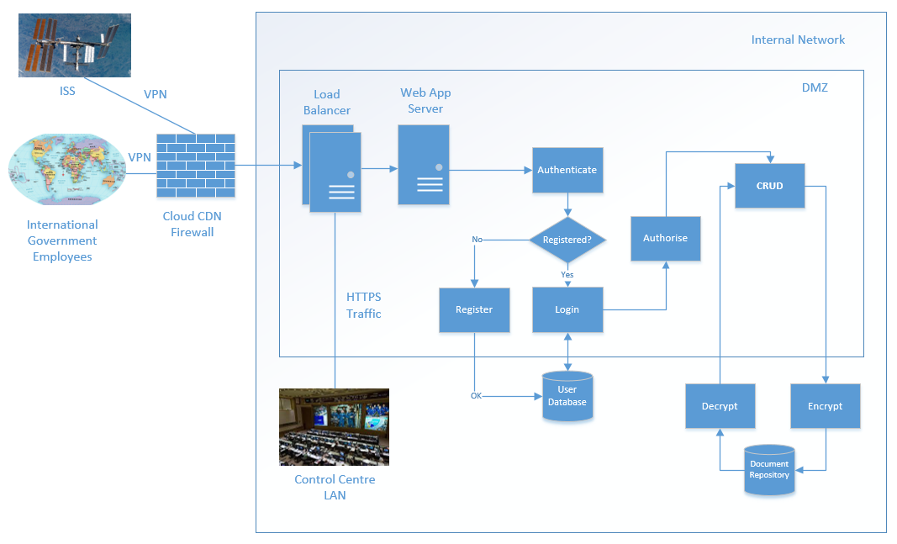

*Figure 3: System Architecture (NASA, N.D)*

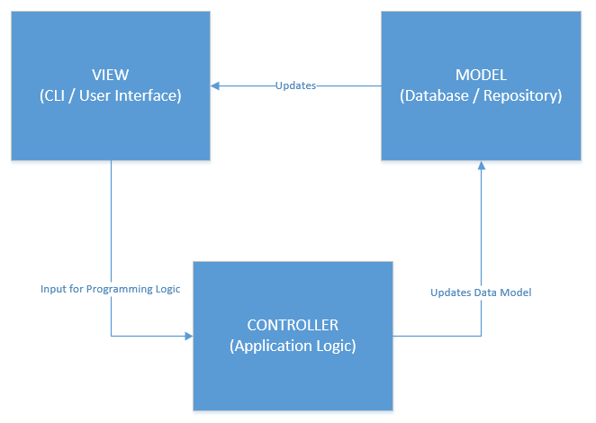

Figure 4: Software Architecture – Model, View, Controller (MVC) (University of Nebraska-Lincoln, N.D.)

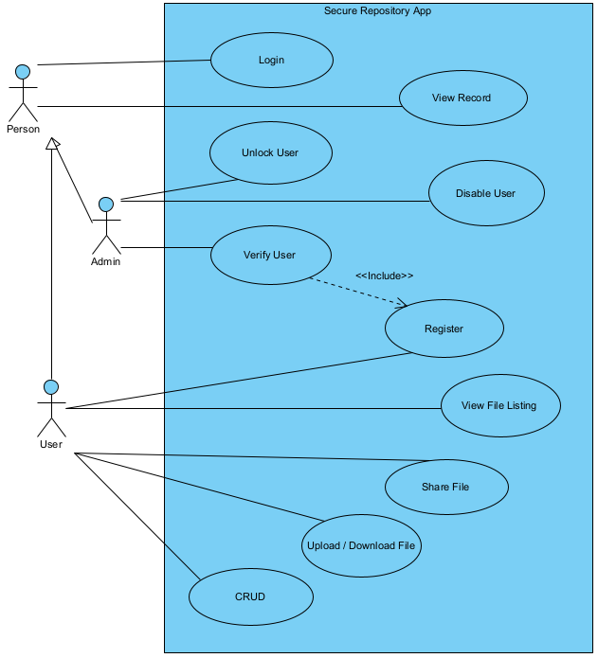

Figure 5: Use Case Diagram

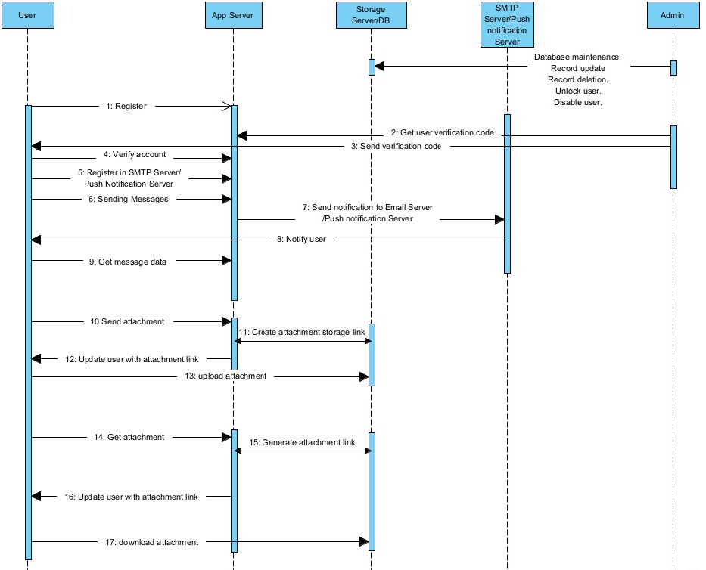

Figure 6: Sequence Diagram

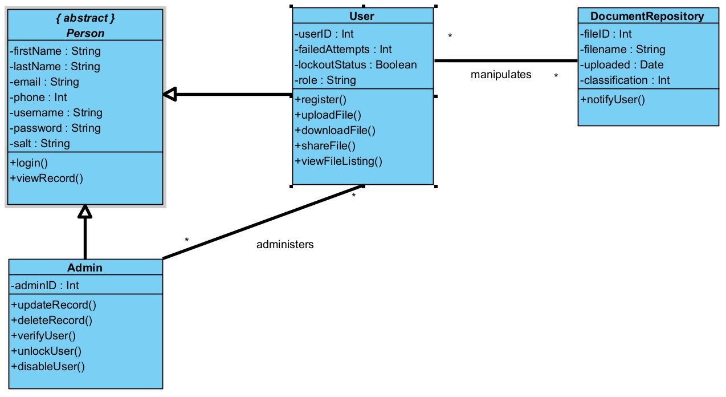

Figure 7: Class Diagram

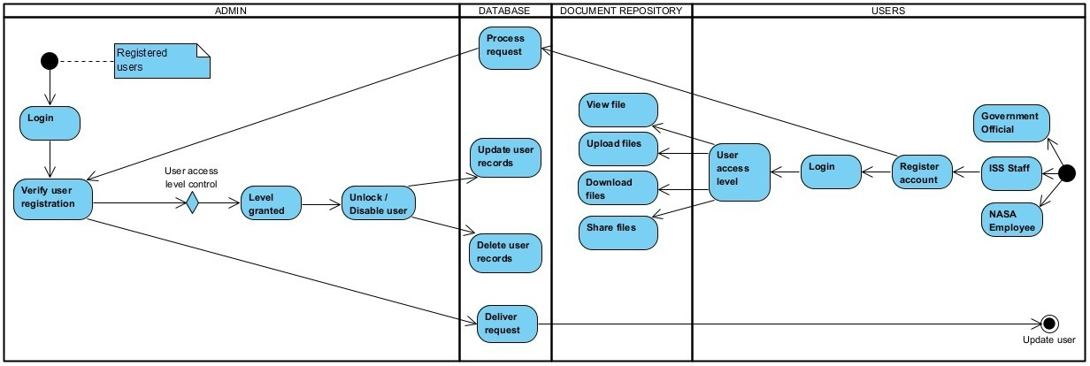

Figure 8: Activity Diagram

**References**

Chieu, T. et al. (December 1, 2009) Dynamic Scaling of Web Applications in a Virtualized Cloud Computing Environment. *2009 IEEE International Conference on e-Business Engineering (ICEBE)*. Available from: https://ieeexplore.ieee.org/document/5342101 [Accessed 20 May 2022].

Cryptography. (N.D.) Fernet (symmetric encryption). *The Recipes Layer*. Available from: https://cryptography.io/en/latest/fernet/ [Accessed 21 May 2022].

EUR-Lex. (2016) Regulation (EU) 2016/679 of the European Parliament and of the Council of 27 April 2016 on the protection of natural persons with regard to the processing of personal data and on the free movement of such data, and repealing Directive 95/46/EC (General Data Protection Regulation). Available from: [EUR-Lex - 02016R0679-20160504 - EN - EUR-Lex (europa.eu)](https://eur-lex.europa.eu/legal-content/EN/TXT/?uri=CELEX%3A02016R0679-20160504&qid=1532348683434) [Accessed 20 May 2022].

Flask-Login. (N.D.) How it Works. *Latest*. Available from: https://flask-login.readthedocs.io/en/latest/ [Accessed 21 May 2022].

GeeksforGeeks. (Jan 13, 2021) Encrypt and Decrypt Files using Python. *Python*. Available from: https://www.geeksforgeeks.org/encrypt-and-decrypt-files-using-python/ [Accessed 21 May 2022].

JetBrains. (N.D.) PyCharm Features. *Features*. Available from: https://www.jetbrains.com/pycharm/ [Accessed 21 May 2022].

Locust. (N.D.) What is Locust?. *Locust Documentation*. Available from: https://docs.locust.io/en/stable/ [Accessed 21 May 2022].

Markandey, A. et al. (March 28, 2019) Data Access Security in Cloud Computing: A Review. *2018 International Conference on Computing, Power and Communication Technologies (GUCON)*. Available from: https://ieeexplore.ieee.org/document/8675033 [Accessed 22 May 2022].

Mhaskar, N. et al. (2021) *Computers & Security: A Formal Approach to Network Segmentation*. ScienceDirect. Available from: https://doi.org/10.1016/j.cose.2020.102162 [Accessed 22 May 2022].

MySQL. (N.D.) General Information. MySQL 8.0. *Reference Manual*. Available from: https://dev.mysql.com/doc/refman/8.0/en/introduction.html [Accessed 21 May 2022].

MySQL. (N.D.) Hardware Requirements. Installing and Launching MySQL Workbench. Available from: http://download.nust.na/pub6/mysql/doc/workbench/en/wb-requirements-hardware.html [Accessed 20 May 2022].

NASA. (N.D.) International Space Station. Available from: https://www.nasa.gov/mission_pages/station/main/index.html [Accessed 18 May 2022].

NASA. (2007) Final Report of the International Space Station Independent Safety Task Force. Available from: <https://www.nasa.gov/pdf/170368main_IIST_%20Final%20Report.pdf> [Accessed 20 May 2022].

OWASP. (2022) OWASP Top Ten. Available from: <https://owasp.org/www-project-top-ten> [Accessed 23 May 2022].

Pallets. (N.D.) Documentation. *Werkzeug*. Available from: https://werkzeug.palletsprojects.com/en/2.1.x/ [Accessed 21 May 2022].

Pallets. (N.D.) Welcome to Flask. *Contents*. Available from: https://flask.palletsprojects.com/en/2.1.x/ [Accessed 21 May 2022].

PyCQA. (May 20, 2022) Pylint documentation. *Latest*. Available from: https://pylint.pycqa.org/en/latest/ [Accessed 21 May 2022].

PyCQA. (N.D.) Flake8: Your Tool For Style Guide Enforcement. *Docs*. Available from: https://flake8.pycqa.org/en/latest/ [Accessed 21 May 2022].

PyPI. (Jan 9, 2021) PyMySQL 1.0.2. *Project*. Available from: https://pypi.org/project/PyMySQL/ [Accessed 21 May 2022].

Pytest. (N.D.) Pytest: helps you write better programs. *Home*. Available from: https://docs.pytest.org/en/7.1.x/ [Accessed 21 May 2022].

Python. (N.D.) About. *Python*. Available from: https://www.python.org/about/ [Accessed 21 May 2022].

Python. (N.D.) Getpass — Portable password input. *Library*. Available from: https://docs.python.org/3/library/getpass.html [Accessed 21 May 2022].

Python. (N.D.) Hashlib — Secure hashes and message digests. *Library*. Available from: https://docs.python.org/3/library/hashlib.html [Accessed 21 May 2022].

Python. (N.D.) Smtplib — SMTP protocol client. *Internet Protocols and Support*. Available from: https://docs.python.org/3/library/smtplib.html [Accessed 21 May 2022].

Pythonhosted. (N.D.) Documentation. *Flask-JWT*. Available from: https://pythonhosted.org/Flask-JWT/ [Accessed 21 May 2022].

SQLAlchemy. (N.D.) SQLAlchemy's Philosophy. *Home*. Available from: https://www.sqlalchemy.org/ [Accessed 21 May 2022].

Tsochev, G. et al. (December 15, 2021) Analysis of Threats to a University Network Using Open Source Technologies. *2021 International Conference Automatics and Informatics (ICAI)*. Available from: https://ieeexplore.ieee.org/document/9639729 [Accessed 20 May 2022].

University of Nebraska-Lincoln. (N.D.) Tiered Architecture and MVC. Available from: <https://its.unl.edu/bestpractices/tiered-architecture-and-mvc> [Accessed 22 May 2022].

V Casteren, W. (2017) The Waterfall Model and Agile Methodologies :

A comparison by project characteristics. Available from:

<https://moam.info/the-waterfall-model-and-agile-methodologies-a-_5b87344a097c4770628b474d.html> [Accessed 20 May 2022].

WhiteSource. (N.D.) What Are The Most Secure Programming Languages?. *Research Reports*. Available from: https://www.whitesourcesoftware.com/most-secure-programming-languages/ [Accessed 21 May 2022].

**Appendix**

|  |  |  |  |
| --- | --- | --- | --- |
| **Tools** | **Name** | **Purpose** | **Justification** |
| **Misc.** | Python | Code language | User-friendly programming language Code reuse via libraries The viable choice for quick prototyping in web development Support garbage collection (Python, N.D.) |
| MySQL | Database | ANSI SQL-compliant Structured Query Language (SQL) database Minimal operating storage space Sufficient for storing passwords and data for the web app Simple to use and set up (MySQL, N.D.) |
| Locust | Load tester | Popular Load testing and user behaviour simulation program written in Python Faster and easier to configure Leaner and does not require bulky configuration files (Locust, N.D.) |
| PyCharm | Editor | PyCharm is designed for the Python programming environment Git integration Clearly debug properties (JetBrains, N.D.) |

Table 3A: Software Justification

|  |  |  |  |
| --- | --- | --- | --- |
| **Libraries Type** | **Name** | **Purpose** | **Justification** |
| **Cryptographic** | Hashlib | Password encryption | Support hash algorithms One way hashing method with SHA-256 and salt (Python, N.D.) |
| Cryptography | File encryption | Support symmetric algorithm  Data encryption and decryption (GeeksforGeeks, Jan 13, 2021) |
| Fernet | Key generation | Methods for generating keys Converting plaintext to ciphertext (Cryptography, N.D.) |
| **Webapp** | Flask | Web framework | A flexible framework for developers to demonstrate the functions of the prototype Micro-based framework and is simple to extend (Pallets, N.D.) |
| Flask-login | Session management | Able to save the active user's session Assist in preventing cookie thieves from stealing sessions Allow logged-in users to see the content (Flask-Login, N.D.) |
| Flask-jwt | Web Token | Protecting routes to transmit data Revoking and block listing token Cross-Site Request Forgery Prevention protection (Pythonhosted, N.D.) |
| Werkzeug | WSGI utilities | Interacts with headers, query args, form data, files, and cookies Capture variables from URLs HTTP utilities are provided (Pallets, N.D.) |
| Getpass | Hiding password | Without echoing the password May delivered warning when password entry is echoed (Python, N.D.) |
| Smtplib | SMTP client | Support secure connection  Send out mail for Multi Factor Authentication (Python, N.D.) |
| **Database connector** | Flask-sqlalchemy | SQL toolkit | Modified into a simple Pythonic language for database access Automate unnecessary processes to avoid SQL injection (SQLAlchemy, N.D.) |
| Pymysql | MySQL client | Pure-Python MySQL client library (PyPI, Jan 9, 2021) |
| **Testing tool** | Pylint | Syntax checker | Checks for errors and sticks to the code standard Analyses code without executing it (PyCQA, May 20, 2022) |
| Flake8 | Syntax checker | Checks for errors and sticks to the code standard Simpler, quicker, and false positives are lowered (PyCQA, N.D.) |
| Pytest | Function tester | Develop simple, understandable tests Never been linked to a security vulnerability (Pytest, N.D.) |

Table 3B: Code Libraries Justification