The main task of our development team was to create a program to display meter data on an IOT device using python. The application will allow a user to log in to the app and view his meter information. The team created the application through the software development life cycle.

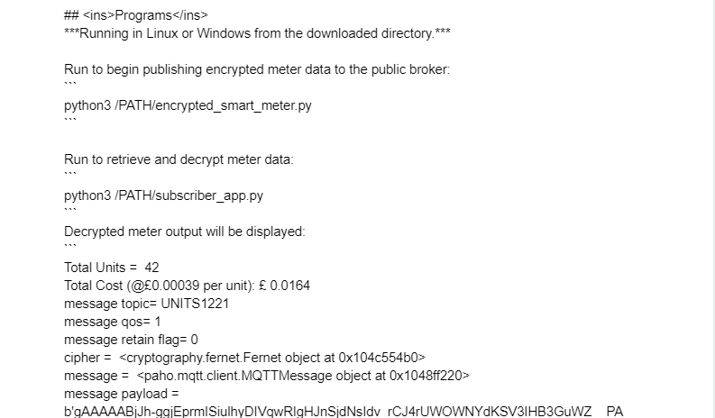

***Figure 1:***

Our biggest challenge was making sure all of our data was encrypted. IoT devices capture and process enormous volumes of data, which makes it difficult to oversee data processing and obtain consent for use. Encryption: To prevent unwanted access and exploitation, data protection rules mandate that data be encrypted both at rest and while in transit. The first role I performed involved troubleshooting of errors in the code. This involved several steps to arrive at the solution.

It was necessary to ensure all elements of the IOT program are working correctly through utilization of test cases. An example of a test case I performed was Server authentication with an incorrect password. A test case's objectives are to ascertain whether or not the various components of a system are carrying out their intended functions, as well as to verify that the system complies with all pertinent industry standards, guidelines, and specific customer requirements. The process of writing a test case can also assist in identifying problems or flaws that exist inside the system. The test case I performed was to ensure there would be no unauthorized access using incorrect passwords. The test case could also reveal an error that is present that allows illegal access.

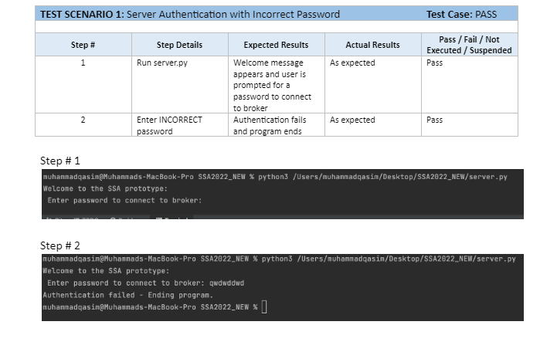

***Figure 2:***

The last task I performed was creating a readme file. The readme file will be used to show threats, how they apply to our IoT network, and mitigation techniques.

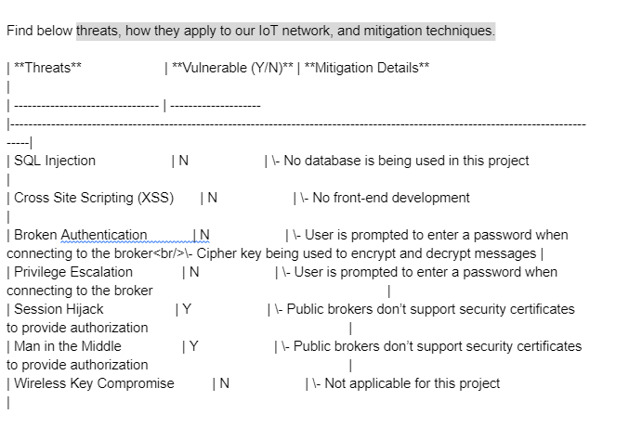

# 

# References

Edwards, P. (2020). Problem Behaviours in Software Development Teams and How to Fix

Them. Retrieved 19 September 2022, from https://www.gdcorner.com/2020/02/28/ProblemBehavioursInSoftwareTeams.html.

Everything I learned about working with people when I went from developer to product lead.

Teamwork.com. (2022). Retrieved 19 September 2022, from https://www.teamwork.com/blog/everything-i-learned-about-working-with-people-when-i-went-from-developer-to-product-lead/.

Jerinic, A. (2022). Importance of writing detailed test cases. Linkedin.com. Retrieved 19

September 2022, from https://www.linkedin.com/pulse/importance-writing-detailed-test-cases-andrea-jerinic.

McKendrick, J. (2022). Software teams spend one day a week, and more, troubleshooting code

issues. ZDNET. Retrieved 19 September 2022, from https://www.zdnet.com/article/software-teams-spend-one-day-a-week-and-more-troubleshooting-code-issues/.

Prabuddha, C. (2022). Mistakes Every Programmer Makes When Learning to Code – and How to Fix Them. freeCodeCamp.org. Retrieved 19 September 2022, from https://www.freecodecamp.org/news/mistakes-programmers-make-when-coding-and-how-to-fix-them/.