DeftSQL
SQL Productivity Extension for SQL Server Management Studio 22
Product Feature Guide for Management and End Users
Item | Detail
Product | DeftSQL for SSMS 22
Version | 2.6.2
Document type | Feature guide with menu paths and screenshots
Audience | Management, team leads, SQL developers, DBAs, analysts
Prepared by | Product Owner, DeftSQL
Date | 13 November 2026
Contents
1. Executive Summary 3
1.1 Value at a glance 3
2. Getting Started 4
2.1 Installation 4
2.2 Where to find DeftSQL 4
3. Feature Guide 8
3.1 Intelligent Code Completion 8
3.2 Snippets 10
3.3 SQL Formatting 12
3.4 Code Analysis 14
3.5 Refactoring 17
3.6 Script Query Results as INSERT / UPDATE / DELETE 21
3.7 Navigation and Object Search 24
3.8 Query History and Tab History 25
3.9 Environment Tab Coloring and Execution Warnings 26
3.10 AI Features (optional) 27
3.11 Results Grid Actions 30
3.12 Team Standards and Settings Sharing 31
3.13 Command Line and CI 32
4. Settings 33
4.1 General 33
4.2 AI 33
4.3 Formatting 34
4.4 Data locations 35
5. Keyboard Shortcut Reference 36
6. Troubleshooting 37

Right-click the table above and choose Update Field if page numbers are missing.

1. Executive Summary
DeftSQL is an extension for Microsoft SQL Server Management Studio (SSMS) 22. It adds intelligent code completion, formatting, real-time code review, safe data scripting, history and optional AI assistance directly inside the query editor that SQL users already work in every day. Nothing new has to be learned or installed beyond the extension itself.
The product is designed around three goals:
- Write SQL faster: schema-aware suggestions, join conditions from foreign keys, snippets and one-key formatting remove most of the typing.
- Ship safer SQL: 72 code-analysis rules flag risky statements as you type, a colored bar shows whether you are on Production or Dev, and dangerous statements ask for confirmation before they run.
- Never lose work: every executed query and every query tab is saved automatically and can be searched and reopened.

1.1 Value at a glance
Area | What the user gets | Business value
Code completion | Tables, columns, procedures and JOIN … ON conditions suggested from the live database | Less typing, fewer wrong column or table names
Formatting | One shortcut formats a whole script to the team standard | Consistent, reviewable code across the team
Code analysis | 72 rules shown as squiggles, with quick fixes and team rule sets | Defects caught before code review or production
Script query results | Turns any SELECT result into INSERT, UPDATE or DELETE scripts | Fast, auditable data fixes and data migration
Team standards | Shared formatting styles, rule sets and settings, plus command-line formatting and analysis for CI | One standard on every PC and in every pull request
Results grid | Copy results as an IN list or CSV, open them in Excel, or script rows as INSERT | Results reach the next query, a colleague or the business in one click
History | Query History and Tab History, saved automatically | No lost work after a crash or a closed tab
Environment safety | Colored environment bar and execution warnings | Fewer accidental changes on Production
AI (optional) | Text to SQL, Explain, Optimize, Fix errors and an Assistant chat, through Claude or a fully offline local model | Faster onboarding and analysis; offline mode keeps data on the PC

Data privacy: AI features are off unless a user enables them. With the local (Ollama) provider nothing leaves the computer. With Claude, only the prompt, the SQL being worked on and, if allowed, table and column names and types are sent. Table data is never sent.

2. Getting Started

2.1 Installation
- Close SSMS.
- Double-click DeftSQL.vsix, or run install.ps1 in PowerShell (use -Quiet for a silent install).
- Start SSMS 22 and connect to a server as usual.
- Recommended: turn off the built-in SSMS IntelliSense list so only one suggestion list appears: Tools ▸ Options ▸ Text Editor ▸ Transact-SQL ▸ IntelliSense ▸ Enable IntelliSense.

2.2 Where to find DeftSQL
All DeftSQL commands can be reached in four ways:
- Main menu: Extensions ▸ DeftSQL. This is the full list of commands (Figure 2).
- DeftSQL toolbar: one-click buttons for the most-used commands. Show or hide it with View ▸ Toolbars ▸ DeftSQL.
- Keyboard shortcuts: listed next to each menu item and in Section 5.
- Right-click menu: right-click anywhere in a query window and choose DeftSQL ▸ for the most-used editor commands (Figure 3).
- Results grid: right-click the results grid and choose DeftSQL ▸ for Copy as IN List, Copy as CSV, Open in Excel and Script Rows as INSERT (Section 3.11).
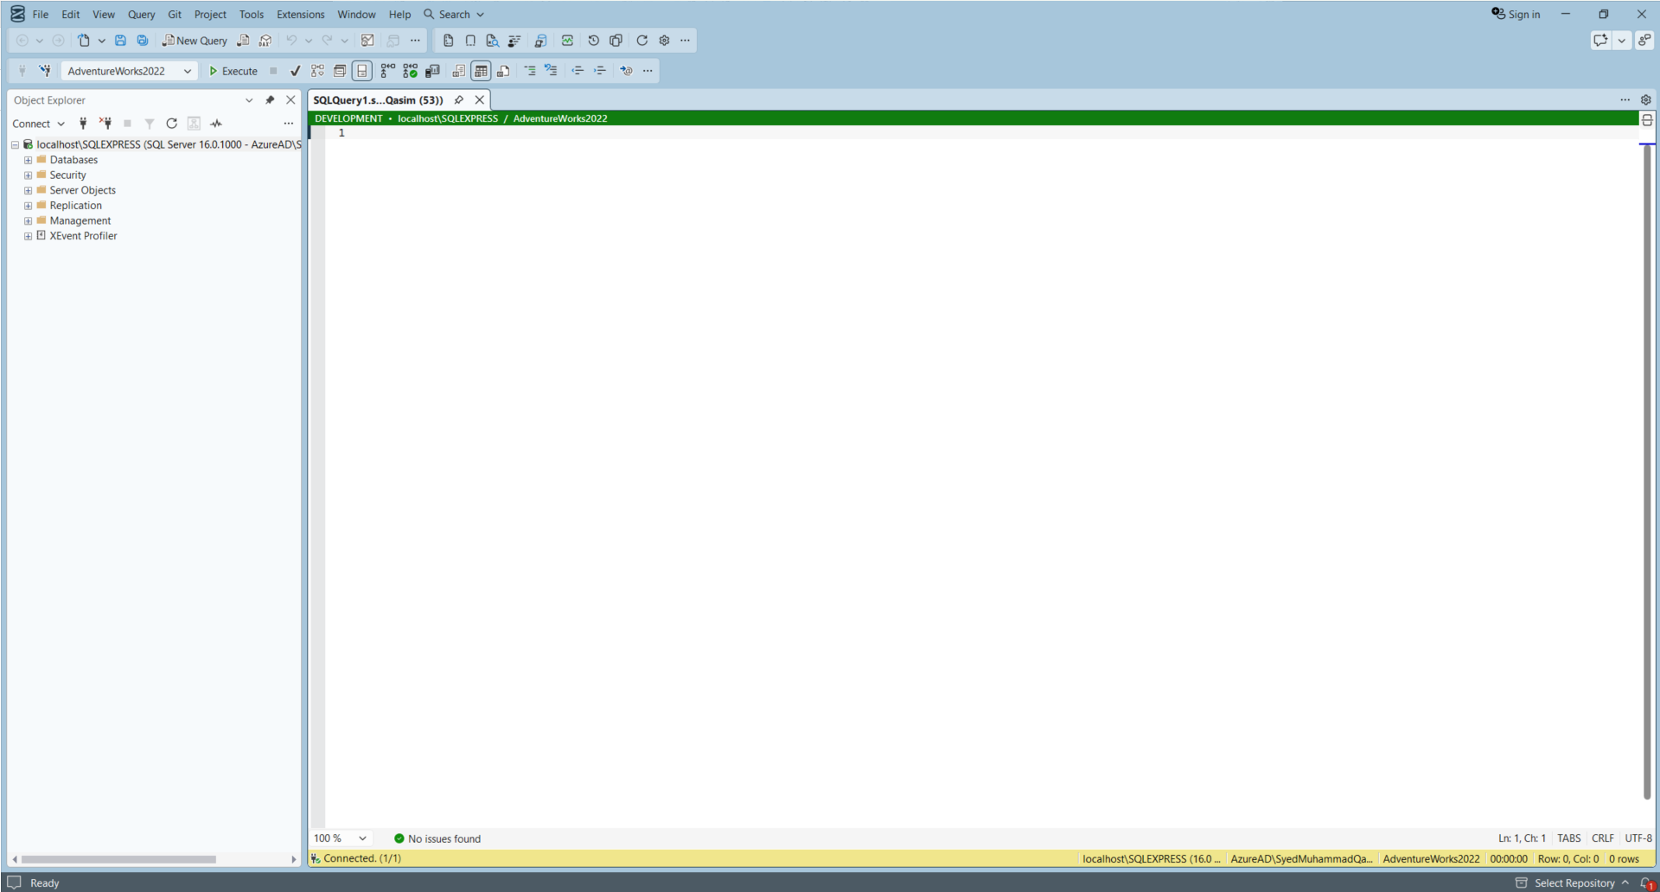
Figure 1: SSMS 22 with DeftSQL loaded. The green bar above the editor is DeftSQL's environment indicator.
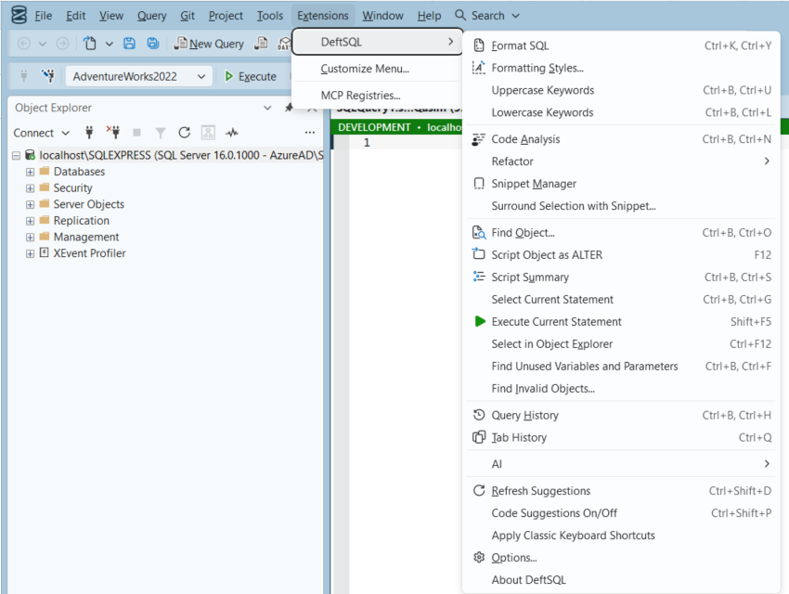
Figure 2: Menu path: Extensions ▸ DeftSQL. The full command menu with shortcuts.
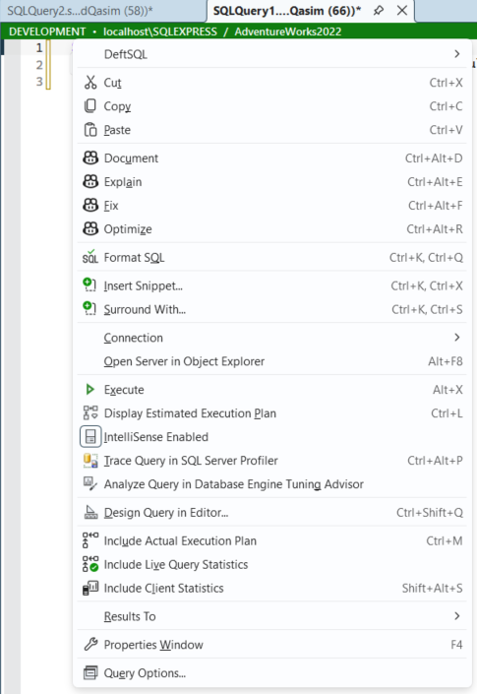
Figure 3: Right-click in a query window: the DeftSQL submenu sits at the top of the SSMS editor menu.
The DeftSQL right-click submenu contains: Format SQL · Expand Wildcards · Qualify Object Names · Smart Rename… · Script Object as ALTER · Encapsulate as Stored Procedure… · Split Table… · Explain SQL · Suggest Fixes and Optimizations · Surround Selection with Snippet… · Script Query Results as INSERT / UPDATE / DELETE… · Execute Current Statement · Select in Object Explorer · Add/Remove Square Brackets · Find Unused Variables and Parameters.

Menu structure
Group | Menu items (Extensions ▸ DeftSQL ▸ …)
Formatting | Format SQL · Format SQL Files… · Formatting Styles… · Uppercase Keywords · Lowercase Keywords
Analysis | Code Analysis
Refactor ▸ | Expand Wildcards · Qualify Object Names · Insert Semicolons · Smart Rename… · Encapsulate as Stored Procedure… · Add/Remove Square Brackets · Script Query Results as INSERT / UPDATE / DELETE… · Split Table…
Snippets | Snippet Manager · Surround Selection with Snippet…
Navigation | Find Object… · Script Object as ALTER · Script Summary · Select Current Statement · Execute Current Statement · Select in Object Explorer · Find Unused Variables and Parameters · Find Invalid Objects…
Results Grid ▸ | Copy as IN List · Copy as CSV · Open in Excel · Script Rows as INSERT… (also on the results grid right-click menu ▸ DeftSQL)
History | Query History · Tab History
AI ▸ | Text to SQL… · Explain SQL · Suggest Fixes and Optimizations · Query Index Analysis · AI Assistant
Settings | Refresh Suggestions · Code Suggestions On/Off · Apply Classic Keyboard Shortcuts · Export Settings… · Import Settings… · Options… · About DeftSQL


Figure 4: DeftSQL toolbar buttons (Format, Snippets, Find Object, Code Analysis, Split Table, Script Results, AI, Query and Tab History, Refresh, Options). Buttons that do not fit are under the toolbar's ⋯ overflow.

3. Feature Guide
Each feature below shows its menu path, shortcut, how to use it, and the benefit it brings. Screenshots were taken in SSMS 22 connected to the AdventureWorks2022 sample database.

3.1 Intelligent Code Completion
Menu path | Automatic while typing. Turn on/off: Extensions ▸ DeftSQL ▸ Code Suggestions On/Off
Shortcuts | Ctrl+Space show list · Ctrl+Shift+P suggestions on/off · Ctrl+Shift+D refresh schema
Who benefits | Everyone who writes SQL

As you type, DeftSQL suggests the tables, views, functions and procedures of the connected database. It adds a short alias automatically after FROM and JOIN, and suggests the columns of every table in scope. The object definition box next to the list shows the selected object's full script: columns and data types, keys, indexes, foreign keys and the approximate row count.
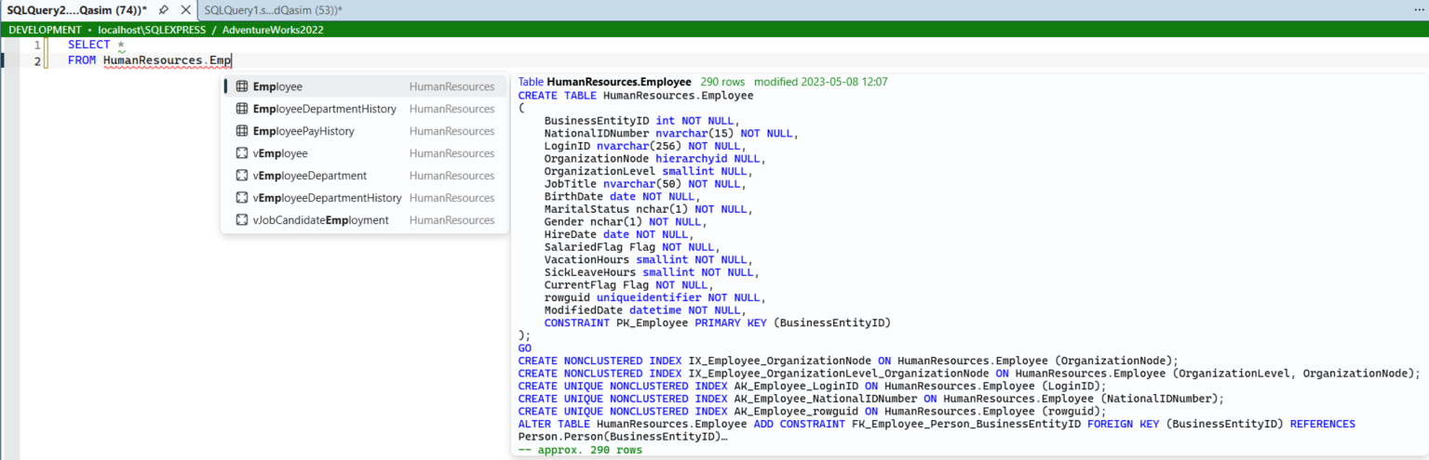
Figure 5: Typing FROM HumanResources.Emp: matching tables and views, with the CREATE TABLE script, indexes and row count of the selected table.

JOIN suggestions from foreign keys
After JOIN, DeftSQL lists complete JOIN … ON conditions built from the database's foreign keys, so users do not have to look up which columns relate two tables.
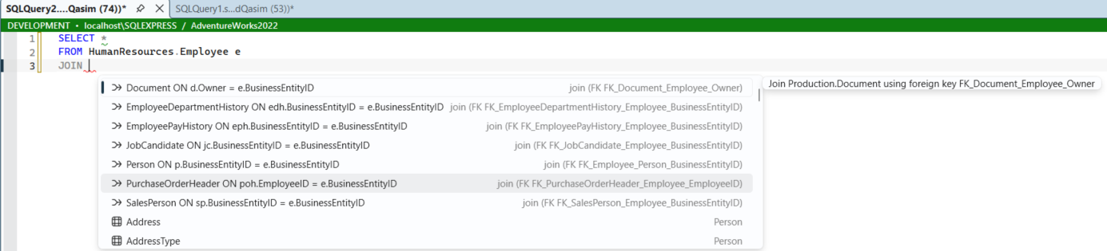
Figure 6: After JOIN, ready-made join conditions are suggested for every table related to Employee.

Productivity keys inside the list
- Ctrl+Up / Ctrl+Down: cycle filters (All, Tables & views, Columns, Procedures & functions, Variables, Schemas, Keywords, Snippets).
- Ctrl+Right: open the column picker, tick the columns you need and press Enter to insert them (Ctrl+Left goes back).
- Tab after SELECT *: expands the asterisk into the full column list (also Extensions ▸ DeftSQL ▸ Refactor ▸ Expand Wildcards).
- Parameter info: after typing ( or a comma in a function or EXEC call, the parameters are shown with the current one in bold. Ctrl+Shift+Space shows it on demand.
- Hover info: hold the mouse over a table or column to see its definition and where a column is used.

Ranking, hidden objects and other databases
- Ranking by usage: tables, columns and procedures you pick often move to the top of the list. Older picks count for less over time (half after 30 days). Turn it off in Options ▸ General.
- Hidden objects: list patterns in Options ▸ General ▸ Hidden objects, separated by semicolons, to keep clutter out of the list: Archive.* hides a schema, tmp_* hides matching names in any schema, database:ReportServer* hides databases.
- Other databases: type OtherDb. to list its schemas, OtherDb.dbo. for its tables, views and routines, and OtherDb.dbo.Table. for its columns. The first use loads that database’s schema in the background; the status bar shows when it is loading. Linked servers are not included.

Business benefit: Less typing and far fewer "invalid column name" errors. New team members can work with an unfamiliar database without searching Object Explorer.

3.2 Snippets
Menu path | Extensions ▸ DeftSQL ▸ Snippet Manager; Extensions ▸ DeftSQL ▸ Surround Selection with Snippet…
Shortcut | Type the snippet shortcut (for example ssf, cte, bt, ij) and press Tab
Who benefits | Developers and DBAs who write repeating code patterns

140 built-in snippets cover common patterns: SELECT templates, joins, CTEs (including recursive), transactions with commit or rollback, MERGE (upsert), PIVOT, duplicate finding, paging, date ranges, JSON and XML, DDL (add column, primary key, foreign key, index, columnstore, trigger, sequence) and DBA queries (blocking, waits, index fragmentation, backups, jobs, users). Snippets support placeholders such as $CURSOR$, $SELECTEDTEXT$, $DATE$, $USER$, $SERVER$ and $DBNAME$.
- Open Extensions ▸ DeftSQL ▸ Snippet Manager.
- Click New, enter a Shortcut, Description and Body, and click Save.
- In any query window type the shortcut and press Tab to insert it.
- Use Import… / Export… to share snippets, or set a shared snippets folder in Options so the whole team uses one set.
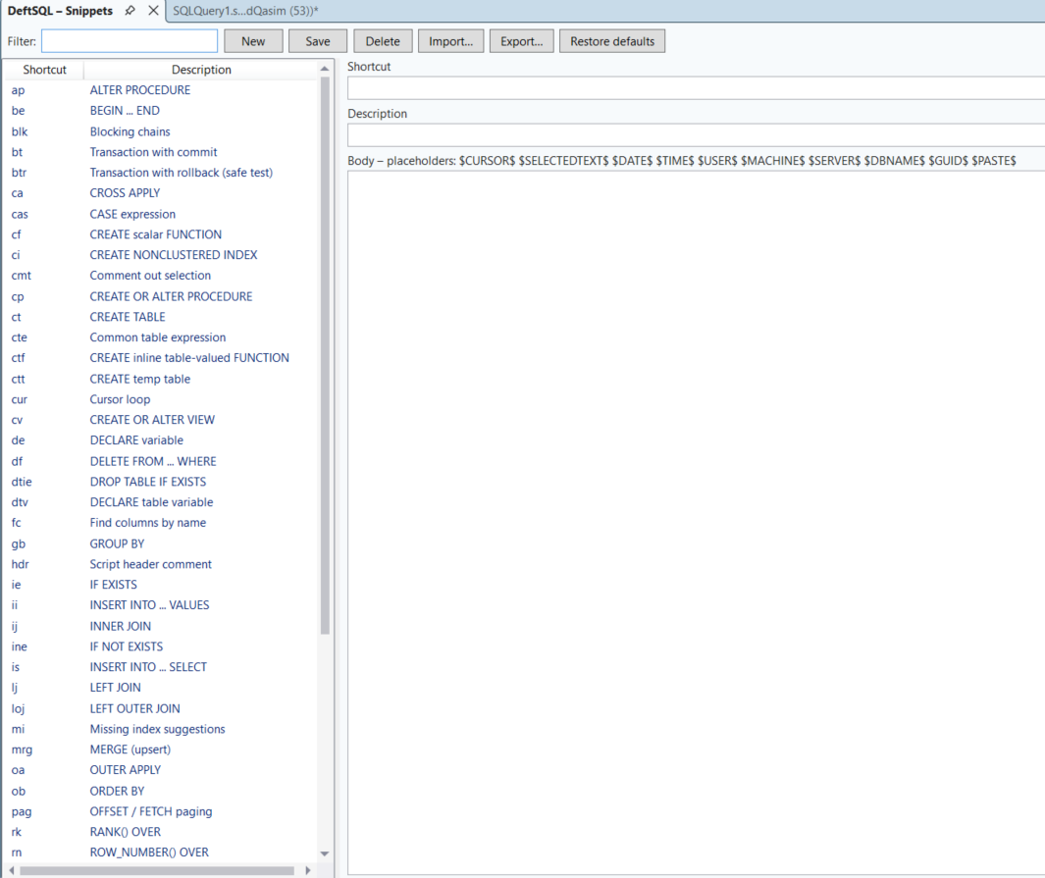
Figure 7: Snippet Manager: built-in and custom snippets, with import, export and restore-defaults.
Business benefit: Team standards (headers, transaction patterns, safe DELETE templates) are typed the same way every time.

3.3 SQL Formatting
Menu path | Extensions ▸ DeftSQL ▸ Format SQL; Extensions ▸ DeftSQL ▸ Formatting Styles…
Shortcut | Ctrl+K, Ctrl+Y (whole document or the selection)
Who benefits | Developers, reviewers, anyone who reads SQL

One shortcut turns unreadable one-line SQL into a clean, consistently indented script. Six built-in styles are provided (Default, Collapsed, Commas before, Expanded, Right aligned, Lowercase) plus a Custom style. A safety check refuses any format that would change the meaning of the code.
Figure 8: Before: a query written on a single line.
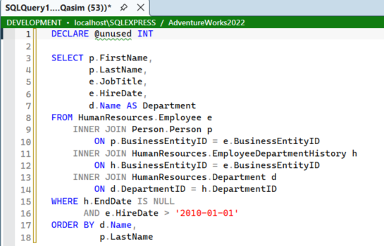
Figure 9: After Ctrl+K, Ctrl+Y: keywords upper-cased, columns aligned, joins and conditions on their own lines.
Formatting Styles lets users pick a style, adjust each setting and see a live preview. Styles can be imported and exported so a team can share one standard.
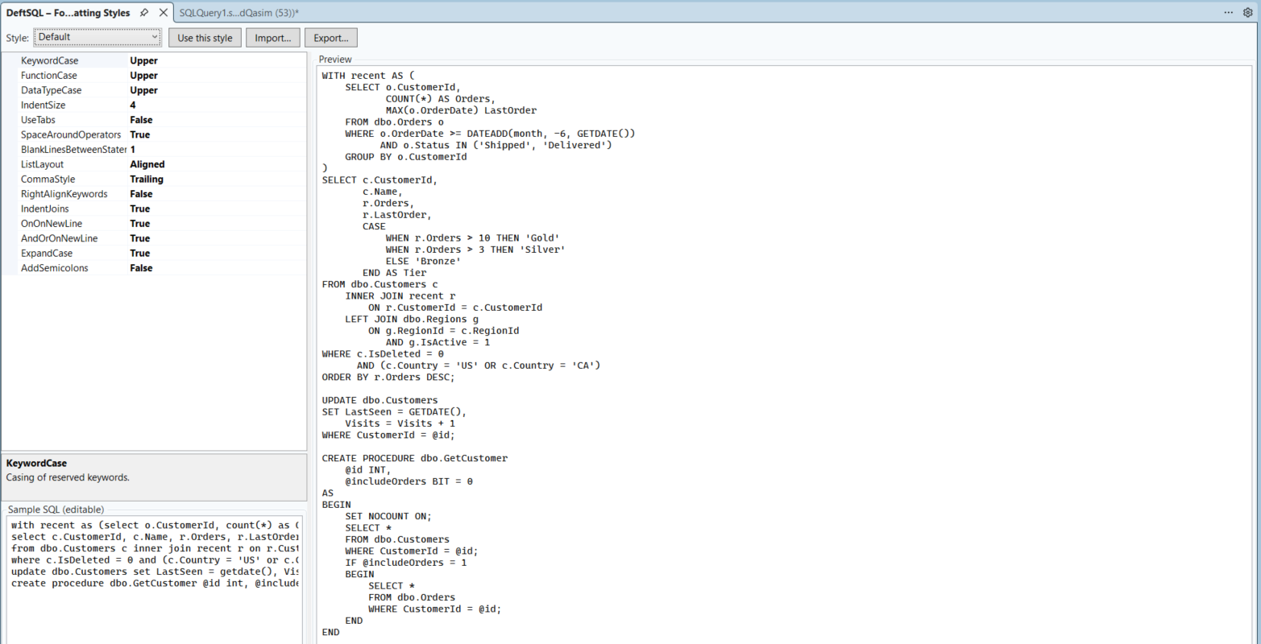
Figure 10: Extensions ▸ DeftSQL ▸ Formatting Styles…: settings on the left, live preview on the right.

More options, team styles and whole folders
- Match object name case: writes schema, table, view, routine and column names exactly as they are defined in the database (dbo.customers becomes dbo.Customers). Aliases, variables and strings are left alone.
- Layout options: space after commas, spaces inside parentheses, aligned column aliases, and collapsing statements shorter than a chosen length onto one line.
- Team styles: set Options ▸ Formatting ▸ Team styles folder to a shared folder. Every style saved there appears in the style list as “Team: name”. In Formatting Styles, Share… saves the current style to that folder for everyone.
- Format SQL Files…: Extensions ▸ DeftSQL ▸ Format SQL Files… formats every .sql file in a folder and its subfolders with the active style. File encodings and line endings are kept, and files the formatter cannot handle safely are skipped and listed.

Business benefit: Code reviews focus on logic instead of layout, and all scripts in source control look the same.

3.4 Code Analysis
Menu path | Extensions ▸ DeftSQL ▸ Code Analysis
Shortcuts | Ctrl+B, Ctrl+N open the window · Ctrl+. apply a quick fix
Who benefits | Developers, reviewers, team leads, DBAs

DeftSQL checks the script continuously against 72 rules in eight categories: execution risks, best practice, performance, deprecated syntax, style, security, miscellaneous (for example FLOAT for money, linked-server names, WAITFOR DELAY) and code review (commented-out code, TODO markers, empty CATCH blocks, very long IN lists, deeply nested subqueries). Problems are underlined in the editor as you type, and the counters at the bottom of the editor show the number of errors and warnings.
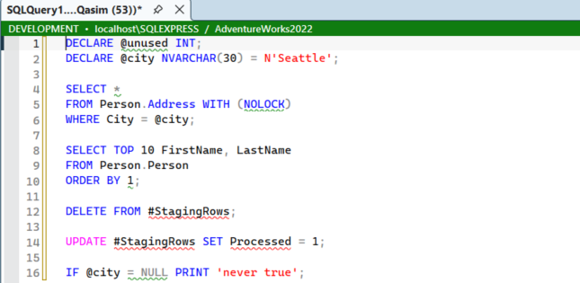
Figure 11: Issues underlined as you type: an unused variable, SELECT *, a NOLOCK hint, ORDER BY ordinal and a comparison with NULL.
The Code Analysis window lists every issue with its line, rule, severity and suggested fix. Select an issue and click Go to to jump to it, or Apply fix to correct it automatically (for example “Expand wildcard” or “Replace with IS NULL”).
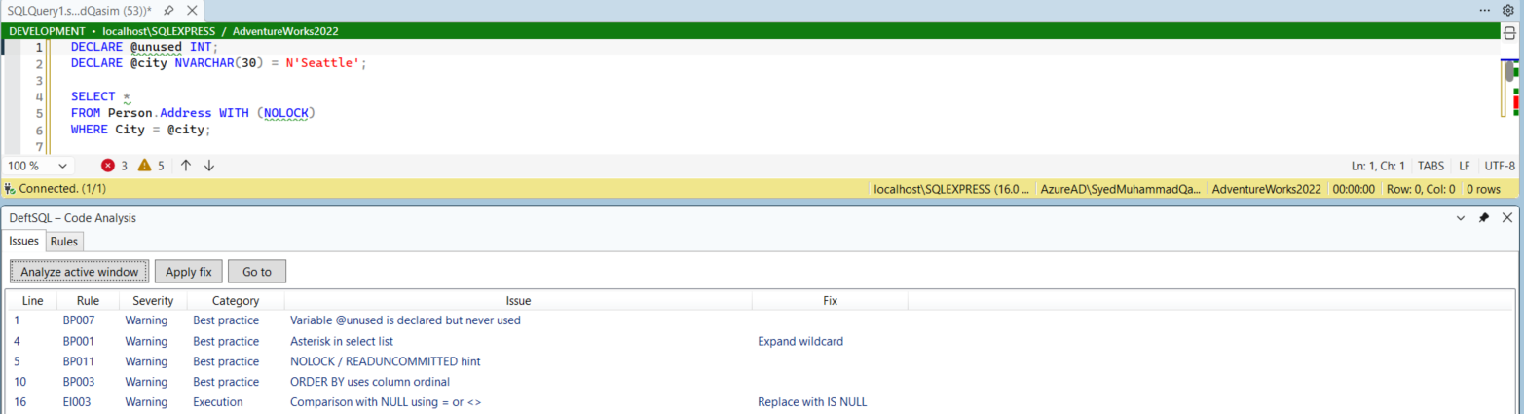
Figure 12: Code Analysis window, Issues tab.
On the Rules tab, each rule can be switched on or off to match the team's coding standard.
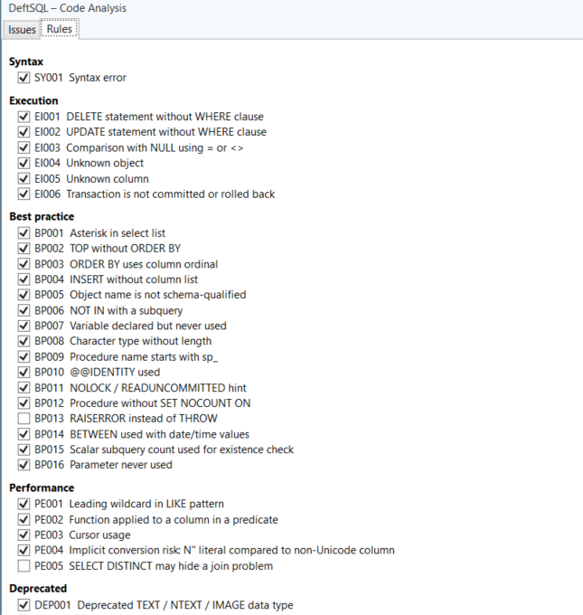
Figure 13: Code Analysis window, Rules tab: rules grouped by category.
Related commands in Extensions ▸ DeftSQL: Find Unused Variables and Parameters (Ctrl+B, Ctrl+F) and Find Invalid Objects…, which finds procedures, views and functions that reference objects that no longer exist.

Turning a rule off in the code
Sometimes a warning is expected, for example a deliberate NOLOCK in a reporting query. Press Ctrl+. on the issue and choose Turn off RULE for this statement or Turn off RULE for this script. DeftSQL writes a comment that the whole team sees and that the command-line tool also honours:
-- deftsql-disable-next BP011
SELECT OrderID FROM Sales.Orders WITH (NOLOCK);
- deftsql-disable [IDs] … deftsql-enable [IDs]: turns rules off for a range of the script (to the end when there is no enable).
- deftsql-disable-next [IDs]: the next statement only.
- deftsql-disable-line [IDs]: its own line (or the next line when the comment stands alone).
Without rule IDs the comment applies to every rule. Comments can be written as -- or /* */.

Team rule sets
On the Rules tab, Export rule set… saves which rules are on and off to a .json file. Point Options ▸ General ▸ Team rule set file at that file on a shared drive and every user gets the same rules; the Rules tab then shows them read-only with a note explaining why.

Business benefit: Bugs such as "= NULL" comparisons, missing WHERE clauses and uncommitted transactions are caught at the keyboard instead of in production.

3.5 Refactoring
Menu path | Extensions ▸ DeftSQL ▸ Refactor ▸ …
Who benefits | Developers maintaining existing code

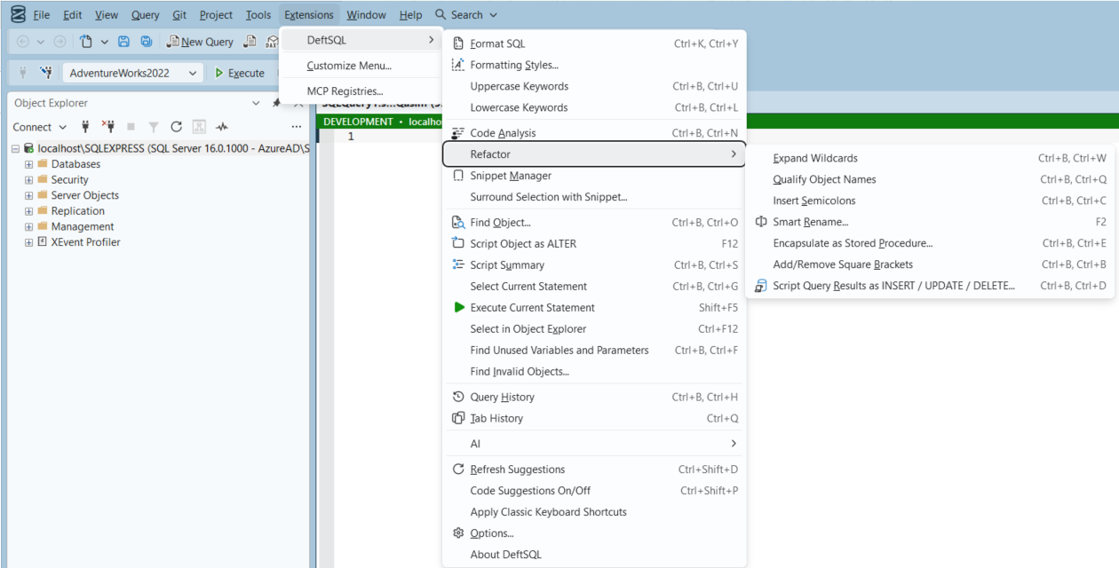
Figure 14: Menu path: Extensions ▸ DeftSQL ▸ Refactor.
Command | Shortcut | What it does
Expand Wildcards | Ctrl+B, Ctrl+W | Replaces SELECT * with the explicit column list
Qualify Object Names | Ctrl+B, Ctrl+Q | Adds schema and alias prefixes to objects and columns
Insert Semicolons | Ctrl+B, Ctrl+C | Terminates every statement with a semicolon
Smart Rename… | F2 | Renames aliases, variables, CTEs and temp tables in place. For tables, views, routines and columns it produces a reviewable script (sp_rename plus every dependent module rewritten) in one transaction
Encapsulate as Stored Procedure… | Ctrl+B, Ctrl+E | Turns the selected SQL into a new stored procedure
Split Table… | Refactor menu, toolbar, right-click menu | Moves chosen columns into a new table with the same primary key and writes a reviewable script (see below)
Add/Remove Square Brackets | Ctrl+B, Ctrl+B | Adds or removes [ ] around identifiers
Uppercase / Lowercase Keywords | Ctrl+B, Ctrl+U / Ctrl+L | Changes keyword case (Extensions ▸ DeftSQL menu)
Script Query Results as INSERT / UPDATE / DELETE… | Ctrl+B, Ctrl+D | See Section 3.6

Split Table
Split Table moves rarely used or wide columns of a table into a new one-to-one table, for example Customer contact details into dbo.CustomerContact.
- Place the caret on a table name (or answer the prompt) and choose Extensions ▸ DeftSQL ▸ Refactor ▸ Split Table…. The same command is on the DeftSQL toolbar (table icon) and in the query editor’s right-click menu under DeftSQL ▸ Split Table….
- Tick the columns to move, then name the new table (default: the table name followed by Details).
- Review the script in the new window, then run it.
The script runs in one transaction with XACT_ABORT ON, so nothing changes unless every step succeeds. It creates the new table with the same primary key and a foreign key back to the original (ON DELETE CASCADE), copies the data, moves the indexes, foreign keys, defaults and check constraints of the moved columns to the new table, drops the columns, and finally lists the views, procedures and functions that may need updating. Tables without a primary key are refused.

Split Table: worked example
Starting point. dbo.Customer mixes identity data with a mailing address. Address columns are read by only a few reports, and the team wants them in their own table:
CREATE TABLE dbo.Customer
(
CustomerID int IDENTITY(1, 1) NOT NULL CONSTRAINT PK_Customer PRIMARY KEY,
FirstName nvarchar(50) NOT NULL,
LastName nvarchar(50) NOT NULL,
Email varchar(255) NOT NULL,
AddressLine1 nvarchar(100) NULL,
City nvarchar(60) NULL,
PostalCode varchar(10) NULL CONSTRAINT CK_Customer_PostalCode
CHECK (PostalCode NOT LIKE '%[^A-Z0-9 -]%'),
CountryCode char(2) NOT NULL CONSTRAINT DF_Customer_CountryCode DEFAULT ('GB')
CONSTRAINT FK_Customer_Country REFERENCES dbo.Country (CountryCode),
CreatedAt datetime2(0) NOT NULL CONSTRAINT DF_Customer_CreatedAt DEFAULT (SYSDATETIME())
);
CREATE INDEX IX_Customer_City ON dbo.Customer (City) INCLUDE (PostalCode);
-- and a view that uses the address: dbo.vCustomerMailing
Step 1. Place the caret on Customer in a query window and choose Extensions ▸ DeftSQL ▸ Refactor ▸ Split Table….
Step 2. In the column list tick AddressLine1, City, PostalCode and CountryCode. Key columns are not offered: CustomerID is copied automatically.
Step 3. Name the new table dbo.CustomerAddress (the suggestion is dbo.CustomerDetails). DeftSQL opens this script in a new window:
/*
Split Table: move 4 column(s) of dbo.Customer to dbo.CustomerAddress
Columns: AddressLine1, City, PostalCode, CountryCode
dbo.CustomerAddress has the same primary key (CustomerID) and a foreign key back to dbo.Customer.
Everything runs in one transaction: review, then execute. Any error rolls the whole change back.
*/
SET XACT_ABORT ON;
BEGIN TRANSACTION;

CREATE TABLE dbo.CustomerAddress
(
CustomerID int NOT NULL,
AddressLine1 nvarchar(100) NULL,
City nvarchar(60) NULL,
PostalCode varchar(10) NULL,
CountryCode char(2) NOT NULL,
CONSTRAINT PK_CustomerAddress PRIMARY KEY (CustomerID),
CONSTRAINT FK_CustomerAddress_Customer FOREIGN KEY (CustomerID) REFERENCES dbo.Customer (CustomerID) ON DELETE CASCADE
);

INSERT INTO dbo.CustomerAddress (CustomerID, AddressLine1, City, PostalCode, CountryCode)
SELECT CustomerID, AddressLine1, City, PostalCode, CountryCode
FROM dbo.Customer;

-- index IX_Customer_City uses only moved columns: it is recreated on dbo.CustomerAddress below
DROP INDEX IX_Customer_City ON dbo.Customer;
CREATE NONCLUSTERED INDEX IX_Customer_City ON dbo.CustomerAddress (City) INCLUDE (PostalCode);
-- foreign key FK_Customer_Country now belongs to dbo.CustomerAddress
ALTER TABLE dbo.Customer DROP CONSTRAINT FK_Customer_Country;
ALTER TABLE dbo.CustomerAddress ADD CONSTRAINT FK_Customer_Country FOREIGN KEY (CountryCode) REFERENCES dbo.Country (CountryCode);
-- default and check constraints of the moved columns move to dbo.CustomerAddress (same names and definitions)
DECLARE @drop NVARCHAR(MAX) = N'', @add NVARCHAR(MAX) = N'';
SELECT @drop += N'ALTER TABLE dbo.Customer DROP CONSTRAINT ' + QUOTENAME(k.name) + N';',
@add += CASE k.kind
WHEN 'D' THEN N'ALTER TABLE dbo.CustomerAddress ADD CONSTRAINT ' + QUOTENAME(k.name) + N' DEFAULT ' + k.definition + N' FOR ' + QUOTENAME(col.name) + N';'
ELSE N'ALTER TABLE dbo.CustomerAddress WITH CHECK ADD CONSTRAINT ' + QUOTENAME(k.name) + N' CHECK ' + k.definition + N';'
END
FROM (SELECT d.name, d.parent_column_id, d.definition, 'D' AS kind FROM sys.default_constraints AS d WHERE d.parent_object_id = OBJECT_ID(N'dbo.Customer')
UNION ALL
SELECT c.name, c.parent_column_id, c.definition, 'C' FROM sys.check_constraints AS c WHERE c.parent_object_id = OBJECT_ID(N'dbo.Customer')) AS k
JOIN sys.columns AS col ON col.object_id = OBJECT_ID(N'dbo.Customer') AND col.column_id = k.parent_column_id
WHERE col.name IN (N'AddressLine1', N'City', N'PostalCode', N'CountryCode');
EXEC sys.sp_executesql @drop;
EXEC sys.sp_executesql @add;

ALTER TABLE dbo.Customer DROP COLUMN AddressLine1, City, PostalCode, CountryCode;

COMMIT TRANSACTION;

-- Views, procedures and functions that may use the moved columns (update them to join dbo.CustomerAddress):
SELECT DISTINCT OBJECT_SCHEMA_NAME(m.object_id) AS SchemaName, OBJECT_NAME(m.object_id) AS ObjectName
FROM sys.sql_modules AS m
WHERE m.definition LIKE N'%Customer%'
AND (m.definition LIKE N'%AddressLine1%' OR m.definition LIKE N'%City%' OR m.definition LIKE N'%PostalCode%' OR m.definition LIKE N'%CountryCode%');
Step 4. Execute the script. The final query lists the modules to review; in this example it returns dbo.vCustomerMailing, which now fails with “Invalid column name ‘City’” until it is updated to join the new table:
ALTER VIEW dbo.vCustomerMailing AS
SELECT c.CustomerID, c.FirstName + N' ' + c.LastName AS FullName, a.AddressLine1, a.City, a.PostalCode
FROM dbo.Customer AS c
LEFT JOIN dbo.CustomerAddress AS a ON a.CustomerID = c.CustomerID;
Result. Verified on SQL Server with this example:
Object | Before | After
dbo.Customer | 9 columns, index IX_Customer_City, FK to dbo.Country, 2 defaults, 1 check | CustomerID, FirstName, LastName, Email, CreatedAt (keeps DF_Customer_CreatedAt)
dbo.CustomerAddress | (does not exist) | CustomerID (PK, FK to dbo.Customer ON DELETE CASCADE), AddressLine1, City, PostalCode, CountryCode; every row copied
Moved with the columns |  | IX_Customer_City, FK_Customer_Country, DF_Customer_CountryCode, CK_Customer_PostalCode (same names and rules)
dbo.vCustomerMailing | Works | Listed by the script; works again after the ALTER VIEW above

Good to know: The copy takes locks on the table for the length of the transaction, so run large splits in a maintenance window, and try them on a test copy first. New rows now need a matching dbo.CustomerAddress row when an address is known (CountryCode still defaults to GB there). An index that mixes moved and remaining columns is dropped with a note rather than recreated; filtered indexes and descending keys are recreated as plain ascending indexes, so review them.

Business benefit: Safe, repeatable code changes. Renaming a column no longer means hunting manually through every dependent procedure.

3.6 Script Query Results as INSERT / UPDATE / DELETE
Menu path | Extensions ▸ DeftSQL ▸ Refactor ▸ Script Query Results as INSERT / UPDATE / DELETE…
Shortcut | Ctrl+B, Ctrl+D (caret inside a SELECT statement)
Who benefits | DBAs, support engineers, developers preparing data fixes or migrations

This feature turns the rows returned by a SELECT into data-change statements. It works through aliases and joins, matches each row on its primary key (even when the key is not in the SELECT) and wraps the script in a transaction. Nothing is executed: the script opens in a new query window for review.
- Write and run a SELECT that returns the rows you want to script.
- With the caret in that SELECT, choose Extensions ▸ DeftSQL ▸ Refactor ▸ Script Query Results as INSERT / UPDATE / DELETE….
- Choose the statement type (INSERT, UPDATE or DELETE) and the method: Row by row uses the values shown; Join-based writes one UPDATE … FROM / DELETE … FROM per table using the query's own joins and filters.
- Tick the table or tables to change. Statements are ordered to respect foreign keys.
- Click Script. Review the new window, run it, then COMMIT or ROLLBACK.
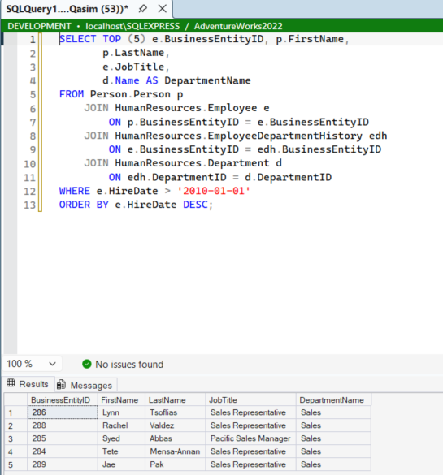
Figure 15: Step 1: a SELECT across four joined tables and its results.
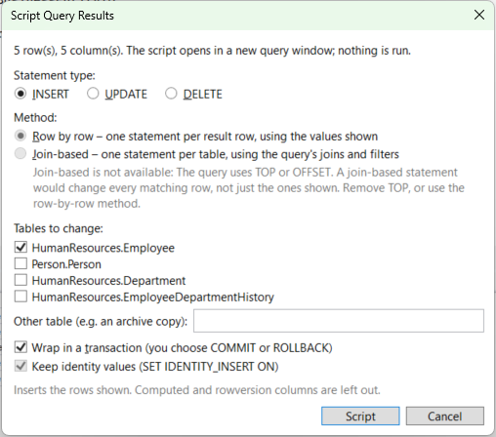
Figure 16: Step 2: the Script Query Results dialog: statement type, method and tables to change.
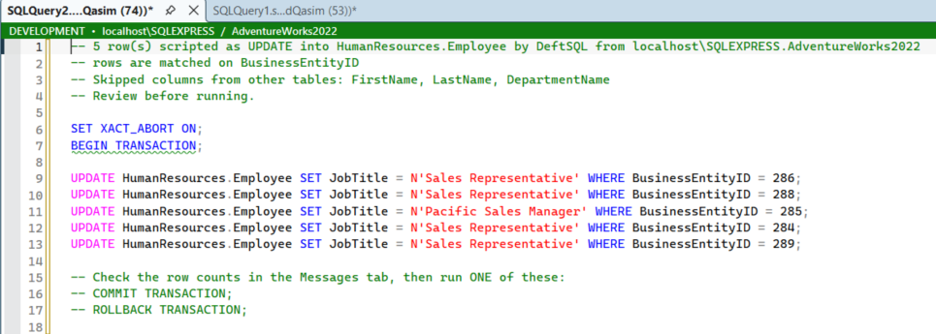
Figure 17: Step 3: the generated UPDATE script in a new window, wrapped in a transaction for review.
Built-in safety: Only a single read-only SELECT can be scripted. Computed and rowversion columns are skipped, identity values are kept, and the generated script always waits for the user to COMMIT or ROLLBACK.

Business benefit: Data corrections and environment-to-environment copies take minutes instead of hours, and each change is a reviewable, reversible script.

3.7 Navigation and Object Search
Menu path | Extensions ▸ DeftSQL ▸ Find Object… / Script Object as ALTER / Script Summary / Select in Object Explorer
Shortcuts | Ctrl+B, Ctrl+O Find Object · F12 Script as ALTER · Ctrl+F12 Select in Object Explorer · Ctrl+B, Ctrl+S Script Summary · Ctrl+B, Ctrl+G Select statement · Shift+F5 Execute current statement
Who benefits | Everyone working in large databases or long scripts

Find Object searches table, view, procedure and function names (and column names) with wildcards. Double-click a result to script it.
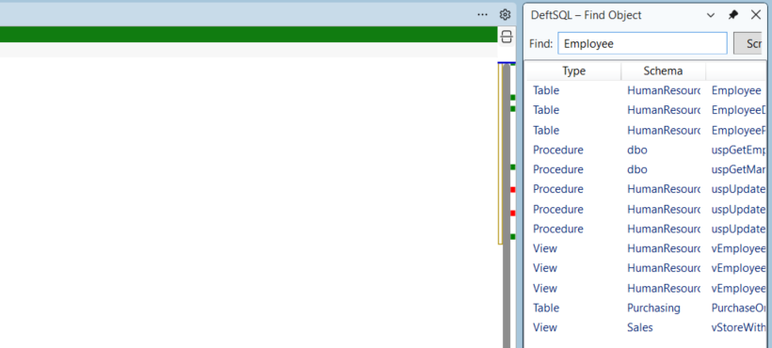
Figure 18: Find Object: searching for "Employee" returns tables, views and procedures across schemas.
Script Summary lists every statement in the current script with its line number. Click a row to jump to it, which is useful in long deployment scripts.
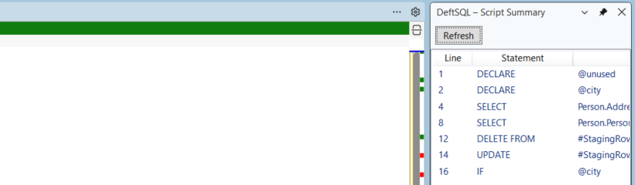
Figure 19: Script Summary for the current script.
- Script Object as ALTER (F12): opens the definition of the object under the caret, ready to edit.
- Select in Object Explorer (Ctrl+F12): finds the object under the caret in Object Explorer.
- Select / Execute Current Statement: selects or runs only the statement at the caret, without selecting it manually.
Business benefit: Less time spent scrolling and browsing Object Explorer, especially in databases with thousands of objects.

3.8 Query History and Tab History
Menu path | Extensions ▸ DeftSQL ▸ Query History; Extensions ▸ DeftSQL ▸ Tab History
Shortcuts | Ctrl+B, Ctrl+H Query History · Ctrl+Q Tab History
Who benefits | Everyone, especially after a crash or an accidentally closed tab

Query History records every executed query with time, server, database and tab. Search it, mark favorites, filter to the current connection, and insert, copy or reopen any query.
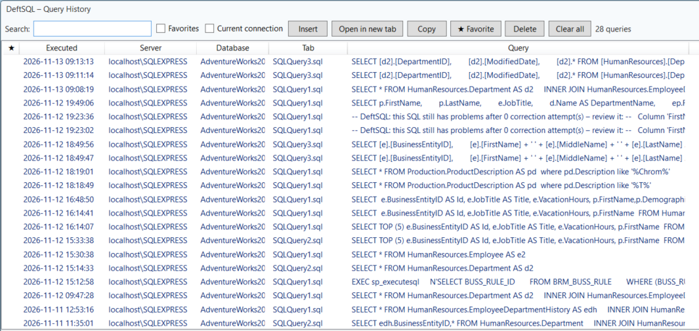
Figure 20: Query History: every executed query, searchable, with favorites.
Tab History saves the content of every query tab every 30 seconds. Closed or crashed tabs can be reopened, renamed or removed. Tabs that were open when SSMS closed can be restored automatically on the next start (optional).
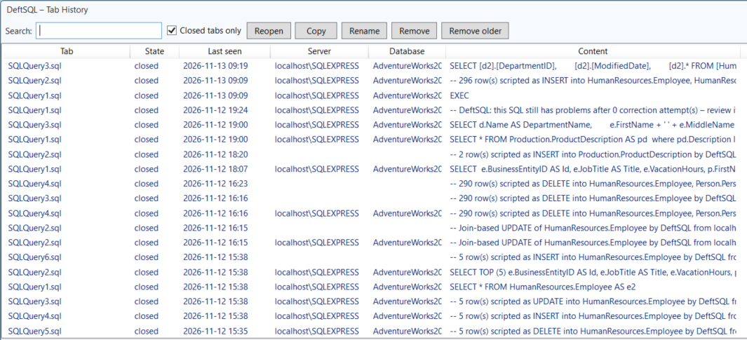
Figure 21: Tab History: closed tabs with their last content, ready to reopen.
Business benefit: Work is never lost to a crash, a reboot or a closed tab, and earlier investigations can be found again in seconds.

3.9 Environment Tab Coloring and Execution Warnings
Where | Automatic. Configure under Tools ▸ Options ▸ DeftSQL ▸ General
Who benefits | DBAs and anyone with access to Production

A colored bar above each query window shows the environment (Production, Staging, Test or Development) together with the server and database, based on configurable server and database name patterns. In the screenshots in this guide the green bar reads DEVELOPMENT · localhost\SQLEXPRESS / AdventureWorks2022.
Execution warnings ask for confirmation before running DELETE or UPDATE without WHERE, DROP or TRUNCATE, or anything on a connection marked “Confirm execution” (Production by default).
Business benefit: Reduces the risk of the most expensive class of mistake: running the right script on the wrong server.

3.10 AI Features (optional)
Menu path | Extensions ▸ DeftSQL ▸ AI ▸ …
Shortcuts | Ctrl+B, Ctrl+A Text to SQL · Ctrl+B, Ctrl+X Explain SQL · Ctrl+B, Ctrl+I AI Assistant
Providers | Claude (with the user's own Anthropic API key) or a local model through Ollama / any OpenAI-compatible server, fully offline
Who benefits | Analysts, new team members, developers tuning queries

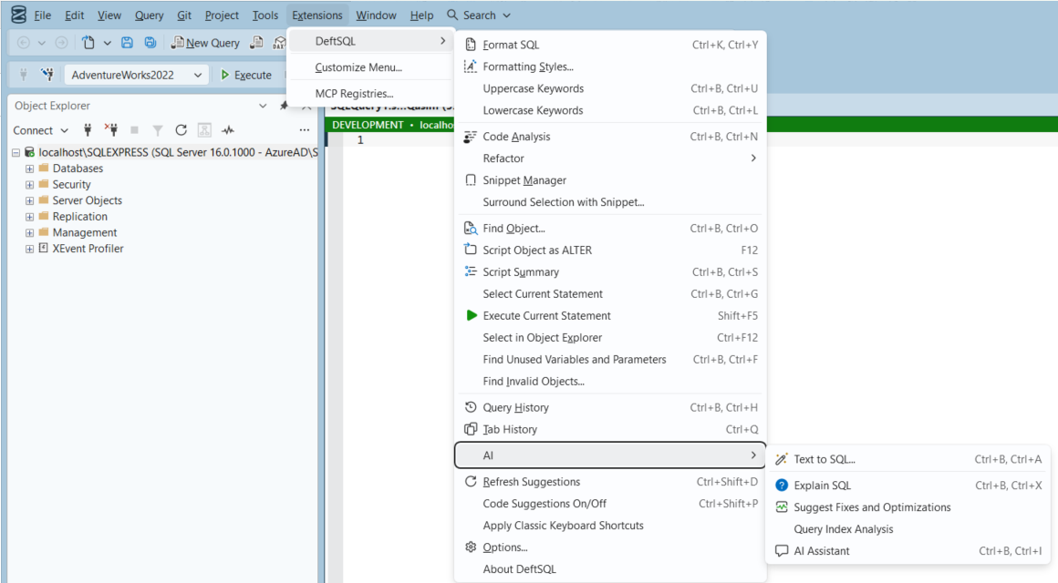
Figure 22: Menu path: Extensions ▸ DeftSQL ▸ AI.
Command | What it does
Text to SQL… | Writes a query from a plain-English description, using the real tables, columns and foreign keys of the database. The result is compiled on the server (without running it) and corrected automatically up to twice if a table or column is invalid.
Explain SQL | Explains in plain language what the selected SQL does, including risks and surprises.
Suggest Fixes and Optimizations | Reviews the selected SQL for errors and performance improvements.
Query Index Analysis | Suggests indexes that would help the query. Works offline without AI as well.
AI Assistant | A chat window docked in SSMS with Explain, Optimize, Fix errors and Index buttons. Can include the editor text automatically.

Text to SQL: example
- Open a query window connected to the target database.
- Choose Extensions ▸ DeftSQL ▸ AI ▸ Text to SQL… (Ctrl+B, Ctrl+A).
- Describe the query, for example: “list employees with their job title and department who were hired after 2010, newest first”.
- Click OK (or Ctrl+Enter). The generated, validated SQL is inserted into the editor.
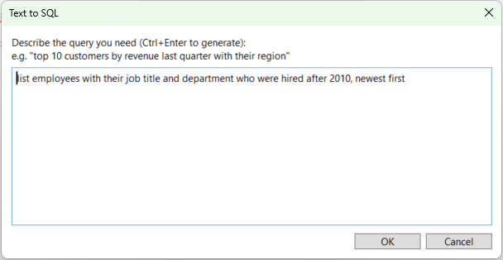
Figure 23: Text to SQL dialog.
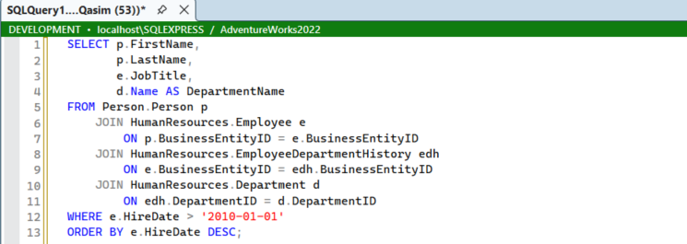
Figure 24: The generated query: correct schemas, joins on the right keys, filter and sort. Generated by the local model, fully offline.

Explain SQL and the AI Assistant
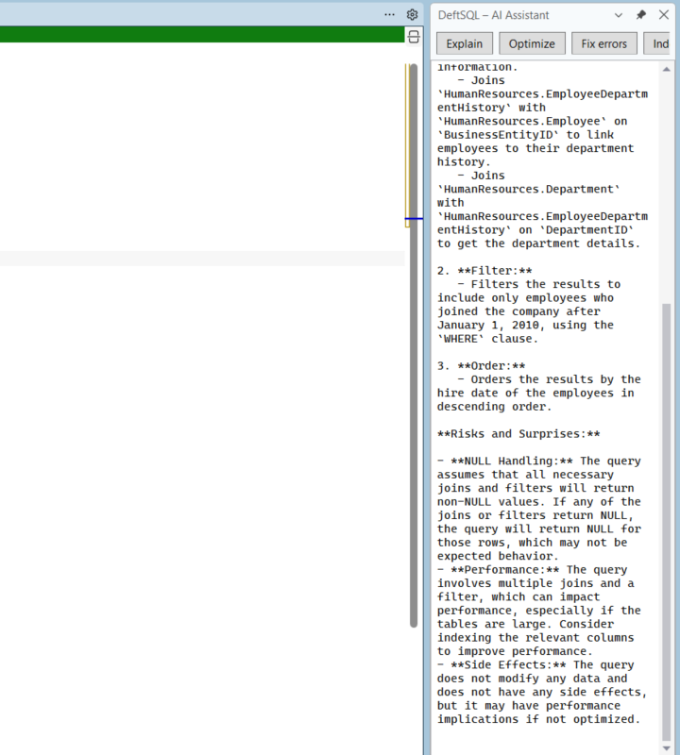
Figure 25: Explain SQL: the AI Assistant window explains each part of the query and lists risks and performance considerations.
Privacy: With the local provider (Ollama) nothing leaves the computer. With Claude, the prompt and SQL are sent; table and column names and types are included only when "Send schema context" is on. Table data is never sent. The API key is encrypted with Windows DPAPI for the current user.

Business benefit: Business users and new hires become productive with an unfamiliar schema much faster, and experienced developers get a second opinion on complex queries without leaving SSMS.

3.11 Results Grid Actions
Menu path | Right-click the results grid ▸ DeftSQL ▸ …; or Extensions ▸ DeftSQL ▸ Results Grid ▸ …
Shortcut | Assign one in Tools ▸ Options ▸ Environment ▸ Keyboard (search for DeftSQL.Results)
Who benefits | Analysts, support engineers, developers and DBAs who pass results on

Select cells in the SSMS results grid and act on them directly, without copying, pasting and editing by hand.
- Copy as IN List: copies the distinct selected values as (1, 2, 3) or (N’A’, N’B’), ready to paste after WHERE … IN. Numbers stay unquoted only when every value is a number, and NULLs are left out. Selecting a single cell takes its whole column.
- Copy as CSV: copies the selected rows and columns with column names, quoted where needed, for Excel, e-mail or a ticket.
- Open in Excel: opens the selection as a real Excel workbook with a bold, frozen header row and filters. Numeric columns become numbers; codes such as 00123 stay text so their leading zeros are kept.
- Script Rows as INSERT…: scripts the selected rows (all columns) as INSERT statements in a new query window. The target table is suggested from the query; column types come from the database, and SET IDENTITY_INSERT is added when an identity column is included.
With one cell selected, CSV, Excel and INSERT use the whole grid. Up to 100,000 rows are handled at once.
Note: Values are read as the grid shows them, so a text value that reads NULL is treated as SQL NULL, and long values are limited to what the grid displays (Tools ▸ Options ▸ Query Results ▸ Results to Grid). To script exact data with keys and UPDATE or DELETE, use Section 3.6.

Business benefit: Answers move from the grid into the next query, a spreadsheet or a test-data script in one click, without manual quoting or reformatting.

3.12 Team Standards and Settings Sharing
Menu path | Extensions ▸ DeftSQL ▸ Export Settings… / Import Settings…; Tools ▸ Options ▸ DeftSQL
Who benefits | Team leads, new team members, anyone using more than one PC

DeftSQL lets a team keep one standard with shared files on a network drive or in source control:
- Formatting: a team styles folder (Section 3.3).
- Code analysis: a team rule set file (Section 3.4).
- Snippets: a shared snippets folder (Section 3.2).
- Everything else: Export Settings… writes all options and your own snippets to one file; Import Settings… loads it on another PC. API keys are never exported, and the importing PC keeps its own key.

Business benefit: New team members are set up in minutes, and every developer formats and reviews code against the same rules.

3.13 Command Line and CI
Program | deftsql.exe (.NET 8), built from src\DeftSQL.Cli in the DeftSQL source
Who benefits | Build and release engineers, team leads enforcing standards in pull requests

The deftsql command runs the same formatter and analysis rules as SSMS, so scripts in source control can be checked automatically in a build pipeline or a pre-commit hook.
deftsql format .\sql --check
deftsql format .\sql --style "Team: house" --user-settings
deftsql analyze .\sql --fail-on warning
deftsql analyze .\sql --rules team.ruleset.json --output json
deftsql rules
- format rewrites files in the chosen style, or with --check only reports files that are not formatted.
- analyze reports issues as file(line,col): severity ID: message, or as JSON. --connection loads the database schema for rules that need it. Suppression comments are honoured.
- Exit codes: 0 clean, 1 issues found or files not formatted, 2 wrong usage, so a pipeline step fails when standards are not met.

Business benefit: Standards are enforced automatically for every change, not just for the developers who remember to run the checks.

4. Settings
Menu path | Extensions ▸ DeftSQL ▸ Options… (or Tools ▸ Options ▸ DeftSQL)
Pages | General · AI · Formatting

4.1 General
Controls completion (auto aliases, object definition box, join suggestions, snippets in the list, Tab expansion of SELECT \*), editor helpers (format on paste, matching-identifier highlight, hover info, parameter info), execution warnings, history and environment colors.
It also holds Rank suggestions by usage, Hidden objects (patterns separated by semicolons) and Team rule set file.
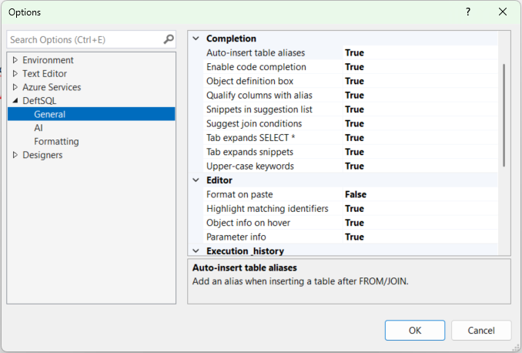
Figure 26: Tools ▸ Options ▸ DeftSQL ▸ General.

4.2 AI
Turns AI on or off and selects the provider (Claude or a local model), the model, the local server URL and context size, and the privacy settings (Send schema context, maximum objects in schema context).
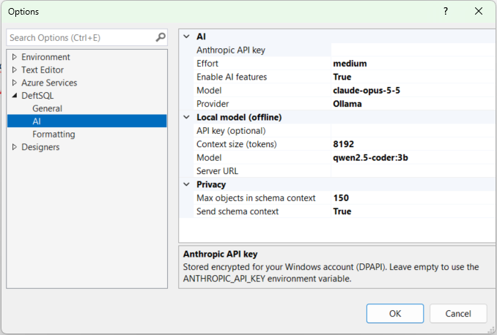
Figure 27: Tools ▸ Options ▸ DeftSQL ▸ AI, here configured for the local Ollama provider.

4.3 Formatting
Selects the active formatting style and the options of the Custom style. Use Formatting Styles (Section 3.3) for a live preview.
Team styles folder points at a shared folder of styles (Section 3.3). Match object name case and the layout options are set here or in Formatting Styles.
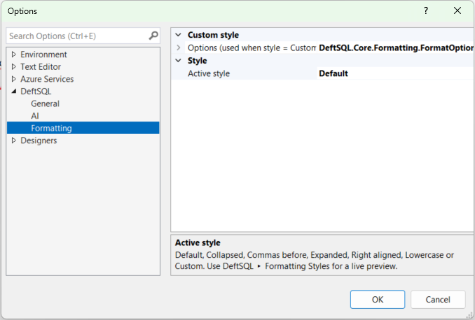
Figure 28: Tools ▸ Options ▸ DeftSQL ▸ Formatting.

4.4 Data locations
Item | Location
Settings, snippets, history, tab history, log | %LOCALAPPDATA%\DeftSQL (settings.json, snippets.json, completion-usage.json, History\, TabHistory\, deftsql.log). Delete completion-usage.json to reset suggestion ranking.
Anthropic API key | Encrypted with Windows DPAPI for the current user; falls back to the ANTHROPIC_API_KEY environment variable

5. Keyboard Shortcut Reference
On first load DeftSQL binds these keys and removes clashing SSMS bindings (listed in deftsql.log). Re-apply them with Extensions ▸ DeftSQL ▸ Apply Classic Keyboard Shortcuts, or change them in Tools ▸ Options ▸ Environment ▸ Keyboard (search for "DeftSQL").
Shortcut | Command
Ctrl+K, Ctrl+Y | Format SQL
Tab | Expand snippet / expand SELECT *
Ctrl+Space | Show suggestions
Ctrl+Shift+Space | Parameter info
Ctrl+Up / Ctrl+Down (in list) | Cycle suggestion filters
Ctrl+Right / Ctrl+Left (in list) | Column picker / back to list
Ctrl+. | Quick fixes and refactorings
F2 | Smart rename
F12 | Script object as ALTER
Ctrl+F12 | Select in Object Explorer
Shift+F5 | Execute current statement
Ctrl+Q | Tab history
Ctrl+Shift+D | Refresh suggestions (reload schema)
Ctrl+Shift+P | Suggestions on/off
Ctrl+B, Ctrl+W | Expand wildcards
Ctrl+B, Ctrl+Q | Qualify object names
Ctrl+B, Ctrl+B | Add/remove square brackets
Ctrl+B, Ctrl+C | Insert semicolons
Ctrl+B, Ctrl+E | Encapsulate as stored procedure
Ctrl+B, Ctrl+D | Script query results as INSERT / UPDATE / DELETE
Ctrl+B, Ctrl+U / Ctrl+L | Keywords upper / lower case
Ctrl+B, Ctrl+S | Script summary
Ctrl+B, Ctrl+F | Find unused variables and parameters
Ctrl+B, Ctrl+O | Find object
Ctrl+B, Ctrl+G | Select current statement
Ctrl+B, Ctrl+H | Query history
Ctrl+B, Ctrl+N | Code analysis
Ctrl+B, Ctrl+A | Text to SQL
Ctrl+B, Ctrl+X | Explain SQL
Ctrl+B, Ctrl+I | AI assistant

6. Troubleshooting
Symptom | Resolution
No suggestions appear | The query window must be connected. Run Extensions ▸ DeftSQL ▸ Refresh Suggestions (Ctrl+Shift+D) and check About DeftSQL for the metadata status. Errors are written to %LOCALAPPDATA%\DeftSQL\deftsql.log.
Two suggestion lists appear | Turn off SSMS IntelliSense: Tools ▸ Options ▸ Text Editor ▸ Transact-SQL ▸ IntelliSense.
A shortcut does nothing | Run Extensions ▸ DeftSQL ▸ Apply Classic Keyboard Shortcuts.
DeftSQL menu missing after an upgrade | Uninstall (install.ps1 -Uninstall), start and close SSMS once, then install again.
AI commands are unavailable | Enable AI in Extensions ▸ DeftSQL ▸ Options… ▸ AI and set a provider (an Anthropic API key, or Ollama running locally).
Another database shows no suggestions | Its schema loads in the background the first time it is used (the status bar says so). Keep typing; the list fills in after a few seconds. You need permission to read that database.
Results grid commands cannot read the grid | Run the query with Results to Grid (Ctrl+D), click a cell in the grid, then run the command again.

